Script:

Slide 1: Title slide

- Good morning. My name is Kevin and we are Team Cochran.
- Today I am joined by my colleagues Xiaoqing, Weishan, and Jianing.
- Next we will present our proposed sample design for the Michigan Teen Smoking and Drug Use Survey, commissioned by the Michigan Department of Education.
- The primary goal is to estimate prevalence for cigarette and marijuana use, and the mean age when first asked to smoke.

Slide 2: Project Objectives & Content

- The customer desires a coefficient of variation, or CV, of no more than 0.05, with the following mean estimates shown in this table.
- Our target population includes roughly 830,000 students in grades 7-12 enrolled in public or private Michigan schools.
- We designed a two-stage stratified cluster sample.
  - The flowchart on the right provides a high-level overview of the process, yet the key points here are that we start with a school list and desired level of precision, examine alternative cluster designs, and strata proportionate allocation.
- We now go into the details of these steps:

Slide 3: Stratification & Allocation

- To improve precision and enable regional estimates, we stratified the state into the nine education regions.
- This map shows the regions, and we allocated the target number of sample schools to these strata proportionally based on the total student enrollment in each region.
- The bar graph shows the resulting allocation proportions across the regions.
- Next, we determine optimum subsample size calculations.

Slide 4: Determining Sample Size Components

- Recall that students within schools are often more similar than students chosen completely at random, so we needed to account for this clustering effect for our key variables using design effects from a pilot study, as shown in the first table.
- With these roh estimates and the cost information shown below, we used the standard formula to estimate the optimal number of students to sample per school, m_opt, for each variable.
- Since we had three outcomes with varying design effects, we had three alternative clustering designs to choose from, shown on the right.
- We choose the middle design with 53 students and 87 schools totaling 4,721 students.
- This design meets the desired standard error and is within our budget.

Slide 5: Stage 1: School Selection (PPeS)

- We adjusted our optimal n (87) and m (53) to account for anticipated non-response, targeting the initial selection of n 290 schools and aiming for m 76 students per school.
- These 290 schools were allocated proportionately across the 9 strata (n_h in the table).
- The selection method within each stratum was systematic PPeS.
- We used total student count as the Measure of Size (MOS) and sorted schools by size for implicit stratification.
- The sampling interval (k_h) was calculated for each stratum, and selection proceeded using a random start, denoted by RN in the table.
- Post-selection linkage was applied as needed, which we'll cover next

Slide 6: Stage 2, Student Selection & Linkage

- In Stage 2, our goal is to select students while maintaining the EPSEM design across strata.
- We calculated the required number of students needed from each selected school to maintain the overall target sampling fraction.
- We performed a Minimum MOS check and if a selected school was too small to yield the required student sample, it was linked with the next school(s) on the sorted list until the combined MOS was sufficient.
- Students are then selected using systematic random sampling from the final roster of the selected linked clusters.
- The probability of inclusion for any student is shown by the formula, which simplifies to the number clusters to be selected multiplied by the number of students to be selected divided by the total students in a given stratum.
- Our target is 4,721 completed student interviews.

Slide 7: Variance Estimation

- For calculating confidence intervals and understanding the precision of our estimates, we used the Paired Difference Replication Method.
- This method is suitable for our complex design as it correctly accounts for stratification and clustering.
- We form pseudo-strata, by sequentially pairing the 290 selected schools based on their selection order within the original strata.
  - This results in a total of 145 pseudo strata.
- Conceptually, the variance of an estimate is calculated based on the sum of squared differences between estimates derived from the two paired schools within each variance stratum, summed across all 145 pairs..
- This approach provides 145 degrees of freedom for statistical inference.
- Importantly, this same variance estimation method and the resulting degrees of freedom can be used for subclass analyses, such as examining results for low-income students.
- However, we are examining other methods since we recognize that we have an odd number of subclass members per school, and we may not be able to use the same variance estimation.

- I haven’t seen any other team overs sample due to non-resposne. Maybe we need to go back to the original values for m_opt and n_opt.
  - Team 2 had the idea of poststratification, this would actually be a good option for adjusting the estimates but would only work at the regional level and not the national level.
  - I am still unclear about what we need to do to adjust for non-response
- Note to myself, for the paper any table should have a title and description.
- Round only when needed, example not for sampling rate, final sample size should be integer.
  - Final sample size is a random variable, and I think it should be similar to our initial idea of our sample size 4, 721.
- We will need to provide how to estimate means, variances, and 95% CI at the national level, regionally, and for the subclass.
- Sorting, an idea would be to sort by grade sizes, not total-sizes, so we can expect to sample schools with somewhat equal distributions for grades 7-12.

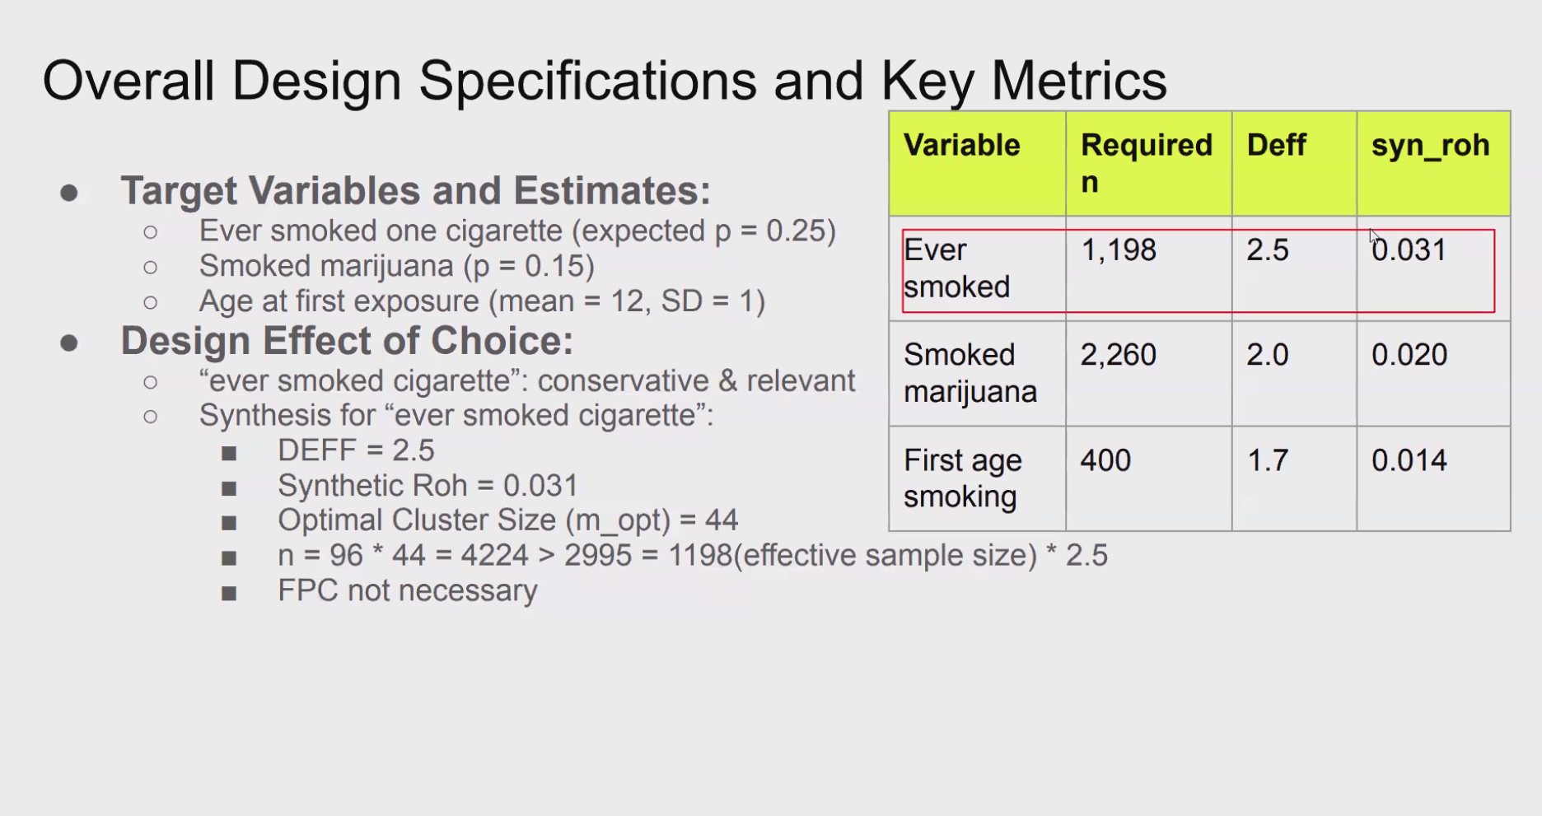

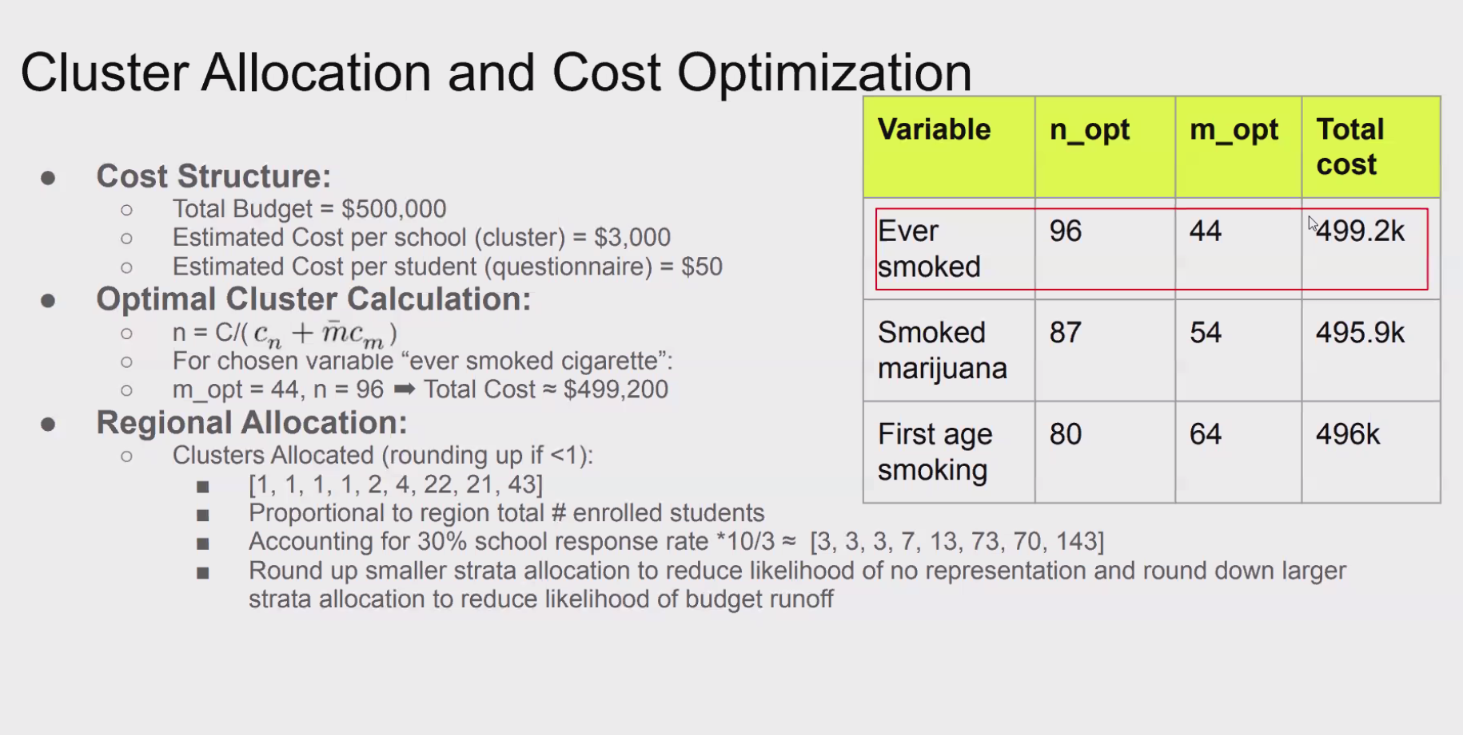

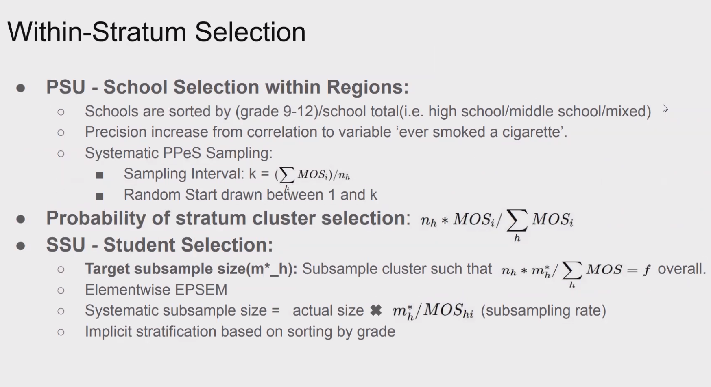

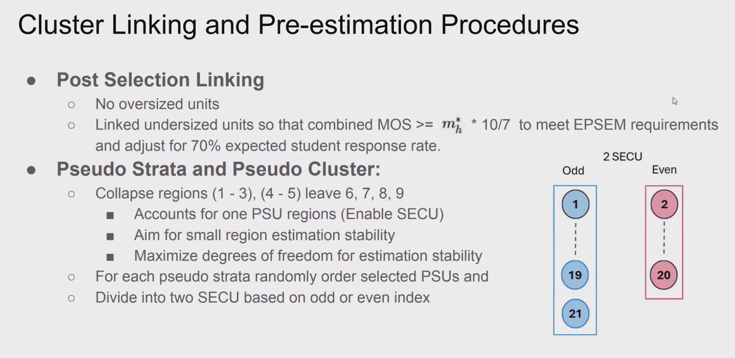

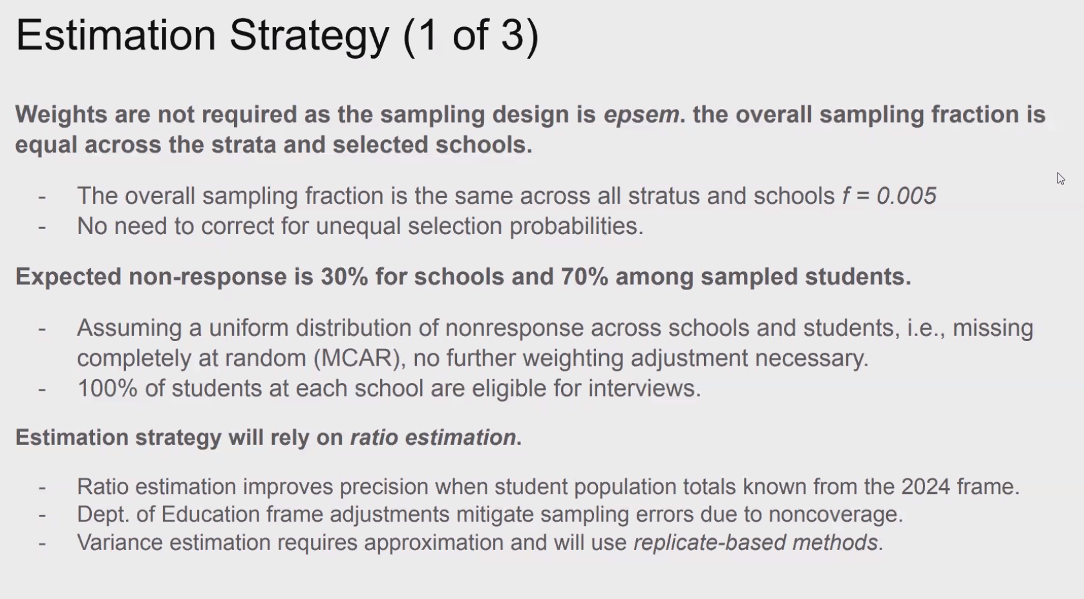

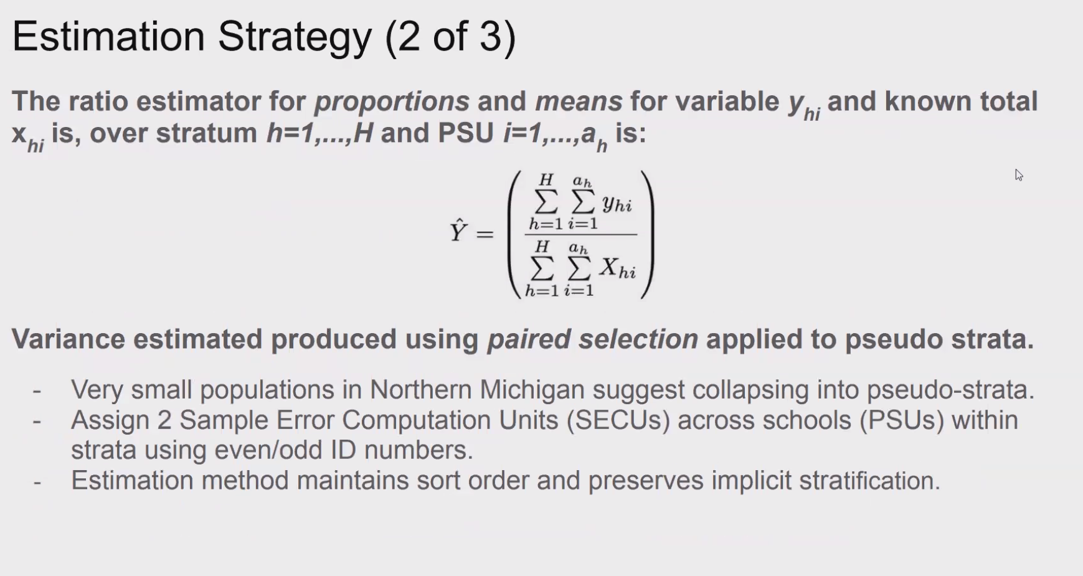

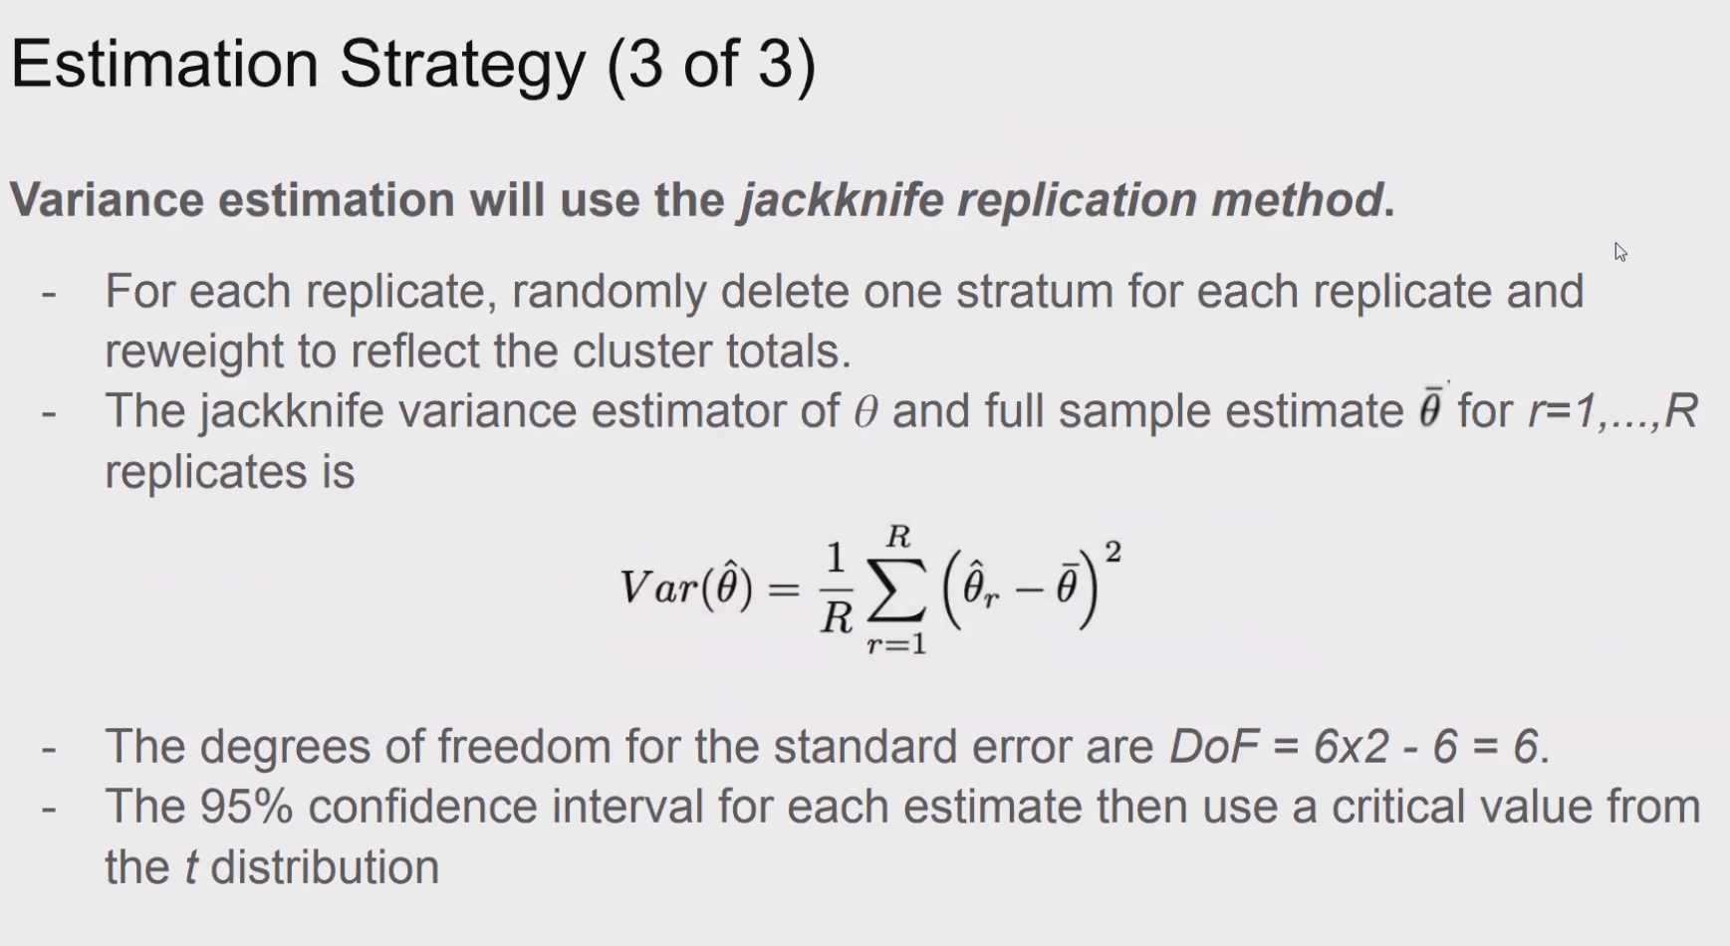
Delete one secu, not one stratum. Df 12-1, not =6.

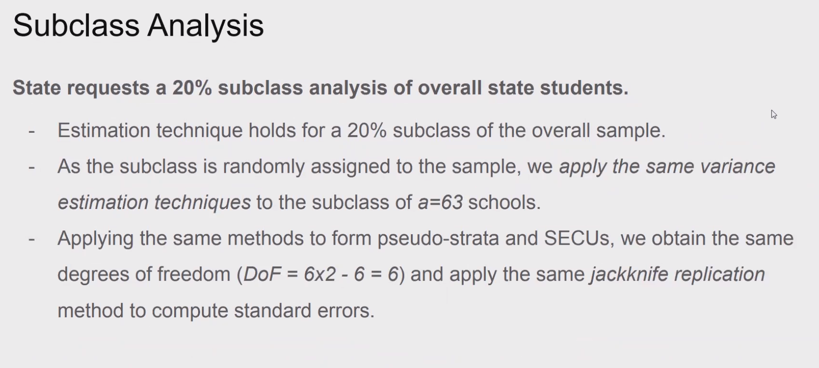

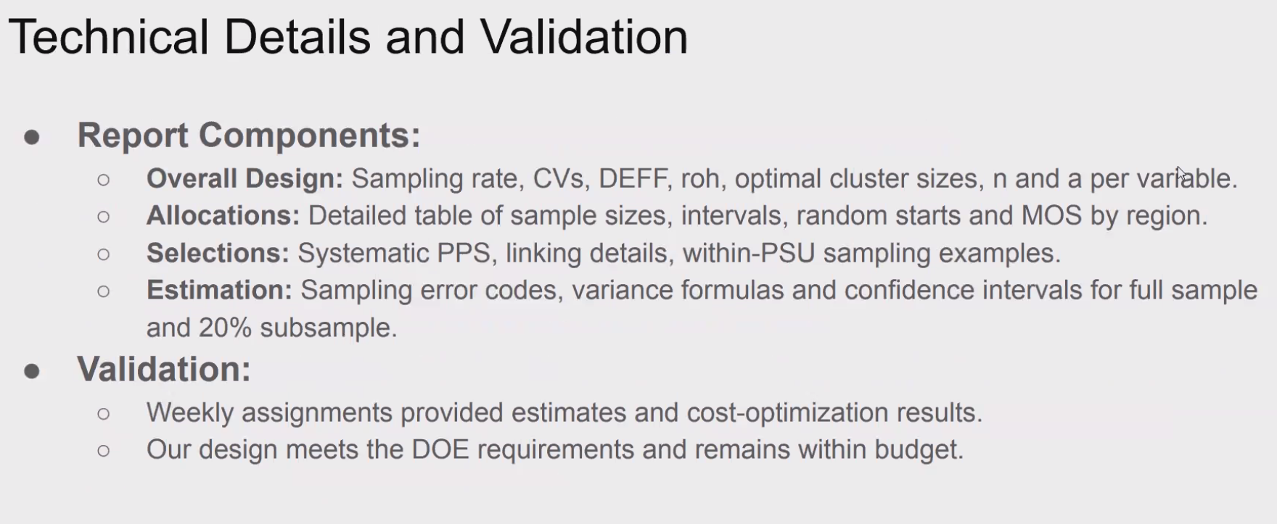

2nd last team

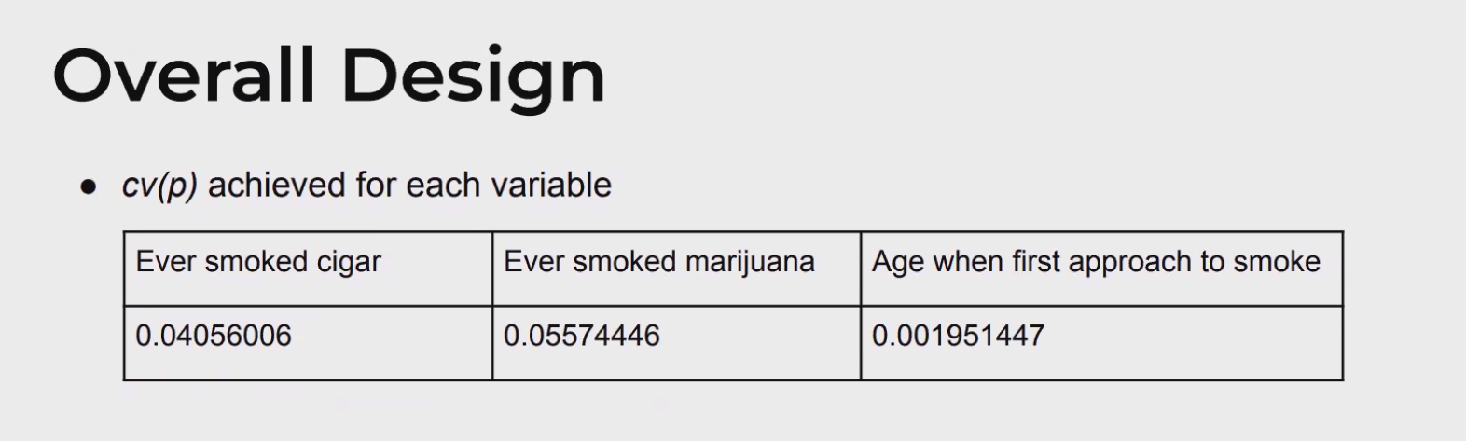
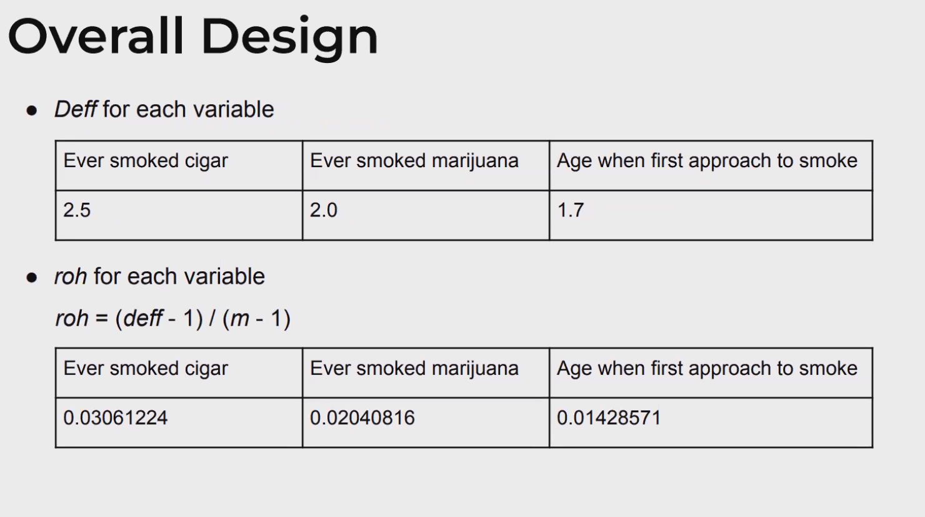

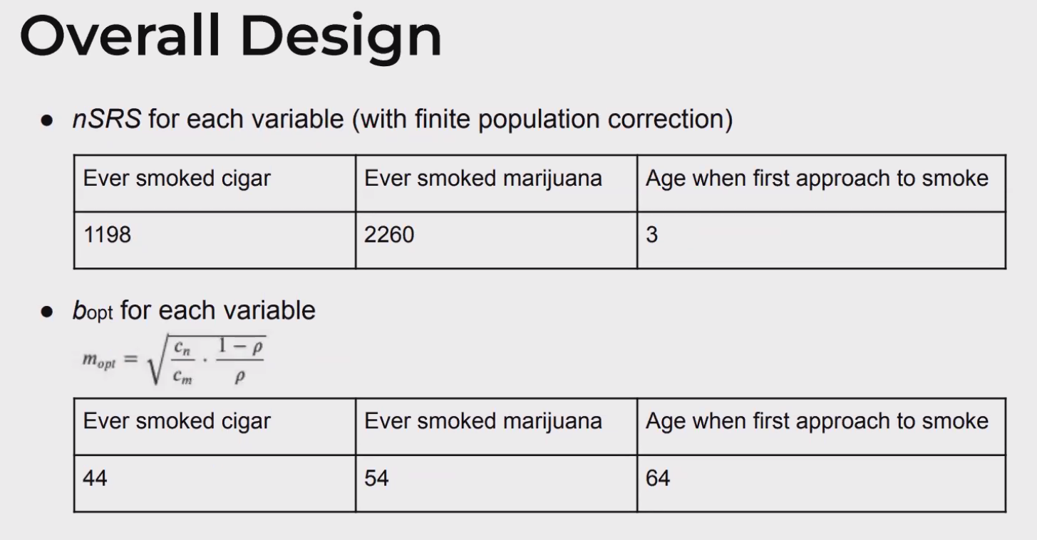

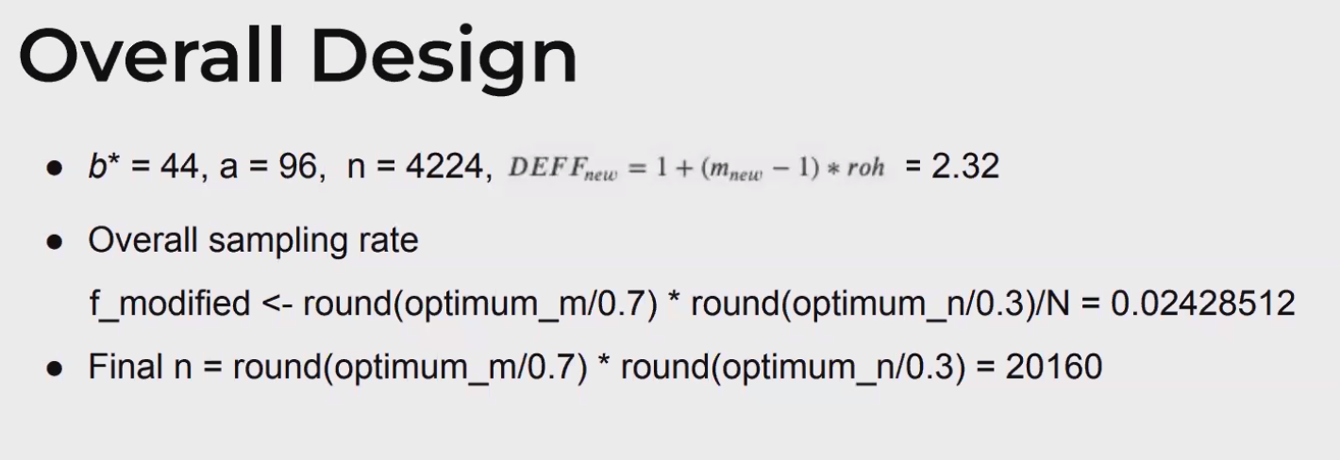

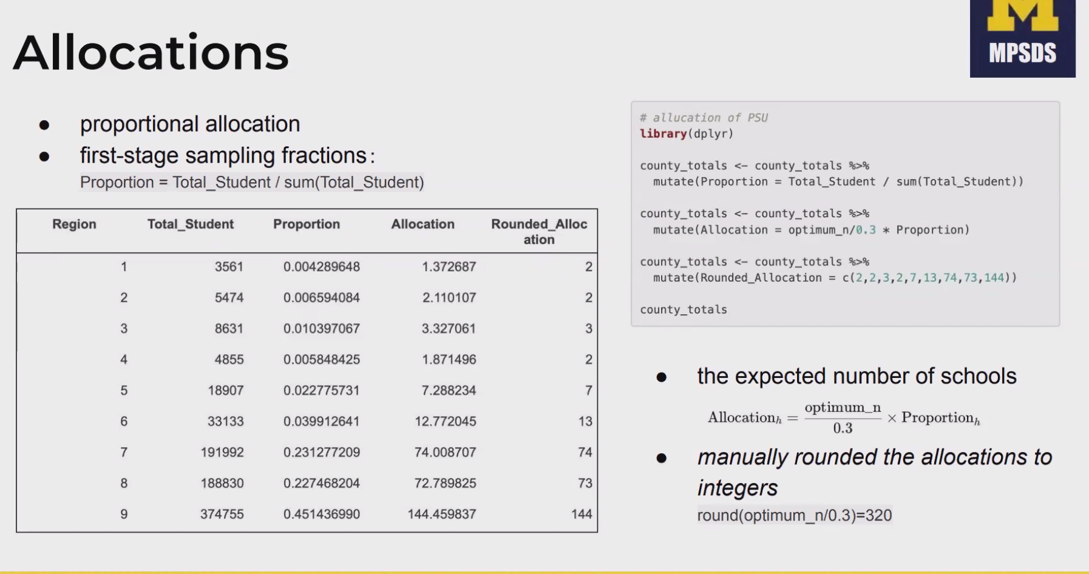
f_h first stage sampling rate, but these should vary

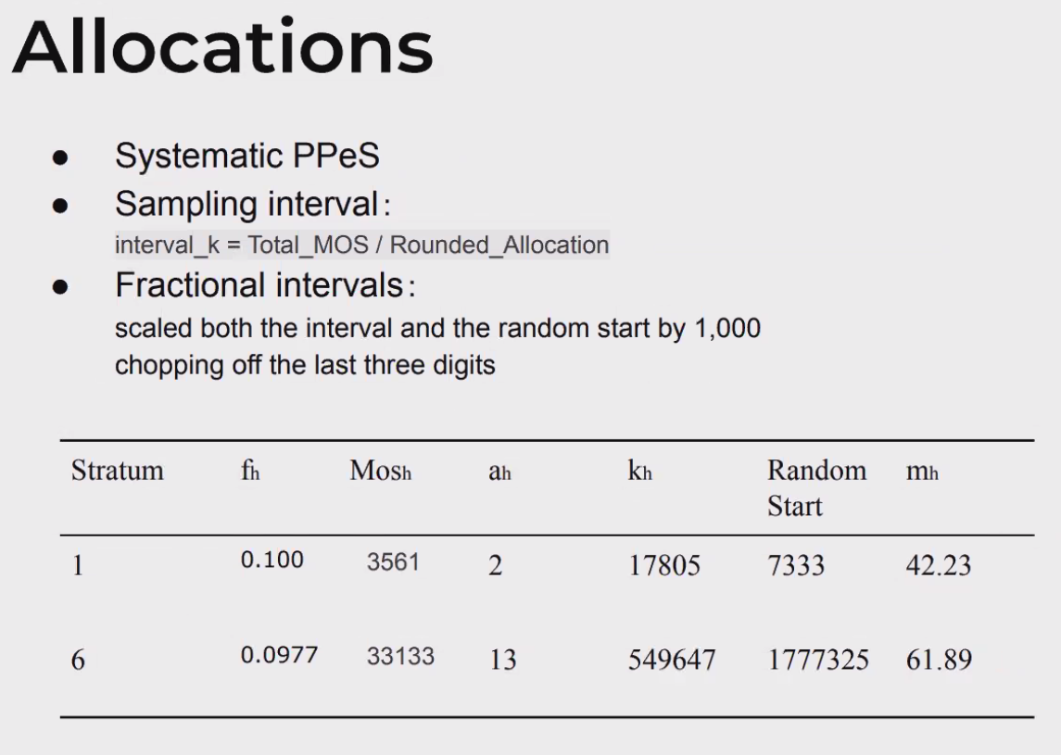

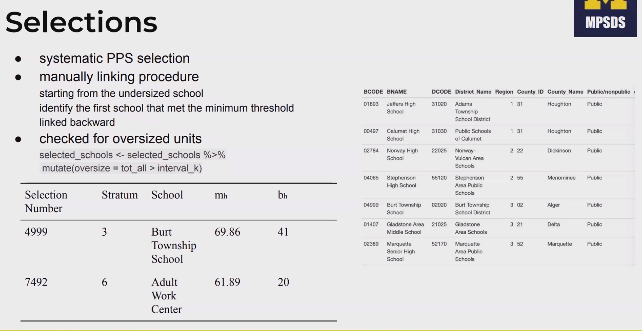

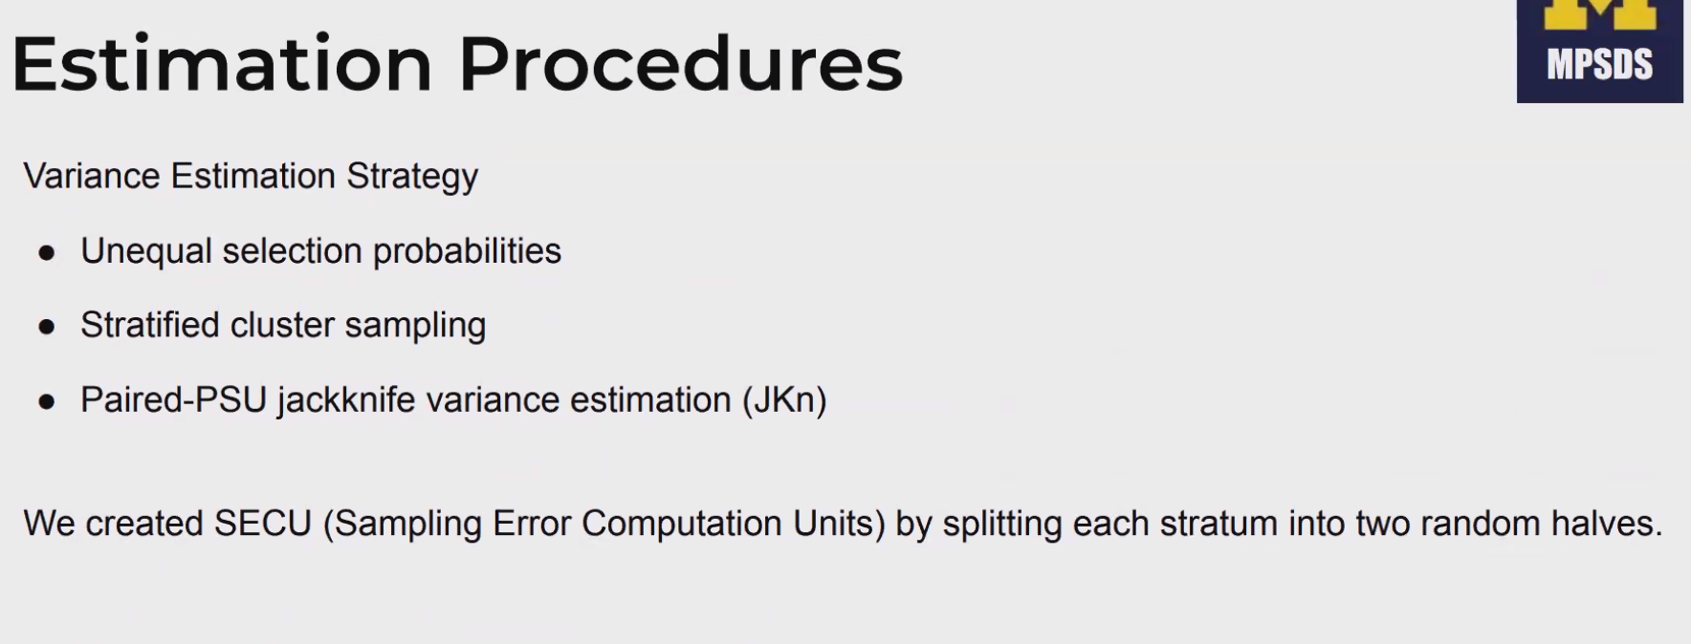

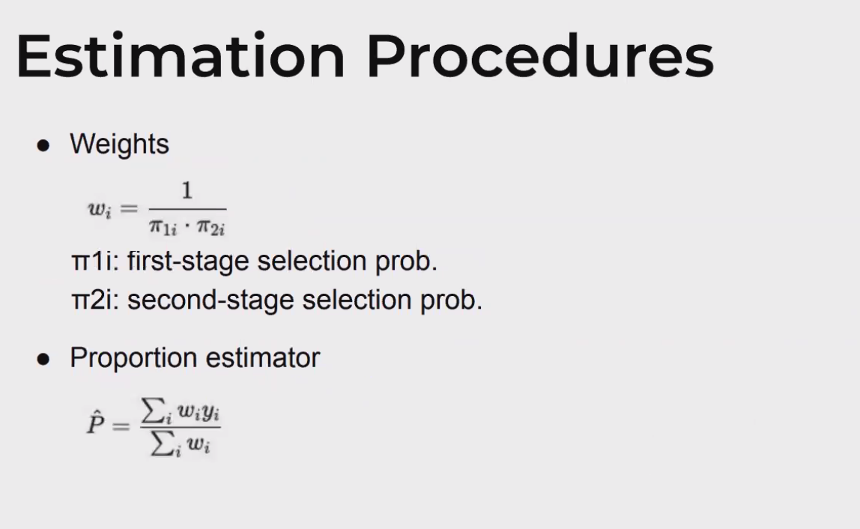
Not right variance estimation for jrr below.

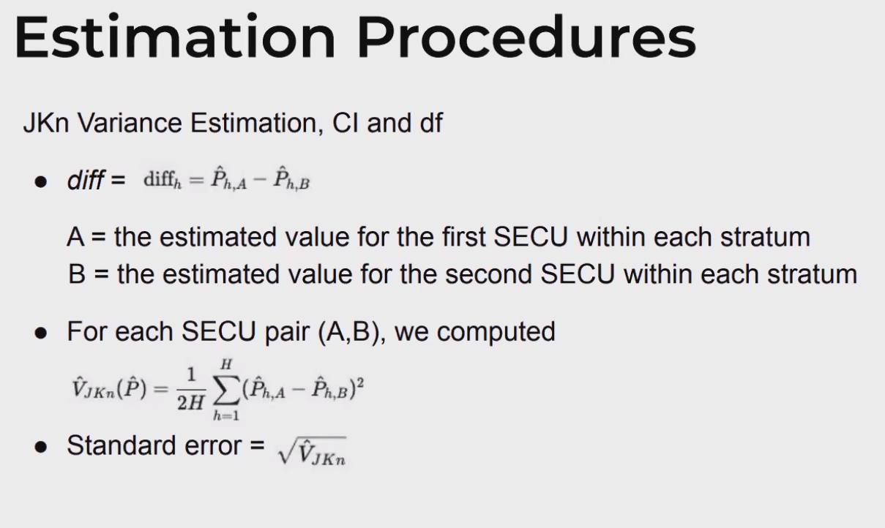

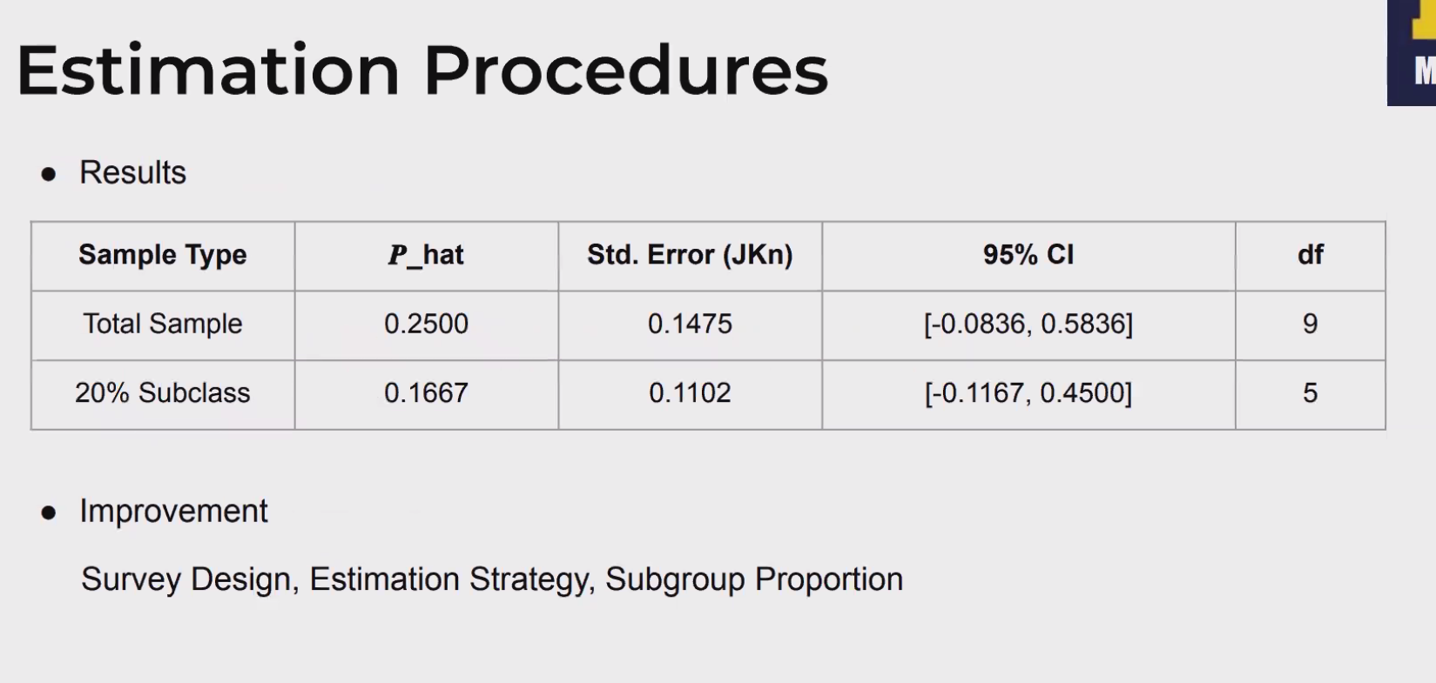

increase PSUs, consider bootstrap. We do not know the estimates.

Last team

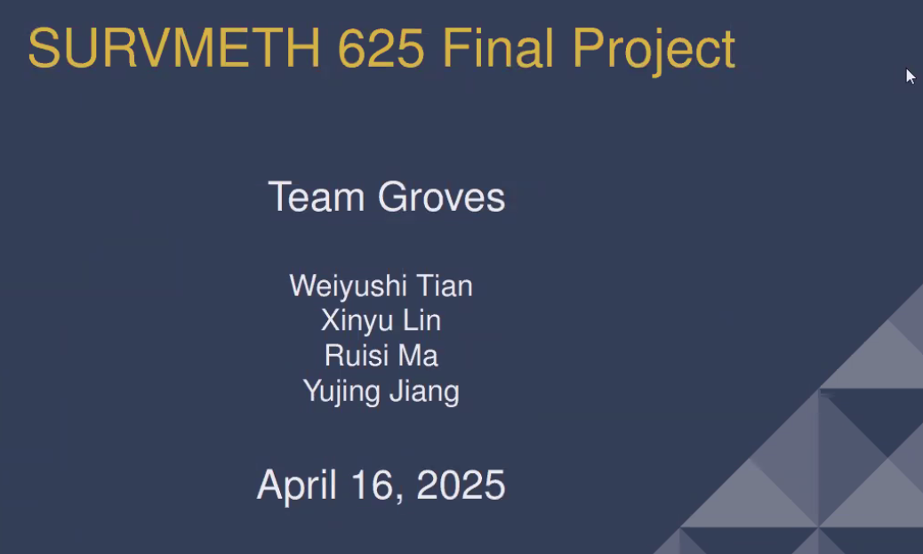

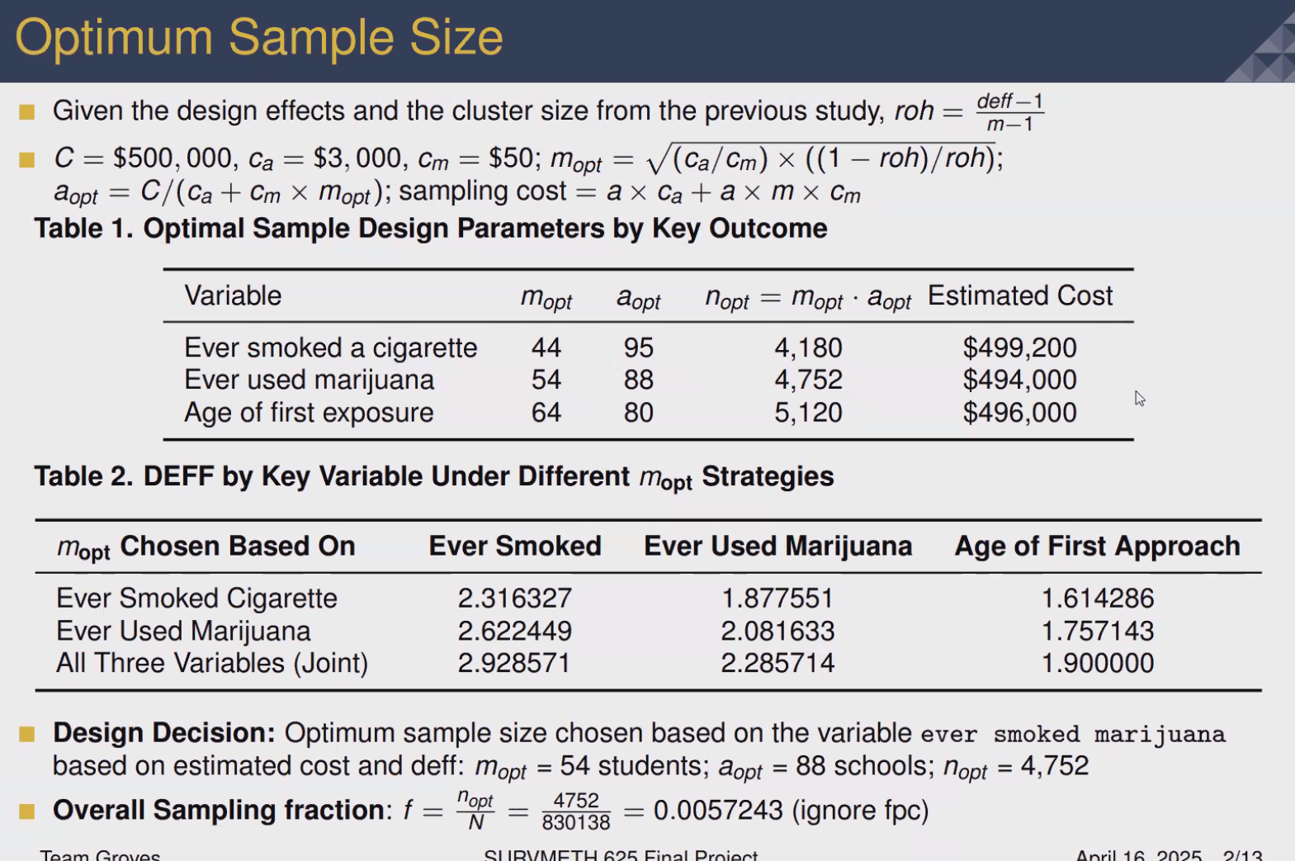

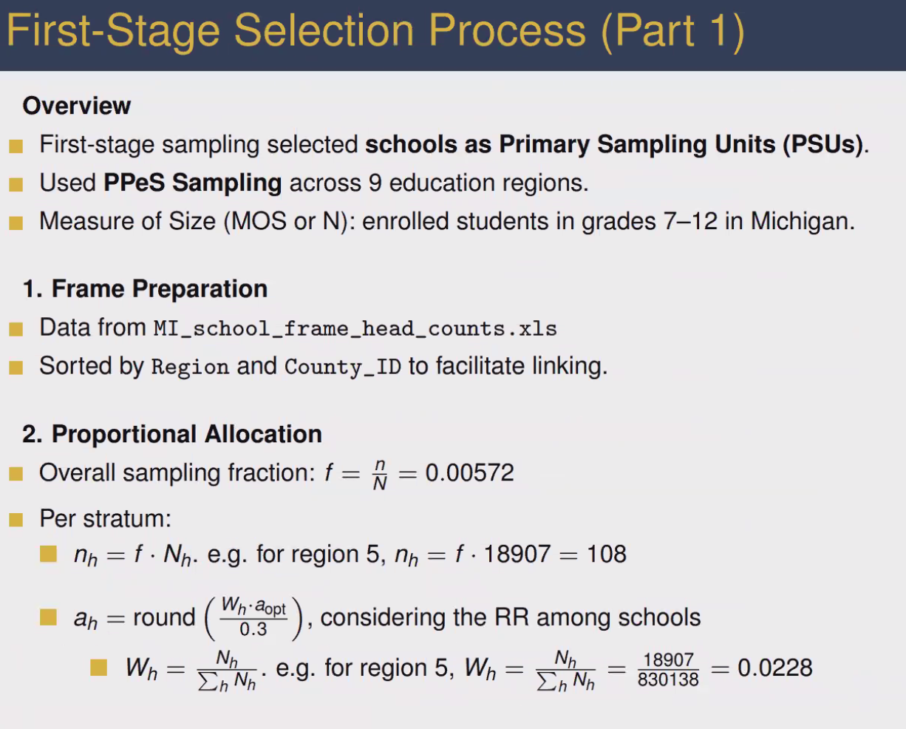

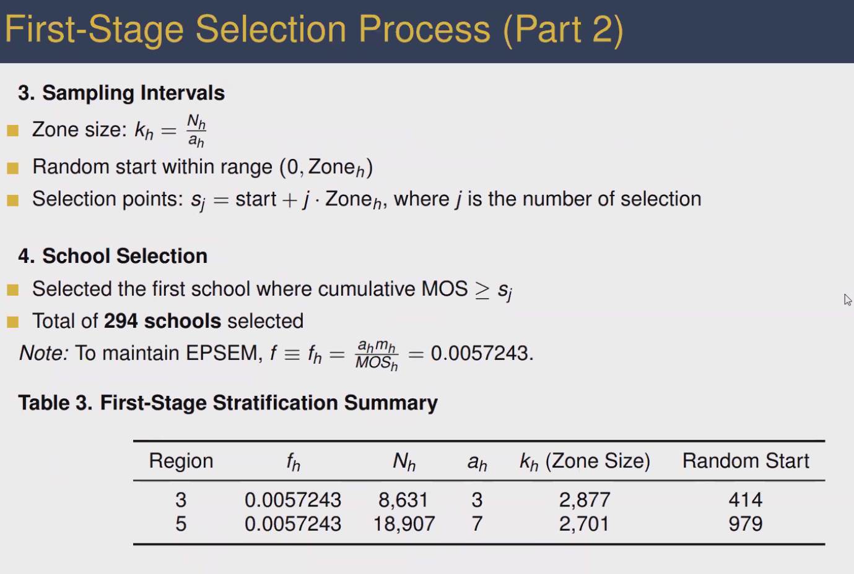

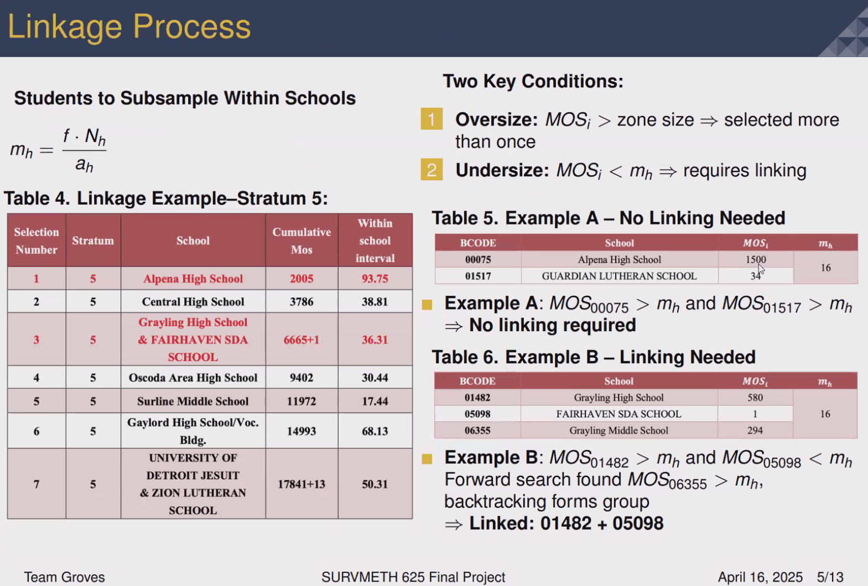

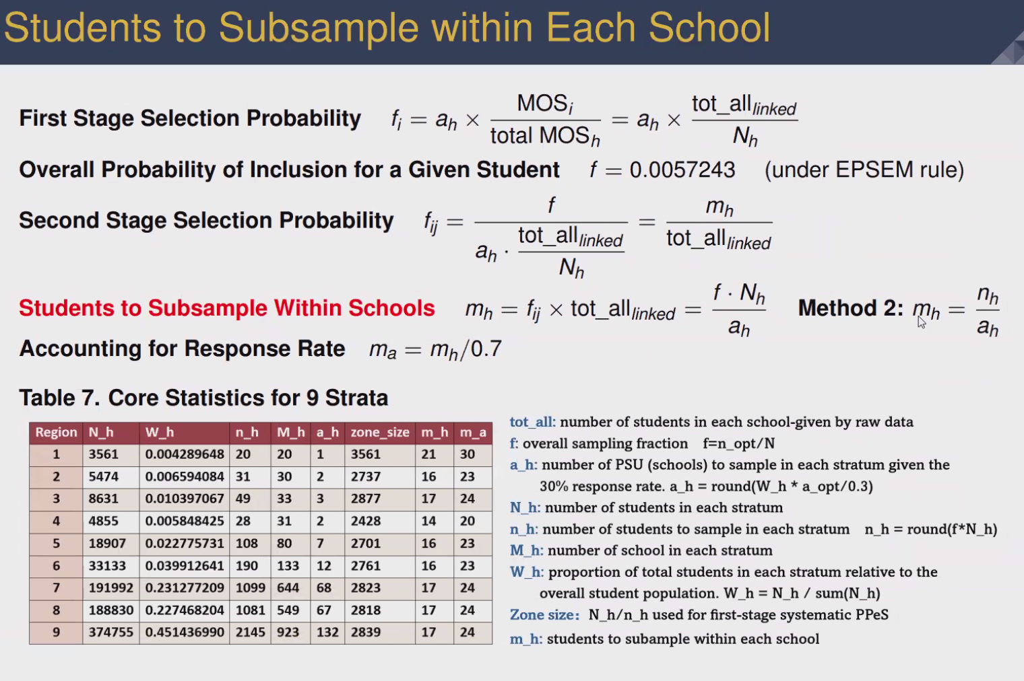

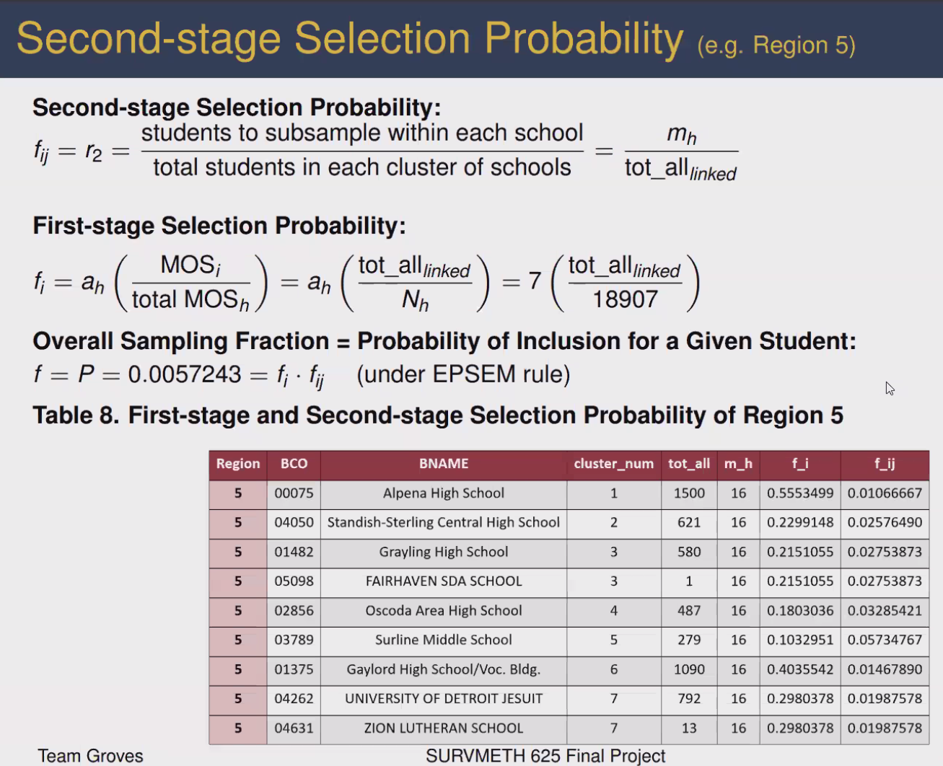

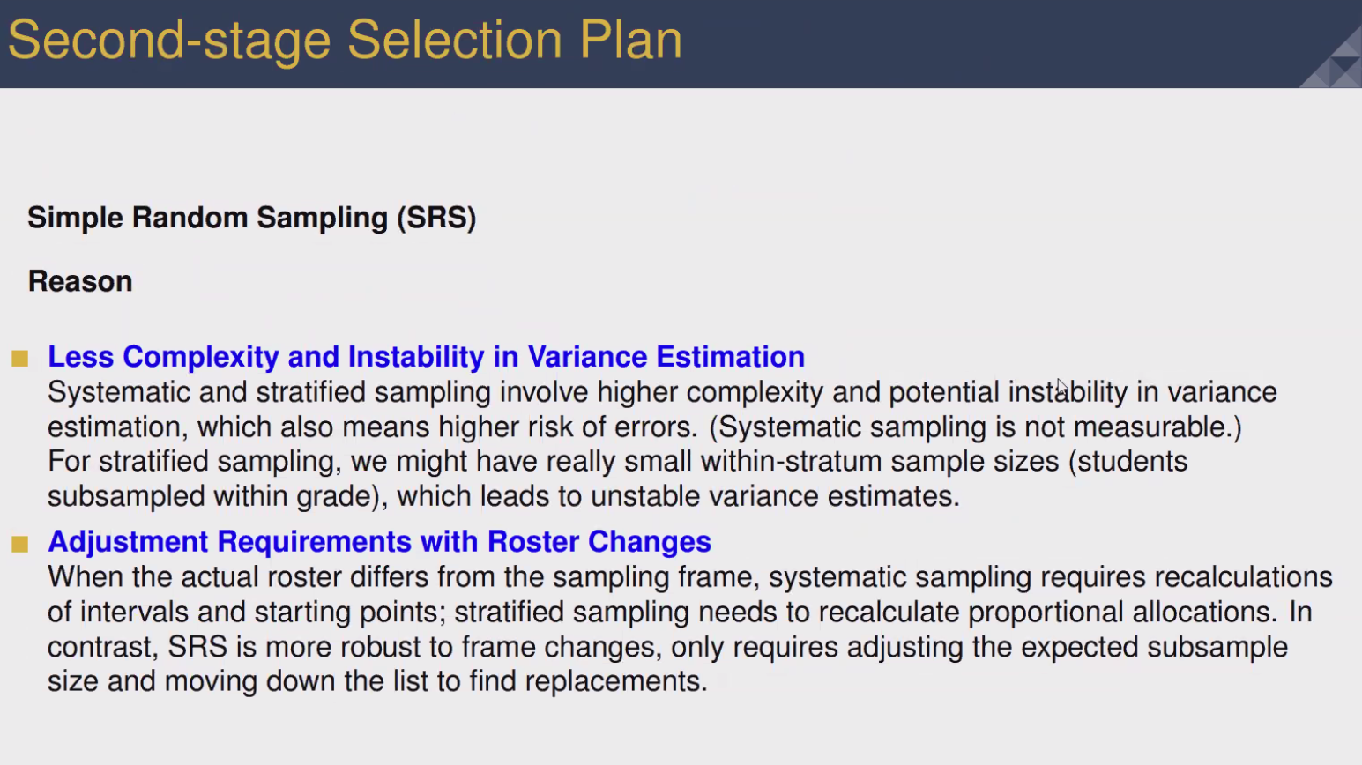

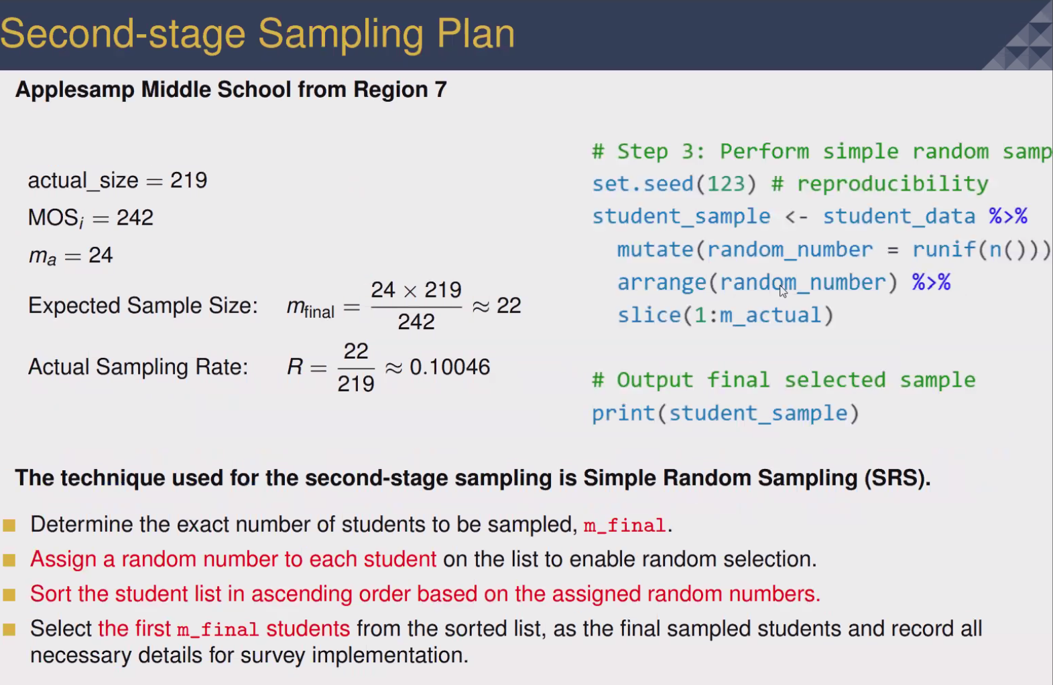

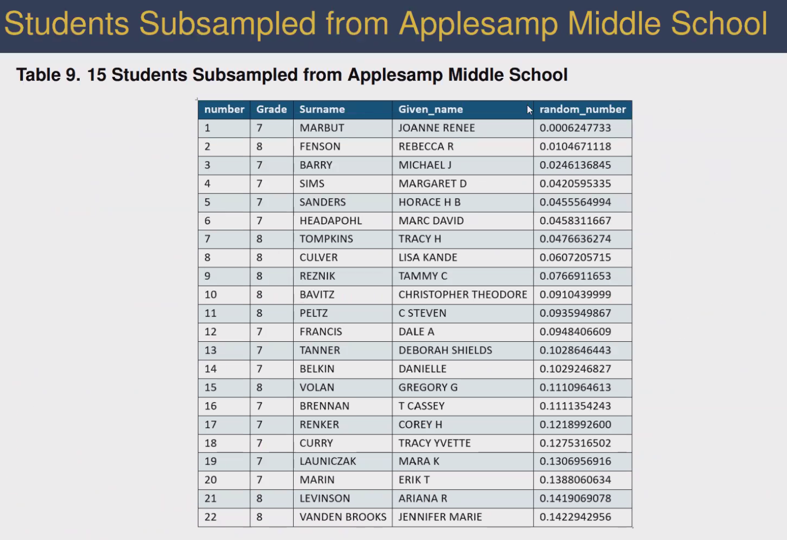
Used list of names to organize.

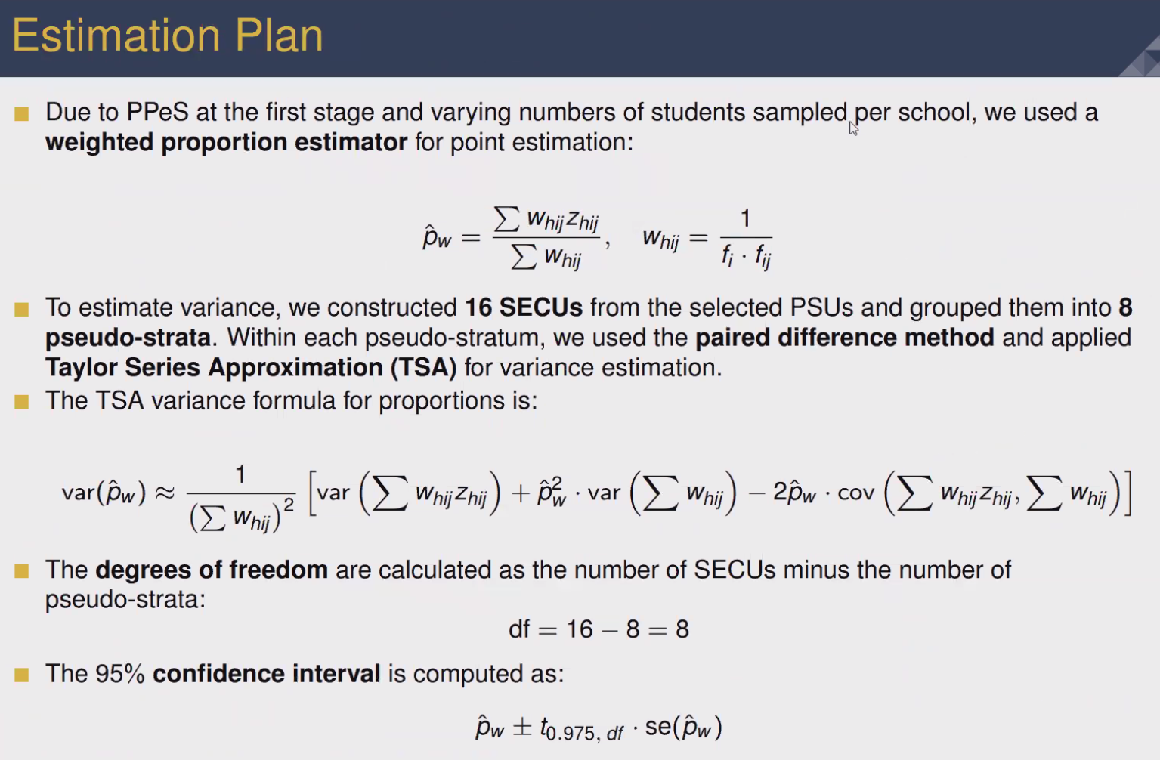
taylor series can be simplified from this.


