**Overall structure**

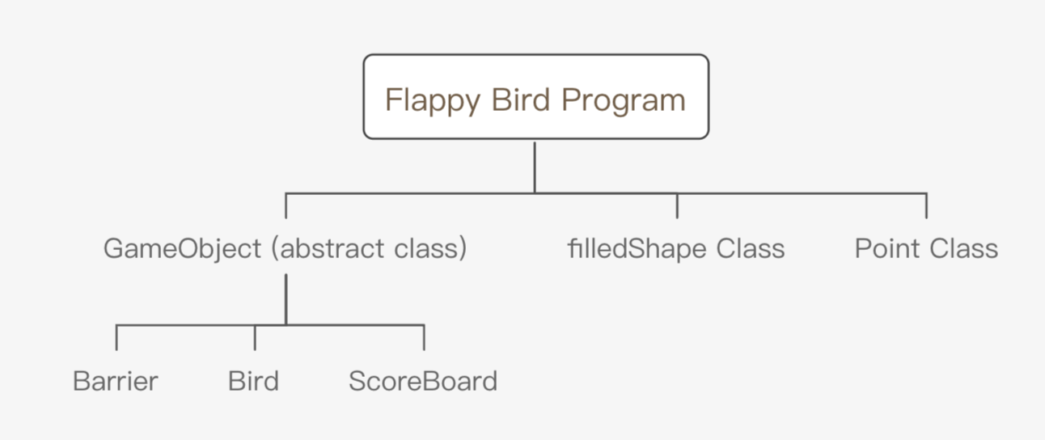

**Brief Game Play**

Introduction:

As the below figure shows: the red circle which movement is controlled by user input (w/s or up arrow/down arrow) is bird and the blue rectangle moving automatically are barriers. User input directions to dodge the barriers and when touch the barriers, game over and a green rectangle shows meanwhile user can get their score in the Windows Console.

Running interface

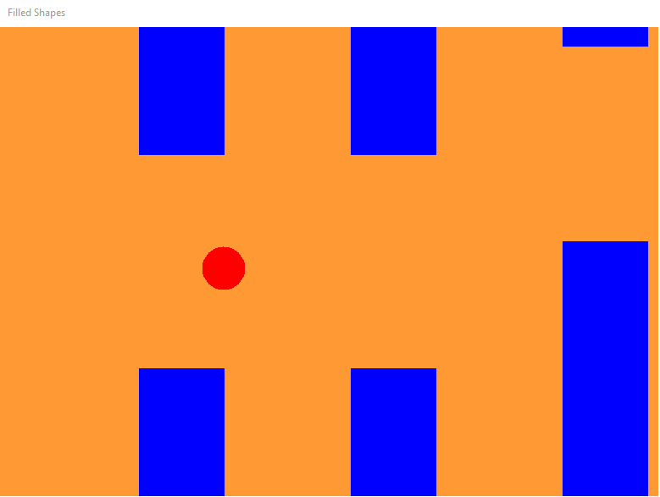

Game over interface

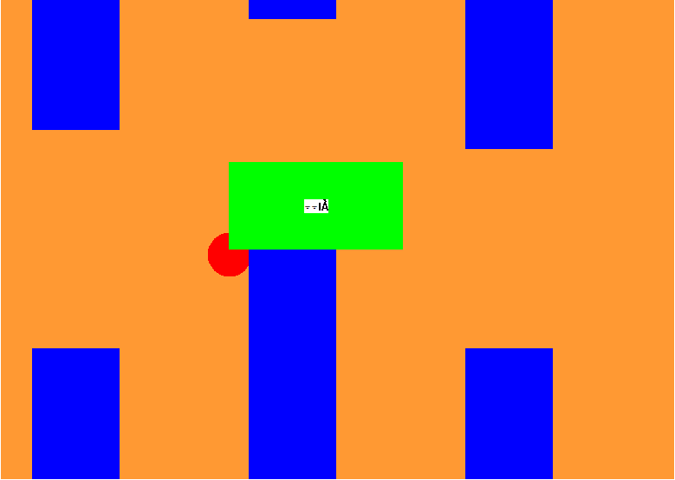

Game score interface

