[RockPi4B Overview]
https://wiki.radxa.com/Rockpi4/getting_started

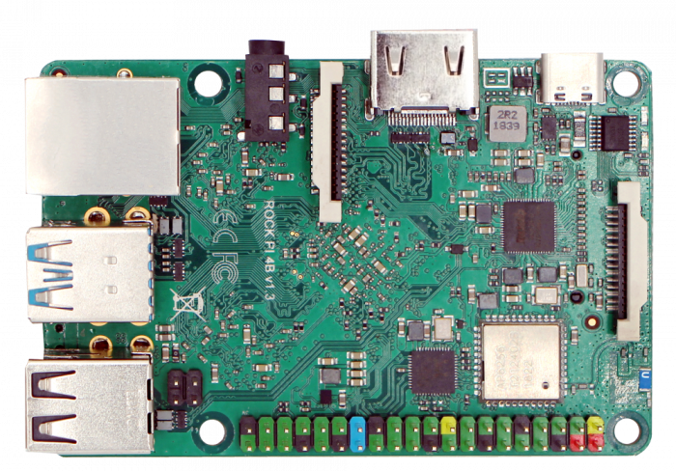

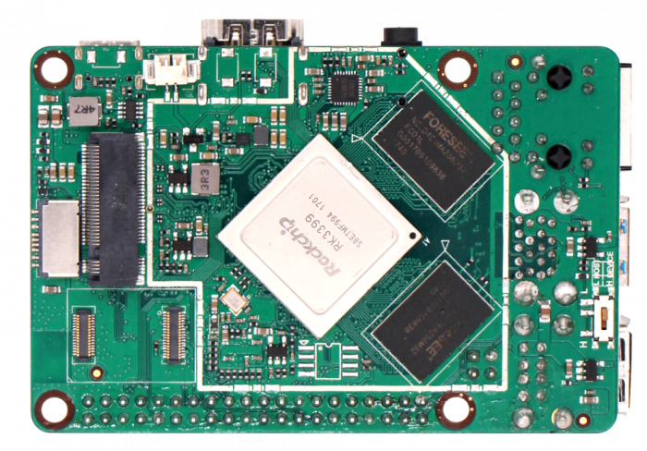

https://wiki.radxa.com/Rockpi4/hardware/rockpi4
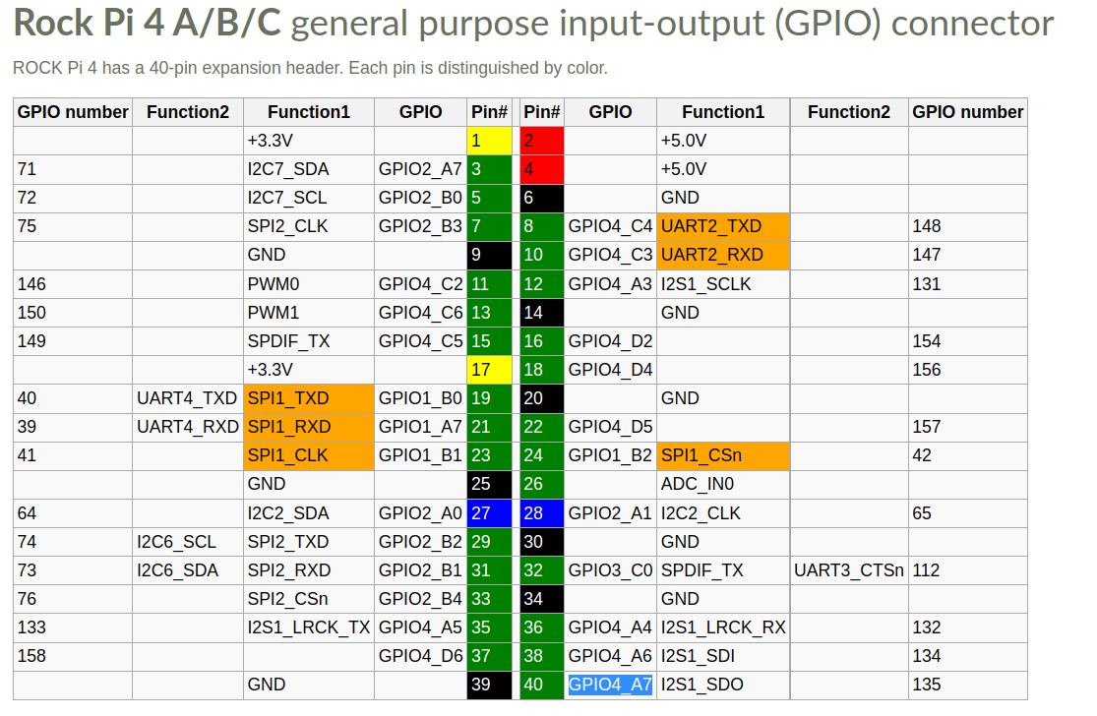

[Debug UART Pin Spec]
https://wiki.radxa.com/Rockpi4/dev/serial-console

ROCK Pi 4 | <---> | USB to TTL cable
RX(pin 10) | <---> | Green wire
TX(pin 8) | <---> | White wire
GND(pin 6) | <---> | Black wire

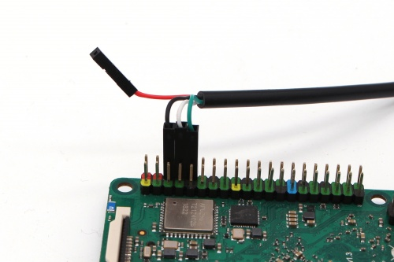

https://wiki.radxa.com/Rockpi4/downloads

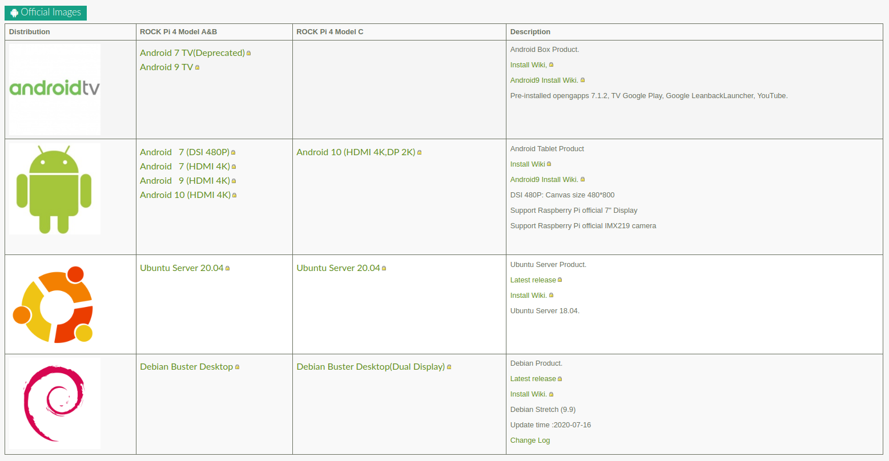

https://wiki.radxa.com/Rockpi4/install/microSD

https://www.balena.io/etcher/

Flash Tool : Etcher
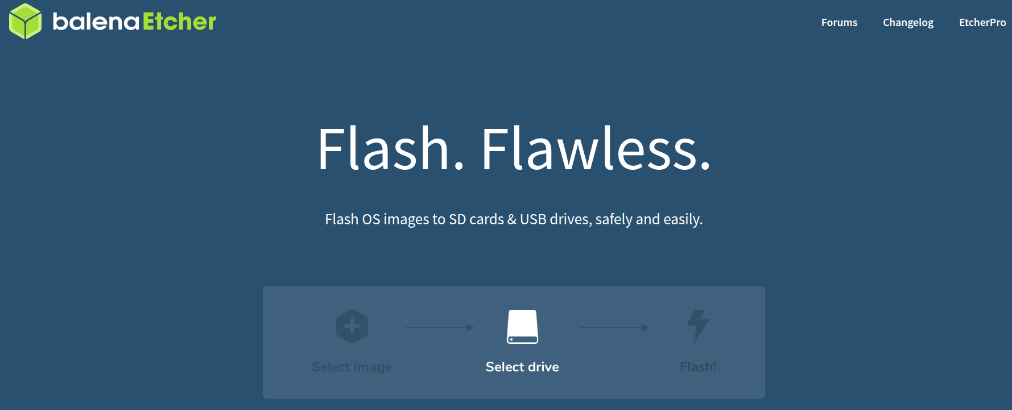

[Prepare Tool for RockPi4B Image Update]

<Step 1> Download RockPi4B Debian Image
https://github.com/radxa/rock-pi-images-released/releases

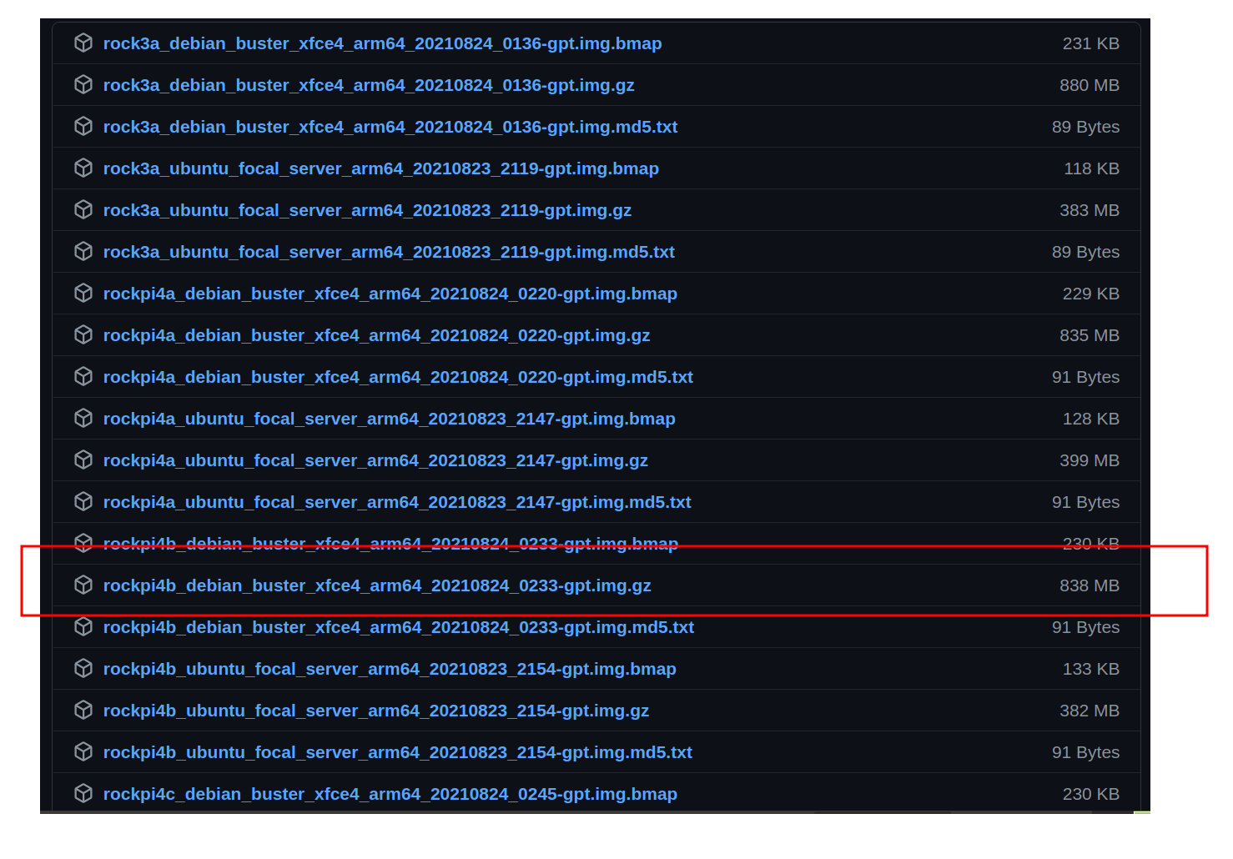

<Step 2> Extract rockpi4b_debian_buster_x005F_xfce4_arm64_20210824_0233-gpt.img.gz

$ cd ~/$Download_Folder
$ tar -xvf rockpi4b_debian_buster_x005F_xfce4_arm64_20210824_0233-gpt.img.gz
$ cd

<Step 3> Look for your SD or MMC device in Linux

$ dmesg | tail
$ lsblk

[For MMCX Style]
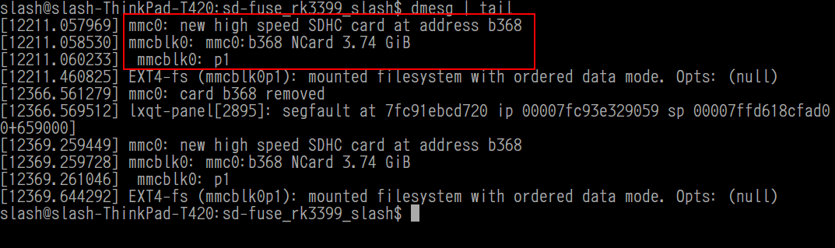
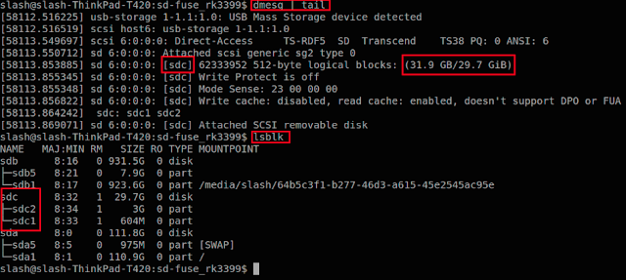
[For SDX Style]

\

<Step 4> Download Flash Tool - Etcher

https://www.balena.io/etcher/

$ cd ~/$Download_Folder
$ unzip ./balena-etcher-electron-1.7.8-linux-x64.zip
$ ./balenaEtcher-1.7.8-x64.AppImage

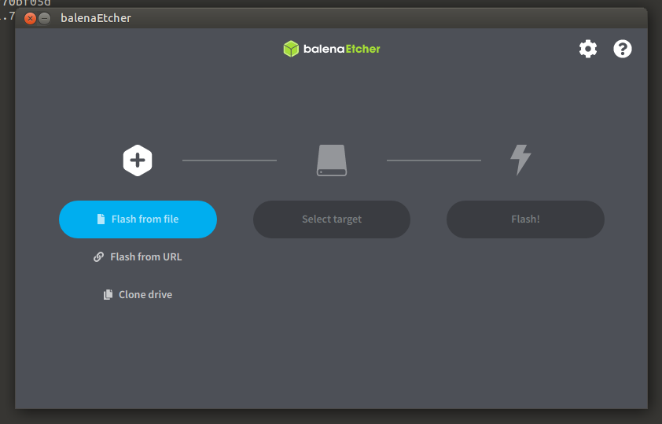

[Write Debian Image To SD Card]

<Step 1> Select RocKPi4B Debian Image

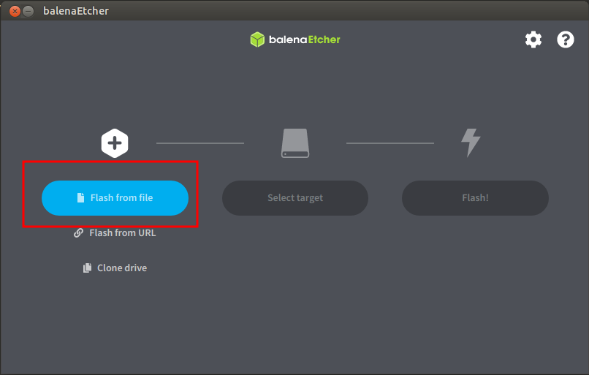
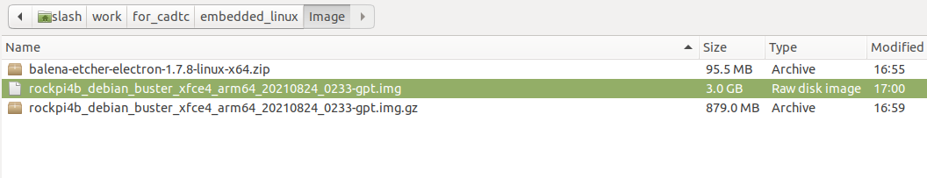

<Step 2> Select SD Card Device

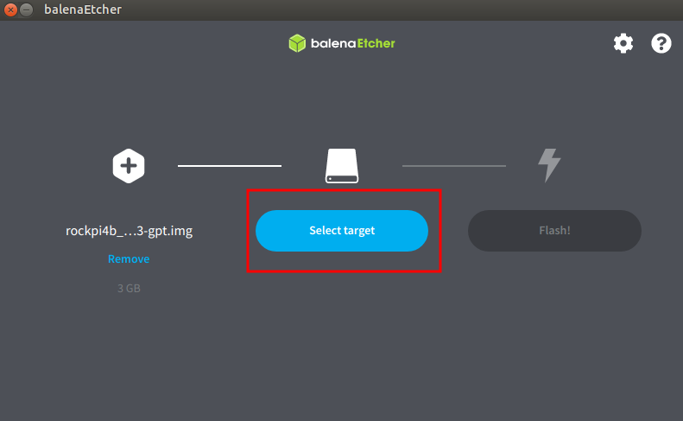
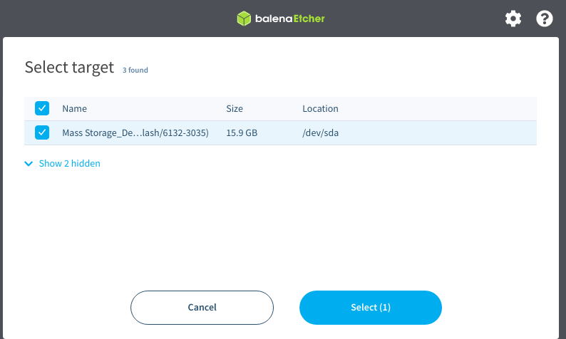

<Step 3> Start Flash

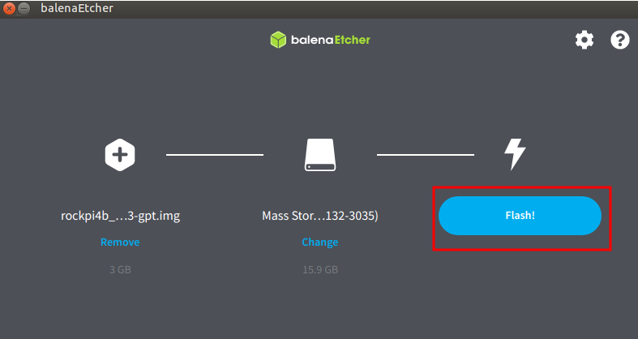

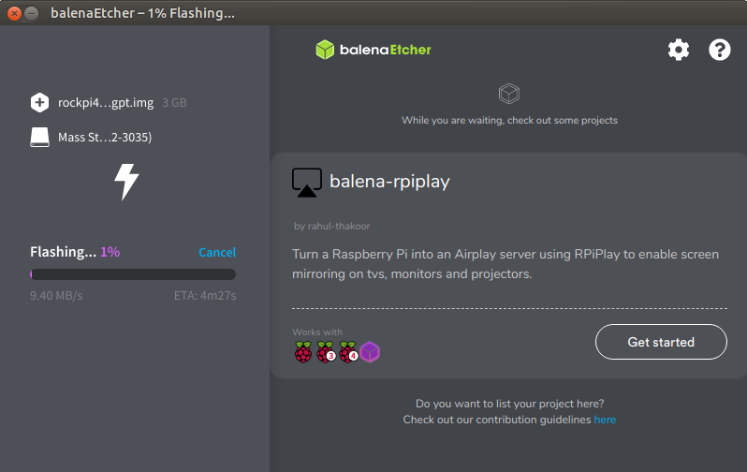

<Step 4> Insert SD/MMC card to Target Slot then Power On

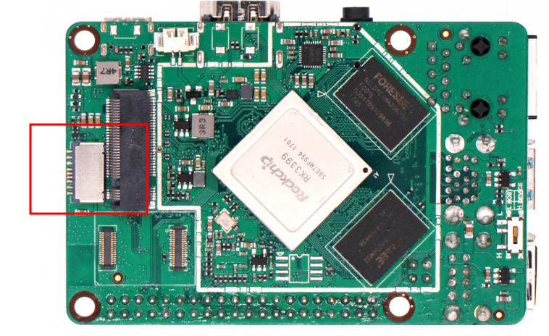

<Step 5> Check LCD Panel

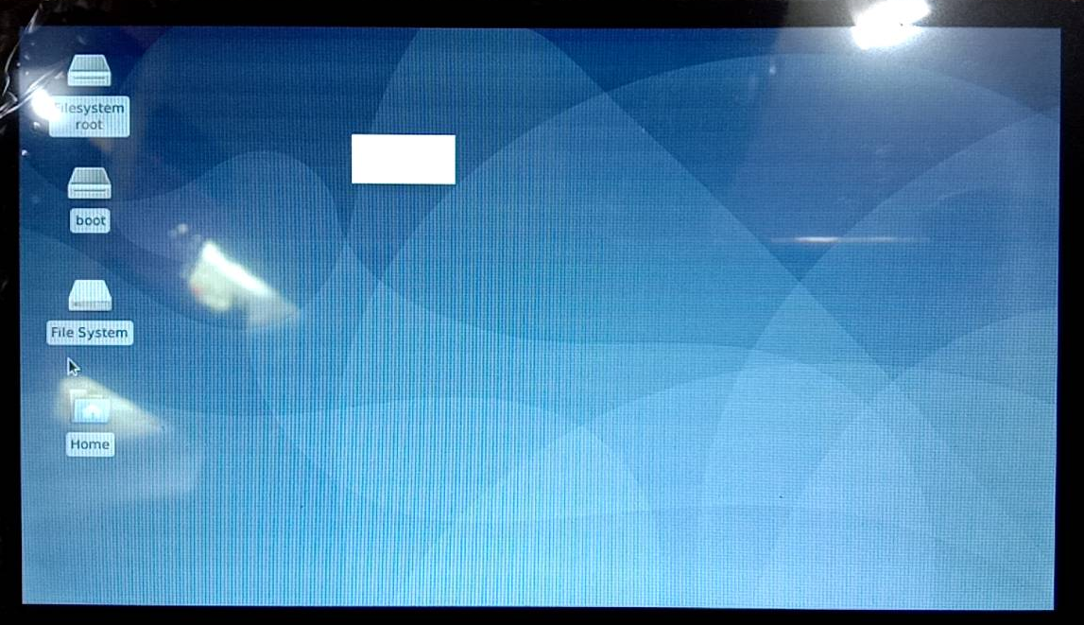

[Install Terminal]

$ apt-get install minicom
# insert Debug Danger to Host PC

# Open minicon then power on targget board
$ sudo minicom -D /dev/ttyUSB0 -b 1500000

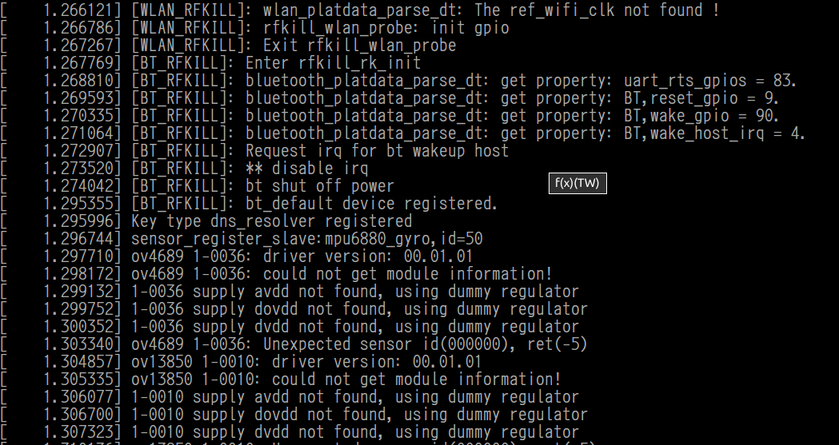

[SSH]
# 透過 SSH 傳送一個檔案 從 Host PC 至 開發板

<Target>
# 先在 EVB 設定密碼
$ password

<Host PC>
# 傳送測試檔案
$ scp [檔案] [EVB 帳號]@[EVB IP]:[EVB PATH]
例如 :
$ scp testme root@192.168.0.100:/tmp

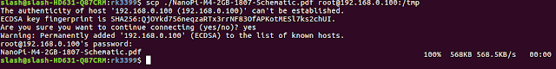

假設遇到如下狀況, 請依紅色框框執行命令
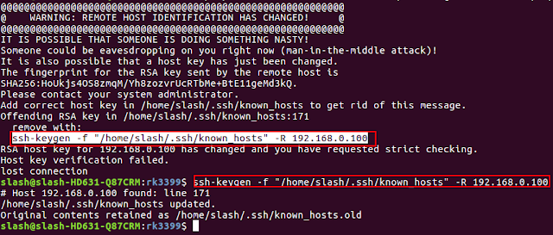

[建立 NFS Server 環境]

[Host]
< Step 1 > install NFS software package
$ sudo apt-get install nfs-kernel-server nfs-common portmap
< Step 2 > comfigure exports
$ sudo geany /etc/exports
$ add your share file folder
example :
/home/cadtc/nfs/ *(rw,sync,no_root_squash)
< Step 3 > Restart Host PC
$ sudo /etc/init.d/nfs-kernel-server restart

< Step 4 > (option) [Host ] :
ifconfig ethx 192.168.0.10

< Step 5>
$ touch /home/cadtc/nfs/

[Target Board]
< Step 6 >
$ sudo mount -t nfs 192.168.0.10:/home/cadtc/nfs/ /mnt/
$ ls -l /mnt
$ sudo umount /mnt

[設定 Toolchain]

Enter toolchain directory
$ cd ~/host_share_folder/toolchain/
$ tar -xvf gcc-linaro-7.3.1-2018.05-x86_64_aarch64-linux-gnu.tar.xz

Modify set_toolchain.sh
$ cd ~/host_share_folder/toolchain/

set_toolchain.sh contents

export PATH=$PATH:/home/slash/for_cadtc/toolchain/gcc-linaro-7.3.1-2018.05-x86_64_aarch64-linux-gnu/bin/
export ARCH=arm64
export CROSS_COMPILE=aarch64-linux-gnu-
export KERNELDIR=/home/cadtc/rockchip-bsp/kernel/

Initial compile environment
$ cd ~/
$ source ./set_toolchain.sh

check environment
$ echo $CROSS_COMPILE
$ aarch64-linux-gnu-gcc -v

