[1] Ubuntu Software Package Manager Tool
User Help
$ apt-get --help or
$ man apt-get

Update apt database
$ sudo apt-get update

Search package
apt-cach search package-name
$ sudo apt-cache search git-cola

Install package
apt-get install package-name
$ sudo apt-get install git git-cola

Remove package
apt-get remove package-name
$ sudo apt-get remove git-cola

[2] Tracking code command

Find Function Name in U-boot source code
grep -r -n “function name” “dir_name”
$ cd /home/cadtc/rockchip-bsp/u-boot/
$ grep -r “rk_board_init” board/rockchip/evb_rk3399/evb-rk3399.c

Find special file include “String”
find -name “*.c” | xarge grep -n “String”
$ cd /home/cadtc/rockchip-bsp/u-boot/
$ find ./ -name "*.c" | xargs grep -r -n “rk_board_init”

[3] Patch File Exercise

1. Create patch file
$ cd ~/cadtc-sample/5-patch_exerise/exercise_1/
$ diff -Naur hello_1.c hello_2.c > hello.patch

2. Add patch file
$ cd ~/cadtc-sample/5-patch_exerise/exercise_2/
$ cp ../exercise_1/hello.patch ./
$ patch -p0 < hello.patch

3. Remove patch file
$ cd ~/cadtc-sample/5-patch_exerise/exercise_2/
$ patch -R -p0 < hello.patch

[4] Git

1. Create an empty Git repository
$ cd ~/cadtc-sample/6-git_exerise/
$ git init
Check the .git directory
$ ls -la
$ tree .git

2. Show the working tree status
$ git status

3. Add file contents to the index
$ git add . [add all file] OR
$ git add ./Makefile
$ git add ./hello.c

4. Record changes to the repository
$ git commit

Write your log

5. Check your git log
$ git log

5. Modify the source code
$ geany [gedit, vim] ./hello.c

6. Show changes between commits, commit and working tree
$ git diff

7. Add file contents to the index
$ git add ./hello.c

8. Check status
$ git status

9. Do git commit and use short comment
$ git commit -m “add slash string”

10. Show the new git patch
$ git show

11. Create a new branch
$ git branch branch-test
$ git branch

12. Check to New branch
$ git checkout branch-test
$ git branch

13. Modify hello.c in New Branch
$ Modify hello.c

13. Commit a new change
Ref Step 7 - 9

14. Create a formation patch
$ git format -1

15. Checkout To master branch then use the patch file
$ git checkout master
$ git am ./0001-PATCH-NAME.patch

[5] Cross Compile Toolchain

Enter toolchain directory
$ cd ~/host_share_folder/toolchain/
$ tar -xvf gcc-linaro-7.3.1-2018.05-x86_64_aarch64-linux-gnu.tar.xz

Modify set_toolchain.sh
$ cd ~/host_share_folder/toolchain/

set_toolchain.sh contents

export PATH=$PATH:/home/cadtc/host_share_folder/toolchain/gcc-linaro-7.3.1-2018.05-x86_64_aarch64-linux-gnu/bin/
export ARCH=arm64
export CROSS_COMPILE=aarch64-linux-gnu-
export KERNELDIR=/home/cadtc/rockchip-bsp/kernel/

Initial compile environment
$ cd ~/
$ source ./set_toolchain.sh

check environment
$ echo $CROSS_COMPILE
$ aarch64-linux-gnu-gcc -v

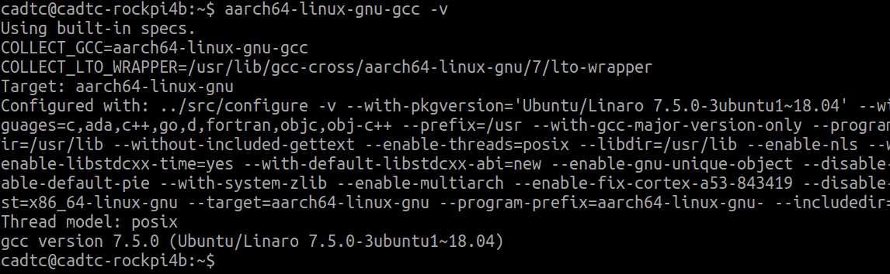

[6] Media Tool For Gstreamer

[For Video]

Set Display Name in Environment
<In Debug Terminal >

[CMD] export DISPLAY=:0.0

Play a Video
<Target Board>

[CMD] gst-launch-1.0 playbin uri=file:///home/rock/Serenity-DVD-320x240.m4v

Play a Video Test Patten
<Target Board>
[CMD] gst-launch-1.0 videotestsrc ! video/x-raw, width=1280, height=720 ! autovideosink

Show a Jpeg File
<Target Board>
[CMD] gst-launch-1.0 filesrc location=FILE_NAME ! jpegparse ! jpegdec ! videoconvert ! imagefreeze ! autovideosink

[For Audio]

Select a Audio Sink
<Target Board>
#Select a audio sink (rockchipes8316c)
$ pacmd set-default-sink 0

#Select a audio sink (HDMICODEC)
$ pacmd set-default-sink 01

Play a Audio Test
<Target Board>
$ gst-launch-1.0 audiotestsrc ! audioconvert ! alsasink device-name=rockchipes8316c
$ gst-launch-1.0 audiotestsrc ! audioconvert ! autoaudiosink

Play a MP3 File
<Target Board>
$ gst-launch-1.0 filesrc location="/home/cadtc/audio/piano2-CoolEdit.mp3" ! \
mpegaudioparse ! \
mpg123audiodec ! \
audioconvert ! autoaudiosink

Play a WAV File
<Target Board>
$ gst-launch-1.0 filesrc location=/usr/share/sounds/alsa/Front_Center.wav ! wavparse ! audioconvert ! autoaudiosink

[7] Media Tool For ALSA-Tool

<command-line sound player and record for ALSA soundcard driver>

list all soundcards and digital audio devices <Target Board>
$ aplay -l

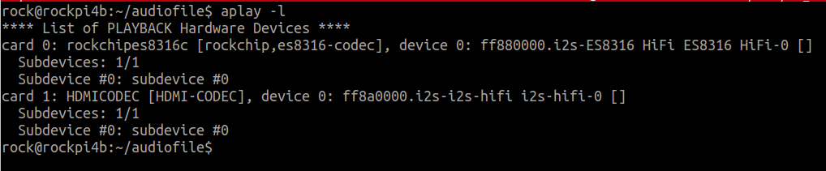

list device names
$ aplay -L

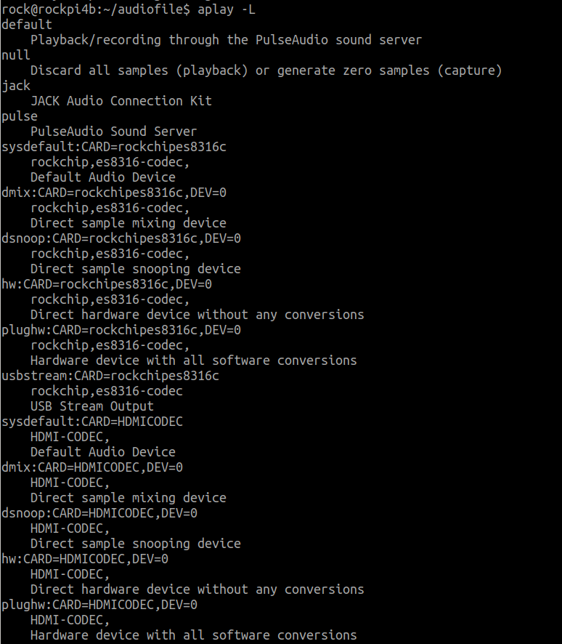

Play a WAV file for ALSA soundcard
aplay -D${PCM_DEVICE} $WAV_FILE

$ aplay -Dsysdefault:CARD=rockchipes8316c /usr/share/sounds/alsa/Front_Center.wav

$ aplay -Dsysdefault:CARD=HDMICODEC /usr/share/sounds/alsa/Front_Center.wav
Record a WAV file from ALSA soundcard
arecord -D${PCM_DEVICE} $WAV_FILE

$ arecord -Dhw:0,0 -r 44100 -t wav -f CD -d 5 /tmp/test.wav

Graphical mixer program
$ alsamixer

command-line mixer for ALSA soundcard driver
$ amixer

show all mixer simple controls
$ amixer -c rockchipes8316c scontrols

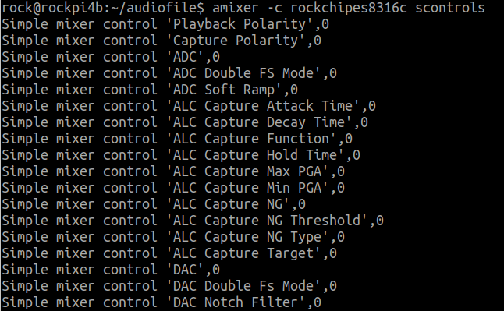

show contents of all mixer simple controls
$ amixer -c rockchipes8316c scontrols

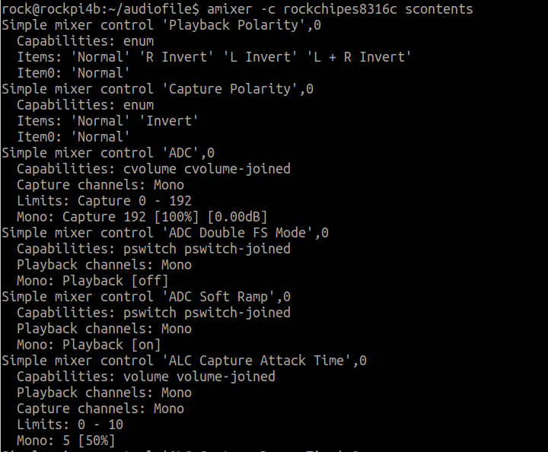

Set contents for one mixer simple control
$ amixer -c rockchipes8316c sget 'DAC'

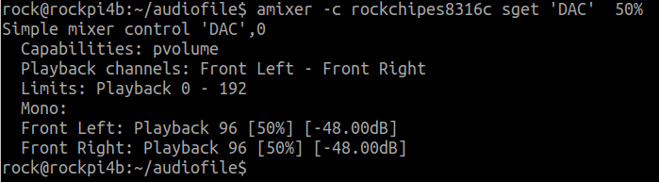

Set contents for one mixer simple control
$ amixer -c rockchipes8316c sset 'DAC' 10%

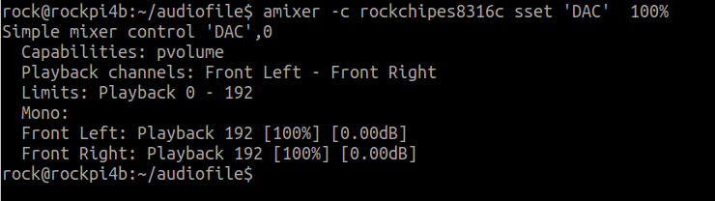

Show all controls for given card
$ amixer -c rockchipes8316c controls

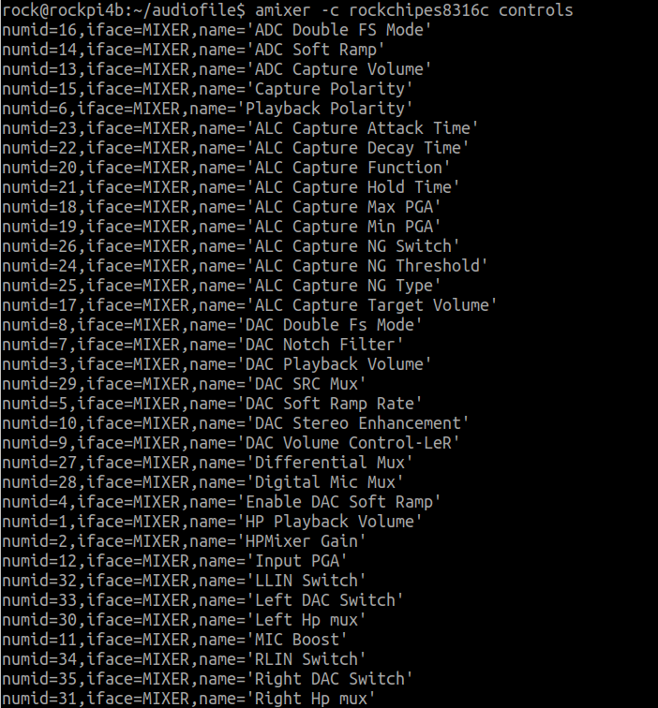

Show contents of all controls for given card
$ amixer -c rockchipes8316c contents

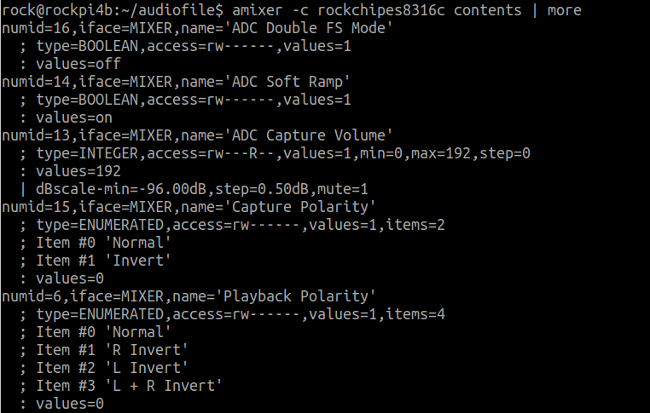

cget cID → get control contents for one contro
$ amixer -c rockchipes8316c cget numid=11

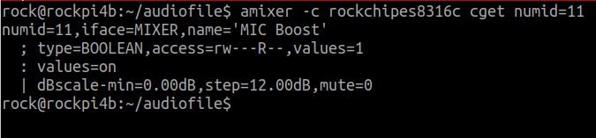

cset cID → set control contents for one control
$ amixer -c rockchipes8316c cset numid=11 off
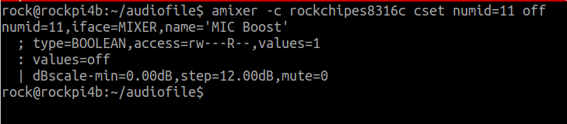

[8] Network

Check network IP
ifconfig $ETHERNET

$ ifconfig eth0

Change MAC address
$ ifconfig $ETHERNET down
$ ifconfig $ETHERNET hw ether $MAC_ADDR
$ ifconfig $ETHERNET up

Get Dynamic Network IP
$ udhcpc -i $ETHERNET

Send ICMP ECHO_REQUEST to network hosts
ping $Host_IP_Address
$ ping 8.8.8.8

Perform network throughput tests
Step 1.
[Host Side]
$ iperf3 -s
Step 2.
[Target Board Side]
$ iperf3 -c $Host_IP_Addr

[9] Wireless Network

Show / manipulate wireless devices and their configuration
$ iw dev
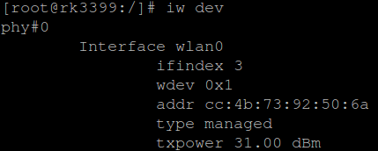

Check Network Device
$ ls /sys/class/net
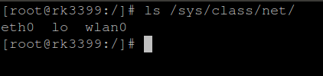

Scan AP Router SSID
$ iw wlan0 scan
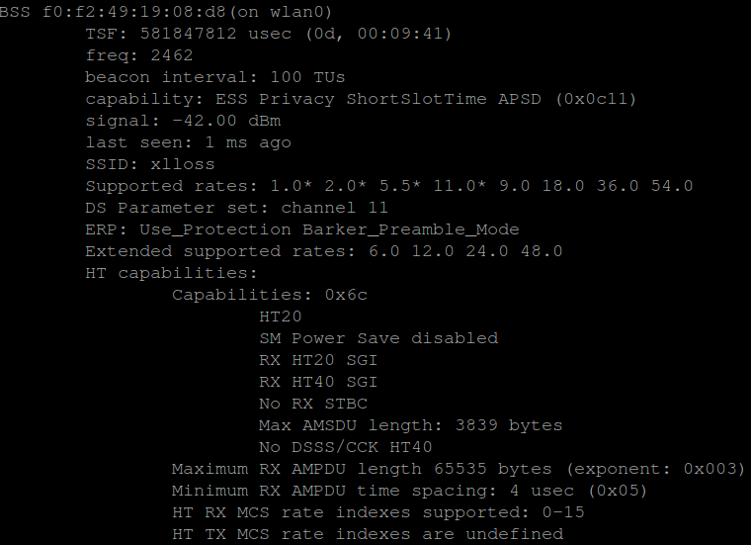

Generate a WPA PSK from an ASCII passphrase for a SSID
wpa_passphrase ${SSID} ${PASSWORD}
$ wpa_passphrase xlloss 12345
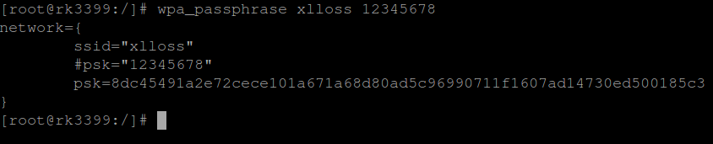
$ wpa_passphrase xlloss 12345 > /etc/wpa_supplicant.conf
$ vim /etc/wpa_supplicant.conf

Connect the Wireless AP Route
wpa_supplicant -B -D wext -i ${WLAN_DEV} -c /etc/wpa_supplicant.conf
$ wpa_supplicant -B -D wext -i wlan0 -c /etc/wpa_supplicant.conf
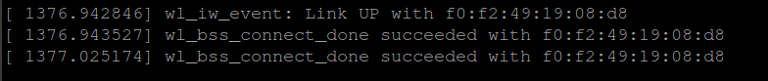

Get IP From DHCP Server
udhcpc -i ${WLAN_DEV}
$ udhcpc -i wlan0
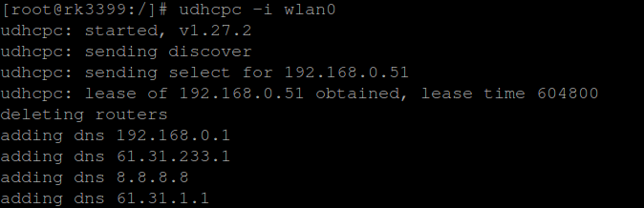

Check WLAN Device – IP Address
Check IP
$ ifconfig wlan0

Check WLAN Device – Ping
Ping a Network IP
$ ping -I wlan0 8.8.8.8

[10] SSH

Transmit a File to Remote
[Host]
scp {FILE} ${Remote_Account}@${Remote_Netowrk_IP}:${Remote_Folder}
$ scp ./test_file root@192.168.1.100:/tmp/test_dir

Mount a Remote Folder to Target board - Step 1
[Target Board]

$ mkdir /tmp/test_dir

$ mkdir /tmp/test_dir/testme

Mount a Remote Folder to Target board – Step 2
[Host]
sshfs ${Remote_Account}@${Remote_Netowrk_IP}:${Remote_Folder} ${Local_Folder}

$ sshfs root@192.168.0.27:/tmp/slash ./test/

[11] I2C Tool

Get a I2C Client Device Register
[Target]
i2cget [-f] [-y] I2CBUS CHIP-ADDRESS [DATA-ADDRESS [MODE]]

$ i2cget -f -y 2 0x50 0x13

Set a Data to I2C Client Device Register
[Target]
i2cset [-f] [-y] [-m MASK] [-r] I2CBUS CHIP-ADDRESS DATA-ADDRESS [VALUE]

$ i2cset -f -y 2 0x50 0x13 0x01

Dump Data From I2C Client Device Register
[Target]
i2cdump [-f] [-y] [-r first-last] I2CBUS ADDRESS

$ i2cdump -f -y 2 0x50

[12] GNU C Compiler

Note:
# source ~/cadtc/nanopim4-slash/toolchain/set_toolchain.sh
# please copy binary to TargetBoard then execute.

exercise 1 :
-S :
Compile only; do not assemble or link
${CROSS_COMPILE}gcc -S main.c

-c :
Compile and assemble, but do not link
${CROSS_COMPILE}gcc -c main.c

exercise 2 :
-o <file> : Place the output into <file>

a.1 ${CROSS_COMPILE} -o main main.o
a.2 Put the executable file to target board then try to execute it.

exercise 3 :
-D : defines a macro to be used by the preprocessor

${CROSS_COMPILE} -DD_FLAG -o main main.c

exercise 4 :
-I : adds include directory of header files

${CROSS_COMPILE} -DI_FLAG -Itest_inc -o main main.c func_1.c

exercise 5 :
-l : links with a library file
${CROSS_COMPILE} -llibm.so -DL_FLAG -Itest_inc -o main main.c

[13] Makefile

Note:
# source ~/cadtc/nanopim4-slash/toolchain/set_toolchain.sh
# please copy binary to TargetBoard then execute.

hello_world_ex4 : Double colon rule
1. $ make
2. Remember the file size
$ ls -l main

3. $ touch debug
4. $ make
5. $ ls -l main
6. Compare the two file size

[14] Binutils Tool
Note:
# source ~/cadtc/nanopim4-slash/toolchain/set_toolchain.sh
# please copy binary to TargetBoard then execute.

Exercise nm :
make
${CROSS_COMPILE}nm -help
${CROSS_COMPILE}nm main.o
${CROSS_COMPILE}nm -a -l ./exerise
${CROSS_COMPILE}nm -a -A ./exerise
A : Global absolute symbol.
a : Local absolute symbol.
B : Global bss symbol.
b : Local bss symbol.
D : Global data symbol.
d : Local data symbol.
f : Source file name symbol.
L : Global thread-local symbol (TLS).
l : Static thread-local symbol (TLS).
T : Global text symbol.
t : Local text symbol.
U : Undefined symbol.

objdump :
${CROSS_COMPILE}objdump -help

${CROSS_COMPILE}objdump -d main.o

${CROSS_COMPILE}objdump -t main.o

strip :
ls -l
${CROSS_COMPILE}strip exerise
ls -l

[15] Library

Note:
# source ~/cadtc/nanopim4-slash/toolchain/set_toolchain.sh
# please copy binary to TargetBoard then execute.

Static library
ar : create, modify, and extract from archives
$ cd create_static_lib

$ make

$ ./test

dymamic library
use so_name
1. $ cd create_dymamic_lib

2. $ make
3. Send output file to Target
$ scp ./libctest.so* root@${TARGET_BOARD_IP}:/tmp
$ scp ./test root@${TARGET_BOARD_IP}:/tmp
[ Target Board ]

4. add below environment variable in linux console
$ export LD_LIBRARY_PATH=$LD_LIBRARY_PATH:/${LIBRARY_PATH}/tmp

5. $ cd /tmp
6. $ ./test

[16] USB Camera

USB Camera with gstreamer
1. $ ls -l /dev/video*

2. $ ls -l /sys/class/video4linux/
3. gstreamer → [Method 1]
$ gst-launch-1.0 -v v4l2src device=/dev/video4 ! video/x-raw,format=YUY2 ! videoconvert ! \ autovideosink
4. gstreamer → [Method 2]
$ gst-launch-1.0 -v v4l2src device=/dev/video4 ! video/x-raw,format=YUY2 ! videoconvert ! \ kmssink

Use v4l2-ctl
0. $ sudo apt-get install v4l-utils

1. $ v4l2-ctl --help

2. v4l2-ctl -l, --list-ctrls display all controls and their values [VIDIOC_QUERYCTRL]
$ v4l2-ctl -d /dev/video4 -L

3. v4l2-ctl -L, --list-ctrls-menus
display all controls and their menus [VIDIOC_QUERYMENU]
$ v4l2-ctl -d /dev/video4 -l
$ v4l2-ctl -d /dev/video4 -C brightness
$ v4l2-ctl -d /dev/video4 -c brightness=255
$ v4l2-ctl -d /dev/video4 -c brightness=128

4. $ v4l2-ctl –help-vidcap
5. v4l2-ctl -V, --get-fmt-video
query the video capture format [VIDIOC_G_FMT]
$ v4l2-ctl -d /dev/video4 -V

