[1] Download u-boot for RockPi4B
Use git to download u-boot source code
$ cd /home/cadtc/rockchip-bsp/

$ git clone https://github.com/xlloss/cadtc-rockpi-uboot.git -b member --depth=5

[2] Compile the u-boot for RockPi4B
Set compile environment
$ source ~/set_toolchain.sh

$ ${CROSS_COMPILE}gcc -v

Build a RockPi4B u-boot -1
$ cd ~/rockchip-bsp/u-boot/

$ ls configs/rock-pi-4b-rk3399_defconfig

$ make rock-pi-4b-rk3399_defconfig

$ make u-boot-dtb.bin -j4

Package u-boot-dtb.bin To uboot.img
$ ../rkbin/tools/loaderimage --pack --uboot ./u-boot-dtb.bin uboot.img

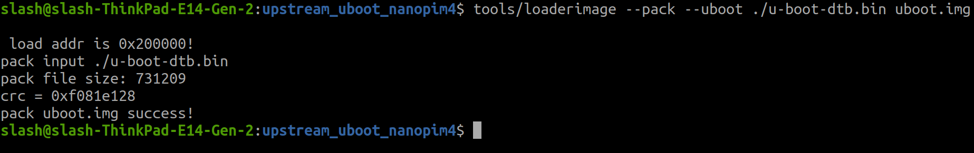

Build a RockPi4B u-boot -2
$ ./build/mk-uboot.sh rockpi4b

[3] Update –1 [From Target Board Linux by SCP]
[1] Prepare u-boot image to update
[ Host ]
$ cd /home/cadtc/rockchip-bsp/
$ ./build/mk-uboot.sh rockpi4b
$ cd /home/cadtc/rockchip-bsp/out/u-boot/
$ scp ./uboot.img rock@${TARGET_BOARD_IP}:/tmp/

[2] Update u-boot image in Target board
[ Target Board ]
# Use dd command to update image to sdcard
$ dd if=/tmp/uboot.img of=/dev/mmcblk0 bs=1M seek=8 count=4

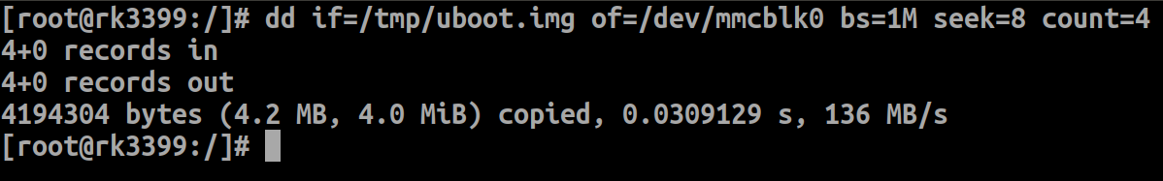

# [ Power-Off then Power-On]
# [ Check update date time from boot log ]

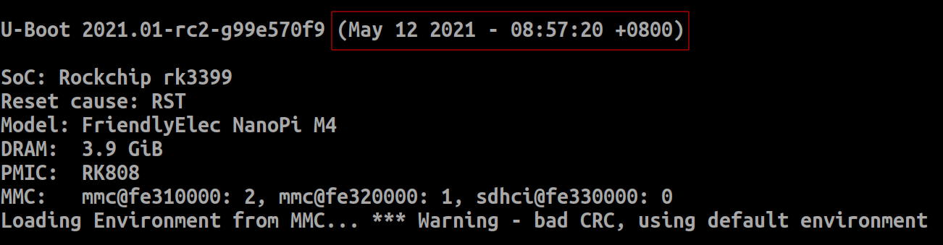

[4] Update – 2 [From Host PC]

[2] Update in “HOST” PC
[ Host ]
# check the media card that you use → SDX Style or MMC style ?

$ dmesg | tail
$ lsblk

(This is SDX style)
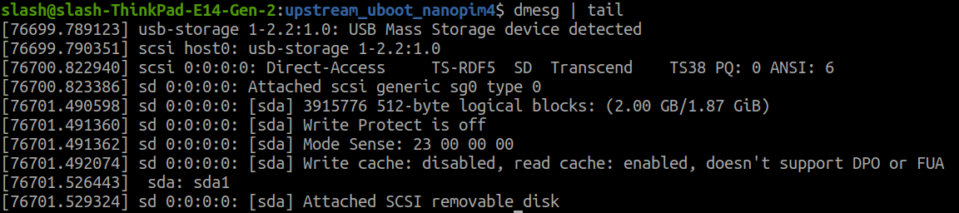

# Use dd command to update image to sdcard

$ dd if=./uboot.img of=/dev/sda bs=1M seek=8 count=4

[ Power-Off then Power-On]
[ Check update date time from boot log ]

[5] Update – 3 [From U-Boot by TFTP]
[1] Prepare u-boot Image File
[ Host ]

[2] Update u-boot image to SD card
[ Target Board ]

[3] Check u-boot version
[ Target Board ]
$ version

[6] U-boot Common Function (Target Board)
Command Help
==> help

##################################################
? - alias for 'help'
base - print or set address offset
bdinfo - print Board Info structure
blkcache - block cache diagnostics and control
boot - boot default, i.e., run 'bootcmd'

...

Show variable content
[CMD ] printenv
==> printenv

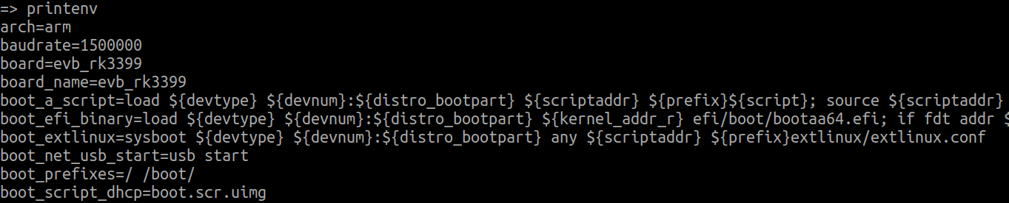

==> printenv board

##############################################################################

board=evb_rk3399

List EXT4 format file
[CMD ] ext4ls
==> help ext4ls

##################################################
ext4ls - list files in a directory (default /)

Usage:
ext4ls <interface> <dev[:part]> [directory]
- list files from 'dev' on 'interface' in a 'directory'

==> ext4ls mmc 1:1

###################################################

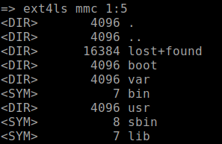

Read a EXT4 format file to RAM
[CMD ] ext4load
==> help ext4load

##################################################
ext4load - load binary file from a Ext4 filesystem

Usage:
ext4load <interface> [<dev[:part]> [addr [filename [bytes [pos]]]]]
- load binary file 'filename' from 'dev' on 'interface'
to address 'addr' from ext4 filesystem

==> ext4load mmc 1:1 $kernel_addr_r boot/Image

###################################################
18250240 bytes read in 1623 ms (10.7 MiB/s)

md - memory display
[CMD ] md
==> fatload mmc 1:4 $kernel_addr_r vmlinuz-4.4.154-113-rockchip-gdb9dfc2cdd25

##################################################
18250240 bytes read in 1622 ms (10.7 MiB/s)

==> printenv kernel_addr_r

##################################################
kernel_addr_r=0x02080000

=> md 0x02080000

##################################################
02080000: 14424000 00000000 00080000 00000000 .@B.............
02080010: 0143a000 00000000 0000000a 00000000 ..C.............
02080020: 00000000 00000000 00000000 00000000 ................
02080030: 00000000 00000000 644d5241 00000000 ........ARMd....
02080040: 00000000 00000000 00000000 00000000 ................
02080050: 00000000 00000000 00000000 00000000 ................
02080060: 00000000 00000000 00000000 00000000 ................
02080070: 00000000 00000000 00000000 00000000 ................
02080080: 00000000 00000000 00000000 00000000 ................
02080090: 00000000 00000000 00000000 00000000 ................
setenv : Set a environment variable
[CMD ] setenv
=> led
led - manage LEDs

Usage:
led <led_label> on|off|toggle|blink [blink-freq in ms] Change LED state
led [<led_label> Get LED state
led list show a list of LEDs

=> led list
user_led1 <inactive>
user_led2 <inactive>
user_led3 <inactive>
user_led4 <inactive>

=> led user_led1 on
=> led user_led1 on

=> setenv led1_on 'led user_led1 on'
=> setenv led1_off 'led user_led1 off'
=> run led1_off
=> run led1_on

save - save file to a filesystem
[CMD ] saveenv
==> setenv test_file 1
==> printenv test_file

############################################################
test_file=1

==> saveenv
==> reset
==> printenv test_file

############################################################
test_file=1

version - print monitor, compiler and linker version
[CMD ] version
==> version

#####################################
U-Boot 2021.01-rc2-g99e570f9 (May 12 2021 - 08:57:20 +0800)

aarch64-linux-gnu-gcc (Linaro GCC 6.3-2017.05) 6.3.1 20170404
GNU ld (Linaro_Binutils-2017.05) 2.27.0.20161019

mmc - MMC sub system
[CMD ] mmc
==> help mmc

=====================================================================
Usage:
mmc info - display info of the current MMC device
mmc read addr blk# cnt
mmc write addr blk# cnt
mmc erase blk# cnt
mmc rescan
mmc part - lists available partition on current mmc device
mmc dev [dev] [part] - show or set current mmc device [partition]
mmc list - lists available devices
mmc wp - power on write protect boot partitions
mmc hwpartition [args...] - does hardware partitioning
arguments (sizes in 512-byte blocks):
[user [enh start cnt] [wrrel {on|off}]] - sets user data area attributes
[gp1|gp2|gp3|gp4 cnt [enh] [wrrel {on|off}]] - general purpose partition
[check|set|complete] - mode, complete set partitioning completed
WARNING: Partitioning is a write-once setting once it is set to complete.
Power cycling is required to initialize partitions after set to complete.
mmc setdsr <value> - set DSR register value

==> mmc list

=====================================================================
=> mmc list
dwmmc@fe320000: 1 (SD)
sdhci@fe330000: 0

run - run commands in an environment variable
[CMD ] run
==> printenv bootcmd

##############################################################################
bootcmd=run distro_bootcmd;boot_android ${devtype} ${devnum};bootrkp;

==> printenv bootargs

##############################################################################
bootargs=sdfwupdate storagemedia=sd androidboot.mode=sd

==> run distro_bootcmd

=> run distro_bootcmd
switch to partitions #0, OK
mmc1 is current device
Scanning mmc 1:4...
Found /extlinux/extlinux.conf
pxefile_addr_str = 0x00500000
bootfile = /extlinux/extlinux.conf
Retrieving file: /extlinux/extlinux.conf
reading /extlinux/extlinux.conf
423 bytes read in 4 ms (102.5 KiB/s)
select kernel
1: kernel-4.4.154-113-rockchip-gdb9dfc2cdd25
Enter choice: Retrieving file: /hw_intfc.conf
~~~~~~~~~~~~~~~~~~~~~~~~~~~~~~~~~~~~~~~~~~~~~~~
## Flattened Device Tree blob at 01f00000
Booting using the fdt blob at 0x1f00000
Loading Ramdisk to 7b924000, end 7bdef854 ... OK
Loading Device Tree to 000000007b821000, end 000000007b923fff ... OK
Adding bank: start=0x00200000, size=0x7fe00000

Starting kernel ...

[ 0.000000] Booting Linux on physical CPU 0x0
[ 0.000000] Initializing cgroup subsys cpuset

tftpboot - boot image via network using TFTP protocol
[CMD ] tftpboot [tftp]
==> setenv ipaddr BOARD-IP
==> setenv serverip SERVER-IP

==> tftp 0x800800 SERVER-IP:FILE
TFTP from server 172.18.8.43; our IP address is 172.18.8.200
Filename 'uboot.img'.
Load address: 0x800800
Loading: #################################################################
#################################################################
#################################################################
#################################################################
##########################
2 MiB/s
done
Bytes transferred = 4194304 (400000 hex)

==> md 0x800800
00800800: 44414f4c 20205245 00000000 00000000 LOADER ........
00800810: 00200000 000b396c d5fb1aab 00000020 .. .l9...... ...
00800820: 520d8182 ecaaa3ef 29ff5909 5336f8b0 ...R.....Y.)..6S
00800830: 2fe322c8 f1c89653 b0b28e47 1bcee525 ."./S...G...%...
00800840: 00000000 00000000 00000000 00000000 ................
00800850: 00000000 00000000 00000000 00000000 ................
00800860: 00000000 00000000 00000000 00000000 ................
00800870: 00000000 00000000 00000000 00000000 ................
00800880: 00000000 00000000 00000000 00000000 ................
00800890: 00000000 00000000 00000000 00000000 ................
008008a0: 00000000 00000000 00000000 00000000 ................
008008b0: 00000000 00000000 00000000 00000000 ................
008008c0: 00000000 00000000 00000000 00000000 ................
008008d0: 00000000 00000000 00000000 00000000 ................
008008e0: 00000000 00000000 00000000 00000000 ................
008008f0: 00000000 00000000 00000000 00000000 ................

[7] Modify Configure File with Menuconfig

Modify configure file with menuconfig
[CMD ] menuconfig
$ cd /home/cadtc/rockchip-bsp/u-boot
$ menuconfig
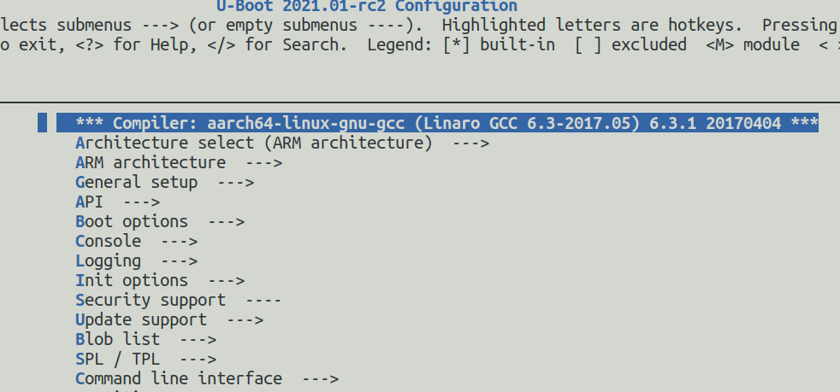

Command line interface →
Misc commands →
[*] time

# check .config file
$ cat .config| grep CONFIG_CMD_TIMER

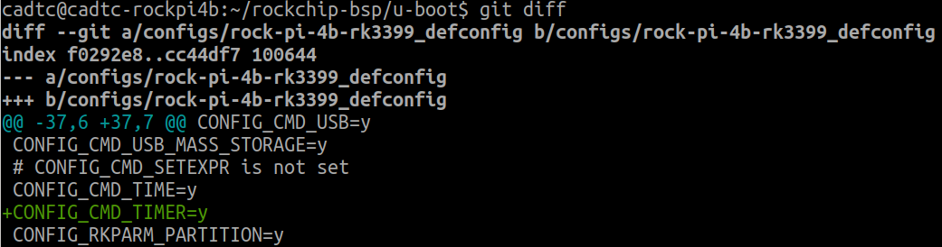
# Update defconfig
$ make savedefconfig
$ cp defconfig configs/rock-pi-4b-rk3399_defconfig
$ git diff

# Update u-boot image and reset system

[8] GPIO For LED Control

Usage:
gpio <input|set|clear|toggle> <pin>
- input/set/clear/toggle the specified pin
gpio status [-a] [<bank> | <pin>] - show [all/claimed] GPIOs

[CMD ] gpio
Top View
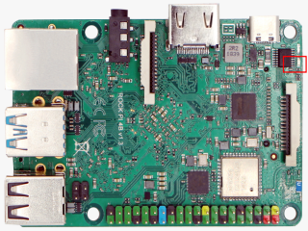

Sch File
1. rockpi4_v13_sch_20181112.pdf
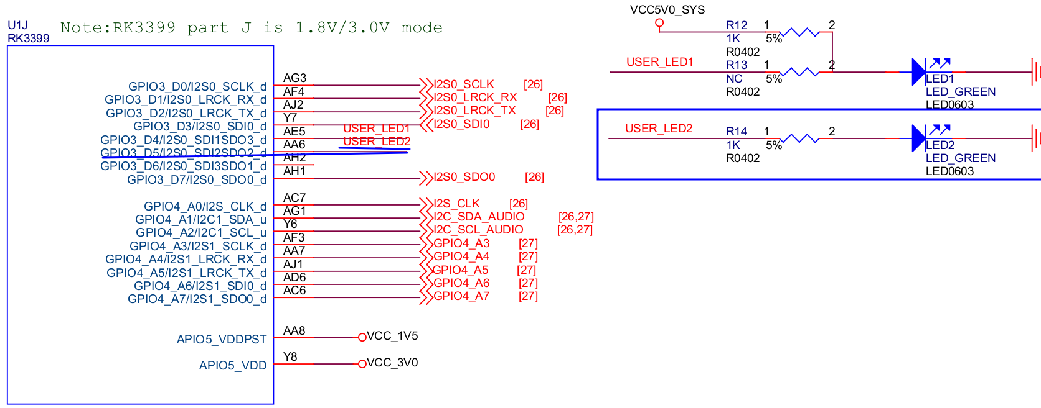

======================================================================

Pin Number :
GPIO-Bank * 32 + (Index – 1) * 8 + Offset
For Example :
GPIO3_D5 :
32 * 3 + (4 – 1) * 8 + 4 = 125

======================================================================
==> gpio clear 125
==> gpio set 125

==> gpio tog 125

==> gpio tog 125

[9] GPIO For Button Control

Usage:
gpio <input|set|clear|toggle> <pin>
- input/set/clear/toggle the specified pin
gpio status [-a] [<bank> | <pin>] - show [all/claimed] GPIOs

[CMD ] gpio
Sch File
1. NanoPIM4_Extend_V01.pdf

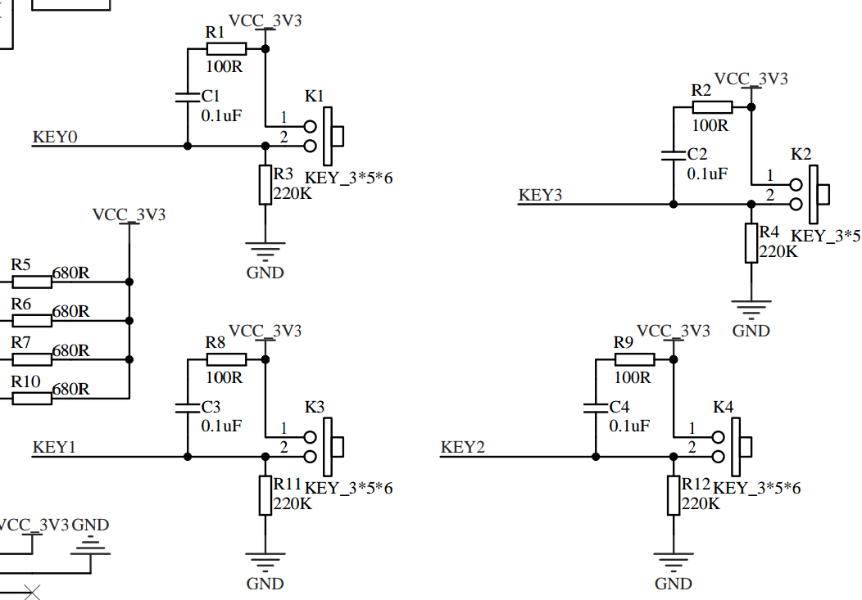

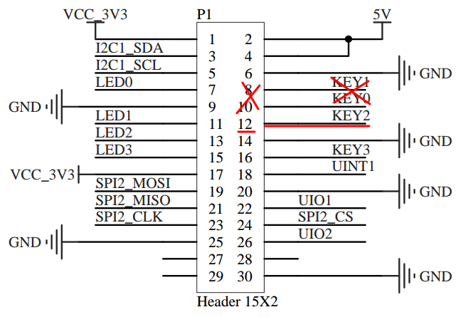

2. ROCK Pi 4 has a 40-pin expansion header
(https://wiki.radxa.com/Rockpi4/hardware/gpio)

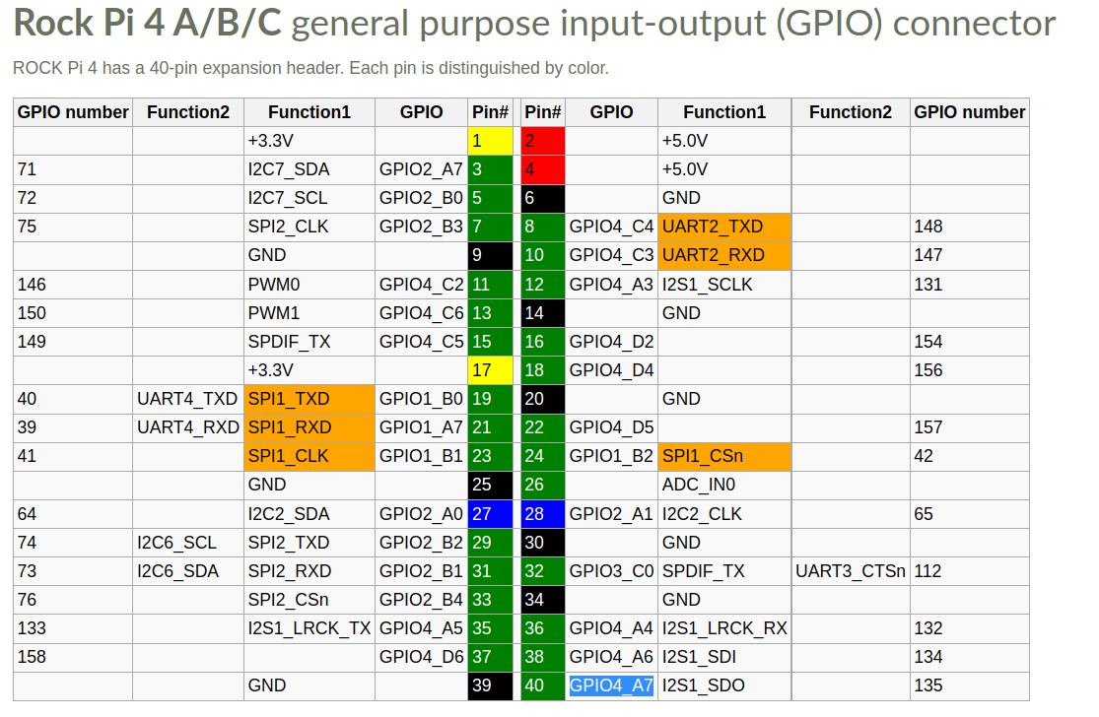

======================================================================
Pin Number :
GPIO-Bank * 32 + (Index – 1) * 8 + Offset
For Example :
GPIO4_A3 :
32 * 4 + (1 – 1) * 8 + 3 = 131

======================================================================
=> gpio input 131
gpio: pin 131 (gpio 131) value is 0
=> gpio input 145
gpio: pin 131 (gpio 131) value is 1

[10] Add New Command

Add a new command
$ cd /home/cadtc/rockchip-bsp/u-boot

$ git remote add slash-github https://github.com/xlloss/cadtc-rockpi-uboot

$ git fetch slash-github

$ git show slash-github/stable-4.4-rockpi4 182c8c74490ef3d4136dec99911f140b8d1bc0b2

$ git cherry-pick 182c8c74490ef3d4136dec99911f140b8d1bc0b2

$ ./build/mk-uboot.sh rockpi4b
Update u-boot ….
You can select one of four update methods to update u-boot

