[1] Download Linux Kernel with git
Download Linux Kernel source code
[CMD] mkdir -p /home/cadtc/rockchip-bsp/kernel

[CMD] cd /home/cadtc/rockchip-bsp/kernel

[CMD] git clone https://github.com/xlloss/rockpi-kernel.git

[2] Configure Linux Kernel with default configure file
Configure Linux Kernel source code
[CMD] source ./set_toolchain.sh

[CMD] cd /home/cadtc/rockchip-bsp/kernel

[CMD] ls arch/arm64/configs/rockchip_linux_defconfig

[CMD] make rockchip_linux_defconfig

[3] Build Linux Kernel Image and DeviceTree Blob
Build a Linux kernel Image
[CMD] source ~/set_toolchain.sh

[CMD] cd /home/cadtc/rockchip-bsp/kernel

[CMD] make -j8
# After building finish, Please check Linux kernel image
[CMD] ls -l arch/arm64/boot
drwxrwxr-x 17 slash slash 4096 四 26 21:53 dts
-rwxrwxr-x 1 slash slash 18250240 四 26 22:11 Image
-rw-rw-r-- 1 slash slash 7634851 四 26 22:11 Image.gz
-rw-rw-r-- 1 slash slash 9017649 一 16 12:09 Image.lz4
-rw-rw-r-- 1 slash slash 1188 一 28 2020 install.sh
-rw-rw-r-- 1 slash slash 1535 一 28 2020 Makefile

# After building finish, Please check DTB
[CMD] ls -l arch/arm64/boot/dts/rockchip
slash@slash-ThinkPad-T420:rockchip-rk3399-nanopi-m4$ ls arch/arm64/boot/dts/rockchip/rk3399-rock-pi-4b.dtb

[4] Update Linux Kernel Image

${KERNEL_DIR}=/home/cadtc/rockchip-bsp/kernel/

Replace Old Image form /boot folder in Target Board
[CMD] cd ${KERNEL_DIR}/
[CMD] make bindeb-pkg

# It will create below Image package file
==> linux-image-4.4.154_4.4.154-1_all.deb
# The First Time Update
[CMD] scp ${KERNEL_DIR}..//home/cadtc/rockchip-bsp root@BOARD_IP:/boot

[ Target Board ]
[CMD] sudo dpkg -i /tmp/linux-image-4.4.154_4.4.154-1_all.deb

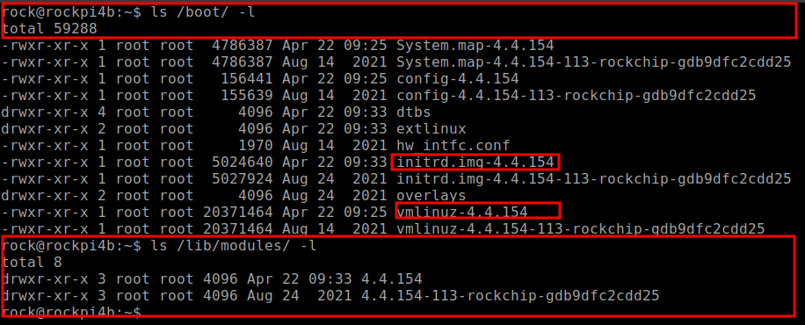

# Update DTB File
# DTB → ${KERNEL_DIR}/arch/arm64/boot/dts/rockchip/rk3399-rock-pi-4b.dtb
[ Build Machine ]
Step 1: [CMD] scp DTB_FILE root@BOARD_IP:/tmp

[ Target Board ]
Step 2: [CMD] sudo cp /tmp/rk3399-rock-pi-4b.dtb /boot/dtbs/4.4.154/rockchip/

# Update Kernel Image File
# Image → ${KERNEL_DIR}/arch/arm64/boot/Image

[ Build Machine ]
Step 1: [CMD] scp Image root@BOARD_IP:/tmp

[ Target Board ]
Step 2: [CMD] sudo cp /tmp/Image /boot/dtbs/4.4.154/rockchip/vmlinuz-4.4.154

# Please Reboot Your Board or PowerOn-Off
[ Target Board ]

[CMD] dmesg | head -n 10

rock@rockpi4b:~$ dmesg | head -n 10
[ 0.000000] Booting Linux on physical CPU 0x0
[ 0.000000] Initializing cgroup subsys cpuset
[ 0.000000] Initializing cgroup subsys cpu
[ 0.000000] Initializing cgroup subsys cpuacct
[ 0.000000] Linux version 4.4.154 (cadtc@cadtc-rockpi4b) (gcc version 7.5.0 (Ubuntu/Linaro 7.5.0-3ubuntu1~18.04) ) #1 SMP Fri Apr 22 09:12:43 UTC 2022
[ 0.000000] Boot CPU: AArch64 Processor [410fd034]
[ 0.000000] Reserved memory: failed to reserve memory for node 'drm-logo@00000000': base 0x0000000000000000, size 0 MiB
[ 0.000000] On node 0 totalpages: 523776
[ 0.000000] DMA zone: 8184 pages used for memmap
[ 0.000000] DMA zone: 0 pages reserved

Please try to use below method :
1. [CMD] mkdir image_install

2. [CMD] export INSTALL_PATH=`pwd`/image_install

3. install Kernel Image
[CMD] make install -j4
4. install DTB
[CMD] make dtbs_install

5. check DTB
[CMD] ls image_install

[5] Change Kernel Configure

For menuconfig
[CMD] source ~/set_toolchain.sh

[CMD] cd ${KERNEL_DIR}

[CMD] make menuconfig

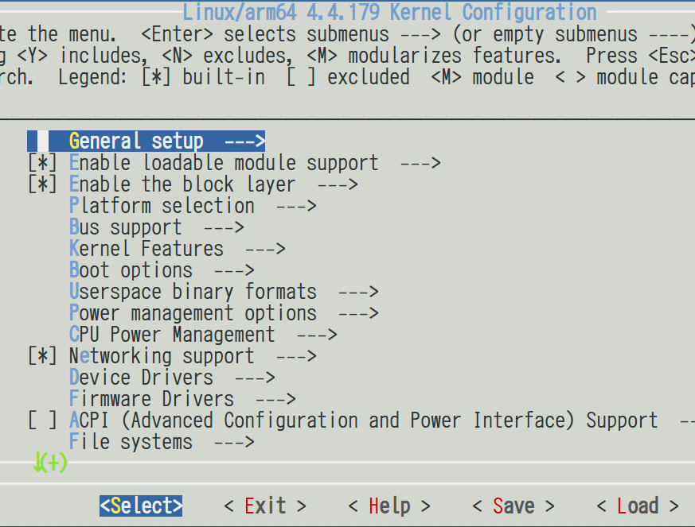

[6] Create a default kernel configure file

Create default kernel configuration file
[CMD] cd ${KERNEL_DIR}

[CMD] make savedefconfig

[CMD] cp ./defconfig ${KERNEL_DIR}/arch/arm64/configs/cadtc_rockpi4b_defconfig

[CMD] make help | grep cadtc
cadtc_rockpi4b_defconfig - Build for cadtc_rockpi4b

# Use default configure file be created by yourself
[CMD] make cadtc_rockpi4b_defconfig

[7] Build DeviceTree Only

${SET_TOOLCHAIN} = /home/cadtc/set_toolchain.sh
Build DTB only
[CMD] source ${SET_TOOLCHAIN}

[CMD] cd ${KERNEL_DIR}

[CMD] touch ${KERNEL_DIR}/arch/arm64/boot/dts/rockchip/rk3399-rock-pi-4b.dts
[CMD] make dtbs

cadtc@cadtc-rockpi4b:~/rockchip-bsp/kernel$ make dtbs
CHK include/config/kernel.release
CHK include/generated/uapi/linux/version.h
CHK include/generated/utsrelease.h
CHK include/generated/bounds.h
CHK include/generated/timeconst.h
CHK include/generated/asm-offsets.h
CALL scripts/checksyscalls.sh
make[1]: 'include/generated/vdso-offsets.h' is up to date.
CHK scripts/mod/devicetable-offsets.h
DTC arch/arm64/boot/dts/rockchip/rk3399-rock-pi-4b.dtb

[8] Check .config file

.config file will be read by Linux kernel root Makefile
[CMD] cd ${KERNEL_DIR}

[CMD] vim .config

#
# General setup
#
CONFIG_INIT_ENV_ARG_LIMIT=32
CONFIG_CROSS_COMPILE="aarch64-linux-"
# CONFIG_COMPILE_TEST is not set
CONFIG_LOCALVERSION=""
CONFIG_LOCALVERSION_AUTO=y
CONFIG_DEFAULT_HOSTNAME="localhost"
CONFIG_SWAP=y
CONFIG_SYSVIPC=y
CONFIG_SYSVIPC_SYSCTL=y
CONFIG_POSIX_MQUEUE=y
CONFIG_POSIX_MQUEUE_SYSCTL=y

→ This feature is be comment : # CONFIG_COMPILE_TEST is not set

→ This feature is be enabled : CONFIG_POSIX_MQUEUE_SYSCTL=y

→ This is a string : CONFIG_DEFAULT_HOSTNAME="localhost"

→ This is a value : CONFIG_INIT_ENV_ARG_LIMIT=32

[9] Enable Hello_World Driver

1. enable hello_world driver by menuconfig
[CMD] cd ${KERNEL_DIR}

[CMD] make menuconfig

# enable (build-in or build module file) hello_world sample driver
Device Drivers -->
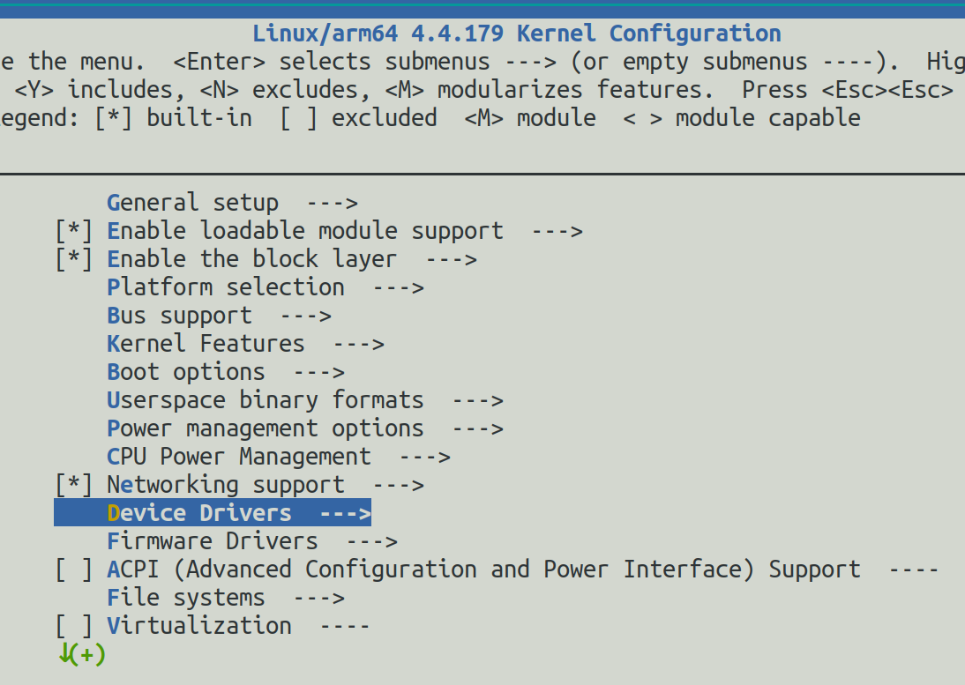
Misc devices --→
< > Hello World

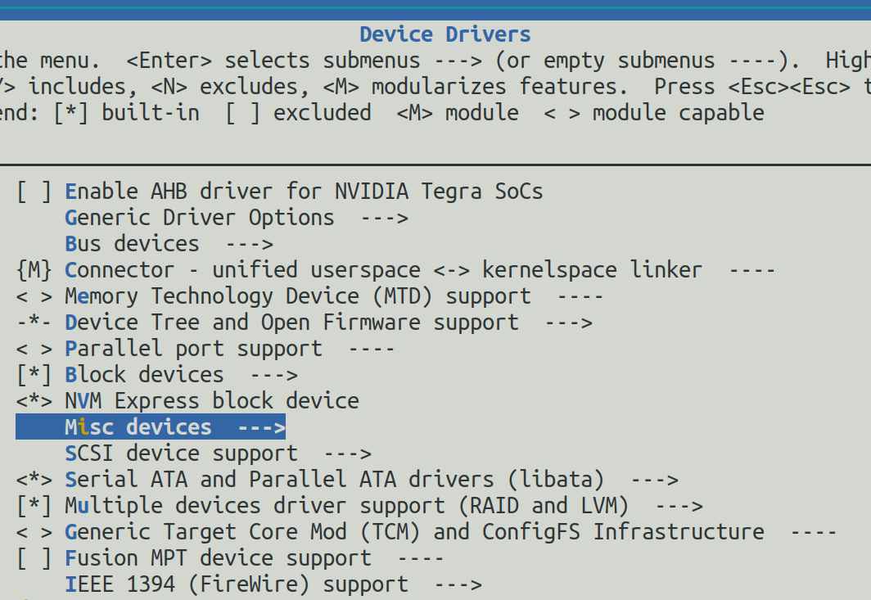

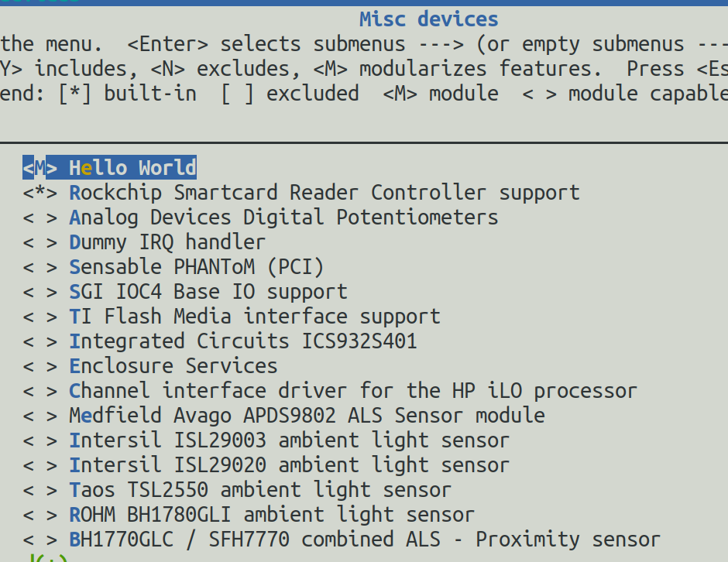

Compile Hello_World Sample Driver
[CMD]{KERNEL_DIR} => /home/cadtc/rockchip-bsp/kernel

[CMD] ls ${KERNEL_DIR}/drivers/misc/hello_world.o

Debug Hello_World Sample Driver
# Debug 1 : check .config
[CMD] vim .config

#
#
# Misc devices
#
CONFIG_CONFIG_HELLO_WORLD=m
CONFIG_ROCKCHIP_SCR=y
# CONFIG_SENSORS_LIS3LV02D is not set
# CONFIG_AD525X_DPOT is not set
# CONFIG_DUMMY_IRQ is not set
# CONFIG_PHANTOM is not set
# CONFIG_SGI_IOC4 is not set
# CONFIG_TIFM_CORE is not set

#Debug 2: check Makefile
[CMD] vim ${KERNEL_DIR}/drivers/misc/Makefile

#Debug 3:
# search hello_world in ${KERNEL_DIR}/drivers/misc/Makefile

#Debug 4:
# Rework CONFIG_HELLO_WORLD in ${KERNEL_DIR}/drivers/misc/Makefile

diff --git a/drivers/misc/Makefile b/drivers/misc/Makefile
index a192dba0fc94..61b57dfa8171 100644
--- a/drivers/misc/Makefile
+++ b/drivers/misc/Makefile
@@ -61,4 +61,4 @@ obj-$(CONFIG_CXL_BASE) += cxl/
obj-$(CONFIG_UID_SYS_STATS) += uid_sys_stats.o
obj-$(CONFIG_MEMORY_STATE_TIME) += memory_state_time.o
obj-$(CONFIG_USB_CAM_GPIO) += usb_cam_gpio.o
-obj-$(CONFIG_HELLO_WORLD) += hello_world.o
+obj-$(CONFIG_CONFIG_HELLO_WORLD) += hello_world.o

# Debug 5:
# Re-compile
[CMD] make

Below is log :
drivers/misc/hello_world.c:8:2: error: expected ‘;’ before ‘return’
return 0;
^~~~~~
drivers/misc/hello_world.c:9:1: warning: no return statement in function returning non-void [-
Wreturn-type]
}
^
make[2]: *** [scripts/Makefile.build:284: drivers/misc/hello_workd.o] Error 1
make[1]: *** [scripts/Makefile.build:484: drivers/misc] Error 2
make[1]: *** Waiting for unfinished jobs....

# Debug 6 :
# Fix drivers/misc/hello_world.c

diff --git a/drivers/misc/hello_workd.c b/drivers/misc/hello_workd.c
index 86b787c0379d..b8f4849a4fe7 100755
--- a/drivers/misc/hello_world.c
+++ b/drivers/misc/hello_world.c
@@ -3,7 +3,7 @@

static int hello_world_init(void)
{
- printk("Hello world\n")
+ printk("Hello world\n");

return 0;
}

# Debug 7 :
# Re-compile
[CMD] make -j4

Below is log :
CC [M] drivers/misc/hello_world.o
make[1]: 'arch/arm64/boot/Image.gz' is up to date.
Building modules, stage 2.
MODPOST 1134 modules
CC drivers/misc/hello_world.mod.o
LD [M] drivers/misc/hello_world.ko

# Debug 8 :
# check output file :
[CMD] ls drivers/misc/hello_world.*

[10] hw_intfc.conf

SOC Hardware Capability Control
[Target Board]

[CMD] cat /boot/hw_intfc.conf
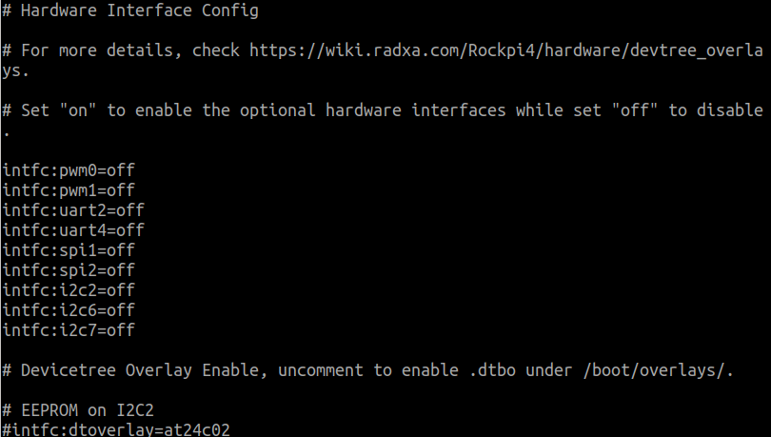

# Enable I2C2 Bus
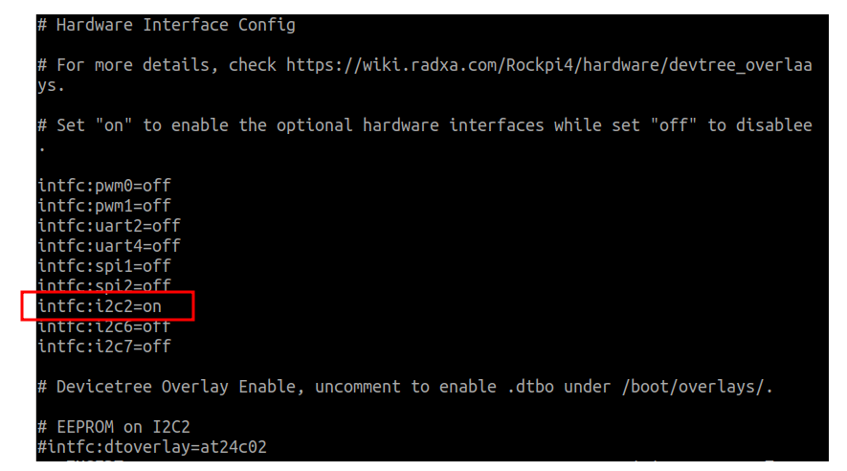

[11] extlinux.conf

Kernel Version Manage Table
[Target Board]

