[1] Build a RK3399 Debian Image
Download Docker Image for RK-Debian
# Reference :
https://github.com/radxa/rockchip-bsp

[Host PC]
[Step 1] download docker image
[CMD] docker pull xlloss/ubuntu1804:v01

[Step 2] run docker image
[CMD] docker run --privileged -it -v /home/cadtc/:/root xlloss/ubuntu1804:v01 /bin/bash

[Step 3] Download BSP
[CMD] cd ~/
[CMD] git clone -b master https://github.com/radxa/rockchip-bsp.git --depth=1
[CMD]
cd rockchip-bsp
git submodule init
git submodule update --depth=1

Install Packages For Build @ Docker Container
[Docker Container]
[Step 1] Install Packages
[CMD] apt-get update
[CMD]
apt-get install repo git-core gitk git-gui gcc-arm-linux-gnueabihf u-boot-tools device-tree-compiler \
gcc-aarch64-linux-gnu mtools parted libudev-dev libusb-1.0-0-dev python-linaro-image-tools \
linaro-image-tools gcc-arm-linux-gnueabihf libssl-dev liblz4-tool genext2fs lib32stdc++6 \
gcc-aarch64-linux-gnu g+conf autotools-dev libsigsegv2 m4 intltool libdrm-dev curl sed make \
binutils build-essential gcc g++ bash patch gzip bzip2 perl tar cpio python unzip rsync file bc wget \
libncurses5 libqt4-dev libglib2.0-dev libgtk2.0-dev libglade2-dev cvs git mercurial rsync openssh-client \
subversion asciidoc w3m dblatex graphviz python-matplotlib libssl-dev texinfo fakeroot \
libparse-yapp-perl default-jre patchutils swig chrpath diffstat gawk time expect-dev

[Step 2] build image
[CMD] cd /root
[CMD] cd rootfs
[CMD] export ARCH=arm64
[CMD] dpkg -i ubuntu-build-service/packages/*
[CMD] apt-get install -f
[CMD] RELEASE=buster TARGET=desktop ARCH=${ARCH} ./mk-base-debian.sh

[Step 3] check rootfs file
[CMD] ls rootfs/linaro-rootfs.img

Build Uboot Linux
[Docker Container]
[Step 1] Build uboot
[CMD] cd /root
[CMD] ./build/mk-uboot.sh rockpi4b #For ROCK Pi 4 Mode B
The generated images will be copied to out/u-boot folder
[CMD] ls out/u-boot/
idbloader.img rk3399_loader_v1.12.112.bin trust.img uboot.img

[Step 2] Build Linux
[CMD] ./build/mk-kernel.sh rockpi4b #For ROCK Pi 4 Mode B
[CMD] ls out/kernel/

Generate system image
[Docker Container]

[Step 1] Building the rk-debain rootfs with debug:
[CMD] VERSION=debug ARCH=${ARCH} ./mk-rootfs-buster.sh && ./mk-image.sh

[Step 2] Combine everything into one image

Generate system image with two partitions
[CMD] build/mk-image.sh -c rk3399 -t system -r rootfs/linaro-rootfs.img

Generate ROCK Pi 4 system image with five partitions.
[CMD] build/mk-image.sh -c rk3399 -b rockpi4 -t system -r rootfs/linaro-rootfs.img
[Step 3] check image
[CMD] out/system.img

[2] Profile.d and Profile
Add a command to to console start script in Profile.d
Example :
[Create Banner]
https://manytools.org/hacker-tools/convert-images-to-ascii-art/go/

[ Target Board ]
[CMD] scp ./ascii-art.txt rock@$BOARD_IP:/home/rock/
[CMD] cd /etc/profile.d/banner.sh
banner.sh contain is below
cat /home/rock/ascii-art.txt

[CMD] sudo reboot

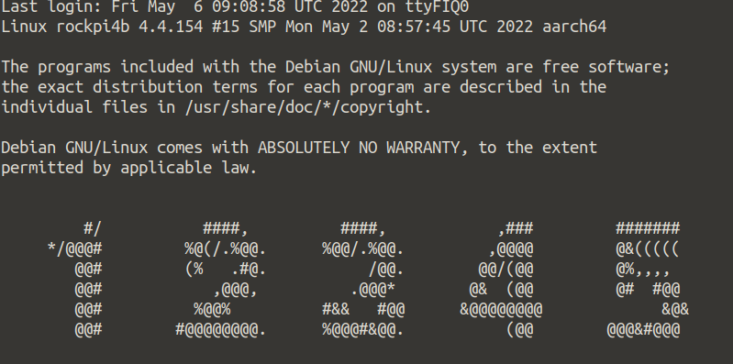

[3] Systemctl
Execute Enable a service
[ Target Board ]

[CMD] sudo systemctl enable lightdm

Execute Stop a service
[ Target Board ]

[CMD] sudo systemctl stop lightdm

Execute Resatrt a service
[ Target Board ]

[CMD] sudo systemctl restart lightdm

Execute Check a service
[ Target Board ]

[CMD] sudo systemctl status lightdm

Execute List service from RK Debian
[ Target Board ]

[CMD] sudo systemctl list-unit-files

[4] Create a New Initial Script
Create a new start up initial script
Example : show a jpeg file on system start-up
[ Host PC ]
[Step 1]
[CMD] rsync -rzav ./systemd_demo_debian rock@Board_IP:/home/rock/

[ Target Board ]

[Step 2] copy test.service to /lib/systemd/system/test.service on target
[CMD] sudo cp systemd_demo_debian/test.service /lib/systemd/system/
[CMD] sudo chmod 755 systemd_demo_debian/demo

[Step 3] start service
[CMD] systemctl enable test
[CMD] systemctl daemon-reload

[Step 4] install feh package
[CMD] sudo install feh

[Step 5] Reboot
[CMD] sudo reboot

[5] File System Mount

Mount a File System
[ Target Board ]

[Step 1] create Fake Image File
[CMD] dd of=/home/rock/test.img if=/dev/zero bs=1M count=5 status=progress

[Step 2] fdisk
[CMD] sudo fdisk ./test.img

[Step 3] format
[CMD] sudo mkfs.ext4 ./test.img

[Step 4] mount image
[CMD] sudo mount -t ext4 ./test.img /mnt

[Step 5] check mounted status
[CMD] mount

[Step 6] add file to /mnt
[CMD] touch /mnt/testme

[Step 7] umount /mnt
[CMD] sudo umount /mnt

[6] Debian Auto Login

Mount a File System
[ Target Board ]

[Step 1] Modify /etc/lightdm/lightdm.conf

[Seat:*]
autologin-user=rock
autologin-user-timeout=0

