[1] LED Control From SysFS
1. Control LED
[Target Board ]
[CMD] cd /sys/class/leds
[CMD] cd user-led2/
[CMD] cat trigger

none rc-feedback kbd-scrolllock kbd-numlock kbd-capslock kbd-kanalock kbd-shiftlock kbd-altgrlock kbd-ctrllock kbd-altlock kbd-shiftllock kbd-shiftrlock kbd-ctrlllock kbd-ctrlrlock mmc0 mmc1 timer oneshot [heartbeat] gpio cpu0 cpu1 cpu2 cpu3 cpu4 cpu5 default-on rfkill0 mmc2 rfkill1 rfkill2

# change trigger type shot [ This is just a sample, please try to change another type ]
[CMD] echo oneshot > trigger
[CMD] cat trigger
none rc-feedback kbd-scrolllock kbd-numlock kbd-capslock kbd-kanalock kbd-shiftlock kbd-altgrlock kbd-ctrllock kbd-altlock kbd-shiftllock kbd-shiftrlock kbd-ctrlllock kbd-ctrlrlock mmc0 mmc1 timer [oneshot] heartbeat gpio cpu0 cpu1 cpu2 cpu3 cpu4 cpu5 default-on rfkill0 mmc2 rfkill1 rfkill2

[CMD] echo 1 > shot

# Please check the Blue LED

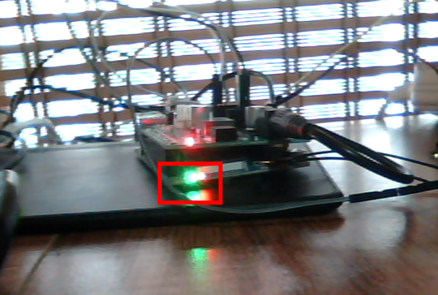

[2] GPIO Control From SysFS
1. Control GPIO
[CMD] cd /sys/class/gpio
# To know what attribute in gpiochX
[CMD] cat gpiochip0/label
[CMD] cat gpiochip0/base
[CMD] cat gpiochip0/ngpio
# Export GPIO2_B3
[CMD] echo 75 > export
# Check gpio32 attribute
[CMD] ls gpio75/
active_low device direction edge power subsystem uevent value

# Please use “cat” cmd to read “all attribution” from gpio32
[CMD] cat gpio75/direction

# Set GPIO75 is a output function
[CMD] echo out > gpio75/direction
# Please check “Read LED” status
# Set GPIO75 is High value
[CMD] echo 1 > gpio75/value
# Set gpio75 is Low value
[CMD] echo 0 > gpio75/value
# Please change other GPIO about LED and Button
# So, please check
# 1. schematic (電路圖) NanoPIM4_Extend_V01.pdf,
# Rockpi4_v13_sch_20181112.pdf
#

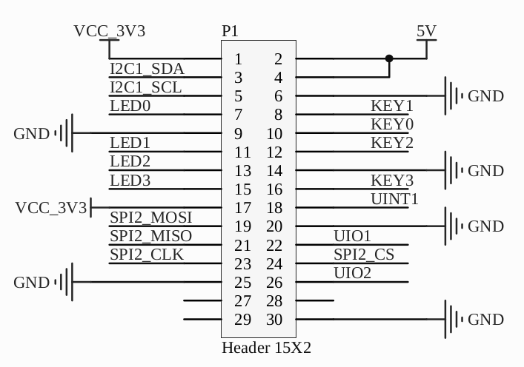

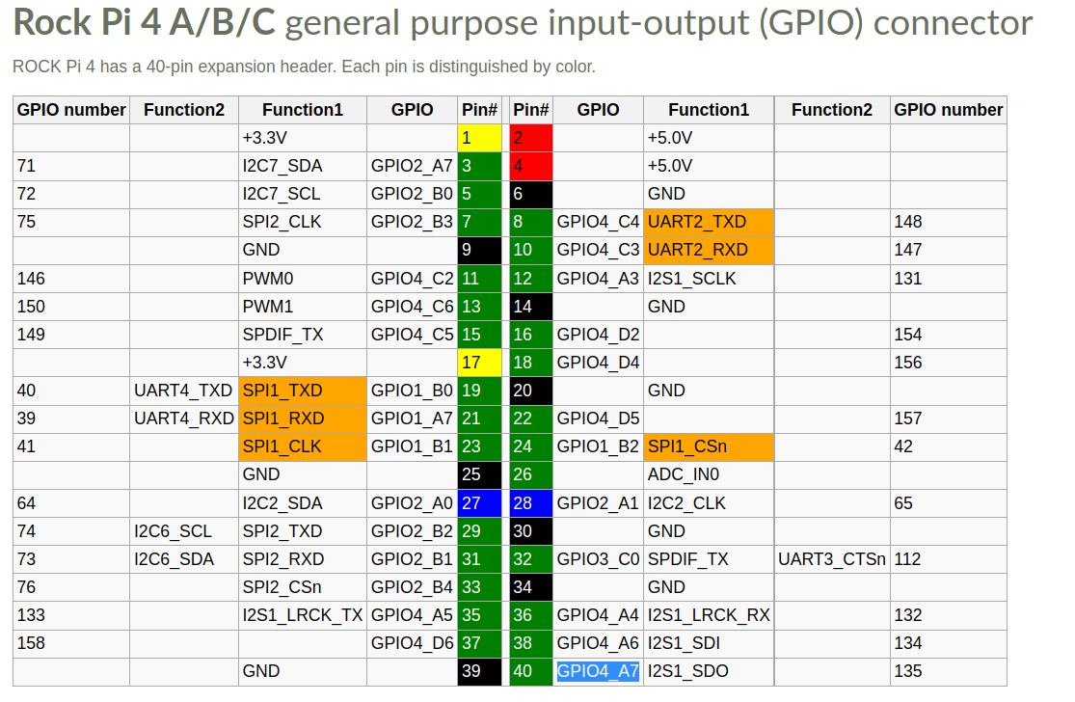

[3] GPIO Control From SysFS with Script
1. Control GPIO
# Use Script to set GPIO from SYSFS
# Below is a Example for controlling GPIO75

# Below is script content for Sample, please create a led_test.sh file.
# Then put below sample code to led_test.sh

=====================================================================
#!/bin/bash

GPIO_SYSFS=/sys/class/gpio
CTRL_GPIO=gpio$1
LED_ONOFF=$2

echo $GPIO_SYSFS/$CTRL_GPIO

if [ ! -d "$GPIO_SYSFS/$CTRL_GPIO" ]; then
echo $1 > $GPIO_SYSFS/export
echo out > $GPIO_SYSFS/$CTRL_GPIO/direction
fi

if [ $2 = "ON" ];then
echo "LED On"
GPIO_VAL=0
else
echo "LED Off"
GPIO_VAL=1
fi

echo $GPIO_VAL > $GPIO_SYSFS/$CTRL_GPIO/value
=====================================================================

# Test <led_test.sh>, please check LED status

[CMD] sh ./led_test.sh 75 ON
[CMD] sh ./led_test.sh 75 OFF

[4] Download GPIO Control with C Program
1. Control GPIO with C program
# Download C source code
[CMD] git clone https://github.com/xlloss/embedded_control_app.git
[CMD] cd embedded_control_app/gpio-sysfs-demo
[CMD] source ~/set_toolchain.sh

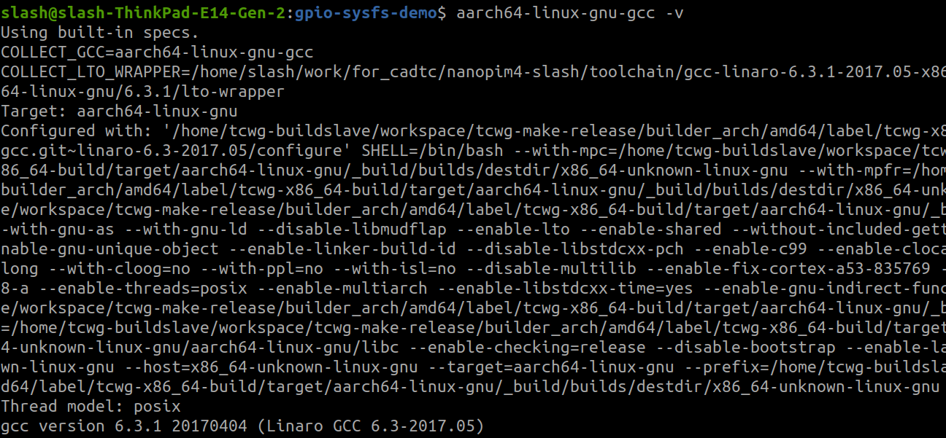
# Check Toolchain is workable
$ aarch64-linux-gnu-gcc -v
# Compile the sample gpio-sysfs-demo
[CMD] make

# Put gpioctl gpiodemo to Targetboard [use scp command]
[CMD] scp ./gpioctl ./gpiodemo rock@BOARD_IP:/tmp/

# Test gpioctl gpiodemo in Target board
[Target Board]

# Test gpioctl
[CMD] /tmp/gpioctl --help
Usage: ./gpioctl [OPTION] ...
Simple gpio access

-h, --help This message
-p, --getin <dio> Returns the input value of n sysfs DIO
-e, --setout <dio> Sets a sysfs DIO output value high
-l, --clrout <dio> Sets a sysfs DIO output value low
-d, --ddrout <dio> Set sysfs DIO to an output
-w, --waitfor <dio> Wait for IO to change to the configured edge
-r, --ddrin <dio> Set sysfs DIO to an input

# Set gpio32 as output function
[CMD] /tmp/gpioctl -d 75

#Check SysFS about gpio
[CMD] ls /sys/class/gpio

# Please check Red Led status after doing below command.
# Set GPIO75 output is Low
[CMD] /tmp/gpioctl -l 75

# Set gpio32 output is High
[CMD] /tmp/gpioctl -e 75

# Test gpiodemo, please try to change control gpoio32 [LED0] from gpiodemo.c

diff --git a/gpio-sysfs-demo/gpiodemo.c b/gpio-sysfs-demo/gpiodemo.c
index f2686ec..3fd7e1f 100644
--- a/gpio-sysfs-demo/gpiodemo.c
+++ b/gpio-sysfs-demo/gpiodemo.c
@@ -43,7 +43,7 @@
#define LED_TEST_NUM 1

/* int led_set[4] = {LED_0, LED_1, LED_2, LED_3}; */
-int led_set[1] = {LED_G};
+int led_set[1] = {LED_0};

pthread_mutex_t mutex;

@@ -182,7 +182,7 @@ int main(int argc, char **argv) {
start_routine[3] = thr_led3;
*/

- start_routine[0] = thr_led_green;
+ start_routine[0] = thr_led0;

for (i = 0; i < LED_TEST_NUM; i++) {
led = led_set[i];

# Re-Compile gpio-sysfs-demo then put gpiodemo to target board
# Please check Red Led status

[CMD] gpiodemo

[5] SH21 Read From SysFS

(humidity and temperature sensor)
Read Temperature and Humidity
# Modify hw_intfc.conf for enabling i2c7
[ Target ]
[CMD] vim /boot/hw_intfc.conf
intfc:i2c7=off → intfc:i2c7=on

[CMD] reboot

# Check i2c7
[CMD] ls /sys/class/i2c-adapter/ -l
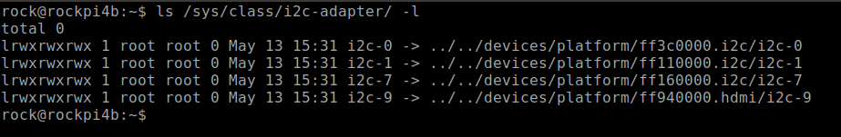
# modify DTS (rockpi-4b-linux.dts)
[CMD] vim arch/arm64/boot/dts/rockchip/rockpi-4b-linux.dts

+&i2c7 {
+ status = "okay";
+ sht21@40 {
+ #address-cells = <1>;
+ #size-cells = <0>;
+ compatible = "sensirion,sht21";
+ reg = <0x40>;
+ };
+};

# Update DTB
[CMD] scp arch/arm64/boot/dts/rockchip/rockpi-4b-linux.dtb rock@board_ip:/tmp/

[Target Board]
[CMD] sudo cp /tmp/rockpi-4b-linux.dtb /boot/dtbs/4.4.154/rockchip/
[CMD] reboot

# Enable SH21 Driver
[CMD] cd /home/cadtc/rockchip-bsp/kernel
[CMD] make menuconfig
Device Drivers --→
<*> Hardware Monitoring support --→
<M> Sensiron humidity and temperature sensors. SHT21 and compat.
[CMD] make modules -j4
[CMD] scp drivers/hwmon/sht21.ko rock@board_ip:/tmp/

[Target Board]
[CMD] insmod /tmp/sht21.ko

# Check SH21 Driver
[CMD] lsmod | grep sh21
# Below is sh21 drive installed in target board
sht21 16384 0

# Enter to HWMON attribution in SysFs
$ cd /sys/class/hwmon/hwmon0/

# Read temperature value
$ cat temp1_input

# Read humidity value
$ cat humidity1_input

# Schematic

Up Board
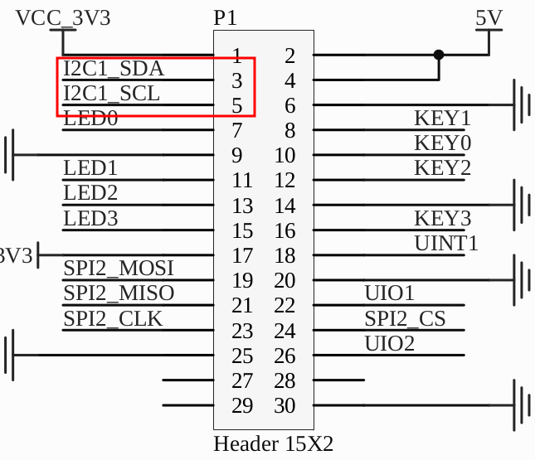

Bottom board
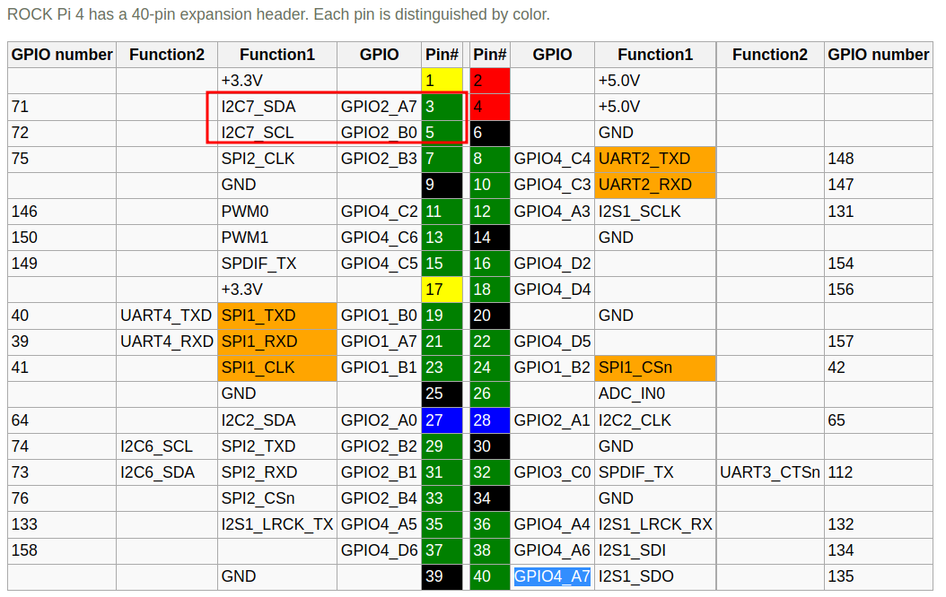

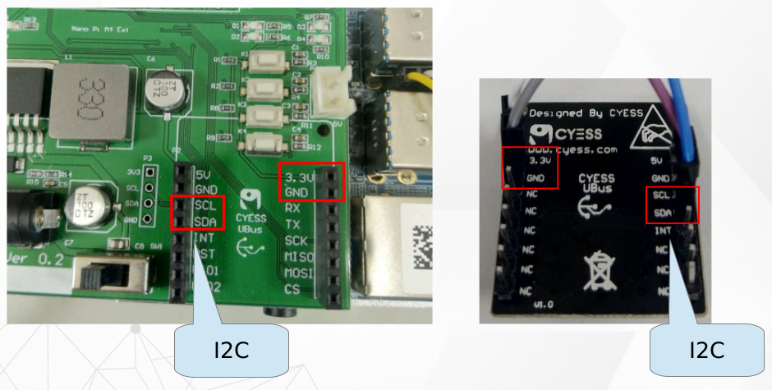

# Please to study control_temp from https://github.com/xlloss/embedded_control_app.git

[6] ISL29023 (Light sensor) Read From SysFS
Read light sensor value
# Modify hw_intfc.conf for enabling i2c7
[ Target ]
[CMD] vim /boot/hw_intfc.conf
intfc:i2c7=off → intfc:i2c7=on

# Enable ISL29023 Driver
[CMD] cd /home/cadtc/rockchip-bsp/kernel
[CMD] make menuconfig
Device Drivers --->
[*] Staging drivers --->
IIO staging drivers --→
Light sensors --→
<*> ISL 29018 light and proximity sensor
or
<M> ISL 29018 light and proximity sensor

# modify DTS (rockpi-4b-linux.dts)
[CMD] vim arch/arm64/boot/dts/rockchip/rockpi-4b-linux.dts

+&i2c7 {
+ status = "okay";
+ isl29023@44 {
+ status = "okay";
+ compatible = "isil,isl29023";
+ reg = <0x44>;
+ };
+};

# Update DTB
[CMD] scp arch/arm64/boot/dts/rockchip/rockpi-4b-linux.dtb rock@board_ip:/tmp/

[Target Board]
[CMD] sudo cp /tmp/rockpi-4b-linux.dtb /boot/dtbs/4.4.154/rockchip/
[CMD] reboot

# 1. if use build-in to kenel. Please update kernel image
# 2. if use module file. Please update isl29018.ko to target board

# Check ISL29023 Driver [module stlye]
[CMD] lsmod | grep isl
# Check ISL29023 Driver [build-in stlye]
[CMD] dmesg | grep isl
# Enter to IIO attribution in SysFs
$ cd /sys/bus/iio/devices/iio:device1

# Read light value
$ cat in_illuminance0_input

# Schematic

Up Board

Bottom board

# Please to study control_light from https://github.com/xlloss/embedded_control_app.git

[7] CPU Temperature Read From SysFS
Read CPU Temperature value
# Enter to thermal attribution in SysFs
$ cd /sys/class/thermal

# Read CPU thermal_zone0 value
$ thermal_zone0/temp

# Read CPU thermal_zone1 value
$ thermal_zone1/temp

# Play a H264 file then check CPU temperature
$ gstvideoplay.sh &
$ watch -n 2 "cat thermal_zone0/temp"

[8] PWM Control From SysFS
1. Control PWM
# Modify hw_intfc.conf for enabling i2c7
[ Target ]
[CMD] vim /boot/hw_intfc.conf
intfc:pwm0=off → intfc:pwm0=on
intfc:pwm1=off → intfc:pwm1=on

[CMD] cd /sys/class/pwm

$ ls -l

lrwxrwxrwx 1 root root 0 pwmchip0 -> ../../devices/platform/ff420000.pwm/pwm/pwmchip0
lrwxrwxrwx 1 root root 0 pwmchip1 -> ../../devices/platform/ff420010.pwm/pwm/pwmchip1
lrwxrwxrwx 1 root root 0 pwmchip2 -> ../../devices/platform/ff420020.pwm/pwm/pwmchip2

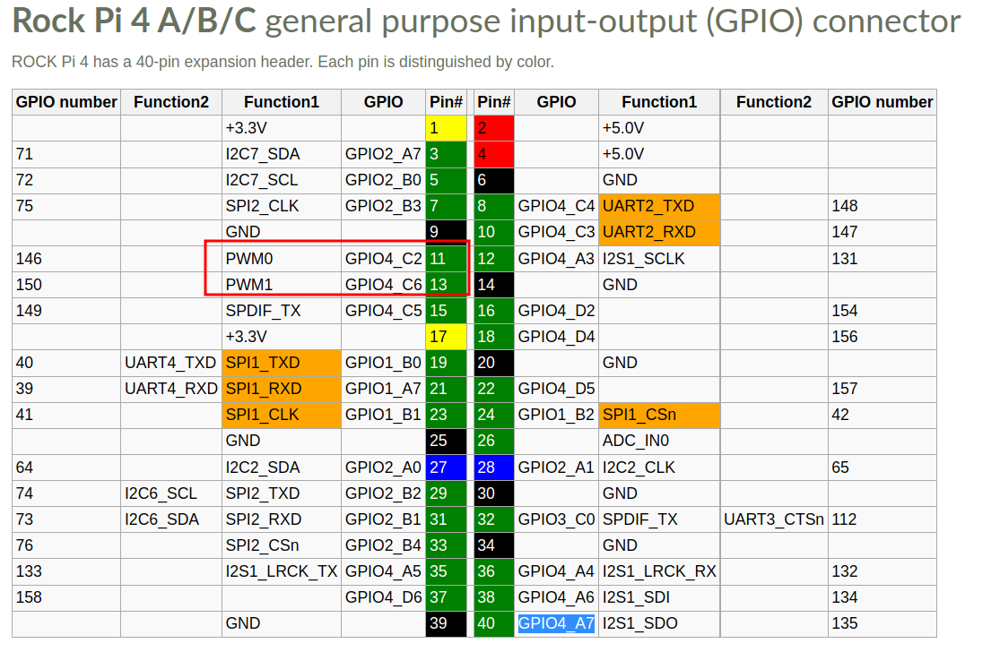

[CMD] cd /sys/class/pwm/pwmchip0/
# Export PWM1 channel 0
[CMD] echo 0 > export
[CMD] cd pwm0

# Set a 1KHz for pules
[CMD] echo 1000000 > period

# Set 50% duty cycle for pules
[CMD] echo 500000 > duty_cycle
# Enable PWM
[CMD] echo 1 > enable

# Set a 1Hz for pules
[CMD] echo 1000000000 > period

# Set 25% duty cycle for pules
[CMD] echo 250000000 > duty_cycle

# Change Polarity
[CMD] echo inversed > polarity
[CMD] echo normal > polarity

# Enable PWM
$ echo 1 > enable

# Please to study control_fan from https://github.com/xlloss/embedded_control_app.git
# Please to study control_buzzer from https://github.com/xlloss/embedded_control_app.git

