[1] Compile HelloWorld Module – Out of Kernel Tree
1. Compile Hello World Module
# Set you Linux kernel source code path in set_toolchain.sh

# Below is set_toolchain.sh content, please modify KERNELDIR
[CMD] export KERNELDIR=/home/cadtc/rockchip-bsp/kernel
[CMD] source ~/set_toolchain.sh
[CMD] cd /home/cadtc/cadtc-sample/7-linux_driver/hello_world/
[CMD] make

# Put hello_world.ko to target board

[ Target Board ]

[CMD] insmod ./hello_world.ko
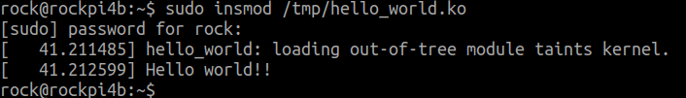

[CMD] lsmod
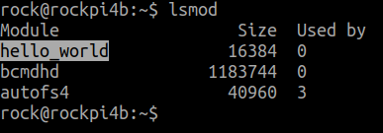

[CMD] rmmod ./hello_world.ko
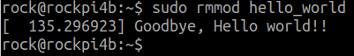

[2] Compile HelloWorld Module – In Kernel Tree
1. Compile Hello World Module for Build-in
# Enter Linux kernel source code
[CMD] cd /home/cadtc/rockchip-bsp/kernel

# Do menuconfig then select Hello World module and let it build-in
[CMD] make menuconfig

→ Device Drivers → Misc devices

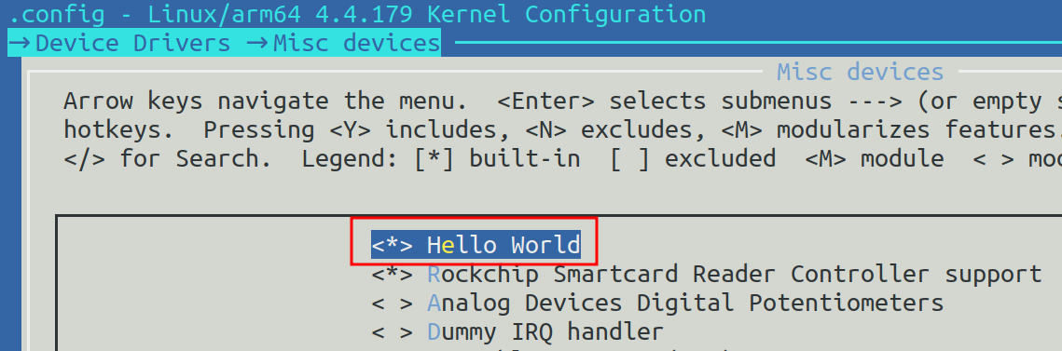

# Re-build Linux kernel then update it to Target board
[CMD] make -j8

# Update Linux kenrel Image for Target board then reboot
[CMD] scp arch/arm64/boot/Image root@Target_Boarad_IP:/boot

[ Target board ]

# Check the Hello World module build-in module message
[CMD] dmesg | grep -i hello
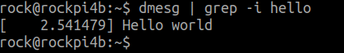

2. Compile Hello World Module for Build Module
# Enter Linux kernel source code
[CMD] cd /home/cadtc/rockchip-bsp/kernel

# Do menuconfig then select Hello World module and let it build-in
[CMD] make menuconfig

→ Device Drivers → Misc devices
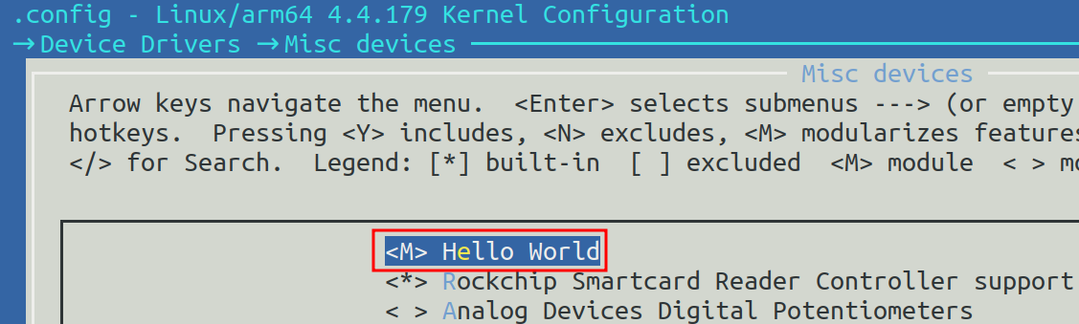

# Re-build Linux kernel then update it to Target board
[CMD] make -j8

# Update Linux kenrel Image for Target board then reboot
[CMD] scp arch/arm64/boot/Image rock@Target_Boarad_IP:/boot

# Put hello_workd.ko to Target Board
[CMD] scp drivers/misc/hello_world.ko rock@Target_Boarad_IP:/tmp

[ Target board ]

# Install kernel module
[CMD] insmod hello_world.ko
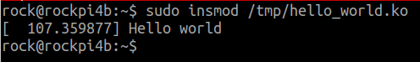

# List the kernel module that be installed
[CMD] lsmod

# Remove kernel module
[CMD] rmmod hello_world.ko
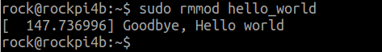

[3] Kernel Modules Install
1. Modules Install
# Enter Linux kernel source code
[CMD] cd /home/cadtc/rockchip-bsp/kernel

# Use make help to check modules install method
[CMD] make help | grep modules

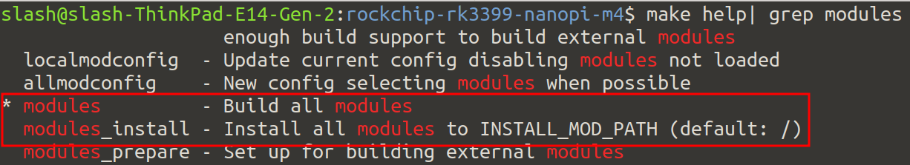

# Build modules all
[CMD] source ~/set_toolchain.sh
[CMD] make modules -j8

# Install kernel modules into INSTALL_MOD_PATH
[CMD] mkdir modules_install_dir
[CMD] export INSTALL_MOD_PATH=`pwd`/modules_install_dir
[CMD] make modules_install -j 8

# Check install folder that be assigned by INSTALL_MOD_PATH

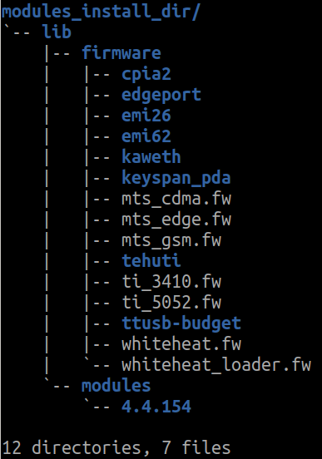
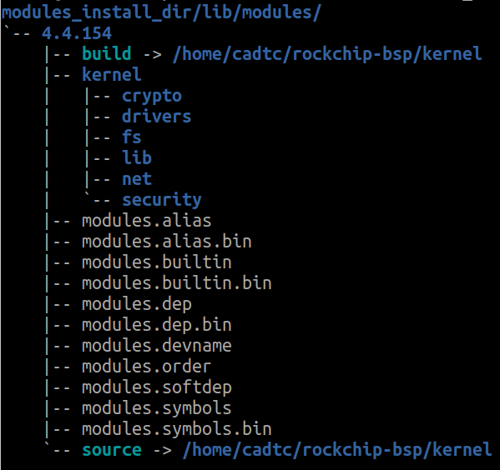

[Host]
# Mount Target Board RootFS to PC folder by sshfs
[CMD] sudo apt-get install rsync
[CMD] rsync -rzav modules_install_dir/lib/modules/ rock@10.0.1.61:/home/rock/

[Target]
# Copy /home/cadtc/4.4.154 to /lib/modules
[CMD] cp -a ~/4.4.154 /lib/modules
[CMD] sync
[CMD] reboot

[4] Install Kernel Modules with Modporbe
1. Use Modprobe
[ Target Board ]

# Install kernel module with modporbe
[CMD] modprobe hello_world
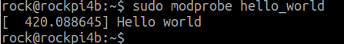

# Remove module with modprobe
[CMD] modprobe -r hello_world
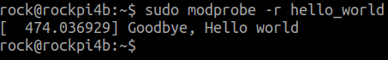

[5] Use Depmod
1. Use Depmod
# Compile Led module
[CMD] source ~/set_toolchain.sh
[CMD] cd /home/cadtc/cadtc-sample/7-linux_driver/led_driver/led
[CMD] make

# Put ioctl_leds.ko to /lib/modules/4.4.179/kernel/drivers/char/ in Target board
[CMD] scp ./ ioctl_leds.ko rock@BOARD_IP:/lib/modules/4.4.179/kernel/drivers/misc/

# Install ioctl_led.ko with modprobe
[CMD] modprobe ioctl_leds

# Use depmod
[CMD] depmod -A

# Install ioctl_led.ko with modprobe again
[CMD] modprobe ioctl_leds

# Check modules.dep in /lib/modules/4.4.179
[CMD] cat modules.dep | grep ioctl_leds
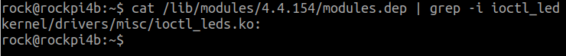

[6] Study ioctl_leds Module
1. Compile ioctl_leds modules
[ Host]

# Compile ioctl_leds modules
[CMD] source ~/set_toolchain.sh
[CMD] cd /home/cadtc/cadtc-sample/7-linux_driver/led_driver/led/
[CMD] make

# Put ioctl_leds modules to Target Board
[CMD] scp ioctl_leds rock@BOARD_IP:${DIR}

# Compile LED test program
[CMD] cd /home/cadtc/cadtc-sample/7-linux_driver/led_driver/led/test_ap
[CMD] make

# Put Test modules application to Target Board
[CMD] scp test_led_char_driver rock@BOARD_IP:${DIR}

[ Target Board ]

# Install ioctl_leds modulels
[CMD] insmod ioctl_leds.ko OR
[CMD] modprobe ioctl_leds

# Check Test modules application help information
[CMD] test_led_char_driver --help

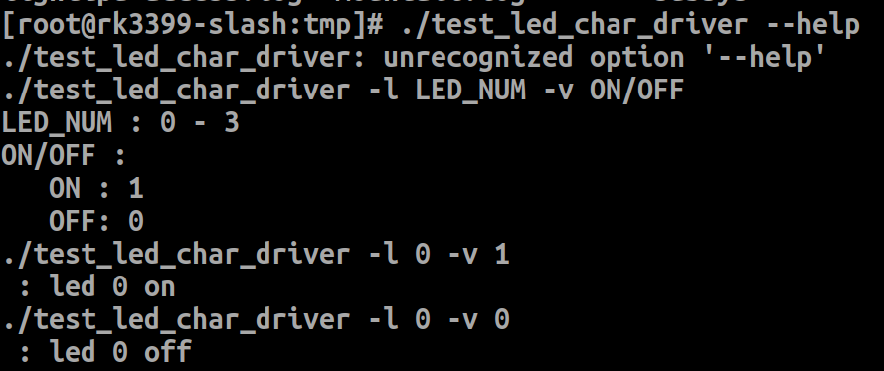

# Execute Test modules application
[CMD] ./test_led_char_driver -l 0 -v 1

