[NaNoPi-M4 Overview]

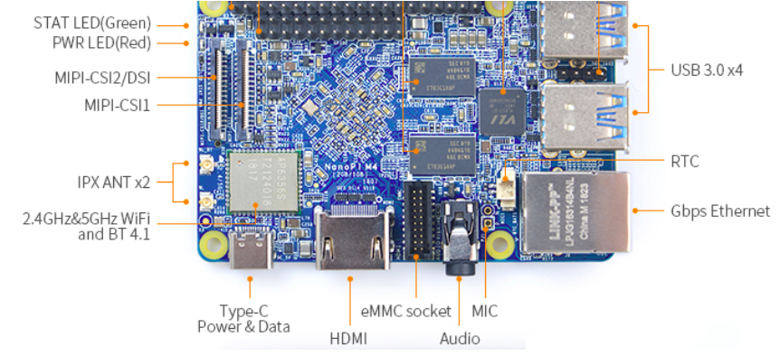
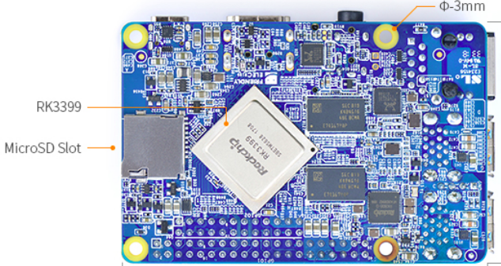

40-Pin Export GPIO1 Pin Spec
Pin# | Assignment | Pin# | Assignment
1 | VCC3V3_SYS | 2 | VDD_5V
3 | I2C2_SDA(3V) | 4 | VDD_5V
5 | I2C2_SCL(3V) | 6 | GND
7 | GPIO1_A0(3V) | 8 | GPIO4_C1/I2C3_SCL(3V)
9 | GND | 10 | GPIO4_C0/I2C3_SDA(3V)
11 | GPIO1_A1(3V) | 12 | GPIO1_C2(3V)
13 | GPIO1_A3(3V) | 14 | GND
15 | GPIO1_A4(3V) | 16 | GPIO1_C6(3V)
17 | VCC3V3_SYS | 18 | GPIO1_C7(3V)
19 | SPI1_TXD/UART4_TX(3V) | 20 | GND
21 | SPI1_RXD/UART4_RX(3V) | 22 | GPIO1_D0(3V)
23 | SPI1_CLK(3V) | 24 | SPI1_CSn0(3V)
25 | GND | 26 | GPIO4_C5/SPDIF_TX(3V)
27 | I2C2_SDA(1.8V) | 28 | I2C2_SCL(1.8V)
29 | I2S0_LRCK_RX(1.8V) | 30 | GND
31 | I2S0_LRCK_TX(1.8V) | 32 | I2S_CLK(1.8V)
33 | I2S0_SCLK(1.8V) | 34 | GND
35 | I2S0_SDI0(1.8V) | 36 | I2S0_SDO0(1.8V)
37 | I2S0_SDI1SDO3(1.8V) | 38 | I2S0_SDI2SDO2(1.8V)
39 | GND | 40 | I2S0_SDI3SDO1(1.8V)

24-Pin GPIO2 Pin Spec
Pin# | Assignment | Pin# | Assignment
1 | VCC5V0_SYS | 2 | VCC5V0_SYS
3 | PCIE_RX1_P | 4 | PCIE_TX1P
5 | PCIE_RX1_N | 6 | PCIE_TX1N
7 | GND | 8 | GND
9 | PCIE_RX0_P | 10 | PCIE_TX0P
11 | PCIE_RX0_N | 12 | PCIE_TX0N
13 | GND | 14 | GND
15 | PCIE_REF_CLKP | 16 | HOST0_DM
17 | PCIE_REF_CLKN | 18 | HOST0_DP
19 | GND | 20 | GND
21 | PWR_KEY | 22 | HOST1_DM
23 | GPIO4_C6/PWM1(3V) | 24 | HOST1_DP

Debug UART Pin Spec
3V level signals, 1500000bps
Pin# | Assignment | Description
1 | GND | 0V
2 | VCC5V0_SYS | 5V power output
3 | UART2DBG_TX | output
4 | UART2DBG_RX | input

Boot from SD Card
< Get an 4G SDHC card >
Distribution Version | Distribution Prebuild Image
Buildroot | rk3399-sd-buildroot-linux-4.4-arm64-YYYYMMDD.img.zip  Buildroot
Ubuntu 18.04 | rk3399-sd-friendlydesktop-bionic-4.4-arm64-YYYYMMDD.img.zip  FriendlyDesktop
Ubuntu core | rk3399-sd-friendlycore-bionic-4.4-arm64-YYYYMMDD.img.zip  FriendlyCore
Lubuntu | rk3399-sd-lubuntu-desktop-xenial-4.4-armhf-YYYYMMDD.img.zip  Lubuntu Desktop

[Update Nanopi-M4 Image To SD Card-1]

<Step 1> Extract sd-fuse_rk3399_slash.tar.bz2

$ cd ~/nanopim4-slash/
$ tar -xvjf sd-fuse_rk3399.tar.bz2
$ cd sd-fuse_rk3399_slash

<Step 2> Look for your SD or MMC device in Linux

$ dmesg | tail
$ lsblk

[For MMCX Style]
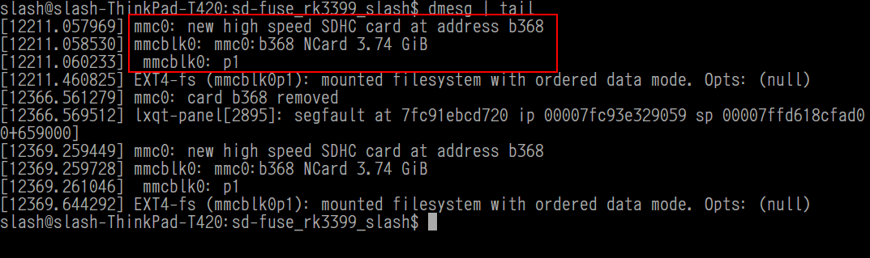
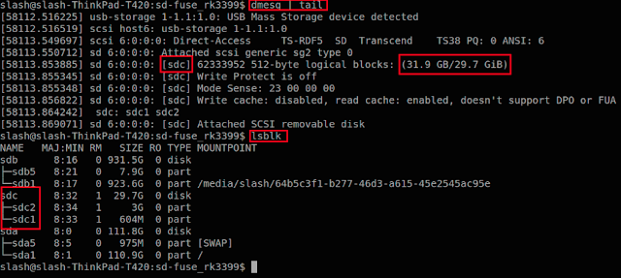
[For SDX Style]

\

<Step 3.1> For SDX Style Write Image to MMC Card

$ sudo ./slash_update.sh sdX [sdX → sda, sdb, sdc, sdd ...]

<Step 3.2> For MMC Style Write Image to SD Card

$ sudo ./slash_update.sh mmcX [mmcX → mmc0, mmc1, mmc2, mmc3 ...]
<Step 4> Insert SD/MMC card to Target Slot then Power On

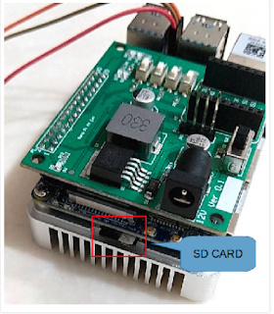

<Step 5> Check LCD Panel

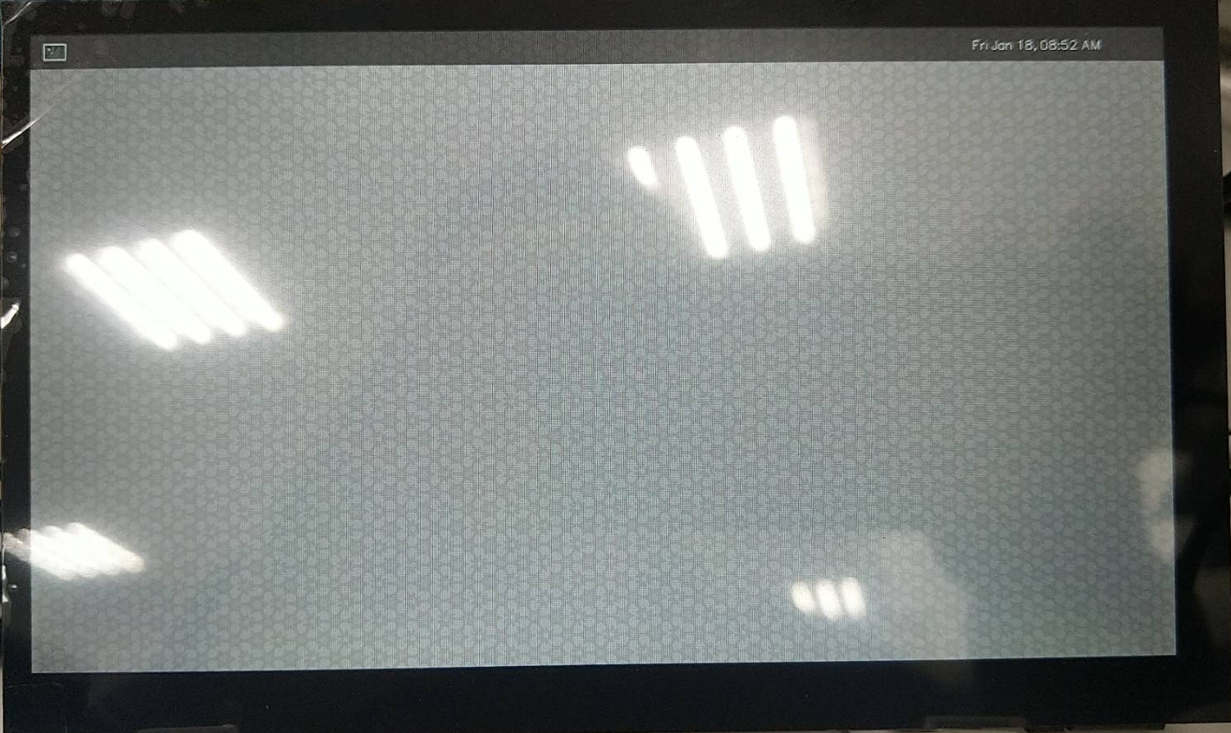

[Update Nanopi-M4 Image To SD Card-2]

https://wiki.friendlyarm.com/wiki/index.php/NanoPi_M4#Boot_from_SD_Card

Download Image (Buildroot)
https://drive.google.com/file/d/1Fh_YAmDZFlU6uoKLnKkLTzBB_RKobPUW/view?usp=sharing

$ sudo dd if=./rk3399-sd-buildroot-linux-4.4-arm64-20201226.img of=/dev/sdX bs=1M status=progress



[Setup Up Debug Port]

<Step 1> Hardware setting
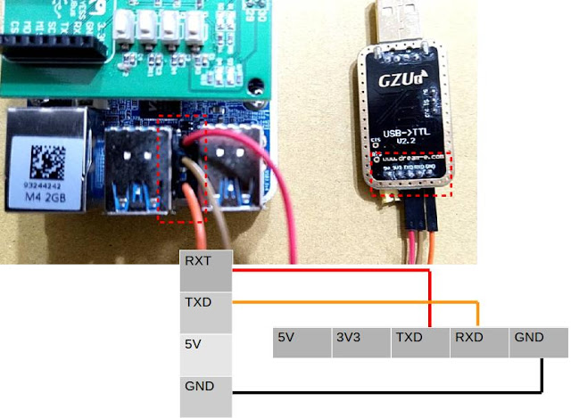

<Step 2> Install Terminal

$ apt-get install minicom
# insert Debug Danger to Host PC
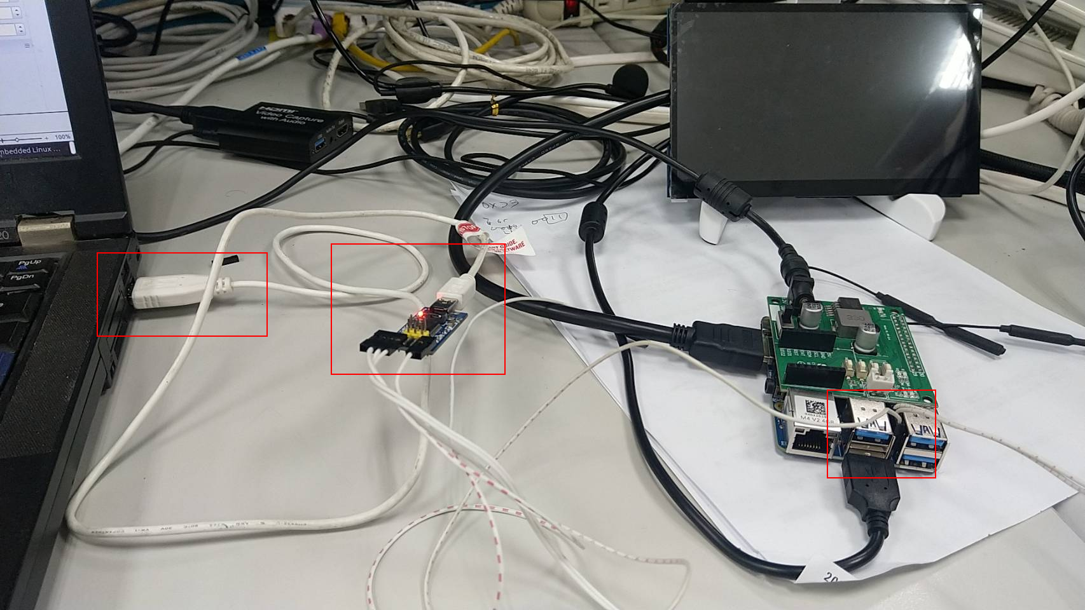

# Open minicon then power on targget board
$ sudo minicom -D /dev/ttyUSB0 -b 1500000

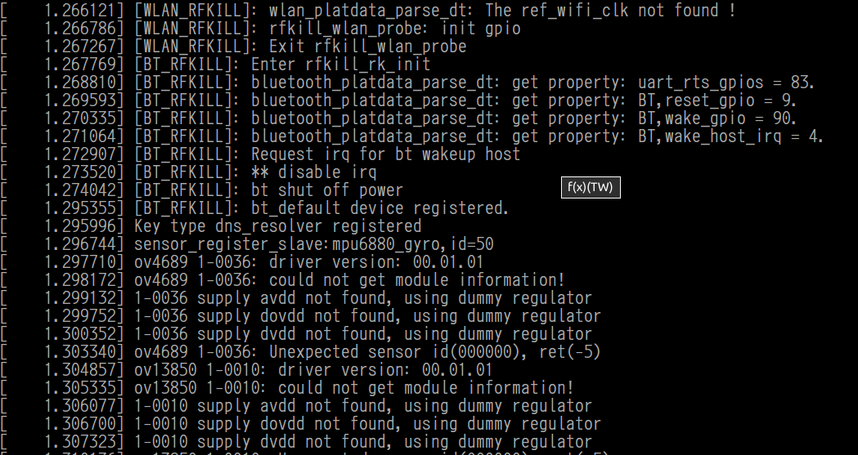

[Setup Up Network]

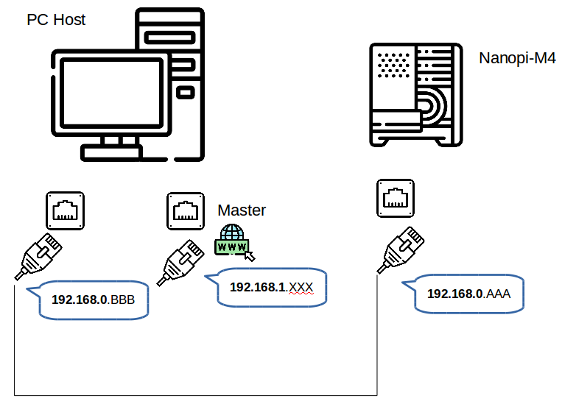

[ PC Hosts 端 網路設定 ]

< Step 1> Ubuntu 桌面右上右角網路設定管理員
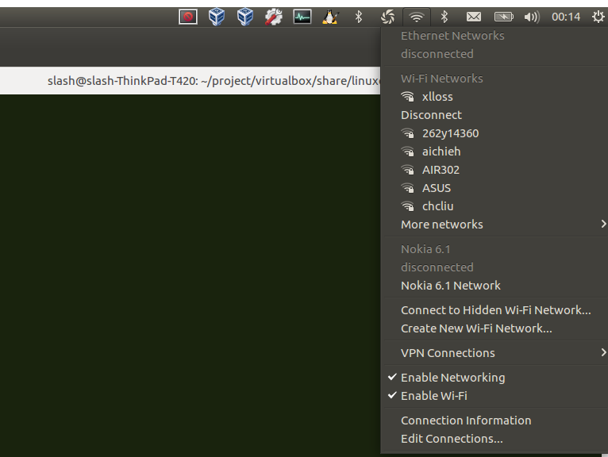

<Step 2> 新增一組給開發板的網路卡設定
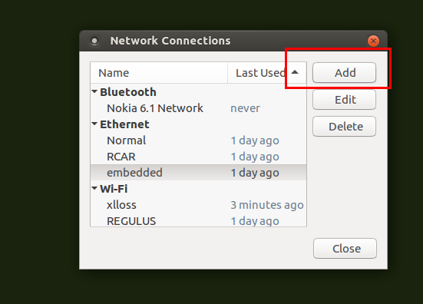

<Step 3> 設定 IP Address
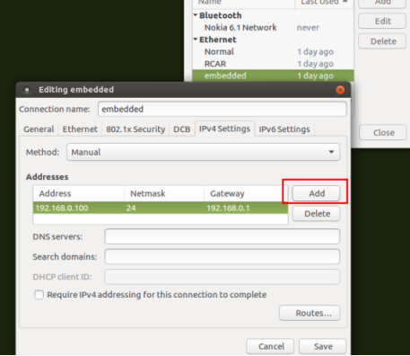

< Step 4> 確認 IP Address

$ ifconfig

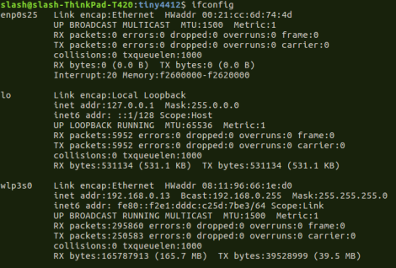

[Target EVB 端 網路設定 – Static ]

< Step 1> 確認網路狀態

$ ifconfig
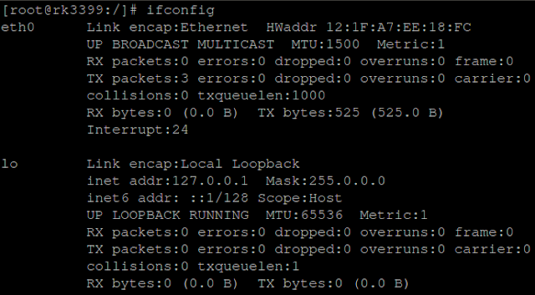

< Step 2> 設定 IP

$ ifconfig eth0 192.168.0.100
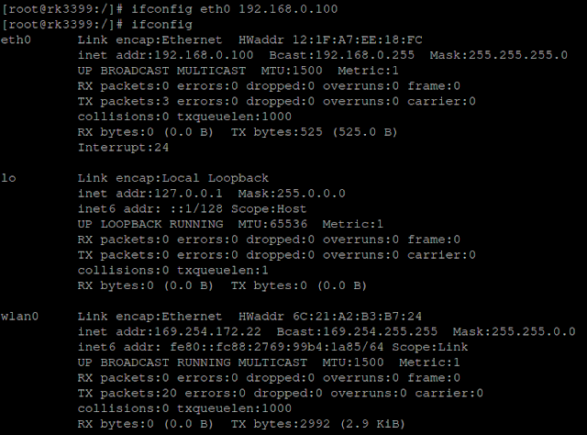

< Step 3> 測試EVB 與 Host PC 網路連線狀態

$ ping [Host PC IP]
例如 : ping 192.168.0.1

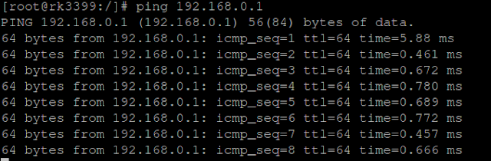

[ Target EVB 端 網路設定 – HUB ]

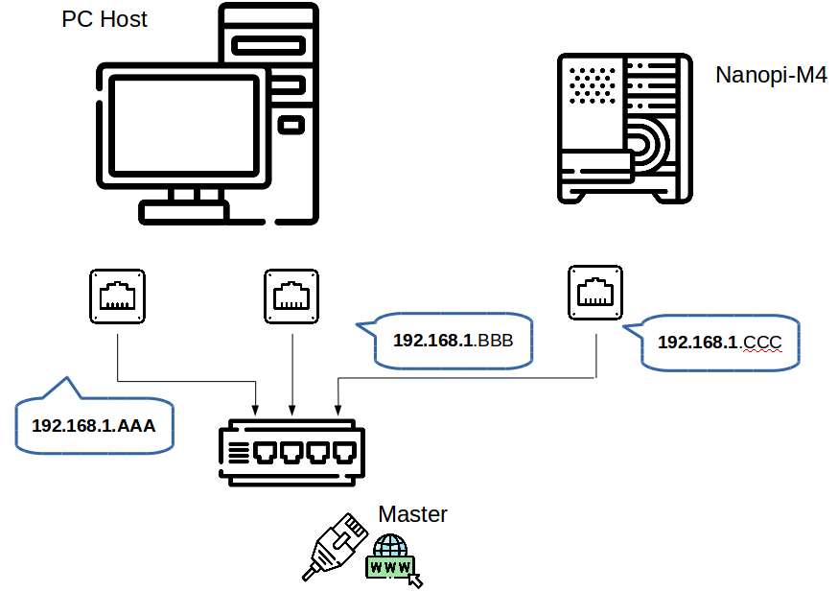

< Step 1> Catch network IP address from dynamic server

[ Target ]
$ udhcpc -i eth0

[SSH]
# 透過 SSH 傳送一個檔案 從 Host PC 至 開發板

<Target>
# 先在 EVB 設定密碼
$ password

<Host PC>
# 傳送測試檔案
$ scp [檔案] [EVB 帳號]@[EVB IP]:[EVB PATH]
例如 :
$ scp testme root@192.168.0.100:/tmp

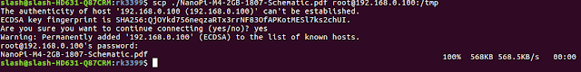

假設遇到如下狀況, 請依紅色框框執行命令
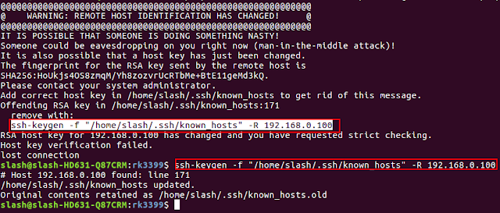

[建立 NFS Server 環境]

[Host]
< Step 1 > install NFS software package
$ sudo apt-get install nfs-kernel-server nfs-common portmap
< Step 2 > comfigure exports
$ sudo geany /etc/exports
$ add your share file folder
example :
/home/cadtc/nfs/ *(rw,sync,no_root_squash)
< Step 3 > Restart Host PC
$ sudo /etc/init.d/nfs-kernel-server restart

< Step 4 > (option) [Host ] :
ifconfig ethx 192.168.0.10

< Step 5>
$ touch /home/cadtc/nfs/

[Target Board]
< Step 6 >
$ sudo mount -t nfs 192.168.0.10:/home/cadtc/nfs/ /mnt/
$ ls -l /mnt
$ sudo umount /mnt

[設定 Toolchain]

$ cd ~/nanopim4-slash
# 修改 設定檔裡面 Toolchain 路徑

$ vim ./set_toolchain.sh

======================= set_toolchain.sh 內容 =================
export PATH=$PATH:/home/cadtc/nanopim4-slash/toolchain/gcc-linaro-6.3.1-2017.05-x86_64_aarch64-linux-gnu/bin/

export CROSS_COMPILE=aarch64-linux-gnu-
export ARCH=arm64
export KERNELDIR=/home/cadtc/nanopim4-slash/kernel/rockchip-rk3399-nanopi-m4
=======================================================

#測試 Toolchain 設定

$ source ./set_toolchain.sh
$ aarch64-linux-gnu-gcc -v



