Build Basic rootfs

1 create necessary directgory
a ) mkdir my_rootfs

b ) mkdir -p bin dev etc home lib proc root sbin sys tmp usr var etc/init.d

c ) copy rootfs_sample/* my_rootfs/etc
(fstab hostname inittab mdev.conf modules.conf mtab passwd profile init.d/rcS)

2 build busybox

a ) wget http://www.busybox.net/downloads/busybox-1.23.0.tar.bz2

b ) tar -xvjf busybox-1.23.0.tar.bz2

c ) source ~/tiny4412/experiment/set_arm_4412_toolchain_path.sh

d ) make menuconfig

e ) make -j4

f ) make install (intsall ./_install)

3 copy C library to rootfs

a ) cp -a FriendlyARM/toolschain/4.5.1/arm-none-linux-gnueabi/sys-root/lib my_rootfs/

4 change u-boot parameters about rootfs

a ) setenv bootargs noinitrd init=/linuxrc root=/dev/nfs
ip=192.168.0.20:192.168.0.10:192.168.0.1:255.255.255.0::eth0:on
nfsroot=192.168.0.10:/home/cadtc/tiny-
4412/experiment/day5/1-create_rootfs/my_rootfs, console=ttySAC0 lcd=S70

5 create device note

a ) sudo mknod console c 5 1

b ) sudo mknod null c 1 3

Use Buildroot to create rootfs

a ) wget http://buildroot.uclibc.org/downloads/buildroot-2015.08.tar.gz

b ) tar -xvzf buildroot-2015.08.tar.gz && cd buildroot-2015.08

c ) make mini2440_defconfig

d ) make menuconfig

e ) cancel build kernel

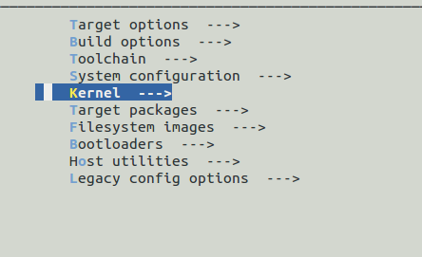

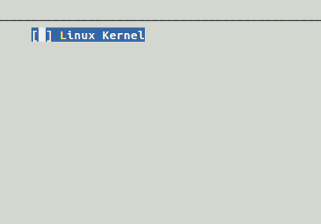

f ) cancel buid bootloader

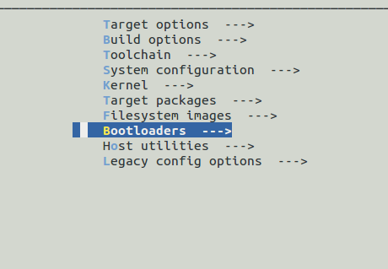

g ) Toolchain setting

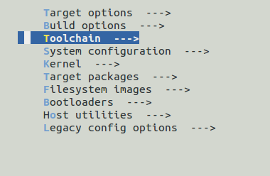

select toolchain type : External toolchain

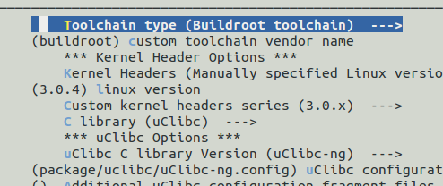

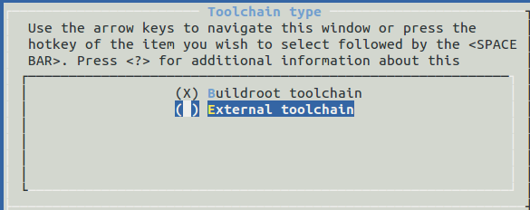

set toolchain path
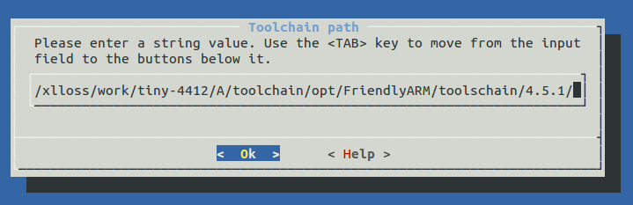

h ) set Toolchain has RPC support

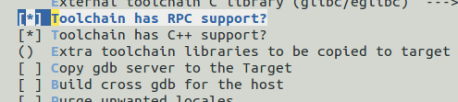

i ) build buildroot
#make

j ) make finish, we enter output directory
cd output/images

k ) extract rootfs.tar
mkdir my_rootfs && tar -xvf rootfs.tar -C my_rootfs/

l ) modify etc/passwd file
sudo vim etc/passwd
-root:x:0:0:root:/root:/bin/sh
+root::0:0:root:/root:/bin/sh

m ) add init process in etc/init.d
cd etc/init.d
sudo vim S00init, paste below :

#!/bin/sh
#
# Start init
#

start() {
echo -n "Starting init: "
/bin/hostname -F /etc/hostname

/bin/mount -n -t proc none /proc
/bin/mount -n -t sysfs none /sys
/bin/mount -t ramfs none /dev

echo /sbin/mdev > /proc/sys/kernel/hotplug
/sbin/mdev -s
/bin/hotplug
# mounting file system specified in /etc/fstab
mkdir -p /dev/pts
mkdir -p /dev/shm
/bin/mount -n -t devpts none /dev/pts -o mode=0622
/bin/mount -n -t tmpfs tmpfs /dev/shm
/bin/mount -n -t ramfs none /tmp
/bin/mount -n -t ramfs none /var
mkdir -p /var/empty
mkdir -p /var/log
mkdir -p /var/lock
mkdir -p /var/run
mkdir -p /var/tmp

/bin/sh /etc/modules.conf

/sbin/getty -L ttySAC0 115200 vt100

echo "OK"
}

stop() {
echo -n "Stopping logging: "
start-stop-daemon -K -q -p /var/run/syslogd.pid
start-stop-daemon -K -q -p /var/run/klogd.pid
echo "OK"
}

case "$1" in
start)
start
;;
stop)
stop
;;
restart|reload)
stop
start
;;
*)
echo "Usage: $0 {start|stop|restart}"
exit 1
esac

exit $?

[ 'n and o ' option, please check NTFS_Setting]
n ) update build_root rootfs to /etc/exports

o ) restart nfs server

