[1] Download Linux Kernel with git
Download Linux Kernel source code
$ mkdir /home/cadtc/nanopim4-slash/kernel

$ cd /home/cadtc/nanopim4-slash/kernel

$ git clone https://github.com/xlloss/rockchip-rk3399-nanopi-m4.git -b for_cadtc_clean --depth=10

[2] Configure Linux Kernel with default configure file
Configure Linux Kernel source code
$ source /home/cadtc/nanopim4-slash/toolchain/set_toolchain.sh

$ cd /home/cadtc/nanopim4-slash/kernel/rockchip-rk3399-nanopi-m4

$ ls arch/arm64/configs/nanopi4_linux_defconfig

$ make nanopi4_linux_defconfig

[3] Build Linux Kernel Image and Device Tree Blob
Build a Linux kernel Image
$ source /home/cadtc/nanopim4-slash/toolchain/set_toolchain.sh

$ cd /home/cadtc/nanopim4-slash/kernel/rockchip-rk3399-nanopi-m4

$ make -j8
# After building finish, Please check Linux kernel image
$ ls -l arch/arm64/boot
drwxrwxr-x 17 slash slash 4096 四 26 21:53 dts
-rwxrwxr-x 1 slash slash 18250240 四 26 22:11 Image
-rw-rw-r-- 1 slash slash 7634851 四 26 22:11 Image.gz
-rw-rw-r-- 1 slash slash 9017649 一 16 12:09 Image.lz4
-rw-rw-r-- 1 slash slash 1188 一 28 2020 install.sh
-rw-rw-r-- 1 slash slash 1535 一 28 2020 Makefile

# After building finish, Please check DTB
$ ls -l arch/arm64/boot
slash@slash-ThinkPad-T420:rockchip-rk3399-nanopi-m4$ ls arch/arm64/boot/dts/rockchip/*nano*.dtb -l
arch/arm64/boot/dts/rockchip/rk3399-nanopi4-rev00.dtb
arch/arm64/boot/dts/rockchip/rk3399-nanopi4-rev01.dtb
arch/arm64/boot/dts/rockchip/rk3399-nanopi4-rev04.dtb
arch/arm64/boot/dts/rockchip/rk3399-nanopi4-rev06.dtb
arch/arm64/boot/dts/rockchip/rk3399-nanopi4-rev07.dtb
arch/arm64/boot/dts/rockchip/rk3399-nanopi4-rev21.dtb
arch/arm64/boot/dts/rockchip/rk3399-nanopi4-rev22.dtb

[4] Update Linux Kernel Image

${KERNEL_DIR}=~/nanopim4-slash/kerenl/rockchip-rk3399-nanopi-m4

Replace Old Image form /boot folder in Target Board
$ ls ${KERNEL_DIR}/arch/arm64/boot/Image

$ scp ${KERNEL_DIR}/arch/arm64/boot/Image root@BOARD_IP:/boot

# DTB → rk3399-nanopi4-rev01.dtb
$ scp ${KERNEL_DIR}/arch/arm64/boot/dts/rockchip/rk3399-nanopi4-rev01.dtb root@BOARD_IP:/boot

# DTB → rk3399-nanopi4-rev21.dtb
$ scp ${KERNEL_DIR}/arch/arm64/boot/dts/rockchip/rk3399-nanopi4-rev21.dtb root@BOARD_IP:/boot

# Please Reboot Your Board or PowerOn-Off
[ Target Board ]

$ dmesg | head -n 10

[ 0.000000] Booting Linux on physical CPU 0x0
[ 0.000000] Initializing cgroup subsys cpuset
~~~~~~~~~~
[ 0.000000] Linux version 4.4.179 (slash@slash-ThinkPad-T420) (gcc version 6.3.1 20170404 (Linaro GCC 6.3-2017.05) ) #100 SMP Sat Apr 17 18:53:11 CST 2021
[ 0.000000] Boot CPU: AArch64 Processor [410fd034]
[ 0.000000] earlycon: Early serial console at MMIO32 0xff1a0000 (options '')

[5] Change Kernel Configure

For menuconfig
$ source ~/nanopim4-slash/toolchain/set_toolchain.sh

$ cd ${KERNEL_DIR}

$ make menuconfig

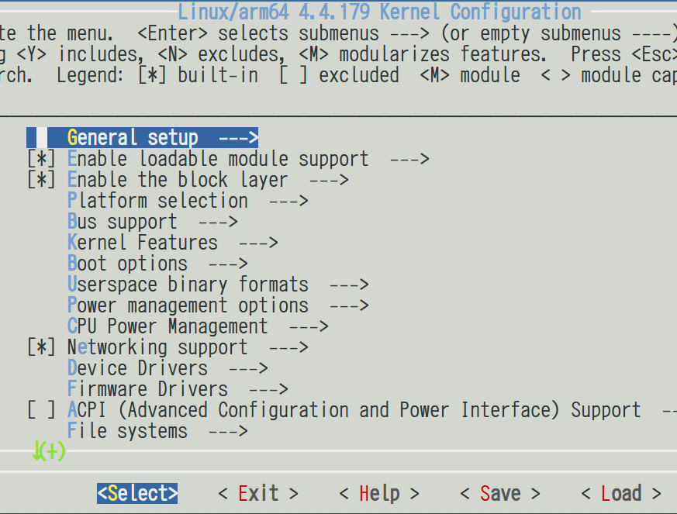

[6] Create a default kernel configure file

Create default kernel configuration file
$ cd ${KERNEL_DIR}

$ make savedefconfig

HOSTCC scripts/kconfig/conf.o
HOSTLD scripts/kconfig/conf
scripts/kconfig/conf --savedefconfig=defconfig Kconfig

$ cp ./defconfig ${KERNEL_DIR}/arch/arm64/configs/cadtc_nanopim4_defconfig

$ make help | grep cadtc

cadtc_defconfig - Build for cadtc

# Use default configure file be created by yourself
$ make cadtc_defconfig

[7] Build Device Tree Only

${SET_TOOLCHAIN} = ~/nanopim4-slash
Build DTB only
$ source ${SET_TOOLCHAIN}

$ cd ${KERNEL_DIR}

$ touch ${KERNEL_DIR}/arch/arm64/boot/dts/rockchip/*.dts*
$ make dtbs

CHK include/generated/timeconst.h
CHK include/generated/asm-offsets.h
CALL scripts/checksyscalls.sh
make[1]: 'include/generated/vdso-offsets.h' is up to date.
CHK scripts/mod/devicetable-offsets.h
DTC arch/arm64/boot/dts/rockchip/rk3399-nanopi4-rev00.dtb
DTC arch/arm64/boot/dts/rockchip/rk3399-nanopi4-rev01.dtb
DTC arch/arm64/boot/dts/rockchip/rk3399-nanopi4-rev04.dtb
DTC arch/arm64/boot/dts/rockchip/rk3399-nanopi4-rev06.dtb
DTC arch/arm64/boot/dts/rockchip/rk3399-nanopi4-rev07.dtb
DTC arch/arm64/boot/dts/rockchip/rk3399-nanopi4-rev21.dtb
DTC arch/arm64/boot/dts/rockchip/rk3399-nanopi4-rev22.dtb

[8] Check .config file

.config file be read by Linux kernel root Makefile
$ cd ${KERNEL_DIR}

$ vim .config

#
# General setup
#
CONFIG_INIT_ENV_ARG_LIMIT=32
CONFIG_CROSS_COMPILE="aarch64-linux-"
# CONFIG_COMPILE_TEST is not set
CONFIG_LOCALVERSION=""
CONFIG_LOCALVERSION_AUTO=y
CONFIG_DEFAULT_HOSTNAME="localhost"
CONFIG_SWAP=y
CONFIG_SYSVIPC=y
CONFIG_SYSVIPC_SYSCTL=y
CONFIG_POSIX_MQUEUE=y
CONFIG_POSIX_MQUEUE_SYSCTL=y

→ This feature is be comment : # CONFIG_COMPILE_TEST is not set

→ This feature is be enabled : CONFIG_POSIX_MQUEUE_SYSCTL=y

→ This is a string : CONFIG_DEFAULT_HOSTNAME="localhost"

→ This is a value : CONFIG_INIT_ENV_ARG_LIMIT=32

