[RockPi4B Overview]

https://wiki.radxa.com/Rockpi4/getting_started

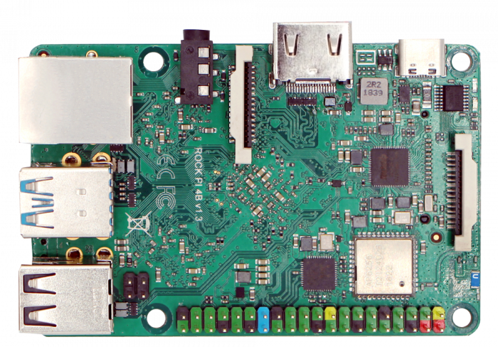

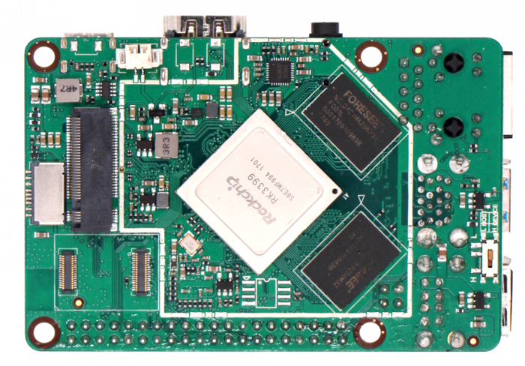

[RockPi4B Pin Head Define]

https://wiki.radxa.com/Rockpi4/hardware/rockpi4

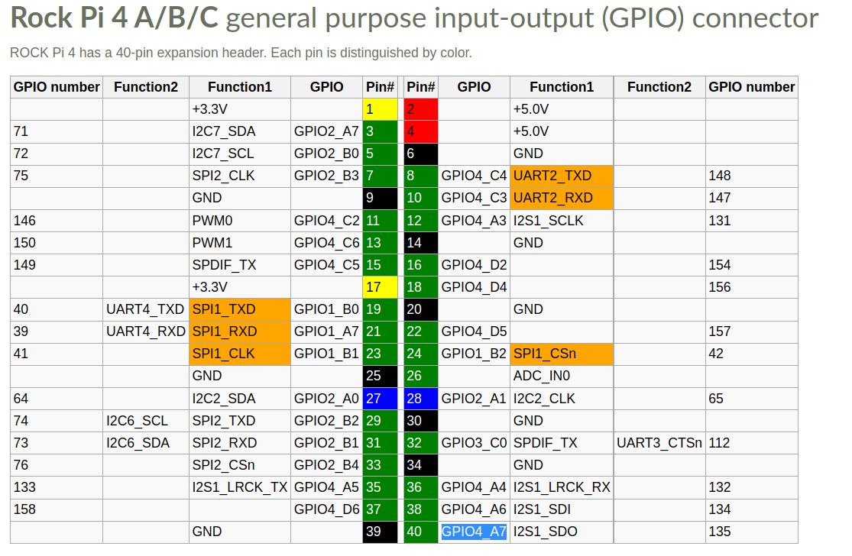

[Debug UART Pin Define]
https://wiki.radxa.com/Rockpi4/dev/serial-console

ROCK Pi 4 | <---> | USB to TTL cable
RX(pin 10) | <---> | Green wire
TX(pin 8) | <---> | White wire
GND(pin 6) | <---> | Black wire

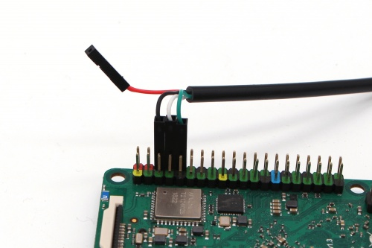

[RockPi4B Debian Image]

https://wiki.radxa.com/Rockpi4/downloads

rockpi4b_debian_buster_x005F_xfce4_arm64

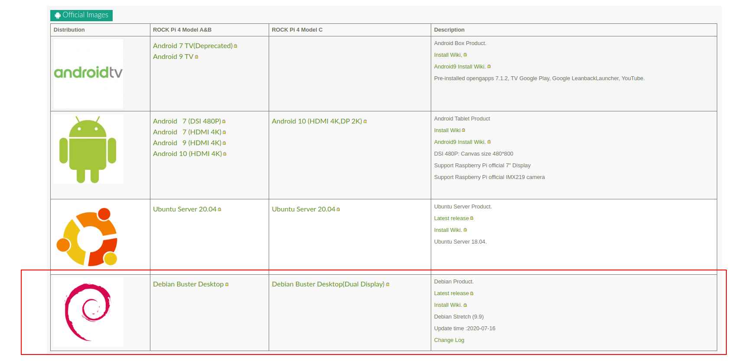

[RockPi4B Image Update Tool]

https://wiki.radxa.com/Rockpi4/install/microSD

https://www.balena.io/etcher/

Flash Tool : Etcher
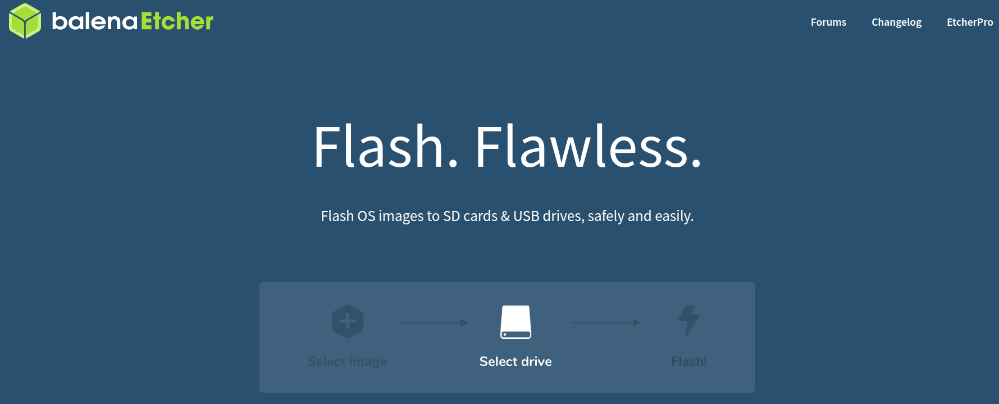

[RockPi4B Image Install]

<Step 1> Download RockPi4B Debian Image
https://github.com/radxa/rock-pi-images-released/releases

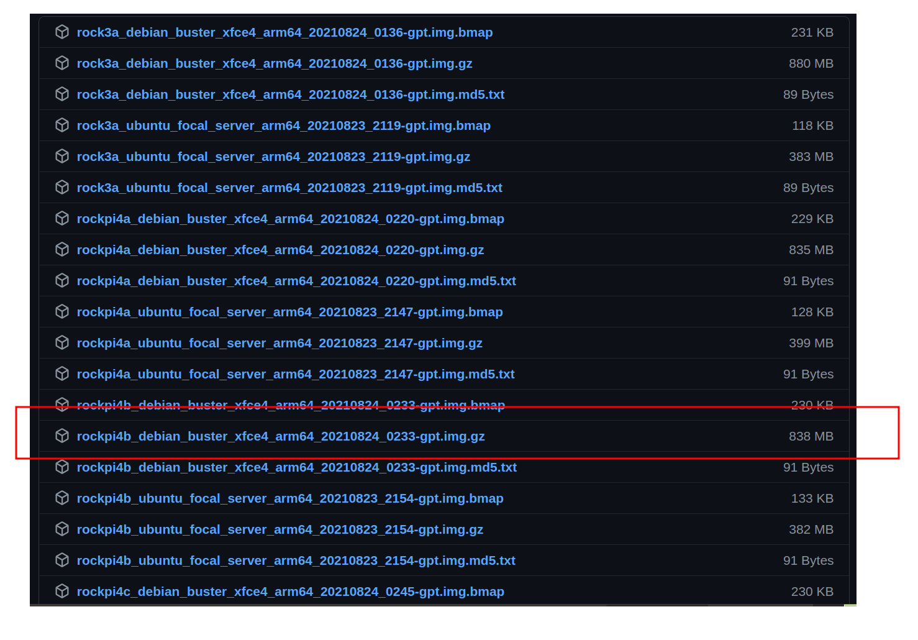

<Step 2> Extract
rockpi4b_debian_buster_x005F_xfce4_arm64_20210824_0233-gpt.img.gz
$ cd ~/$Download_Folder
$ tar -xvf rockpi4b_debian_buster_x005F_xfce4_arm64_20210824_0233-gpt.img.gz

<Step 3> Look for your SD or MMC device in Linux

$ dmesg | tail
$ lsblk

[For MMCX Style]
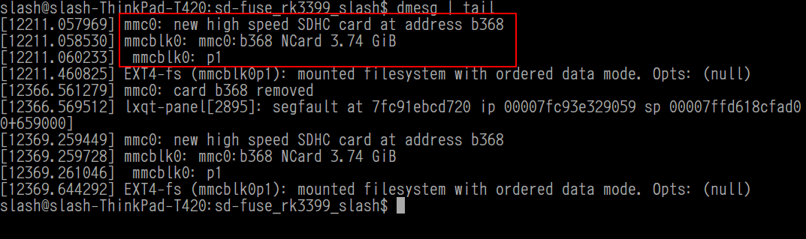
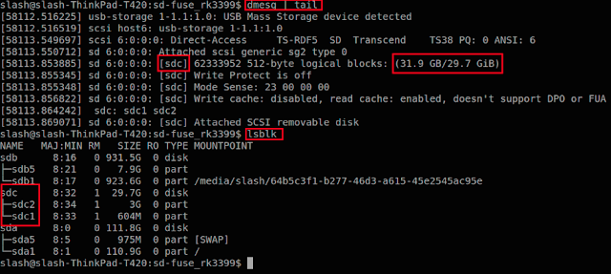
[For SDX Style]

\

<Step 4> Download Flash Tool - Etcher

https://www.balena.io/etcher/

$ cd ~/$Download_Folder
$ unzip ./balena-etcher-electron-1.7.8-linux-x64.zip
$ ./balenaEtcher-1.7.8-x64.AppImage

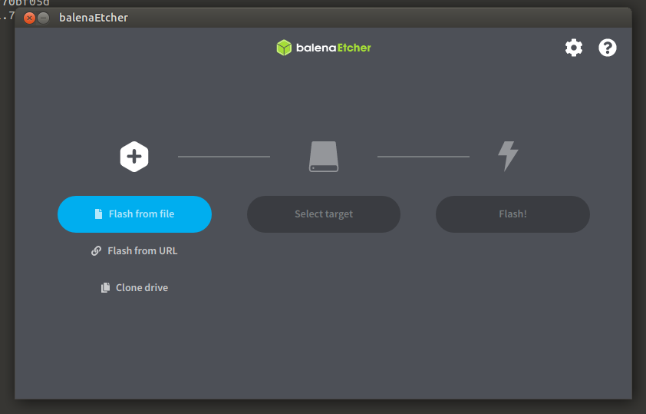

[Write Debian Image To SD Card]

<Step 1> Select RocKPi4B Debian Image

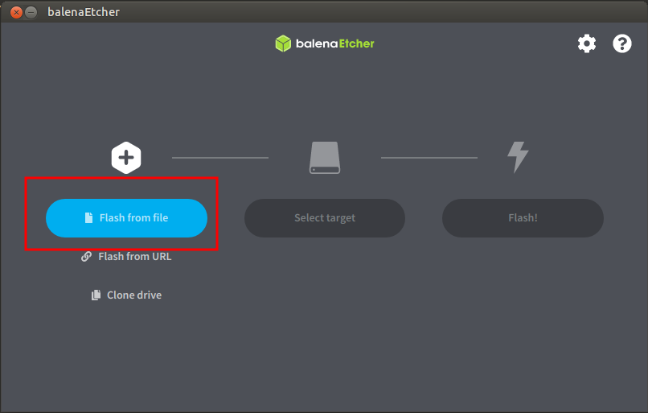
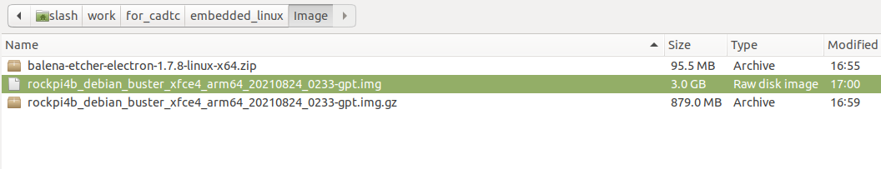

<Step 2> Select SD Card Device

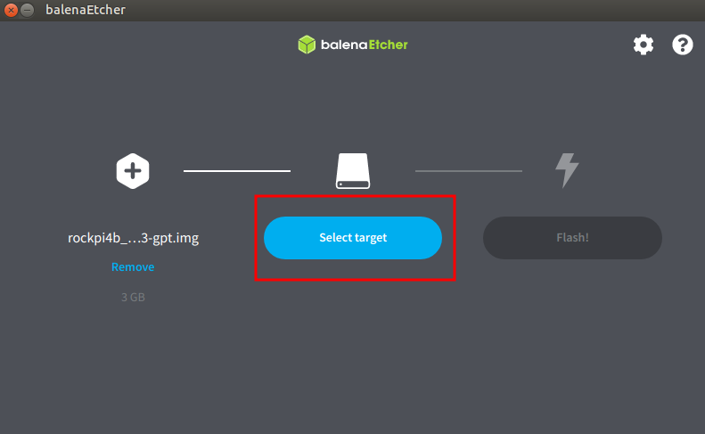
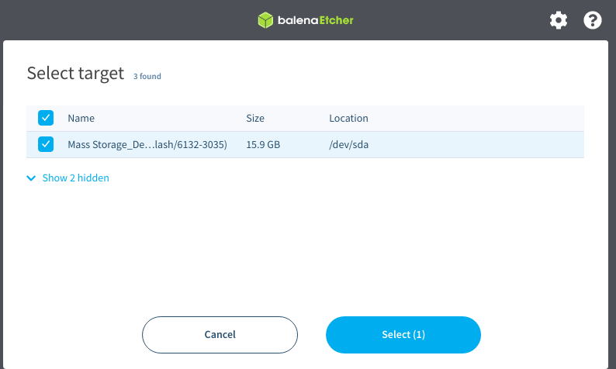

<Step 3> Start Flash

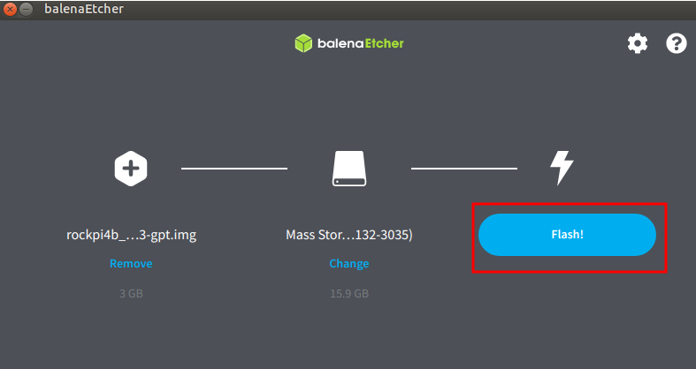

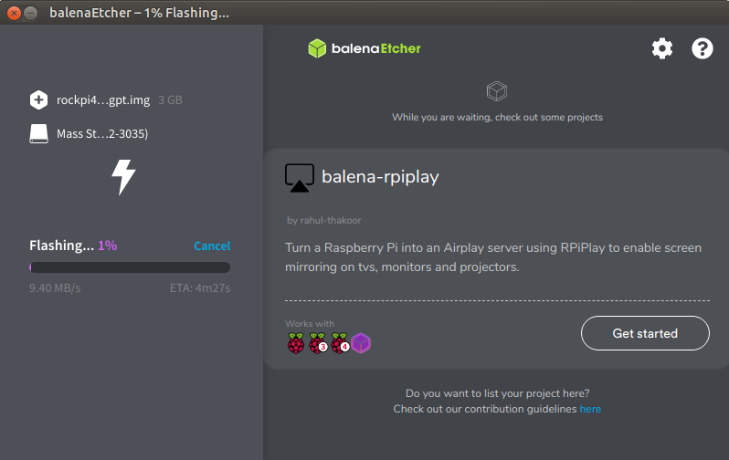

<Step 4> Insert SD/MMC card to Target Slot then Power On

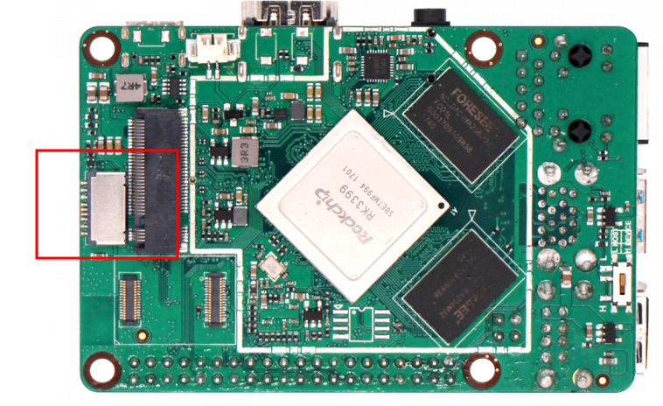

<Step 5> Check LCD Panel

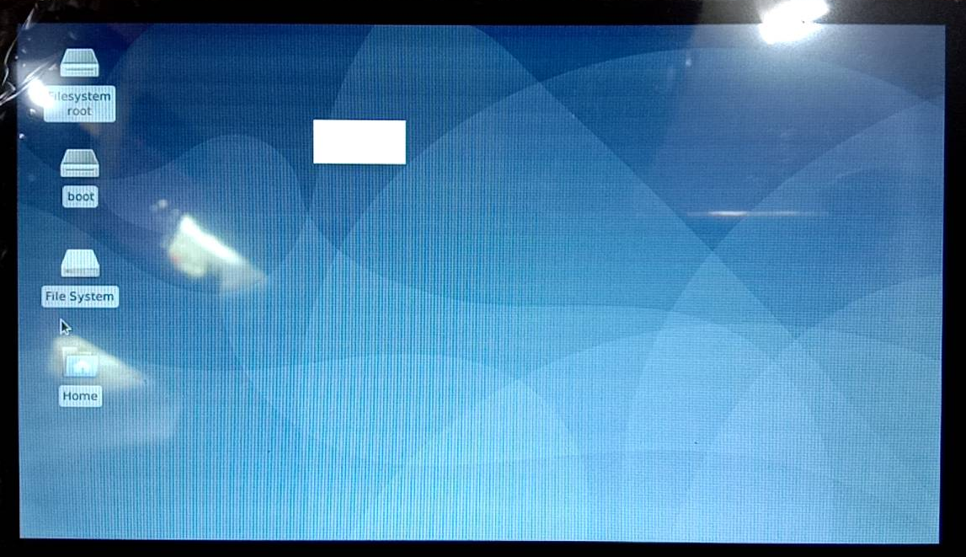

[Install Terminal]

$ apt-get install minicom
# insert Debug Danger to Host PC

# Open minicon then power on targget board
$ sudo minicom -D /dev/ttyUSB0 -b 1500000

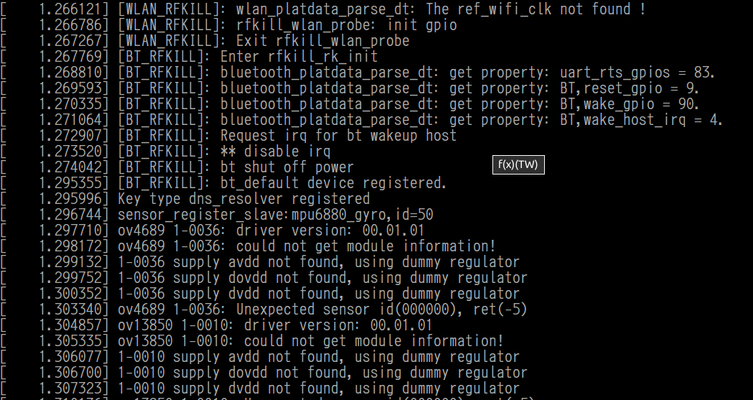

[SSH]
# 透過 SSH 傳送一個檔案 從 Host PC 至 開發板

<Target>
# 先在 EVB 設定密碼
$ password

<Host PC>
# 傳送測試檔案
$ scp [檔案] [EVB 帳號]@[EVB IP]:[EVB PATH]
例如 :
$ scp testme root@192.168.0.100:/tmp

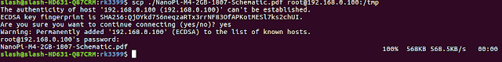

假設遇到如下狀況, 請依紅色框框執行命令
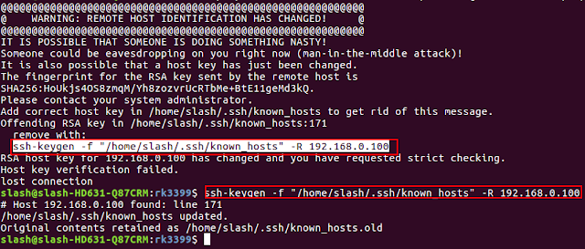

[建立 NFS Server 環境]

[Host]
< Step 1 > install NFS software package
$ sudo apt-get install nfs-kernel-server nfs-common portmap
< Step 2 > comfigure exports
$ sudo geany /etc/exports
$ add your share file folder
example :
/home/cadtc/nfs/ *(rw,sync,no_root_squash)
< Step 3 > Restart Host PC
$ sudo /etc/init.d/nfs-kernel-server restart

< Step 4 > (option) [Host ] :
ifconfig ethx 192.168.0.10

< Step 5>
$ touch /home/cadtc/nfs/

[Target Board]
< Step 6 >
$ sudo mount -t nfs 192.168.0.10:/home/cadtc/nfs/ /mnt/
$ ls -l /mnt
$ sudo umount /mnt

[設定 Tool-Chain]

Enter toolchain directory
$ cd ~/host_share_folder/toolchain/
$ tar -xvf gcc-linaro-7.3.1-2018.05-x86_64_aarch64-linux-gnu.tar.xz

Modify set_toolchain.sh
$ cd ~/host_share_folder/toolchain/

set_toolchain.sh contents

export PATH=$PATH:/home/slash/for_cadtc/toolchain/gcc-linaro-7.3.1-2018.05-x86_64_aarch64-linux-gnu/bin/
export ARCH=arm64
export CROSS_COMPILE=aarch64-linux-gnu-
export KERNELDIR=/home/cadtc/rockchip-bsp/kernel/

Initial compile environment
$ cd ~/
$ source ./set_toolchain.sh

check environment
$ echo $CROSS_COMPILE
$ aarch64-linux-gnu-gcc -v

[1] Kernel Modules Install
1. Modules Install
# Enter Linux kernel source code
[CMD] cd /home/cadtc/rockchip-bsp/kernel

# Use make help to check modules install method
[CMD] make help | grep modules

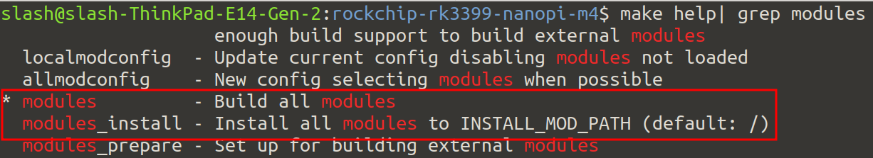

# Build modules all
[CMD] source ~/set_toolchain.sh
[CMD] make modules -j8

# Install kernel modules into INSTALL_MOD_PATH
[CMD] mkdir modules_install_dir
[CMD] export INSTALL_MOD_PATH=`pwd`/modules_install_dir
[CMD] make modules_install -j 8

# Check install folder that be assigned by INSTALL_MOD_PATH

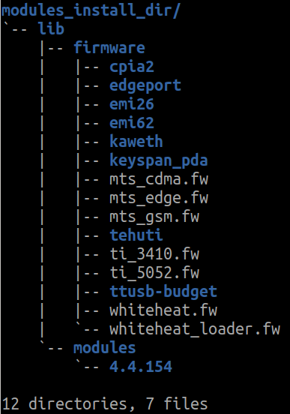
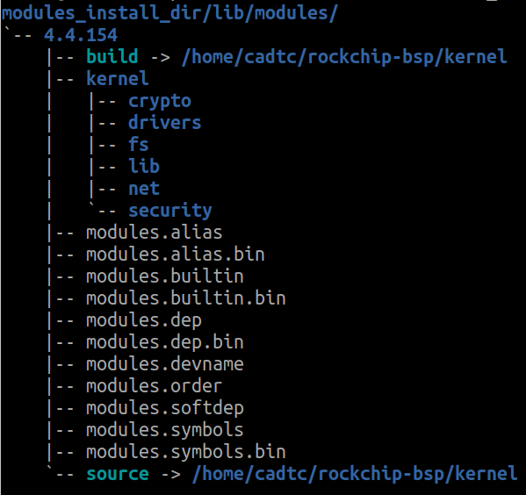

[Host]
# Mount Target Board RootFS to PC folder by sshfs
[CMD] sudo apt-get install rsync
[CMD] rsync -rzav modules_install_dir/lib/modules/ rock@10.0.1.61:/home/rock/

[Target]
# Copy /home/cadtc/4.4.154 to /lib/modules
[CMD] cp -a ~/4.4.154 /lib/modules
[CMD] sync
[CMD] reboot

[2] Install Kernel Modules with Modporbe
1. Use Modprobe
[ Target Board ]

# Install kernel module with modporbe
[CMD] modprobe hello_world
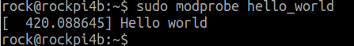

# Remove module with modprobe
[CMD] modprobe -r hello_world
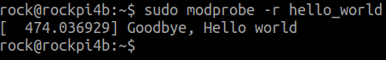

[3] Use Depmod
1. Use Depmod
# Compile Led module
[CMD] source ~/set_toolchain.sh
[CMD] cd /home/cadtc/cadtc-sample/7-linux_driver/led_driver/led
[CMD] make

# Put ioctl_leds.ko to /lib/modules/4.4.179/kernel/drivers/char/ in Target board
[CMD] scp ./ ioctl_leds.ko rock@BOARD_IP:/lib/modules/4.4.179/kernel/drivers/misc/

# Install ioctl_led.ko with modprobe
[CMD] modprobe ioctl_leds

# Use depmod
[CMD] depmod -A

# Install ioctl_led.ko with modprobe again
[CMD] modprobe ioctl_leds

# Check modules.dep in /lib/modules/4.4.179
[CMD] cat modules.dep | grep ioctl_leds
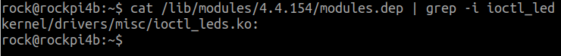

[4] Compile HelloWorld Module – Out of Kernel Tree
1. Compile Hello World Module
# Set you Linux kernel source code path in set_toolchain.sh

# Below is set_toolchain.sh content, please modify KERNELDIR
[CMD] export KERNELDIR=/home/cadtc/rockchip-bsp/kernel
[CMD] source ~/set_toolchain.sh
[CMD] cd /home/cadtc/cadtc-sample/7-linux_driver/hello_world/
[CMD] make

# Put hello_world.ko to target board

[ Target Board ]

[CMD] insmod ./hello_world.ko
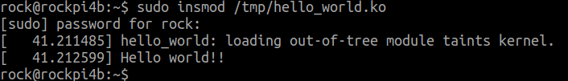

[CMD] lsmod
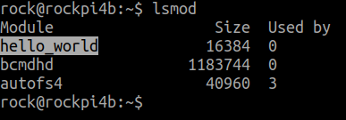

[CMD] rmmod ./hello_world.ko
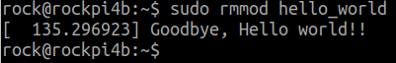

[5] Compile HelloWorld Module – In Kernel Tree
1. Compile Hello World Module for Build-in
# Enter Linux kernel source code
[CMD] cd /home/cadtc/rockchip-bsp/kernel

# Do menuconfig then select Hello World module and let it build-in
[CMD] make menuconfig

→ Device Drivers → Misc devices

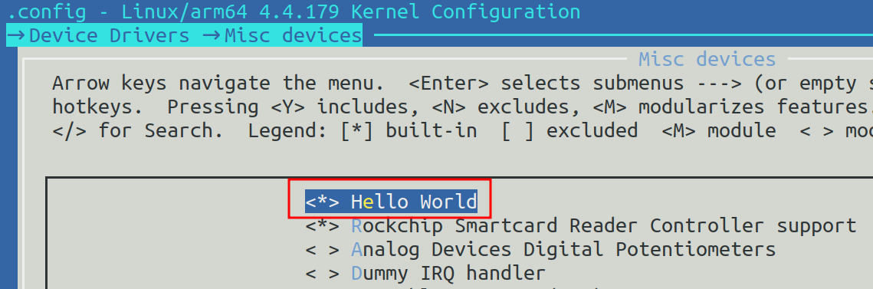

# Re-build Linux kernel then update it to Target board
[CMD] make -j8

# Update Linux kenrel Image for Target board then reboot
[CMD] scp arch/arm64/boot/Image root@Target_Boarad_IP:/boot

[ Target board ]

# Check the Hello World module build-in module message
[CMD] dmesg | grep -i hello
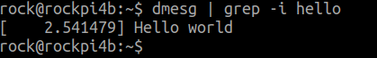

2. Compile Hello World Module for Build Module
# Enter Linux kernel source code
[CMD] cd /home/cadtc/rockchip-bsp/kernel

# Do menuconfig then select Hello World module and let it build-in
[CMD] make menuconfig

→ Device Drivers → Misc devices
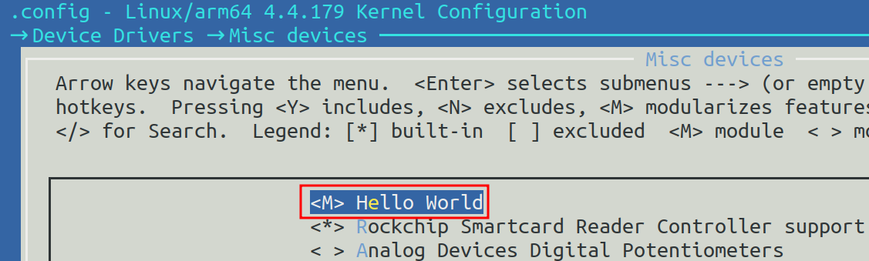

# Re-build Linux kernel then update it to Target board
[CMD] make -j8

# Update Linux kenrel Image for Target board then reboot
[CMD] scp arch/arm64/boot/Image rock@Target_Boarad_IP:/boot

# Put hello_workd.ko to Target Board
[CMD] scp drivers/misc/hello_world.ko rock@Target_Boarad_IP:/tmp

[ Target board ]

# Install kernel module
[CMD] insmod hello_world.ko
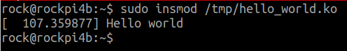

# List the kernel module that be installed
[CMD] lsmod

# Remove kernel module
[CMD] rmmod hello_world.ko
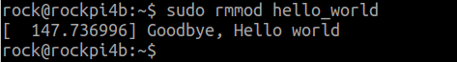

[6] Study ioctl_leds Module
1. Compile ioctl_leds modules
[ Host]

# Compile ioctl_leds modules
[CMD] source ~/set_toolchain.sh
[CMD] cd /home/cadtc/cadtc-sample/7-linux_driver/led_driver/led/
[CMD] make

# Put ioctl_leds modules to Target Board
[CMD] scp ioctl_leds rock@BOARD_IP:${DIR}

# Compile LED test program
[CMD] cd /home/cadtc/cadtc-sample/7-linux_driver/led_driver/led/test_ap
[CMD] make

# Put Test modules application to Target Board
[CMD] scp test_led_char_driver rock@BOARD_IP:${DIR}

[ Target Board ]

# Install ioctl_leds modulels
[CMD] insmod ioctl_leds.ko OR
[CMD] modprobe ioctl_leds

# Check Test modules application help information
[CMD] test_led_char_driver --help

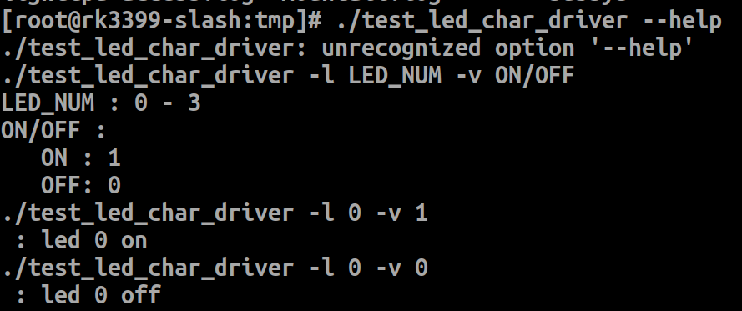

# Execute Test modules application
[CMD] ./test_led_char_driver -l 0 -v 1



