[1] Linux Kernel Message
[CMD] dmesg
1. [CMD] dmesg
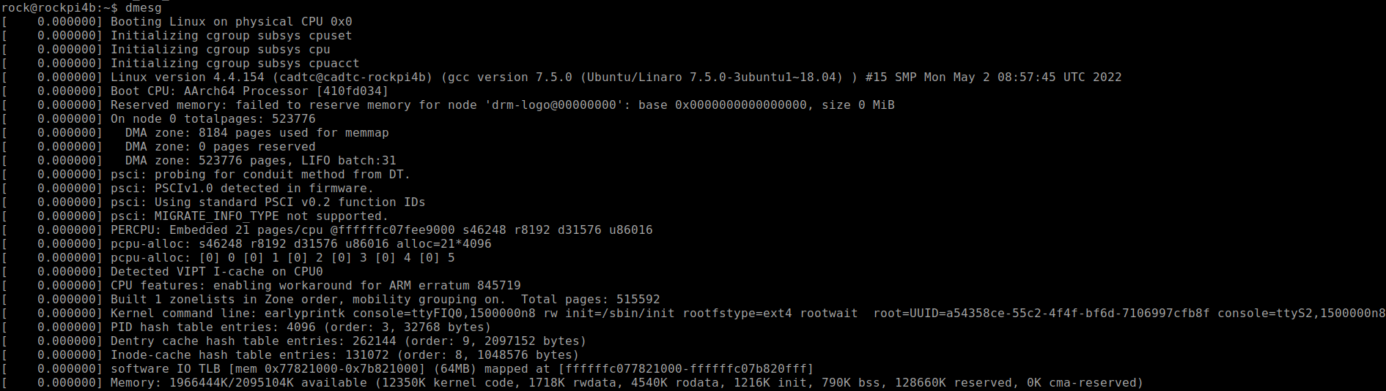
2. [CMD] dmesg | head -n 30
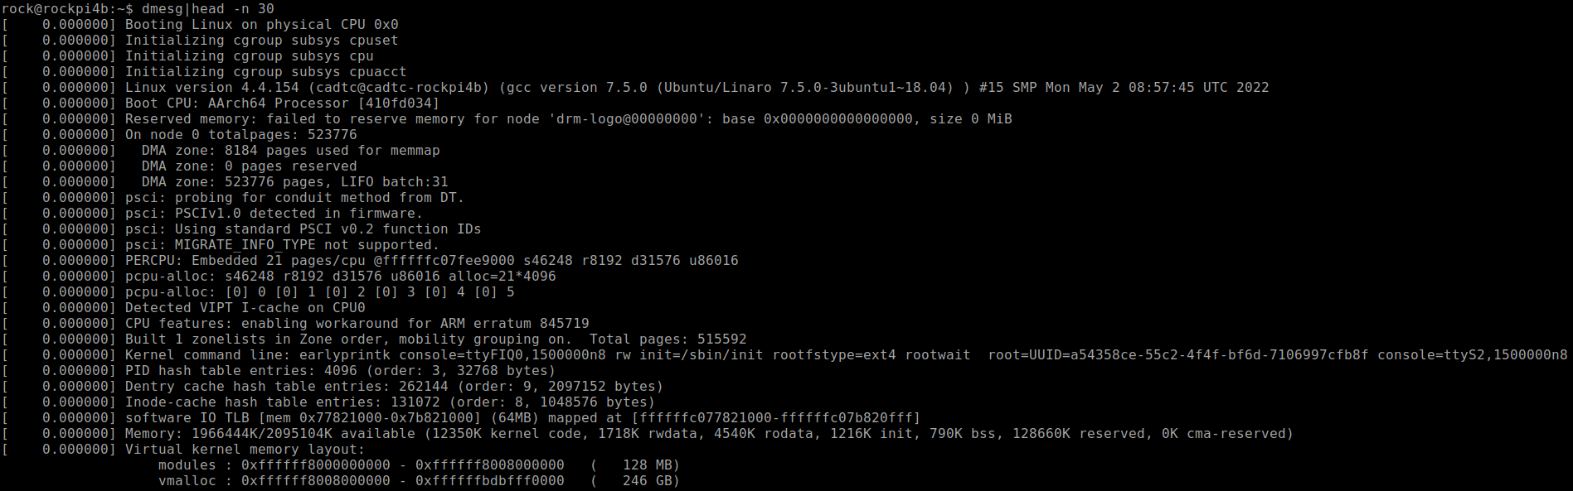
3. [CDM] dmesg | grep -n 30
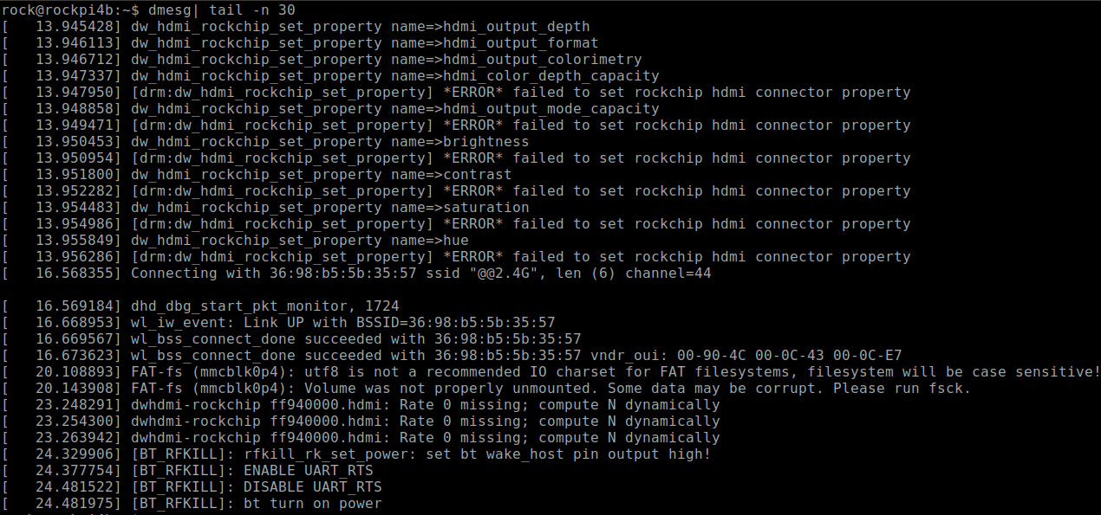

[2] Printk in ProcFS
[CMD] cat /proc/sys/kernel/printk
[CMD] echo Message_Priority > /proc/sys/kernel/printk
1. [ CMD ] cat /proc/sys/kernel/printk

2. [ CMD ] echo 8 > /proc/sys/kernel/printk
[ CMD ] cat /proc/sys/kernel/printk
[ CMD ] dmesg

[3] Exercise
Exercise
1. sample_code/CH2/CH2-1-Linux_Driver_Debugg/2-2-1-hello_debug

2. sample_code/CH2/CH2-1-Linux_Driver_Debugg/2-2-3-led

[4] Information in SysFS
1. /sys/
[ Info ] Please check the information /sys/

[For Example]

[CMD] ls bus/platform/drivers

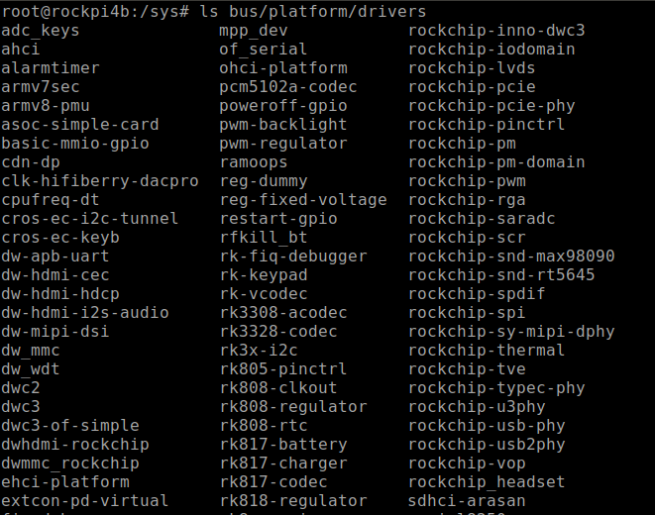

[CMD] ls bus/platform/drivers/leds-gpio/gpio-leds/leds/

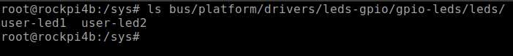

[5] DebugFS in SysFS
1. /sys/kernel/debug
[ Info ] Please check the information /sys/kernel/debug/

[For Example]

[CDM] cat pinctrl/pinctrl-maps
