Setup EVB Environment

$ dmesg | tail

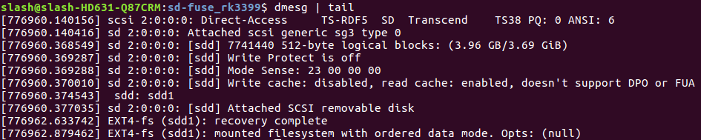

$ sudo umount /dev/sdd1

$ lsblk

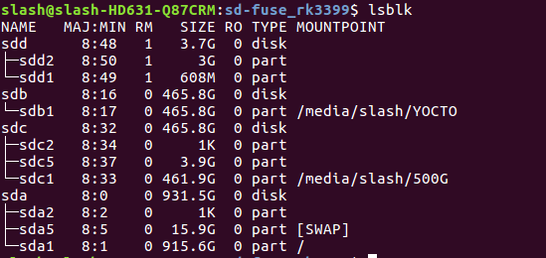

$ cd sd-fuse_rk3399
$ sudo ./fusing.sh /dev/sdd buildroot

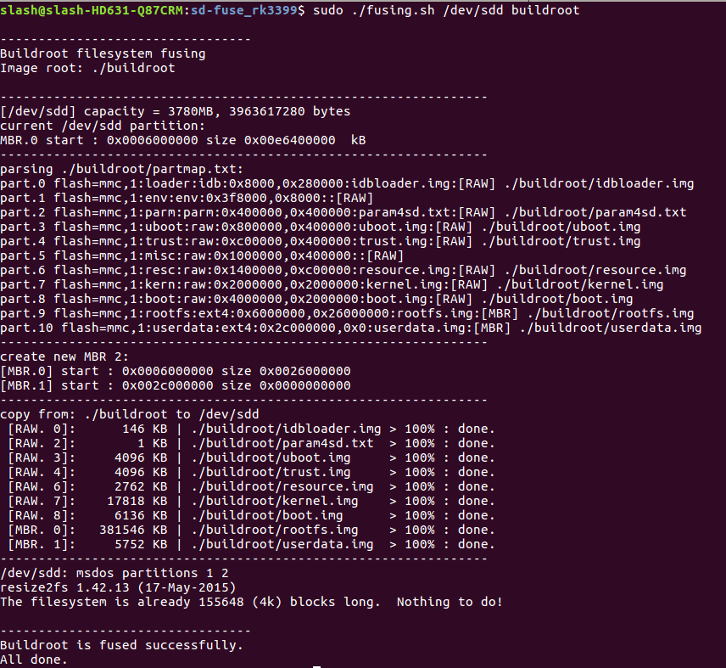

$ ls /dev/tty*

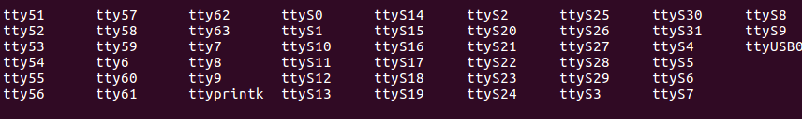
$ sudo minicom -D /dev/ttyUSB0 -b 1500000

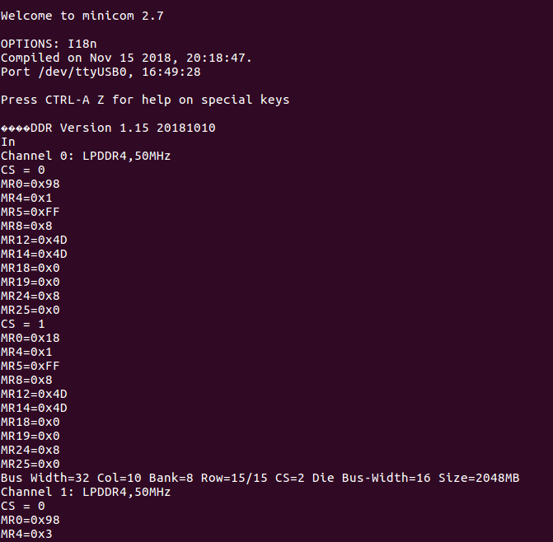

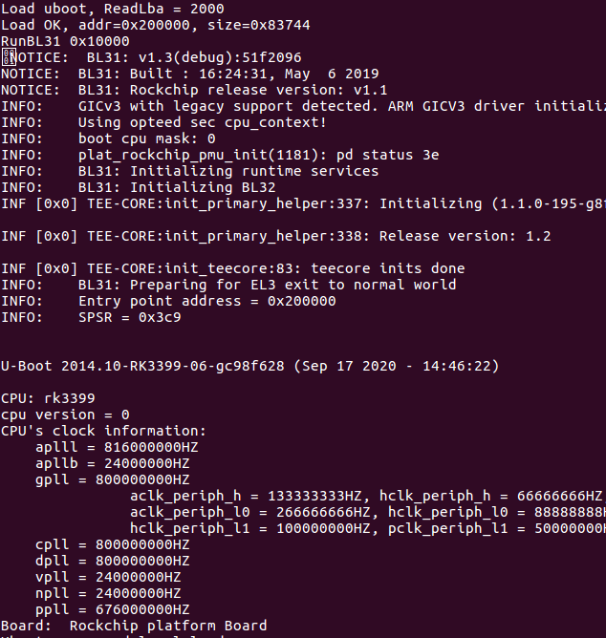

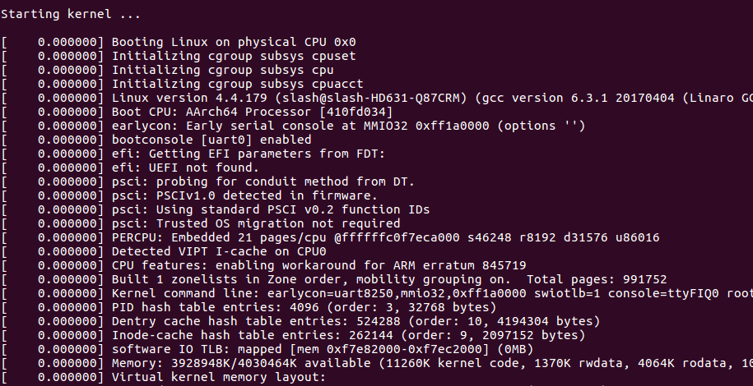

Update Kernel

