Linux Device Driver - Develop Environment Setting
=======================================================================

安裝開發相關軟體
1. install gtkterm
#sudo apt-get install gtkterm
2. install geany
#sudo apt-get install geany vim
3. install toolchan
# cd ~/tiny4412/toolchain/
# tar -xvf ./gcc-linaro-4.9.4-2017.01-x86_64_arm-linux-gnueabi.tar.xz
4. setting toolchain
#cd ~/tiny4412/
#source ./set_toolchain.sh
5. install library
# sudo apt-get install autoconf automake libtool libexpat1-dev \
libncurses5-dev bison flex patch curl cvs texinfo git bc \
build-essential git gawk python-dev gperf unzip \
pkg-config wget libusb-dev fastboot
=======================================================================

製作開機 SD CARD
A. Check pre-build binary file
1. # ls ttiny4412/image_file/tiny4412_booloader/E4412_N.bl1.bin
2. # ls tiny4412/image_file/tiny4412_booloader/mkbl2.bin
3. # ls tiny4412/image_file/tiny4412_booloader/E4412_tzsw.bin
4. # ls tiny4412/image_file/tiny4412_booloader/u-boot.bin
B. Format SD card. Please check your SD card device note number first
1. # df -h
2. # ~/tiny4412/image_file/tiny4412_booloader/sd_fdisk /dev/???
(??? is sdb or sdbc or sdd .....)
for example : # sd_fdisk /dev/sdc
C. Run image install script
1. # ~/tiny4412/image_file/tiny4412_booloader/sd_fusing.sh /dev/sd?
for example : # sd_fusing.sh /dev/sdc
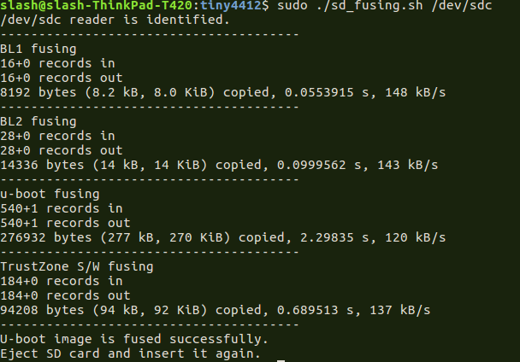

How do know which sd card device node in my computer ?
1. Use df -h command : /dev/sdc1 is my SD card
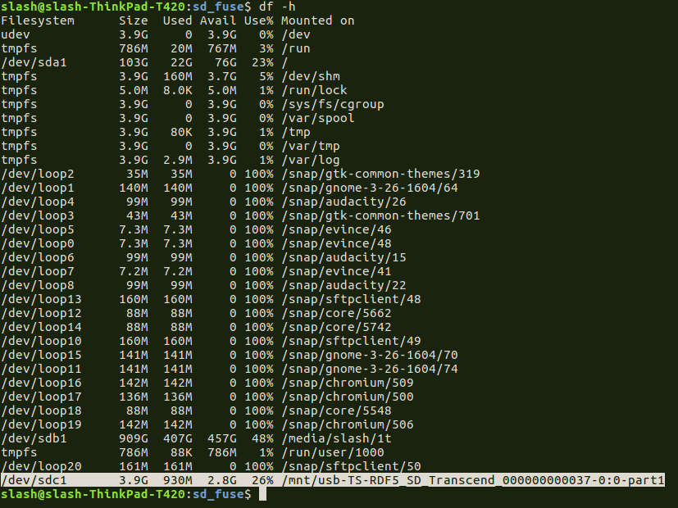
2. Use sudo fdisk -l command : /dev/sdc1 is my SD card
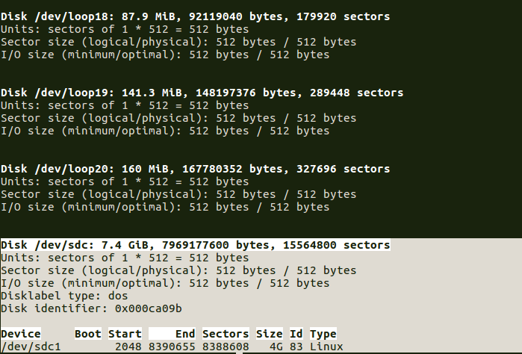
=======================================================================

燒寫 Bootloader 至 eMMC
方法 1.
[ Target ] u-boot environment
0.
Current, use sd boot (SD 卡 開機) # setenv mmc_device 1
Current, use emmc boot (eMMC 開機) # setenv mmc_device 0
Format eMMC
(if you had done below command process before, you can bypass below)
[Target]
1. fdisk -c $mmc_device 600 2048 220
2. fatformat mmc $mmc_device:1
3. ext3format mmc $mmc_device:2
4. ext3format mmc $mmc_device:3
5. ext3format mmc $mmc_device:4
[Host]
8. sudo dnw init_boot_v2/E4412_N.bl1.bin
11. sudo dnw init_boot_v2/bl2.bin
14. sudo dnw init_boot_v2/u-boot.bin
17. sudo dnw init_boot_v2/E4412_tzsw.bin
[ Target ]
6. emmc open $mmc_device
(download and write E4412_N.bl1.bin)
7. dnw
9. mmc write $mmc_device 0xc0000000 0 0x10
(0x10 = 十進位16, 16個block, 一個block是512B, 16*512=8*1024=8KB)
(download and write bl2.bin)
10. dnw
12. mmc write $mmc_device 0xc0000000 0x10 0x1C
(download and write u-boot.bin)
13. dnw
15. mmc write $mmc_device 0xc0000000 0x30 0x21D
(u-boot.bin size 270K，space is 328K. So 48th block start，write 541 blocks,
541*512B=270.5*1024 :=270K)
(download and write E4412_tzsw.bin)
16. dnw
18. mmc write $mmc_device 0xc0000000 0x2c0 0xB8
(tzsw.bin size about 92K，space is 160K. So, 704 block start，write 184 blocks,
184*512=92*1024=92K)
19. emmc close $mmc_device
[ 用 eMMC 開機 ]
20. setenv bootargs 'noinitrd init=/linuxrc root=/dev/mmcblk0p2 rw noinitrd rootfstype=ext4 console=ttySAC0 video=card0-VGA-1:e'

[ 用 NFS 開機 ]
20. cd ~/tiny4412/image_file/rootFS
21. tar -xvf ./rootfs.tar -C nfs_rootfs
22. set bootargs "noinitrd init=/linuxrc root=/dev/nfs ip=192.168.0.20:192.168.0.10:192.168.0.1:255.255.255.0::eth0:on nfsroot=192.168.0.10:/home/cadtc/tiny4412/image_file/rootFS/nfs_rootfs, console=ttySAC0 video=card0-VGA-1:e"
21. saveenv
=======================================================================
方法 2.
[Host]
2. sudo ~/tiny4412/tool/dnw ~/tiny4412/image_file/tiny4412_booloader/auto_update_bootloader/bootloader_combin.bin
[目前用 emmc 開機]
4. sudo ~/tiny4412/tool/dnw ~/tiny4412/image_file/tiny4412_booloader/auto_update_bootloader/update_uboot_auto_from_emmc.script
[目前用 SDCARD 開機 ]
4. sudo ~/tiny4412/tool/dnw ~/tiny4412/image_file/tiny4412_booloader/auto_update_bootloader/update_bootloader_from_sdcard.script
[Target]
1. dnw 0xc0000000
3. dnw 0xd0000000
5. source 0xd0000000
=======================================================================

燒寫 Linux kernel and rootFS 至 eMMC
A. Linux kernel
[Target_board Side]
1. fastboot
[Host Side]
1. cd ~/tiny4412/image_file
2. sudo fastboot flash kernel ./zImage_dtb
B. rootFS
[Target_board Side]
1. fastboot
[Host Side]
2. sudo fastboot flash system rootfs.ext2
C. Create user account in Targetboard
1. adduser test
2. mkdir -p /home/test
D. Boot into Linux kernel
3. do scp command test
[Target]
1. # ifconfig eth0 192.168.0.20
4. # cat /tmp/testme
[Host]
2. touch ./test_me && echo "test hello" > ./test_me
3. # scp ./test_me test@192.168.0.18:/tmp
======================================================================

PC Hosts 端 網路設定

1. Ubuntu 桌面右上右角網路設定管理員
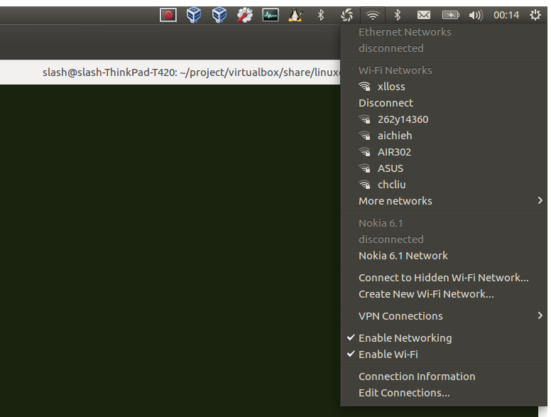
2. 新增一組給開發板的網路卡設定
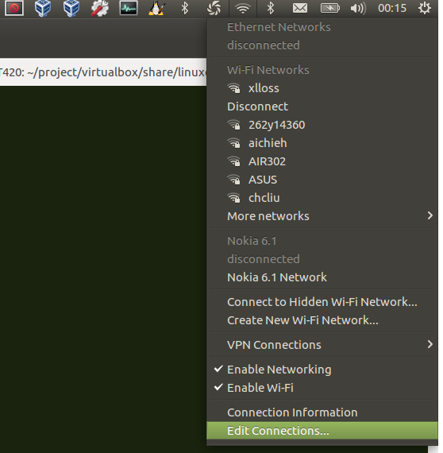
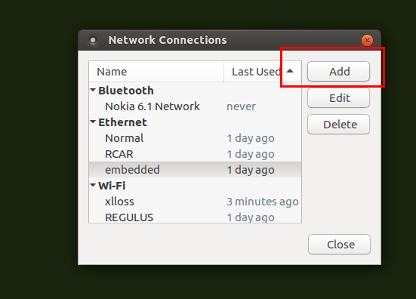
3. 設定 IP Address
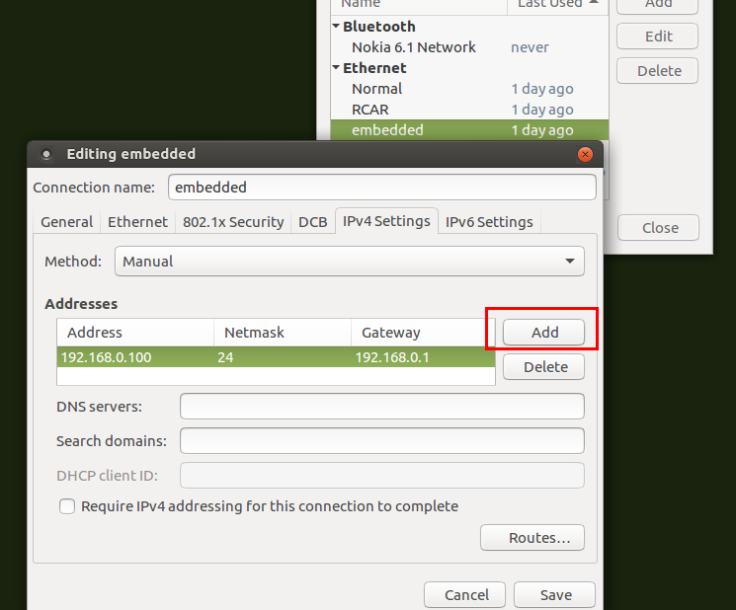
4. 確認 IP Address
#ifconfig
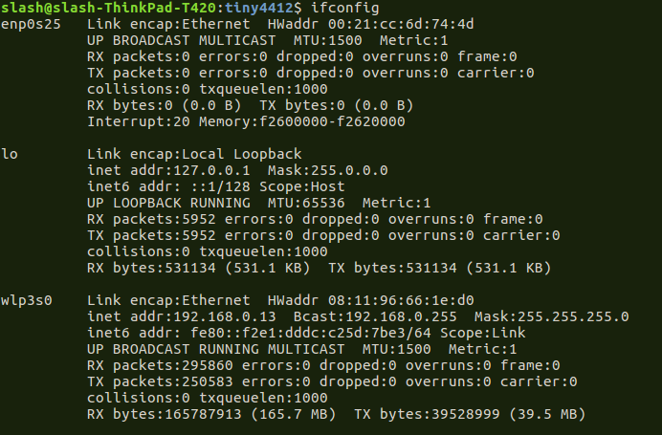
5. 用網路線連接開發板與 PC, 並確認網路線是否接穩

=========================================================================

建立 NFS Server 環境

1. sudo apt-get install nfs-kernel-server nfs-common portmap
2. comfigure exports
a. sudo geany /etc/exports
b. add your share file folder
example :
/home/cadtc/tiny4412/nfs/ *(rw,sync,no_root_squash)
3. restart
sudo /etc/init.d/nfs-kernel-server restart
4. (option) [Host ] :
ifconfig ethx 192.168.0.10
5. sudo tar -xvf rootfs.tar -C /home/cadtc/tiny4412/nfs/
6. Local or TargetBoard Test
a. # sudo mount -t nfs 192.168.0.10:/home/cadtc/tiny4412/nfs/ /mnt/
b. # ls -l /mnt
c. # sudo umount /mnt
=======================================================================

開發板端透過 NFS 協定掛載遠端的服務資料夾
[ Host ]
1. 確認遠端資料夾為 NFS Server 的服務設定中
cat /etc/export

[Target]
2. mount -o nolock -t nfs 192.168.1.189:/home/cadtc/tiny4412/nfs /mnt/
*請修改為自己的 IP 和 遠端資料夾名稱
======================================================================

進入系統
A.
開發板進入系統後會看見提示命令. 請輸入帳號與密碼
帳號 : root
密碼 :
B.
如果覺得每次進入帳號輸入密碼不方便, 請依照下面步驟修改
[ Target board]
1. # vi /etc/inittab
2.
# Put a getty on the serial port
-- console::respawn:/sbin/getty -L console 115200 vt100 # GENERIC_SERIAL
++ ::respawn:/sbin/getty -n -L console 115200 vt100 -n -l /bin/sh # GENERIC_SERIAL
=======================================================================

SSH 登入 與 SCP 不用密碼
每次做實驗 傳送檔案至開發板上都要打密碼, 如果覺得不方便的話請按下面步驟.
[ Target Side ]
1.
# adduser cadtc
# ls -l
確認 cadtc 確認 cadtc 帳號的 home 目錄 : cadtc 是否被建立在 /home/ 底下.
正常應該要看到 /home/cadtc
[ Host Side ]
2.
# ssh-keygen -t rsa
Generating public/private rsa key pair.
Enter file in which to save the key (/home/slash/.ssh/id_rsa):
/home/slash/.ssh/id_rsa already exists.
Overwrite (y/n)? Y
Enter passphrase (empty for no passphrase):
Enter same passphrase again:
Your identification has been saved in /home/slash/.ssh/id_rsa.
Your public key has been saved in /home/slash/.ssh/id_rsa.pub.
The key fingerprint is:
SHA256:jqaEKtcyIKTvpQdjvhcKJ0rdmrxcwOxXKXgZvTGooIw cadtc@slash-ThinkPad-T420
The key's randomart image is:
+---[RSA 2048]----+
| |
| o |
| . o + |
|+.+ o o = |
|E..*.+ +S |
|*.*o+.oo |
|+Oo*=+o . |
|o.OB*o |
|oo+Oo |
+----[SHA256]-----+
3. # ssh cadtc@192.168.0.20 mkdir -p .ssh
4. cat ~/.ssh/id_rsa.pub | ssh cadtc@192.168.0.20 'cat >> .ssh/authorized_keys'
5.test
# ssh cadtc@192.168.0.20 or
# scp FILE cadtc@192.168.0.20:/tmp
[ 問題 ]
如果在 TEST 階段遇到 sign_and_send_pubkey: signing failed: agent refused operation
請在 [ Host Side ] 執行 # ssh-add

