CI 103 - Team Charter

Complete the information below for your project. This will inform the instructor about how teams are organized and/or changed. Note that team membership changes are subject to final approval by the instructor.

Team

Lab section: 63

Team Number: #38 (Use the same team number from CI102)

Team Members and Roles

List the full name and user ID of every member of your team. Assign initial roles that team members will play. Team members without specific roles should be assigned as “Developer”.
Name | User ID | Role
Jacky Chen | Jc4283 | Developer/Scrum Master/UI and Sound Designer
Lester Chacon-Posada | Ljc83 | Developer/Technical Assistant/ Databases
Michael Wu | Mw3269 | Developer/Technical Manager
Peter Chong | Pc662 | Developer/Art
Kaifeng Zhou | Kz359 | Developer/Art/ Project Owner

Project mission or Anchor statement: A Dungeon themed RPG Game with rouge like elements, including enemies, events and static NPCs. Within it, we will also have dialogues, cut-scenes, weapons, and simple battle mechanics.

Success is … Having Act 1 (beta version) finished with a solid storyline and simple battle mechanics. Main menu, battle system and inventory UI finished and having at least 3 floors and a boss on each floor.

Done is … when a specific task is made, implemented, and tested. Testing the task will be assigned to a non-coder team member and will only be verified by the non-coders. Done is when the component testing is completed and is able to move onto the acceptance testing phase.

We work best together when … we are physically together to talk to one another and help each other out when needed. We dedicated to have 4 hours minimum outside of class for our project. For communication purposes we will be using discord to contact each other. We decided to meet after certain times (ex: Tuesdays at 12pm) for group members to meet.

Testing Section:
Unit Testing | Once per Week
Component Testing | Once per Week
Acceptance Testing | Week 8

Team Calendar:
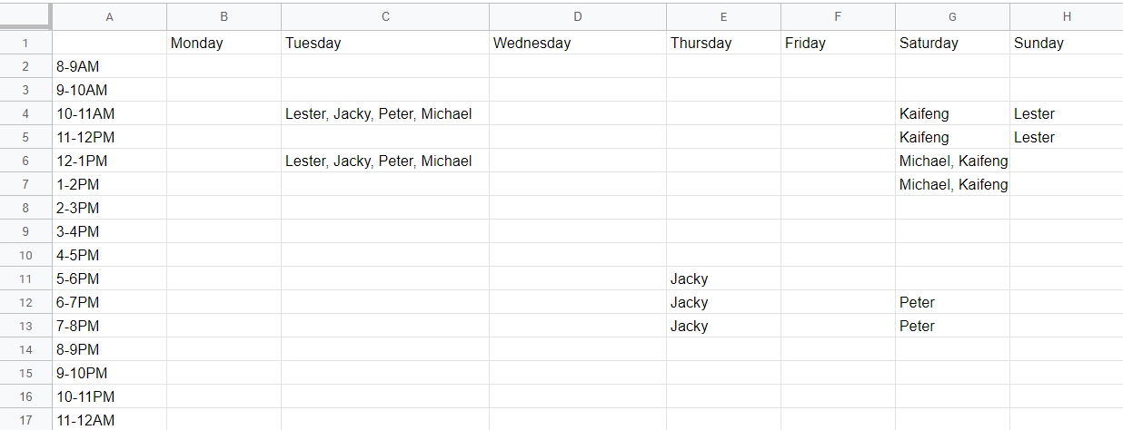

Identify the open issues and/or technology gaps related to your project: (100-300 words)

One of the main issues we have is our inexperience with coding games and that we’re still just basically beginners when it comes to coding. We recently got a new member who’s fluent in C# so that will help lessen the burden by a lot. We wanted photoshop in order to make the artwork, but we’ve settled with Krita as a nice alternative. Looking at the time availability of each member, it seems a bit hard always find times to work together physically so most of the work must be done solo, whether we like it or not. But one of the biggest issues would be our procrastination. Setting time intervals of when we can meet and work independently may help resolve this issue well.

Test test test

