GML_03_01-latent.R
frank
2024-03-29
# feb 2023
# r script for simulation of BINARY RESPONSE MODELS
# written by Frank Lehrbass (->lehrbass.de) for teaching purposes only
# students are solely responsible for whatever they do with this coding
# this R coding is WITHOUT ANY WARRANTY
rm(list=ls(all=TRUE))
# Load packages
library(logistf)
library(pscl)
## Classes and Methods for R developed in the
## Political Science Computational Laboratory
## Department of Political Science
## Stanford University
## Simon Jackman
## hurdle and zeroinfl functions by Achim Zeileis
#sample size
n=1000
set.seed(2023)
#NOTE: R assumes that Y=1 if latent variable is above zero
e=rlogis(n, location = 0, scale = 1) #pi/sqrt(3))is another scale setting usual in logit models
#wir sparen uns e=-e wg Symmetrie der Dichte
x=round(runif(n,min = 20, max = 70),0)#mit 18 Fuehrerschein, mit 70+ besser nicht
x11()
hist(x, main = "Alter Autointeressenten")
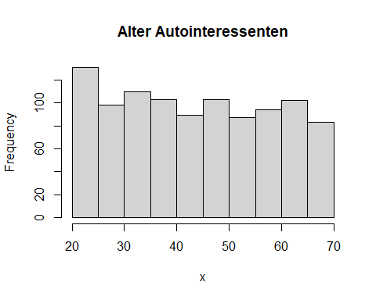
c=-45
b=0.9
#latent variable
a =c+b*x+e
#binary outcome, buys car if unknown income or whatever is >0
y=(a>0)
for (i in 1:length(y)){
if(y[i]) y[i]=1 else y[i]=0
}
mean(y)#percentage responders
## [1] 0.375
x11()
hist(y, main = "Response Histogram")
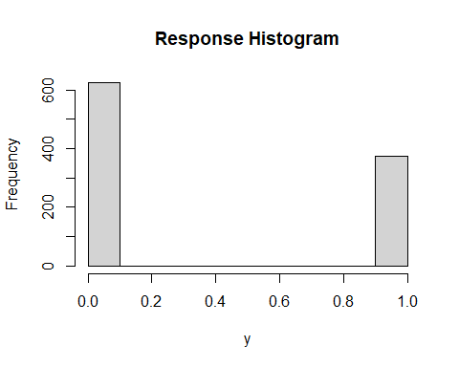
x11()
hist(a, main = "Agitation Histogram")
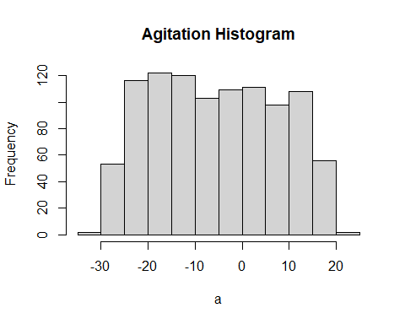
#logit estimation way 1
fit1 <- logistf(y~x,pl=FALSE, method = "Standard ML",firth = F)
#if firth is true u get a penalty deducted from likelihood
#pl=FALSE makes it use the Wald method
fit1
## logistf(formula = y ~ x, pl = FALSE, firth = F, method = "Standard ML")
## Model fitted by Standard ML
## Confidence intervals and p-values by Wald
##
## Coefficients:
## (Intercept) x
## -44.2140136 0.8837828
##
## Likelihood ratio test=1184.934 on 1 df, p=0, n=1000
#logit estimation way 2
fit2 = glm(y~x, family = "binomial")
summary(fit2)
##
## Call:
## glm(formula = y ~ x, family = "binomial")
##
## Coefficients:
## Estimate Std. Error z value Pr(>|z|)
## (Intercept) -44.2140 5.2059 -8.493 <2e-16 ***
## x 0.8838 0.1041 8.488 <2e-16 ***
## ---
## Signif. codes: 0 '***' 0.001 '**' 0.01 '*' 0.05 '.' 0.1 ' ' 1
##
## (Dispersion parameter for binomial family taken to be 1)
##
## Null deviance: 1323.13 on 999 degrees of freedom
## Residual deviance: 138.19 on 998 degrees of freedom
## AIC: 142.19
##
## Number of Fisher Scoring iterations: 10
#COMPARE
c(c, b)
## [1] -45.0 0.9
coef(fit1)
## (Intercept) x
## -44.2140136 0.8837828
coef(fit2)
## (Intercept) x
## -44.2140136 0.8837828
#end

