GML_04_01-buns.R
frank
2024-05-06
# Variablen l?schen und Pakete laden------
rm(list=ls(all=TRUE))
library(corrplot)
## Warning: Paket 'corrplot' wurde unter R Version 4.3.3 erstellt
## corrplot 0.92 loaded
library(lmtest)
## Warning: Paket 'lmtest' wurde unter R Version 4.3.3 erstellt
## Lade nötiges Paket: zoo
##
## Attache Paket: 'zoo'
## Die folgenden Objekte sind maskiert von 'package:base':
##
## as.Date, as.Date.numeric
library(sandwich)
## Warning: Paket 'sandwich' wurde unter R Version 4.3.3 erstellt
library(car)
## Warning: Paket 'car' wurde unter R Version 4.3.3 erstellt
## Lade nötiges Paket: carData
library(tseries)
## Registered S3 method overwritten by 'quantmod':
## method from
## as.zoo.data.frame zoo
library(forecast)
library(stats)
library(fGarch)
## NOTE: Packages 'fBasics', 'timeDate', and 'timeSeries' are no longer
## attached to the search() path when 'fGarch' is attached.
##
## If needed attach them yourself in your R script by e.g.,
## require("timeSeries")
#library(rugarch)
#Daten laden--------------
daten = read.csv("GML_04_01 buns.csv")
weekday = daten[,5]
#Wochentage hinzuf?gen
mon = daten$mon <- ifelse(weekday == 0, 1, 0)
tue = daten$tue <- ifelse(weekday == 1, 1, 0)
wed = daten$wed <- ifelse(weekday == 2, 1, 0)
thu = daten$thu <- ifelse(weekday == 3, 1, 0)
fri = daten$fri <- ifelse(weekday == 4, 1, 0)
sat = daten$sat <- ifelse(weekday == 5, 1, 0)
sun = daten$sun <- ifelse(weekday == 6, 1, 0)
x11()
plot(daten$AMOUNT, type = "l", lty = 1, ylab = "Absatz", xlab = "Tageszaehler", main = "Original-Zeitreihe")
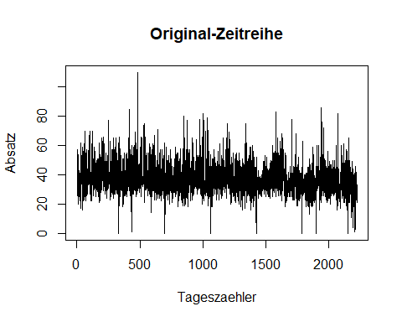
#check pot time trend and corona impact, first lockdown 22 Macrh 2020
daten$date[1879]
## [1] "3/22/2020"
tail(daten$date) #data ends in corona time
## [1] "2/27/2021" "2/28/2021" "3/1/2021" "3/2/2021" "3/3/2021" "3/4/2021"
daycounter = c(1:length(daten$AMOUNT))
covid = rep(0,length(daten$AMOUNT))
covid[1879:length(daten$AMOUNT)] = rep(1, (length(daten$AMOUNT)-1878))
mean(covid)#percentage of covid days
## [1] 0.1563342
summary(lm(daten$AMOUNT~daycounter+covid))
##
## Call:
## lm(formula = daten$AMOUNT ~ daycounter + covid)
##
## Residuals:
## Min 1Q Median 3Q Max
## -37.492 -6.486 -2.282 3.982 72.804
##
## Coefficients:
## Estimate Std. Error t value Pr(>|t|)
## (Intercept) 38.1298196 0.4931076 77.326 < 2e-16 ***
## daycounter -0.0019329 0.0004542 -4.255 2.18e-05 ***
## covid -1.6309690 0.8037310 -2.029 0.0426 *
## ---
## Signif. codes: 0 '***' 0.001 '**' 0.01 '*' 0.05 '.' 0.1 ' ' 1
##
## Residual standard error: 10.71 on 2223 degrees of freedom
## Multiple R-squared: 0.02404, Adjusted R-squared: 0.02316
## F-statistic: 27.38 on 2 and 2223 DF, p-value: 1.798e-12
#Mulitple Lineare Regression-------------
#Lin Reg. final
reg_final = lm(AMOUNT~ daycounter + mon + tue + wed + thu + fri + sat + sun +
BOCHUM_TOTAL + KEMNADE_IN_FLAMMER + holiday + covid + -1 , data = daten)
summary(reg_final, digits = 4)
##
## Call:
## lm(formula = AMOUNT ~ daycounter + mon + tue + wed + thu + fri +
## sat + sun + BOCHUM_TOTAL + KEMNADE_IN_FLAMMER + holiday +
## covid + -1, data = daten)
##
## Residuals:
## Min 1Q Median 3Q Max
## -71.320 -4.318 -0.254 4.067 55.569
##
## Coefficients:
## Estimate Std. Error t value Pr(>|t|)
## daycounter -0.0018968 0.0003447 -5.503 4.17e-08 ***
## mon 35.3335914 0.5657842 62.451 < 2e-16 ***
## tue 33.5728103 0.5642086 59.504 < 2e-16 ***
## wed 34.3420027 0.5644066 60.846 < 2e-16 ***
## thu 35.1827653 0.5675384 61.992 < 2e-16 ***
## fri 34.1390956 0.5669721 60.213 < 2e-16 ***
## sat 37.4061440 0.5660995 66.077 < 2e-16 ***
## sun 52.4756284 0.5658694 92.735 < 2e-16 ***
## BOCHUM_TOTAL 3.4435418 1.8326925 1.879 0.06038 .
## KEMNADE_IN_FLAMMER 3.9289039 1.8494494 2.124 0.03375 *
## holiday 20.1647763 1.0848763 18.587 < 2e-16 ***
## covid -1.6576039 0.6101629 -2.717 0.00665 **
## ---
## Signif. codes: 0 '***' 0.001 '**' 0.01 '*' 0.05 '.' 0.1 ' ' 1
##
## Residual standard error: 8.123 on 2214 degrees of freedom
## Multiple R-squared: 0.9529, Adjusted R-squared: 0.9527
## F-statistic: 3733 on 12 and 2214 DF, p-value: < 2.2e-16
#Diagnostik zum Modell------------------
#[A0]: Der Zusammenhang zwischen der abh?ngigen und den unabh?ngigen Variablen muss linear sein.
#RESET-Test
resettest(reg_final) #H0: Kein Spezifikationserror.
##
## RESET test
##
## data: reg_final
## RESET = 41.415, df1 = 2, df2 = 2212, p-value < 2.2e-16
#[A3]: Die Varianz der Residuen ist konstant und endlich (Homoskedastizit?t bzw.keine Heteroskedastizit?t)
plot(residuals(reg_final), type='l')
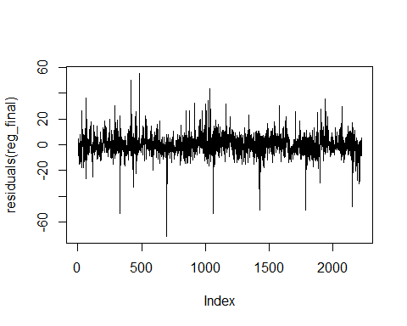
#Breusch-Pagan-Test
bptest(reg_final) #H0: Homoskedastizit?t.
##
## studentized Breusch-Pagan test
##
## data: reg_final
## BP = 381.75, df = 11, p-value < 2.2e-16
#Ergebnis: Heterosekdastizit?t liegt vor.
#[A4]: Die Residuen d?rfen nicht untereinander korrelieren (keine Autokorrelation).
#Korrelogramm
acf(coredata(residuals(reg_final)), ci = 0.95, lag.max = 20)
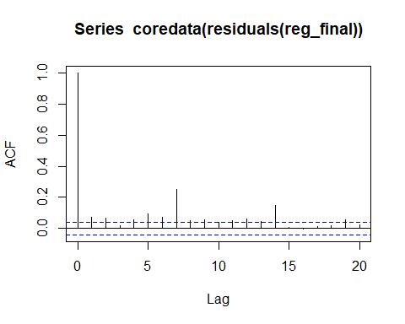
#Durbin-Watson-Test
dwtest(reg_final) #HO: Keine Autokorrelation.
##
## Durbin-Watson test
##
## data: reg_final
## DW = 1.8607, p-value = 0.0004232
## alternative hypothesis: true autocorrelation is greater than 0
#Ergebnis: Autokorrelation liegt vor.
#Da Heteroskedastizitaet und Autokorrelation vorliegen, muss mit HAC SE gearbeitet werden:
coeftest(reg_final)#compare
##
## t test of coefficients:
##
## Estimate Std. Error t value Pr(>|t|)
## daycounter -0.00189684 0.00034471 -5.5028 4.17e-08 ***
## mon 35.33359141 0.56578417 62.4507 < 2.2e-16 ***
## tue 33.57281027 0.56420862 59.5042 < 2.2e-16 ***
## wed 34.34200271 0.56440657 60.8462 < 2.2e-16 ***
## thu 35.18276529 0.56753844 61.9919 < 2.2e-16 ***
## fri 34.13909557 0.56697212 60.2130 < 2.2e-16 ***
## sat 37.40614402 0.56609955 66.0770 < 2.2e-16 ***
## sun 52.47562837 0.56586943 92.7345 < 2.2e-16 ***
## BOCHUM_TOTAL 3.44354181 1.83269248 1.8790 0.060382 .
## KEMNADE_IN_FLAMMER 3.92890389 1.84944940 2.1244 0.033750 *
## holiday 20.16477630 1.08487625 18.5872 < 2.2e-16 ***
## covid -1.65760385 0.61016294 -2.7167 0.006646 **
## ---
## Signif. codes: 0 '***' 0.001 '**' 0.01 '*' 0.05 '.' 0.1 ' ' 1
coeftest(reg_final,vcov=NeweyWest(reg_final))
##
## t test of coefficients:
##
## Estimate Std. Error t value Pr(>|t|)
## daycounter -0.00189684 0.00049729 -3.8143 0.0001403 ***
## mon 35.33359141 0.73765012 47.9002 < 2.2e-16 ***
## tue 33.57281027 0.68648967 48.9050 < 2.2e-16 ***
## wed 34.34200271 0.64063042 53.6066 < 2.2e-16 ***
## thu 35.18276529 0.68619331 51.2724 < 2.2e-16 ***
## fri 34.13909557 0.69168672 49.3563 < 2.2e-16 ***
## sat 37.40614402 0.68797429 54.3714 < 2.2e-16 ***
## sun 52.47562837 0.78063815 67.2215 < 2.2e-16 ***
## BOCHUM_TOTAL 3.44354181 2.05394542 1.6765 0.0937717 .
## KEMNADE_IN_FLAMMER 3.92890389 2.36746915 1.6595 0.0971492 .
## holiday 20.16477630 3.44124370 5.8597 5.329e-09 ***
## covid -1.65760385 0.92666501 -1.7888 0.0737862 .
## ---
## Signif. codes: 0 '***' 0.001 '**' 0.01 '*' 0.05 '.' 0.1 ' ' 1
#[A5]: Es darf kein sehr starker linearer Zusammenhang zwischen den einzelnen erkl?renden Variablen bestehen
#(keine bzw. h?chstens geringe Multikollinearit?t).
#Variance Inflation Factor (VIF)
vif(reg_final)
## Warning in vif.default(reg_final): No intercept: vifs may not be sensible.
## daycounter mon tue wed
## 6.626112 1.542926 1.534345 1.535422
## thu fri sat sun
## 1.552509 1.549412 1.544647 1.543391
## BOCHUM_TOTAL KEMNADE_IN_FLAMMER holiday covid
## 1.018182 1.036887 1.052516 1.963755
#Korrelationsmatrix
df <- data.frame(as.matrix(daycounter), daten$mon, daten$tue, daten$wed, daten$thu, daten$fri, daten$sat, daten$sun,
daten$BOCHUM_TOTAL, daten$KEMNADE_IN_FLAMMER, daten$holiday, as.matrix(covid))
corrplot(cor(df))#does not help
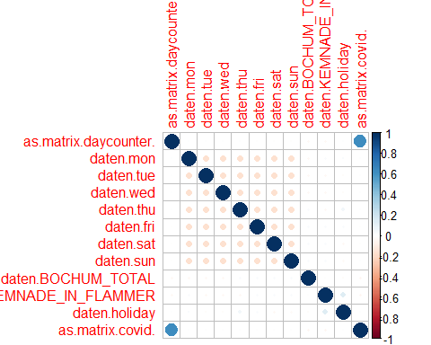
#Zeitreihenanaylse Residuen------------------
#acf shows structure
resis = residuals(reg_final)
x11()
plot(resis, type='l')
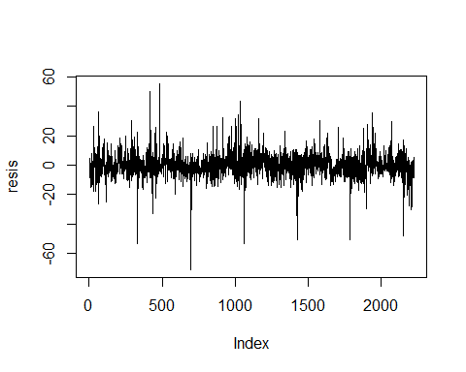
x11()
#Korrelogramm, für alpha = 1% diesmal weil viele Daten
acf(resis, ci = 0.99, lag.max = 20)
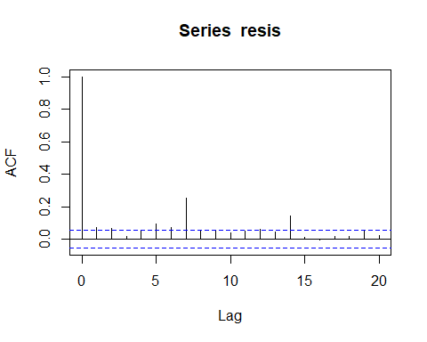
#this will get clear ...
adf.test(resis)
## Warning in adf.test(resis): p-value smaller than printed p-value
##
## Augmented Dickey-Fuller Test
##
## data: resis
## Dickey-Fuller = -8.3202, Lag order = 13, p-value = 0.01
## alternative hypothesis: stationary
# Phillips-Perron (PP) Test
pp.test(resis)
## Warning in pp.test(resis): p-value smaller than printed p-value
##
## Phillips-Perron Unit Root Test
##
## data: resis
## Dickey-Fuller Z(alpha) = -2486.4, Truncation lag parameter = 8, p-value
## = 0.01
## alternative hypothesis: stationary
# Kwiatkowski-Phillips-Schmidt-Shin (KPSS) Test
kpss.test(resis)
## Warning in kpss.test(resis): p-value greater than printed p-value
##
## KPSS Test for Level Stationarity
##
## data: resis
## KPSS Level = 0.23956, Truncation lag parameter = 8, p-value = 0.1
#see https://otexts.com/fpp2/arima-r.html
#variation of the Hyndman-Khandakar algorithm
#which combines unit root tests, minimisation of the AICc to obtain an ARIMA model
autofitarima <- auto.arima(resis, max.p = 14, max.q = 14, stationary=TRUE)
autofitarima
## Series: resis
## ARIMA(2,0,1) with zero mean
##
## Coefficients:
## ar1 ar2 ma1
## 0.9540 0.0142 -0.9186
## s.e. 0.0283 0.0227 0.0189
##
## sigma^2 = 63.34: log likelihood = -7774.47
## AIC=15556.94 AICc=15556.95 BIC=15579.77
x11()
checkresiduals(autofitarima)#evident that GARCH needed
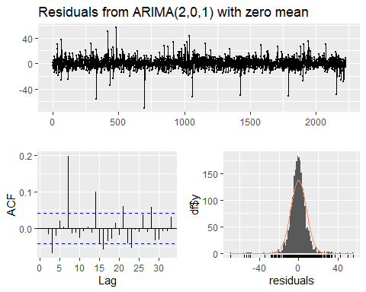
##
## Ljung-Box test
##
## data: Residuals from ARIMA(2,0,1) with zero mean
## Q* = 103.43, df = 7, p-value < 2.2e-16
##
## Model df: 3. Total lags used: 10
x11()
autoplot(forecast(autofitarima))
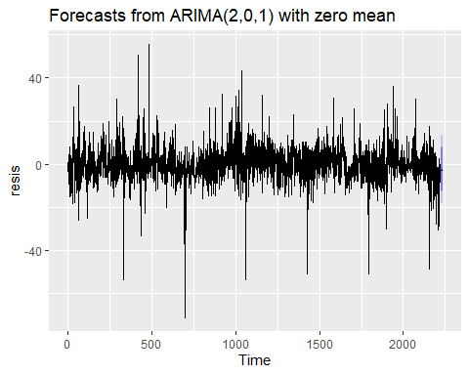
x11()
tsdiag(autofitarima)
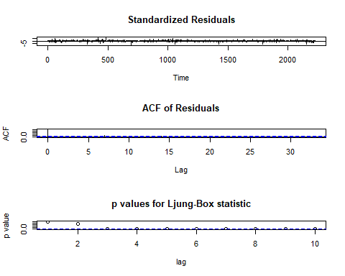
#deep dive
fitarma21 = arma(resis, order = c(2, 1), include.intercept = F)
summary(fitarma21)#note significant paras!
##
## Call:
## arma(x = resis, order = c(2, 1), include.intercept = F)
##
## Model:
## ARMA(2,1)
##
## Residuals:
## Min 1Q Median 3Q Max
## -69.867 -4.110 -0.176 4.020 55.707
##
## Coefficient(s):
## Estimate Std. Error t value Pr(>|t|)
## ar1 0.95435 0.02793 34.17 <2e-16 ***
## ar2 0.01382 0.02265 0.61 0.542
## ma1 -0.91937 0.01833 -50.15 <2e-16 ***
## ---
## Signif. codes: 0 '***' 0.001 '**' 0.01 '*' 0.05 '.' 0.1 ' ' 1
##
## Fit:
## sigma^2 estimated as 63.28, Conditional Sum-of-Squares = 140682.1, AIC = 15555.77
fitarma11 = arma(resis, order = c(1, 1), include.intercept = F)
summary(fitarma11)#small change in para values, sign same, enjoy inside unit circle
##
## Call:
## arma(x = resis, order = c(1, 1), include.intercept = F)
##
## Model:
## ARMA(1,1)
##
## Residuals:
## Min 1Q Median 3Q Max
## -69.8426 -4.1481 -0.1672 3.9916 55.6820
##
## Coefficient(s):
## Estimate Std. Error t value Pr(>|t|)
## ar1 0.96903 0.01138 85.16 <2e-16 ***
## ma1 -0.92079 0.01742 -52.87 <2e-16 ***
## ---
## Signif. codes: 0 '***' 0.001 '**' 0.01 '*' 0.05 '.' 0.1 ' ' 1
##
## Fit:
## sigma^2 estimated as 63.36, Conditional Sum-of-Squares = 140912.7, AIC = 15556.4
#cross chk forecast. of ARMA11
fitarma11$fitted.values[100]
## 100
## 1.104654
resis[100]
## 100
## 9.78354
#hence error100
error100 = resis[100]-fitarma11$fitted.values[100]
error100
## 100
## 8.678886
forecast101 = 0.96903 * resis[100] -0.92079 * error100
forecast101
## 100
## 1.489112
fitarma11$fitted.values[101]
## 101
## 1.489113
#end of chking, go for garch
# GARCH(1,1) - Normal
# Modell 1 - Normal GARCH
NormalGgf<-garchFit(~garch(1,1),data=resis,include.mean = F, trace=FALSE)
coef(NormalGgf)
## omega alpha1 beta1
## 15.31631609 0.04834394 0.72096099
summary(NormalGgf)
##
## Title:
## GARCH Modelling
##
## Call:
## garchFit(formula = ~garch(1, 1), data = resis, include.mean = F,
## trace = FALSE)
##
## Mean and Variance Equation:
## data ~ garch(1, 1)
## <environment: 0x0000020742274828>
## [data = resis]
##
## Conditional Distribution:
## norm
##
## Coefficient(s):
## omega alpha1 beta1
## 15.316316 0.048344 0.720961
##
## Std. Errors:
## based on Hessian
##
## Error Analysis:
## Estimate Std. Error t value Pr(>|t|)
## omega 15.31632 4.43185 3.456 0.000548 ***
## alpha1 0.04834 0.01721 2.809 0.004974 **
## beta1 0.72096 0.07613 9.471 < 2e-16 ***
## ---
## Signif. codes: 0 '***' 0.001 '**' 0.01 '*' 0.05 '.' 0.1 ' ' 1
##
## Log Likelihood:
## -7805.754 normalized: -3.506628
##
## Description:
## Mon May 6 09:37:10 2024 by user: frank
##
##
## Standardised Residuals Tests:
## Statistic p-Value
## Jarque-Bera Test R Chi^2 8698.199 0
## Shapiro-Wilk Test R W 0.9143244 0
## Ljung-Box Test R Q(10) 213.3141 0
## Ljung-Box Test R Q(15) 281.5604 0
## Ljung-Box Test R Q(20) 291.2525 0
## Ljung-Box Test R^2 Q(10) 15.30894 0.121198
## Ljung-Box Test R^2 Q(15) 18.41426 0.2415134
## Ljung-Box Test R^2 Q(20) 21.57838 0.3638198
## LM Arch Test R TR^2 15.84307 0.19853
##
## Information Criterion Statistics:
## AIC BIC SIC HQIC
## 7.015952 7.023644 7.015948 7.018761
#JB Tests (#H0 normal)of normalized resis point to misspecified distribtuion
#Ljung checks independence of resis and sqrd resis,
#looks good, can keep H0: Indep
# GARCH(1,1) - skew & more fat
# hints at potential developmts
SkewedStdGgf<-garchFit(~garch(1,1),data=resis,include.mean = FALSE,cond.dist="sstd", trace=FALSE)
SkewedStdGgf
##
## Title:
## GARCH Modelling
##
## Call:
## garchFit(formula = ~garch(1, 1), data = resis, cond.dist = "sstd",
## include.mean = FALSE, trace = FALSE)
##
## Mean and Variance Equation:
## data ~ garch(1, 1)
## <environment: 0x000002073ed7b448>
## [data = resis]
##
## Conditional Distribution:
## sstd
##
## Coefficient(s):
## omega alpha1 beta1 skew shape
## 6.50046 0.01897 0.87820 1.08128 3.84740
##
## Std. Errors:
## based on Hessian
##
## Error Analysis:
## Estimate Std. Error t value Pr(>|t|)
## omega 6.50046 5.03151 1.292 0.196
## alpha1 0.01897 0.01265 1.500 0.134
## beta1 0.87820 0.08796 9.984 <2e-16 ***
## skew 1.08128 0.02769 39.056 <2e-16 ***
## shape 3.84740 0.31129 12.360 <2e-16 ***
## ---
## Signif. codes: 0 '***' 0.001 '**' 0.01 '*' 0.05 '.' 0.1 ' ' 1
##
## Log Likelihood:
## -7558.425 normalized: -3.395519
##
## Description:
## Mon May 6 09:37:11 2024 by user: frank
#include lagged Y
head(cbind(daten$AMOUNT[-1],daten$AMOUNT[-length(daten$AMOUNT)]))
## [,1] [,2]
## [1,] 34 35
## [2,] 57 34
## [3,] 32 57
## [4,] 27 32
## [5,] 26 27
## [6,] 30 26
#Lin Reg. w lagged Y
reg_final_extended = lm(AMOUNT[-1] ~ AMOUNT[-length(AMOUNT)] + daycounter[-1] + mon[-1] + tue[-1] + wed[-1] + thu[-1] + fri[-1] + sat[-1]
+ sun[-1] +
BOCHUM_TOTAL[-1] + KEMNADE_IN_FLAMMER[-1] + holiday[-1] + covid[-1] + -1 , data = daten)
summary(reg_final, digits = 4)
##
## Call:
## lm(formula = AMOUNT ~ daycounter + mon + tue + wed + thu + fri +
## sat + sun + BOCHUM_TOTAL + KEMNADE_IN_FLAMMER + holiday +
## covid + -1, data = daten)
##
## Residuals:
## Min 1Q Median 3Q Max
## -71.320 -4.318 -0.254 4.067 55.569
##
## Coefficients:
## Estimate Std. Error t value Pr(>|t|)
## daycounter -0.0018968 0.0003447 -5.503 4.17e-08 ***
## mon 35.3335914 0.5657842 62.451 < 2e-16 ***
## tue 33.5728103 0.5642086 59.504 < 2e-16 ***
## wed 34.3420027 0.5644066 60.846 < 2e-16 ***
## thu 35.1827653 0.5675384 61.992 < 2e-16 ***
## fri 34.1390956 0.5669721 60.213 < 2e-16 ***
## sat 37.4061440 0.5660995 66.077 < 2e-16 ***
## sun 52.4756284 0.5658694 92.735 < 2e-16 ***
## BOCHUM_TOTAL 3.4435418 1.8326925 1.879 0.06038 .
## KEMNADE_IN_FLAMMER 3.9289039 1.8494494 2.124 0.03375 *
## holiday 20.1647763 1.0848763 18.587 < 2e-16 ***
## covid -1.6576039 0.6101629 -2.717 0.00665 **
## ---
## Signif. codes: 0 '***' 0.001 '**' 0.01 '*' 0.05 '.' 0.1 ' ' 1
##
## Residual standard error: 8.123 on 2214 degrees of freedom
## Multiple R-squared: 0.9529, Adjusted R-squared: 0.9527
## F-statistic: 3733 on 12 and 2214 DF, p-value: < 2.2e-16
summary(reg_final_extended, digits = 4)
##
## Call:
## lm(formula = AMOUNT[-1] ~ AMOUNT[-length(AMOUNT)] + daycounter[-1] +
## mon[-1] + tue[-1] + wed[-1] + thu[-1] + fri[-1] + sat[-1] +
## sun[-1] + BOCHUM_TOTAL[-1] + KEMNADE_IN_FLAMMER[-1] + holiday[-1] +
## covid[-1] + -1, data = daten)
##
## Residuals:
## Min 1Q Median 3Q Max
## -71.488 -4.213 -0.316 4.040 55.063
##
## Coefficients:
## Estimate Std. Error t value Pr(>|t|)
## AMOUNT[-length(AMOUNT)] 0.075745 0.019732 3.839 0.000127 ***
## daycounter[-1] -0.001752 0.000346 -5.064 4.44e-07 ***
## mon[-1] 31.310928 1.189897 26.314 < 2e-16 ***
## tue[-1] 30.829721 0.909292 33.905 < 2e-16 ***
## wed[-1] 31.760977 0.876646 36.230 < 2e-16 ***
## thu[-1] 32.531673 0.892690 36.442 < 2e-16 ***
## fri[-1] 31.377099 0.915053 34.290 < 2e-16 ***
## sat[-1] 34.748895 0.893023 38.912 < 2e-16 ***
## sun[-1] 49.607578 0.936075 52.995 < 2e-16 ***
## BOCHUM_TOTAL[-1] 3.409286 1.827480 1.866 0.062234 .
## KEMNADE_IN_FLAMMER[-1] 3.866158 1.844238 2.096 0.036165 *
## holiday[-1] 20.600866 1.087712 18.940 < 2e-16 ***
## covid[-1] -1.532874 0.609395 -2.515 0.011960 *
## ---
## Signif. codes: 0 '***' 0.001 '**' 0.01 '*' 0.05 '.' 0.1 ' ' 1
##
## Residual standard error: 8.099 on 2212 degrees of freedom
## Multiple R-squared: 0.9532, Adjusted R-squared: 0.9529
## F-statistic: 3466 on 13 and 2212 DF, p-value: < 2.2e-16
#[A4]: Die Residuen d?rfen nicht untereinander korrelieren (keine Autokorrelation).
acf(coredata(residuals(reg_final)), ci = 0.99, lag.max = 20)
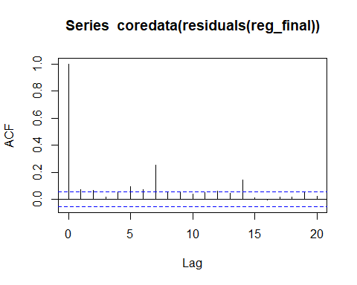
acf(coredata(residuals(reg_final_extended)), ci = 0.99, lag.max = 20)
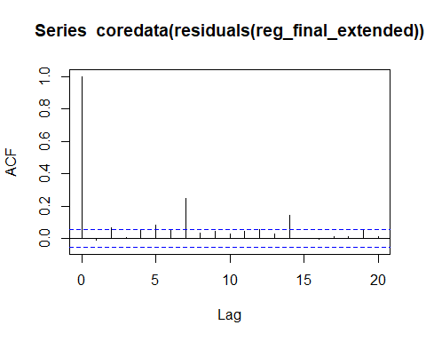
#Durbin-Watson-Test
dwtest(reg_final_extended) #HO: Keine Autokorrelation.
##
## Durbin-Watson test
##
## data: reg_final_extended
## DW = 2.0188, p-value = 0.6505
## alternative hypothesis: true autocorrelation is greater than 0
dwtest(reg_final)
##
## Durbin-Watson test
##
## data: reg_final
## DW = 1.8607, p-value = 0.0004232
## alternative hypothesis: true autocorrelation is greater than 0
#Ergebnis: Autokorrelation ist weg.
#Breusch-Pagan-Test
bptest(reg_final_extended) #H0: Homoskedastizit?t.
##
## studentized Breusch-Pagan test
##
## data: reg_final_extended
## BP = 379.02, df = 12, p-value < 2.2e-16
#Ergebnis: Heterosekdastizitaet liegt vor.
#deshalb:
#manchmal muss man ausprobieren mit den Ans?tzen bis es l?uft numerisch (-> R Hilfe!), oder Wechsel auf
coeftest(reg_final_extended)
##
## t test of coefficients:
##
## Estimate Std. Error t value Pr(>|t|)
## AMOUNT[-length(AMOUNT)] 0.07574490 0.01973236 3.8386 0.0001272 ***
## daycounter[-1] -0.00175227 0.00034601 -5.0643 4.438e-07 ***
## mon[-1] 31.31092828 1.18989743 26.3140 < 2.2e-16 ***
## tue[-1] 30.82972087 0.90929183 33.9052 < 2.2e-16 ***
## wed[-1] 31.76097715 0.87664587 36.2301 < 2.2e-16 ***
## thu[-1] 32.53167289 0.89268998 36.4423 < 2.2e-16 ***
## fri[-1] 31.37709856 0.91505329 34.2899 < 2.2e-16 ***
## sat[-1] 34.74889535 0.89302352 38.9115 < 2.2e-16 ***
## sun[-1] 49.60757761 0.93607478 52.9953 < 2.2e-16 ***
## BOCHUM_TOTAL[-1] 3.40928576 1.82748024 1.8656 0.0622343 .
## KEMNADE_IN_FLAMMER[-1] 3.86615827 1.84423783 2.0963 0.0361650 *
## holiday[-1] 20.60086591 1.08771244 18.9396 < 2.2e-16 ***
## covid[-1] -1.53287446 0.60939466 -2.5154 0.0119599 *
## ---
## Signif. codes: 0 '***' 0.001 '**' 0.01 '*' 0.05 '.' 0.1 ' ' 1
coeftest(reg_final_extended,vcov = vcovHC(reg_final_extended, type = "HC0"))#White estimator
##
## t test of coefficients:
##
## Estimate Std. Error t value Pr(>|t|)
## AMOUNT[-length(AMOUNT)] 0.07574490 0.02027224 3.7364 0.0001914 ***
## daycounter[-1] -0.00175227 0.00034025 -5.1500 2.836e-07 ***
## mon[-1] 31.31092828 1.32663338 23.6018 < 2.2e-16 ***
## tue[-1] 30.82972087 0.96519626 31.9414 < 2.2e-16 ***
## wed[-1] 31.76097715 0.81417643 39.0099 < 2.2e-16 ***
## thu[-1] 32.53167289 0.89661794 36.2826 < 2.2e-16 ***
## fri[-1] 31.37709856 0.89482424 35.0651 < 2.2e-16 ***
## sat[-1] 34.74889535 0.87619083 39.6590 < 2.2e-16 ***
## sun[-1] 49.60757761 1.00588341 49.3174 < 2.2e-16 ***
## BOCHUM_TOTAL[-1] 3.40928576 1.84807900 1.8448 0.0652042 .
## KEMNADE_IN_FLAMMER[-1] 3.86615827 2.14673533 1.8009 0.0718473 .
## holiday[-1] 20.60086591 3.28954279 6.2625 4.537e-10 ***
## covid[-1] -1.53287446 0.59529023 -2.5750 0.0100883 *
## ---
## Signif. codes: 0 '***' 0.001 '**' 0.01 '*' 0.05 '.' 0.1 ' ' 1
#Ende

