GML_04_02-equities.R
frank
2024-05-06
#feb 2023, FL
# STEP 1
# Clean previous variables
rm(list = ls())
library(tseries)
## Registered S3 method overwritten by 'quantmod':
## method from
## as.zoo.data.frame zoo
#library(egcm)
#diese auskommentierte Sektion zeigt, wo die Daten herkommen
#beginDate = as.Date("2010-01-01")
#endDate = as.Date("2016-01-01")
#quote = c("Open", "High", "Low", "Close","Volume")
#compression = "d"
#provider = "yahoo"
#retclass = c("zoo", "its", "ts")
# Daten runterladen
#thyssenkrupp = get.hist.quote(instrument='TKA.DE',start = beginDate, end = endDate,
# quote = quote, provider = provider, method = NULL,
# origin = "1899-12-30", compression = compression,
# retclass = retclass, quiet = TRUE, drop = FALSE)
#thyssenkruppStock = thyssenkrupp
#SalzgitterAG = get.hist.quote(instrument='SZG.DE',start = beginDate, end = endDate,
# quote = quote, provider = provider, method = NULL,
# origin = "1899-12-30", compression = compression,
# retclass = retclass, quiet = TRUE, drop = FALSE)
#SalzgitterStock = SalzgitterAG
#DAX = get.hist.quote(instrument='^GDAXI',start = beginDate, end = endDate,
# quote = quote, provider = provider, method = NULL,
# origin = "1899-12-30", compression = compression,
# retclass = retclass, quiet = TRUE, drop = FALSE)
#DAXIndex = DAX
#Mergen
#zDataPre <- merge(thyssenkruppStock, SalzgitterStock, DAXIndex)
#zDataPrice <- zDataPre[complete.cases(zDataPre)]
#nrow(zDataPrice)
#store equity data for following exercises
#OUTPUT<-zDataPrice
#write.csv2(OUTPUT, file="xxx.csv") #write.csv2 uses a comma for the decimal point
data_table <- read.table("GML_04_02 equities.csv", header=TRUE, sep=";",dec=",")
TK <- data_table[,2][111:211]
SG <- data_table[,7][111:211]
x11()
plot(TK, ylab = "EUR", xlab = "Zeitindex", type='l', main = "Kurse thyssenkrupp")
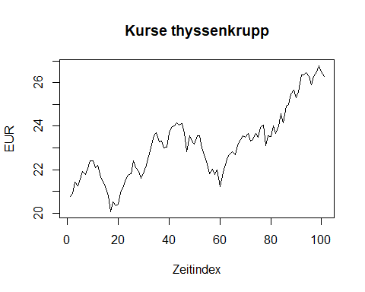
x11()
plot(diff(log(TK)),ylab = "Prozent", xlab = "Zeitindex",type='l', main = "Tagesrenditen thyssenkrupp")
abline(h=0)
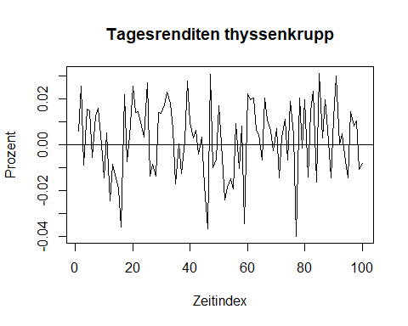
# STEP 2
length(TK)
## [1] 101
TS = TK
# Apply usual tests
adf.test(TS)#H0 Non-stat
##
## Augmented Dickey-Fuller Test
##
## data: TS
## Dickey-Fuller = -2.1513, Lag order = 4, p-value = 0.514
## alternative hypothesis: stationary
pp.test(TS)
##
## Phillips-Perron Unit Root Test
##
## data: TS
## Dickey-Fuller Z(alpha) = -9.3001, Truncation lag parameter = 4, p-value
## = 0.5767
## alternative hypothesis: stationary
kpss.test(TS)#H0 Stat
## Warning in kpss.test(TS): p-value smaller than printed p-value
##
## KPSS Test for Level Stationarity
##
## data: TS
## KPSS Level = 1.475, Truncation lag parameter = 4, p-value = 0.01
# STEP 3
#make sure same degree of integration = I(1)
# Apply usual tests TK:
TS = diff(TK)
adf.test(TS)#H0 Non-stat
## Warning in adf.test(TS): p-value smaller than printed p-value
##
## Augmented Dickey-Fuller Test
##
## data: TS
## Dickey-Fuller = -4.4152, Lag order = 4, p-value = 0.01
## alternative hypothesis: stationary
pp.test(TS)
## Warning in pp.test(TS): p-value smaller than printed p-value
##
## Phillips-Perron Unit Root Test
##
## data: TS
## Dickey-Fuller Z(alpha) = -106.84, Truncation lag parameter = 3, p-value
## = 0.01
## alternative hypothesis: stationary
kpss.test(TS)#H0 Stat
## Warning in kpss.test(TS): p-value greater than printed p-value
##
## KPSS Test for Level Stationarity
##
## data: TS
## KPSS Level = 0.074314, Truncation lag parameter = 4, p-value = 0.1
# Apply usual tests SG:
TS = diff(SG)
adf.test(TS)#H0 Non-stat
## Warning in adf.test(TS): p-value smaller than printed p-value
##
## Augmented Dickey-Fuller Test
##
## data: TS
## Dickey-Fuller = -4.4483, Lag order = 4, p-value = 0.01
## alternative hypothesis: stationary
pp.test(TS)
## Warning in pp.test(TS): p-value smaller than printed p-value
##
## Phillips-Perron Unit Root Test
##
## data: TS
## Dickey-Fuller Z(alpha) = -112.56, Truncation lag parameter = 3, p-value
## = 0.01
## alternative hypothesis: stationary
kpss.test(TS)#H0 Stat
## Warning in kpss.test(TS): p-value greater than printed p-value
##
## KPSS Test for Level Stationarity
##
## data: TS
## KPSS Level = 0.050905, Truncation lag parameter = 4, p-value = 0.1
#confirmed
# STEP 4
#check a la Engle Granger
reg = lm(SG ~ TK)
summary(reg)
##
## Call:
## lm(formula = SG ~ TK)
##
## Residuals:
## Min 1Q Median 3Q Max
## -5.2570 -1.0381 0.0349 0.9835 4.6196
##
## Coefficients:
## Estimate Std. Error t value Pr(>|t|)
## (Intercept) 32.9719 2.8195 11.694 < 2e-16 ***
## TK 0.7670 0.1216 6.309 7.94e-09 ***
## ---
## Signif. codes: 0 '***' 0.001 '**' 0.01 '*' 0.05 '.' 0.1 ' ' 1
##
## Residual standard error: 1.959 on 99 degrees of freedom
## Multiple R-squared: 0.2867, Adjusted R-squared: 0.2795
## F-statistic: 39.8 on 1 and 99 DF, p-value: 7.938e-09
resis = residuals(reg)#if cointegrated should have nice R²!
# Apply ordinary tests
# Apply usual tests SG:
TS = resis
adf.test(TS)#H0 Non-stat
##
## Augmented Dickey-Fuller Test
##
## data: TS
## Dickey-Fuller = -3.3387, Lag order = 4, p-value = 0.06854
## alternative hypothesis: stationary
pp.test(TS)
##
## Phillips-Perron Unit Root Test
##
## data: TS
## Dickey-Fuller Z(alpha) = -14.602, Truncation lag parameter = 4, p-value
## = 0.2685
## alternative hypothesis: stationary
kpss.test(TS)#H0 Stat
##
## KPSS Test for Level Stationarity
##
## data: TS
## KPSS Level = 0.49953, Truncation lag parameter = 4, p-value = 0.04177
#plotting residuals
x11()
plot(residuals(reg), type='l', ylab = "Spread SG/TK", main = "Full Data")
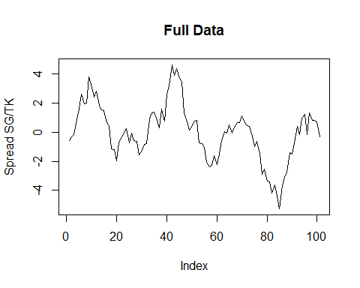
x11()
plot(residuals(reg)[1:8], type='l', ylab = "Spread", main = "First 8 Days")
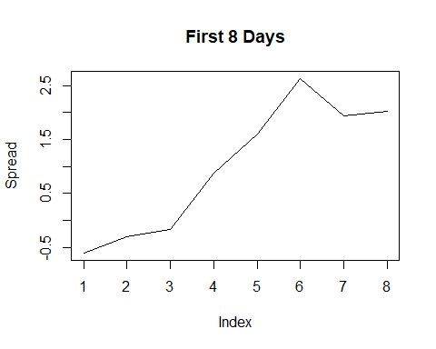
# STEP 5
#go for ECM
#take resi t-1
lagged_resis = residuals(reg)[-length(residuals(reg))]
regECM = lm(diff(SG)~diff(TK)+lagged_resis-1)
summary(regECM)#as hoped for the coef of ECterm is negative
##
## Call:
## lm(formula = diff(SG) ~ diff(TK) + lagged_resis - 1)
##
## Residuals:
## Min 1Q Median 3Q Max
## -2.10077 -0.52319 -0.07532 0.36043 1.60884
##
## Coefficients:
## Estimate Std. Error t value Pr(>|t|)
## diff(TK) 1.96378 0.18329 10.714 <2e-16 ***
## lagged_resis -0.03011 0.03491 -0.862 0.391
## ---
## Signif. codes: 0 '***' 0.001 '**' 0.01 '*' 0.05 '.' 0.1 ' ' 1
##
## Residual standard error: 0.6604 on 98 degrees of freedom
## Multiple R-squared: 0.565, Adjusted R-squared: 0.5561
## F-statistic: 63.63 on 2 and 98 DF, p-value: < 2.2e-16
head(cbind(TK,SG))
## TK SG
## [1,] 20.775 48.305
## [2,] 20.900 48.700
## [3,] 21.440 49.250
## [4,] 21.245 50.150
## [5,] 21.580 51.120
## [6,] 21.900 52.400
# Apply ordinary tests
adf.test(resis )#H0 Non-stat
##
## Augmented Dickey-Fuller Test
##
## data: resis
## Dickey-Fuller = -3.3387, Lag order = 4, p-value = 0.06854
## alternative hypothesis: stationary
pp.test(resis )
##
## Phillips-Perron Unit Root Test
##
## data: resis
## Dickey-Fuller Z(alpha) = -14.602, Truncation lag parameter = 4, p-value
## = 0.2685
## alternative hypothesis: stationary
kpss.test(resis )#H0 Stat
##
## KPSS Test for Level Stationarity
##
## data: resis
## KPSS Level = 0.49953, Truncation lag parameter = 4, p-value = 0.04177
#nevertheless assume coint, based on ADF an pedagogics
#noch ein Kointegrationstest: H0 not cointegrated.
po.test(as.matrix(cbind(TK,SG)))
## Warning in po.test(as.matrix(cbind(TK, SG))): p-value greater than printed
## p-value
##
## Phillips-Ouliaris Cointegration Test
##
## data: as.matrix(cbind(TK, SG))
## Phillips-Ouliaris demeaned = -0.5108, Truncation lag parameter = 1,
## p-value = 0.15
#a final word
#egcm(SG,TK)#use this also in live
#Ende

