GML_04_03-usdeur.R
frank
2024-05-06
# feb 2023
# r script for simulation of GARCH
# written by Frank Lehrbass (->lehrbass.de) for teaching purposes only
# students are solely responsible for whatever they do with this coding
# this R coding is WITHOUT ANY WARRANTY
#is an example from Verbeek
# Step 1
rm(list=ls(all=TRUE))
# Load packages
library(denstrip)
library(tseries)
## Registered S3 method overwritten by 'quantmod':
## method from
## as.zoo.data.frame zoo
library(fGarch)
## NOTE: Packages 'fBasics', 'timeDate', and 'timeSeries' are no longer
## attached to the search() path when 'fGarch' is attached.
##
## If needed attach them yourself in your R script by e.g.,
## require("timeSeries")
library(zoo)
##
## Attache Paket: 'zoo'
## Die folgenden Objekte sind maskiert von 'package:base':
##
## as.Date, as.Date.numeric
library(rugarch)
## Lade nötiges Paket: parallel
##
## Attache Paket: 'rugarch'
## Das folgende Objekt ist maskiert 'package:stats':
##
## sigma
library(moments)
data_table <- read.table("GML_04_03 usdeur.csv", header=TRUE, sep=";",dec=",")
usd <- data_table$usd
dates <- data_table$Date
DateStamp = as.Date(dates,format="%d.%m.%Y")
zusd = zoo(usd,DateStamp)
zFX <- na.omit(zusd)
FX = coredata(zFX)
x11()
#Figure 8.12
plot(zFX, ylim = c(-6,6), main = "Figure 8.12: daily change in log USD/EUR")
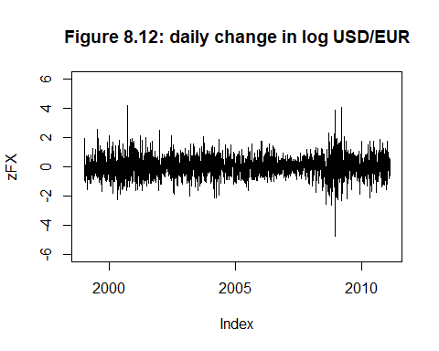
length(zFX)
## [1] 3087
summary(FX)
## Min. 1st Qu. Median Mean 3rd Qu. Max.
## -4.735441 -0.380585 0.008172 0.004693 0.393003 4.204134
kurtosis(FX)
## [1] 5.591918
skewness(FX)
## [1] 0.1038479
set.seed(123)
skewness(rnorm(1000,0,1))#zum Vgl
## [1] 0.06529391
adf.test(zFX)#series is stationary
## Warning in adf.test(zFX): p-value smaller than printed p-value
##
## Augmented Dickey-Fuller Test
##
## data: zFX
## Dickey-Fuller = -13.542, Lag order = 14, p-value = 0.01
## alternative hypothesis: stationary
x11()
acf(FX, main = "ACF of daily change in log USD/EUR")
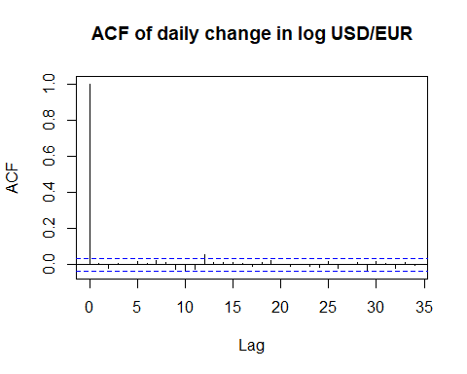
x11()
acf(FX^2, main = "ACF of SQUARED daily change in log USD/EUR")
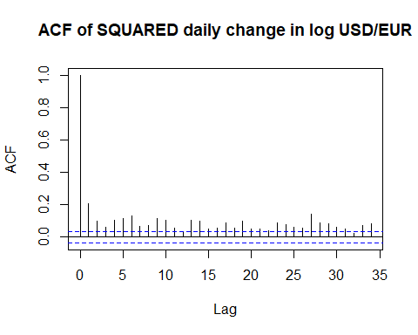
# Step 2
#test for ARCH as in Schwarz FOM Skript--------------------------
olstest = lm(FX ~ 1)
olstest
##
## Call:
## lm(formula = FX ~ 1)
##
## Coefficients:
## (Intercept)
## 0.004693
rt = residuals(olstest)
rt = rt[-1]
rt_1 = residuals(olstest)
rt_1 = rt_1[-length(rt_1)]
summary(lm(rt^2 ~ rt_1^2))
##
## Call:
## lm(formula = rt^2 ~ rt_1^2)
##
## Residuals:
## Min 1Q Median 3Q Max
## -0.7208 -0.4097 -0.2790 0.0541 21.6005
##
## Coefficients:
## Estimate Std. Error t value Pr(>|t|)
## (Intercept) 0.45059 0.01733 25.995 < 2e-16 ***
## rt_1 0.10766 0.02583 4.169 3.15e-05 ***
## ---
## Signif. codes: 0 '***' 0.001 '**' 0.01 '*' 0.05 '.' 0.1 ' ' 1
##
## Residual standard error: 0.9629 on 3084 degrees of freedom
## Multiple R-squared: 0.005603, Adjusted R-squared: 0.005281
## F-statistic: 17.38 on 1 and 3084 DF, p-value: 3.148e-05
# Step 3
#=============================================================================
# NOW garch (danielsson, 2011) but notation as in fGarch Docu by WurtzEtAlGarch.pdf
#=============================================================================
fit0 <- garchFit(~garch(1,1),cond.dist = "norm", data=FX,include.mean = T, trace = FALSE)
summary(fit0) #see Gehrke 2022 393ff
##
## Title:
## GARCH Modelling
##
## Call:
## garchFit(formula = ~garch(1, 1), data = FX, cond.dist = "norm",
## include.mean = T, trace = FALSE)
##
## Mean and Variance Equation:
## data ~ garch(1, 1)
## <environment: 0x000001c4b6f252a8>
## [data = FX]
##
## Conditional Distribution:
## norm
##
## Coefficient(s):
## mu omega alpha1 beta1
## 0.016652 0.001671 0.031369 0.965223
##
## Std. Errors:
## based on Hessian
##
## Error Analysis:
## Estimate Std. Error t value Pr(>|t|)
## mu 0.0166516 0.0106787 1.559 0.1189
## omega 0.0016710 0.0007214 2.316 0.0205 *
## alpha1 0.0313690 0.0042462 7.388 1.5e-13 ***
## beta1 0.9652231 0.0045897 210.303 < 2e-16 ***
## ---
## Signif. codes: 0 '***' 0.001 '**' 0.01 '*' 0.05 '.' 0.1 ' ' 1
##
## Log Likelihood:
## -2970.405 normalized: -0.9622304
##
## Description:
## Mon May 6 09:34:46 2024 by user: frank
##
##
## Standardised Residuals Tests:
## Statistic p-Value
## Jarque-Bera Test R Chi^2 125.179 0
## Shapiro-Wilk Test R W 0.9941491 8.706726e-10
## Ljung-Box Test R Q(10) 3.899319 0.9517746
## Ljung-Box Test R Q(15) 13.63544 0.5533382
## Ljung-Box Test R Q(20) 14.75284 0.7903712
## Ljung-Box Test R^2 Q(10) 5.428987 0.8607435
## Ljung-Box Test R^2 Q(15) 7.017233 0.9571698
## Ljung-Box Test R^2 Q(20) 9.182842 0.9806911
## LM Arch Test R TR^2 5.790116 0.9262902
##
## Information Criterion Statistics:
## AIC BIC SIC HQIC
## 1.927052 1.934872 1.927049 1.929861
#hence set mue to zero
fit1 <- garchFit(~garch(1,1),cond.dist = "norm", data=FX,include.mean = F, trace = FALSE)
fit1@fit$llh
## LogLikelihood
## 2971.618
fit1@fit$ics
## AIC BIC SIC HQIC
## 1.927190 1.933055 1.927188 1.929297
coef(fit1)
## omega alpha1 beta1
## 0.001682886 0.031009508 0.965544726
summary(fit1) #see Gehrke 2022 393ff
##
## Title:
## GARCH Modelling
##
## Call:
## garchFit(formula = ~garch(1, 1), data = FX, cond.dist = "norm",
## include.mean = F, trace = FALSE)
##
## Mean and Variance Equation:
## data ~ garch(1, 1)
## <environment: 0x000001c4b38a7480>
## [data = FX]
##
## Conditional Distribution:
## norm
##
## Coefficient(s):
## omega alpha1 beta1
## 0.0016829 0.0310095 0.9655447
##
## Std. Errors:
## based on Hessian
##
## Error Analysis:
## Estimate Std. Error t value Pr(>|t|)
## omega 0.0016829 0.0007237 2.326 0.02 *
## alpha1 0.0310095 0.0041855 7.409 1.27e-13 ***
## beta1 0.9655447 0.0045410 212.629 < 2e-16 ***
## ---
## Signif. codes: 0 '***' 0.001 '**' 0.01 '*' 0.05 '.' 0.1 ' ' 1
##
## Log Likelihood:
## -2971.618 normalized: -0.9626232
##
## Description:
## Mon May 6 09:34:46 2024 by user: frank
##
##
## Standardised Residuals Tests:
## Statistic p-Value
## Jarque-Bera Test R Chi^2 127.6274 0
## Shapiro-Wilk Test R W 0.9940898 7.408946e-10
## Ljung-Box Test R Q(10) 3.939719 0.9500254
## Ljung-Box Test R Q(15) 13.82707 0.5386831
## Ljung-Box Test R Q(20) 15.02977 0.7747019
## Ljung-Box Test R^2 Q(10) 5.076129 0.8860348
## Ljung-Box Test R^2 Q(15) 6.72859 0.9647482
## Ljung-Box Test R^2 Q(20) 8.88158 0.9842387
## LM Arch Test R TR^2 5.450219 0.9412289
##
## Information Criterion Statistics:
## AIC BIC SIC HQIC
## 1.927190 1.933055 1.927188 1.929297
predict(fit1, n.ahead = 3)
## meanForecast meanError standardDeviation
## 1 0 0.6400567 0.6400567
## 2 0 0.6402686 0.6402686
## 3 0 0.6404797 0.6404797
# Step 4
fit2 <- garchFit(~garch(1,1),cond.dist = "std", data=FX,include.mean = FALSE,
include.delta = FALSE, trace = FALSE)
fit2@fit$llh
## LogLikelihood
## 2947.204
fit2@fit$ics
## AIC BIC SIC HQIC
## 1.912021 1.919841 1.912018 1.914830
coef(fit2)
## omega alpha1 beta1 shape
## 0.001978934 0.031576576 0.964447375 10.000000000
summary(fit2)
##
## Title:
## GARCH Modelling
##
## Call:
## garchFit(formula = ~garch(1, 1), data = FX, cond.dist = "std",
## include.mean = FALSE, include.delta = FALSE, trace = FALSE)
##
## Mean and Variance Equation:
## data ~ garch(1, 1)
## <environment: 0x000001c4bcfd3e18>
## [data = FX]
##
## Conditional Distribution:
## std
##
## Coefficient(s):
## omega alpha1 beta1 shape
## 0.0019789 0.0315766 0.9644474 10.0000000
##
## Std. Errors:
## based on Hessian
##
## Error Analysis:
## Estimate Std. Error t value Pr(>|t|)
## omega 1.979e-03 8.599e-04 2.301 0.0214 *
## alpha1 3.158e-02 4.900e-03 6.444 1.16e-10 ***
## beta1 9.644e-01 5.352e-03 180.219 < 2e-16 ***
## shape 1.000e+01 1.464e+00 6.829 8.56e-12 ***
## ---
## Signif. codes: 0 '***' 0.001 '**' 0.01 '*' 0.05 '.' 0.1 ' ' 1
##
## Log Likelihood:
## -2947.204 normalized: -0.9547147
##
## Description:
## Mon May 6 09:34:47 2024 by user: frank
##
##
## Standardised Residuals Tests:
## Statistic p-Value
## Jarque-Bera Test R Chi^2 128.8512 0
## Shapiro-Wilk Test R W 0.9940576 6.790797e-10
## Ljung-Box Test R Q(10) 3.976858 0.9483849
## Ljung-Box Test R Q(15) 13.86805 0.5355592
## Ljung-Box Test R Q(20) 15.07798 0.7719281
## Ljung-Box Test R^2 Q(10) 5.116729 0.8832451
## Ljung-Box Test R^2 Q(15) 6.824199 0.9623456
## Ljung-Box Test R^2 Q(20) 8.978839 0.9831511
## LM Arch Test R TR^2 5.496303 0.9393194
##
## Information Criterion Statistics:
## AIC BIC SIC HQIC
## 1.912021 1.919841 1.912018 1.914830
# Step 5
#=============================================================================
# NOW EGarch (Schröder)
#=============================================================================
eGARCH_SET<-ugarchspec(variance.model = list(model="eGARCH",garchOrder=c(1,1)),mean.model = list(armaOrder=c(0,0),include.mean=FALSE))
fit3 <- ugarchfit(spec=eGARCH_SET,data =FX,solver="hybrid")
coef(fit3)
## omega alpha1 beta1 gamma1
## -0.002791764 -0.009082580 0.994859948 0.075070074
str(fit3)
## Formal class 'uGARCHfit' [package "rugarch"] with 2 slots
## ..@ fit :List of 27
## .. ..$ hessian : num [1:4, 1:4] 1315942 23186 -1253309 -41055 23186 ...
## .. ..$ cvar : num [1:4, 1:4] -1.23e-06 -1.29e-06 -2.81e-06 2.11e-05 -1.29e-06 ...
## .. ..$ var : num [1:3087] 0.45 0.425 0.422 0.451 0.435 ...
## .. ..$ sigma : num [1:3087] 0.671 0.652 0.65 0.671 0.659 ...
## .. ..$ condH : num NaN
## .. ..$ z : num [1:3087] 0.0126 -0.6126 -1.4615 0.3454 -1.1753 ...
## .. ..$ LLH : num -2968
## .. ..$ log.likelihoods: num [1:3087] 0.52 0.679 1.556 0.58 1.193 ...
## .. ..$ residuals : num [1:3087] 0.00848 -0.39944 -0.94974 0.23185 -0.77493 ...
## .. ..$ coef : Named num [1:4] -0.00279 -0.00908 0.99486 0.07507
## .. .. ..- attr(*, "names")= chr [1:4] "omega" "alpha1" "beta1" "gamma1"
## .. ..$ robust.cvar : num [1:4, 1:4] 8.61e-06 6.18e-06 8.72e-06 -2.23e-05 6.18e-06 ...
## .. ..$ A : num [1:4, 1:4] 426.29 7.51 -406 -13.3 7.51 ...
## .. ..$ B : num [1:4, 1:4] 602.01 5.52 -499.74 -8.56 5.52 ...
## .. ..$ scores : num [1:3087, 1:4] 0 0.312 -1.118 1.25 -0.723 ...
## .. .. ..- attr(*, "dimnames")=List of 2
## .. .. .. ..$ : NULL
## .. .. .. ..$ : chr [1:4] "omega" "alpha1" "beta1" "gamma1"
## .. ..$ se.coef : num [1:4] 0.00111 0.00553 0.00194 0.0078
## .. ..$ tval : Named num [1:4] -2.51 -1.64 512.97 9.62
## .. .. ..- attr(*, "names")= chr [1:4] "omega" "alpha1" "beta1" "gamma1"
## .. ..$ matcoef : num [1:4, 1:4] -0.00279 -0.00908 0.99486 0.07507 0.00111 ...
## .. .. ..- attr(*, "dimnames")=List of 2
## .. .. .. ..$ : chr [1:4] "omega" "alpha1" "beta1" "gamma1"
## .. .. .. ..$ : chr [1:4] " Estimate" " Std. Error" " t value" "Pr(>|t|)"
## .. ..$ robust.se.coef : num [1:4] 0.00293 0.00794 0.00323 0.01428
## .. ..$ robust.tval : Named num [1:4] -0.952 -1.143 307.739 5.259
## .. .. ..- attr(*, "names")= chr [1:4] "omega" "alpha1" "beta1" "gamma1"
## .. ..$ robust.matcoef : num [1:4, 1:4] -0.00279 -0.00908 0.99486 0.07507 0.00293 ...
## .. .. ..- attr(*, "dimnames")=List of 2
## .. .. .. ..$ : chr [1:4] "omega" "alpha1" "beta1" "gamma1"
## .. .. .. ..$ : chr [1:4] " Estimate" " Std. Error" " t value" "Pr(>|t|)"
## .. ..$ fitted.values : num [1:3087] 0 0 0 0 0 0 0 0 0 0 ...
## .. ..$ convergence : num 0
## .. ..$ kappa : num 0.798
## .. ..$ persistence : num 0.995
## .. ..$ timer : 'difftime' num 0.677191019058228
## .. .. ..- attr(*, "units")= chr "secs"
## .. ..$ ipars : num [1:19, 1:6] 0 0 0 0 0 ...
## .. .. ..- attr(*, "dimnames")=List of 2
## .. .. .. ..$ : chr [1:19] "mu" "ar" "ma" "arfima" ...
## .. .. .. ..$ : chr [1:6] "Level" "Fixed" "Include" "Estimate" ...
## .. ..$ solver :List of 2
## .. .. ..$ sol :List of 10
## .. .. .. ..$ pars : Named num [1:4] -0.00279 -0.00908 0.99486 0.07507
## .. .. .. .. ..- attr(*, "names")= chr [1:4] "omega" "alpha1" "beta1" "gamma1"
## .. .. .. ..$ convergence: num 0
## .. .. .. ..$ values : num [1:5] 8672 2970 2968 2968 2968
## .. .. .. ..$ lagrange : num [1, 1] -2.55e-07
## .. .. .. ..$ hessian : num [1:5, 1:5] 0.39618 -0.00911 0.05471 0.90493 0.32476 ...
## .. .. .. ..$ ineqx0 : Named num 1.01
## .. .. .. .. ..- attr(*, "names")= chr ""
## .. .. .. ..$ nfuneval : num 255
## .. .. .. ..$ outer.iter : num 4
## .. .. .. ..$ elapsed : 'difftime' num 0.653506994247437
## .. .. .. .. ..- attr(*, "units")= chr "secs"
## .. .. .. ..$ vscale : num [1:6] 1 1 1 1 1 1
## .. .. ..$ hess: NULL
## ..@ model:List of 11
## .. ..$ modelinc : Named num [1:22] 0 0 0 0 0 0 1 1 1 1 ...
## .. .. ..- attr(*, "names")= chr [1:22] "mu" "ar" "ma" "arfima" ...
## .. ..$ modeldesc :List of 3
## .. .. ..$ distribution: chr "norm"
## .. .. ..$ distno : int 1
## .. .. ..$ vmodel : chr "eGARCH"
## .. ..$ modeldata :List of 4
## .. .. ..$ T : int 3087
## .. .. ..$ data : num [1:3087] 0.00848 -0.39944 -0.94974 0.23185 -0.77493 ...
## .. .. ..$ index : POSIXct[1:3087], format: "1970-01-02" ...
## .. .. ..$ period: 'difftime' num 1
## .. .. .. ..- attr(*, "units")= chr "days"
## .. ..$ pars : num [1:19, 1:6] 0 0 0 0 0 ...
## .. .. ..- attr(*, "dimnames")=List of 2
## .. .. .. ..$ : chr [1:19] "mu" "ar" "ma" "arfima" ...
## .. .. .. ..$ : chr [1:6] "Level" "Fixed" "Include" "Estimate" ...
## .. ..$ start.pars: NULL
## .. ..$ fixed.pars: NULL
## .. ..$ maxOrder : num 1
## .. ..$ pos.matrix: num [1:21, 1:3] 0 0 0 0 0 0 1 2 3 4 ...
## .. .. ..- attr(*, "dimnames")=List of 2
## .. .. .. ..$ : chr [1:21] "mu" "ar" "ma" "arfima" ...
## .. .. .. ..$ : chr [1:3] "start" "stop" "include"
## .. ..$ fmodel : NULL
## .. ..$ pidx : num [1:19, 1:2] 1 2 3 4 5 6 7 8 9 10 ...
## .. .. ..- attr(*, "dimnames")=List of 2
## .. .. .. ..$ : chr [1:19] "mu" "ar" "ma" "arfima" ...
## .. .. .. ..$ : chr [1:2] "begin" "end"
## .. ..$ n.start : num 0
#eGARCH_VOLA <- as.numeric(ugarchforecast(fit3, n.ahead=1)@forecast[["sigmaFor"]])*sqrt(252)
#compare
summary(fit1)
##
## Title:
## GARCH Modelling
##
## Call:
## garchFit(formula = ~garch(1, 1), data = FX, cond.dist = "norm",
## include.mean = F, trace = FALSE)
##
## Mean and Variance Equation:
## data ~ garch(1, 1)
## <environment: 0x000001c4b38a7480>
## [data = FX]
##
## Conditional Distribution:
## norm
##
## Coefficient(s):
## omega alpha1 beta1
## 0.0016829 0.0310095 0.9655447
##
## Std. Errors:
## based on Hessian
##
## Error Analysis:
## Estimate Std. Error t value Pr(>|t|)
## omega 0.0016829 0.0007237 2.326 0.02 *
## alpha1 0.0310095 0.0041855 7.409 1.27e-13 ***
## beta1 0.9655447 0.0045410 212.629 < 2e-16 ***
## ---
## Signif. codes: 0 '***' 0.001 '**' 0.01 '*' 0.05 '.' 0.1 ' ' 1
##
## Log Likelihood:
## -2971.618 normalized: -0.9626232
##
## Description:
## Mon May 6 09:34:46 2024 by user: frank
##
##
## Standardised Residuals Tests:
## Statistic p-Value
## Jarque-Bera Test R Chi^2 127.6274 0
## Shapiro-Wilk Test R W 0.9940898 7.408946e-10
## Ljung-Box Test R Q(10) 3.939719 0.9500254
## Ljung-Box Test R Q(15) 13.82707 0.5386831
## Ljung-Box Test R Q(20) 15.02977 0.7747019
## Ljung-Box Test R^2 Q(10) 5.076129 0.8860348
## Ljung-Box Test R^2 Q(15) 6.72859 0.9647482
## Ljung-Box Test R^2 Q(20) 8.88158 0.9842387
## LM Arch Test R TR^2 5.450219 0.9412289
##
## Information Criterion Statistics:
## AIC BIC SIC HQIC
## 1.927190 1.933055 1.927188 1.929297
summary(fit2)
##
## Title:
## GARCH Modelling
##
## Call:
## garchFit(formula = ~garch(1, 1), data = FX, cond.dist = "std",
## include.mean = FALSE, include.delta = FALSE, trace = FALSE)
##
## Mean and Variance Equation:
## data ~ garch(1, 1)
## <environment: 0x000001c4bcfd3e18>
## [data = FX]
##
## Conditional Distribution:
## std
##
## Coefficient(s):
## omega alpha1 beta1 shape
## 0.0019789 0.0315766 0.9644474 10.0000000
##
## Std. Errors:
## based on Hessian
##
## Error Analysis:
## Estimate Std. Error t value Pr(>|t|)
## omega 1.979e-03 8.599e-04 2.301 0.0214 *
## alpha1 3.158e-02 4.900e-03 6.444 1.16e-10 ***
## beta1 9.644e-01 5.352e-03 180.219 < 2e-16 ***
## shape 1.000e+01 1.464e+00 6.829 8.56e-12 ***
## ---
## Signif. codes: 0 '***' 0.001 '**' 0.01 '*' 0.05 '.' 0.1 ' ' 1
##
## Log Likelihood:
## -2947.204 normalized: -0.9547147
##
## Description:
## Mon May 6 09:34:47 2024 by user: frank
##
##
## Standardised Residuals Tests:
## Statistic p-Value
## Jarque-Bera Test R Chi^2 128.8512 0
## Shapiro-Wilk Test R W 0.9940576 6.790797e-10
## Ljung-Box Test R Q(10) 3.976858 0.9483849
## Ljung-Box Test R Q(15) 13.86805 0.5355592
## Ljung-Box Test R Q(20) 15.07798 0.7719281
## Ljung-Box Test R^2 Q(10) 5.116729 0.8832451
## Ljung-Box Test R^2 Q(15) 6.824199 0.9623456
## Ljung-Box Test R^2 Q(20) 8.978839 0.9831511
## LM Arch Test R TR^2 5.496303 0.9393194
##
## Information Criterion Statistics:
## AIC BIC SIC HQIC
## 1.912021 1.919841 1.912018 1.914830
fit3
##
## *---------------------------------*
## * GARCH Model Fit *
## *---------------------------------*
##
## Conditional Variance Dynamics
## -----------------------------------
## GARCH Model : eGARCH(1,1)
## Mean Model : ARFIMA(0,0,0)
## Distribution : norm
##
## Optimal Parameters
## ------------------------------------
## Estimate Std. Error t value Pr(>|t|)
## omega -0.002792 0.001111 -2.5139 0.011939
## alpha1 -0.009083 0.005528 -1.6431 0.100356
## beta1 0.994860 0.001939 512.9702 0.000000
## gamma1 0.075070 0.007804 9.6196 0.000000
##
## Robust Standard Errors:
## Estimate Std. Error t value Pr(>|t|)
## omega -0.002792 0.002934 -0.95151 0.34135
## alpha1 -0.009083 0.007945 -1.14319 0.25296
## beta1 0.994860 0.003233 307.73911 0.00000
## gamma1 0.075070 0.014276 5.25850 0.00000
##
## LogLikelihood : -2968.271
##
## Information Criteria
## ------------------------------------
##
## Akaike 1.9257
## Bayes 1.9335
## Shibata 1.9257
## Hannan-Quinn 1.9285
##
## Weighted Ljung-Box Test on Standardized Residuals
## ------------------------------------
## statistic p-value
## Lag[1] 0.2281 0.6329
## Lag[2*(p+q)+(p+q)-1][2] 0.2365 0.8322
## Lag[4*(p+q)+(p+q)-1][5] 0.8380 0.8951
## d.o.f=0
## H0 : No serial correlation
##
## Weighted Ljung-Box Test on Standardized Squared Residuals
## ------------------------------------
## statistic p-value
## Lag[1] 0.04236 0.8369
## Lag[2*(p+q)+(p+q)-1][5] 0.81749 0.8994
## Lag[4*(p+q)+(p+q)-1][9] 2.31411 0.8644
## d.o.f=2
##
## Weighted ARCH LM Tests
## ------------------------------------
## Statistic Shape Scale P-Value
## ARCH Lag[3] 0.0001589 0.500 2.000 0.9899
## ARCH Lag[5] 0.9891289 1.440 1.667 0.7362
## ARCH Lag[7] 2.1490910 2.315 1.543 0.6858
##
## Nyblom stability test
## ------------------------------------
## Joint Statistic: 0.6241
## Individual Statistics:
## omega 0.09023
## alpha1 0.07129
## beta1 0.14551
## gamma1 0.32696
##
## Asymptotic Critical Values (10% 5% 1%)
## Joint Statistic: 1.07 1.24 1.6
## Individual Statistic: 0.35 0.47 0.75
##
## Sign Bias Test
## ------------------------------------
## t-value prob sig
## Sign Bias 3.562 0.0003742 ***
## Negative Sign Bias 2.175 0.0296894 **
## Positive Sign Bias 3.136 0.0017310 ***
## Joint Effect 15.878 0.0012010 ***
##
##
## Adjusted Pearson Goodness-of-Fit Test:
## ------------------------------------
## group statistic p-value(g-1)
## 1 20 36.17 0.0100647
## 2 30 46.09 0.0229840
## 3 40 78.70 0.0001715
## 4 50 69.77 0.0271852
##
##
## Elapsed time : 0.677191
#=============================================================================
# LR Test
#=============================================================================
#LR Test
LR = fit1@fit$llh
LU = fit2@fit$llh
#test_stat as in Danielsson p 45 6 verbeek p191
#H0 restriction for shape is correct,
#L2 is Unrestricted cause free shape
LR_stats = 2*(LU-LR)
noofrestrictions = 1 #shape is set to infinity to make it normal
LR_crit = qchisq(0.99, noofrestrictions )
LR_crit
## [1] 6.634897
LR_stats
## LogLikelihood
## -48.82741
#p-val, H0: restriction is true
round(2*pchisq(-abs(LR_stats),noofrestrictions ),5)
## LogLikelihood
## 0
# Step 6
#=============================================================================
# Apply GARCH student t
#=============================================================================
fit2
##
## Title:
## GARCH Modelling
##
## Call:
## garchFit(formula = ~garch(1, 1), data = FX, cond.dist = "std",
## include.mean = FALSE, include.delta = FALSE, trace = FALSE)
##
## Mean and Variance Equation:
## data ~ garch(1, 1)
## <environment: 0x000001c4bcfd3e18>
## [data = FX]
##
## Conditional Distribution:
## std
##
## Coefficient(s):
## omega alpha1 beta1 shape
## 0.0019789 0.0315766 0.9644474 10.0000000
##
## Std. Errors:
## based on Hessian
##
## Error Analysis:
## Estimate Std. Error t value Pr(>|t|)
## omega 1.979e-03 8.599e-04 2.301 0.0214 *
## alpha1 3.158e-02 4.900e-03 6.444 1.16e-10 ***
## beta1 9.644e-01 5.352e-03 180.219 < 2e-16 ***
## shape 1.000e+01 1.464e+00 6.829 8.56e-12 ***
## ---
## Signif. codes: 0 '***' 0.001 '**' 0.01 '*' 0.05 '.' 0.1 ' ' 1
##
## Log Likelihood:
## -2947.204 normalized: -0.9547147
##
## Description:
## Mon May 6 09:34:47 2024 by user: frank
Omega = coef(fit2)[1]
Alpha = coef(fit2)[2]
Beta = coef(fit2)[3]
Shape = coef(fit2)[4]
predict(fit2, n.ahead = 3)
## meanForecast meanError standardDeviation
## 1 0 0.6394095 0.6394095
## 2 0 0.6396857 0.6396857
## 3 0 0.6399607 0.6399607
std_res1 <- fit2@residuals/fit2@sigma.t #this standardizes the residuals to mean = 0, s=1
x11()
plot(std_res1, type = 'l')
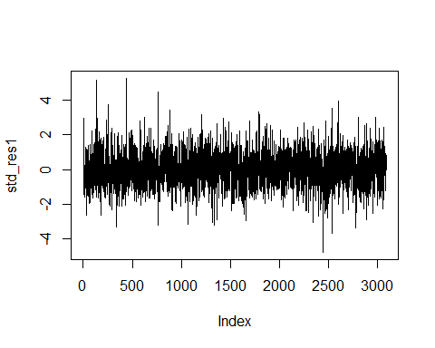
kernel_den = density(std_res1)
x11()
plot(kernel_den, main="Standardized residuals vs Student t Density", xlab = " ")
x <- seq(min(kernel_den$x),max(kernel_den$x),length = 1000)
std_den = dstd(x,mean = mean(std_res1),sd = sd(std_res1), nu = Shape)
lines(x,std_den,type="l",col="red")
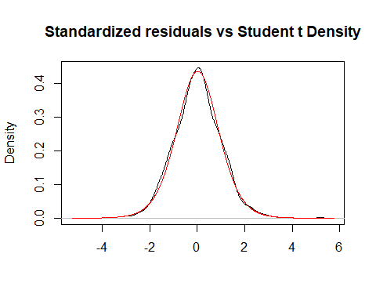
#=============================================================================
# analyze the standardized residuals from the model
#=============================================================================
x11()
acf(std_res1, main="ACF for Student t residuals")
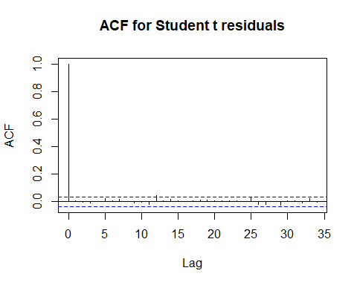
x11()
acf(std_res1^2, main="ACF for SQUARED Student t residuals")
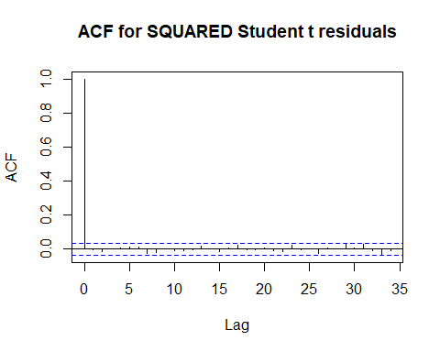
#=============================================================================
# do QQ & KS
#=============================================================================
x11()
plot(qstd(ppoints(std_res1), mean = mean(std_res1),sd = sd(std_res1), nu = Shape),
sort(std_res1), main="QQ Plot of residuals", xlab = "Quantile", ylab = "Empirical Quantile")
abline(a=0, b=1)
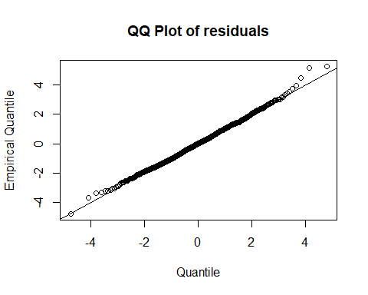
#end

