GML_04_04-capm.R
frank
2024-05-06
# feb 2023
# r script for estimation of CAPM
# written by Frank Lehrbass (->lehrbass.de) for teaching purposes only
# students are solely responsible for whatever they do with this coding
# this R coding is WITHOUT ANY WARRANTY
#CAPM data from example in Verbeek book ch 2, pls read the stuff to get the background
#also read Schroeder 2002, chapter on CAPM using DB and DAX!
#u may want to use this as template for "Determinanten des Aktienkurses von XYZ"
#u may add Fama French factors http://mba.tuck.dartmouth.edu/pages/faculty/ken.french/data_library.html#Research
#and add other X acc to your understanding of the business of XYZ
# Clean previous variables
rm(list=ls(all=TRUE))
# Load packages
library(tseries)
## Registered S3 method overwritten by 'quantmod':
## method from
## as.zoo.data.frame zoo
library(lmtest)
## Warning: Paket 'lmtest' wurde unter R Version 4.3.3 erstellt
## Lade nötiges Paket: zoo
##
## Attache Paket: 'zoo'
## Die folgenden Objekte sind maskiert von 'package:base':
##
## as.Date, as.Date.numeric
library(car)
## Warning: Paket 'car' wurde unter R Version 4.3.3 erstellt
## Lade nötiges Paket: carData
library(sandwich)
## Warning: Paket 'sandwich' wurde unter R Version 4.3.3 erstellt
library(rugarch)
## Lade nötiges Paket: parallel
##
## Attache Paket: 'rugarch'
## Das folgende Objekt ist maskiert 'package:stats':
##
## sigma
data_table <- read.table("GML_04_04 capm.csv", header=TRUE, sep=";",dec=",")
summary(data_table)
## month constrrf durblrf foodrf
## Min. :196001 Min. :-29.8100 Min. :-25.9000 Min. :-18.800
## 1st Qu.:197209 1st Qu.: -3.1800 1st Qu.: -2.8500 1st Qu.: -1.603
## Median :198506 Median : 0.4200 Median : 0.4250 Median : 0.715
## Mean :198498 Mean : 0.4379 Mean : 0.3275 Mean : 0.653
## 3rd Qu.:199802 3rd Qu.: 3.7475 3rd Qu.: 4.0000 3rd Qu.: 3.223
## Max. :201010 Max. : 25.5200 Max. : 29.4500 Max. : 19.520
## hml jan rf rmrf
## Min. :-12.7800 Min. :0.00000 Min. :0.000 Min. :-23.140
## 1st Qu.: -1.1500 1st Qu.:0.00000 1st Qu.:0.280 1st Qu.: -2.205
## Median : 0.4350 Median :0.00000 Median :0.410 Median : 0.840
## Mean : 0.4022 Mean :0.08361 Mean :0.427 Mean : 0.437
## 3rd Qu.: 1.7975 3rd Qu.:0.00000 3rd Qu.:0.530 3rd Qu.: 3.462
## Max. : 13.8400 Max. :1.00000 Max. :1.350 Max. : 16.050
## smb
## Min. :-16.670
## 1st Qu.: -1.460
## Median : 0.070
## Mean : 0.230
## 3rd Qu.: 2.038
## Max. : 22.190
#your data should be daily and at least 2 yrs, more is bettter but watch out for structural breaks
#note that Verbeek uses excess returns with rf = return on 1 mth T Bills
#WPs (auditors, corp valuation) love a longer rate eg Treasuries 20yrs
# Diagnostics of one specific regression
#adjust this section!!!====================================================
Y = data_table$constrrf #xcess return for a sub-index of industrials, cap weighted like dax
X = data_table$rmrf #xcess for broad CRSP index
reg = lm(Y~X) #play here if u want
summary(reg)
##
## Call:
## lm(formula = Y ~ X)
##
## Residuals:
## Min 1Q Median 3Q Max
## -12.879 -1.641 -0.115 1.520 11.725
##
## Coefficients:
## Estimate Std. Error t value Pr(>|t|)
## (Intercept) -0.07259 0.11542 -0.629 0.53
## X 1.16817 0.02549 45.837 <2e-16 ***
## ---
## Signif. codes: 0 '***' 0.001 '**' 0.01 '*' 0.05 '.' 0.1 ' ' 1
##
## Residual standard error: 2.837 on 608 degrees of freedom
## Multiple R-squared: 0.7756, Adjusted R-squared: 0.7752
## F-statistic: 2101 on 1 and 608 DF, p-value: < 2.2e-16
# Estimate CAPM with GARCH for Construction
data_ext<-matrix(data= NA , nrow=length(residuals(reg)), ncol=2)
data_ext<-cbind(data_table$constrrf,data_table$rmrf)
data_ext=rbind(data_ext,data_ext)
spec2 <- ugarchspec(variance.model = list(model = "sGARCH", garchOrder = c(1, 1),
variance.targeting = TRUE),
mean.model = list(armaOrder = c(0, 0), include.mean = TRUE,
external.regressors = matrix(data_ext[,2])),
distribution.model = "norm")
garch2 <- ugarchfit(spec=spec2,data=matrix(data_ext[,1]),solver.control=list(trace=0))
coef(garch2)
## mu mxreg1 alpha1 beta1 omega
## -0.13517802 1.19623699 0.07863426 0.89519503 0.21049941
#compare and note that beta is now slightly higher than in ordinary OLS
coefficients(reg)
## (Intercept) X
## -0.07258514 1.16816828
std_res2 = residuals(garch2)/sigma(garch2)
kernel_den = density(std_res2)
x11()
plot(kernel_den, main="Density w exogeneous X but no AR1")
x <- seq(min(kernel_den$x),max(kernel_den$x),length = 1000)
normal_den = dnorm(x,mean = mean(std_res2),sd = sd(std_res2))
lines(x,normal_den,type="l",col="red")
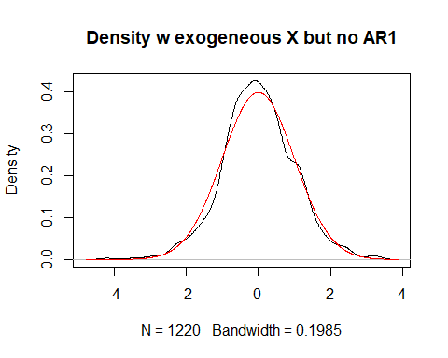
x11() #note that ARCH effects captured now in model
acf(std_res2^2)
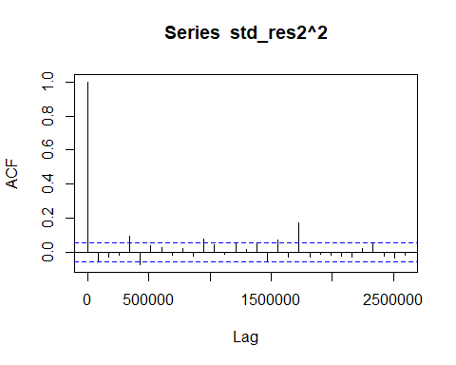
#end
#Ende

