GML_05_01-sure.R
frank
2024-05-06
# feb 2023
# r script for simulation of CAPM and SURE
# written by Frank Lehrbass (->lehrbass.de) for teaching purposes only
# students are solely responsible for whatever they do with this coding
# this R coding is WITHOUT ANY WARRANTY
#data from example in book Finanzmarkt?konometrie CH 2
# Step 1
# Clean previous variables
rm(list=ls(all=TRUE))
# Load packages
library(tseries)
## Registered S3 method overwritten by 'quantmod':
## method from
## as.zoo.data.frame zoo
library(fUnitRoots)
#library(fts)
library(lmtest)
## Warning: Paket 'lmtest' wurde unter R Version 4.3.3 erstellt
## Lade nötiges Paket: zoo
##
## Attache Paket: 'zoo'
## Die folgenden Objekte sind maskiert von 'package:base':
##
## as.Date, as.Date.numeric
library(sandwich)
## Warning: Paket 'sandwich' wurde unter R Version 4.3.3 erstellt
library(systemfit)
## Lade nötiges Paket: Matrix
## Lade nötiges Paket: car
## Warning: Paket 'car' wurde unter R Version 4.3.3 erstellt
## Lade nötiges Paket: carData
##
## Please cite the 'systemfit' package as:
## Arne Henningsen and Jeff D. Hamann (2007). systemfit: A Package for Estimating Systems of Simultaneous Equations in R. Journal of Statistical Software 23(4), 1-40. http://www.jstatsoft.org/v23/i04/.
##
## If you have questions, suggestions, or comments regarding the 'systemfit' package, please use a forum or 'tracker' at systemfit's R-Forge site:
## https://r-forge.r-project.org/projects/systemfit/
library(MASS)
#UPDATE HERE========================================================
INDEX_FILE = "GML_05_01 sure.csv"
#define in sample
START_DATE = "1995-12-31"
END_DATE = "2000-12-29"
#UPDATE ENDS========================================================
data_table <- read.table(INDEX_FILE, header=TRUE, sep=";",dec=",")
INDEX <- data_table[,2]
Dates <- data_table[,1]
DateStamp = as.Date(Dates,format="%d.%m.%Y")
zINDEX = zoo(INDEX,DateStamp)
# Generate sample
zDataIS <- window(zINDEX, start = START_DATE, end = END_DATE)
# Write data to file for Excel analysis and plot it, give intuitive names
indexReturn = diff(log(zDataIS[,1]))#book uses stetige Renditen, S. 42 Fn
# 2 Firmen Event Studie - Datensimulation --------------------
set.seed(1)
n=length(indexReturn)
volas = c(0.03,0.02)
means = c(0,0)
rho = 0.85
VOLS = diag(,2,2)
diag(VOLS) = volas
VOLS
## [,1] [,2]
## [1,] 0.03 0.00
## [2,] 0.00 0.02
RHO <- matrix(c(1,rho,rho,1),2,2)
COV = t(VOLS) %*% RHO %*% VOLS
COV
## [,1] [,2]
## [1,] 0.00090 0.00051
## [2,] 0.00051 0.00040
EE <- mvrnorm(n,means,COV)
epsa = EE[,1]
epsb = EE[,2]
X=coredata(indexReturn) #this removes time stamps
Ya = 1 * X + epsa
Yb = 2 * X + epsb
head(Ya)
## [1] 0.121681603 -0.004247059 0.033020324 -0.039344027 0.001557505
## [6] 0.032486926
head(Yb)
## [1] 0.1763536608 -0.0003302463 0.0200653877 -0.0141396263 0.0293825831
## [6] 0.0282671403
# 2 Firmen Event Studie - Ereignisbau --------------------
#now event of xtra return of 10%/2% on day 30/40
Ya[30]=Ya[30]+0.1
Yb[40]=Yb[40]+0.02
#create dummy
Da = rep(0,60)
Db=Da
Da[30]=1
Db[40]=1
Da[1:30]
## [1] 0 0 0 0 0 0 0 0 0 0 0 0 0 0 0 0 0 0 0 0 0 0 0 0 0 0 0 0 0 1
# Step 2
# 2 Firmen Event Studie - NAIV --------------------
eq1 <- Ya~X+Da
eq2 <- Yb~X+Db
#two separate OLS
summary(lm(eq1))
##
## Call:
## lm(formula = eq1)
##
## Residuals:
## Min 1Q Median 3Q Max
## -0.057746 -0.017792 0.000531 0.017210 0.062473
##
## Coefficients:
## Estimate Std. Error t value Pr(>|t|)
## (Intercept) -0.002862 0.003534 -0.810 0.42150
## X 1.021027 0.052647 19.394 < 2e-16 ***
## Da 0.090559 0.026590 3.406 0.00122 **
## ---
## Signif. codes: 0 '***' 0.001 '**' 0.01 '*' 0.05 '.' 0.1 ' ' 1
##
## Residual standard error: 0.02628 on 57 degrees of freedom
## Multiple R-squared: 0.8755, Adjusted R-squared: 0.8711
## F-statistic: 200.4 on 2 and 57 DF, p-value: < 2.2e-16
summary(lm(eq2))
##
## Call:
## lm(formula = eq2)
##
## Residuals:
## Min 1Q Median 3Q Max
## -0.030982 -0.009791 -0.000948 0.008082 0.051850
##
## Coefficients:
## Estimate Std. Error t value Pr(>|t|)
## (Intercept) -0.002523 0.002314 -1.090 0.280
## X 1.987918 0.034902 56.958 <2e-16 ***
## Db 0.013267 0.017628 0.753 0.455
## ---
## Signif. codes: 0 '***' 0.001 '**' 0.01 '*' 0.05 '.' 0.1 ' ' 1
##
## Residual standard error: 0.01724 on 57 degrees of freedom
## Multiple R-squared: 0.9833, Adjusted R-squared: 0.9827
## F-statistic: 1675 on 2 and 57 DF, p-value: < 2.2e-16
# Step 3
# 2 Firmen Event Studie - DIAG --------------------
#check correlation of resis of OLS
#H0: rho is zero
corResis = cor(residuals(lm(eq1)), residuals(lm(eq2)))
corResis
## [1] 0.8261268
#test as in assenmacher, 2002, 196, is based on resis of OLS
T = n #sample size
G = 2 #no of eqs
sure_stat = T*corResis^2
#critical
sure_df = G * (G-1)/2
sure_crit = qchisq(0.99, sure_df)
#compare
sure_stat
## [1] 40.94913
sure_crit
## [1] 6.634897
#hence reject H0 = time for SURE
# Step 4
# 2 Firmen Event Studie - SURE --------------------
myData = data.frame(cbind(Ya,Yb,X,Da,Db))
#as before but compact
fitOLS <- systemfit( list(eq1, eq2), method = "OLS", data=myData)
#a more adequate approach
fitSUR <- systemfit( list(eq1, eq2), method = "SUR", data=myData)
summary(fitSUR)
##
## systemfit results
## method: SUR
##
## N DF SSR detRCov OLS-R2 McElroy-R2
## system 120 114 0.056557 0 0.957444 0.981481
##
## N DF SSR MSE RMSE R2 Adj R2
## eq1 60 57 0.039436 0.000692 0.026303 0.875320 0.870945
## eq2 60 57 0.017121 0.000300 0.017331 0.983094 0.982501
##
## The covariance matrix of the residuals used for estimation
## eq1 eq2
## eq1 0.000690787 0.000374382
## eq2 0.000374382 0.000297299
##
## The covariance matrix of the residuals
## eq1 eq2
## eq1 0.000691865 0.000380951
## eq2 0.000380951 0.000300364
##
## The correlations of the residuals
## eq1 eq2
## eq1 1.000000 0.835668
## eq2 0.835668 1.000000
##
##
## SUR estimates for 'eq1' (equation 1)
## Model Formula: Ya ~ X + Da
##
## Estimate Std. Error t value Pr(>|t|)
## (Intercept) -0.00297176 0.00352109 -0.84399 0.4022
## X 1.01976826 0.05253147 19.41252 < 2.22e-16 ***
## Da 0.09849193 0.01498794 6.57141 1.6419e-08 ***
## ---
## Signif. codes: 0 '***' 0.001 '**' 0.01 '*' 0.05 '.' 0.1 ' ' 1
##
## Residual standard error: 0.026303 on 57 degrees of freedom
## Number of observations: 60 Degrees of Freedom: 57
## SSR: 0.039436 MSE: 0.000692 Root MSE: 0.026303
## Multiple R-Squared: 0.87532 Adjusted R-Squared: 0.870945
##
##
## SUR estimates for 'eq2' (equation 2)
## Model Formula: Yb ~ X + Db
##
## Estimate Std. Error t value Pr(>|t|)
## (Intercept) -0.00267124 0.00230848 -1.15714 0.2520395
## X 1.98351963 0.03457848 57.36284 < 2.22e-16 ***
## Db 0.02678104 0.00993607 2.69533 0.0092253 **
## ---
## Signif. codes: 0 '***' 0.001 '**' 0.01 '*' 0.05 '.' 0.1 ' ' 1
##
## Residual standard error: 0.017331 on 57 degrees of freedom
## Number of observations: 60 Degrees of Freedom: 57
## SSR: 0.017121 MSE: 3e-04 Root MSE: 0.017331
## Multiple R-Squared: 0.983094 Adjusted R-Squared: 0.982501
#For comparison
coeftest(fitOLS)
##
## t test of coefficients:
##
## Estimate Std. Error t value Pr(>|t|)
## eq1_(Intercept) -0.0028616 0.0035343 -0.8097 0.419824
## eq1_X 1.0210271 0.0526470 19.3938 < 2.2e-16 ***
## eq1_Da 0.0905595 0.0265902 3.4058 0.000912 ***
## eq2_(Intercept) -0.0025229 0.0023140 -1.0903 0.277893
## eq2_X 1.9879178 0.0349017 56.9577 < 2.2e-16 ***
## eq2_Db 0.0132669 0.0176276 0.7526 0.453229
## ---
## Signif. codes: 0 '***' 0.001 '**' 0.01 '*' 0.05 '.' 0.1 ' ' 1
coeftest(fitSUR)
##
## t test of coefficients:
##
## Estimate Std. Error t value Pr(>|t|)
## eq1_(Intercept) -0.0029718 0.0035211 -0.8440 0.400443
## eq1_X 1.0197683 0.0525315 19.4125 < 2.2e-16 ***
## eq1_Da 0.0984919 0.0149879 6.5714 1.556e-09 ***
## eq2_(Intercept) -0.0026712 0.0023085 -1.1571 0.249632
## eq2_X 1.9835196 0.0345785 57.3628 < 2.2e-16 ***
## eq2_Db 0.0267810 0.0099361 2.6953 0.008096 **
## ---
## Signif. codes: 0 '***' 0.001 '**' 0.01 '*' 0.05 '.' 0.1 ' ' 1
# Step 5
# 2 Firmen Event Studie - SURE Diagnostik --------------------
#NOTE: Below only for eq1, for eq2 it is the same procedure ...
#systematic part of model, ie we can use ols if needed!!!-----
#Linearity?
x11()
regline = lm(Ya ~ X)
plot(Ya ~ X)
abline(regline)
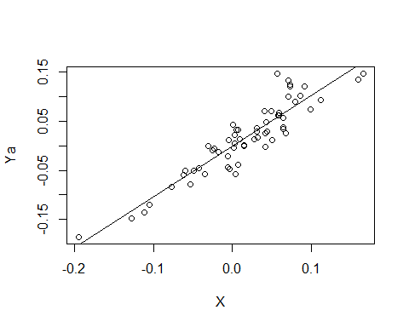
#RESET Test von Ramsey H0 = Linearer Zusammenhang
resettest(regline,power=2,type="regressor")
##
## RESET test
##
## data: regline
## RESET = 0.17457, df1 = 1, df2 = 57, p-value = 0.6777
#multicoll, how should it?---------------------
cor(X,Da)#says it all
## [1] 0.0801516
vif(lm(eq1))
## X Da
## 1.006466 1.006466
#breaks?
betavek = rep(0,10)
for (i in c(1:10))
{
betavek[i]=coef(lm(Ya[1:(50+i)]~X[1:(50+i)]))[2]
}
plot(betavek, type = 'l')
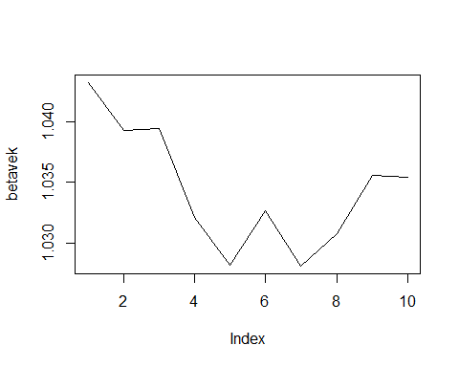
#stochastic part-----------------------------------------------
#Autokorr---------------------------------------
#analyze resis of sure, here eq1
acf(residuals(fitSUR)$eq1, ci = 0.95) #etc
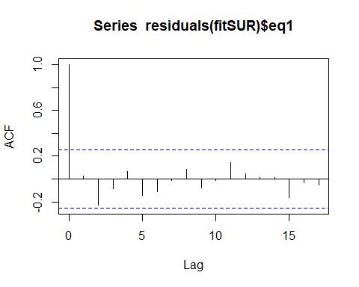
TT = length(Ya)
dw_SURE<-(sum((residuals(fitSUR)$eq1[-1]-residuals(fitSUR)$eq1[1:TT-1])^2))/(sum((residuals(fitSUR)$eq1)^2))
dw_SURE
## [1] 1.923541
#use DW Tables if u want exact reading
#hetero-----------------------------------------
x11()
plot(residuals(fitSUR)$eq1, type='l', ylab = "Residuals eq1")
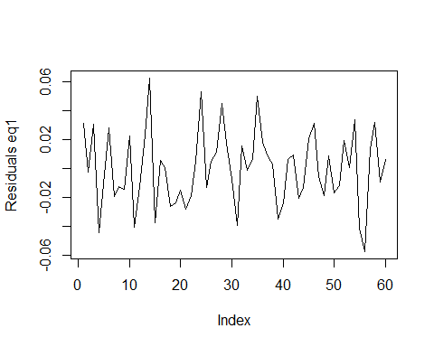
#White Test (handles non-normal terms, details see schr?der book, p 115)
#H0: Homo
#aux reg
Xsq = X^2
Dsq = Da^2
XD = X*Da
aux_reg = lm((residuals(fitSUR)$eq1)^2~X+Da+Xsq+Dsq+XD)
summary(aux_reg)
##
## Call:
## lm(formula = (residuals(fitSUR)$eq1)^2 ~ X + Da + Xsq + Dsq +
## XD)
##
## Residuals:
## Min 1Q Median 3Q Max
## -0.0007711 -0.0005631 -0.0002539 0.0001745 0.0031155
##
## Coefficients: (2 not defined because of singularities)
## Estimate Std. Error t value Pr(>|t|)
## (Intercept) 0.0006652 0.0001366 4.870 9.52e-06 ***
## X 0.0027649 0.0017239 1.604 0.114
## Da -0.0007313 0.0008702 -0.840 0.404
## Xsq -0.0098171 0.0158830 -0.618 0.539
## Dsq NA NA NA NA
## XD NA NA NA NA
## ---
## Signif. codes: 0 '***' 0.001 '**' 0.01 '*' 0.05 '.' 0.1 ' ' 1
##
## Residual standard error: 0.00086 on 56 degrees of freedom
## Multiple R-squared: 0.0592, Adjusted R-squared: 0.008795
## F-statistic: 1.175 on 3 and 56 DF, p-value: 0.3277
#calc R? by feet
sigma_hat1 = coefficients(aux_reg)[1]+coefficients(aux_reg)[2]*X+coefficients(aux_reg)[3]*Da+
coefficients(aux_reg)[4]*I(X^2)
#other terms na coeffs, I() = take as is, no interpretation
aux_R_sq = cor(sigma_hat1,(residuals(fitSUR)$eq1)^2)^2
#test stat
white_stat = n*aux_R_sq
#crit val
k = 5 #count above
white_df = k
white_crit = qchisq(0.99, white_df)
#compare, H0: Homo
white_stat
## [1] 3.551713
white_crit
## [1] 15.08627
#hence keep H0
#normality---------------------------------------
resi1 = residuals(fitSUR)$eq1
x11()#smooth it
kernel_den = density(resi1)
plot(kernel_den, main="Smoothed Residual Distribution", xlab = " ")
x <- seq(min(kernel_den$x),max(kernel_den$x),length = 1000)
#compare to normal
std_den = dnorm(x,mean = mean(resi1),sd = sd(resi1))
lines(x,std_den,type="l",col="red")
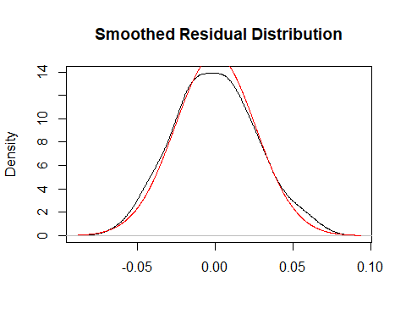
shapiro.test(resi1)#H0: Is normal
##
## Shapiro-Wilk normality test
##
## data: resi1
## W = 0.99112, p-value = 0.9417
jarque.bera.test(resi1)#Nullhypothese ?Normalverteilung?
##
## Jarque Bera Test
##
## data: resi1
## X-squared = 0.47274, df = 2, p-value = 0.7895
#hence, keep H0
#BONUS: Event Study Old Style
#Unterstelle sogar Kenntnis des wahren Marktmodells, d.h. normal returns sind
NRa = 1 * X[30]
NRb = 2 * X[30]
ARa = Ya[30]-NRa
ARb = Yb[30]-NRb
AAR = (ARa+ARb)/2
t_stat<-sqrt(2)*AAR/sd(c(ARa,ARb))
t_stat
## [1] 0.8019752
#crit value one sided
qnorm(0.95)
## [1] 1.644854
#Ende

