GML_05_02-projection.R
frank
2024-05-06
### Willkommen in R!
# lin algebra of lin reg in a nutshell
# Clean previous variables
rm(list=ls(all=TRUE))
#define a Y
Y = matrix(0,2,1)
Y[1,1]=3
Y[2,1]=2
Y
## [,1]
## [1,] 3
## [2,] 2
X = matrix(0,2,1)
X[1,1]=2
X[2,1]=1
X
## [,1]
## [1,] 2
## [2,] 1
plot(c(0,4),c(0,4),xlab="Point in time t=1", ylab ="Point in time t=2", type = "n", main = "Our Data")
arrows(0,0,Y[1,1],Y[2,1],lwd=3)
text(Y[1,1],Y[2,1],"Y",pos=4,cex=2)
arrows(0,0,X[1,1],X[2,1],lwd=3)
text(X[1,1],X[2,1],"X",pos=4,cex=2)
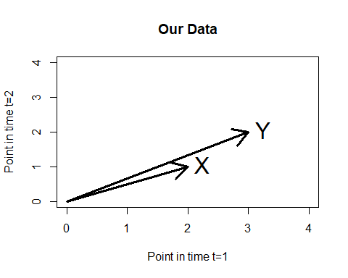
#do reg without abcissa cause it would be trivial to explain two obs with two regressors X and (1,1)!
#would result in zero residuals!
reg = lm(Y~X-1)
summary(reg)
##
## Call:
## lm(formula = Y ~ X - 1)
##
## Residuals:
## 1 2
## -0.2 0.4
##
## Coefficients:
## Estimate Std. Error t value Pr(>|t|)
## X 1.6 0.2 8 0.0792 .
## ---
## Signif. codes: 0 '***' 0.001 '**' 0.01 '*' 0.05 '.' 0.1 ' ' 1
##
## Residual standard error: 0.4472 on 1 degrees of freedom
## Multiple R-squared: 0.9846, Adjusted R-squared: 0.9692
## F-statistic: 64 on 1 and 1 DF, p-value: 0.07917
#so what's going on here?
x11()
plot(c(0,4),c(0,4),xlab="Point in time t=1", ylab ="Point in time t=2", type = "n", main = "Our Regression")
arrows(0,0,Y[1,1],Y[2,1],lwd=3)
text(Y[1,1],Y[2,1],"Y",pos=4,cex=2)
arrows(0,0,X[1,1],X[2,1],lwd=3)
text(X[1,1],X[2,1],"X",pos=4,cex=2)
sample_XY = crossprod(X,Y)#scalar product x1y1+x2y2
sample_XY
## [,1]
## [1,] 8
sample_XX = crossprod(X,X)
b_hat = sample_XY / sample_XX
Y_hat = coef(reg)[1] * X
arrows(X[1,1],X[2,1],Y_hat[1,1],Y_hat[2,1],lwd=3,col="red")
text(Y_hat[1,1],Y_hat[2,1],expression(hat(Y)),pos=4,cex=2,col="red")
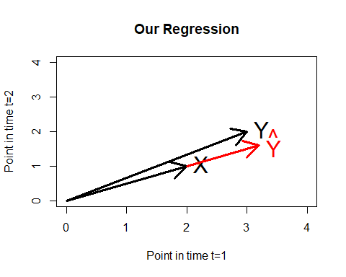
#compare slope b estimators
b_hat#as we have learned
## [,1]
## [1,] 1.6
coef(reg)[1]#the easy way
## X
## 1.6
#do dumb stuff
reg_dumb = lm(Y~X)
summary(reg_dumb)
##
## Call:
## lm(formula = Y ~ X)
##
## Residuals:
## ALL 2 residuals are 0: no residual degrees of freedom!
##
## Coefficients:
## Estimate Std. Error t value Pr(>|t|)
## (Intercept) 1 NaN NaN NaN
## X 1 NaN NaN NaN
##
## Residual standard error: NaN on 0 degrees of freedom
## Multiple R-squared: 1, Adjusted R-squared: NaN
## F-statistic: NaN on 1 and 0 DF, p-value: NA
#and conclude with some reflections
var(X)#note that the squared diffs to mean are divided by n-2=1!
## [,1]
## [1,] 0.5
#for the following read Assenmacher page 87ff (relation between crossproducts and moments)
#in case we had an abcissa as in the last regression we could determine the slope by
cov(X,Y)/var(X)
## [,1]
## [1,] 1
coef(reg_dumb)[2]
## X
## 1
#but without intercept it is as above and cov/var does not work so easily ...
#and what about the residuals?-------------------------------------------------
Xinv = solve(crossprod(X))
resis = Y-X %*% Xinv %*% crossprod(X,Y)
#cross check
residuals(reg)
## 1 2
## -0.2 0.4
resis
## [,1]
## [1,] -0.2
## [2,] 0.4
#ready to get the std dev!----------------------------------------------
#go for sigma-hat...................................
n=length(X)
k=dim(X)[2]
n
## [1] 2
k #number of regressors
## [1] 1
sigma_hat = sqrt(sum(resis^2)/(n-k))
#note division by degrees of freedom makes this an unbiased estimator! in contrast ML esti!
#cross check
summary(reg)
##
## Call:
## lm(formula = Y ~ X - 1)
##
## Residuals:
## 1 2
## -0.2 0.4
##
## Coefficients:
## Estimate Std. Error t value Pr(>|t|)
## X 1.6 0.2 8 0.0792 .
## ---
## Signif. codes: 0 '***' 0.001 '**' 0.01 '*' 0.05 '.' 0.1 ' ' 1
##
## Residual standard error: 0.4472 on 1 degrees of freedom
## Multiple R-squared: 0.9846, Adjusted R-squared: 0.9692
## F-statistic: 64 on 1 and 1 DF, p-value: 0.07917
sigma_hat
## [1] 0.4472136
#and std err of slope..............................
std_error = sqrt(diag(Xinv))*sigma_hat
#cross check
summary(reg)
##
## Call:
## lm(formula = Y ~ X - 1)
##
## Residuals:
## 1 2
## -0.2 0.4
##
## Coefficients:
## Estimate Std. Error t value Pr(>|t|)
## X 1.6 0.2 8 0.0792 .
## ---
## Signif. codes: 0 '***' 0.001 '**' 0.01 '*' 0.05 '.' 0.1 ' ' 1
##
## Residual standard error: 0.4472 on 1 degrees of freedom
## Multiple R-squared: 0.9846, Adjusted R-squared: 0.9692
## F-statistic: 64 on 1 and 1 DF, p-value: 0.07917
std_error
## [1] 0.2
#and a final word:
#demean X towards Xd
Xd = X-mean(X)
crossprod(Xd,Xd)
## [,1]
## [1,] 0.5
var(X)#now it fits
## [,1]
## [1,] 0.5
Yd=Y-mean(Y)
crossprod(Yd,Xd)
## [,1]
## [1,] 0.5
cov(Y,X)#now it fits
## [,1]
## [1,] 0.5
#end

