­­­

**Requirement Walkthrough**

Moments



**COMP208 Team 7**

Yifan Xu

Chen Sun

Chang Liu

Wenxi Ran

Zhanyu Sha

Wentao Shi

14th Feb 2019

***Preface***

The project is consisted of a team of six person, and its developing period is from Feb.2019 to June.2019. The project aims to develop a website to provides students at university of Liverpool with an online interactive platform for integrating social events and campus activities. It will help students interact with student clubs online and quickly gain information on campus events and society activities, facilitate the management of campus society activities, and strengthen the role of communication between students’ societies and students.

We name the website ***Moments*** because the word 'moment' always linked with the picture of 'quicker', 'jiffy', 'short' or 'marrow' which matches what we want to provide to our users, highly integration, high efficiency and timely information. We hope the product could achieve the features that scanning information in a moment, finding information in a moment and sharing information just with one click.

This report will give an overview of the project and analysis users requirements aiming to design an appropriate and feasible system. The report is separated into four sections: project description, statement of deliverables, planning of project and bibliography. The first section *project description* will be talking about the project background, the project target market and give a general description about the project. In second section, *statement of deliverable* will deliver a detailed requirement analysis, anticipated product, documentation and experiments. Use case diagram and system boundary diagram are also provided here to help understanding. Next, *planning of the project* involves work breakdown, people and roles, actives in different stages and time Gantt graph. In the end, the references will be presented for the readers to have a further reading.

Contents

**I.Project Description5**

1.1 Mission Statement5

1.2 Main Users5

1.3 Mission Objectives6

**II. Statement of Deliverable** **7**

2.1 Anticipated Software7

2.2 Anticipated Documentation7

2.3 Anticipated Experiments and Evaluation8

2.4 User Views11

2.5 Functional Requirements14

2.6 System Boundary Diagram19

2.7 Transaction Requirements20

2.8 System Requirements21

**III. Project Planning23**

3.1 Work Breakdown23

3.2 Preperation Stage23

3.3 Design Stage24

3.4 Implement Stage25

3.5 Risk Management26

3.6 People and roles29

3.7 Gantt Graph30

**IV. Bibliography31**

I. Project Description

Chapter 1

**Mission Statement**

*“As a result of the development of computers and communications during the last several decades, information overload has become a great concern, in which case the amount of information that worth attention actually outdistances the individual's ability on dealing with it[1].”*

We are making an interactive and user-oriented social media website, which creates an active environment for students and societies to interact with each other. Its target users are students, clubs and societies in the university of Liverpool, and some of the university official departments. Students are allowed to get approach to various societies and events quickly and easily. Also, various functions added helps students interact with their societies much more efficiently.

Chapter 2

**Main Users**

The intended audience for the system includes 200+ students societies and clubs[2]. Our main users will be 22,000+ students, 7,700+ travel from across the world to study at the university of Liverpool[3]. They are mainly youths around age of 20 with broad interest and are active in participation of social activities.

Chapter 3

**Mission Objectives**  
*“Participation in clubs and organizations has proven to be positively related to several areas of psychosocial development[4].”*

Specifically, third-year college students who are members of student organizations score higher than non-student in factors such as educational participation, career planning, lifestyle planning, cultural participation, and academic autonomy [5]. The study also showed that first-year students who joined the student organization scored higher on development goals than students who did not join the student organization [5].

In light of student societies activity posts on Facebook or Twitter, we feel like it is not efficient for people, especially for international students or freshman, to overlook important activities due to information overload and reading fragmentation. Scattered information is inefficient, which leads to the phenomenon that a number of international students, or even local students, do not know the exist of some of the societies, or it is hard to get in touch to some known societies. Also, the relations between different societies are weak, so there are few cooperation events or competition.

Due to the reasons above, there is a need for an ease use, interactive platform with various interactive functions to enhance relationships between societies and students, societies and societies, which will benefit for both students and student clubs and societies.

The web is designed to be applied to most of the scene related to the societies. Such as create a society, join in a society, manage a society, launch events, participate evens, make comments, recommend, vote, group chat and so on. Furthermore, it has search, subscribe, language transfer and other functions to make it more convenient to participate in events, communicate or share information and make friends.

The web aims to help and encourage young people to join in clubs and societies, participate more events and find friends in the same camp. By reduce the information barriers and make information in order, users can enjoy their school life with societies and clubs better.

II. Statement of Deliverable

Chapter 1

**Anticipated Software**

1. Current anticipated software:

* Website: The website is our core of the product. It is a connection between the database system and the users, services will be provided via the website interface.
* MySQL database: Database will store the basic information about the users

2. Further developing project:

* App: Including Android and IOS app. Considering it might be more convenient for students to use the system, we also will develop mobile application version of the system.

Chapter 2

**Anticipated Documentation**

* User manual for the users
* Full description of system design and architecture, for future maintenance
* Full description of database design
* Description about the related vital algorithms applied to the website
* A testing summary and website evaluation report
* Interface documentation

Chapter 3

**Anticipated Experiments and Evaluation**

* **Functional Testing**

*Determine whether the systems meet all functional requirements and ensures the requirements are properly satisfies by the website.*

* List a collection of system inputs data based on the functional requirements.
* Determine expected outputs according to the functional requirements.
* Feed the system test cases and record the actual outputs.
* Compare the actual outputs with the expected results.

During the functional testing, ***equivalence partitioning technique*** and ***black box testing*** technique are used. The test case will be divides into valid and invalid partitions and the representative values from each partition will be selected from each partition as test data. The internal structure and implementation of the item being tested will not be considered. If all the inputs have the expected corresponding output results, the system passes functional testing.

* **Performance Testing**

*Evaluating how well the website will perform under the expected workload*.

* Determine the time from when a user enters a request until the first character of the response is received
* Determine maximum number of users load the software website simultaneously can handle
* Determine if the website is stable and the request can be handling correctly under varying loads

A specific workload will be simulated by automated clients performing user actions at random. The system should be capable of allowing these clients to communicate with one another in a limit time.

* **Usability Testing**

*Ensure the system is ease of use to the most of the first-time-use users under the situation which without consulting the manual.*

* Users should be able to implement the basic functions like **searching societies** (or activity), posting personal information, registering for events with the minimal frustration after a 10 minutes trial.
* Ensure the users could get their expected outcomes in a **suitable limited time**. Take an example, the users are able to quickly find the related society activities holds recently by searching specific keywords in search bar.

After the training, giving five random system instructions to test the users and record their correctness rate and the time to implement each instruction. If **more than 95% first-time-use users** do not make exceed one errors on average and the average time is in an acceptable manner, the system passes the testing.

* **Recoverability Testing**

*The purpose of recoverability testing is to verify the system’s ability to recover from varying points of failure. Testing whether the operations can be continued after a disaster or after the integrity of the system has been lost.*

* Provide some unexpected situations which might **possibly cause problems to test**. The system should be able to keep running after receiving unexpected data.
* Terminate the network connection while the website is running and **analyse the system’s ability** to continue receiving data from the point at which the network connection is broken
* **Restart the system** while the website has a definite number of sessions are uploading and check whether the system is able to recover all the information or not

The testing bed should be as close to the actual conditions as possible. The places where the obsolescence happens, corresponding testing results and the time recovery from damage should be recorded. Each test should be run at least three times and the system is not perfect at recovering from the crashes if any test fails once or more times on one specific failures. After restoration, the basic function implementations including searching, uploading, editing and deleting record should be retest again in case the restoration test damage.

* **Security Testing**

*The system should ensure the security of users’ personal information and prevention the misuse or attack of the system. Experiments could be implemented from following aspects:*

* Test the **aspect of authentication** by inputting different pairs of username and password. The system should only allow correct pairs of username and passwords and reject continuing user’s operations under wrong pairs account information.
* **Detect sensitive information**. Cookies should not store any sensitive information likes password, username etc and all sensitive information should be encrypted. Once the risk of account leakage is detecting, the system should remind users.
* Test the **website on professional testing software**.

The system should be adjusted immediately if any test fails in security testing period. It is important to keep the system itself and vital information safe.

Chapter 4

**User Views**

Our project aims to provide a specific campus student with effective information integration, campus activity online interaction, campus society services and other services. It helps students to quickly browse information on campus events and society activities, facilitate the management of campus society activities, and strengthen the role of communication between universities and students. The essential features of the project are **integrating information** about university, societies and events. The desirable features of the project are to using the website to **make friends and finding the events interested** the user. The website has three different types of users: **students of a specific campus, society management and university department administrators.** All three types of users can perform searching university activity information and register for events.

* **Requirement According to Different User**

*The website mainly designed for college students and helps students integrate the societies and university official information and facilitate students' timely knowledge of societies and university trends.*

Hence, there are three main user perspectives: **student, society management and university official department administrator**. The following paragraphs will describe the user requirements regarding different user views in details.

**1. Student**

In our definition of the project, 'Student' user indicates all the students who are from the same university. Student is the largest and most regular user group of our webpage. For students, Moment website is a platform to **finding interesting events**, catching university information timely, joining societies and providing advises to university department. Students could search for their favourite activities and societies, apply joining the societies they like. They could register the activities and give comments to the events through the website. Moreover, users could post their personal updates to share information. One more attractive function to students is that students could feedback in the university department's homepage anonymously which brings more convenience for students to give advices to university.

|  |  |
| --- | --- |
| **Student** | *Student* user indicates all students who are from the same university. |
| **Related Requirements** | 1. Own an account on the website 2. Edit personal information 3. Search information 4. Join/quit societies 5. Register/cancel events 6. Post information on personal webpage 7. Group chat 8. Make comments under society/ event/ department homepage |

Table1: Student view

**2. Society Management**

'Society management' user represents the administrators of the societies. Society management is an important role in our webpage system, they will in charge of the Moment webpage to do the operations like **launch information, creating actives** and **managing society members**. They could use the website to advertise their societies and post their activities. At the first beginning, the society administrator needs to apply for creating a society platform on the website. Once verifying, each society will **be assigned a specific website** account for managing the homepage. By using Moment, society managements could launch/delete events and official information and modify events. Secondly, societies could use the website to manage the members of the society. Each society would have their own chat room which brings a better communication method for society members.

|  |  |
| --- | --- |
| **Society Management** | *Society management* user represents the administrators of the societies and the person who will in charge of the Moment webpage operations |
| **Related Requirements** | 1. Own an independent account on the website 2. Edit society homepage information 3. Create & edit activities 4. Launch notifications 5. Group chat 6. Managing society members (like deleting person etc.) |

Table2: Society management view

**3. University Official Department Administrator**

University official department administrator user represents the administrators of the university department (like library, student office etc). For university department administrator, the website's target is to **sharing official notification,** collecting students’ thoughts and advises. This system could be beneficial to strengthen the connection between students and university. Same as the society management, each university department will be firstly assigned an account for homepage maintenance. (However, department administrator does not need to create a page in website for department pages are already set in advance.) University department could launch official event or information through the platform. In addition, each university department will have a particular section in homepage for collecting feedback or questions from students.

|  |  |
| --- | --- |
| **University Department Administrator** | *University official department administrator* user represents the administrators of the university department (like library, student office etc) and the person who will in charge of the Moment webpage to do the operations |
| **Related Requirements** | 1. Own an account on the website 2. Edit university department homepage information 3. Create & edit activities 4. Launch official notifications 5. Group chat 6. Collect feedback (comments) from students |

Table3: University official department view

**In summary**, the requirements of the system could be possibly divided into **three main parts** according to the different user views. The types of user, the relationship between users and how they could use the system properly has been shown in the system use case diagram below.

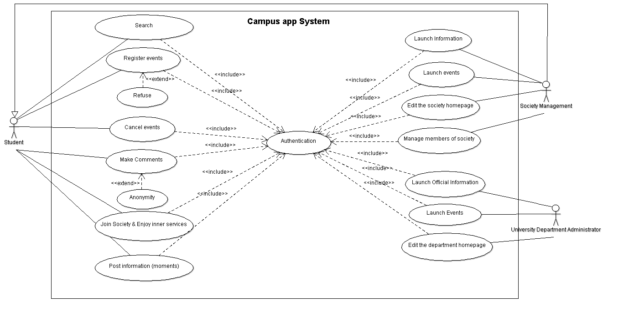Figure1: System User case Diagram

Chapter 5

**Functional Requirements**

*This Chapter will discuss about the functional requirements of the webpage point by point and will provide the user an overall impression of the system about what the website can do*. *Chapter5 is divided into two sections. The first section 'Essential Functions' will set forth ten main essential functions of the webpage which will be developed during the project. The second section 'Inessential Functions' will deliver six webpage functions which might be developed during this project or will be produced in the future webpage developing projects.*

* **Essential Functions**

**1. Registration and login**

The web provides a registration and login page for the user to register and log in. There are three kinds of accounts provided by the system and each kind of accounts own different privileges and permissions. They are student account, society management account and university official account. Each user will have their own account, which includes their personal information, societies’ information and personal activities’ information. The account information will be stored in the system database.

**2. Create a society**

The user can call four more users together and create a society by providing the relation documents and gain acceptation. During this procedure, a university API may be used to match the official information provided by the university and the creating-society documentation from the applier. After verifying, their accounts become society management accounts. Each society has its own home page providing the basic information like society introduction, contact information and recent activities.

**3. Join in a society**

The user can join in a society by entering the society’s home page and providing the application form. After gain one of the society management account’s permission, he/she could become a member of this society. A member of a society can uses some inner functions of a society, such as chatting in the group and sharing documents within the group.

**4. Manage members of the society**

The society manager can **manage the society** by permitting a user to join in, kicking a user out and adjusting members’ privilege in the society. A management account can transfer the management authority to another account.

**5. Post activities**

A society or a university official department can **post its activities** on their homepages. The activity manager only needs to filling in the content into corresponding places and an event page could be produced automatically. Usually an activity has its basic information, such as time, place, description and restrictions. It can also set to be free to all participates or only after confirming. It can also invite some of the users to participate. In addition, when the organizer posting an activity, the system provides voting service which benefits to statistics data.

**6. Participate/Cancel an activity**

A user can participate an activity by clicking the button which shown on the activity main page. If the activity has constraints on the number of participants, activity participant or any other limitations, users who willing to join the activities need to be confirmed by the activity organizer. After confirming, the event schedule will be shown on the users' personal page.

**7. Make comments**

Students could make comments on activities or share their activity moments under the discussion board. A user can make comments to an activity after participating the event. They also could comment under the department homepage to give advises and the users could choose comments anonymously. Hence, manager of student societies or departments could hear students’ voice and get feedback though this discussion board. The right to delete or keep the comments only kept by the student user and departments or societies do not have privilege to delete comments. The data of this discussion board will be stored in MySQL database system. Followed by the web privacy policy, our system constructive database would ensure the data independent and easily manipulate, with system scalability and modifiability.

**8. Post information**

All accounts can post their information. For a student account, it can post their moments on their personal page. It can also post notifications under a society’s home page or an official department’s homepage, intending to make comments, ask questions, giving feedback, or looking for friends. For a society management account or an official account, it can post information on its homepage to advertise.

**9. Group Chatting**

Users can chat with each other if they are both members of the same society. Group chatting system is based on the PHP and MySQL technical language to provide a communication room. Users in the same society can also chat in the society’s group. They can also share documents and send pictures on their chatting interface. The system may support users several activities, such as creating generating with an identifier, inviting member joining, searching for the identifier and joining a group.

**10. Search**

The website allows users to search for an activity, official notifications or an official department/society account on its home page. The result list can be shown in order with the similarity or time depending on the users’ option. Moreover, the website applies the function by content recommendation algorithm to recommend similar activities to the user based on the user's search item content.

* **Inessential Functions**

There are six potential functions will be applied to provide closely interaction between students and students societies, including subscription and push, message reminder, location, language transfer, recommender and voting function.

**1. Subscription and Push**

A user can subscribe a society, an official account or another user. After that, their information posted will be pushed to the web’s home page. Moreover, if an activity or any notification is popular enough (the pageview index exceed the standard level), the hot content will also be pushed with its popularity index to the home page automatically.

**2. Message Reminder**

The web will remind the user information automatically by jumping out the mobile phone notification. There are two main types of information remind the users, the incoming events and new release notifications. For example, the student will receive new activity news from the club and activity reminders on his calendar, as well as he becomes one of member in the student clubs.

**3. Location**

The web provides a location position function. Societies can set their default office place or activity space. It can also be used to mark a meeting or an activity place.

**4.Language transfer**

To be international user friendly, the web use English as the default language. Additionally, it provides language transfer function and Chinese will be supported at least

**5. Recommender**

Compared with the other universities’ websites, we feel like applying the **recommender system** could be a useful strategy to develop a **more user-oriented web**. Our recommender system will be based on the database of comments and rating system and **apply ML algorithm** to mining data. For example, if users A, B and C gave a 5-star rating to books X and Y then when a user D buys book Y they also get a recommendation to purchase book X because the system identifies book X and Y as similar based on the ratings of users A, B and C [6]. Slimily, our system can recommend the potential interest of clubs and activities to users based on users’ **previous participated or searched or rated activities**. During the registration part, system could also provide students a questionnaire about which categories of activities they are interested in. These data will be stored on the MySQL databases and later be used by the recommendation system. This ‘**activity similarity-based recommender system’**(Figure2) to encourage students to join more interesting activities.

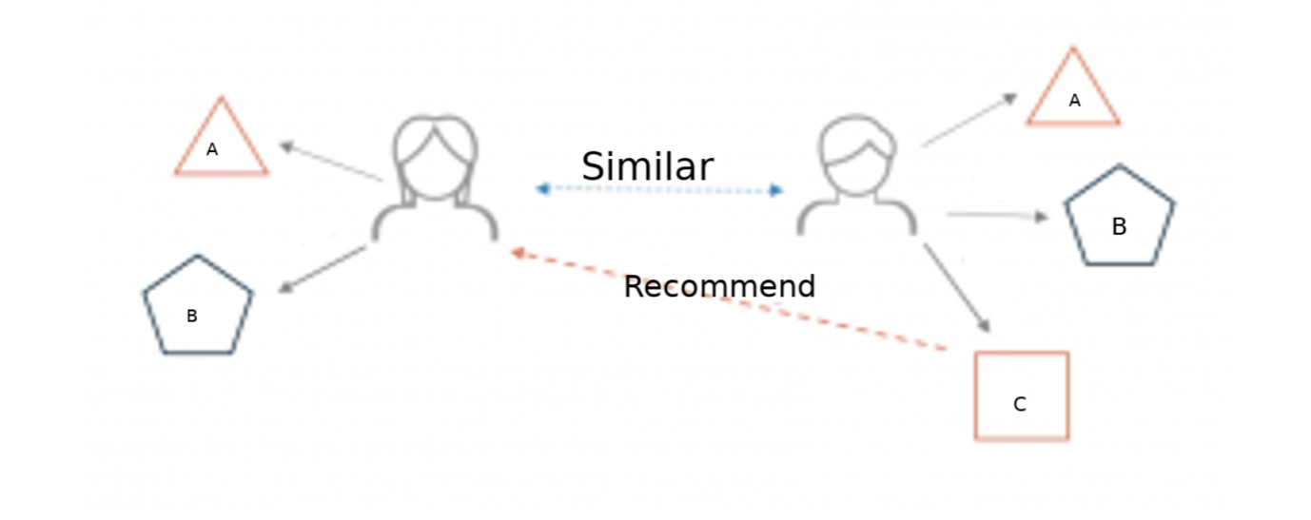

Figure2: Activity Similarity based Recommender System

**6. Voting system**

**Voting system** could also be a useful strategy to collect feedback or hear notices from students. Voting system could support students to vote for activities of student clubs and societies such as Top Ten Singers Vote or Student Council Presidential Election. The system will be based on Java, JavaScript and XML languages. In order to designing a secure voting system and protecting users form accidental failure, analysis of attack, and intentionally malicious code [7]. Our system would apply safety strategies to validate user and vote before counting to the final result [8]. The database that created would also calculate the data before show the data to the official website interface [8].

Chapter 6

**System Boundary Diagram**

The user can register the website by the user interface. All functions and data flow that produced by the user’s operation will be included in the system boundary. All the data will be stored in a database, which may include the information of each user, society, and activity, the relations between users, societies and activities, users’ comments and their dialogue. The administrator manages the database. So, the administrator can supervise all the operation on the web. But the user must give their permission before using the website.

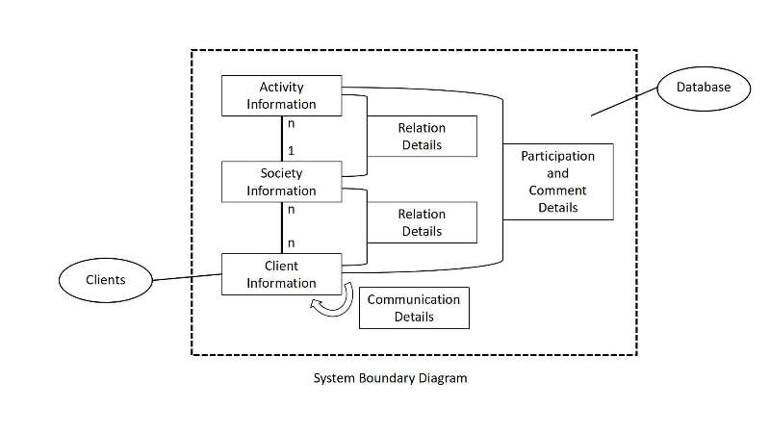

Figure3: System Boundary Diagram

Chapter 7

**Transaction Requirements**

**1.Data Entry**

1. Enter the details of a new client.
2. Enter the details of a new society.
3. Enter a new activity to a society.
4. Enter the details of a new activity.
5. Enter a new member to a society.
6. Enter a new comment to an activity.
7. Enter a dialogue to another client.

**2.Data Update/Deletion**

1. Update/delete the details of a client.
2. Update/delete the details of a society.
3. Update/delete the details of an activity.
4. Update/delete the details of a comment.

**3.Data Queries**

The database should be capable of supporting the following sample queries:

1. List the details of a society.
2. List the details of an activity.
3. List the members of a society.
4. List the societies that a client has joined in.
5. List the activities that a client has participated in.
6. List the comments of an activity.
7. List the dialogues between two clients.
8. List the most popular activities.
9. List the most popular societies.

Chapter 8

**System Requirements**

1. Each user should use a pair of username and password to log into the system. The system should also have the ability to login remotely. Moreover, the system should have high-intensity passwords to access, which should include uppercase and lowercase letters and numbers, and be longer than 9 digits. The password should be stored as cipher text encrypted by HASH such as MD5, SHA1, SHA256 rather than plain text in the database.
2. The webpage should be compatible on kinds of browsers, like Firefox, Chrome, IE etc. Functions should be run normally; the webpage layout can be adjusted according to the user's browser window size. In addition, the webpage should be enabled to fit into different operation systems, such as Windows and IOS system.
3. The operation of the system should under the condition of network connection. Website background management system will also be applied here bringing convenience to manage the website.
4. The system should be able to detect the stolen of sensitive information, like user password. Encryption methods will be used here to protect the user privacy.
5. PHP, Apache, MySQL should be used in the development of a new environment for network station. Website should be developed in Linux such as CentOS 7.
6. The database size can store at least 100 tuples.
7. A work load will be simulated by automated clients performing user action at random. The system should allow at least 100 users use the webpage simultaneously.
8. The website related source code and database should be backed up every 30 days, and the backup data is stored in the developer's local computer. The backed-up data should not be open to the public and it should be only accessed by secret password if they will be stored on the website server.
9. The website should obey EU data protection regulations, local laws and regulations. It is better to revise the privacy protection policy of our own system, corresponding to the EU's new Personal Data Protection Act.
10. The database system should maintain the 'ACID' properties: Atomicity, Consistency, Isolation and Durability. Atomicity indicates all transactions should be executed as an atomic unit of processing. Consistency means that a correct execution of the transaction must take the database from one consistent state to another. Isolation means that a transaction only makes its updates visible to other transactions after it has committed. Durability focuses on that when a transaction commits and changes the database the changes cannot be lost because of subsequent failure.
11. Considering security, the related software that developing website might concerns should be the newest or nearly fresh new version.
12. The following parameters are specific version numbers of programming language, operating system, software tools and database which will be used in the testing environment. (But might have some adjustments in later period)

* Operating system: CentOS 7.5
* Web server software: Apache 2.4.25
* Database: MySQL 5.7.19
* Database management software: phpMyAdmin 4.7
* Backend programming language: PHP 7.0

III. Project Planning

Chapter 1

**Work Breakdown**

Our project focuses on providing interactive serves between students and students clubs and societies. The *Work Breakdown* part is about an overview of several different stages of our project. The main plan involves the following four flowing stages:

1. Background search and requirement analysis

2. Design website stage

3. Implementation and testing stage

4. Risks analysis and demo project stage

Chapter 2

**Background Preparation**

Before starting the project, we have done preparations from four aspects, including background search, competition analysis, requirement analysis and information privacy. **Background research** focus on finding out the mission statement and mission objective of our project. Information overload could be one of main problems that our website wants to solve. In terms of competition advantage, we find out that the interactive relationship between students and student clubs and societies is not very strong, when being compared other university’s society website with guild society website. Information privacy could be another issue we decide to focus on enhancing the privacy of database and Network encryption. Also, we will have a security policy for users, we have no access to their personal information, before they agree the privacy policy. For the requirements analyses, we would divide it into functional and non-functional requirements, followed by some potential optional systems, in order to meet the user’s requirements. In summary, we will spend 3 weeks on this part.

Chapter 3

**Design Stage**

The design stage aims to produce an integral structure of the particular product which is set as the implementation target later stages. We will spend 3 weeks on design period. This stage contains two parts including method design and the documents design. As for the design method, we will use ***Object-oriented design methods*** in this stage. According to the actual condition to complete the architectural design, database design, interface design and components selection and design. The first stage in most of the software design processes is to develop an understanding of the relationships between the software that is being designed and its external environment. Understand and define the context and the external interactions with the system. Once the interactions between the software system and the system’s situation have been described, the interactions will serve as a basis for designing the system architecture. Then we will identify the object classes. As the understanding of the design develops, we refine these ideas about the system objects. The use case description also contributes to identifying objects and operations in the system after this consider interface and multiplexing. Design documentations will include system architecture documentation, database design description, interface specification documentation and component descriptions. The expected result in design stage is all parts of the activity and class diagram and the design report.

Chapter 4

**Implementation stage**

Implementation stage is about the process to achieve the requirements from the users. As the plan, we will spend 4 weeks on the implementation stage. In this period, programming (including hardware and software) and testing are applied. However, programming and testing are not completely separated and are often interleaved. At the beginning, we aim to produce an interactive website. If time is available, we will also design a mobile app version of the application in the later period. The workload of producing the website will be divided into two steps, including Web frontend design and Web backend design. On the first step, there will be three persons in charge of designing the user interfaces of the website, and mainly using *HTML*, *CSS* and *JavaScript* languages to reach the webpages. On the side of backend, there are also three people assigned here will using *MySQL* and *PHP* to design the database and the interaction between web and web server.

The testing part will be divided into five parts, including functional testing, performance testing, usability testing, recoverability testing and security testing. More details about testing methods and processes are already discussed in *Anticipated experiments and Evaluation* chapter of *Statement of Deliverables* section.All testings will be done before presenting our website to users. If any testing fails, the system will be retested again to ensure the problem will not happen again.

Chapter 5

**Risk management**

*Every project has risks. If a potential risk of the project is not identified early, then the project will have a high risk to fail as per schedule or complete with a low quality [9]. Hence, risk management is necessary for the project implementation. List general risks is beneficial*

*to identify the project risks and find the corresponding solutions quicker. The primary purpose in this section is to estimate potential risks and analyze effect or threat of that then establish corresponding solutions to minimize effect, ensuring the completion of the whole project*.

* **Risk Analysis**

**1.People risk**

There are always some unavoidable human factors will cause effects to the implementation of the project. The following list four possible situations which belongs to people risk:

1. Team members may be sick or have accidents that he/she cannot finish work or complete the task on time.
2. There are divergence exists between team members which might lead to the gap cooperation and thus a low team work efficiency.
3. Team members have different understandings on the design and requirements, hence the work outcomes of individuals might exist gaps which makes it difficult to integrate results into a complete and consistent product.
4. Personnel need extra time to get familiar with the hardware, programming language or software tools.

*Risk Effect: Catastrophic*

1. Lead to low efficiency. A delay in one task causes cascading delays in the dependent tasks. In the end, the cascading delays might result in the project cannot complete within the limited time.
2. Other team members workload will be increased to fill in the loss / delay caused by people risks

*Avoidance strategies*:

1. Assign two members to each partition task. Each task is implemented interactively. The job of every team members needs equally distributed and when accidents appears everyone in the group can share some works.
2. Set a detailed agenda in advance and leave extra time for unpredictable risks
3. Make a sufficient preparation before the project starts. For example, arrange team members learn the requisite knowledge ahead of schedule.

*Minimization strategies*: Assign more people to join the sub-task and ensure every task is shared by several person simultaneously.

2.**Estimation risk**

Estimation risk indicates that the group cannot estimate the time properly when developing our fundamental and extensive functions. The following shows two situations about the estimation risk:

1. Unfamiliar areas of the product take more time than expected to get familiar with.
2. Programmers are not familiar with the requirements and take more time to learn the requirements

*Risk effect*: Serious.

1. Lead to low efficiency. A delay in one task causes cascading delays in the dependent tasks. In the end, the cascading delays might result in the project cannot complete within the limited time. The whole plan might be broken down.
2. Other team members workload will be increased to fill in the loss / delay caused by people risks

*Avoidance strategies*:

1. Setting milestones and deadlines for each step. Re-planning the timetable during the different stages.
2. Assign two members to each partition task. Each task is implemented interactively. The job of every team members needs equally distributed and when accidents appears everyone in the group can share some works.
3. Set a detailed agenda in advance and leave extra time for unpredictable risks
4. Make a sufficient preparation before the project starts.

*Minimization strategies*:

Flexible assign more group members to handle delayed or important main tasks.

3. **Technology risk**

Technology risk means that there are some unexcepted situations on the accept of technical realization. The following list four situations of the technology risk:

1. Failure of transactions in database
2. Development of wrong webpage interface results in redesign and implementation [9]
3. The backend design operations cannot match with the frontend design operations
4. The requirements for interfacing with other systems are bounded the group’s knowledge scope [9].

*Risk effect*: Catastrophic.

1. Might lead to information leak problem and users will not use our web sandy more.
2. The webpage cannot work normally. More seriously, the webpage might crash down when the user is using it
3. Technical risk will cause the revise work of the codes and might lead to the delay of the whole project.

*Avoidance strategies*:

1. Be familiar with and obey related programming rules: Construct database according ACID principles and being serious in database modification queries. Enhance the security privacy encryption level.
2. Have a good communication with all the team members. Consensus the design, requirements and the coding distribution of each member. Ensure the work outcome keeps consistency.

*Minimization strategies*:

Adjust the defective software components, limiting their functionalities.

Chapter 6

**People and Roles**

This chapter will show the project workload distribution. The workload including the writing of documentations, the design of project structure, testing system, programming and etc. From the following table, we could easily to find every member's responsibility.

|  |  |
| --- | --- |
| People and Roles | |
| **Group Member** | **Major Tasks** |
| Yifan Xu | * Requirements elicitation and analysis * UI design * Collection and entry of sample data * Website back-end implementation |
| Chen Sun | * Requirements elicitation and analysis * Website front-end implementation and Supervision * Acceptance/user testing * Application design and implementation |
| Wentao Shi | * Requirements elicitation and analysis * Website front-end implementation * Acceptance/user testing * Editor of Report |
| Wenxi Ran | * Requirements elicitation and analysis * UI design and implementation * Website front-end design * Acceptance/user testing |
| Chang Liu | * Requirements elicitation and analysis * UI design and implementation * Website back-end implementation * Collection and entry of sample data * Database design and implementation |
| Zhanyu Sha | * Website back-end implementation and Supervision * Database design and implementation * System testing * Collection and entry of sample data |

Table4: Workload Distribution

Chapter 7

**Gantt graph**

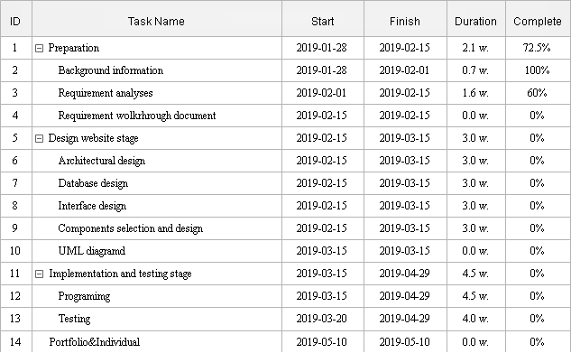

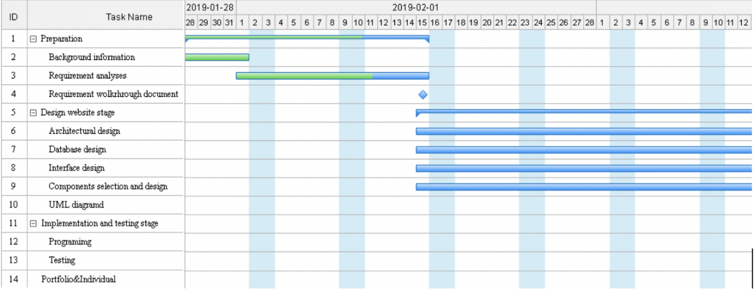

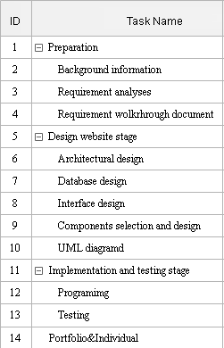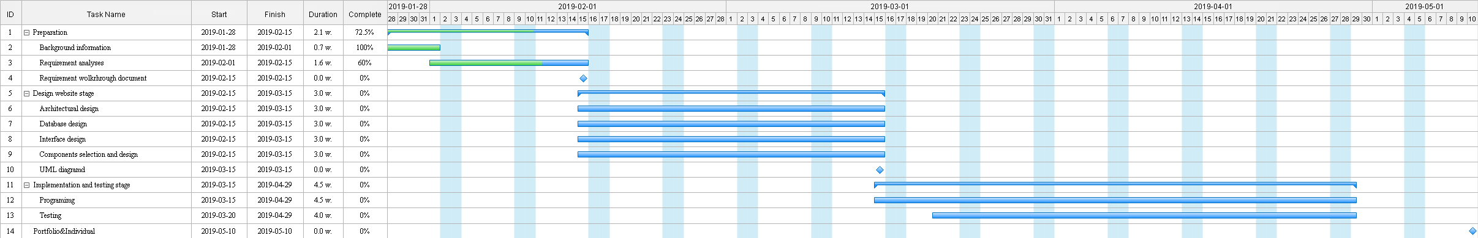

Figure 4. Gannt gragh

IV. Bibliography

1.U.lrike,B.Vandenbosch,”Information Overload in a Groupware Environment: Now You See It, Now You Don't,”Journal of Organizational Computing and Electronic Commerce ,Vol.8,pp127-148,June 09,2010.[Online].Available:

<https://www.tandfonline.com/doi/abs/10.1207/s15327744joce0802_3>

2.“About us,”[liverpool.ac.uk,2019.[online].Availabel](http://liverpool.ac.uk):

<https://www.liverpool.ac.uk/about/>

3.“Societies,”[liverpoolguild.org,2019.[online].Available](http://liverpoolguild.org):

<https://www.liverpoolguild.org/main-menu/societies>

4. J.D.Foubert and L.A.Urbanski, “Effects of Involvement in Clubs and Organizations on the Psychosocial Development of First-Year and Senior College Students,”NASPA Journal,Feb 10,2006.[Online].Available:

<https://www.tandfonline.com/doi/pdf/10.2202/1949-6605.1576>

5. Cooper, D. L., Healy, M. A., & Simpson, J. (1994). Student development through involvement: Specific changes over time. Journal of College Student Development, 35, 98–102.

6.D.Mwiti, “How to build a Simple Recommender System in Python,” Towards Data Science, Oct 3, 2018.[Online].Available:

<https://towardsdatascience.com/how-to-build-a-simple-recommender-system-in-python-375093c3fb7d>

7.T.Selker and J.Goler,“The SAVE System — Secure Architecture for Voting Electronically,” BT Technology Journal, Vol 22, pp 89-95, Oct, 2004.[Online].Available:

<https://link.springer.com/article/10.1023/B%3ABTTJ.0000047587.09395.e5>

8.N.M.Salish and M.Z.Norsid,“A DESIGN OF VOTING SYSTEM BY USING AN ANDROID APPS FOR FISHERMAN,” ARPN Journal of Engineering and Applied Sciences, Vol 12,Mar, 2017. [Online].Available:

<https://www.researchgate.net/publication/315665861_A_DESIGN_OF_VOTING_SYSTEM_BY_USING_AN_ANDROID_APPS_FOR_FISHERMAN>

9.R.M.Rawi,“Project Risk Identification For New Project Manager,” [PMtimes.com](http://PMtimes.com), 2013.[Online].Available:

<https://www.projecttimes.com/articles/project-risk-identification-for-new-project-manager.html>

10.T.M.Connolly and C.E.Begg,“Database Solutions,” Addison Wesley, Nov, 2007.[Online].Available: <https://www-dawsonera-com.liverpool.idm.oclc.org/abstract/9781405890342>