Overview
This file is a specification of the model created by UML definition

Package List
Full Name | Summary
[Root]
Diagrama BCE::Casa Lar
Diagrama BCE::Crianca
Diagrama BCE::Familia
Diagrama BCE::Plano de atendimento familiar
Diagrama BCE::Plano de atendimento individual
Diagrama BCE::Rede de apoio
Diagrama BCE::Usuário
Diagrama de Classes
java::lang
java::util

[Root] Package

Classifier List
Name | Type | Summary
BigDecimal | Class

Class

BigDecimal [Class]

Declaration
public class BigDecimal

Namespace
[Root]

Diagrama BCE::Casa Lar Package

Classifier List
Name | Type | Summary
CasaLarService | Control
casa-lar-controller | Control
casa-lar-form | Boundary
casa-lar-list | Boundary

Diagram

Diagrama BCE::Casa Lar::Casa lar[Class Diagram]

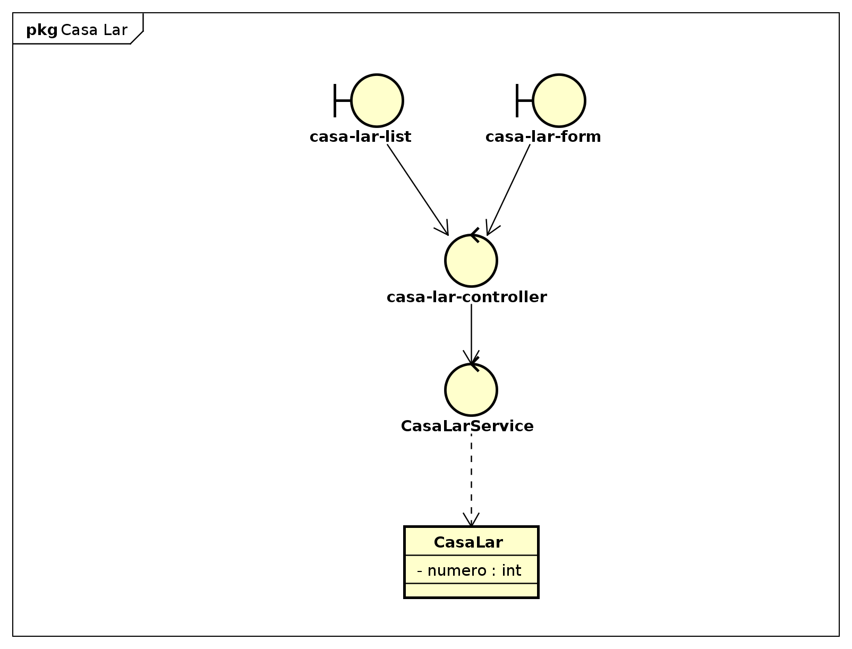

figure 1: Diagrama BCE::Casa Lar::Casa lar[Class Diagram]

Class

CasaLarService [Control]

Declaration
public class CasaLarService

Namespace
Diagrama BCE::Casa Lar

Stereotype
<<control>>

Relation (From Source To Target)
Name | Type | Target | Summary
 | Dependency | CasaLar

casa-lar-controller [Control]

Declaration
public class casa-lar-controller

Namespace
Diagrama BCE::Casa Lar

Stereotype
<<control>>

Relation (From Source To Target)
Name | Type | Target | Summary
 | Association | CasaLarService

casa-lar-form [Boundary]

Declaration
public class casa-lar-form

Namespace
Diagrama BCE::Casa Lar

Stereotype
<<boundary>>

Relation (From Source To Target)
Name | Type | Target | Summary
 | Association | casa-lar-controller

casa-lar-list [Boundary]

Declaration
public class casa-lar-list

Namespace
Diagrama BCE::Casa Lar

Stereotype
<<boundary>>

Relation (From Source To Target)
Name | Type | Target | Summary
 | Association | casa-lar-controller

Diagrama BCE::Crianca Package

Classifier List
Name | Type | Summary
crianca-controller | Control
crianca-form | Boundary
crianca-list | Boundary

Diagram

Diagrama BCE::Crianca::Criança[Class Diagram]

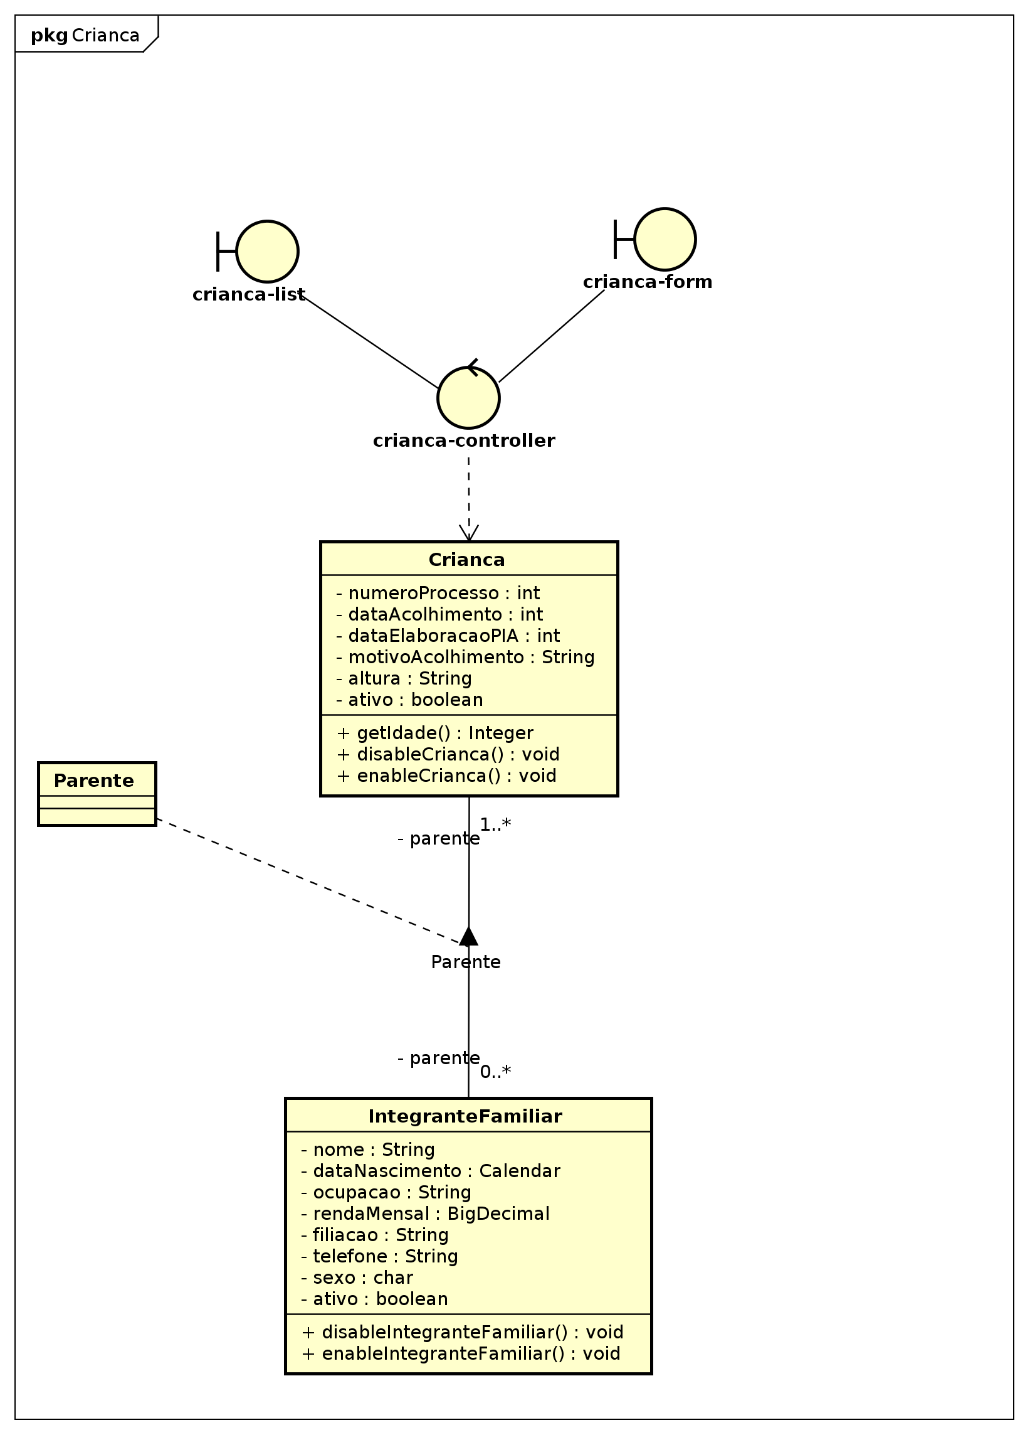

figure 2: Diagrama BCE::Crianca::Criança[Class Diagram]

Class

crianca-controller [Control]

Declaration
public class crianca-controller

Namespace
Diagrama BCE::Crianca

Stereotype
<<control>>

Relation (From Source To Target)
Name | Type | Target | Summary
 | Dependency | Crianca

crianca-form [Boundary]

Declaration
public class crianca-form

Namespace
Diagrama BCE::Crianca

Stereotype
<<boundary>>

Relation (From Source To Target)
Name | Type | Target | Summary
 | Association | crianca-controller

crianca-list [Boundary]

Declaration
public class crianca-list

Namespace
Diagrama BCE::Crianca

Stereotype
<<boundary>>

Relation (From Source To Target)
Name | Type | Target | Summary
 | Association | crianca-controller

Diagrama BCE::Familia Package

Classifier List
Name | Type | Summary
familia-controller | Control
familia-form | Boundary
familia-list | Boundary
integrante-familiar-controller | Control
integrante-familiar-form | Boundary

Diagram

Diagrama BCE::Familia::Familia[Class Diagram]

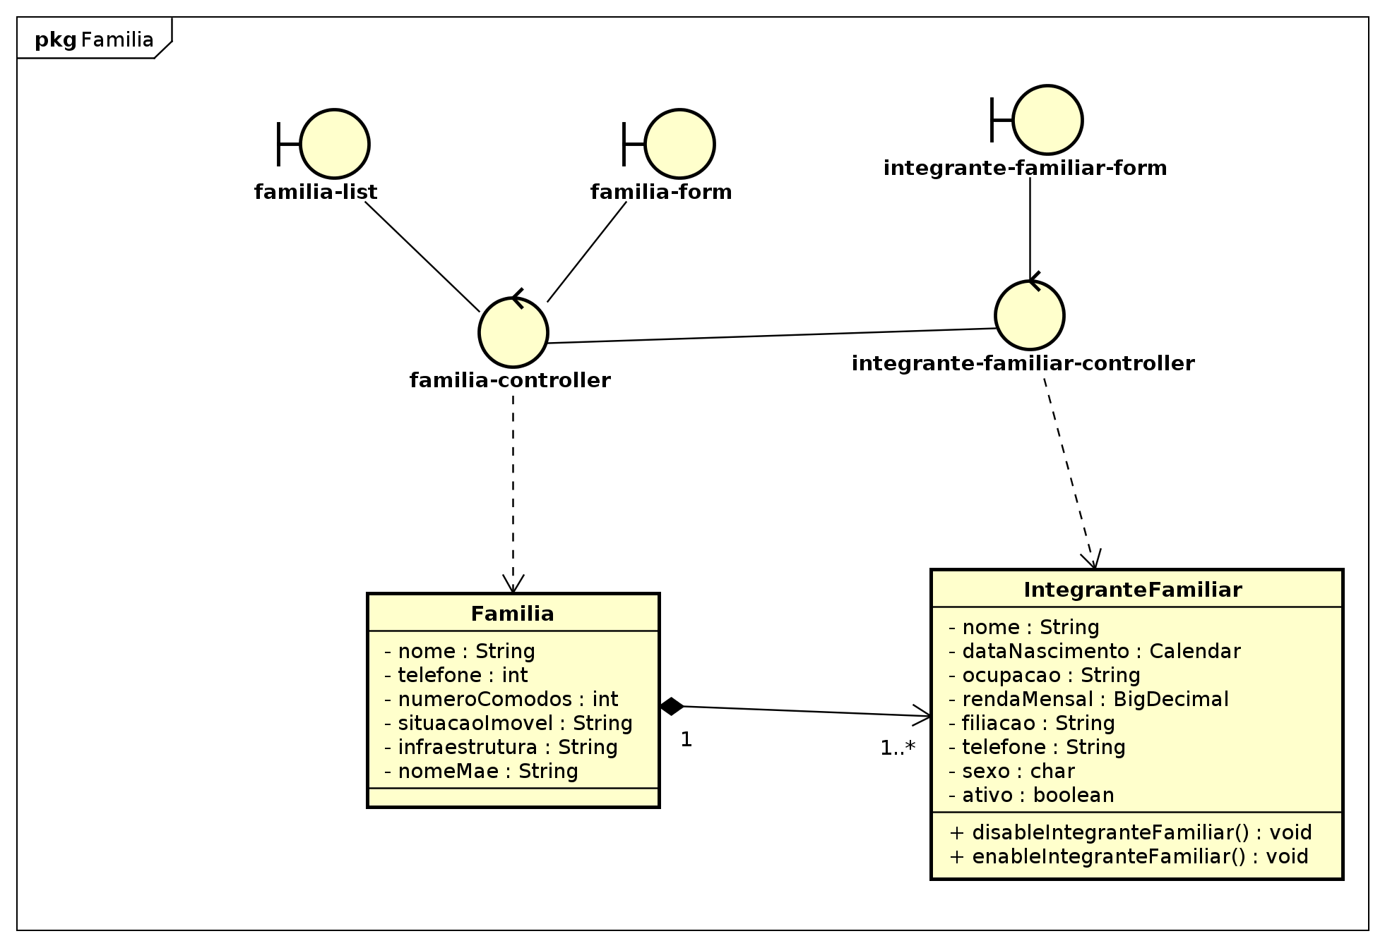

figure 3: Diagrama BCE::Familia::Familia[Class Diagram]

Class

familia-controller [Control]

Declaration
public class familia-controller

Namespace
Diagrama BCE::Familia

Stereotype
<<control>>

Relation (From Source To Target)
Name | Type | Target | Summary
 | Association | integrante-familiar-controller
 | Dependency | Familia

familia-form [Boundary]

Declaration
public class familia-form

Namespace
Diagrama BCE::Familia

Stereotype
<<boundary>>

Relation (From Source To Target)
Name | Type | Target | Summary
 | Association | familia-controller

familia-list [Boundary]

Declaration
public class familia-list

Namespace
Diagrama BCE::Familia

Stereotype
<<boundary>>

Relation (From Source To Target)
Name | Type | Target | Summary
 | Association | familia-controller

integrante-familiar-controller [Control]

Declaration
public class integrante-familiar-controller

Namespace
Diagrama BCE::Familia

Stereotype
<<control>>

Relation (From Source To Target)
Name | Type | Target | Summary
 | Dependency | IntegranteFamiliar

integrante-familiar-form [Boundary]

Declaration
public class integrante-familiar-form

Namespace
Diagrama BCE::Familia

Stereotype
<<boundary>>

Relation (From Source To Target)
Name | Type | Target | Summary
 | Association | integrante-familiar-controller

Diagrama BCE::Plano de atendimento familiar Package

Classifier List
Name | Type | Summary
plano-atendimento-familiar-controller | Control
plano-atendimento-familiar-form | Boundary
plano-atendimento-familiar-list | Boundary

Diagram

Diagrama BCE::Plano de atendimento familiar::Plano de atendimento familiar[Class Diagram]

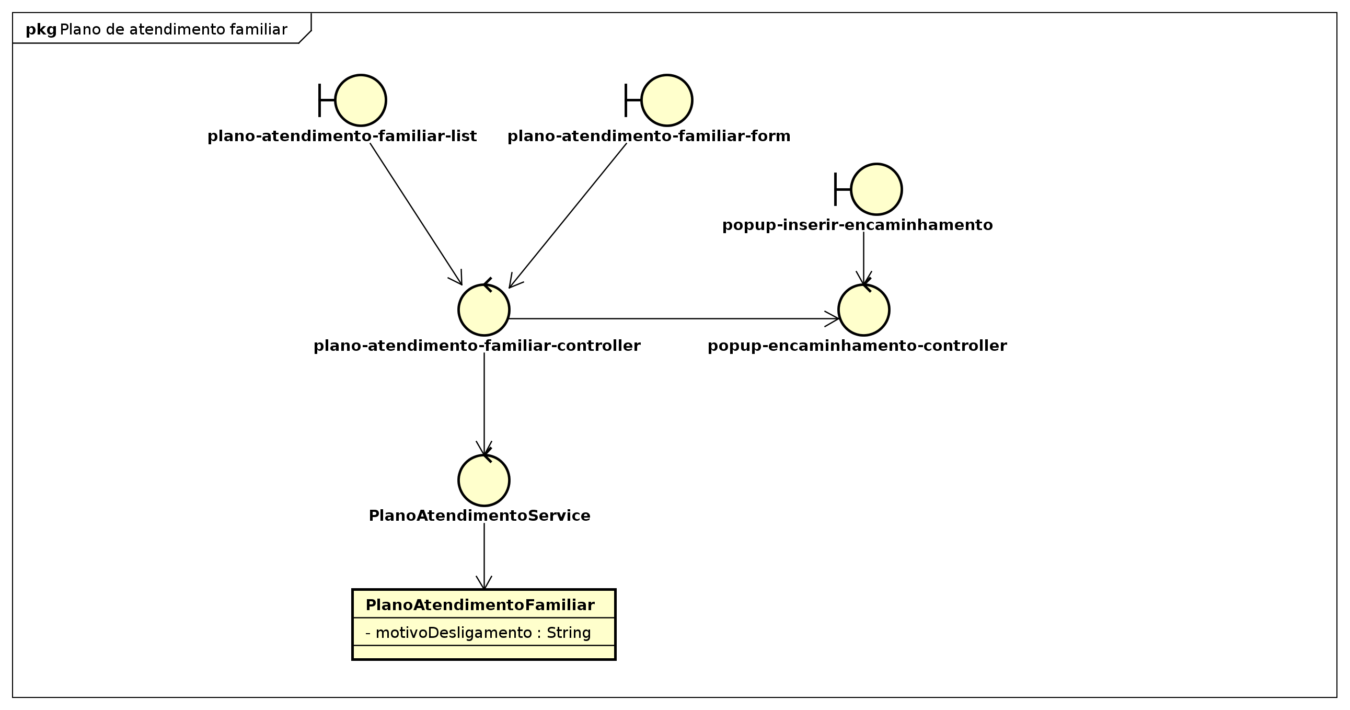

figure 4: Diagrama BCE::Plano de atendimento familiar::Plano de atendimento familiar[Class Diagram]

Class

plano-atendimento-familiar-controller [Control]

Declaration
public class plano-atendimento-familiar-controller

Namespace
Diagrama BCE::Plano de atendimento familiar

Stereotype
<<control>>

Relation (From Source To Target)
Name | Type | Target | Summary
 | Association | PlanoAtendimentoService
 | Association | popup-encaminhamento-controller

plano-atendimento-familiar-form [Boundary]

Declaration
public class plano-atendimento-familiar-form

Namespace
Diagrama BCE::Plano de atendimento familiar

Stereotype
<<boundary>>

Relation (From Source To Target)
Name | Type | Target | Summary
 | Association | plano-atendimento-familiar-controller

plano-atendimento-familiar-list [Boundary]

Declaration
public class plano-atendimento-familiar-list

Namespace
Diagrama BCE::Plano de atendimento familiar

Stereotype
<<boundary>>

Relation (From Source To Target)
Name | Type | Target | Summary
 | Association | plano-atendimento-familiar-controller

Diagrama BCE::Plano de atendimento individual Package

Classifier List
Name | Type | Summary
PlanoAtendimentoService | Control
plano-atendimento-individual-controller | Control
plano-atendimento-individual-form | Boundary
plano-atendimento-individual-list | Boundary
popup-encaminhamento-controller | Control
popup-inserir-encaminhamento | Boundary

Diagram

Diagrama BCE::Plano de atendimento individual::Plano de atendimento individual[Class Diagram]

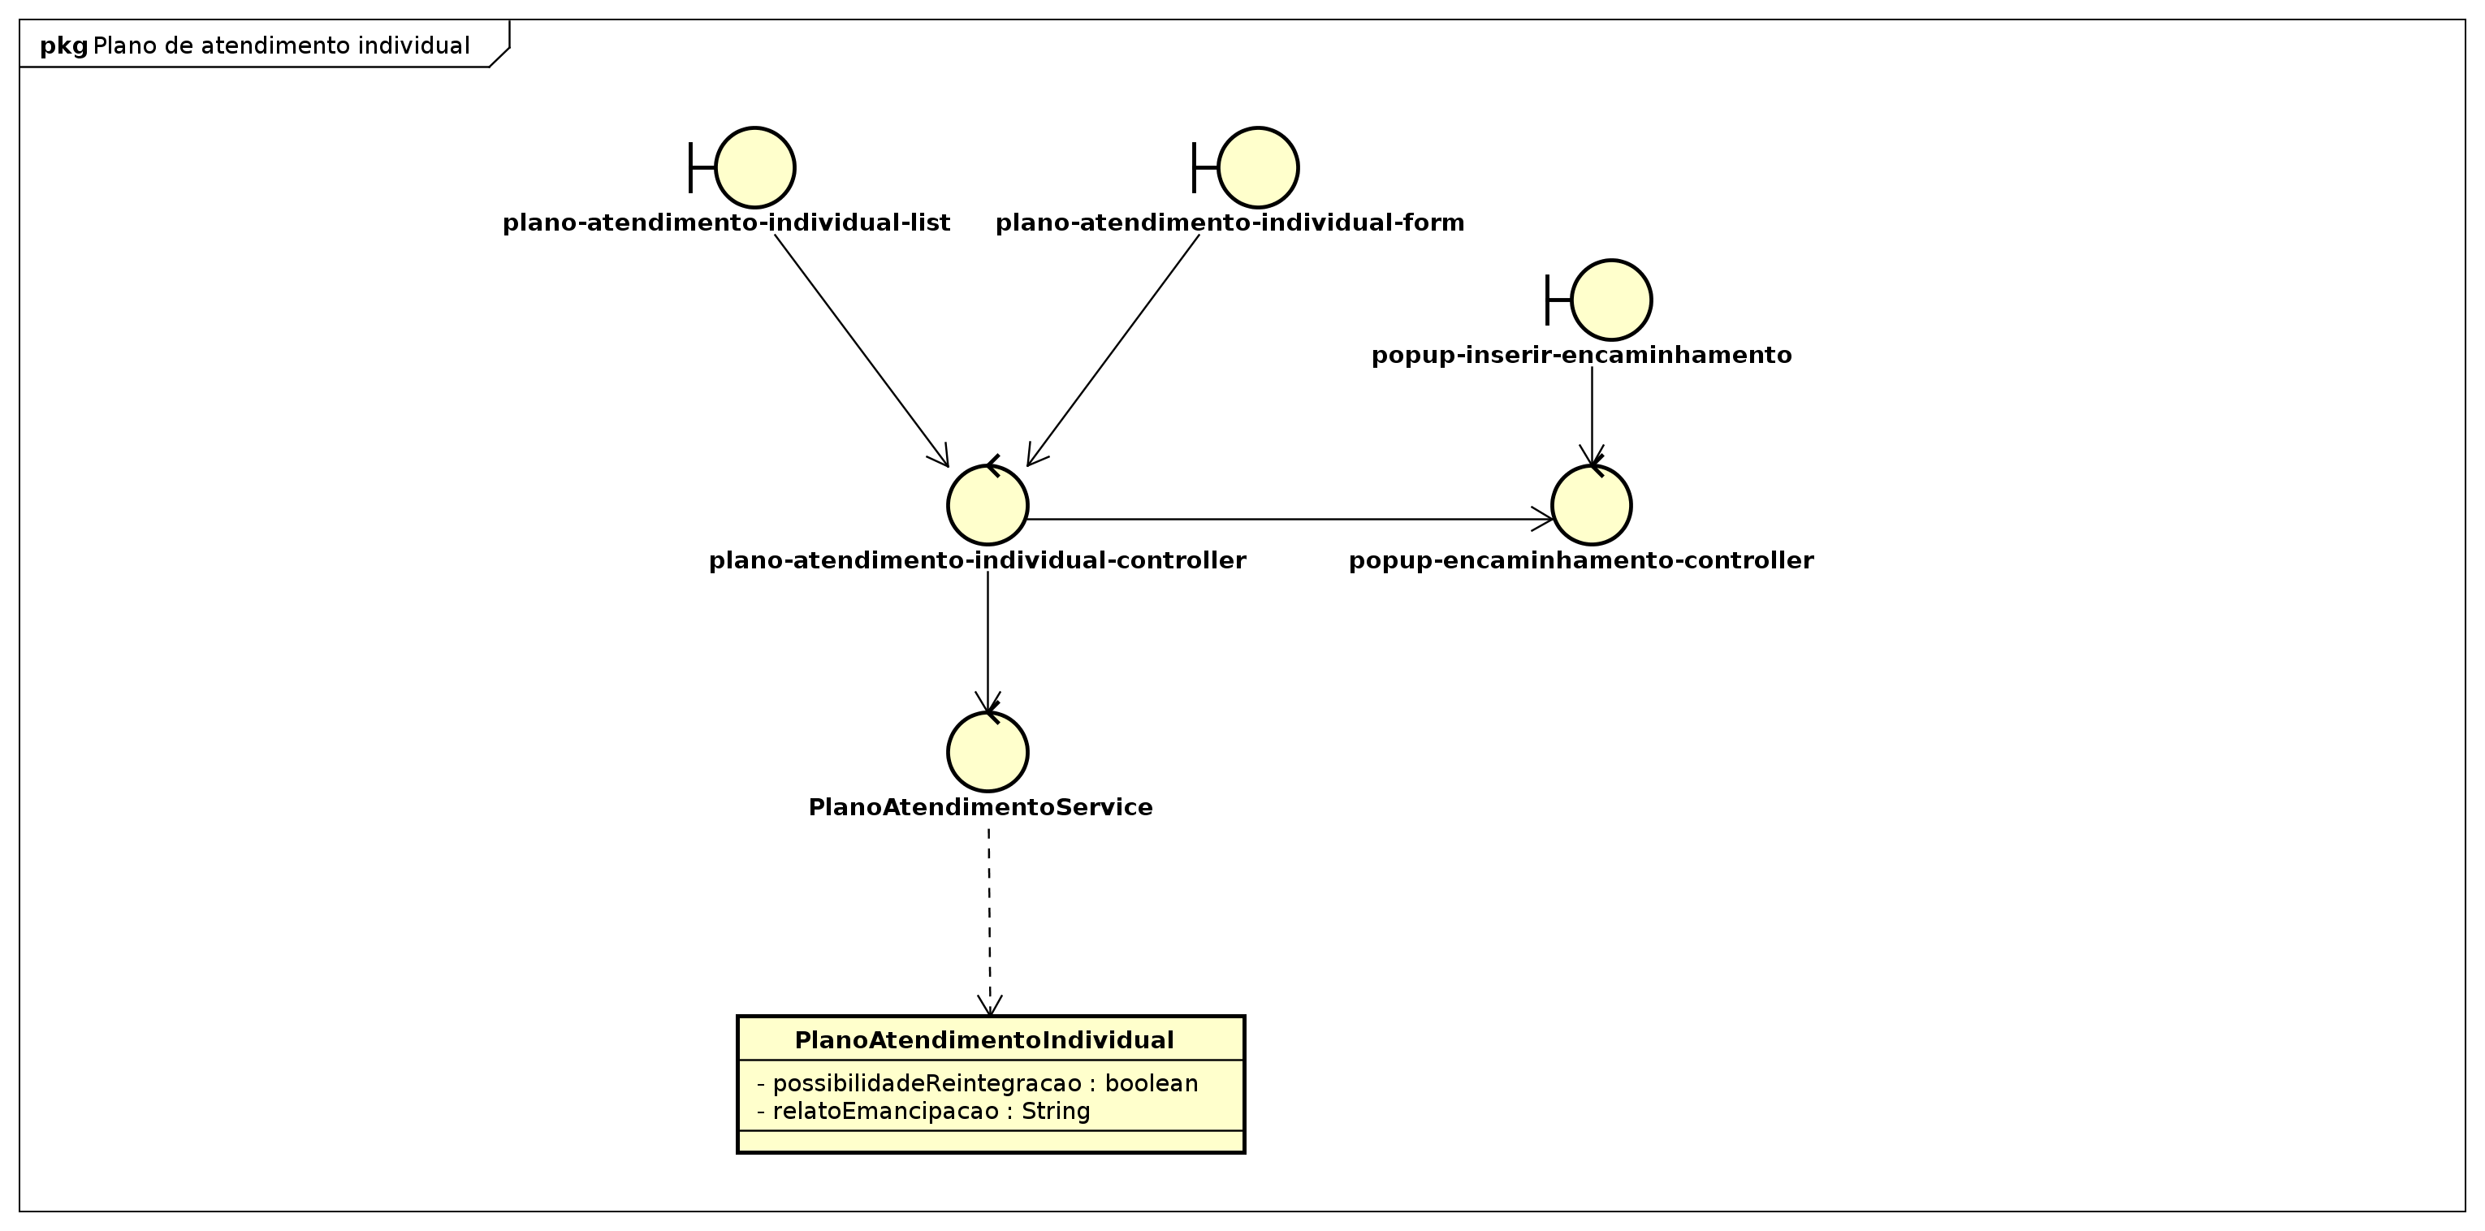

figure 5: Diagrama BCE::Plano de atendimento individual::Plano de atendimento individual[Class Diagram]

Class

PlanoAtendimentoService [Control]

Declaration
public class PlanoAtendimentoService

Namespace
Diagrama BCE::Plano de atendimento individual

Stereotype
<<control>>

Relation (From Source To Target)
Name | Type | Target | Summary
 | Association | PlanoAtendimentoFamiliar
 | Dependency | PlanoAtendimentoIndividual

plano-atendimento-individual-controller [Control]

Declaration
public class plano-atendimento-individual-controller

Namespace
Diagrama BCE::Plano de atendimento individual

Stereotype
<<control>>

Relation (From Source To Target)
Name | Type | Target | Summary
 | Association | PlanoAtendimentoService
 | Association | popup-encaminhamento-controller
 | Dependency | PlanoAtendimentoService

plano-atendimento-individual-form [Boundary]

Declaration
public class plano-atendimento-individual-form

Namespace
Diagrama BCE::Plano de atendimento individual

Stereotype
<<boundary>>

Relation (From Source To Target)
Name | Type | Target | Summary
 | Association | plano-atendimento-individual-controller

plano-atendimento-individual-list [Boundary]

Declaration
public class plano-atendimento-individual-list

Namespace
Diagrama BCE::Plano de atendimento individual

Stereotype
<<boundary>>

Relation (From Source To Target)
Name | Type | Target | Summary
 | Association | plano-atendimento-individual-controller

popup-encaminhamento-controller [Control]

Declaration
public class popup-encaminhamento-controller

Namespace
Diagrama BCE::Plano de atendimento individual

Stereotype
<<control>>

Relation (From Source To Target)
Name | Type | Target | Summary
 | Association | plano-atendimento-individual-controller
 | Association | plano-atendimento-familiar-controller

popup-inserir-encaminhamento [Boundary]

Declaration
public class popup-inserir-encaminhamento

Namespace
Diagrama BCE::Plano de atendimento individual

Stereotype
<<boundary>>

Relation (From Source To Target)
Name | Type | Target | Summary
 | Association | popup-encaminhamento-controller

Diagrama BCE::Rede de apoio Package

Classifier List
Name | Type | Summary
RedeApoioService | Control
rede-apoio-controller | Control
rede-apoio-form | Boundary
rede-apoio-list | Boundary

Diagram

Diagrama BCE::Rede de apoio::Rede de apoio[Class Diagram]

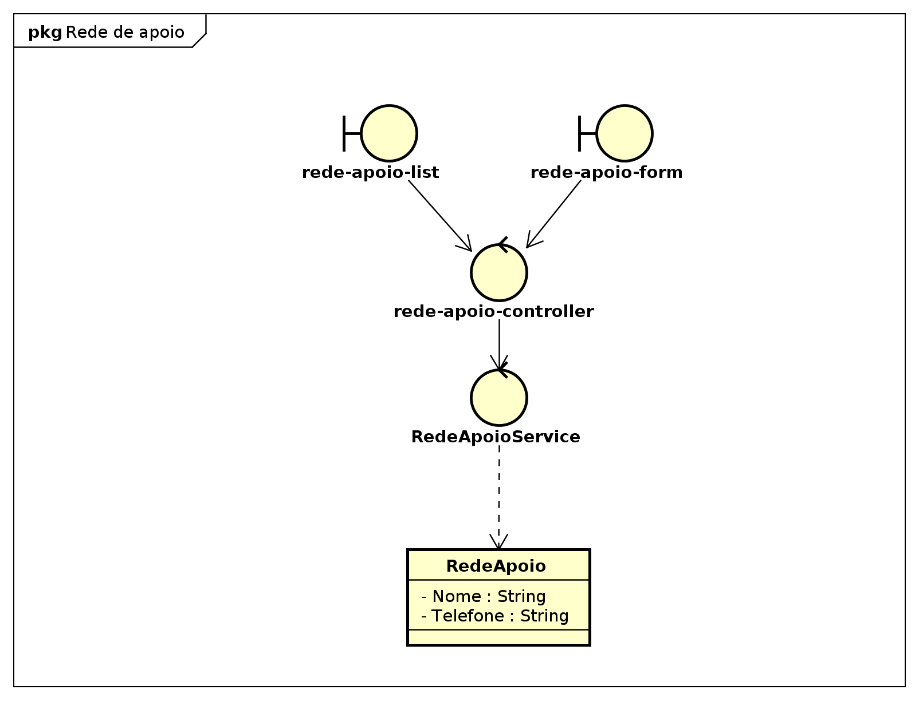

figure 6: Diagrama BCE::Rede de apoio::Rede de apoio[Class Diagram]

Class

RedeApoioService [Control]

Declaration
public class RedeApoioService

Namespace
Diagrama BCE::Rede de apoio

Stereotype
<<control>>

Relation (From Source To Target)
Name | Type | Target | Summary
 | Dependency | RedeApoio

rede-apoio-controller [Control]

Declaration
public class rede-apoio-controller

Namespace
Diagrama BCE::Rede de apoio

Stereotype
<<control>>

Relation (From Source To Target)
Name | Type | Target | Summary
 | Association | RedeApoioService

rede-apoio-form [Boundary]

Declaration
public class rede-apoio-form

Namespace
Diagrama BCE::Rede de apoio

Stereotype
<<boundary>>

Relation (From Source To Target)
Name | Type | Target | Summary
 | Association | rede-apoio-controller

rede-apoio-list [Boundary]

Declaration
public class rede-apoio-list

Namespace
Diagrama BCE::Rede de apoio

Stereotype
<<boundary>>

Relation (From Source To Target)
Name | Type | Target | Summary
 | Association | rede-apoio-controller

Diagrama BCE::Usuário Package

Classifier List
Name | Type | Summary
AccountService | Control
account-controller | Control
account-form | Boundary
account-list | Boundary
rede-apoio-popup | Boundary

Diagram

Diagrama BCE::Usuário::Usuario[Class Diagram]

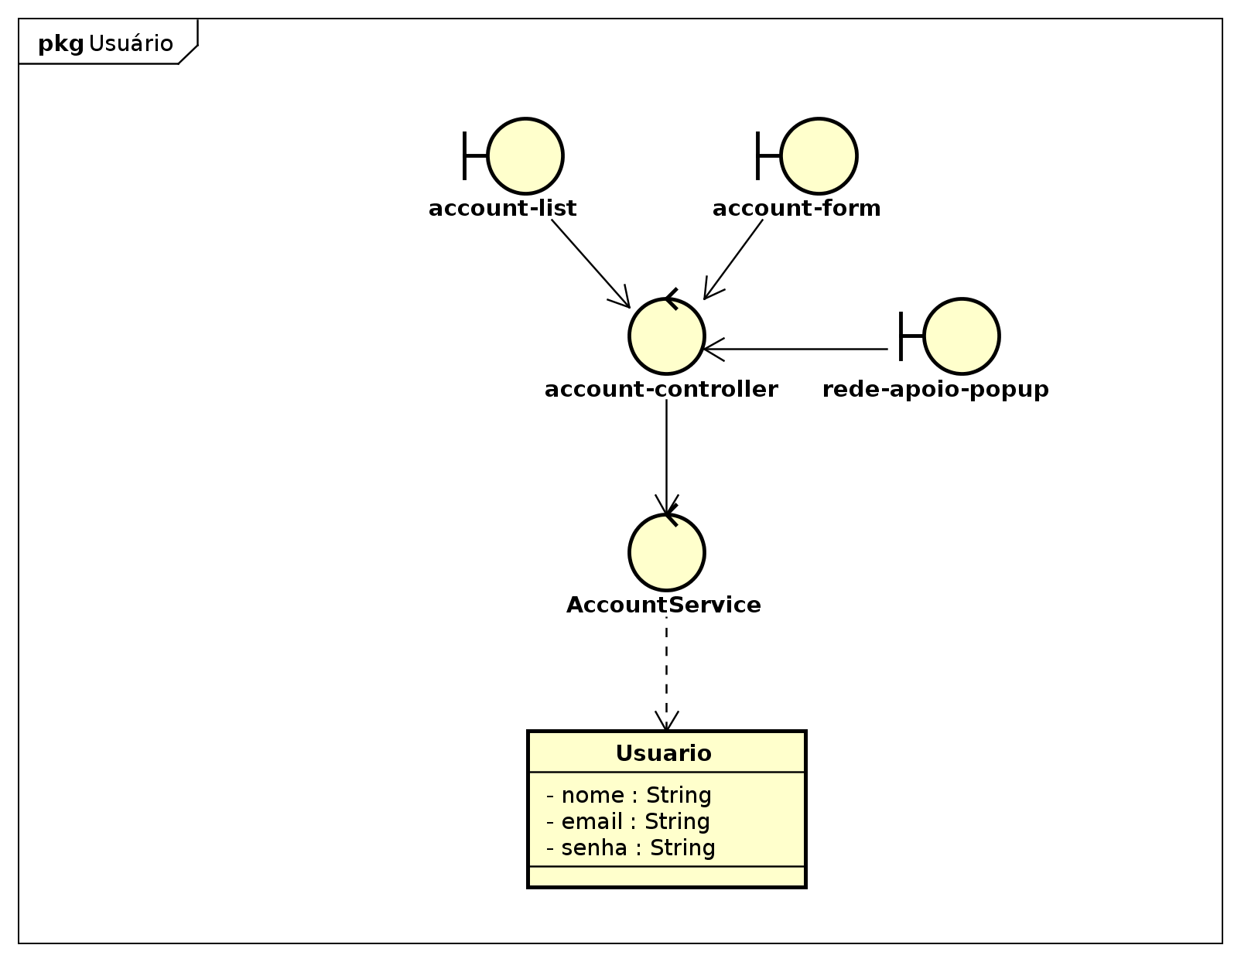

figure 7: Diagrama BCE::Usuário::Usuario[Class Diagram]

Class

AccountService [Control]

Declaration
public class AccountService

Namespace
Diagrama BCE::Usuário

Stereotype
<<control>>

Relation (From Source To Target)
Name | Type | Target | Summary
 | Dependency | Usuario

account-controller [Control]

Declaration
public class account-controller

Namespace
Diagrama BCE::Usuário

Stereotype
<<control>>

Relation (From Source To Target)
Name | Type | Target | Summary
 | Association | AccountService

account-form [Boundary]

Declaration
public class account-form

Namespace
Diagrama BCE::Usuário

Stereotype
<<boundary>>

Relation (From Source To Target)
Name | Type | Target | Summary
 | Association | account-controller

account-list [Boundary]

Declaration
public class account-list

Namespace
Diagrama BCE::Usuário

Stereotype
<<boundary>>

Relation (From Source To Target)
Name | Type | Target | Summary
 | Association | account-controller

rede-apoio-popup [Boundary]

Declaration
public class rede-apoio-popup

Namespace
Diagrama BCE::Usuário

Stereotype
<<boundary>>

Relation (From Source To Target)
Name | Type | Target | Summary
 | Association | account-controller

Diagrama de Classes Package

Classifier List
Name | Type | Summary
CasaLar | Class
Cidade | Class
Crianca | Class
Encaminhamento | Class
Endereco | Class
Estado | Class
Familia | Class
IntegranteFamiliar | Class
Pais | Class
Parecer | Class
PlanoAtendimento | Class
PlanoAtendimentoFamiliar | Class
PlanoAtendimentoIndividual | Class
Questao | Class
Questionario | Class
RedeApoio | Class
Responsavel | Class
StatusEncaminhamento | Class
TipoEncaminhamento | Class
TipoImovel | Class
Usuario | Class
VersaoQuestionario | Class

Class

CasaLar [Class]

Declaration
public class CasaLar

Namespace
Diagrama de Classes

Attribute
Name | Type | Summary
numero | private int

Relation (From Source To Target)
Name | Type | Target | Summary
 | Association | Crianca
 | Association | Responsavel
 | Association | Responsavel
 | Association | Responsavel

Cidade [Class]

Declaration
public class Cidade

Namespace
Diagrama de Classes

Attribute
Name | Type | Summary
nome | private String

Crianca [Class]

Declaration
public class Crianca
extends IntegranteFamiliar

Namespace
Diagrama de Classes

Attribute
Name | Type | Summary
numeroProcesso | private int
dataAcolhimento | private int
dataElaboracaoPIA | private int
motivoAcolhimento | private String
altura | private String
ativo | private boolean

Operation
Name | Type | Summary
getIdade | public Integer
disableCrianca | public void
enableCrianca | public void

Relation (From Source To Target)
Name | Type | Target | Summary
 | Association | Familia
 | Association | Familia
 | Association | PlanoAtendimentoIndividual
CriancaFamilia | AssociationClass | Familia
pertence | Association | Familia
 | Association | PlanoAtendimento
atendida | Association | PlanoAtendimentoIndividual
 | Association | Familia
 | Generalization | IntegranteFamiliar

Encaminhamento [Class]

Declaration
public class Encaminhamento

Namespace
Diagrama de Classes

Attribute
Name | Type | Summary
numero | private int
descricao | private int
dataCriacao | private Calendar
responsavel | private String
observacao | private String

Relation (From Source To Target)
Name | Type | Target | Summary
 | Association | StatusEncaminhamento
 | Association | PlanoAtendimento
criador | Association | Usuario

Endereco [Class]

Declaration
public class Endereco

Namespace
Diagrama de Classes

Attribute
Name | Type | Summary
bairro | private String
rua | private String
numero | private int
complemento | private String

Relation (From Source To Target)
Name | Type | Target | Summary
 | Association | Cidade
 | Association | Familia
 | Association | RedeApoio

Estado [Class]

Declaration
public class Estado

Namespace
Diagrama de Classes

Attribute
Name | Type | Summary
nome | private String

Relation (From Source To Target)
Name | Type | Target | Summary
 | Association | Cidade
 | Association | Pais

Familia [Class]

Declaration
public class Familia

Namespace
Diagrama de Classes

Attribute
Name | Type | Summary
nome | private String
telefone | private int
numeroComodos | private int
situacaoImovel | private String
infraestrutura | private String
nomeMae | private String

Relation (From Source To Target)
Name | Type | Target | Summary
 | Association | IntegranteFamiliar
 | Association | Endereco
 | Association | TipoImovel
 | Association | PlanoAtendimentoIndividual
 | Association | PlanoAtendimentoIndividual
 | Association | PlanoAtendimentoFamiliar

IntegranteFamiliar [Class]

Declaration
public class IntegranteFamiliar

Namespace
Diagrama de Classes

Attribute
Name | Type | Summary
nome | private String
dataNascimento | private Calendar
ocupacao | private String
rendaMensal | private BigDecimal
filiacao | private String
telefone | private String
sexo | private char
ativo | private boolean

Operation
Name | Type | Summary
disableIntegranteFamiliar | public void
enableIntegranteFamiliar | public void

Relation (From Source To Target)
Name | Type | Target | Summary
 | Association | Crianca
Parente | AssociationClass | Crianca
 | Association | Estado
 | Association | Cidade
 | Association | Endereco
 | Association | Encaminhamento

Pais [Class]

Declaration
public class Pais

Namespace
Diagrama de Classes

Attribute
Name | Type | Summary
nome | private String

Parecer [Class]

Declaration
public class Parecer

Namespace
Diagrama de Classes

Attribute
Name | Type | Summary
descricao | private String

Relation (From Source To Target)
Name | Type | Target | Summary
 | Association | Usuario
 | Association | TipoEncaminhamento

PlanoAtendimento [Class]

Declaration
public class PlanoAtendimento

Namespace
Diagrama de Classes

Relation (From Source To Target)
Name | Type | Target | Summary
 | Association | Parecer

PlanoAtendimentoFamiliar [Class]

Declaration
public class PlanoAtendimentoFamiliar
extends PlanoAtendimento

Namespace
Diagrama de Classes

Attribute
Name | Type | Summary
motivoDesligamento | private String

Relation (From Source To Target)
Name | Type | Target | Summary
 | Association | PlanoAtendimento
 | Generalization | PlanoAtendimento

PlanoAtendimentoIndividual [Class]

Declaration
public class PlanoAtendimentoIndividual
extends PlanoAtendimento

Namespace
Diagrama de Classes

Attribute
Name | Type | Summary
possibilidadeReintegracao | private boolean
relatoEmancipacao | private String

Relation (From Source To Target)
Name | Type | Target | Summary
 | Association | Encaminhamento
 | Generalization | PlanoAtendimento

Questao [Class]

Declaration
public class Questao

Namespace
Diagrama de Classes

Attribute
Name | Type | Summary
descricao | private int

Questionario [Class]

Declaration
public class Questionario

Namespace
Diagrama de Classes

Attribute
Name | Type | Summary
nome | private String
descricao | private String

Relation (From Source To Target)
Name | Type | Target | Summary
 | Association | Questionario
 | Association | VersaoQuestionario

RedeApoio [Class]

Declaration
public class RedeApoio

Namespace
Diagrama de Classes

Attribute
Name | Type | Summary
Nome | private String
Telefone | private String

Relation (From Source To Target)
Name | Type | Target | Summary
 | Association | PlanoAtendimentoIndividual
RedeApoioAtendimento | AssociationClass | PlanoAtendimentoIndividual
 | Association | Usuario
 | Association | PlanoAtendimento
Apoio | AssociationClass | PlanoAtendimento
 | Association | Responsavel

Responsavel [Class]

Declaration
public class Responsavel

Namespace
Diagrama de Classes

Attribute
Name | Type | Summary
Nome | private String
Telefone | private String
Email | private String

Relation (From Source To Target)
Name | Type | Target | Summary
 | Association | Encaminhamento

StatusEncaminhamento [Class]

Declaration
public class StatusEncaminhamento

Namespace
Diagrama de Classes

Stereotype
<<enum>>

Attribute
Name | Type | Summary
ABERTO | private StatusEncaminhamento
EM_EXECUCAO | private StatusEncaminhamento
CONCLUIDO | private StatusEncaminhamento
CANCELADO | private StatusEncaminhamento

TipoEncaminhamento [Class]

Declaration
public class TipoEncaminhamento

Namespace
Diagrama de Classes

Stereotype
<<enum>>

Attribute
Name | Type | Summary
SAUDE | private TipoEncaminhamento
ESPORTE_E_LAZER | private TipoEncaminhamento
EDUCACAO_E_PROFISSIONALIZACAO | private TipoEncaminhamento
CONVIVIO_FAMILIAR | private TipoEncaminhamento

Relation (From Source To Target)
Name | Type | Target | Summary
 | Association | Encaminhamento

TipoImovel [Class]

Declaration
public class TipoImovel

Namespace
Diagrama de Classes

Stereotype
<<enum>>

Attribute
Name | Type | Summary
CASA  <<enum constant>> | private TipoImovel
APARTAMENTO  <<enum constant>> | private TipoImovel
INVASAO  <<enum constant>> | private TipoImovel

Usuario [Class]

Declaration
public class Usuario

Namespace
Diagrama de Classes

Attribute
Name | Type | Summary
nome | private String
email | private String
senha | private String

Relation (From Source To Target)
Name | Type | Target | Summary
 | Association | PlanoAtendimentoIndividual
 | Association | Questionario

VersaoQuestionario [Class]

Declaration
public class VersaoQuestionario

Namespace
Diagrama de Classes

Attribute
Name | Type | Summary
numeroVersao | private int
dataAvaliacao | private Calendar

Relation (From Source To Target)
Name | Type | Target | Summary
 | Association | Usuario
 | Association | Questao
QuestaoVersa | AssociationClass | Questao
 | Association | Questao

java::lang Package

Classifier List
Name | Type | Summary
Integer | Class
String | Class

Class

Integer [Class]

Declaration
public class Integer

Namespace
java::lang

String [Class]

Declaration
public class String

Namespace
java::lang

java::util Package

Classifier List
Name | Type | Summary
Calendar | Class

Class

Calendar [Class]

Declaration
public class Calendar

Namespace
java::util

