Policy Memo: Renewables Curtailment in CAISO: Modeling the Opportunity for Green Hydrogen
To: California Public Utilities Commission & California Independent System Operator
From: Sayaka Hirano, Harmony Lebovic, Xinhui Luo, Jeffrey Wang
Department of Civil and Environmental Engineering, Tufts University

The California Public Utilities Commission (CPUC) and California Independent System Operator (CAISO) should add green hydrogen production as an energy storage option in Assembly Bill 2514 and offer green hydrogen producers favorable time-of-use rates during off-peak spring hours to incentivize production during peak curtailment. Our analysis of CAISO’s 2023 and 2024 operational data shows that curtailment peaks in spring. Moreover, the 75th quantile of curtailment is correlated with low demand and the deployment of existing curtailment reduction strategies, suggesting there is additional opportunity to absorb excess energy. Aligning green hydrogen production with these surplus periods could reduce waste, limit financial losses for CAISO, and support expansion of renewables in California.
BACKGROUND
With California’s commitment to achieve 100% zero-carbon electricity by 2045 [1], the expansion of renewable energy resources like solar and wind, is critical. In pursuit of that goal, CAISO, which serves as grid operator for 80% of the state [2], has added 18.5 GW of wind and solar capacity since 2015 [3]. While these resources are vital to California’s net-zero ambitions, their integration presents significant challenges due to their intermittent nature, which can result in curtailment – the planned reduction of electricity output due to oversupply or transmission congestion. CAISO curtailed a total of 3.4 million MWh of utility-scale wind and solar in 2024, a 29% increase from 2023 [3].
CAISO’s existing renewable curtailment reduction strategies include increasing battery storage capacity, exporting excess energy to other balancing authorities, and engineering time-of-use (TOU) electricity prices that incentivize grid customers to shift load to off-peak hours [3], [4], [5]. We propose establishing a new TOU program that incentivizes green hydrogen production during peak curtailment times. Production of green hydrogen using excess zero-emissions electricity presents an appealing strategy given hydrogen’s high energy density, high costs, and versatility as a resource fuel or feedstock [6], [7].
STUDY AND ANALYSIS
Classification and quantile regression analyses were performed to establish feature correlations with the occurrence of curtailment and the 75th quantile of curtailment. The 75th quantile represents a regime of concentrated curtailed energy, thus representing the greatest opportunity for green hydrogen generation.
Data was collected on eleven different features related to CAISO’s grid operations based on a thorough literature review [3], [8], [9], [10], [11]. These features were split into four categories: seasonal (spring, summer, and winter, with fall as the baseline category), generation and load (% wind in total generation, % solar in total generation, and total system load), storage and exports (battery charge state, battery charging delta, exports), and price (total locational marginal price [LMP]). The analysis period spans 2023 – 2024 on an hourly basis for the whole CAISO operating region.
We analyzed our data for multicollinearity concerns and added an interaction term to address the correlation between % solar generation and exports. We found a low percentage of outliers (0.5%) and influential points (3.2%); thus, these were retained. Standardization was applied to address the difference in the magnitudes of the features and enable comparison of the coefficients.
Quantitative curtailment data were transformed into binary curtailment and no-curtailment classes for classification. The classes were then balanced using SMOTE. For classification, we applied multivariate logistic regression due to its interpretability and suitability for a binary response. The linearity of the log-odds with respect to the continuous variables was assessed, and the non-linearity of total load and LMP was addressed. We used 10-fold cross-validation and regularization to tune the model, which resulted in the removal of spring and the interaction term. A logistic regression model was rerun using the resulting subset of features to obtain coefficients, p-values, and 95% confidence intervals.
Quantile regression is applied to identify which features are most strongly correlated with high curtailment. We only focused on the 75th quantile (Q3) since we noticed that the top 25% of hours contained 85% of the total energy curtailment. All features were standardized using StandardScaler for model convergence. After reviewing the p-values of each feature at Q3, a final quantile process plot was produced to map coefficient levels of the significant features across different quantiles.
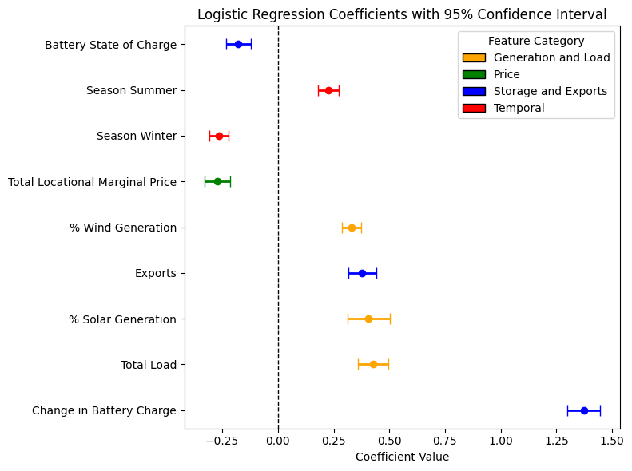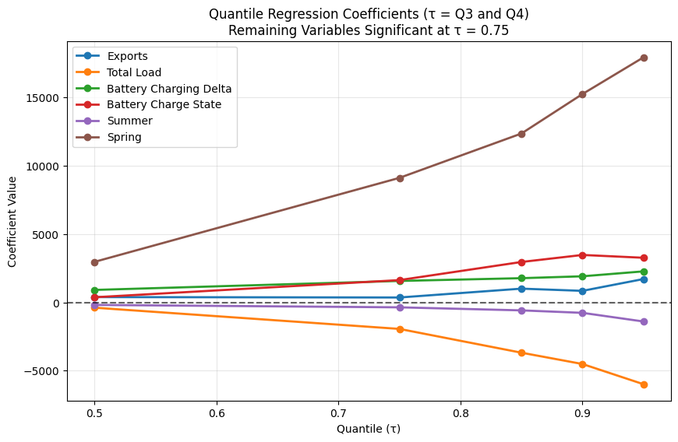
CONCLUSIONS AND RECOMMENDATIONS
Our logistic regression model produced the largest coefficient for battery charging delta, indicating curtailment occurs when grid batteries are charging. This correlation possibly suggests that, during curtailment intervals, more excess energy is available than existing battery storage can absorb.
The quantile regression model generated six significant features in the 75th quantile: exports, total load, battery charge delta, battery charge state, summer, and spring. Of the six, spring had the largest positive coefficients in the highest quantiles with a small confidence interval range, suggesting a large, positive correlation with curtailment, likely due to the abundance of renewable energy, long days, and mild temperatures. The large negative coefficient for total load indicates curtailment in these quantiles could be related to oversupply and low demand rather than grid congestion. This result suggests that producing green hydrogen during periods of high curtailment in the spring could help rebalance grid operations.
While this study provides insight into curtailment patterns in CAISO, it has important limitations. Curtailment is highly dependent on local weather and grid infrastructure, limiting the applicability of these results to other balancing authorities. In addition, ongoing changes to CAISO’s grid may reduce model accuracy over time. Although the results suggest that incentivizing green hydrogen production through energy storage procurement and time-of-use policies could help reduce renewable curtailment, causal relationships remain unestablished and require further study.
REFERENCES
- California Energy Commission, SB 100 Joint Agency Report, State of California, 2025. [Online] Available: https://www.energy.ca.gov/sb100
- California Independent System Operator, California ISO, 2025. [Online]. Available: https://www.caiso.com/
- U.S. Energy Information Administration, “Solar and wind power curtailments are increasing in California,” Today in Energy, May 2025. [Online]. Available: https://www.eia.gov/todayinenergy/detail.php?id=65364
- California Energy Commission, “Energy Storage Targets – Publicly Owned Utilities – AB 2514,” 2025. [Online]. Available: https://www.energy.ca.gov/data-reports/reports/energy-storage-targets-publicly-owned-utilities
- Bear Valley Electric Service, Inc. “Schedule No. TOU-EV-1 – General Service Time-of-Use Electric Vehicle Charging (Revised),” Advice Letter No. 354-E, original Cal. P.U.C. Sheet No. 2605-E, effective Jan. 16, 2019. [Online]. Available: https://www.bvesinc.com/media/managed/ratechange010119/Sch_TOU_EV_1_354_E_Revised.pdf
- R. Cho, “Why we need green hydrogen,” State of the Planet, Jan, 2021. [Online]. Available: https://news.climate.columbia.edu/2021/01/07/need-green-hydrogen/
- M. Younas, et al., “An overview of hydrogen production: current status, potential, and challenges,” Fuel, vol. 316 May 2022. [Online]. Available: https://www.sciencedirect.com/science/article/pii/S0016236122001867
- H. Hadian and F. Naderkhani, “Deep learning-based models for wind and solar curtailment forecasting,” in Proc. Int. Conf. on Energy Harvesting, Storage, and Transfer (EHST), Jun. 2023. [Online]. Available: https://avestia.com/EHST2023_Proceedings/files/paper/EHST_120.pdf
- M. H. Shams et al., “Artificial intelligence-based prediction and analysis of the oversupply of wind and solar energy in power systems,” Energy Conversion and Management, vol. 250, Dec. 2021. [Online]. Available: https://www.sciencedirect.com/science/article/abs/pii/S0196890421010682
- M. H. Shams et al., “Machine learning-based utilization of renewable power curtailment under uncertainty by planning of hydrogen systems and battery storages.” Journal of Energy Storage, vol. 41, Aug. 2021. [Online]. Available: https://www.sciencedirect.com/science/article/pii/S2352152X21007210
- M. Hernandez and M. Ng, “Predicting solar curtailment using XGBoost and random forests,” National High School Journal of Science, Nov. 2024. [Online]. Available: https://nhsjs.com/wp-content/uploads/2024/11/Predicting-Solar-Curtailment-Using-XGBoost-and-Random-Forest.pdf

