Supplementary data
Cell line model | p-value | r
COV504 | 7.6398 x 10⁻²² | -0.498762
SNU8 | 6.6205 x 10⁻⁵² | -0.468450
JHOS2 | 3.00298 x 10⁻³¹ | -0.452691
PEA1 | 1.63158 x 10⁻⁹⁷ | -0.404164
59M | 6.41651 x 10⁻¹⁰ | -0.368615
OAW28 | 9.09970 x 10⁻⁷⁹ | -0.355036
PEO4 | 5.18932 x 10⁻⁹ | -0.183914
CAOV3 | 2.68982 x 10⁻⁵ | -0.173970
JHOS4 | 4.09742 x 10⁻⁴ | -0.165705
ES2 | 8.57693 x 10⁻¹⁰ | -0.139105
PEO1 | 2.68663 x 10⁻⁹ | -0.130448
CAOV4 | 2.94089 x 10⁻¹⁰ | -0.119685
NIHOVCAR3 | 0.0452459 | -0.117682
COV318 | 0.1400247 | -0.100973
HEYA8 | 0.6149733 | -0.028539
KURAMOCHI | 0.6070811 | 0.012544
COV362 | 0.3106583 | 0.023102

Supplementary Table 1. Pearson correlation and p-values for gene knockdown simulations. The 13 out of 17 significant models are those below with p≤0.05. Ordered from smallest to largest r.

Dataset | General description | Normalisation and processing details | Reference and accession
CCLE transcriptomics | 64 ovarian cell lines;  53,970 genes | RSEM; Log₂(TPM+1) | CCLE_expression.csv; Depmap
CCLE CRISPR-Cas9 gene dependency dataset | 1,086 total cell lines; 17,387 genes |  | CRISPR_gene_dependency.csv; Depmap

Supplementary Table 2. Description of input and validation datasets. RSEM: RNAseq by expectation-maximisation; TPM: transcripts per million. Cell line annotations including source of experimental proliferation rate and optimal media conditions, which were replicated in silico, have been described in the Supplementary file ‘CCLE_2020_transcriptomics_annotations.xlsx’.

Cell line | Experimental cell culture conditions | Seeding dilution into new flask
A549 | RPMI1640 + 10% fetal bovine serum (FBS) + 50 µg/mL penicillin/streptomycin | 1:6
OV56 | 1:1 ratio of Dulbecco’s Modified Eagle’s Medium (DMEM) and Ham’s F-12 nutrient mix + 5% FBS + 2 mM glutamine + 0.5 μg/mL hydrocortisone (Sigma Aldrich) + 10 μg/mL insulin (Sigma Aldrich) + 50 μg/mL penicillin/streptomycin | 1:8

Supplementary Table 3. Experimental conditions for cell culture. All media and supplements are from Life Technologies.

Target gene | Manufacturer details | Sequences
TPI1 | ON-TARGETplus Human TPI1 siRNA  Cat # L-009776-00-0005 | - GAGCCUGUGUGGGCCAUUG  - CCAGGAAGUACACGAGAAG  - GGGUGGUGCUUCCCUCAAG  - GCAGAAAGUGGCCCAUGCU
MYC | ON-TARGETplus MYC siRNA oligonucleotide #4  Cat# J-003282-26  (Topham et al., 2015) | CGAUGUUGUUUCUGUGGAA
Non-targeting control pool | ON-TARGETplus Non-targeting Control Pool  Cat# D-001810-10 | - UGGUUUACAUGUCGACUAA  - UGGUUUACAUGUUGUGUGA  - UGGUUUACAUGUUUUCUGA  - UGGUUUACAUGUUUUCCUA

Supplementary Table 4. Details of siRNA sequences.

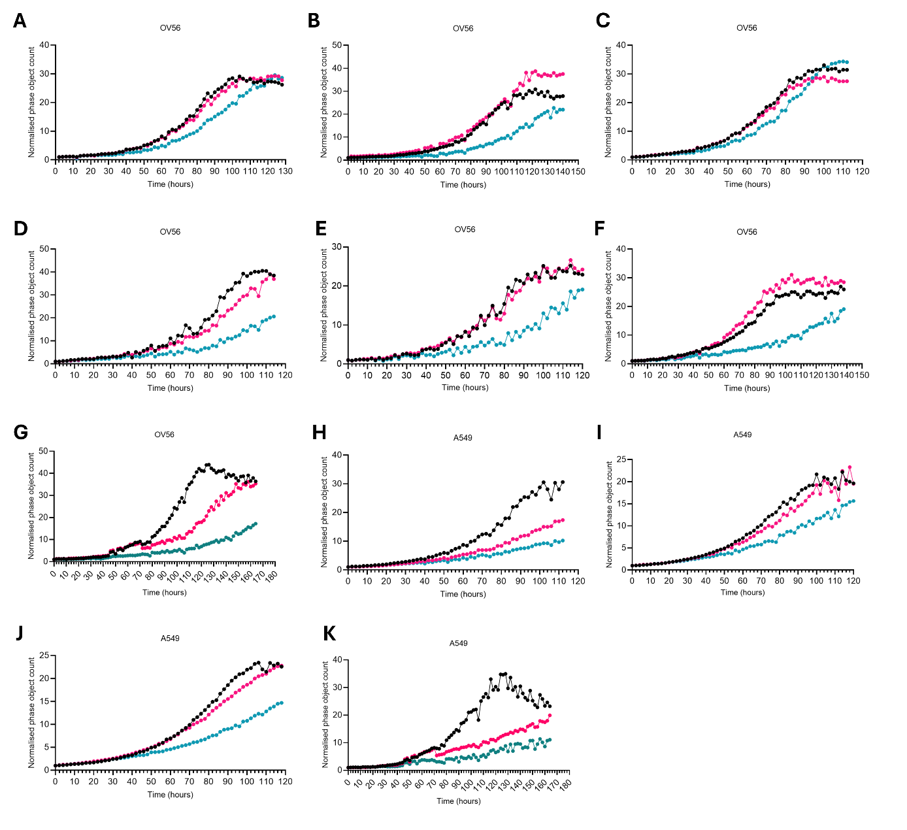
Supplementary Figure 1. Biological repeats for the siRNA transfection of OV56 and A549.
A-G Proliferation of OV56 cells upon siRNA transfection (NTsiRNA: black, siTPI1: pink, siMYC: teal). Live cell microscopy assay, using the Incucyte S3® live-cell analysis system (Sartorius). H-K Proliferation of A549 cells upon siRNA transfection (NTsiRNA: black, siTPI1: pink, siMYC: teal). Live cell microscopy assay, using the Incucyte S3® live-cell analysis system (Sartorius). Associated with Figure 3, showing biological replicates for the siRNA transfection of OV56 and A549 cell lines. The growth effect, as calculated using the normalised phase object count at 100 hours for siTPI1 transfection compared to NTsiRNA transfection has been included in Figure 3F.

