**Problem 2: The biological oscillator:**

**a).**

A is activator and R is inhibitor;

d_a describes the degradation process.

The basal rate is when Ca=0, and the max. rate is when Ca much larger than Cr.

**b).**

Stable means after small perturbation that takes you away from S.S. will return to S.S. According to our figures, it does not return to S.S. so the point is unstable.

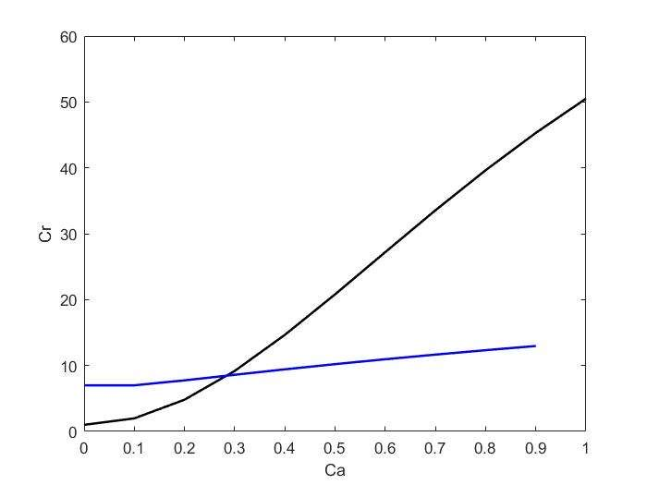

**c).**

**D).**

The phase portrait is a geometric representation of the trajectories of a dynamical system in the phase plane. It indicates the direction of motion by arrows pointing in the direction of increasing t. In our figure, the part of arrows points to the right and the part of arrows points to the left. So it describes how oscillators work to produce a continuous, repeated, alternating waveform.

**e).**

**MATLAB codes for b-e**

**The code file is also attached**

clear all

%% b)

ca=0:1:200;

cr1(:)=(1+100*ca.^2)./(1+ca.^2);

figure(1)

plot(ca,cr1,'k-','LineWidth',1.5)

hold on

cr2=[];

syms cr_x

for i=1:length(ca)

e2=30*ca(i)-(100+5000*ca(i)^2)/(1+ca(i)^2+cr_x^2);

cr_result=solve(e2,cr_x);

check=double(cr_result);

for j=1:length(check)

if check(j)>0

cr2(end+1)=real(check(j));

end

end

end

plot(ca(1:length(cr2)),cr2,'b-','LineWidth',1.5)

hold on

xlabel('Ca')

ylabel('Cr')

%% c)

ca=linspace(0,200,20);

cr=linspace(0,100,20);

[x_axis,y_axis]=meshgrid(ca,cr);

u=zeros(size(x_axis));

v=zeros(size(y_axis));

t=0;

for k=1:numel(x_axis)

yprime=JSPODE(t,[x_axis(k);y_axis(k)]);

u(k)=yprime(1);

v(k)=yprime(2);

end

quiver(x_axis,y_axis,u,v,'r');

hold on

%% add solution for ODE

ca0=1;

cr0=10;

[t_solve,y_solve]=ode45(@JSPODE,[0,20],[ca0;cr0]);

plot(y_solve(:,1),y_solve(:,2),'r','LineWidth',1.2)

plot(y_solve(1,1),y_solve(1,2),'bo') % start point

plot(y_solve(end,1),y_solve(end,2),'ks') % end point

%% function

function dy=JSPODE(t,y)

dy(1)=-30*y(1)+(100+5000*y(1).^2)./(1+y(1).^2+y(2).^2);

dy(2)=-y(2)+(1+100*y(1).^2)./(1+y(1).^2);

dy=dy(:);

end