**2e**

**Below the Hopf bifurcation point s=0.4**

**Julia code is “hopf”**

In order to plot every figure, you need to plot individually in Julia by adding # before other codes.

**Above the Hopf bifurcation point s=30000**

**Julia code is “saddle”**

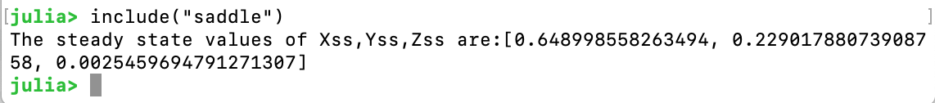

In order to plot every figure, you need to plot individually in Julia by adding # before other codes.

**2f**

According to the figure, coherent oscillation does occur. The figure agrees the results of the concentration of Z before change and not agree the result of the concentration of Z after change. So the coherent oscillation can achieve at the decreasing value of S.