Project 2: Udagram

1. Git repository

<https://github.com/xmalsan/UdacityProjects>

1. Elastic beanstalk application dashboard

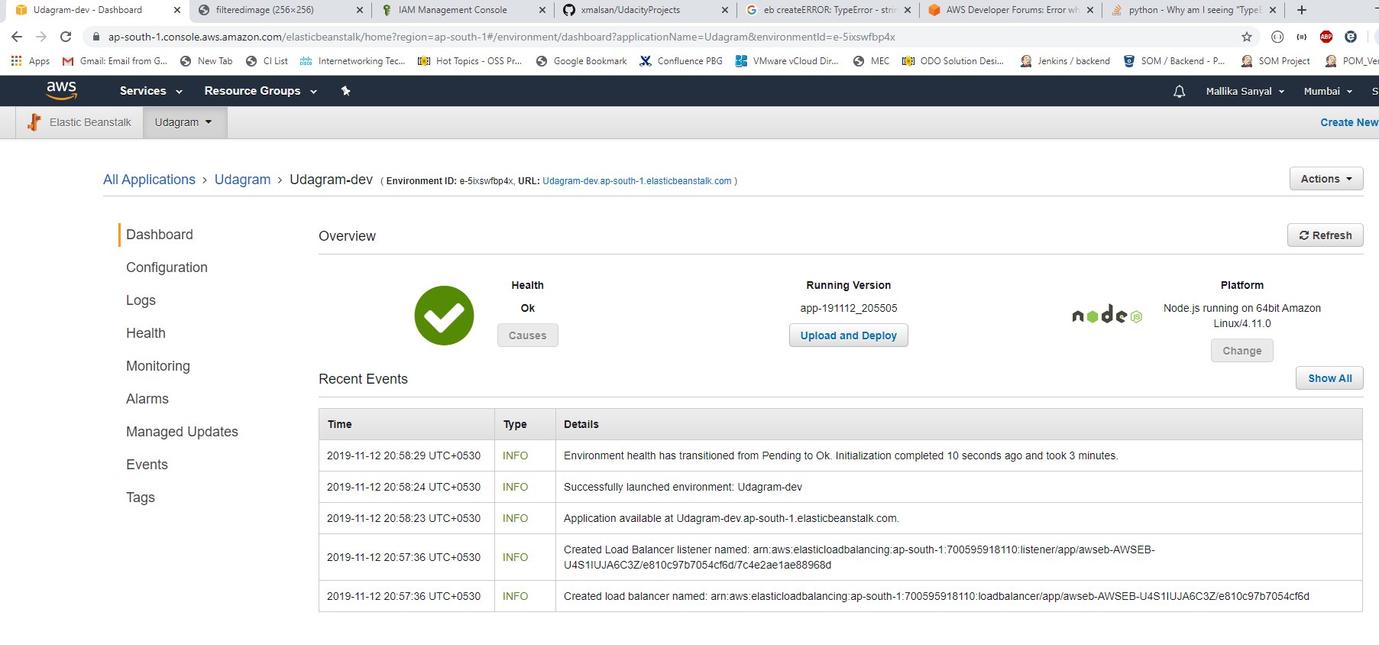

1. Link to endpoint URL

<http://udagram-dev.ap-south-1.elasticbeanstalk.com/filteredimage?image_url=https://timedotcom.files.wordpress.com/2019/03/kitten-report.jpg>