Project 3:

1. Link for the GitHub repository:

<https://github.com/xmalsan/UdacityProjects/tree/develop/Project3/exercises>

1. CI/CD with Travis

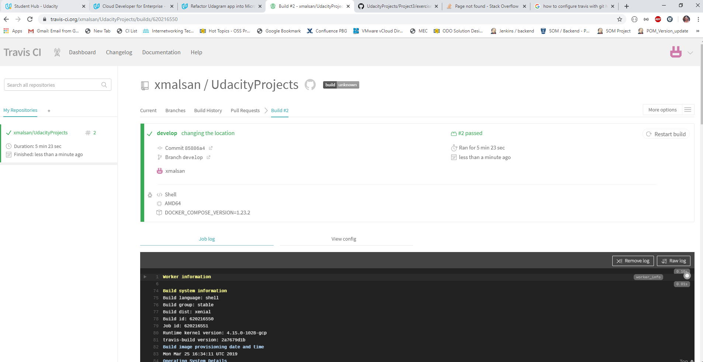

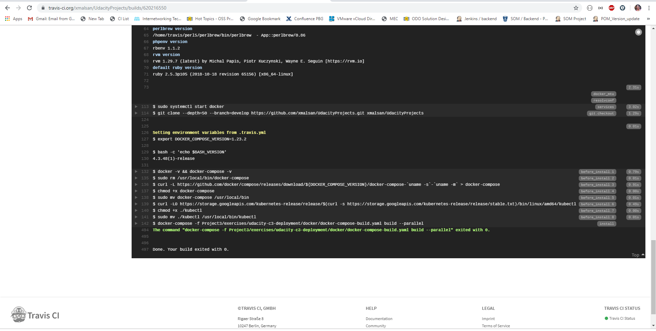

1. Containerization of application

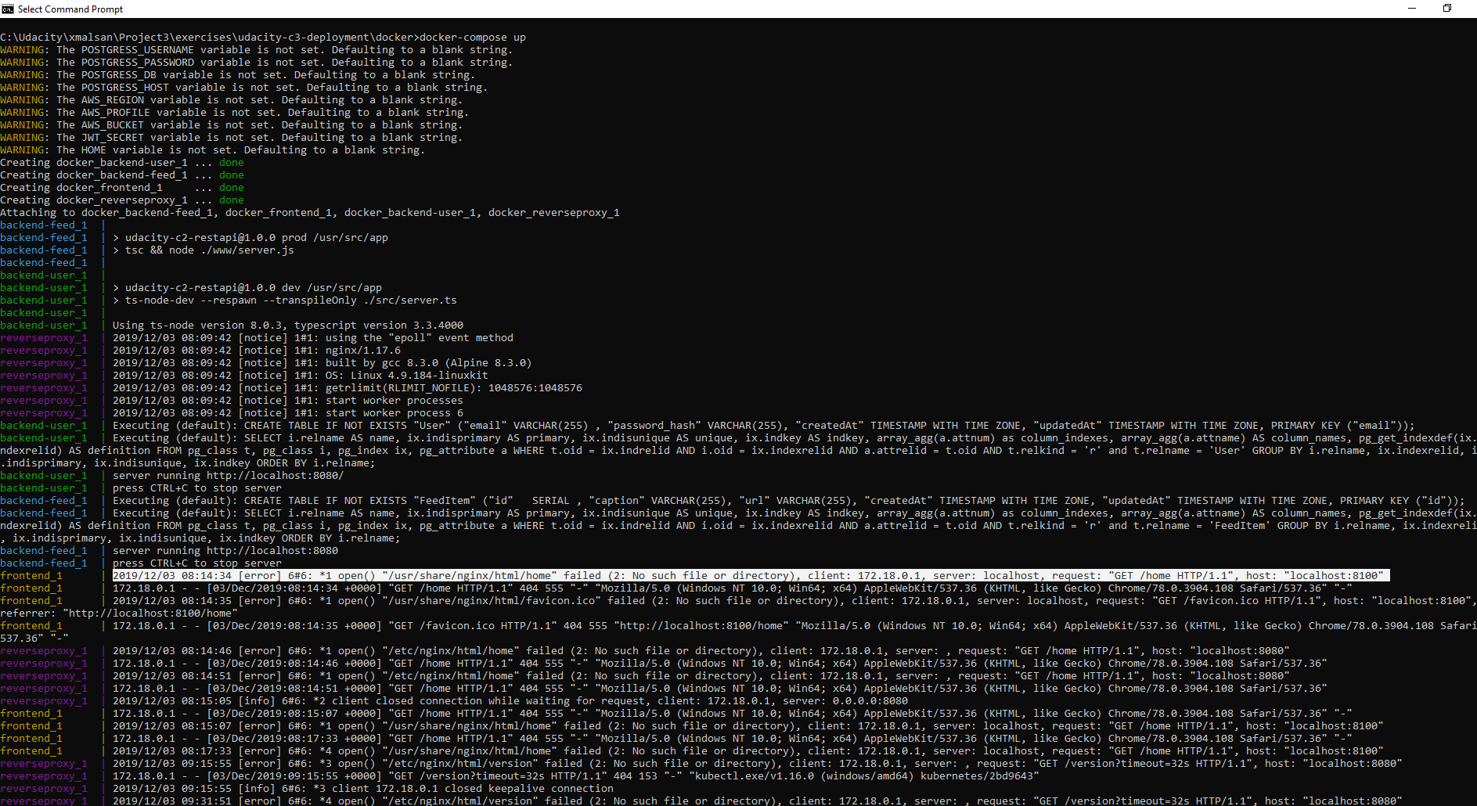

I faced challenge with making frontend and reverse-proxy deploy successfully.

Local docker images:

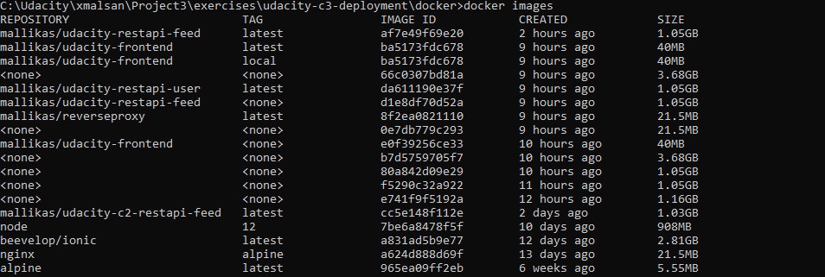

Docker Hub

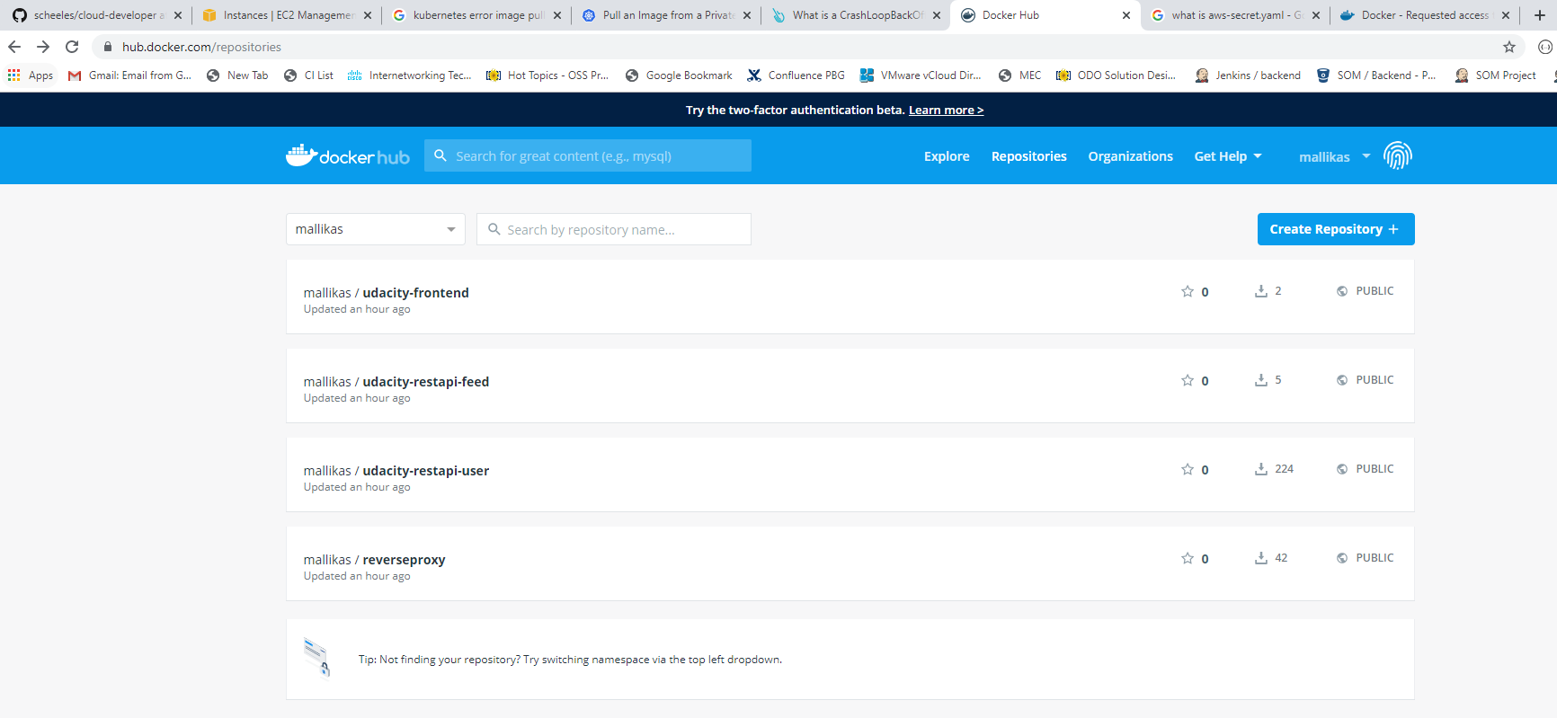

1. AWS cluster

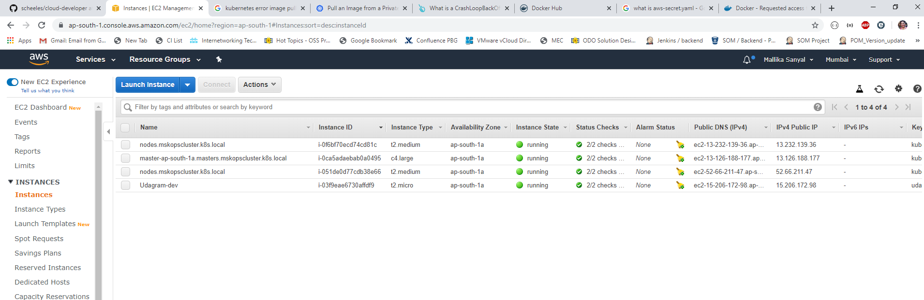

1. Kubernetes pods

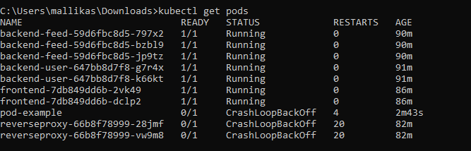

1. Rolling upgrade example:

