CURR_ID[P_PRICE_RETURNS_PR('1Y',2),DIST=NONE,CONV=NONE]-SPEC_ID[SP50:P_PRICE_RETURNS_PR('52W',2),DIST=NONE,CONV=NONE]

Chart of the Day

**Are Companies Underestimating Inflation (Again)?**

According to UBS Evidence Lab's new [‘Inflation’-focused Earnings Call Theme Explorer](https://neo.ubs.com/shared/d2rNNFt6G64b?campid=ELP_EM_SEGDS_ENMS_EH~889_X_X_2021-07-05), the proportion of negative ‘inflation-related’ conference call mentions is now at the highest level in 11 years with the weakest sentiment among corporates toward price, wage and cost inflation**:**

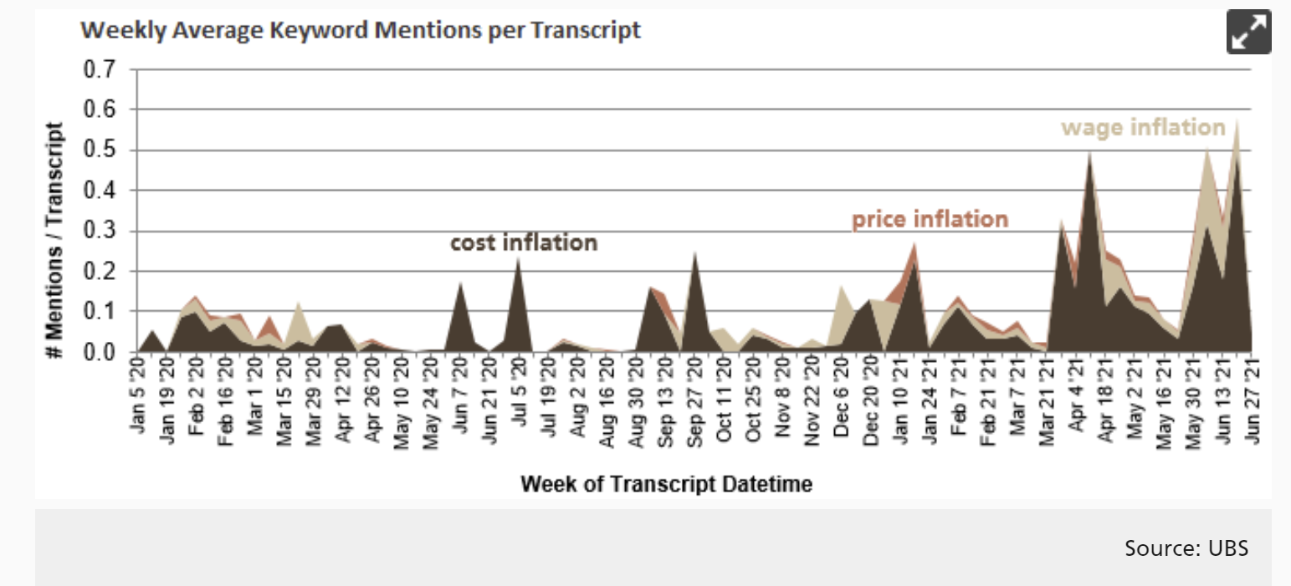

Their global theme explorer allows investors to scan over 3,600+ companies for inflation-linked keywords. They note that overall mentions have risen ~80% QoQ into 1Q21 - the sharpest rise since 2010. For those companies discussing this topic most, the data shows **Campbell Soup, Graphic Packaging and General Mills** are among the most vocal (bottom chart).

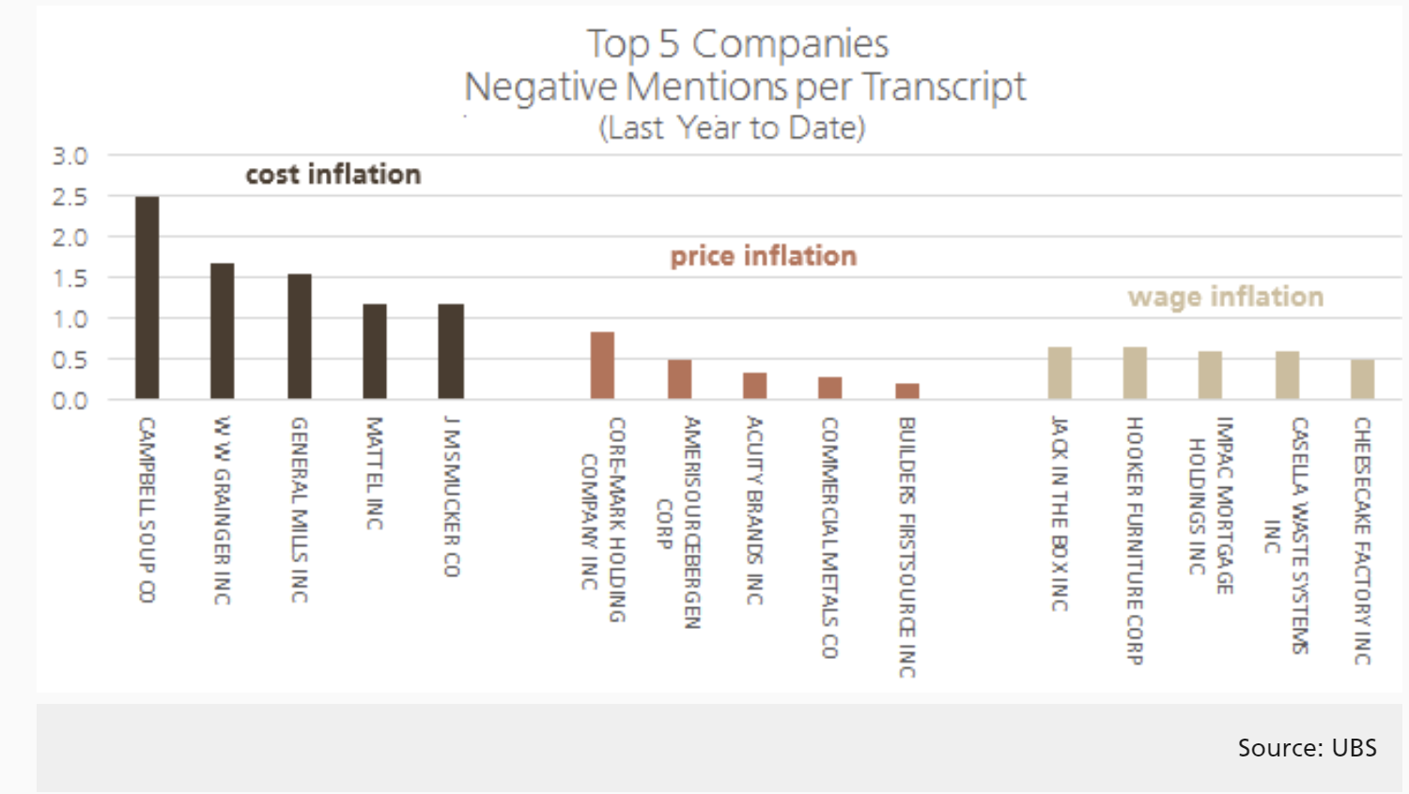

For those interested in more information: The [Earnings Call Theme Explorer: Inflation](https://neo.ubs.com/shared/d2eK0P66DTJswt?campid=ELP_EM_SEGDS_ENMS_EH~889_X_X_2021-07-05) provides an in-depth view of inflation sentiment across our earnings call transcript database of over 500+ million words and 160,000+ earnings calls, containing over 3,600 companies, segmented by global region with over 30+ searchable inflation-linked keywords.

