GENESIS USER MANUAL AND HELP

TABLE OF CONTENTS:

1.REQUIREMENTS 3
MINIMUM 3
RECOMMENDED 3
2.COMPATIBILITY 4
3.INSTALLATION 5
INSTALLATION INSTRUCTIONS 5
4.USER MANUAL 6
a. INITIALIZATION MODULE 6
b. LOG IN 7
c. MAIN MENU 8
d. CLIENT AND LAWYER REGISTRATION MODULES 9
e. CASE MANAGEMENT MODULE 11
f. PAYMENT MANAGEMENT MODULE 15
g. BACKUP MODULE 16
h. USER ADMINISTRATION MODULE (ADMIN) 18
5. SMALL VILLE HELPDESK 23

1.REQUIREMENTS

MINIMUM

- Windows 98 or higher
- Pentium 2 / AMD Thunderbird or higher
- 64 MB RAM
- 800x600 resolution capable screen and video card
- 5 MB of free disk space

RECOMMENDED

- Windows XP
- Pentium 4 / AMD Athlon 2800+ or higher
- 512 MB RAM
- 1024x768 resolution capable screen and video card
- 50 MB of free disk space

2.COMPATIBILITY

Some compatibility issues with AMD Athlon 64 are known but don’t affect program’s functionality (only some Windows error messages during Setup)

3.INSTALLATION

INSTALLATION INSTRUCTIONS

- From the GENESIS installation CD-ROM root double-click the Setup icon.
- Follow the Setup wizard steps.
- Once the program is successfully installed, you can run it from Start->Applications->GENESIS
- If you run the program for the first time you are required to press “ i ” while the INITIALIZATION MODULE (the first program’s form) is displayed, in order to indicate where the program’s data will be stored. This is a routine that allows you to run the program as a server application or a client application (if the program is installed on a machine different than the one having the main database file, you are required to MAP the network folder holding the main database before running the application). More information about both INITIALIZATION MODULE and Client/Server Setup you will find in USER MANUAL section.

4.USER MANUAL

a. INITIALIZATION MODULE

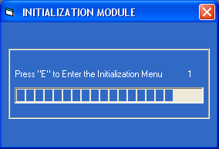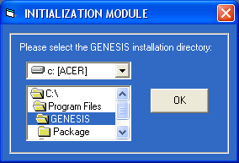

This is the first screen you see when you run the program. It counts 6 seconds until it starts loading stored data to the program. By pressing “E” while this screen is displayed, you can access the INITIALIZATION MENU screen from where you can setup the program’s data file details (you can indicate where the program’s files reside as you may want to use the program as a client application and, if so, possibly the files you want to use reside in another machine). If you installed the application on a network workstation (CLIENT) and you want to store on another machine’s (SERVER) data file directory you must MAP the SERVER’s directory from WINDOWS Explorer BEFORE running the application.

WARNING: You should run this routine the first time you run the application or you won’t be able to run the application (as no data file directory has been set).
If no data file directory is set the application will be AUTOMATICALLY TERMINATED.

b. LOG IN

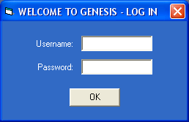

This is a simple login form, which asks for Username and Password and validates user access level rights.

c. MAIN MENU

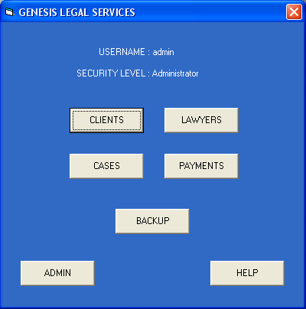

This is the main screen of the program. From here you can access all other program’s modules (some of the buttons of this screen may not be available depending on the user’s Rights. For more information see the ADMINISTRATION SECTION of the USER MANUAL).

d. CLIENT AND LAWYER REGISTRATION MODULES

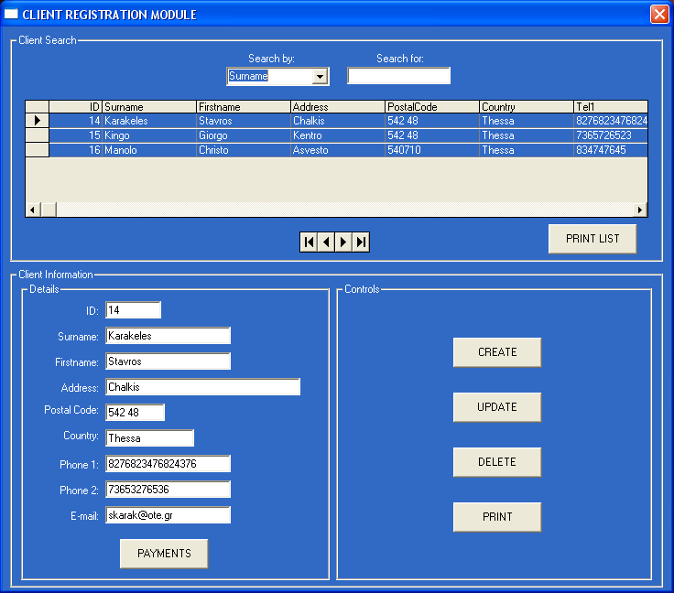

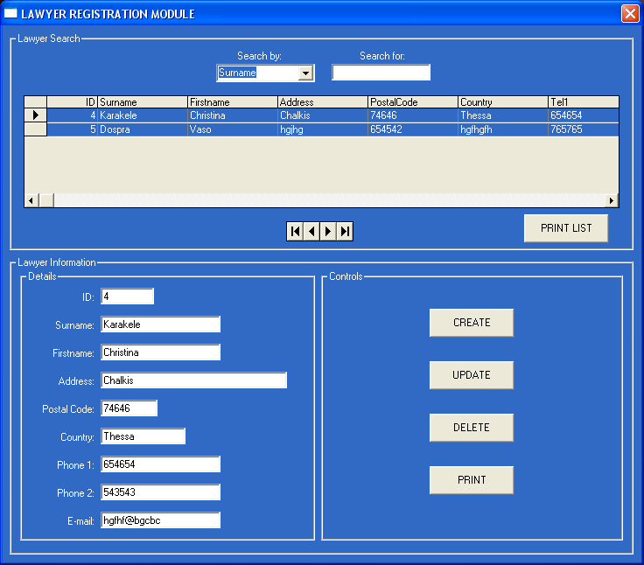

Those, almost identical, screens allow you to Create, Update, Delete, Find and Print, Client or Lawyer details. It features a Search Machine (with multiple criteria search option) a Details section which allows you to edit or update Details (you must press the UPDATE button every time you want to send the changes to the database or the changes WILL NOT be stored until you close the module).
The PRINT LIST button sends the filtered list to the default printer while the PRINT sends ONLY the selected record to the default printer, as well (if you want to set another printer as default printer, you should do so from the Windows related screen: Start->Control Panel->Printers).

ONLY FOR CLIENTS MODULE: After you have chosen a Client, you can press the PAYMENTS button which will open the PAYMENT MODULE. From there you can add payment transaction records for the selected Client – please refer to f. PAYMENT MANAGEMENT MODULE).

e. CASE MANAGEMENT MODULE

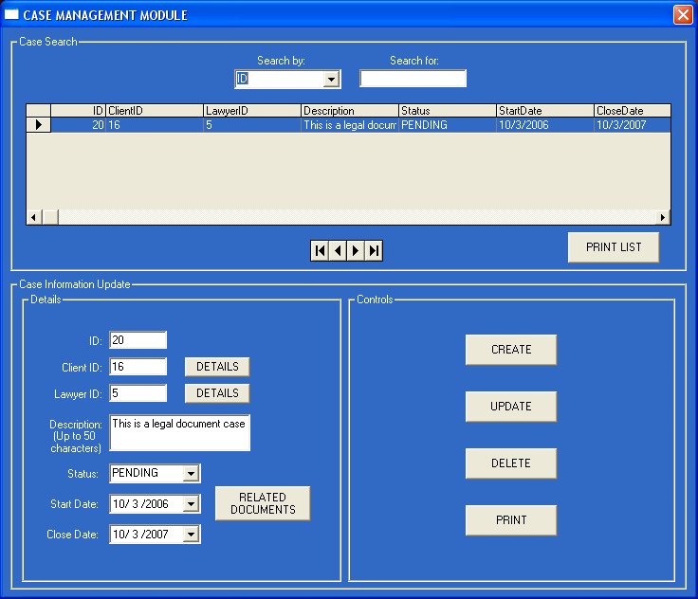

This is, probably, the most important screen of the program as it allows you to Create, Update, Delete, Find and Print, vital Case Details as :

- Client ID – The ID of the Concerned Client.
- Lawyers ID – The ID of the Lawyer who has been assigned to the case.
- Description - A brief description of the case.
- Status – This field allows the user (normally a Lawyer) to mark a case as PENDING if the it is still in progress and CLOSED if the it is finished.
- Start and Close Dates – The starting and closing (real or estimated) dates of the case.

The two DETAILS buttons allows the user to see all Client or Lawyer data as in the form only the ID of each of them appears. By pressing the DETAILS button a form similar to the following will appear (as a popup window):

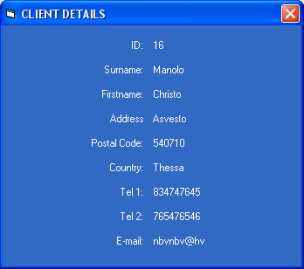

Also, when you press the CREATE key to register a new case, two SEARCH buttons will appear near the Cient ID and Lawyer ID Labels:
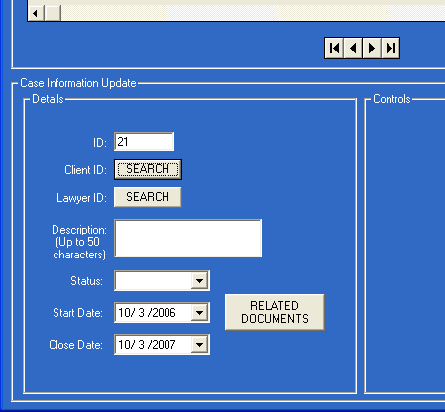

These buttons allows you to open the CLIENT or LAWYER SEARCH MODULE in order to search which Client/Lawyer to assign to the case (instead of remembering the corresponding IDs). The Search Module is a simple multiple-field Search Machine which assignes the selected Client’s/Lawyer’s ID to the case. A screenshot of the Module follows:

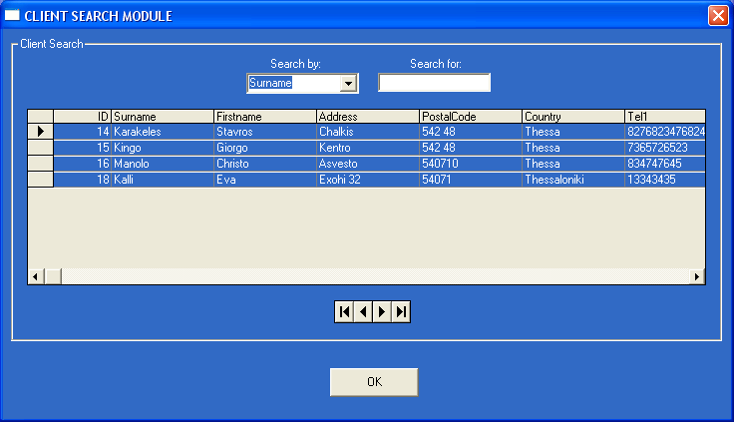

At last (but not least), the CASE MANAGEMENT MODULE provides a RELATED DOCUMENTS button which opens the CASE DOCUMENTS interface. From there you can Add, Remove, Update or Open (already stored) documents related to the specified case regardless of the computer or folder each of them reside. This is extremely useful when a specific case’s documents are stored in different locations, but you want to be able to access them when you are working on the case. The CASE DOCUMENTS screenshot follows:

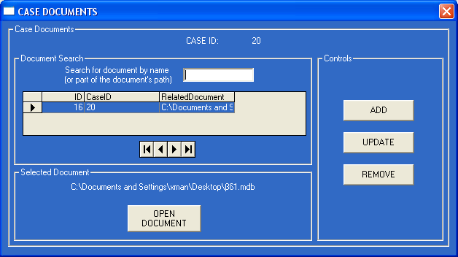

The selection of the documents’ location is performed through a Windows Open Dialog Interface:

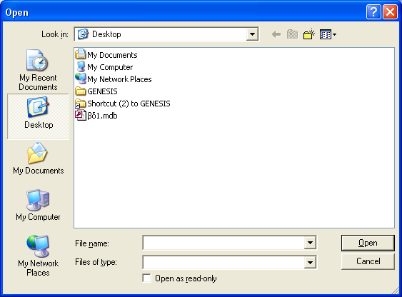

f. PAYMENT MANAGEMENT MODULE

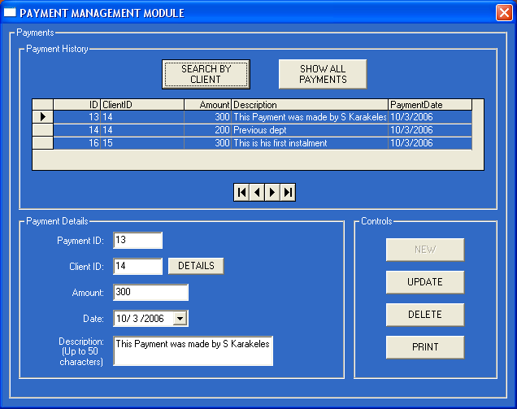

This module allows you to register New payments or Update, Delete and Print existing payment records (if the NEW button appears DISABLED like in the screenshot above, it means that no Client is selected as required. In that case you should close the PAYMENT module, open the CLIENTS module and choose the client who performs the payment transaction. There is no need to re-open the PAYMENTS MODULE from the MAIN MENU screen as you can call it directly from the CLIENT MODULE – please refer to d. CLIENT AND LAWYER REGISTRATION MODULES).
Also, a Search Machine and Detail fields (Amount, Date, Description) are available in order to provide record management.

g. BACKUP MODULE

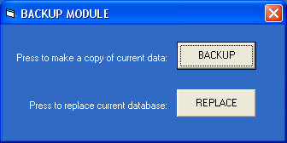

This module allows a user with ADMINISTRATIVE RIGHTS to make copies of the program’s main Database File (BACKUP) and replace the main Database File with other, already stored copies (in case any data loss or corruption occurs to the Main Database file). The interface provides two Buttons:

- BACKUP – It opens a Save As Dialog Window. From there the user can decide the location and name of the Data File copy.
- REPLACE – It opens an Open Dialog Window. The user must choose the copied version of the Data File. Afterwards, the program replaces the existing Data File with the copied one.

Screenshots of both Dialog Windows:

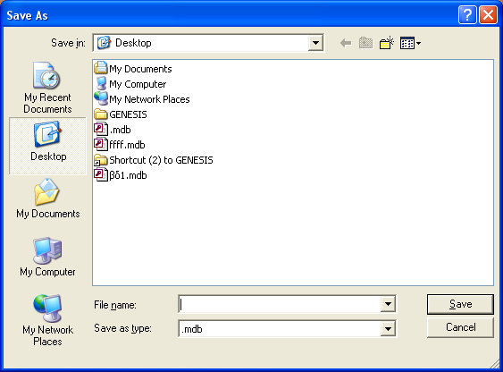

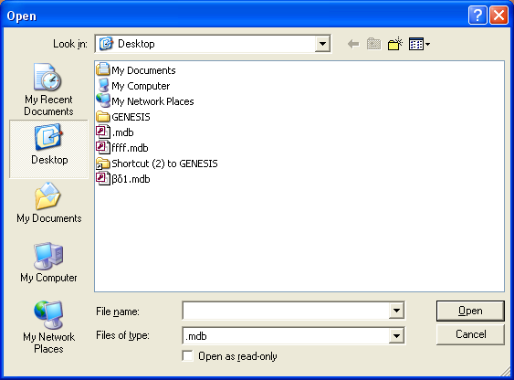

h. USER ADMINISTRATION MODULE (ADMIN)

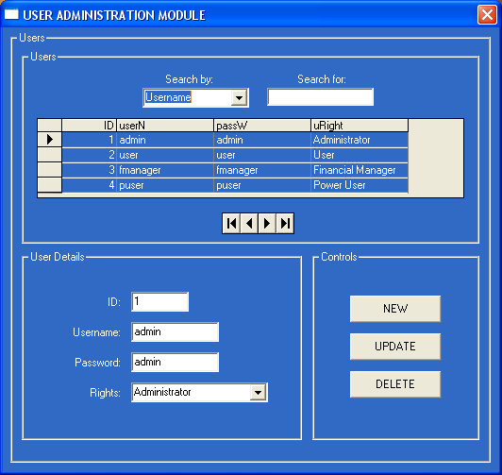

From this form a user with ADMINISTRATIVE RIGHTS can Create, Update, Find (Search) or Delete GENESIS system users records. Each user is assigned to a unique ID number, a Username, a Password and an Access Rights keyword (Administrator, Power User, User or Financial Manager). Depending on that Rights keyword the selected user will (or will not) be eligible to access specific program functions. Following you will find screenshots of the four different Access Levels interfaces:

- Administrator:

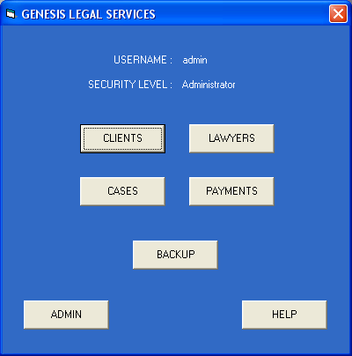

- Power User:

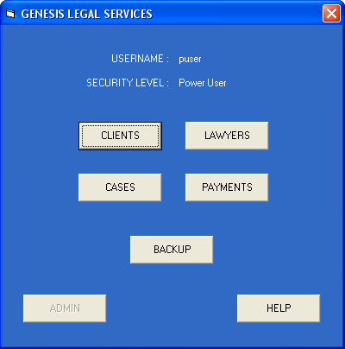

- User:

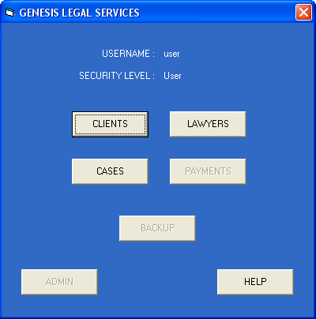

- Finincial Manager:

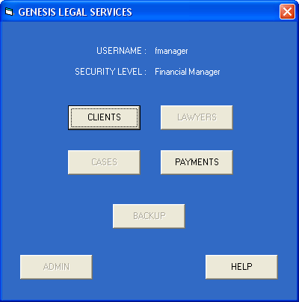

WARNING!: You should ALWAYS leave AT LEAST ONE USER WITH Administrator Rights in the Database OR YOU WILL BE LOCKED OUT OF THE ADMIN SECTION. If you are in such a situation please refer to SMALL VILLE HELPDESK section.

5. SMALL VILLE HELPDESK

You can get help by e-mail or phone:

E-mail us at: xmanolas@gmail.com

24 hours helpdesk phone: 0030 6947 029 525

