(1) Did you receive any help whatsoever from anyone in solving this assignment? Yes / No. If you answered 'yes', give full details:

Yes. Xiaoyu Bai explained to me how to analyze d-separation for a Bayes network in problem 4. We also discussed some ambiguity in problem 6.

(2) Did you give any help whatsoever to anyone in solving this assignment? Yes / No. If you answered 'yes', give full details:

No.

* 1. Yes, because P(X, Y) = P(X) \* P(Y):

P(X=1, Y=1) = 1/8, P(X=1) \* P(Y=1) = (3/8 + 1/8) \* (1/8 + 1/8) = 1/8

P(X=1, Y=0) = 3/8, P(X=1) \* P(Y=0) = (3/8 + 1/8) \* (3/8 + 3/8) = 3/8

P(X=0, Y=1) = 1/8, P(X=0) \* P(Y=1) = (3/8 + 1/8) \* (1/8 + 1/8) = 1/8

P(X=0, Y=0) = 3/8, P(X=0) \* P(Y=0) = (3/8 + 1/8) \* (3/8 + 3/8) = 3/8

* 1. No, because there exists case when P(X|Y, Z) ≠ P(X|Z), since P(X=0|Y=0, Z=1) = 0, while P(X=0|Z=1) = 1/4
  2. No, because there exists case when P(X|Y, W) ≠ P(X|W), since P(X=0|Y=0, W=0) = 3/7, while P(X=0|W=0) = 4/7
  3. Yes, because P(X|Y, C) = P(X|Y)P(C) = P(X)P(C), and P(X|C)=P(X)P(C), they are equal

2.1 By adding pseudo counts, P(w7=1|L=T) = 0.25, P(w7=1|L=F) = 0.5, P(w10=1|L=T) = 0.25, P(w10=1|L=F) = 0.5

P(L5=T|E5) = P(w7=1|L=T) P(w10=1|L=T) P(L=T)/(P(w7=1|L=T) P(w10=1|L=T) P(L=T) + P(w7=1|L=F) P(w10=1|L=F) P(L=F)) = 0.5 \* 0.25 \* 0.25 / (0.5 \* 0.25 \* 0.25 + 0.5 \* 0.5 \* 0.5) = 1/5

P(L5=F|E5) = 4/5

2.2 By adding pseudo counts, P(w2=1|L=T) = 0.75, P(w2=1|L=F) = 0.5, P(w3=1|L=T) = 0.75, P(w3=1|L=F) = 0.25, P(w11=1|L=T) = 0.5, P(w11=1|L=F) = 0.25

P(L6=T|E6) = P(w2=1|L=T) P(w3=1|L=T) P(w11=1|L=T) P(L=T)/( P(w2=1|L=T) P(w3=1|L=T) P(w11=1|L=T) P(L=T) + P(w2=1|L=F) P(w3=1|L=F) P(w11=1|L=F) P(L=F)) = 9/10

P(L5=T|E5) = 1/10

2.3 By performing the M step, the resulted parameters are

P(w3=1|L=T) = 0.7647, P(w3=1|L=F) = 0.2245, P(w10=1|L=T) = 0.2353, P(w10=1|L=F) = 0.5714, P(L=T)= 0.5167, P(L=F)= 0.4833

So the classification will be

P(L=T|Efinal) = P(w3=1|L=T) P(w10=1|L=T)P(L=T)/( P(w3=1|L=T) P(w10=1|L=T)P(L=T) + P(w3=1|L=F) P(w10=1|L=F)P(L=F)) = 0.6

P(L=F|Efinal) = 0.4

It will be classified as true.

3.1 P(Y,A,B,C) = P(Y|A,B,C)P(A)P(B)P(C)

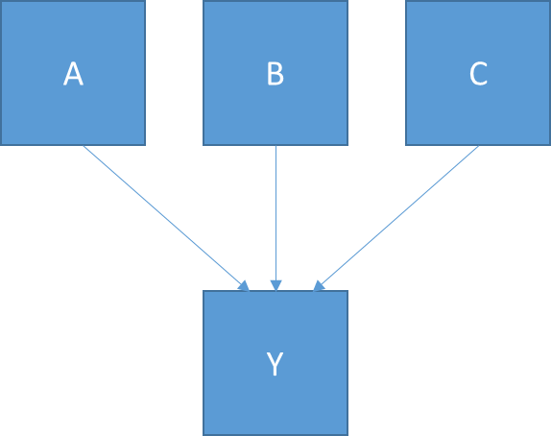

3.2 P(Y,A,B,C) = P(Y|A,B,C)P(A|C)P(C)P(B)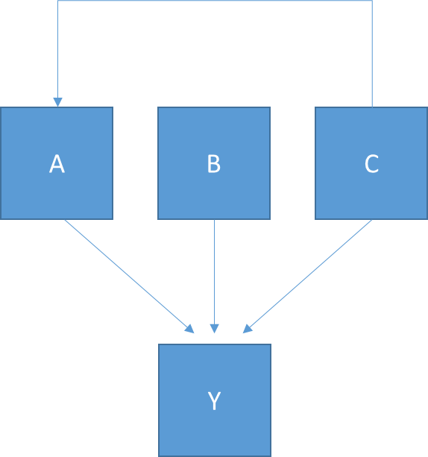

3.3 {B, C, D, E, F, G, H}

3.4 P(Y, B, C, D, E, F, G, H) = P(B)P(C)P(E|B,C)P(Y|E)P(H|Y,E)P(G|Y)P(F|Y,D)P(D|A)

4.1 {A, B, C, E, F, H, I}

4.2 {B, D, G, H, I}

4.3 {A, B, C, D, E, G, H, I}

4.4 {}

4.5 {}

4.6 {I}

5.1 P(A=F,B=F,C=F,D=F) = P(A=F)P(B=F|A=F)P(C=F|B=F)P(D=F|B=F,C=F) = 0.8\*0.6\*0.8\*0.1 = 0.0384

5.2 P(B=T|A=T,C=F) = P(A=T,B=T,C=F)/P(A=T,C=F)

Let X = P(A=T,B=T,C=F) = P(A=T,B=T,C=F, D=T) + P(A=T,B=T,C=F, D=F) = P(A=T)P(B=T|A=T)P(C=F|B=T)(P(D=T|B=T,C=F) + P(D=F|B=T,C=F)) = 0.1\*0.5\*0.2\*(0.98+0.02) = 0.01

Let Y = P(A=T,B=F,C=F) = P(A=T)P(B=F|A=T)P(C=F|B=F)(P(D=T|B=F,C=F) + P(D=F|B=F,C=F)) = 0.8\*0.5\*0.2\*(0.9+0.1) = 0.08

So P(A=T,C=F) = X + Y, and P(B=T|A=T,C=F) = X/(X+Y) = 1/9

So P(B=F|A=T,C=F) = 8/9

5.3 Based on P(A,B,C,D) = P(A)P(B|A)P(C|B)P(D|B,C)

P(D=T|A=F) = P(D=T,A=F)/P(A=F) = (P(A=F,B=T,C=T,D=T) + P(A=F,B=T,C=F,D=T) + P(A=F,B=F,C=T,D=T) + P(A=F,B=F,C=F,D=T)) /P(A=F) = (0.8\*0.4\*0.9\*0.99 + 0.8\*0.4\*0.1\*0.98 + 0.8\*0.6\*0.2\*0.95 + 0.8\*0.6\*0.8\*0.9) / 0.8 = 0.9416

P(D=F|A=F) = 0.0584

5.4 Based on P(A,B,C,D) = P(A)P(B|A)P(C|B)P(D|B,C)

P(D=T|B=F) = P(D=T,B=F)/P(B=F) = (P(A=T,B=F,C=T,D=T) + P(A=T,B=F,C=F,D=T) + P(A=F,B=F,C=T,D=T) + P(A=F,B=F,C=F,D=T)) / (P(B=F|A=T) + P(B=F|A=F)) = (0.2\*0.5\*0.2\*0.95 + 0.2\*0.5\*0.8\*0.9 + 0.8\*0.6\*0.2\*0.95 + 0.8\*0.6\*0.8\*0.9) / (0.5\*0.2 + 0.6\*0.8) = 0.91

P(D=F|B=F) = 0.09

5.5 D is conditionally independent on A given A, B, C. So P(D=T|A=T,B=T,C=F) = P(D=T|B=T,C=F) = 0.99

6. For the first E step

1. P(C=1|A=0,B=1,D=0) = P(A=0,B=1,D=0,C=1)/P(A=0,B=1,D=0) = P(A=0,B=1,D=0,C=1) / (P(A=0,B=1,D=0,C=1) + P(A=0,B=1,D=0,C=0)) = 1/2

2. P(C=1|A=0,B=1,D=0) = 1/2

For the first M step

1. P(C=1|B=1) = P(C=1,B=1)/P(B=1), where P(C=1, B=1) = (4+1/2)/17, P(B=1) = (8+1)/17, so the result will be (4+1/2)/9 = 1/2

P(C=0|B=1) = 1/2

2. P(C=1|B=0) = P(C=1,B=0)/P(B=0) = (4/17)/(8/17) = ½

P(C=0|B=0) = 1/2

3. P(A=0,B=1,C=0,D=1) = 1/17

For the second E step

1. P(C=1|A=0,B=1,D=0) = P(A=0,B=1,D=0,C=1)/P(A=0,B=1,D=0) = (1+1/2)/3 = 1/2