1. **Introduction**

**1.1 Purpose**

This SDD describes the scope and system design of “Wazifa”  
which is created in sake of making it easier to connect with other people works the same as you work or working in the same job. “Wazifa” will minimize the time and efforts in searching for companies or other workers.

**1.2 scope**

“Wazifa” is a business and employment-oriented social media service that works as web application that allows users to make friends with each other and post anything about jobs or advice to other employees.   
  
Users can sign-up and make their profile as their CV they will add their skills past jobs, current jobs, education .  
They can comment, like or share someone's post and they can chat with any user.

Users can add a page about the company they work in with logo, description, position.

Users can search about other users and companies and discover their profile or page.  
Users will be able to update their profile info (CV)   
  
an administrator will use web-portal to administrate the system and keep the information accurate. The admin can verify the company page and manage its information.

**1.3 Out Scope**

No job offers.  
no bidding on jobs.  
Not a freelancing application  
you can’t login by fake mail or password.

1. **System Overview**

“Wazifa” is built to make it easier to find other people works with you in the same company or works the same work as you are and make friends with them in order to learn from them and exchange your experiences.

**3**.**System architecture**

3.1 architecture design

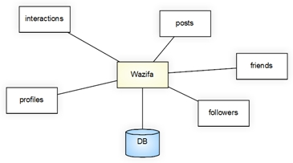

block Diagram

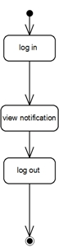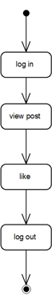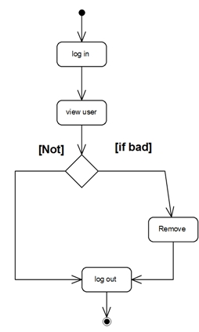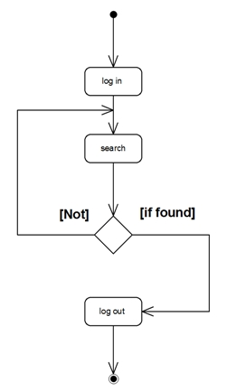3.2 Decomposition Description

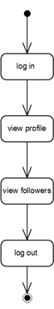

activity diagrams

like post

view followers

View notification

Search

Remove user

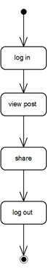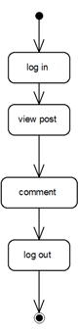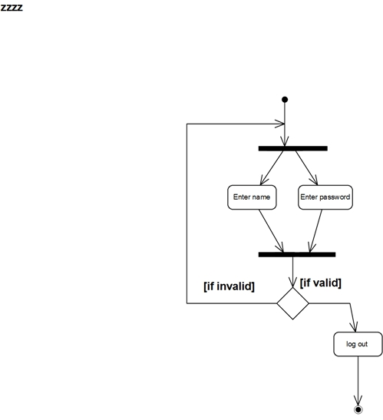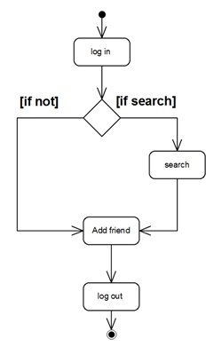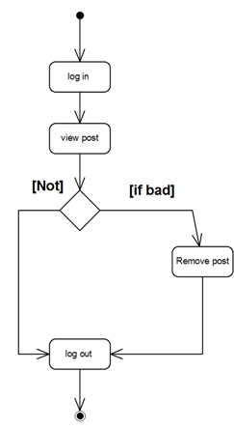

login

Add friend

Remove post

comment

share

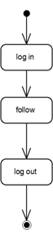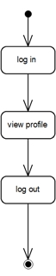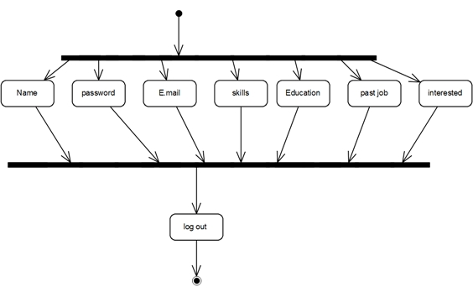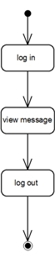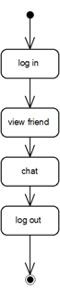

register

chat

follow

View profile

View message

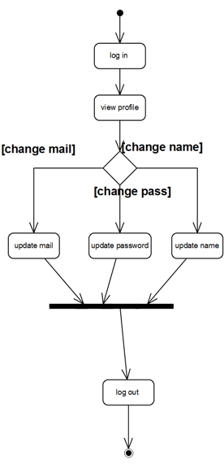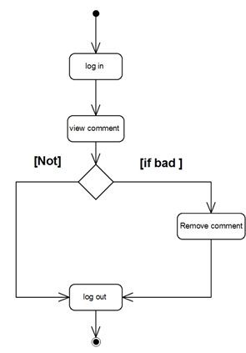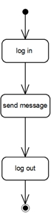 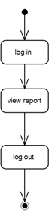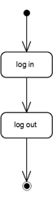

Remove comment

Update profile

Send message

Log out

View report

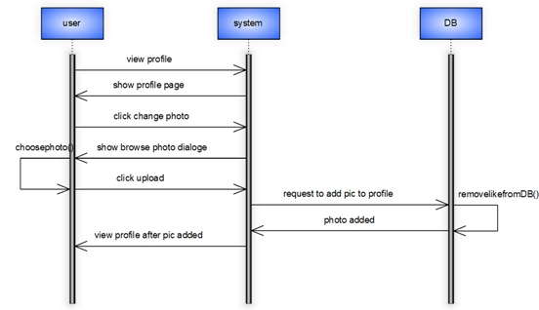sequence diagrames

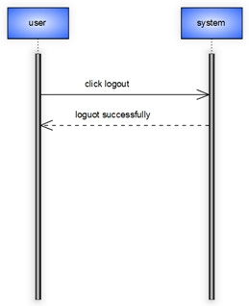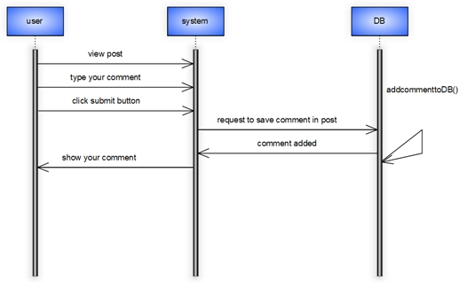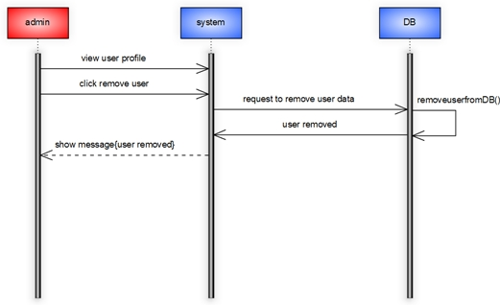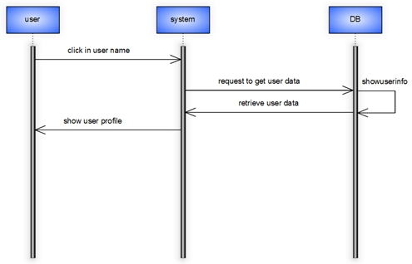

Show user profile

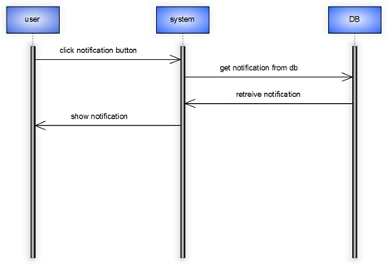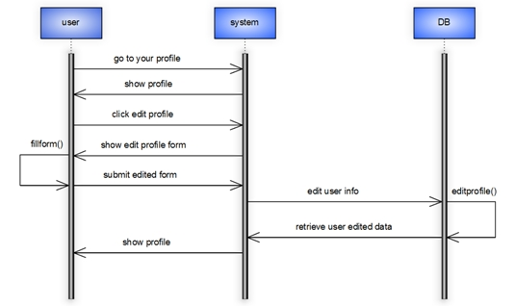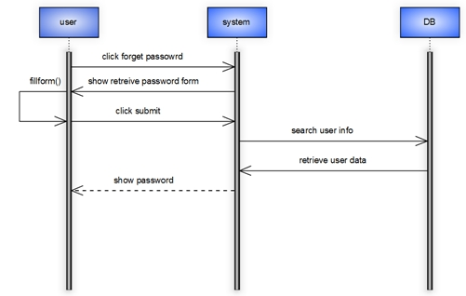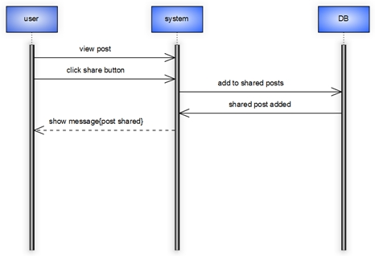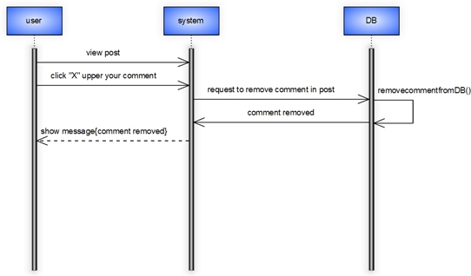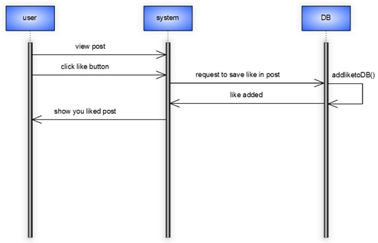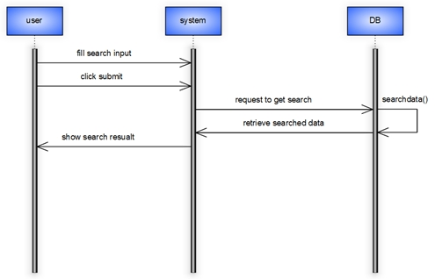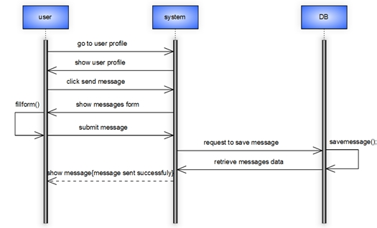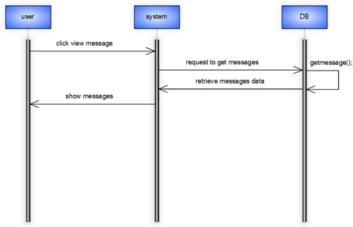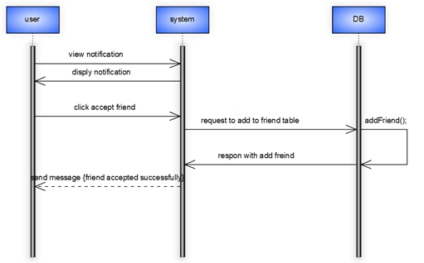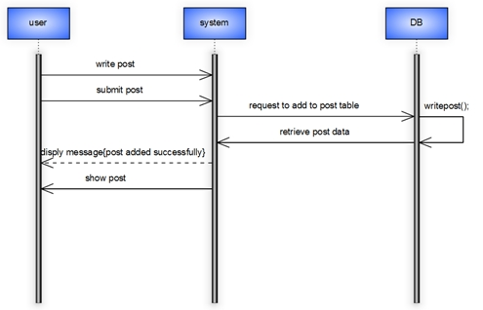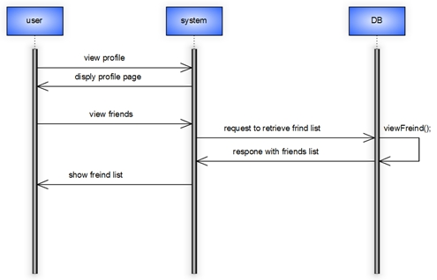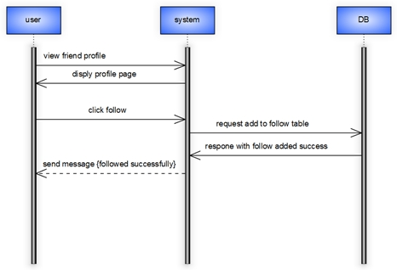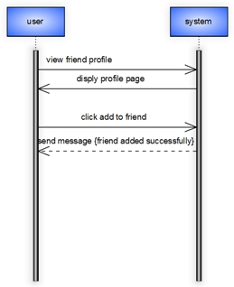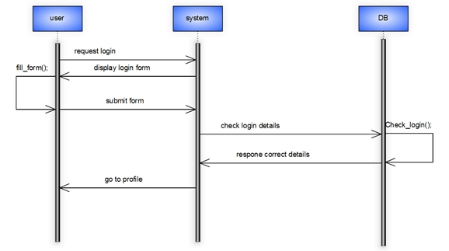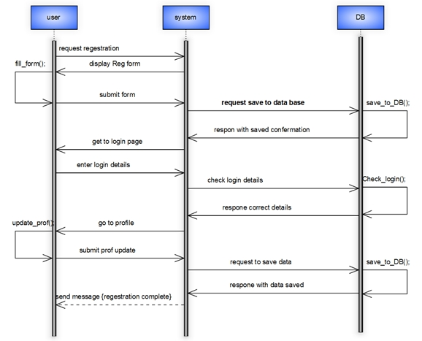

View notification

Update profile

Retrieve password

“Share”

Remove comment

Like post

search

Send message

View message

Accept friend

Write post

View friends

Follow

Add friend

login

registration

Class diagram

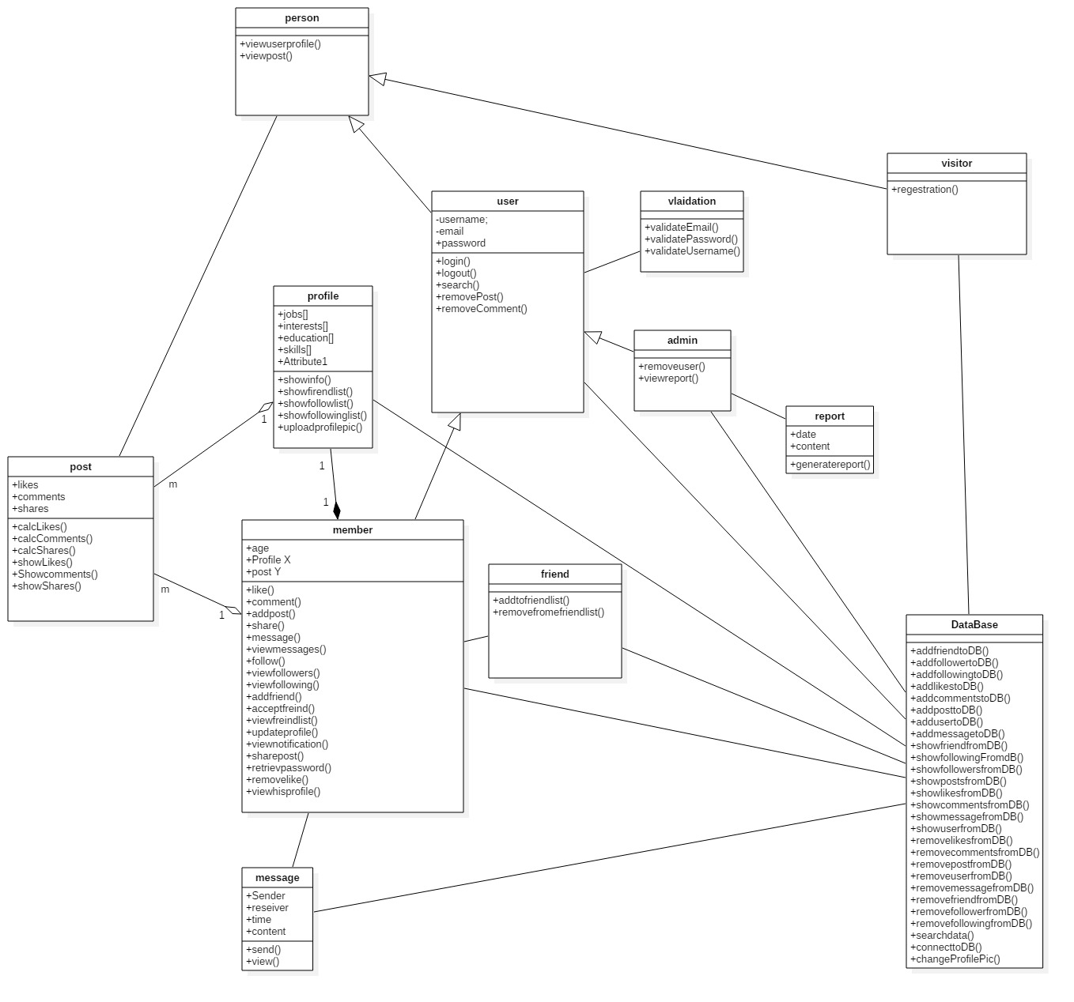

**3. Data Design**

**3.1 Data Description**

Data stored in database of the system, the stored data in the database like username of users, their password, skills, and their activities.

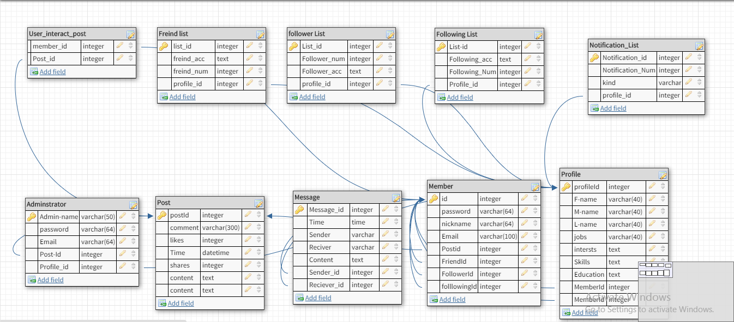

DB schema

ER diagram

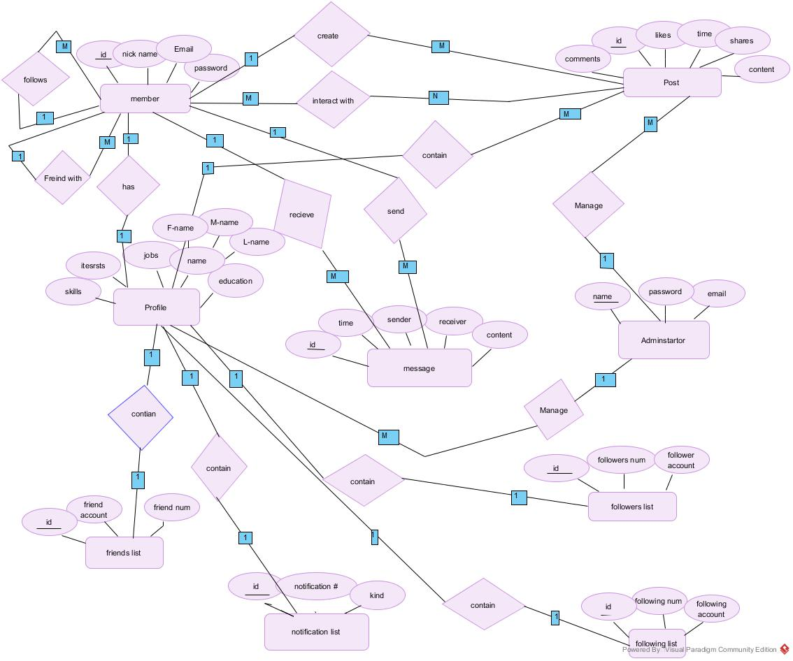

**4. Human Interface Design**

**4.1 Overview of User Interface**

Any user in the system can do many functions by using the application like communication with other, searching for jobs, add more experience to him, and collect a lot of information about his career . user can easily do all of this function by making an account on the application and add his skills and career to make searching and communication mare easy to him .

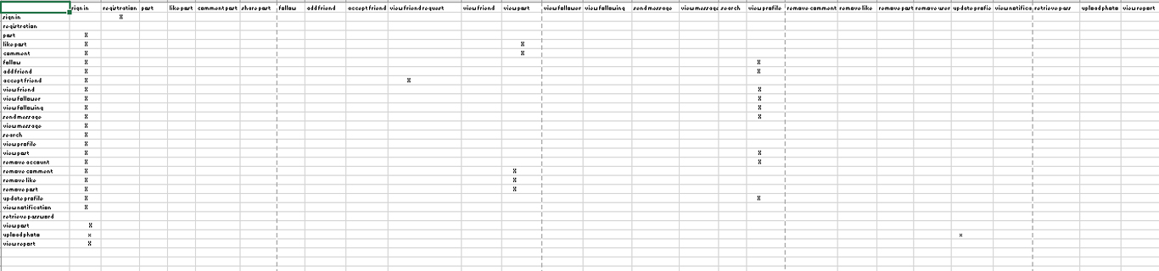 **5.Requirements Matrix**