**Q. How to configure firebase console setup for Running Project chat?**

**Ans:** To use firebase follow the procedure which are mentioned below:

1. Go to this URL to create project <https://console.firebase.google.com/u/0/>

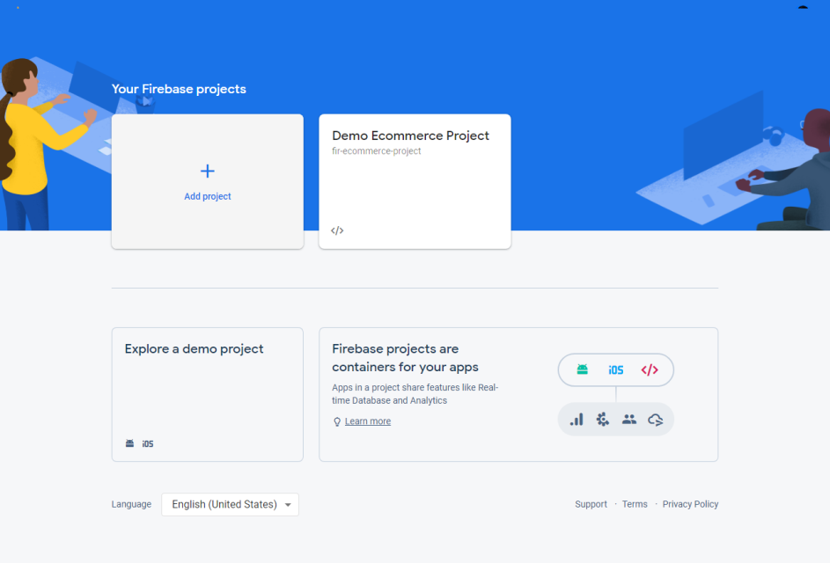

1. Enter project name and then click on **continue** button

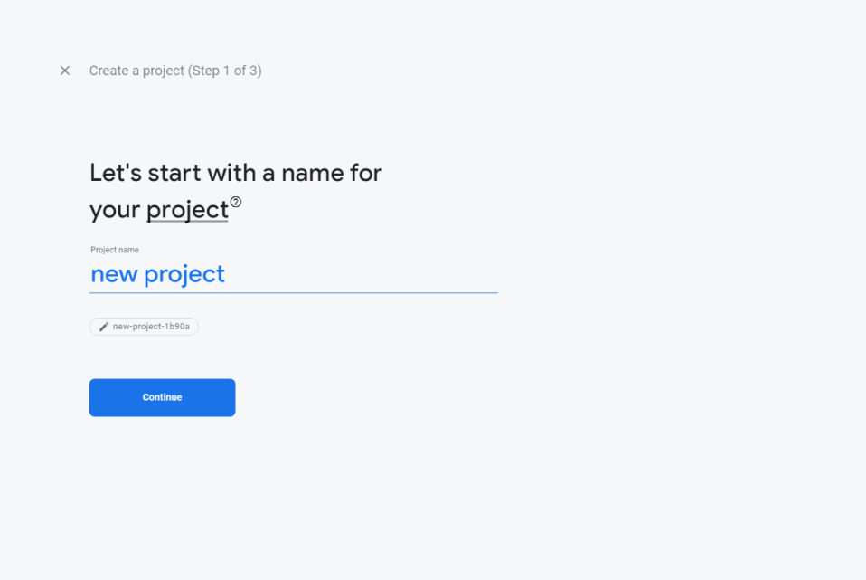

1. Disable the Google analytics for this project option and click **Create project** button

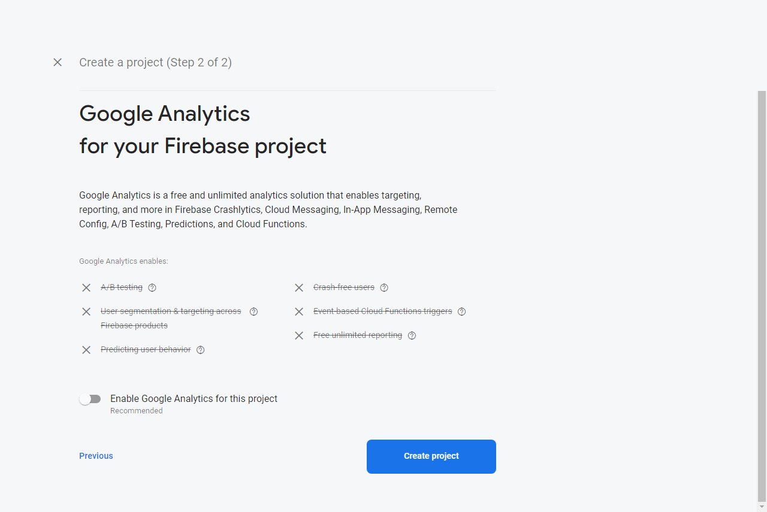

1. After then click on **continue** button

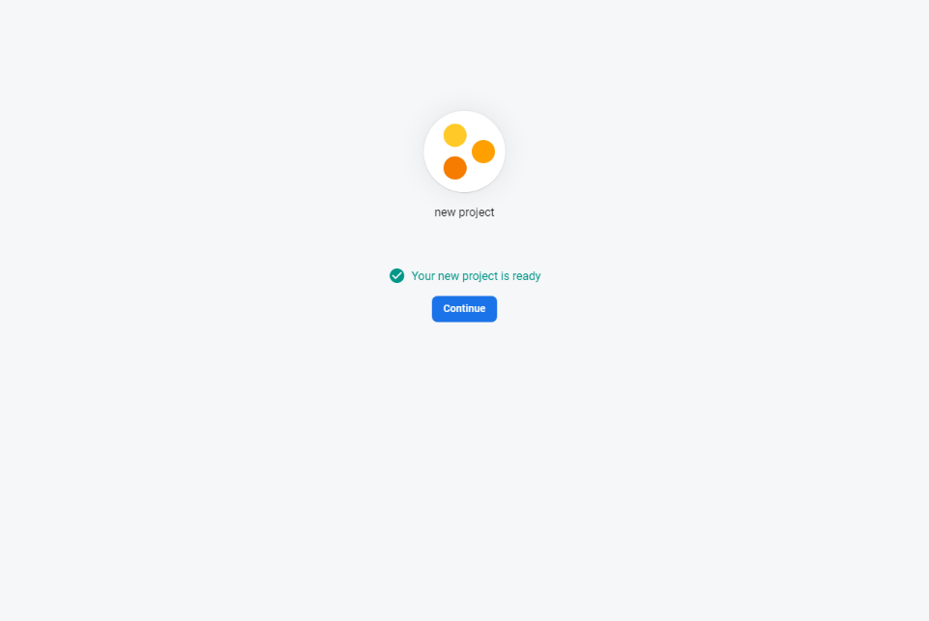

1. After then you need to add an app for web.

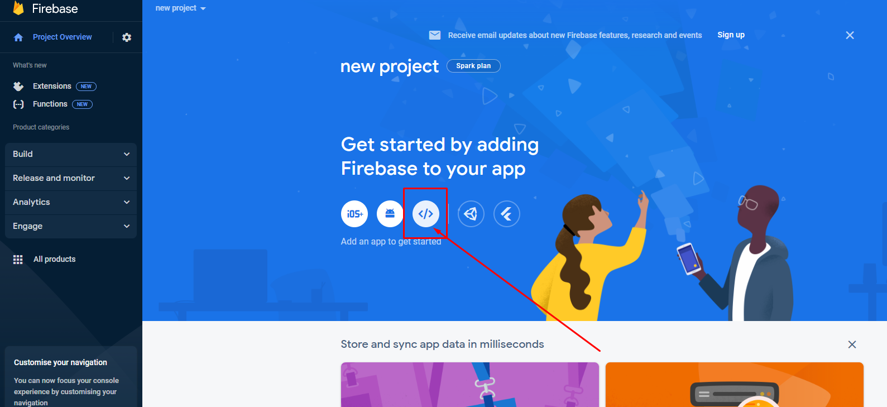

1. Put your app nickname & then click on **Register App** button.

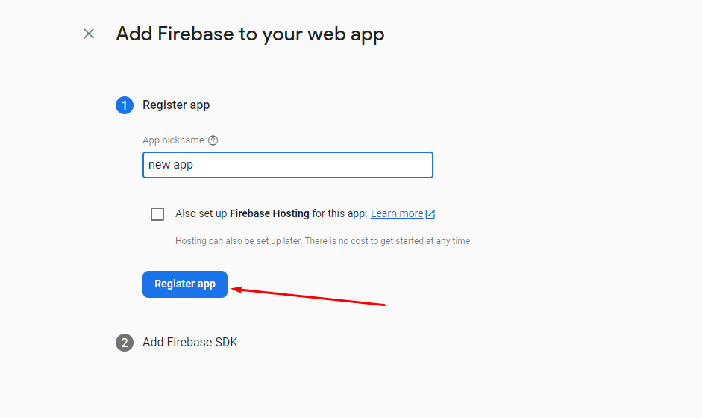

1. Then just click on **Continue to the console**

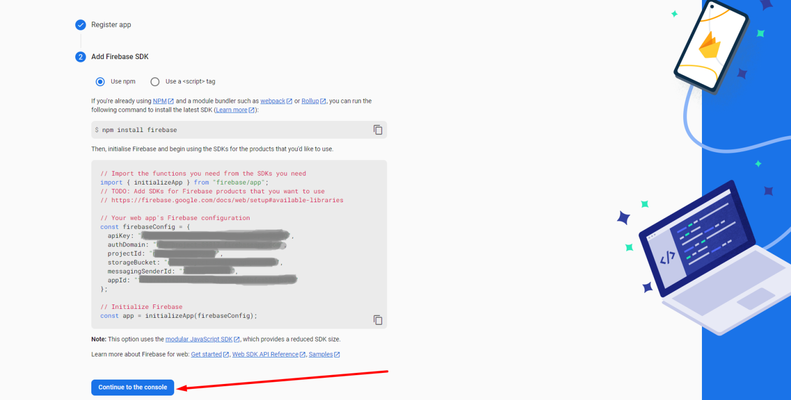

1. Create a **Real time Database** by following steps given bellow.

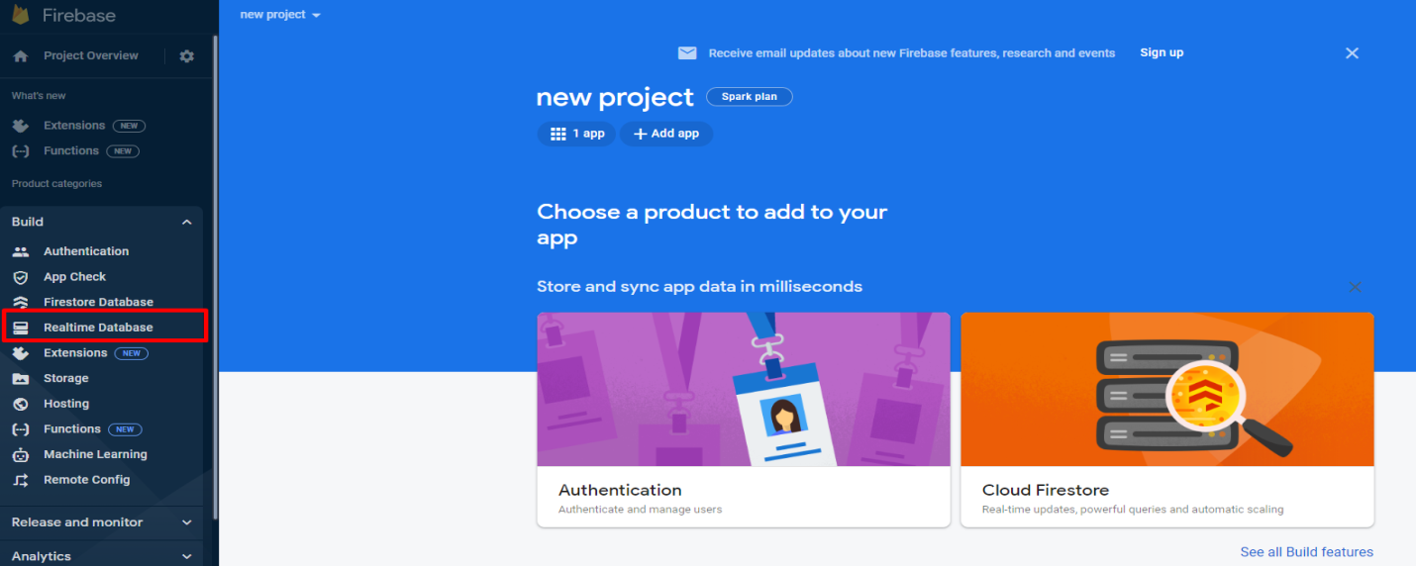

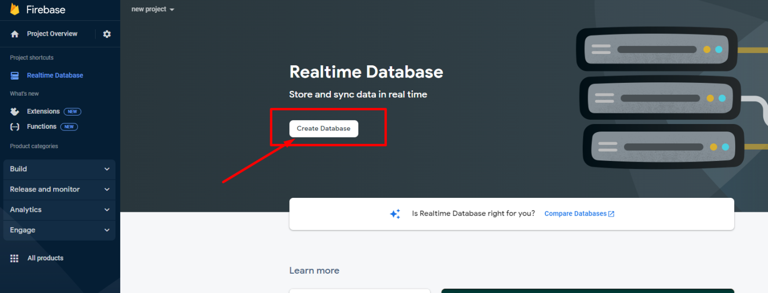

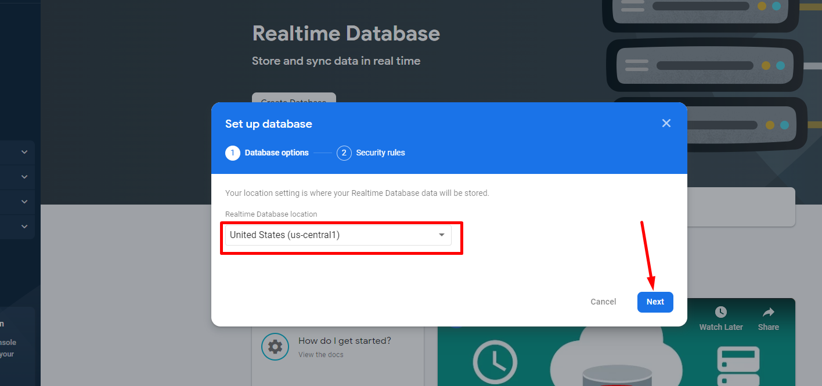

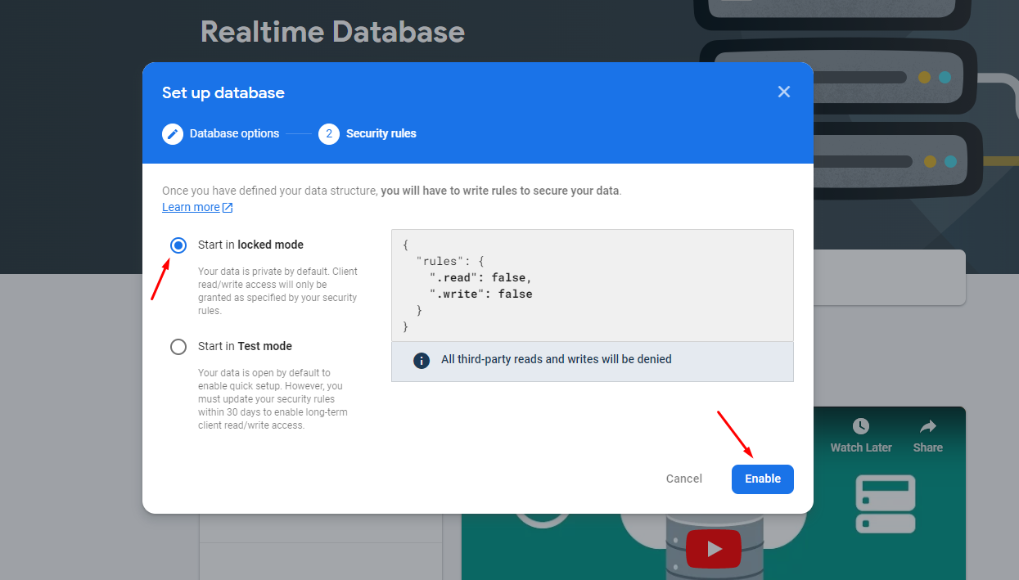

1. Edit Rules of Real time Database and make ‘read’ & ‘write’ true.

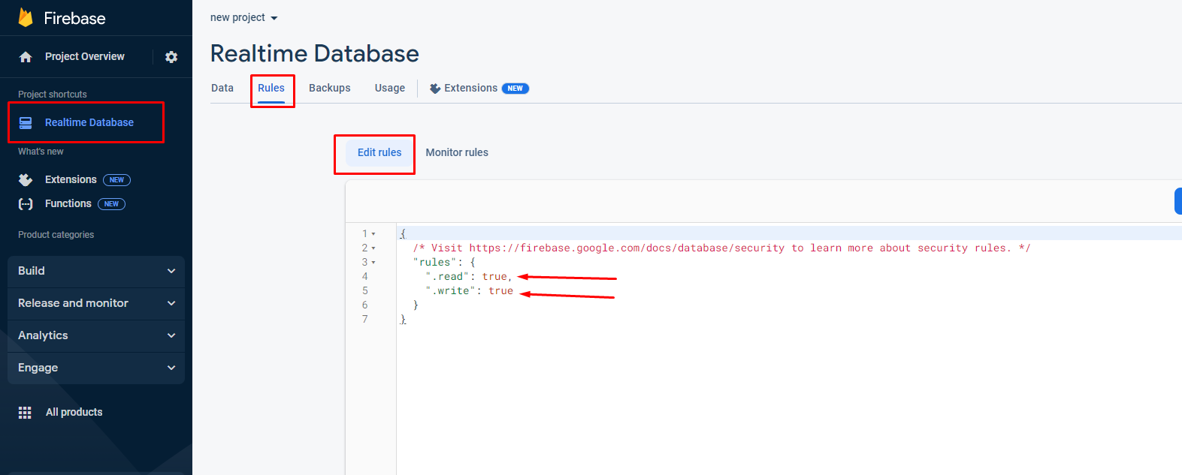

1. Now go to **project settings** to get API Key, Auth Domain, Database URL, Project Id, Storage Bucket, Messaging Sender Id, App Id, server key & Public Vapid Key (Key pair).

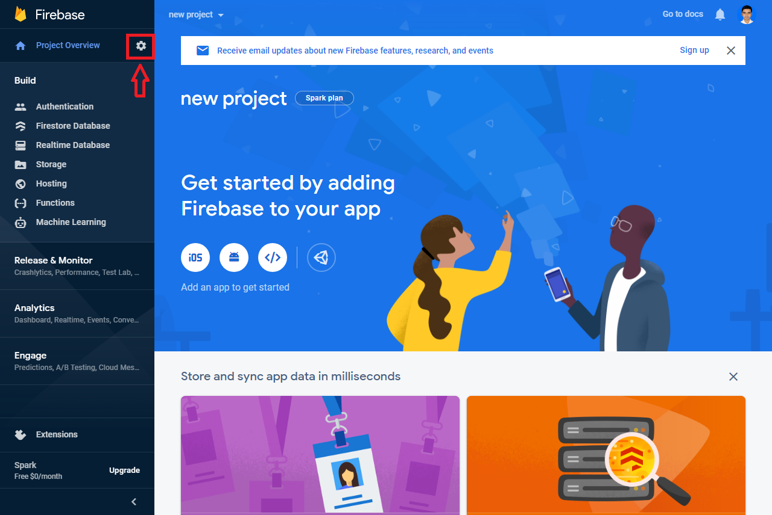

1. To get ‘API Key’, ‘Auth Domain’, ‘Database URL’, ‘Project Id’, ‘Storage Bucket’, ‘Messaging Sender Id’, ‘App Id’ click on **General** option & select **Config** option of ‘SDK setup & configuration’.

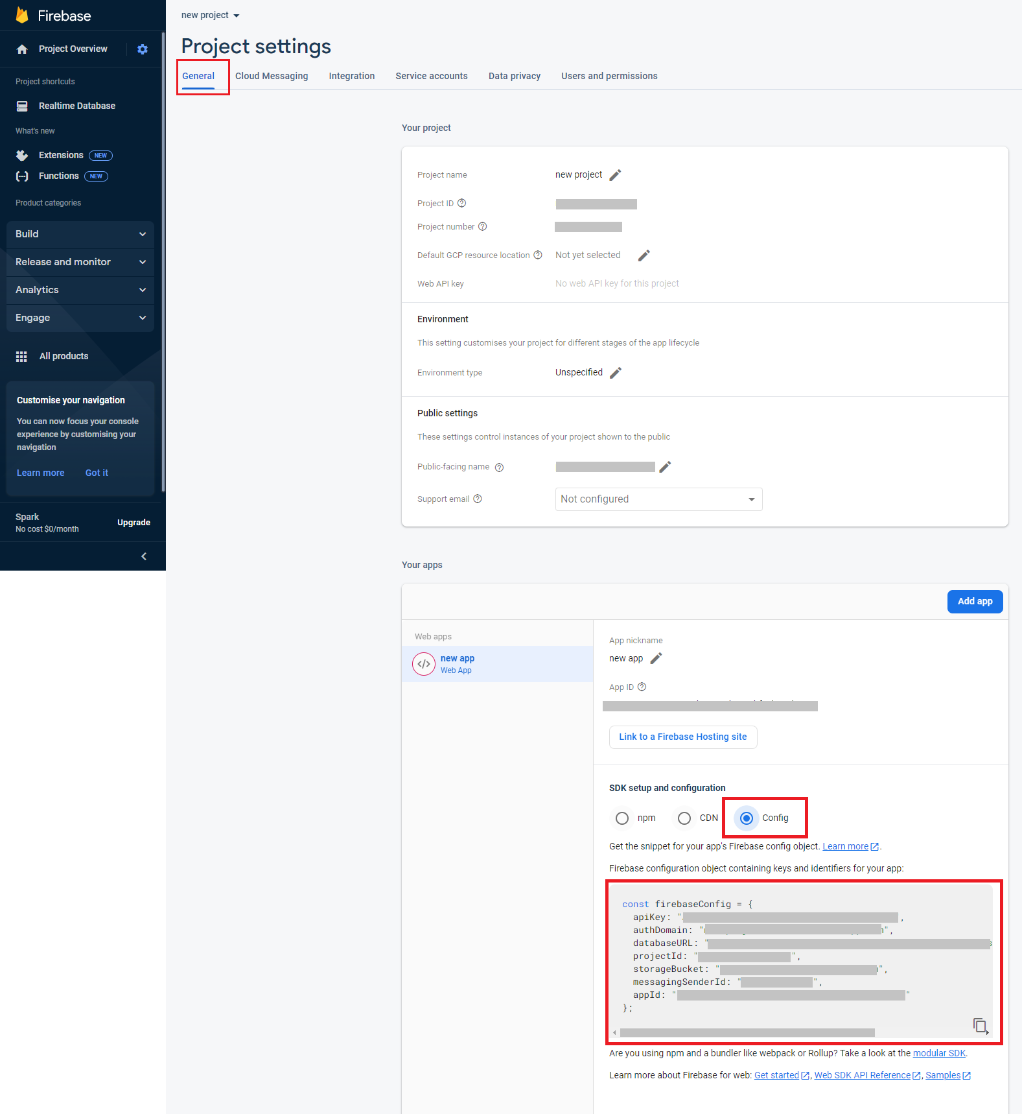

1. To get ‘server key’ & ‘Public Vapid Key’ click on **Cloud Messaging** option. Here ‘Server Key’ is the ‘FCM SERVER KEY’ & ‘Key pair’ is the ‘Public Vapid Key’. You need to ‘generate Key pair’ to get ‘Public Vapid Key’.

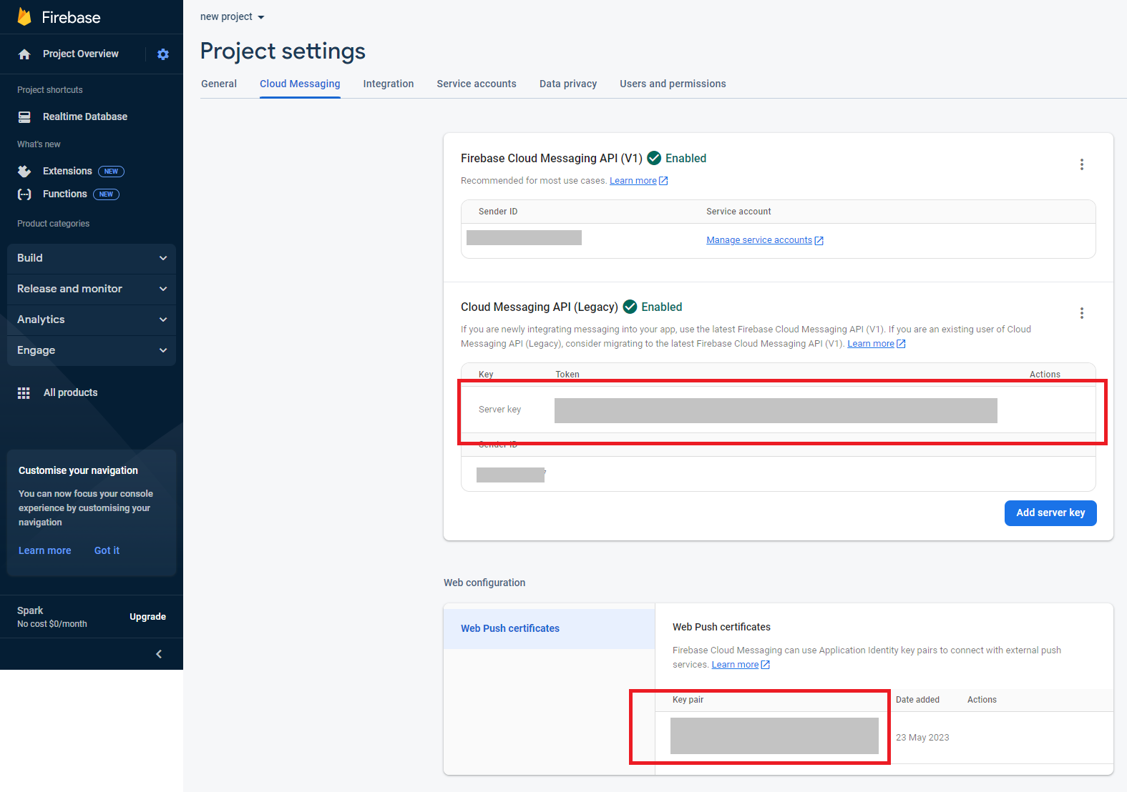

Note: You need to make sure that the ‘firebase-messaging-sw.js’ file (we provided) is in your root directory & edit the file to configure with your actual data.