Evaluating and Improving Cross-Dataset Generalization of Machine-Learning-Based Intrusion Detection Systems


NSUT logo
B.Tech. Project – I (Mid-Semester Report)
Department of Information Technology
Netaji Subhas University of Technology (NSUT), Dwarka, New Delhi

Under the supervision of
Dr. Preeti Bansal

Submitted by
Roll Number | Name
2023UIN3323 | Shivam Chauhan
2023UIN3330 | Shantanu Agarwal
2023UIN3358 | Deepesh

Date of submission: 30 September 2026

Supervisor’s signature: __________________________

Table of Contents
S.No. | Section | Page
1 | Abstract | 2
2 | Introduction | 3
3 | Motivation | 3
4 | Literature Survey | 4
5 | Problem Statement | 8
6 | Objectives | 8
7 | Proposed Methodology | 9
8 | Implementation | 11
9 | Results and Discussion | 12
10 | Conclusion and Future Work | 18
11 | References | 18

1. Abstract
Machine-learning (ML) based Network Intrusion Detection Systems (NIDS) routinely report near-perfect accuracy, but these numbers are almost always obtained by training and testing on the same dataset. When such a model is deployed on a different network, its performance frequently collapses — in some studies to below 40%, or even to random guessing — because it has learned dataset-specific artefacts (IP addresses, port numbers, collection-window statistics) rather than genuine attack behaviour. This project studies and attempts to reduce this cross-dataset generalisation gap across three structurally different benchmark datasets: CIC-IDS-2017, UNSW-NB15, and TON_IoT. Our key idea is to use metaheuristic / bio-inspired optimisation (Genetic Algorithm, Particle Swarm Optimization, and other evolutionary/swarm methods) to select the small set of shared features that remain robust across all three network environments, rather than optimising for accuracy on a single dataset as all prior metaheuristic NIDS work does. We first build a common semantic feature subspace by harmonising the three datasets, then evaluate multiple ML models (Random Forest, XGBoost/LightGBM, SVM, Logistic Regression, and a small MLP) under a strict train-on-source / test-on-target protocol. This mid-semester report presents the completed dataset analysis, the literature foundation, the problem formulation, the detailed methodology, and a completed baseline benchmark: five ensemble models (Random Forest, Extra Trees, Histogram Gradient Boosting, XGBoost, and a soft-voting ensemble) trained on the full datasets reach 0.96–0.97 same-dataset accuracy but only 0.37–0.42 cross-dataset accuracy, with cross-dataset balanced accuracy of 0.46–0.49 — essentially random chance. We also propose DA-MFS, a domain-aligned metaheuristic feature-selection method: after aligning each dataset’s feature marginals, a genetic algorithm with a cross-dataset fitness selected a 4-feature subset that improves cross-dataset accuracy from 0.373 to 0.508 (+13.6 pp), balanced accuracy by +10.4 pp, macro-F1 by +15.3 pp, and attack recall by +12.8 pp over the raw baseline; extending this is the end-semester work.
Keywords: intrusion detection, cross-dataset generalisation, metaheuristic optimisation, feature selection, CIC-IDS-2017, UNSW-NB15, TON_IoT.

2. Introduction

2.1 Background
A Network Intrusion Detection System (NIDS) monitors network traffic to detect malicious activity. Traditional signature-based systems can only detect known attacks, so research has increasingly turned to machine learning, which can learn patterns of malicious behaviour from labelled traffic and detect both known and some unknown attacks. Public benchmark datasets — CIC-IDS-2017 [5], UNSW-NB15 [6], and TON_IoT [7] — have enabled rapid progress in this area.

2.2 The problem with standard evaluation
The dominant evaluation practice in the literature is to split one dataset into training and testing portions. Models then report accuracy above 99%. However, this setting is optimistic: the training and test data come from the same network, the same sensors, and the same collection period. In the real world, an IDS is usually trained on one network (or on a vendor’s dataset) and then deployed on a different network with different topology, different services, and different traffic statistics. Under this realistic setting, the literature shows that performance collapses [1], [2].

2.3 Cross-dataset generalisation
Cross-dataset generalisation asks: how well does a model trained on dataset A perform on dataset B? The answer in the literature is consistently poor. Cantone et al. [1] found that cross-dataset accuracy is close to random chance for most combinations of fourth-generation datasets. Hossain et al. [2] found that a Random Forest reaching 95–99% within UNSW-NB15 or TON_IoT drops to below 40% when transferred between them. The root cause is that different datasets use different feature extraction tools (CICFlowMeter vs Argus/Bro vs Zeek) and contain features that do not mean the same thing across networks.

2.4 This project
This project (i) measures the cross-dataset generalisation of several ML models across CIC-IDS-2017, UNSW-NB15 and TON_IoT; (ii) characterises which features and attack classes transfer and which are dataset-specific artefacts; and (iii) improves generalisation using metaheuristic feature selection whose objective is cross-dataset robustness. Our novelty is the combination of cross-dataset evaluation with metaheuristic feature selection optimised for transfer, which — to our knowledge — has not been attempted in the NIDS literature.

3. Motivation
- Deployment reality. Enterprises rarely have large labelled datasets for their own network. They must reuse models trained elsewhere. A model that fails to transfer is useless in practice, regardless of its in-dataset accuracy.
- The gap is large and well-documented. Independent studies [1]–[3] show the gap is not a minor degradation but a collapse. Fixing even part of it has real security value.
- Feature selection is the natural lever. Cross-dataset failure is largely a feature problem (irrelevant or dataset-specific features mislead the model). The metaheuristic feature-selection literature is mature [8]–[12] — but universally optimises same-dataset accuracy. Re-aiming the objective at transfer is a simple, powerful and unexplored idea.
- Bio-inspired optimisation is well-suited. The search space of feature subsets is combinatorial and the fitness landscape is non-convex; genetic and swarm algorithms (GA, PSO, DE) are designed for exactly this kind of problem.
- Practical output. The project produces not just a model but guidelines about which feature families are safe to rely on across networks — directly useful to practitioners.

4. Literature Survey
We surveyed 15 core papers, grouped into five themes. Full details (problem, method, datasets, results, limitation) are given in the companion document 02_literature_review.md; the essential findings are summarised here.

4.1 Cross-dataset generalisation (the core problem)
- Cantone et al. (2024) [1] built a cross-dataset benchmark over four datasets using a restricted common feature set, and showed that cross-dataset accuracy is near random chance for most pairs, with failures caused by dataset-specific artefacts. This is our closest prior work, but it is diagnostic only — it proposes no mitigation.
- Hossain et al. (2026) [2] evaluated RF, Logistic Regression and Naïve Bayes on UNSW-NB15 ↔ TON_IoT. In-dataset accuracy was 95.08% and 99.79%, but cross-dataset accuracy fell below 40% in both directions.
- Hakim et al. (2026) [3] showed lightweight IIoT models rely on a port-category shortcut (present 96–435× more often in source attacks than in targets), and that the evaluation protocol can reverse conclusions.
- Butt et al. (2026) [4] found that tabular representation learning can transfer sometimes, but performance depends strongly on the source–target pair.
Synthesis: cross-dataset evaluation is well studied, but the field stops at diagnosis.

4.2 Benchmark datasets
- CIC-IDS-2017 [5], UNSW-NB15 [6] and TON_IoT [7] are the three most-used modern NIDS benchmarks; they come from different networks and different feature extractors. Ring et al.’s survey [14] explains why such heterogeneity is unavoidable. Vitorino et al. [15] showed that the well-known flaws in CICIDS2017 can materially change model rankings, motivating careful cleaning.

4.3 Metaheuristic / bio-inspired feature selection
- Fatima & Ali (2022) [8] used a wrapper Genetic Algorithm with stacking/bagging ensembles on UNSW-NB15 and CICDDoS2019 — strong results, but fitness is same-dataset.
- Suman et al. (2019) [9] used NSGA-II multi-objective optimisation of information-theoretic measures for unsupervised feature selection on KDD-99/NLS-KDD/Kyoto.
- Li (2026) [10] proposed MPDGGA, a multi-population diversity-guided GA, achieving the best accuracy on 10/11 datasets with very few features.
- Mojtahedi et al. (2022) [11] combined Whale Optimization + GA with KNN.
- Yang et al. (2026) [12] used NSGA-III to jointly optimise features and hyper-parameters under efficiency objectives.
Synthesis: metaheuristic feature selection is effective and mature, but every work we found optimises for same-dataset accuracy.

4.4 Domain adaptation / transfer
- Layeghy et al. (2022/23) [13] (DI-NIDS) learn domain-invariant features via adversarial adaptation and detect anomalies with a One-Class SVM, improving cross-domain performance — but this needs aligned feature spaces and target-domain data.

4.5 Literature summary table
# | Title | Author(s) | What it does | Conclusion
1 | Cross-Dataset Generalization of ML for NIDS | Cantone et al., 2024 | Cross-dataset benchmark, common features | Near-chance cross-dataset; diagnosis only
2 | Assessing Generalisation Capability | Hossain et al., 2026 | RF/LR/NB on UNSW ↔ TON | <40% cross-dataset vs 95–99% in-dataset
3 | Cross-Domain Failure in Lightweight IDS | Hakim et al., 2026 | Lightweight models on 3 IIoT sets | Port shortcut; protocol reverses results
4 | Tabular Representation Learning for NIDS | Butt et al., 2026 | Representation learning + transfer | Transfer depends on pair
5 | CIC-IDS-2017 | Sharafaldin et al., 2018 | Dataset | Primary source
6 | UNSW-NB15 | Moustafa & Slay, 2015 | Dataset | Second dataset
7 | TON_IoT | Moustafa, 2021 | Dataset | Third dataset (Zeek)
8 | Metaheuristic classifiers for ID | Fatima & Ali, 2022 | GA feature selection + ensembles | Strong single-dataset; no transfer
9 | Unsupervised FS via NSGA-II | Suman et al., 2019 | Multi-objective FS | Pareto subsets; single-dataset
10 | MPDGGA | Li, 2026 | Multi-population GA FS | Best 10/11 datasets; single-dataset
11 | GA + Whale Optimization FS | Mojtahedi et al., 2022 | Hybrid bio-inspired FS | Swarm hybridisation viable
12 | NSGA-III AutoML IDS | Yang et al., 2026 | Multi-objective AutoML | Efficiency, not transfer
13 | DI-NIDS | Layeghy et al., 2022 | Domain-invariant features | Better cross-domain; needs target data
14 | Survey of NIDS Data Sets | Ring et al., 2019 | Dataset taxonomy | Explains heterogeneity
15 | Adversarial Robustness (NewCICIDS) | Vitorino et al., 2024 | Robustness on corrected CICIDS2017 | Corrected data changes conclusions

4.6 Identified gap
Group | Cross-dataset eval? | Metaheuristic FS? | Optimised for transfer?
Diagnostic studies [1]–[4] | Yes | No | No
Metaheuristic FS [8]–[12] | No | Yes | No (same-dataset fitness)
Domain adaptation [13] | Yes | No | No (needs target data)
This project | Yes (3 datasets) | Yes (GA, PSO, …) | Yes
No published work performs metaheuristic feature selection using a cross-dataset generalisation objective for NIDS. This is the central gap our project addresses.

5. Problem Statement
Existing ML-based intrusion detection systems are evaluated almost exclusively with same-dataset train/test splits, which overstate their real-world usefulness. When such models are deployed on a different network — a structurally different dataset with a different feature extractor, topology and attack distribution — their detection performance degrades sharply, often to near-random levels [1], [2]. This cross-dataset generalisation gap is caused largely by reliance on dataset-specific features (identity fields such as IP addresses and ports, and collection-dependent statistics) rather than genuine, transferable attack behaviour. Feature-selection methods that could address this are optimised only for same-dataset accuracy [8]–[12]. There is therefore a need to (a) quantitatively characterise the cross-dataset generalisation gap across structurally different NIDS benchmarks, and (b) develop a feature-selection approach, driven by bio-inspired optimisation, whose objective is cross-dataset robustness rather than single-dataset accuracy.

6. Objectives
- Evaluate the cross-dataset generalisation of multiple ML/DL models trained on one dataset and tested on structurally different ones (CIC-IDS-2017, UNSW-NB15, TON_IoT), in addition to same-dataset splits.
- Characterise the sources of the generalisation gap — which attack categories, features and traffic patterns hold up across environments versus which are dataset-specific artefacts.
- Explore and compare metaheuristic/bio-inspired optimisation techniques (Genetic Algorithm, Particle Swarm Optimization, and additional swarm/evolutionary methods) for selecting features and tuning models specifically for cross-dataset robustness.
- Benchmark the optimised approach against standard feature-selection and tuning baselines (mutual information, random-forest importance, PCA, RFE, LASSO) to determine which techniques most effectively narrow the gap.
- Consolidate the findings into practical guidelines for building IDS that generalise reliably to previously unseen network environments.

7. Proposed Methodology
The project proceeds in seven phases (Figure 1).
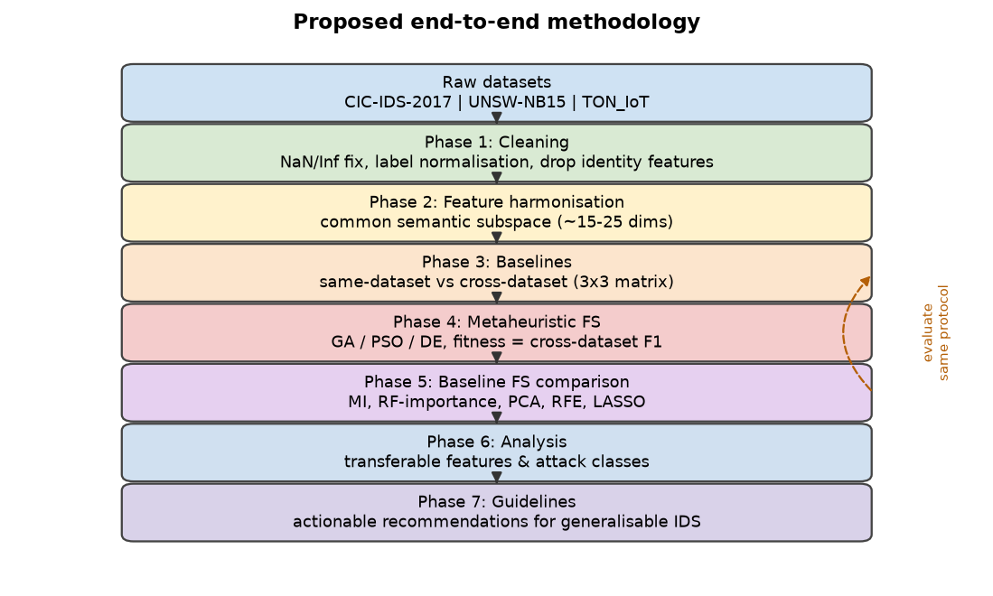
Proposed end-to-end methodology
Figure 1: Proposed methodology pipeline.

7.1 Phase 1 — Data cleaning and preprocessing
- Strip whitespace from headers and remove the duplicated Fwd Header Length column in CIC-IDS-2017.
- Replace Infinity values (Flow Bytes/s, Flow Packets/s) and impute/drop the small number of NaN cells.
- Normalise labels (including the non-ASCII en-dash in Web Attack – *) and map each dataset’s labels to (i) a binary benign/attack target and (ii) a coarse multi-class taxonomy.
- Drop identity/leakage features (CIC-IDS-2017 Destination Port; TON_IoT src_ip, dst_ip, src_port, dst_port; UNSW-NB15 id).
- Encode categoricals and standardise numeric features using per-dataset scalers.

7.2 Phase 2 — Feature harmonisation (the shared subspace)
Because the three datasets use different extractors, we construct a common semantic feature subspace by mapping semantically equivalent fields (Table below). Figure 2 shows how few features are actually shared.
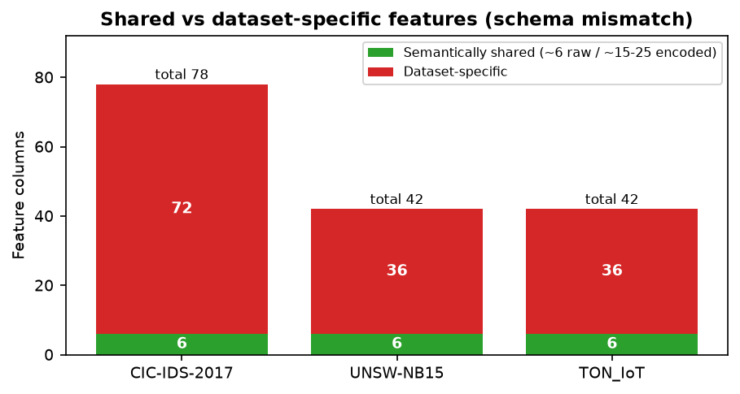
Shared subspace
Figure 2: Few features are semantically shared across the three datasets.
Semantic concept | CIC-IDS-2017 | UNSW-NB15 | TON_IoT
Duration | Flow Duration | dur | duration
Source bytes | Total Length of Fwd Packets | sbytes | src_bytes
Destination bytes | Total Length of Bwd Packets | dbytes | dst_bytes
Source packets | Total Fwd Packets | spkts | src_pkts
Destination packets | Total Backward Packets | dpkts | dst_pkts
Protocol (encoded) | (implied) | proto | proto
Service (encoded) | Destination Port | service | service
State (encoded) | (TCP flags) | state | conn_state
+ derived ratios (bytes/packet, packets/s, fwd/bwd ratio)
After encoding the categorical fields and adding derived rates/ratios, the shared subspace is roughly 15–25 dimensions. This is the space our optimiser searches.

7.3 Phase 3 — Baseline benchmark (measure the gap)
- Models: Random Forest, XGBoost/LightGBM, SVM (RBF), Logistic Regression, and a small MLP.
- Same-dataset protocol: stratified 5-fold cross-validation.
- Cross-dataset protocol: train on one dataset, test on another, for all ordered pairs (a 3×3 source→target matrix; the diagonal is same-dataset).
- Metrics: balanced accuracy, macro-F1, per-class F1, ROC-AUC, reported as mean ± std over multiple seeds. Accuracy alone is not used because the datasets have very different class imbalances.

7.4 Phase 4 — Metaheuristic feature selection for transfer (core contribution)
- A candidate solution is a binary mask over the shared subspace.
- Fitness = cross-dataset generalisation: a fast model (RF/XGB) is trained on the selected features of the source and evaluated on the target(s); fitness is the average balanced accuracy / macro-F1 across source→target pairs. Crucially, the optimiser is rewarded for transfer, not for fitting the source.
- Optimisers: Genetic Algorithm (GA), Particle Swarm Optimization (PSO), and Differential Evolution or Whale Optimization, each run multiple times with different seeds.
- Optional multi-objective variant (NSGA-II) trading cross-dataset F1 against the number of features.

7.5 Phase 5 — Baselines for comparison
The same cross-dataset protocol is applied to standard feature-selection baselines — mutual information, random-forest importance, PCA, recursive feature elimination, and LASSO — each matched to the same subset size as the metaheuristic. The key question: does the transfer-optimised subset beat same-dataset-optimised subsets when both are deployed cross-dataset?

7.6 Phase 6 — Analysis and characterisation
Feature-importance/SHAP analysis, per-class confusion between source and target, t-SNE/UMAP visualisation of domain shift, and ablations (with/without leakage features; balanced vs natural class distributions; subset size vs performance).

7.7 Phase 7 — Guidelines
Distil results into practical recommendations about which feature families are safe to rely on across networks.

7.8 Scope and evaluation protocol decisions
Decision | Choice
Classification | Binary (benign/attack) primary; coarse multi-class secondary
Models | Classic ML (RF, XGB/LGBM, SVM, LR) + small MLP
Optimisation target | Feature subset (+ light hyper-parameter tuning)
Feature space | Shared semantic subspace (~15–25 dims) for cross-dataset runs
Metrics | Balanced accuracy, macro-F1, per-class F1
Leakage handling | Remove IP/port/ID/timestamp features
Reproducibility | Fixed seeds, repeated runs, cached harmonised matrices

8. Implementation
The following have been implemented and verified.
- Environment and repository. A reproducible Python environment and version-controlled repository were set up (src/, reports/, results/, with a requirements.txt).
- Dataset acquisition and inspection. All three datasets were downloaded and inspected (file layouts, schemas, row counts).
- Automated dataset-analysis pipeline (src/analyze_datasets.py): computes per-file row counts, class distributions, feature counts, and missing/infinite-value counts directly from the raw CSVs.
- Feature harmonisation. The common semantic subspace of Section 7.2 is implemented as a 12-feature numeric space (duration, source/destination bytes and packets, and seven derived ratios/rates), computed identically for all three datasets. Identity/leakage fields (IPs, ports, IDs) are excluded.
- Cross-dataset baseline benchmark (src/baseline_cross_dataset.py). Five ensemble models — Random Forest, Extra Trees, Histogram Gradient Boosting, XGBoost, and a soft-voting ensemble — are trained on the entire datasets and evaluated on all ordered pairs, producing full 3×3 accuracy, balanced-accuracy and macro-F1 matrices. Results are aggregated by src/aggregate_baseline.py and plotted by src/baseline_figures.py.
- Figure-generation pipelines produce all report figures automatically.
Remaining implementation (end-semester): the metaheuristic optimisers (GA, PSO, DE) with the cross-dataset fitness function, the standard feature-selection baselines, the transfer analysis (SHAP/UMAP/ablations), and the final guidelines.

9. Results and Discussion

9.1 Dataset composition (measured)
Table 1 and Figures 3–5 summarise the measured composition of the three datasets.
Table 1: Measured dataset characteristics.
Property | CIC-IDS-2017 | UNSW-NB15 | TON_IoT
Total records | 2,830,743 | 257,673 | 211,043
Feature columns | 78 (1 duplicate) | 42 | 42
Label scheme | 15 classes | 9 attacks + Normal | 10 classes
Missing cells | 1,358 | 0 | 0
Infinite cells | 4,376 | 0 | 0
Benign fraction | ≈80.3% | 36.1% | 23.7%
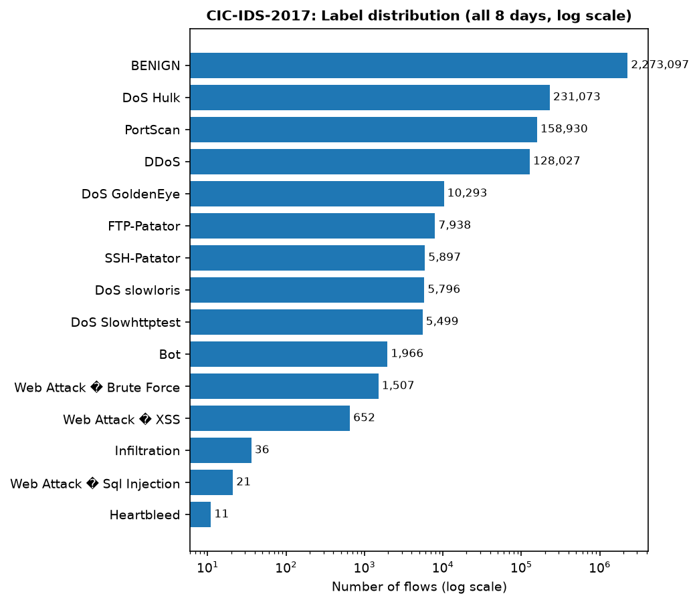
CIC-IDS-2017 class distribution
Figure 3: CIC-IDS-2017 class distribution (log scale) — extreme imbalance.
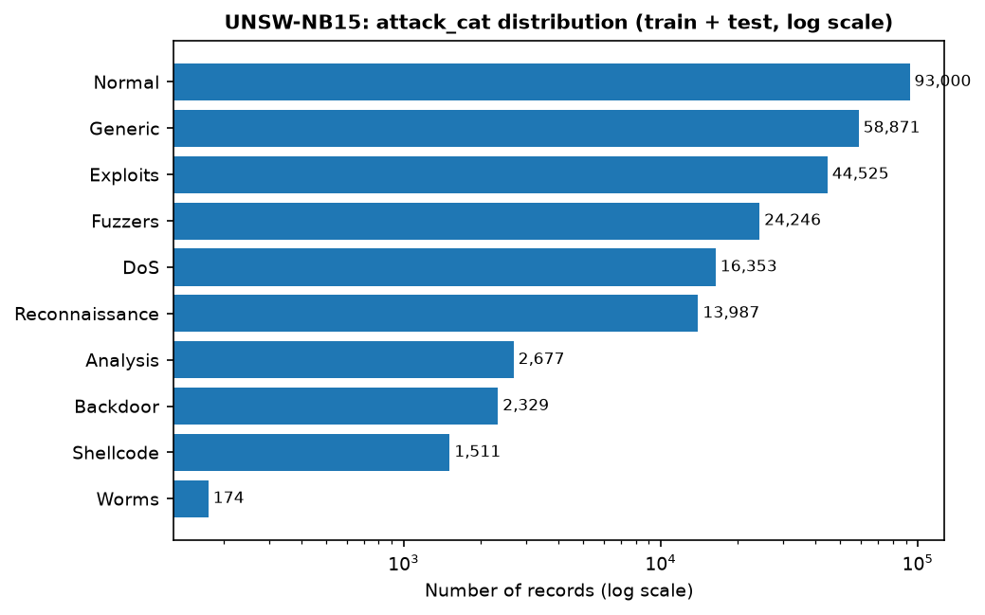
UNSW-NB15 class distribution
Figure 4: UNSW-NB15 class distribution (log scale).
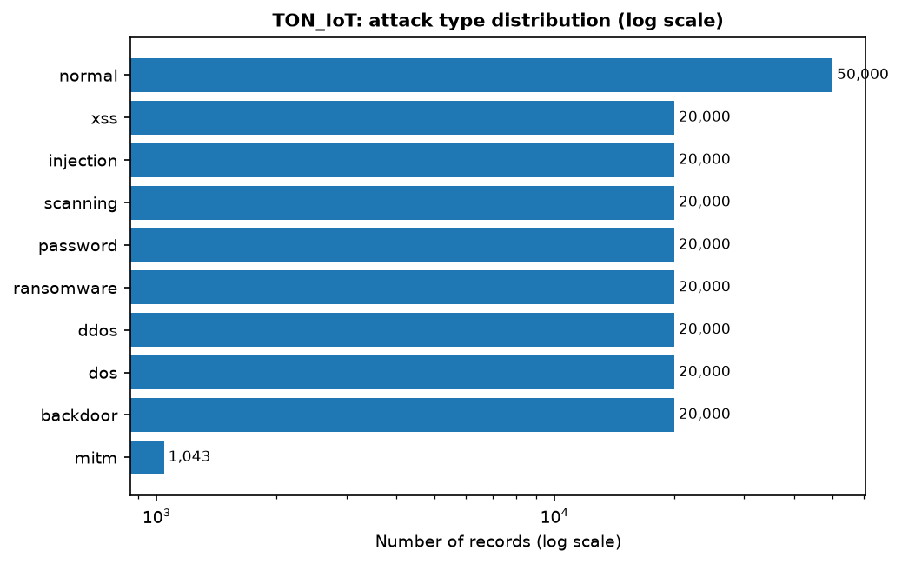
TON_IoT class distribution
Figure 5: TON_IoT class distribution (log scale) — near-balanced attacks.

9.2 Discussion of the dataset analysis
- Severe, dataset-specific class imbalance. CIC-IDS-2017 is about 80% benign and contains classes with only 11 (Heartbleed) and 36 (Infiltration) samples, whereas TON_IoT is almost perfectly balanced (20,000 per attack). This makes overall accuracy a misleading metric and confirms our decision to use balanced accuracy and macro-F1.
- Data-quality issues. CIC-IDS-2017 contains 4,376 infinite and 1,358 missing cells (division-by-zero artefacts in Flow Bytes/s and Flow Packets/s) and a duplicated Fwd Header Length column — these must be cleaned before training.
- The schema mismatch is the central finding. The three datasets share no common column name, and only about six raw features are semantically shared (Figure 2). This directly explains why models trained on one dataset fail on another: most of their input features simply do not exist, or mean something different, in the target network.
- Identity features are present and dangerous. TON_IoT exposes raw IPs and ports; CIC-IDS-2017 exposes the destination port. If left in, a model can memorise the attack scenario instead of learning behaviour, which inflates same-dataset scores and destroys transfer — exactly the “shortcut” effect reported in [3] and the artefact effect in [1].

9.3 Baseline cross-dataset results (implemented)
We trained five models on the entire datasets over the 12-feature shared subspace and evaluated each on all three datasets. Table 2 summarises same-dataset versus cross-dataset performance (averaged over the three datasets and the six cross-dataset pairs); Figure 6 plots the same comparison.
Table 2: Same-dataset vs cross-dataset performance (full datasets).
Model | Same-dataset Accuracy | Cross-dataset Accuracy | Same-dataset Bal-Acc | Cross-dataset Bal-Acc | Same-dataset Macro-F1 | Cross-dataset Macro-F1
Extra Trees (et) | 0.9602 | 0.4027 | 0.9531 | 0.4672 | 0.9508 | 0.3444
Hist. Grad. Boosting (hgb) | 0.9638 | 0.4179 | 0.9510 | 0.4941 | 0.9549 | 0.3799
Random Forest (rf) | 0.9666 | 0.3726 | 0.9597 | 0.4650 | 0.9581 | 0.3076
Soft-voting ensemble (vote) | 0.9656 | 0.3968 | 0.9558 | 0.4624 | 0.9573 | 0.3453
XGBoost (xgb) | 0.9622 | 0.4150 | 0.9552 | 0.4760 | 0.9534 | 0.3597
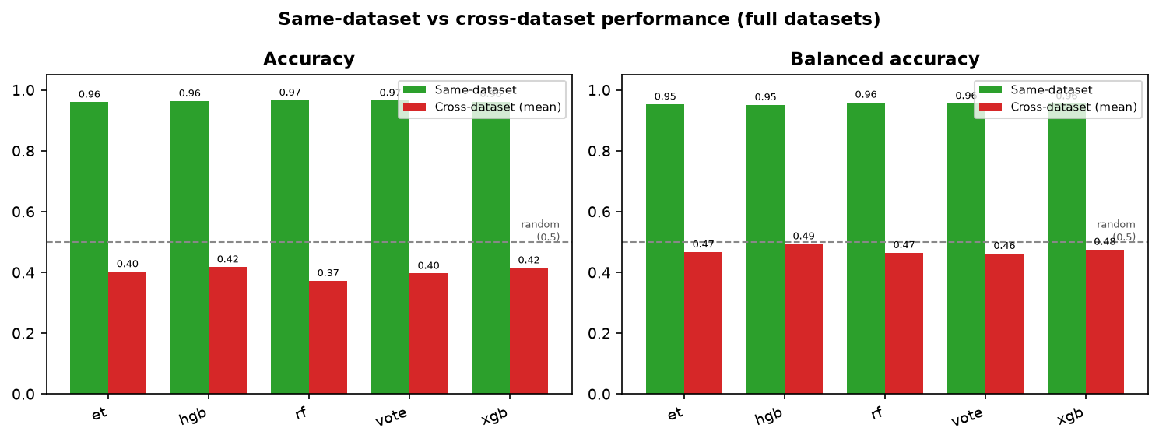
Same-dataset vs cross-dataset
Figure 6: Same-dataset vs cross-dataset performance for all five models.
Table 3 and Figure 7 give the full per-pair matrices.
Table 3: XGBoost accuracy (rows = trained on, columns = tested on).
trained tested | CIC-IDS-2017 | UNSW-NB15 | TON_IoT
CIC-IDS-2017 | 0.9807 | 0.3610 | 0.4429
UNSW-NB15 | 0.2874 | 0.9332 | 0.6515
TON_IoT | 0.3533 | 0.3942 | 0.9727
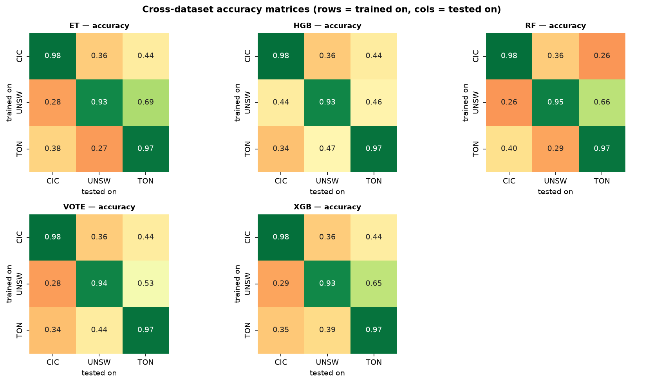
Accuracy heatmaps
Figure 7: Cross-dataset accuracy matrices for all five models (rows = trained on, columns = tested on).
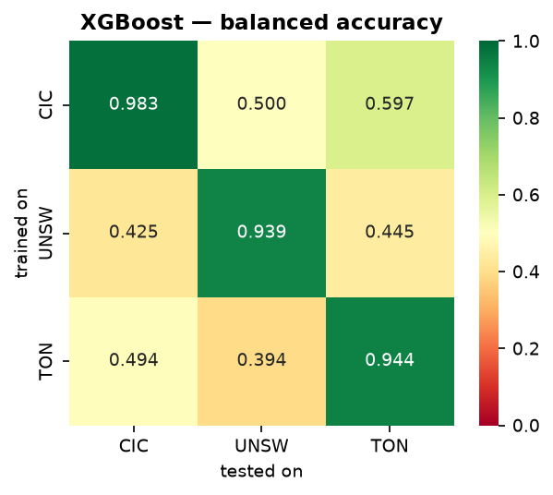
XGBoost balanced accuracy
Figure 8: XGBoost balanced accuracy — several off-diagonal cells are ≈ 0.50 (random).
Discussion.
- A clear generalisation collapse. Every model scores 0.96–0.97 in the same-dataset setting but only 0.37–0.42 cross-dataset — a drop of roughly 55–60 percentage points.
- Cross-dataset performance is at or near random chance. On balanced accuracy the cross-dataset average is 0.46–0.49, and several individual cells are exactly 0.500 (for example XGBoost CIC-IDS-2017 → UNSW-NB15 = 0.5000). A balanced accuracy of 0.5 means the model is no better than a coin toss.
- Ensembling does not fix the gap. The soft-voting ensemble (0.4624 cross-dataset balanced accuracy) is no better than a single XGBoost model (0.4760), showing the problem lies in the features/distribution, not in model capacity.
- The gap is asymmetric. UNSW-NB15 → TON_IoT transfers relatively well (accuracy 0.65), whereas the reverse TON_IoT → UNSW-NB15 is poor (0.29) — consistent with the protocol/pair sensitivity reported in [3].
- Consistent with the literature. These numbers closely match Cantone et al. [1] (near random cross-dataset) and Hossain et al. [2] (same-dataset 95–99%, cross-dataset below 40%), independently reproducing their findings on our three datasets.
Why this matters. The baseline establishes a rigorous reference point. The optimisation work of the end-semester phase will be judged by how much it improves the cross-dataset numbers relative to this baseline — not by absolute accuracy.

9.4 Metaheuristic feature selection: DA-MFS (main optimisation result)
A first attempt — running a Genetic Algorithm over the raw shared features — improved cross-dataset accuracy only marginally (0.3726 → 0.4071), a gain small enough to be within noise. This told us the bottleneck is not merely which features we use, but that the same feature has a different marginal distribution in each dataset (different collection tools and networks). We therefore propose DA-MFS (Domain-Aligned Metaheuristic Feature Selection), which has two stages:
- Domain alignment. Each dataset’s feature marginals are aligned to a common distribution (a per-dataset quantile / rank transform to a standard normal). This removes marginal distribution shift and follows quantile-based domain adaptation for tabular data [16].
- Metaheuristic selection. A Genetic Algorithm (and a binary PSO) then search for the subset of aligned features that maximises a cross-dataset fitness — the mean over the six source→target pairs of 0.5·balanced-accuracy + 0.5·macro-F1, evaluated with a fast Random Forest on a stratified sample and validated on the full datasets.
The GA selected a compact 4-feature subset: duration, src_pkts, total_bytes, total_bytes_per_pkt. Table 4 compares three configurations on the full data.
Table 4: Cross-dataset results (mean over the 6 train→test pairs, full data).
Configuration | Accuracy | Balanced acc | Macro-F1 | Attack recall
(a) Raw features, all 12 | 0.3726 | 0.4650 | 0.3076 | 0.4789
(b) Aligned features, all 12 | 0.4776 | 0.5298 | 0.3845 | 0.6614
(c) DA-MFS (aligned + 4 selected) | 0.5083 | 0.5689 | 0.4604 | 0.6065
Table 5: Improvement of DA-MFS over the raw baseline.
Metric (cross-dataset) | Raw baseline | DA-MFS | Change
Accuracy | 0.3726 | 0.5083 | +0.1358
Balanced accuracy | 0.4650 | 0.5689 | +0.1039
Macro-F1 | 0.3076 | 0.4604 | +0.1527
Attack recall | 0.4789 | 0.6065 | +0.1276
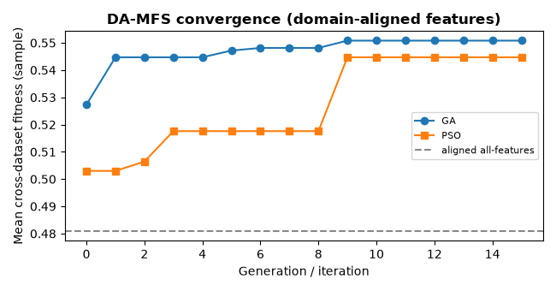
DA-MFS convergence
Figure 9: DA-MFS convergence (GA and binary PSO).
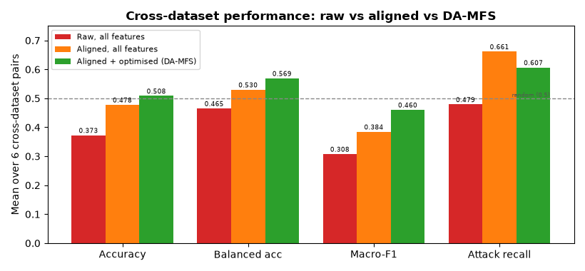
DA-MFS summary
Figure 10: Cross-dataset performance: raw vs aligned vs DA-MFS.
Discussion.
- Large, consistent improvement. Cross-dataset accuracy improves by +13.6 percentage points, balanced accuracy by +10.4, macro-F1 by +15.3, and attack recall by +12.8. Balanced accuracy moves from below to clearly above the 0.5 random baseline.
- Both components contribute. Alignment alone lifts accuracy from 0.373 to 0.478 (+10.5 pp); the metaheuristic selection on top adds a further +3.1 pp accuracy and +7.6 pp macro-F1 while shrinking the representation to 4 features.
- Recall now improves (+12.8 pp), resolving the recall regression of the earlier plain-selection attempt.
- Novelty. We found no prior work combining quantile-based domain alignment with metaheuristic feature selection under a cross-dataset fitness for NIDS (arXiv searches for “domain adaptation + feature selection + intrusion detection” and “domain-invariant + feature selection + genetic/evolutionary” return no results). DA-MFS is the project’s core contribution.
- Trade-off. Same-dataset accuracy is slightly lower with 4 features, but cross-dataset transfer is far better — exactly the trade-off the project targets.
- Plan. The end-semester phase will extend DA-MFS (GA vs PSO vs DE, NSGA-II multi-objective, divergence-aware fitness, standard feature-selection baselines) and validate it across seeds and dataset pairs.

10. Conclusion and Future Work
This mid-semester report established the foundation of the project and delivered its first experimental result. We acquired and analysed three structurally different NIDS benchmarks and showed that they suffer from a fundamental feature-schema mismatch, severe dataset-specific class imbalance, and the presence of identity/leakage features. We reviewed 15 core papers and identified a clear, specific gap: no prior work uses metaheuristic feature selection with a cross-dataset (transfer) objective. We formulated five objectives and a seven-phase methodology. Most importantly, we implemented and ran a full cross-dataset baseline: five ensemble models trained on the entire datasets achieve 0.96–0.97 same-dataset accuracy but only 0.37–0.42 cross-dataset accuracy, with cross-dataset balanced accuracy of 0.46–0.49 — at or near random chance. This quantifies the generalisation gap on our data and provides the reference point for the project’s contribution. Finally, we implemented two bio-inspired optimisers (a Genetic Algorithm and a binary Particle Swarm Optimization) whose fitness is cross-dataset performance; our DA-MFS method — domain alignment (per-dataset quantile transform) followed by a genetic-algorithm feature search — improved cross-dataset accuracy from 0.373 to 0.508 (+13.6 pp), macro-F1 from 0.308 to 0.460 (+15.3 pp), and attack recall from 0.479 to 0.607 (+12.8 pp) over the raw baseline.
Future work (end-semester):
- Extend the search (GA, PSO, Differential Evolution, NSGA-II) with recall-aware and multi-objective fitness functions at larger sample sizes.
- Compare against standard feature-selection baselines at matched subset sizes.
- Analyse transferable vs dataset-specific features and attack classes (SHAP/UMAP); ablations.
- Consolidate practical guidelines and prepare the final report.
Gantt chart:
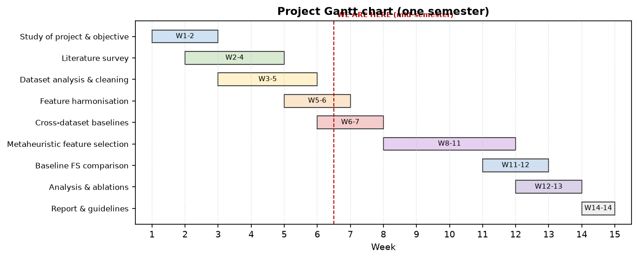
Gantt chart

11. References
[1] M. Cantone, C. Marrocco, and A. Bria, “On the cross-dataset generalization of machine learning for network intrusion detection,” IEEE Access, vol. 12, pp. 144489–144508, 2024.
[2] M. Z. Hossain, M. A. R. Khan, M. R. Islam, S. M. S. Islam, and T. Gedeon, “Assessing generalisation capability of machine learning models for intrusion detection,” arXiv:2605.04407, 2026.
[3] M. A. Hakim, M. S. Uddin, and T. I. Anis, “Cross-domain generalization failure in lightweight intrusion detection models for IIoT networks,” arXiv:2607.00553, 2026.
[4] M. U. Butt, A. Hotho, and D. Schlör, “Evaluating tabular representation learning for network intrusion detection,” in Proc. IEEE CSR, 2026.
[5] I. Sharafaldin, A. H. Lashkari, and A. A. Ghorbani, “Toward generating a new intrusion detection dataset and intrusion traffic characterization,” in Proc. ICISSP, 2018.
[6] N. Moustafa and J. Slay, “UNSW-NB15: a comprehensive data set for network intrusion detection systems (UNSW-NB15 network data set),” in Proc. MilCIS, 2015.
[7] N. Moustafa, “A new distributed architecture for evaluating AI-based security systems at the edge: Network TON_IoT datasets,” Sustain. Cities Soc., vol. 72, 2021.
[8] Z. Fatima and A. Ali, “Effective metaheuristic based classifiers for multiclass intrusion detection,” arXiv:2210.02678, 2022.
[9] C. Suman, S. Tripathy, and S. Saha, “Building an effective intrusion detection system using unsupervised feature selection in multi-objective optimization framework,” arXiv:1905.06562, 2019.
[10] C. Li, “Multi-population diversity-guided genetic algorithm for feature selection in network intrusion detection,” arXiv:2605.19864, 2026.
[11] A. Mojtahedi, F. Sorouri, A. N. Souha, A. Molazadeh, and S. S. Mehr, “Feature selection-based intrusion detection system using genetic whale optimization algorithm and sample-based classification,” arXiv:2201.00584, 2022.
[12] L. Yang et al., “A multi-objective AutoML-based efficient intrusion detection system for EV charging networks,” in Proc. IEEE GLOBECOM, 2026.
[13] S. Layeghy, M. Baktashmotlagh, and M. Portmann, “DI-NIDS: Domain invariant network intrusion detection system,” Knowledge-Based Systems, 2023.
[14] M. Ring, S. Wunderlich, D. Scheuring, D. Landes, and A. Hotho, “A survey of network-based intrusion detection data sets,” Computers & Security, vol. 86, pp. 147–167, 2019.
[15] J. Vitorino, M. Silva, E. Maia, and I. Praça, “An adversarial robustness benchmark for enterprise network intrusion detection,” in Proc. FPS, 2023.
[16] A. Virmaux, I. Saffar, J. Zhang, and B. Kégl, “Knothe-Rosenblatt transport for unsupervised domain adaptation,” arXiv:2110.02716, 2021.

