Dataset Report — Understanding the Three Benchmark Network-Intrusion Datasets
Project: Evaluating and Improving Cross-Dataset Generalization of ML-Based Intrusion Detection Systems Document: 01 — Dataset Analysis Status: Prepared for mid-semester review

1. Executive Summary
This report documents a first-hand analysis of the three benchmark network-traffic datasets selected for this project: CIC-IDS-2017, UNSW-NB15, and TON_IoT. The analysis was performed directly on the downloaded CSV files (statistics recomputed by the authors, not quoted from the literature), and it reveals the single most important structural fact of the project:
The three datasets were produced by different collection tools and represent almost disjoint feature spaces. CIC-IDS-2017 exposes 78 CICFlowMeter flow statistics, UNSW-NB15 exposes 42 Argus/Bro hybrid counters, and TON_IoT exposes 42 raw Zeek (Bro) log fields. Only a small handful of features are semantically equivalent across all three. Any “cross-dataset” experiment must therefore either (a) restrict itself to a small shared feature subspace, or (b) build dataset-specific models that cannot be directly transferred.
This feature-schema mismatch is not an obstacle to be worked around — it is the central phenomenon the project studies, because it is precisely what a real, deployable Intrusion Detection System (IDS) faces when it encounters a network it has never seen before.
All figures referenced in this document are stored under reports/figures/.

2. Datasets at a Glance
Property | CIC-IDS-2017 | UNSW-NB15 | TON_IoT (network)
Origin | Canadian Institute for Cybersecurity (CIC), Univ. of New Brunswick | Australian Centre for Cyber Security (ACCS), UNSW Canberra | UNSW Canberra / Moustafa et al.
Year | 2017 | 2015 | 2019–2020
Collection tool | CICFlowMeter (flow exporter) | Argus + Bro-IDS hybrid | Zeek (Bro-IDS) connection logs
Network type | Enterprise/office LAN | Emulated enterprise (IXIA PerfectStorm) | IoT / IIoT testbed (edge–fog–cloud)
Total records (this copy) | 2,830,743 | 257,673 (train 175,341 + test 82,332) | 211,043
Feature columns | 78 (one duplicated → 77 unique) | 42 (+ id, attack_cat, label) | 42 (+ label, type)
Label scheme | Label (per-attack string) | attack_cat (9 classes + Normal) + binary label | type (10 classes) + binary label
Missing / infinite values | 1,358 NaN + 4,376 Inf | none | none
Key structural traits | Extreme class imbalance; identity features (ports) | Partly de-identified (IPs/ports already removed) | Heavy categoricals (conn_state, dns_*, http_*, ssl_*)

3. CIC-IDS-2017

3.1 Provenance and collection methodology
CIC-IDS-2017 [1] is the most widely used intrusion-detection benchmark. It was captured at the Canadian Institute for Cybersecurity over five working days (Monday–Friday, July 2017) on a realistic testbed that emulated a small enterprise network: victim machines, a firewall, and an attacker network. Realistic background (benign) traffic was generated with a behavioural profiling tool (B-Profile), while attacks were executed on specific days. Flows were extracted with CICFlowMeter, which computes 78+ statistical features per bidirectional flow (packet-length statistics, inter-arrival times, TCP flag counts, bulk and sub-flow statistics, and active/idle timing).
The dataset ships as eight per-day CSV files under datasets/CIC-IDS-2017/MachineLearningCVE/.

3.2 File-by-file composition (measured)
File | Rows | Attack labels present
Monday-WorkingHours | 529,918 | BENIGN only
Tuesday-WorkingHours | 445,909 | BENIGN, FTP-Patator, SSH-Patator
Wednesday-workingHours | 692,703 | BENIGN, DoS Hulk/GoldenEye/slowloris/Slowhttptest, Heartbleed
Thursday-WorkingHours-Morning-WebAttacks | 170,366 | BENIGN, Web Attack – Brute Force/XSS/Sql Injection
Thursday-WorkingHours-Afternoon-Infilteration | 288,602 | BENIGN, Infiltration
Friday-WorkingHours-Morning | 191,033 | BENIGN, Bot
Friday-WorkingHours-Afternoon-DDos | 225,745 | BENIGN, DDoS
Friday-WorkingHours-Afternoon-PortScan | 286,467 | BENIGN, PortScan
Full label distribution (log scale):
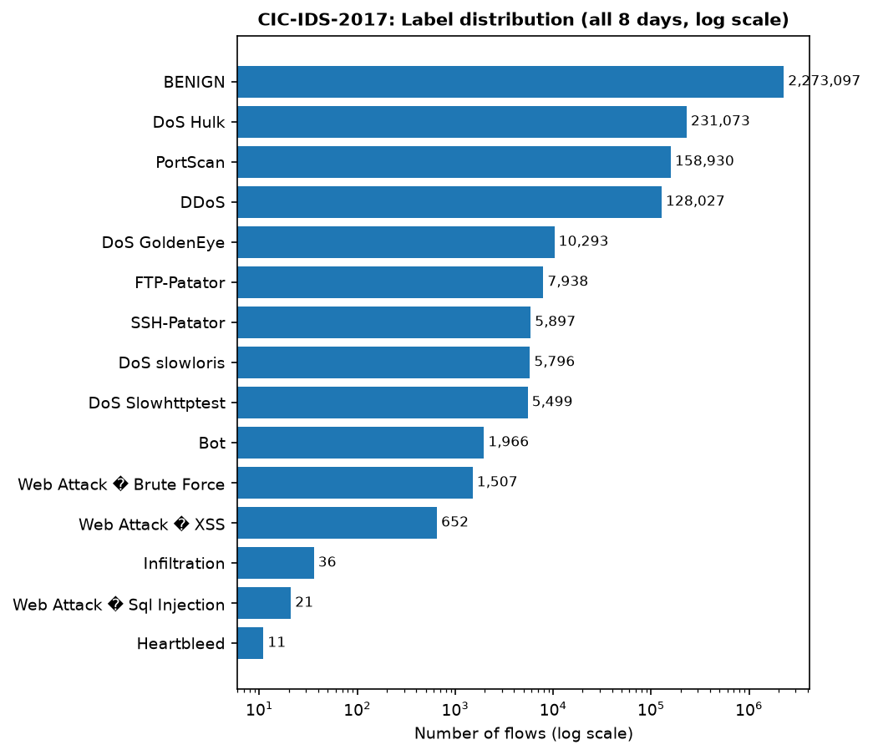
CIC-IDS-2017 class distribution
Key observations:
- BENIGN dominates (2,273,097 of 2,830,743 ≈ 80.3%). Attacks total ≈ 557,646 (19.7%).
- DoS Hulk is the single largest attack class (231,073), followed by PortScan (158,930) and DDoS (128,027).
- Extreme minority classes: Heartbleed (11) and Infiltration (36) are effectively unlearnable in a per-dataset setting and would be impossible to transfer cross-dataset.
- Label encoding issue: the Web-Attack labels contain a non-ASCII en-dash that reads as a replacement character (Web Attack � Brute Force) under default UTF-8 decoding. Labels must be normalised before use.

3.3 Feature schema
The header contains 79 columns: 78 numeric feature columns plus the Label column. One feature — Fwd Header Length — is duplicated (appears twice; pandas renames the second occurrence to Fwd Header Length.1), so there are 77 unique features. Notable schema characteristics:
- Features are numeric flow statistics (no categorical protocol/service columns).
- The only categorical column is Label.
- The first column Destination Port is a de-facto identity feature (see §6): it encodes the attack scenario rather than traffic behaviour and is a known source of inflated same-dataset accuracy [4], [22].

3.4 Data-quality issues (measured)
- Infinite values: 4,376 cells equal Infinity, concentrated in Flow Bytes/s and Flow Packets/s (a division-by-zero artefact when a flow has zero packets). These must be replaced (e.g. with NaN/median/zero) before training tree models that reject infinities.
- Missing values: 1,358 cells are NaN (same columns, plus a few scattered others).
- Combined, non-finite values are a tiny fraction of the ~221 million feature cells (~0.0026%), but they are exactly the rows/columns a robust pipeline must handle.
- Imbalance (see §3.2) means per-class metrics (not overall accuracy) are mandatory.

3.5 Implications
CIC-IDS-2017 provides rich flow statistics, but (i) its port/identity features, (ii) its extreme imbalance, and (iii) its non-finite values make it the dataset most prone to giving a falsely high same-dataset score that fails to transfer. This is exactly the behaviour documented in [4].

4. UNSW-NB15

4.1 Provenance and collection methodology
UNSW-NB15 [2] was produced at the ACCS (UNSW Canberra) in 2015 using the IXIA PerfectStorm traffic generator to emulate nine modern attack families (Fuzzers, Analysis, Backdoors, DoS, Exploits, Generic, Reconnaissance, Shellcode, Worms) alongside realistic background traffic. Features were extracted with the Argus tool augmented by Bro-IDS scripts, yielding a hybrid set of flow counters, connection-state counters, and time-window-based connection-count features (ct_*).
This copy ships as UNSW_NB15_training-set.csv (175,341 rows) and UNSW_NB15_testing-set.csv (82,332 rows) under datasets/UNSW-NB15/.

4.2 Composition (measured)
Set | Normal | Generic | Exploits | Fuzzers | DoS | Recon | Analysis | Backdoor | Shellcode | Worms
Train | 56,000 | 40,000 | 33,393 | 18,184 | 12,264 | 10,491 | 2,000 | 1,746 | 1,133 | 130
Test | 37,000 | 18,871 | 11,132 | 6,062 | 4,089 | 3,496 | 677 | 583 | 378 | 44
Total | 93,000 | 58,871 | 44,525 | 24,246 | 16,353 | 13,987 | 2,677 | 2,329 | 1,511 | 174
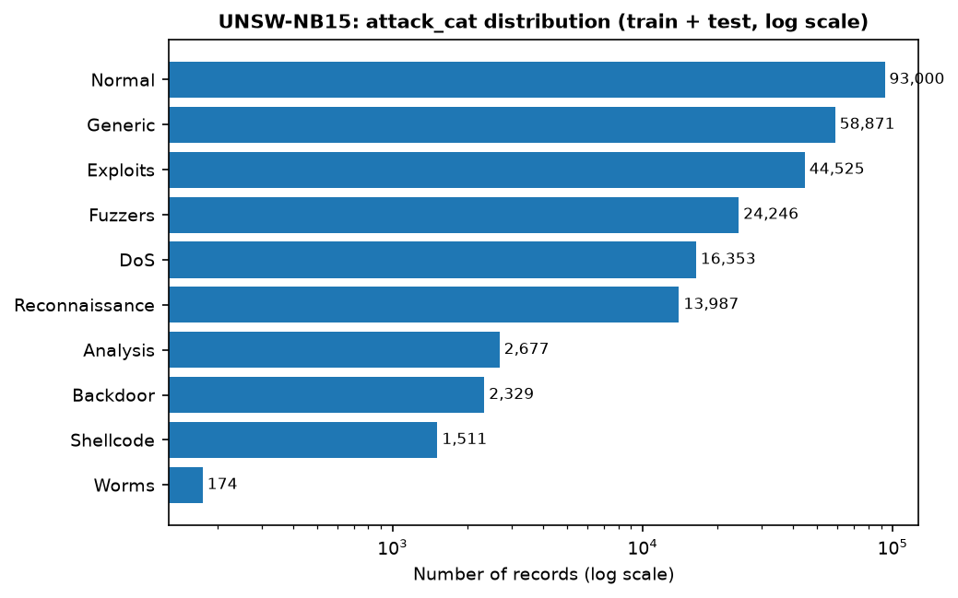
UNSW-NB15 attack distribution
Key observations:
- Binary split is well balanced: label=1 (attack) = 164,673 vs label=0 (Normal) = 93,000.
- attack_cat is imbalanced across the 9 attack classes (Worms = 174 vs Generic = 58,871).
- The provided CSVs already exclude the raw identity columns (srcip, sport, dstip, dsport) that are present in the full 49-column canonical release — this copy is the reduced 45-column variant (id + 42 features + attack_cat + label).

4.3 Feature schema
42 features, a mix of numeric counters and a few categoricals (proto, service, state). The ct_* features (e.g. ct_srv_src, ct_dst_ltm) count how many of the last 100 connections share the same service/host/port — these are temporal-window aggregations that depend on the collection window and are a known source of non-transferable signal [4], [6]. Two timestamp columns (stime, ltime) are absent in this variant.

4.4 Data quality
No missing or infinite values were found. The main caveats are (i) the train/test split is a provided fixed split rather than a random partition, and (ii) the ct_* features are time-dependent and leak collection-order information.

5. TON_IoT (network)

5.1 Provenance and collection methodology
TON_IoT [3], [28] is a heterogeneous IoT/IIoT dataset collected from a three-layer testbed (edge, fog, cloud) orchestrated with SDN (VMware NSX) and NFV. The network portion contains traffic from IoT sensors and hosts, with attacks in ten families. Network features are the raw Zeek (Bro) connection-log fields — a fundamentally different feature philosophy from CICFlowMeter (no aggregate statistics; instead protocol-specific fields such as dns_*, http_*, ssl_*, and conn_state).
This copy ships as the combined train_test_network.csv (211,043 rows) under datasets/TON_IOT network train-test/Train_Test_Network_dataset/, plus 24 per-day Network_dataset_*.csv files under datasets/TON_IOT network processed/.

5.2 Composition (measured)
Class | normal | backdoor | ddos | dos | injection | password | ransomware | scanning | xss | mitm
Count | 50,000 | 20,000 | 20,000 | 20,000 | 20,000 | 20,000 | 20,000 | 20,000 | 20,000 | 1,043
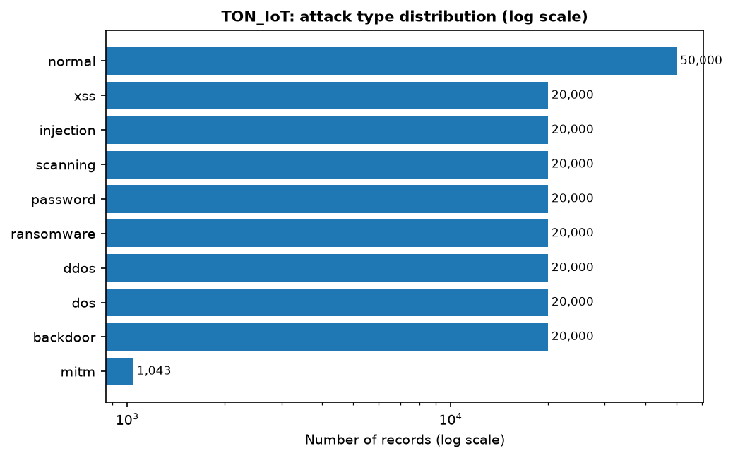
TON_IoT type distribution
Key observations:
- Attack classes are near-uniformly balanced (20,000 each) except mitm (1,043) — a deliberate design choice that removes the class-imbalance confound present in the other two datasets.
- Binary split: label=1 (attack) = 161,043 vs label=0 (normal) = 50,000.

5.3 Feature schema
42 feature columns plus label and type. Unlike the other two datasets, most columns are categorical strings: proto, service, conn_state, dns_query, dns_*, ssl_*, http_method, http_uri, http_user_agent, weird_*, etc. Only ~15 columns are numeric (duration, src_bytes, dst_bytes, src_pkts, dst_pkts, src_ip_bytes, dst_ip_bytes, port fields, and a few counters).
Implications:
- Requires one-hot / target encoding of high-cardinality categoricals (http_uri, dns_query have very large vocabularies).
- Contains explicit identity columns (src_ip, dst_ip, src_port, dst_port) that must be dropped or treated with extreme care to avoid memorisation.
- The Zeek schema is the “rawest” of the three — closest to what a production sensor emits — which makes it the most realistic target domain for transfer.

6. Cross-Dataset Comparison — The Feature-Schema Mismatch

6.1 Feature-space size
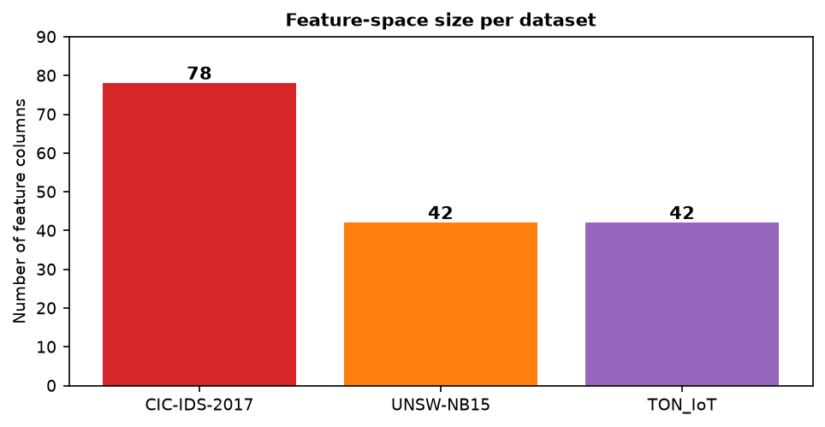
Feature counts per dataset
The three datasets expose comparable numbers of columns (78 vs 42 vs 42), but these columns are almost disjoint. There is no shared column name across all three datasets.

6.2 Semantic feature mapping (the shared subspace)
To run any cross-dataset experiment, one must map features to a common semantic subspace. The table below is the core of our feature-harmonisation design. A ✓ in three columns means the feature can be constructed in all three datasets directly.
# | Semantic concept | CIC-IDS-2017 | UNSW-NB15 | TON_IoT | All three?
1 | Flow/connection duration | Flow Duration | dur | duration | ✓
2 | Source→dest bytes | Total Length of Fwd Packets | sbytes | src_bytes | ✓
3 | Dest→source bytes | Total Length of Bwd Packets | dbytes | dst_bytes | ✓
4 | Source→dest packets | Total Fwd Packets | spkts | src_pkts | ✓
5 | Dest→source packets | Total Backward Packets | dpkts | dst_pkts | ✓
6 | Protocol | (implicit via flags/port) | proto | proto | partial
7 | Service | Destination Port (proxy) | service | service | partial
8 | Connection state | (TCP flag counts, proxy) | state | conn_state | partial
9 | Byte/packet rate | Flow Bytes/s, Flow Packets/s | rate, sload, dload | derivable | partial
10 | Packet-size statistics | * Packet Length * (16 cols) | smean, dmean | — | ✗
11 | Inter-arrival/jitter | Flow IAT *, Fwd/Bwd IAT * | sinpkt,dinpkt,sjit,djit | — | ✗
12 | TCP flags | SYN/FIN/RST/PSH/ACK/URG/ECE/CWE Flag Count | — | — | ✗
13 | TCP window / bulk | Init_Win_bytes_*, * Bulk *, Subflow * | swin,dwin,stcpb,dtcpb | — | ✗
14 | TTL | — | sttl, dttl | — | ✗
15 | Connection-count windows | (partly via Subflow) | ct_* (10 cols) | — | ✗
16 | HTTP application fields | — | trans_depth,response_body_len | http_* (14 cols) | partial
17 | DNS fields | — | — | dns_* (8 cols) | ✗
18 | SSL fields | — | — | ssl_* (6 cols) | ✗
Conclusion: the directly shared numeric subspace is roughly 6 raw features (duration, src/dst bytes, src/dst packets, plus proto/service/state after encoding). After one-hot encoding protocol/service/state and deriving rate-like ratios, this expands to roughly 15–25 comparable dimensions. This is consistent with prior cross-dataset work that deliberately restricts to a common representation [4], [6], [7] — and it is the feature set our metaheuristic optimiser will search over.

6.3 Class-taxonomy mapping (binary + coarse multi-class)
Because each dataset names attacks differently, cross-dataset multi-class evaluation requires a shared taxonomy. We propose the following mapping (binary = benign vs attack is the primary target; coarse multi-class is the secondary target):
Coarse class | CIC-IDS-2017 | UNSW-NB15 | TON_IoT
Benign / Normal | BENIGN | Normal | normal
DoS / DDoS | DoS Hulk, DoS GoldenEye, DoS slowloris, DoS Slowhttptest, DDoS | DoS | dos, ddos
Reconnaissance / Scanning | PortScan | Reconnaissance, Analysis | scanning
Brute-force / Credential | FTP-Patator, SSH-Patator | (part of Generic)* | password
Backdoor / Bot | Bot | Backdoor | backdoor
Web / Injection | Web Attack – Brute Force/XSS/Sql Injection | Exploits, Shellcode* | injection, xss
Generic / Exploit / Worm | — | Generic, Exploits, Shellcode, Worms, Fuzzers | —
Ransomware | — | — | ransomware
MITM | — | — | mitm
Other (rare) | Heartbleed, Infiltration | — | —
* Note: the UNSW Generic/Exploits/Shellcode categories do not cleanly map to the others; this semantic fuzziness is itself a finding and a documented cause of the generalisation gap (Objective 2 of the project).

7. What This Means for the Project
- Feature harmonisation is unavoidable and is a first-class deliverable, not a preprocessing detail.
- Identity/leakage features must be removed (CICIDS Destination Port; TON src_ip, dst_ip, src_port, dst_port) — otherwise cross-dataset scores measure memorisation.
- Non-finite and categorical handling differs per dataset, so the pipeline must be dataset-aware yet produce a common numeric matrix.
- Class imbalance is dataset-specific (CICIDS extreme, TON balanced), so evaluation must use per-class and macro metrics, not overall accuracy.
- The shared subspace is small (~15–25 dims), which makes feature selection (the focus of our metaheuristic work) both more important and more tractable.

References
[1] I. Sharafaldin, A. H. Lashkari, and A. A. Ghorbani, “Toward generating a new intrusion detection dataset and intrusion traffic characterization,” in Proc. 4th Int. Conf. Inf. Syst. Secur. Privacy (ICISSP), 2018.
[2] N. Moustafa and J. Slay, “UNSW-NB15: a comprehensive data set for network intrusion detection systems (UNSW-NB15 network data set),” in Proc. Mil. Commun. Inf. Syst. Conf. (MilCIS), 2015.
[3] N. Moustafa, “A new distributed architecture for evaluating AI-based security systems at the edge: Network TON_IoT datasets,” Sustain. Cities Soc., vol. 72, 2021.
[4] M. Cantone, C. Marrocco, and A. Bria, “On the cross-dataset generalization of machine learning for network intrusion detection,” IEEE Access, vol. 12, pp. 144489–144508, 2024.
[6] M. A. Hakim, M. S. Uddin, and T. I. Anis, “Cross-domain generalization failure in lightweight intrusion detection models for IIoT networks,” arXiv:2607.00553, 2026.
[22] J. Vitorino, M. Silva, E. Maia, and I. Praça, “An adversarial robustness benchmark for enterprise network intrusion detection,” in Proc. FPS, 2023.
[28] N. Moustafa, M. Keshk, E. Debie, and H. Janicke, “Federated TON_IoT Windows datasets for evaluating AI-based security applications,” arXiv:2010.08522, 2020.

