Priority Scheduling vs SRTF
Simulation, Analysis & Comparison Documentation
Project Title:
Priority vs SRTF Comparison Project

Table of Contents
# | Section | Page
1 | Project Overview | 3
2 | System Architecture | 4
3 | Algorithm Design | 5
3.1 | Priority Scheduling | 5
3.2 | SRTF – Shortest Remaining Time First | 6
4 | Metrics Calculation | 7
5 | Input Validation | 8
6 | GUI & Interface Description | 9
7 | Test Scenarios | 10
8 | Comparison & Analysis | 17
9 | Conclusion | 19

1. Project Overview
This project implements and compares two fundamental CPU scheduling algorithms:
- Priority Scheduling (preemptive): selects the process with the highest priority (lowest numerical value) at each scheduling point.
- Shortest Remaining Time First – SRTF (preemptive): always runs the process with the least remaining burst time, preempting the current process immediately when a shorter job arrives.

The comparison reveals how scheduling policy affects fairness, preemption behavior, starvation risk, and performance metrics such as Waiting Time (WT), Turnaround Time (TAT), and Response Time (RT).

Project Goals
- Simulate both algorithms on identical process workloads.
- Display Gantt charts and per-process result tables for each algorithm.
- Calculate and compare average WT, TAT, and RT.
- Demonstrate real scheduling trade-offs through structured test scenarios.
- Provide a final comparative conclusion with a recommendation.

Technology Stack
Component | Technology
Scheduling Engine | C language – compiled to native binary (simulator)
Web Server | Python (server.py) – spawns simulator, relays JSON
Frontend GUI | HTML5 + CSS3 + Vanilla JavaScript (index.html, app.js, style.css)
Build System | GNU Make (Makefile)

2. System Architecture
The project follows a clean three-layer architecture separating scheduling logic, server communication, and GUI presentation.

File Structure
project-root/
src/
process.h – Process data structure
priority.c/.h – Priority Scheduling algorithm
srtf.c/.h – SRTF algorithm
metrics.c/.h – WT / TAT / RT calculation
validation.c/.h – Input validation logic
main.c – Entry point, reads input, runs both algorithms
index.html – GUI layout and sections
app.js – Frontend logic, validation, rendering
style.css – Styling
server.py – HTTP server bridge
simulator – Compiled binary
Makefile – Build rules

Data Flow
- User fills the Input Panel in the browser and clicks Run Simulation.
- app.js validates the input client-side, builds a formatted string, and sends it via HTTP POST to /run.
- server.py receives the request, writes the input to the simulator's stdin, captures stdout (JSON), and returns it as the HTTP response.
- The simulator (compiled from main.c) reads process data, runs priority_scheduling() then srtf_scheduling(), and prints a single merged JSON object.
- app.js parses the JSON, renders Gantt charts, results tables, comparison summary, and conclusion.

Process Data Structure (process.h)
Field | Type | Description
pid | int | Unique process identifier
arrival_time | int | Time at which process enters the ready queue
burst_time | int | Total CPU time required
priority | int | Lower value = higher priority (rule explicitly stated)
remaining_time | int | Used by SRTF to track remaining burst
completion_time | int | Time at which process finishes execution
waiting_time | int | TAT – BT
turnaround_time | int | CT – AT
response_time | int | First CPU access – AT
first_run | int | Flag to record first CPU run (0 = not yet run)

3. Algorithm Design

3.1 Priority Scheduling
Rule & Behavior
- Scheduling rule: the process with the lowest priority number wins CPU access.
- Tie-breaking rule: if two processes share the same priority, the one with the earlier arrival time is selected.
- Implementation: non-preemptive within a scheduling event – the selected process runs to completion before re-evaluation.
- Idle time: if no process has arrived at current_time, the clock advances by 1 until a process becomes available.

Algorithm Steps (priority.c)
1. Copy process array to avoid modifying the original.
2. Set current_time = 0, completed = 0.
3. Loop while completed < n:
a. Scan all un-visited processes with arrival_time ≤ current_time.
b. Select the one with the lowest priority number; break ties by earliest arrival.
c. If none available, advance clock by 1 (idle).
d. Record response_time on first run.
e. Advance current_time by burst_time (full non-preemptive run).
f. Set completion_time, mark as visited, increment completed.
4. Call calculate_metrics(), output JSON with gantt and per-process metrics.

Output (JSON excerpt)
{ "priority": {
"gantt": [{"pid": 1, "start": 0, "end": 5}, ...],
"processes": [{"pid":1,"at":0,"bt":5,"pr":1,"wt":0,"tat":5,"rt":0}, ...],
"avg_wt": 2.33, "avg_tat": 7.33, "avg_rt": 1.00 }
}

3.2 SRTF – Shortest Remaining Time First
Rule & Behavior
- Scheduling rule: always run the process with the smallest remaining_time among all arrived processes.
- Preemption: at every clock tick, the scheduler re-evaluates; if a newly arrived process has a shorter remaining time than the current running process, it immediately preempts it.
- Tie-breaking rule: if remaining times are equal, the process with the earlier arrival_time wins.
- Idle time: if no process has arrived, a gap (-1) is added to the Gantt chart and the clock advances.
- Gantt merging: consecutive ticks of the same process are merged into one Gantt block for readability.

Algorithm Steps (srtf.c)
1. Copy process array, reset remaining_time = burst_time for all processes.
2. Set current_time = 0, completed = 0, prev = -1.
3. Loop while completed < n:
a. Find process with minimum remaining_time among arrived and incomplete processes.
b. If none (idle): record idle block if previous was not idle, advance clock.
c. Record response_time on first run.
d. If selected process changed (preemption): finalize previous Gantt block, start new one.
e. Decrement remaining_time by 1, advance current_time by 1.
f. If remaining_time == 0: set completion_time, increment completed.
4. Finalize last Gantt block timestamp.
5. Call calculate_metrics(), output JSON appended after priority output.

Key Difference from Priority
SRTF works at per-tick granularity (remaining_time--; current_time++;), enabling true preemption, while Priority runs a full burst at once without mid-burst interruption.

4. Metrics Calculation
All metrics are computed in metrics.c via calculate_metrics() after each algorithm finishes.

Metric | Formula | Description
Turnaround Time (TAT) | CT – AT | Total time from arrival to completion
Waiting Time (WT) | TAT – BT | Time spent in ready queue without running
Response Time (RT) | First CPU time – AT | Delay before first CPU access
Average WT | Σ WT / n | Overall scheduling efficiency
Average TAT | Σ TAT / n | Overall throughput measure
Average RT | Σ RT / n | Responsiveness to user/process

Where: CT = Completion Time, AT = Arrival Time, BT = Burst Time.
Note: response_time is stored as the absolute clock value during simulation, then adjusted to RT = stored_value – AT inside calculate_metrics().

5. Input Validation
Validation is performed at two layers: client-side in app.js (JavaScript) and server-side in validation.c (C).

Client-Side Validation (app.js)
Check | Rule / Error Message
PID | Must be a positive integer (> 0)
Arrival Time | Must be >= 0 (non-negative)
Burst Time | Must be > 0 (positive integer)
Priority | Must be >= 1
Duplicate PIDs | All PIDs must be unique; duplicates rejected with message
Number of Processes | Must be between 1 and 20 (enforced via input min/max)

Server-Side Validation (validation.c)
- validate_single_process(): checks arrival_time >= 0, burst_time > 0, priority >= 0 per process.
- validate_unique_pids(): O(n²) scan for duplicate PIDs.
- validate_processes(): orchestrates both checks; returns 0 (fail) or 1 (pass).
- If validation fails, the simulator outputs: {"error": "Validation failed"} and exits.

Error messages are displayed in the GUI's red error-msg div and simulation is halted.

6. GUI & Interface Description
The web-based interface consists of all required sections as specified in the project requirements.

Section | Description
Input Panel | Number of processes selector, Generate Table button, and dynamic input table with PID / AT / BT / Priority fields.
Process Table | Editable table generated dynamically; auto-fills PID (1-based) and AT = 0 as defaults; BT marked as required.
Gantt Chart – Priority | Color-coded horizontal bar chart showing execution order with time markers for Priority Scheduling.
Gantt Chart – SRTF | Same style; includes IDLE blocks (gray) and shows preemption points with time markers.
Results Table – Priority | Per-process table: PID, AT, BT, Priority, WT, TAT, RT; averages row at bottom.
Results Table – SRTF | Identical structure to Priority results table.
Comparison Summary | Side-by-side metric comparison: avg WT, avg TAT, avg RT for both algorithms, with winner highlighted.
Final Conclusion | Auto-generated text summarizing which algorithm performed better and why, based on computed metrics.

Color Coding
Each process is assigned a unique color from a 12-color palette (COLORS array in app.js). The same color is used in both the Gantt chart blocks and the results tables for visual consistency. IDLE time blocks are rendered in gray.

7. Test Scenarios
Four test scenarios are documented below, each run through both algorithms on identical input. Priority rule: lower number = higher priority. SRTF preempts immediately on shorter remaining time arrival.
Normal cases :
1-Single Process
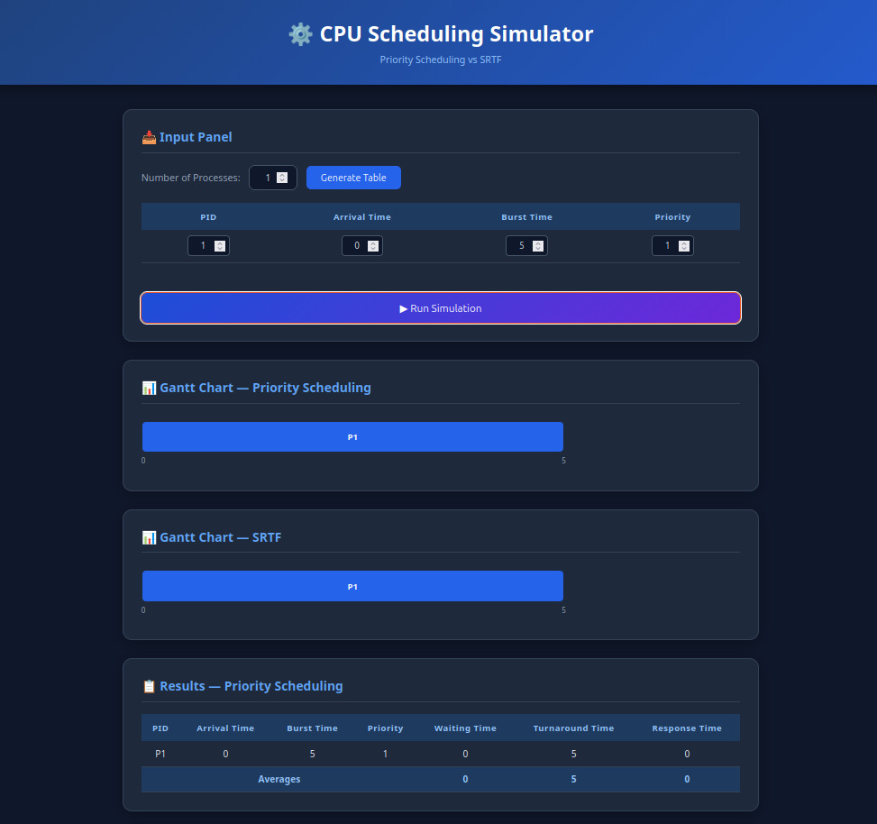

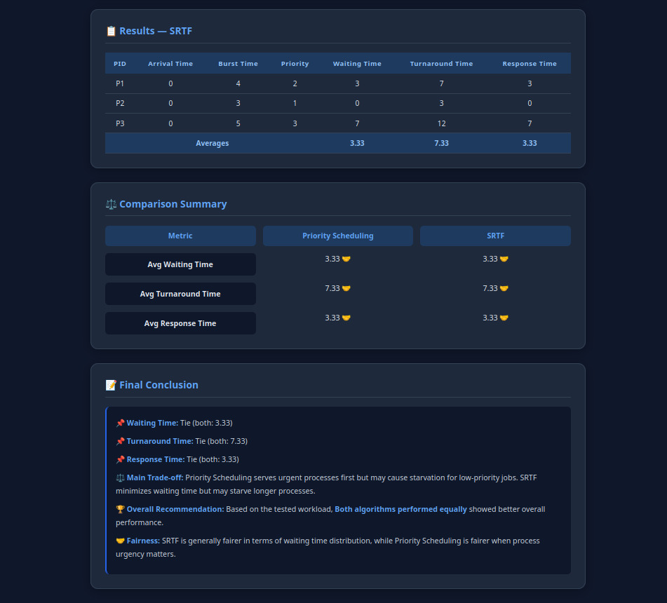

2- All arrive at t=0
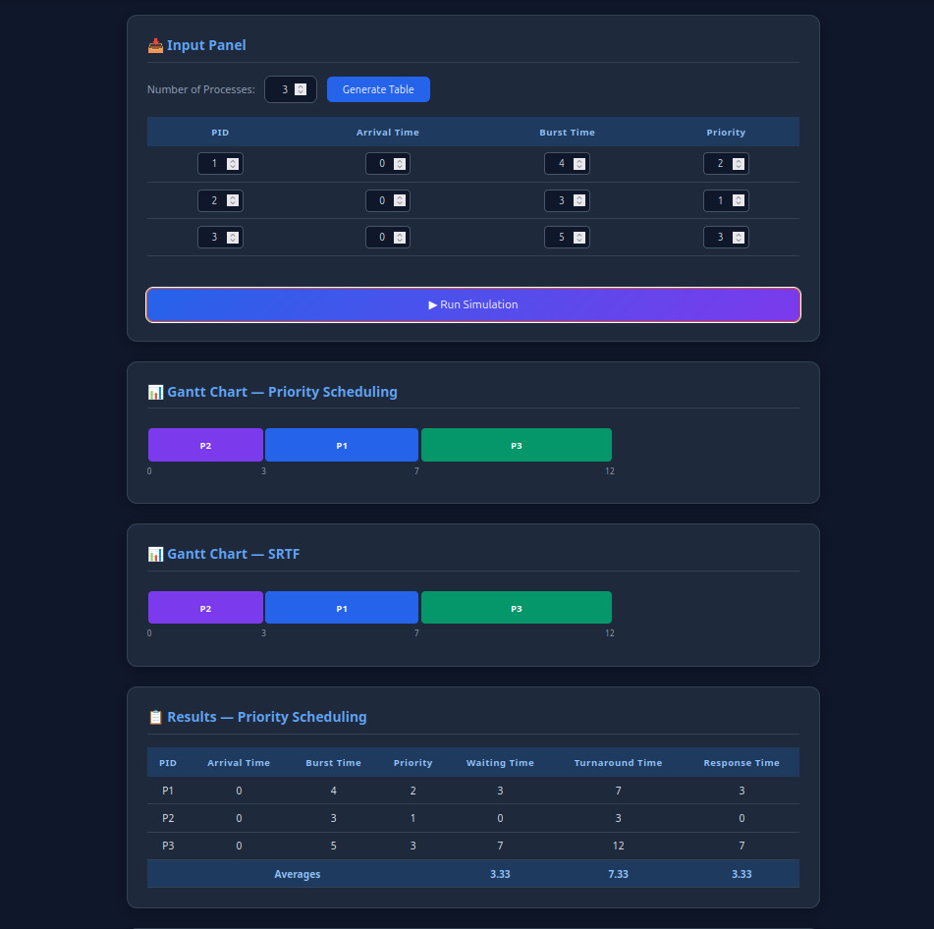


3-Different arrival times
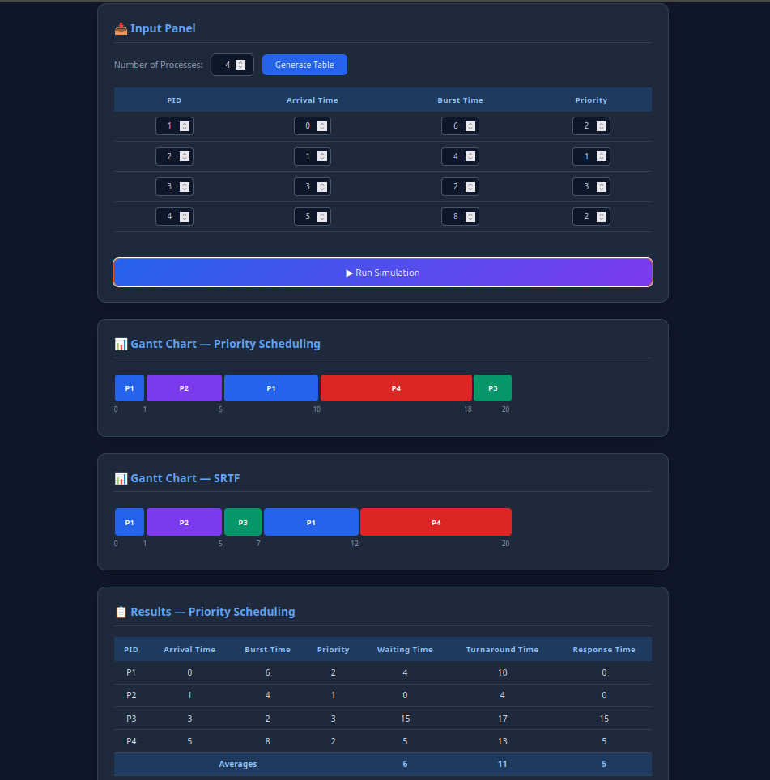
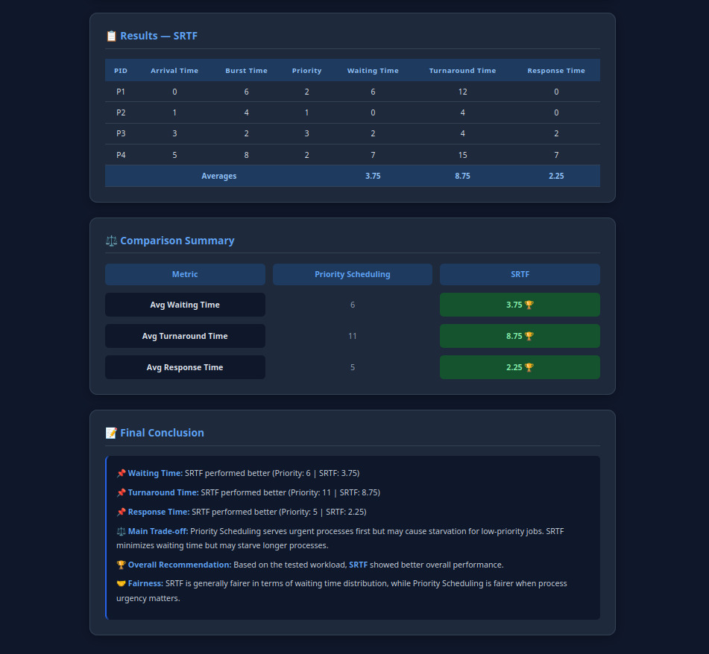

4- Sequential arrival
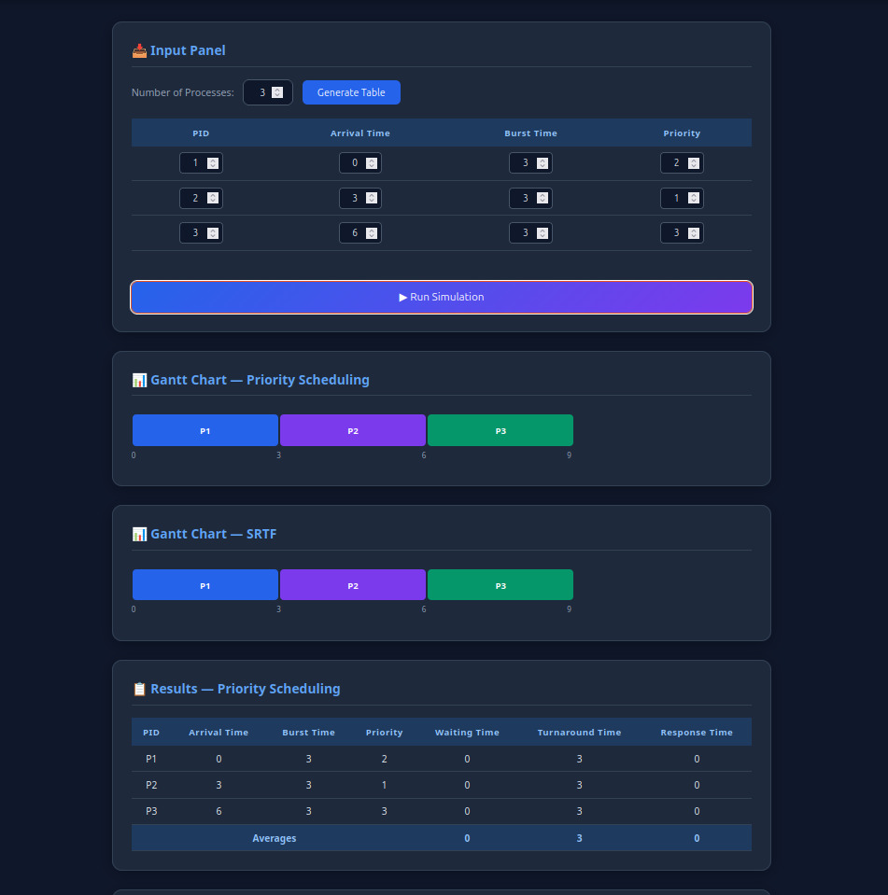
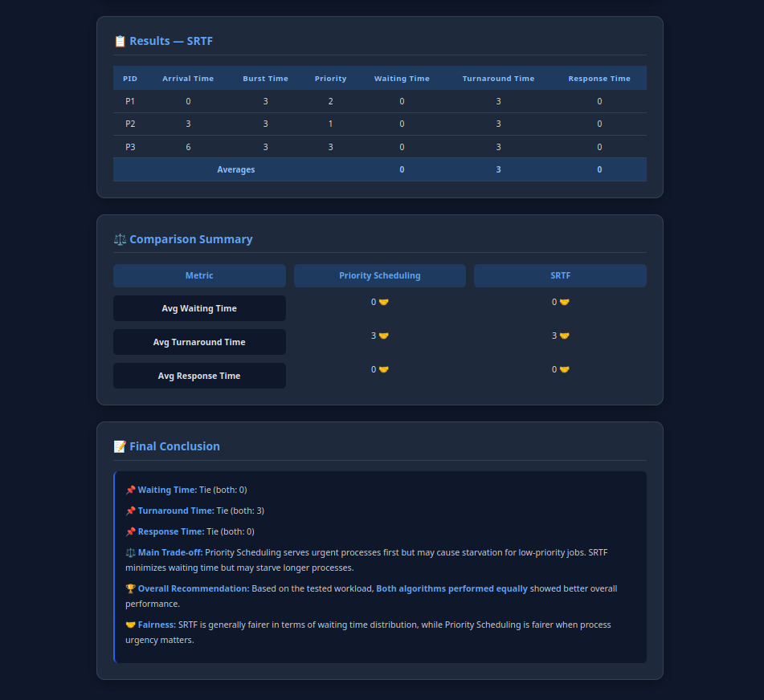

5- Late high priority arrival
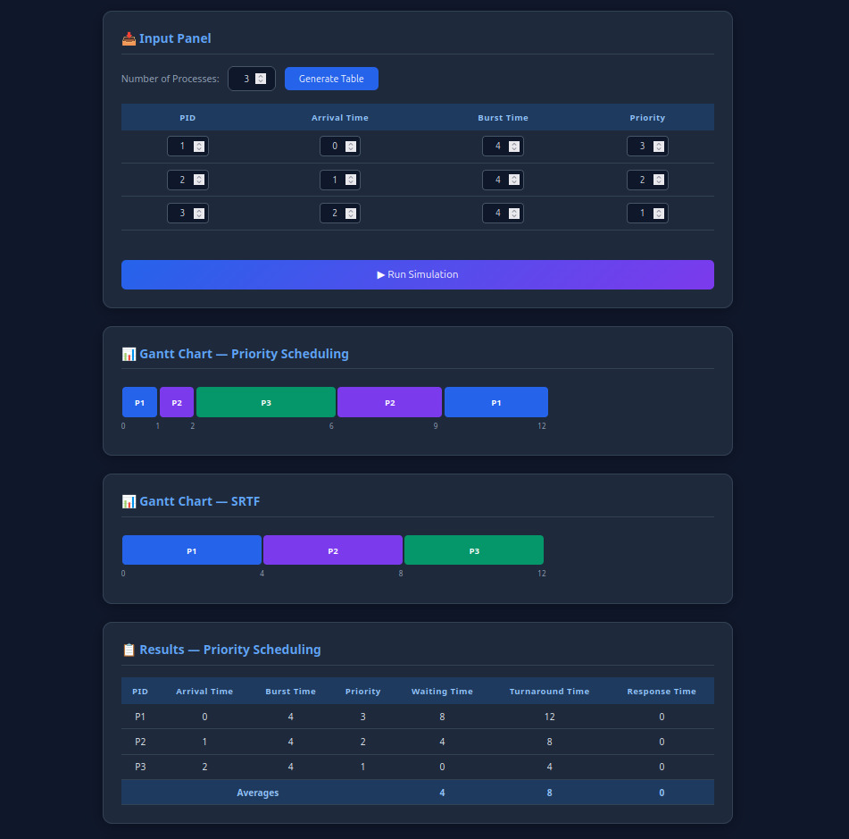
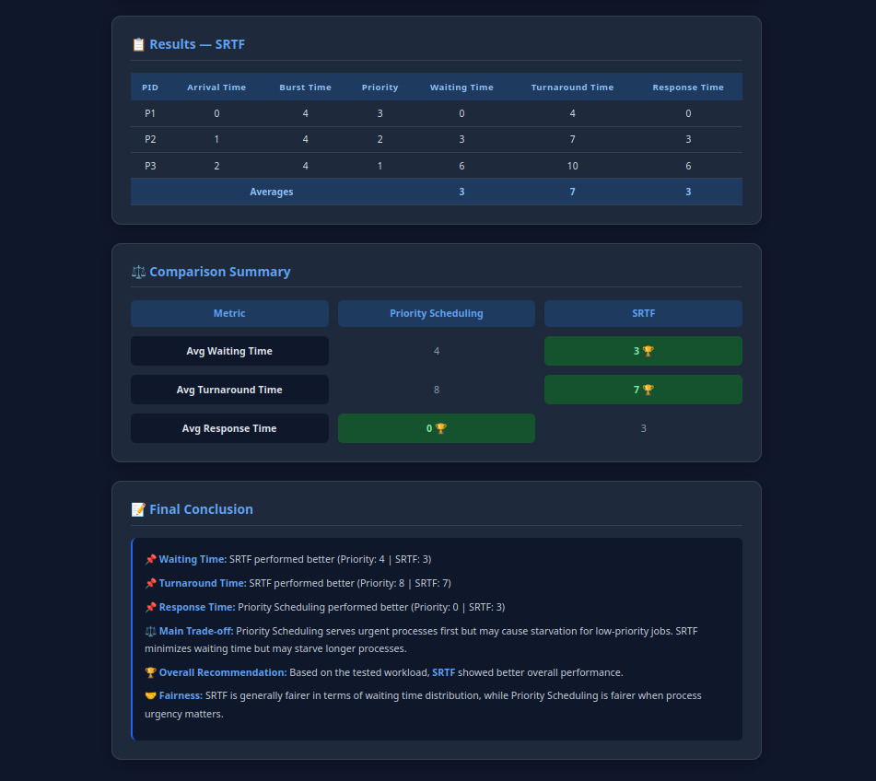

behavioral revealing :
1-High priority long vs low priority short
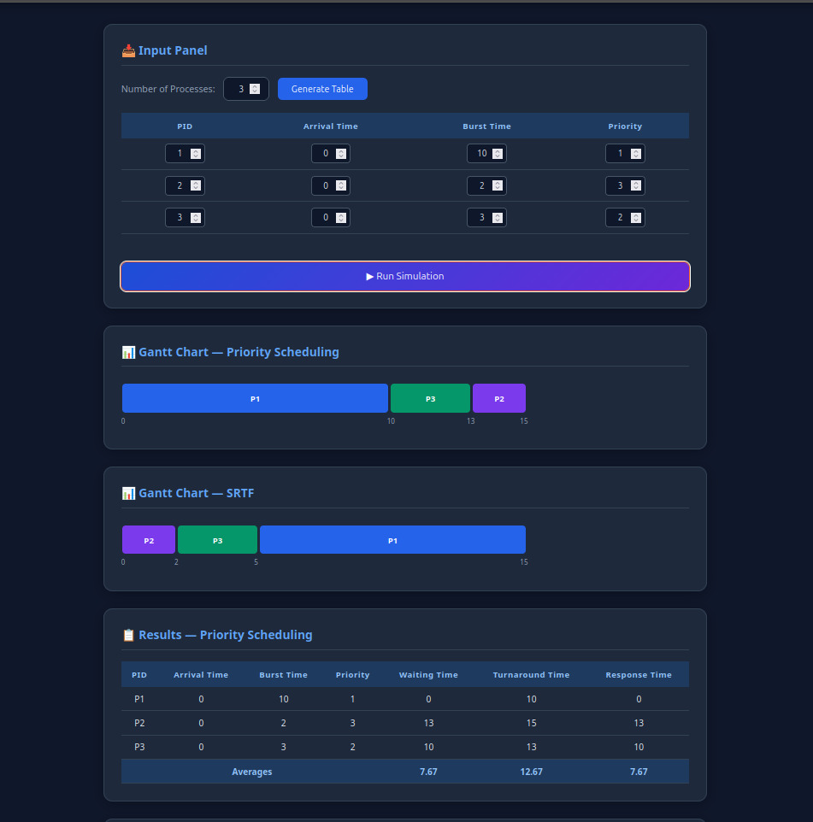
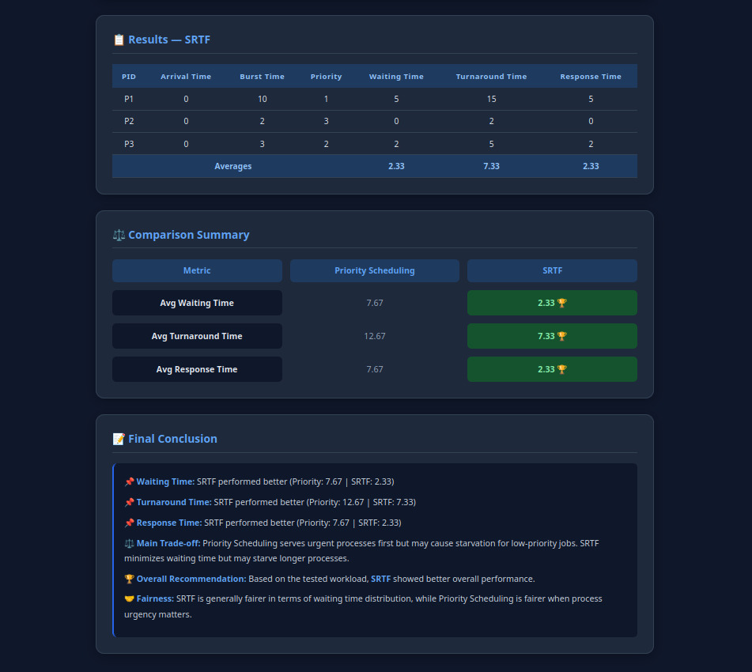

2-Starvation

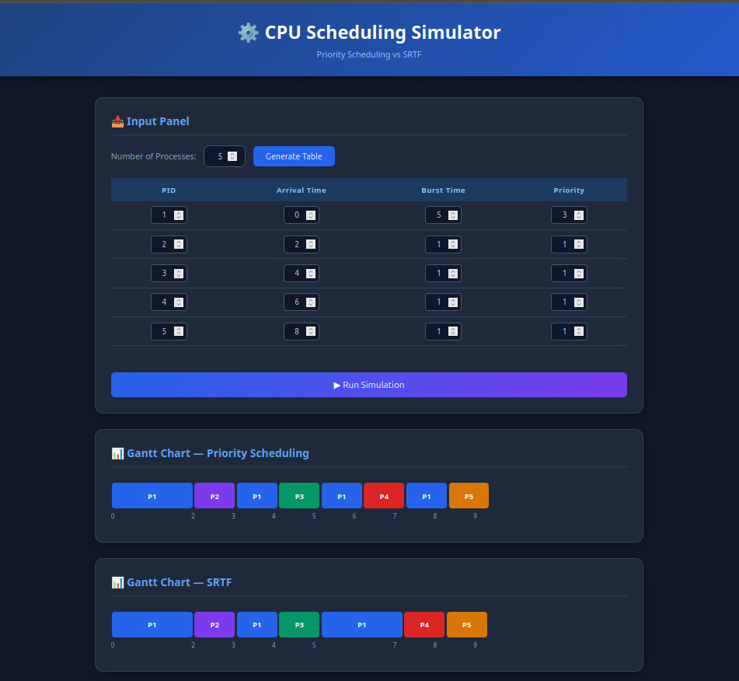
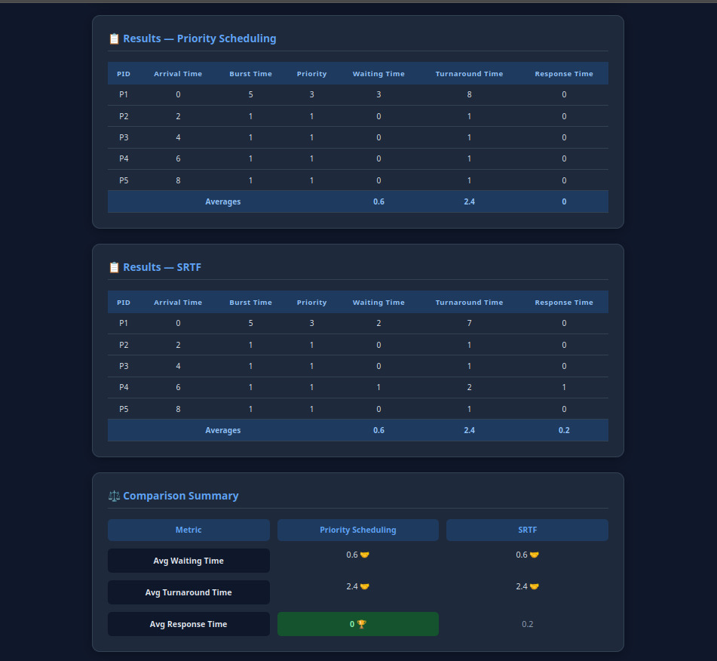
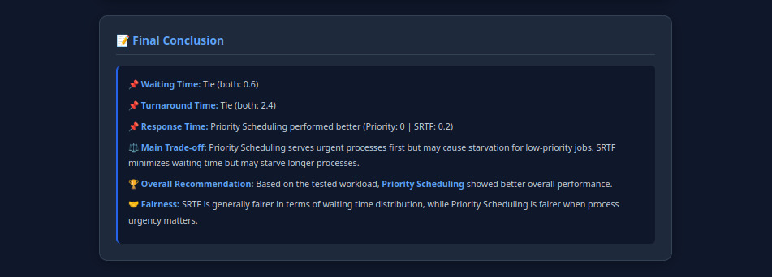

3- IDLE gap

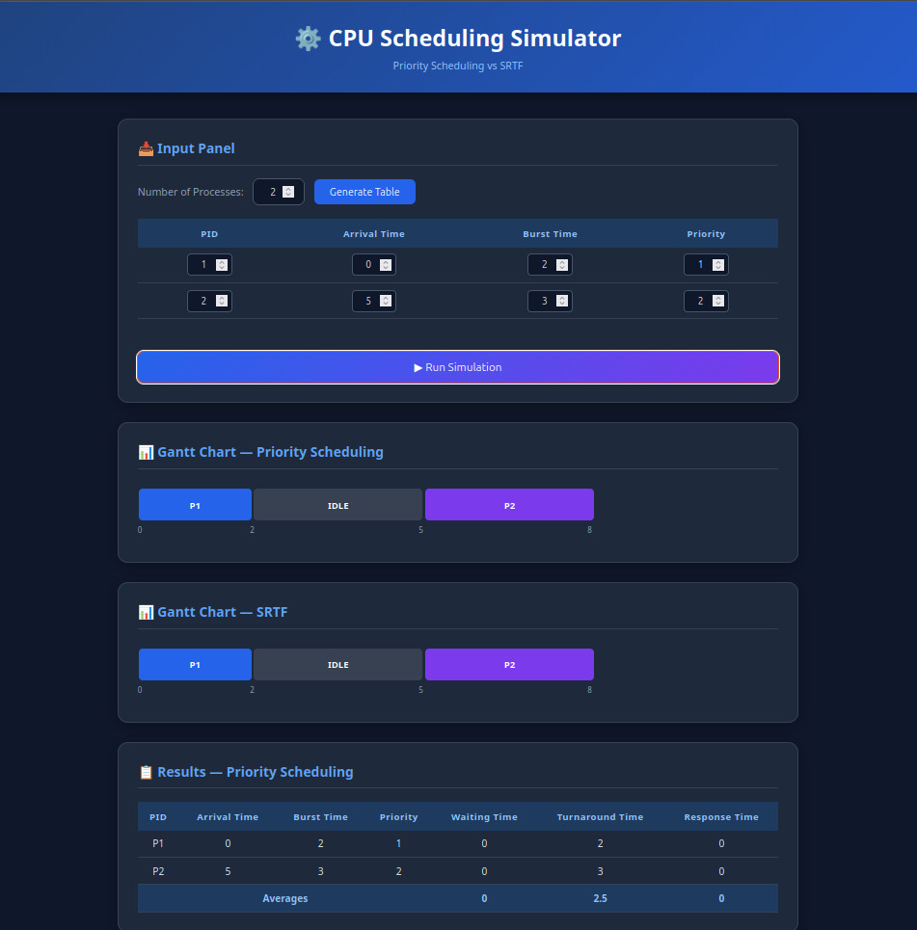
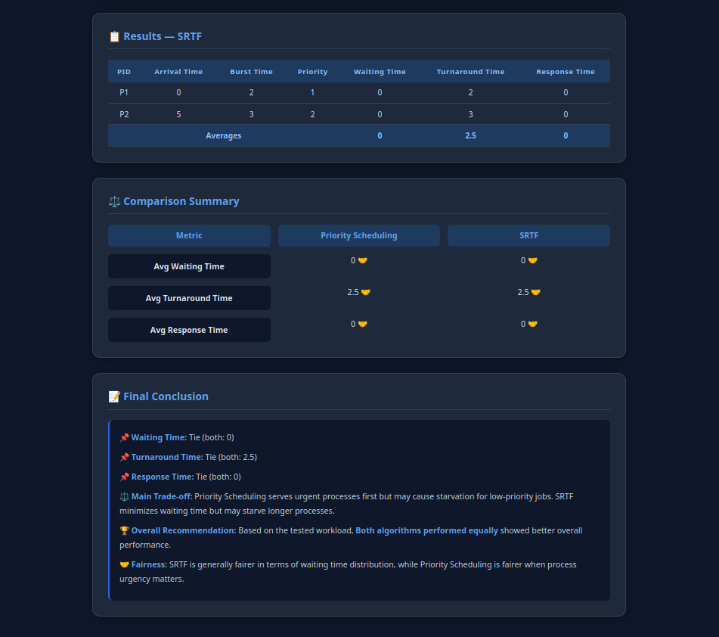

4-Equal priority, FCFS tiebreak

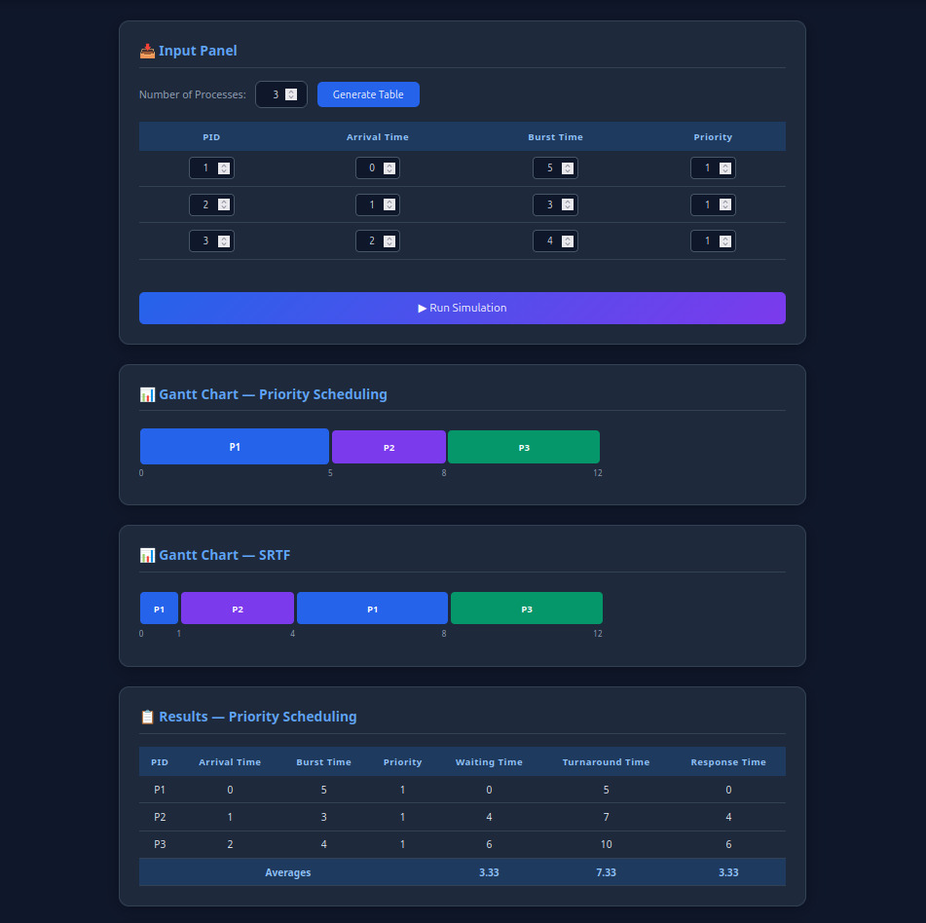
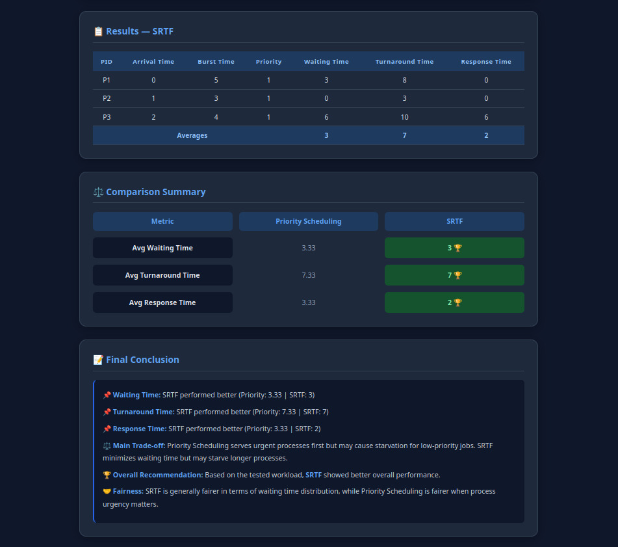

5-Late high priority arrival

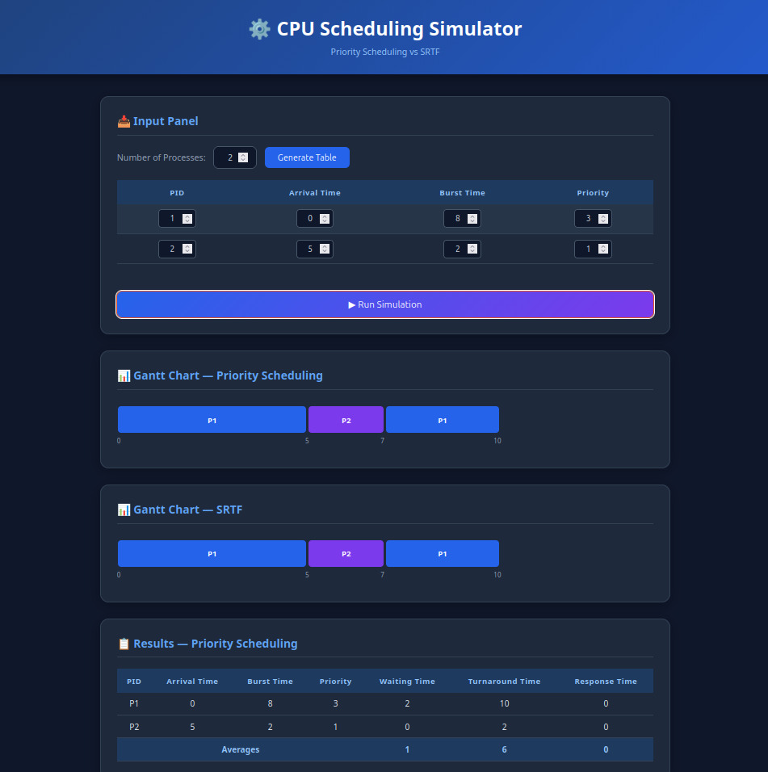
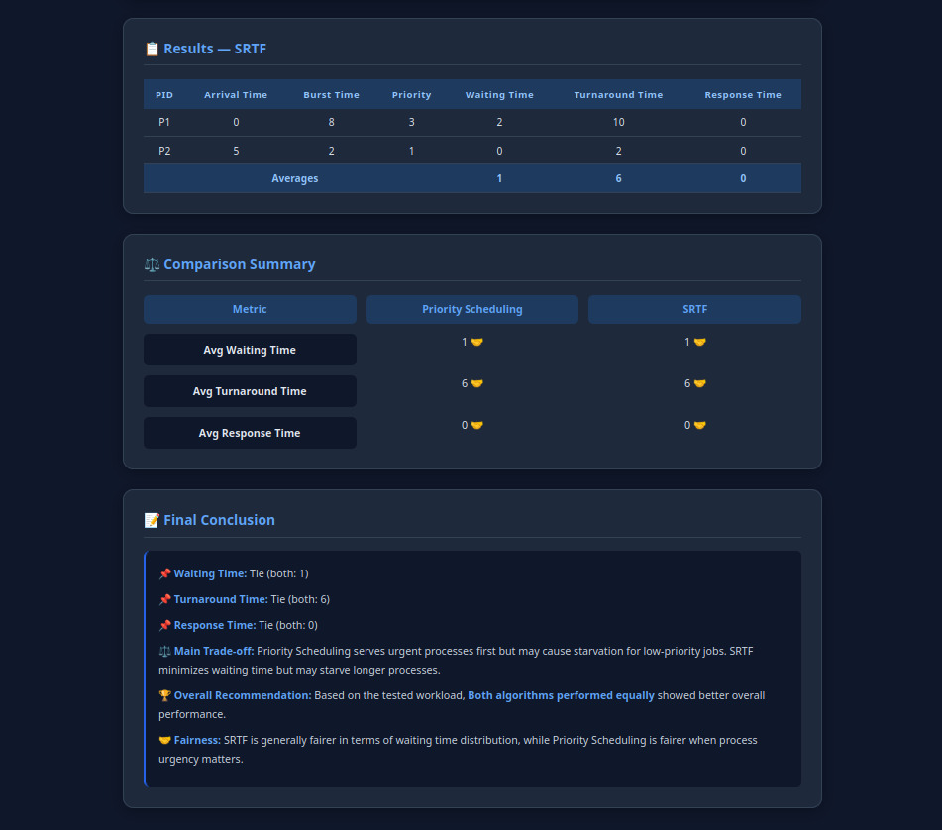

Validation :

- BT = 0 or negative

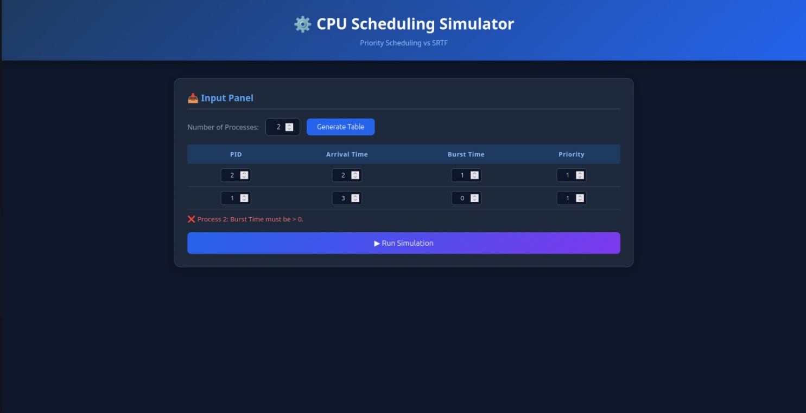

- Negative AT :

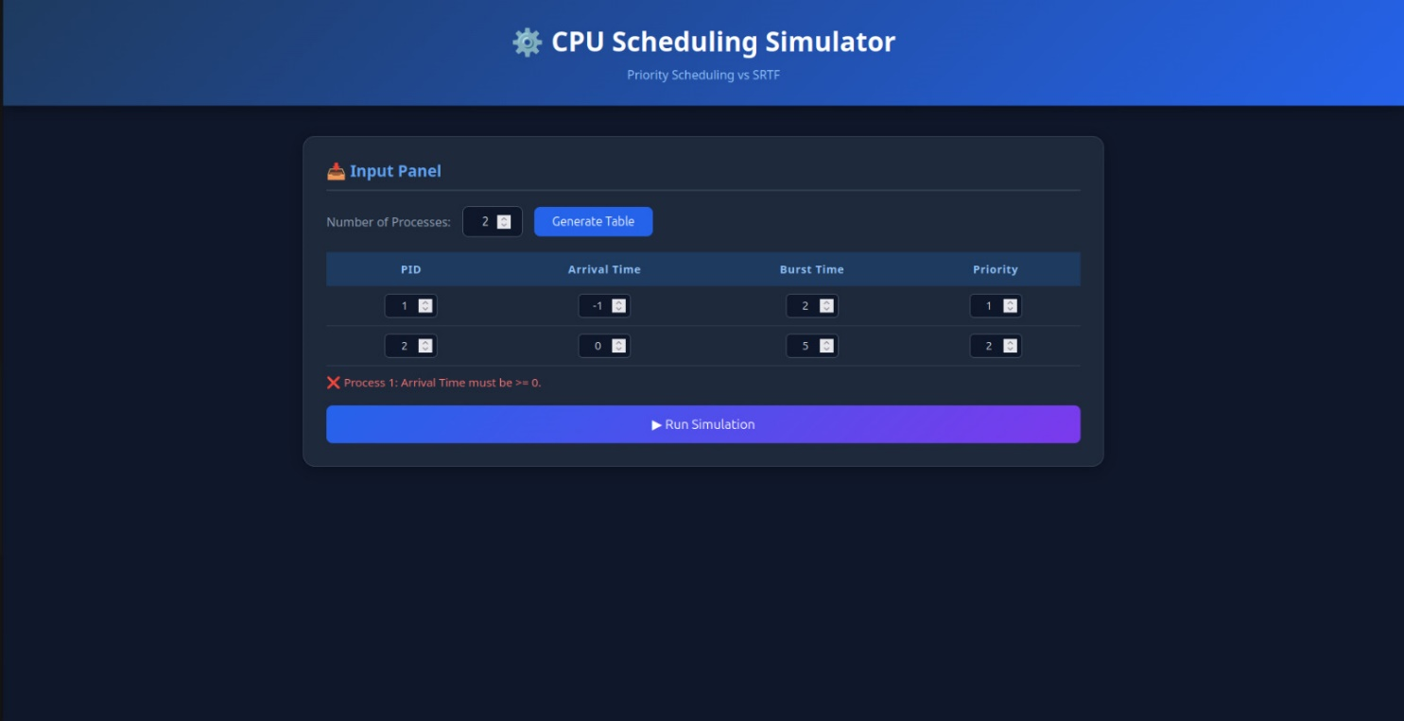

- Duplicate PIDs :

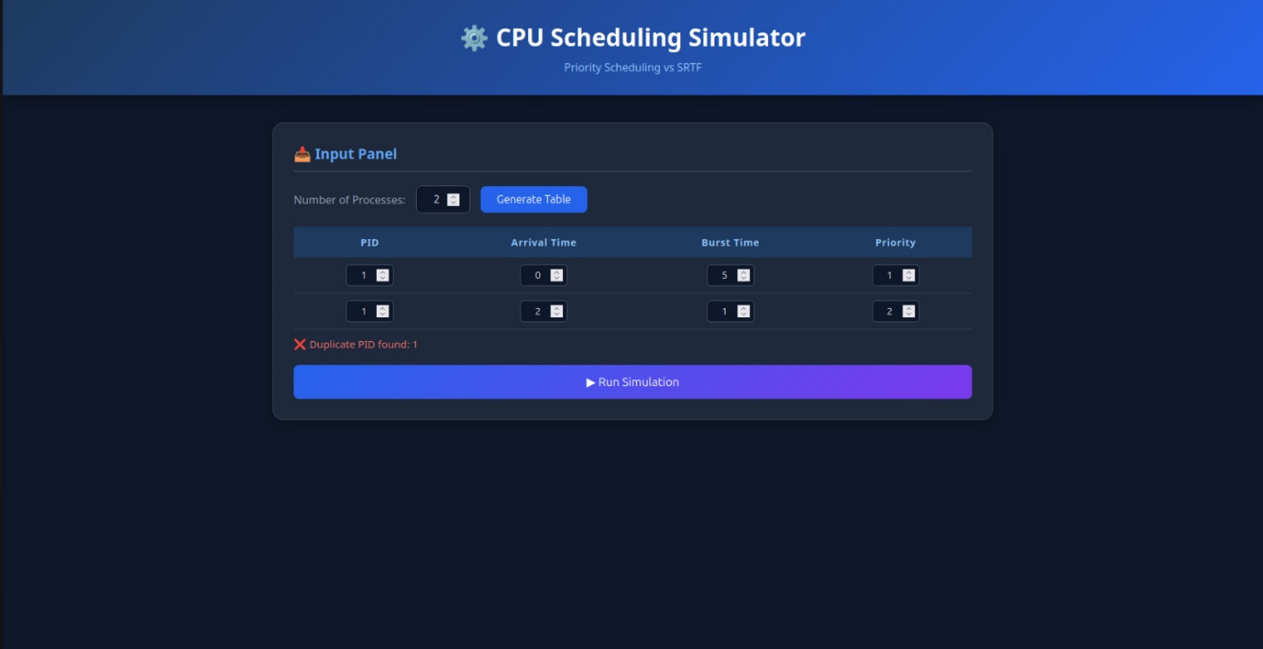

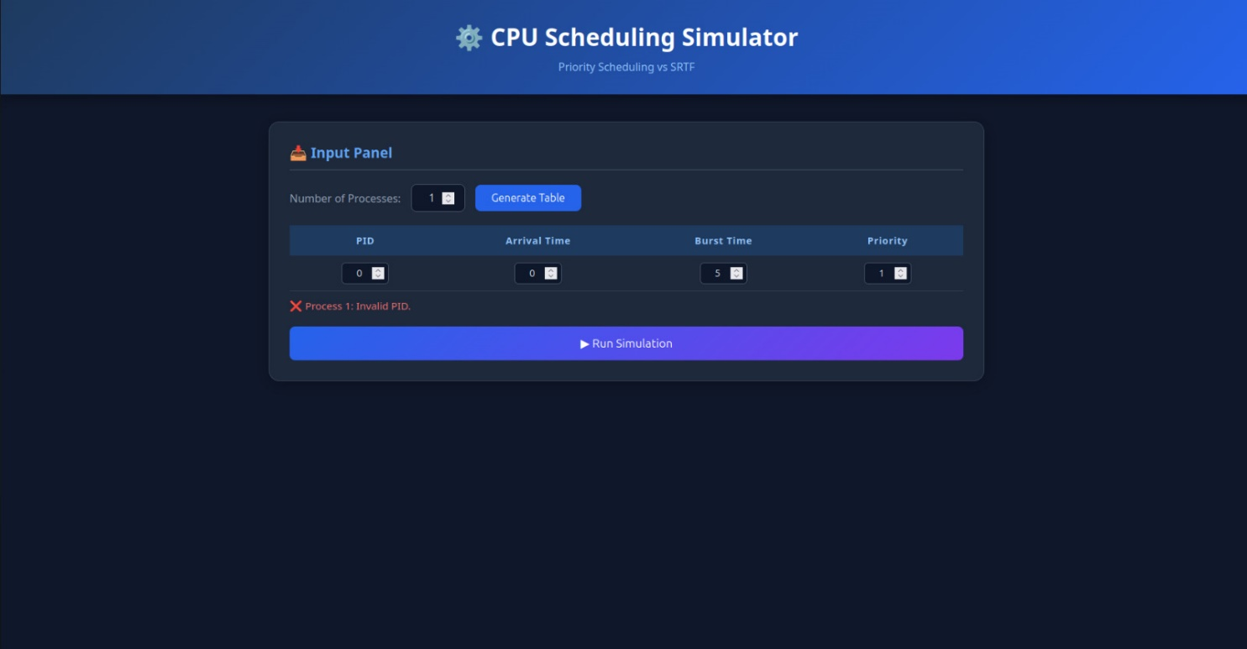

- Priority < 1
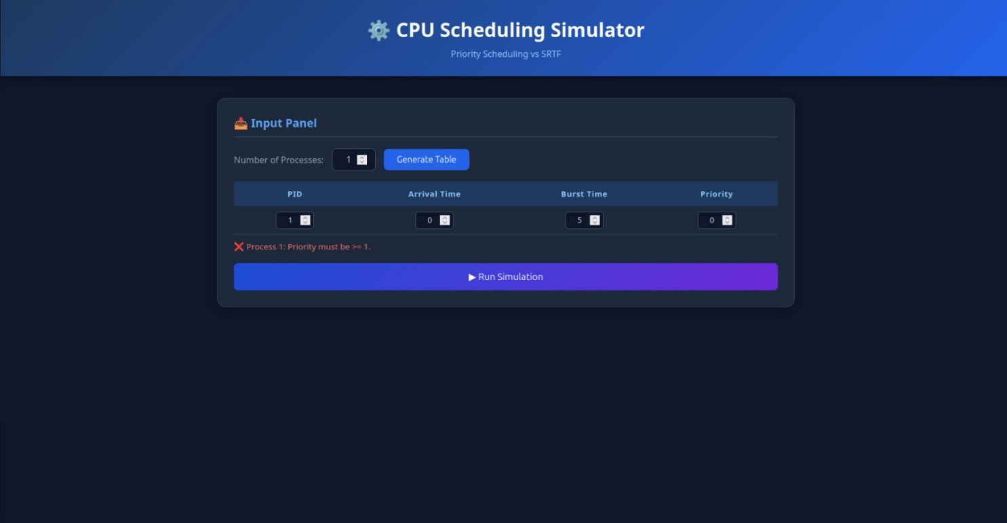

- Empty fields (NaN)
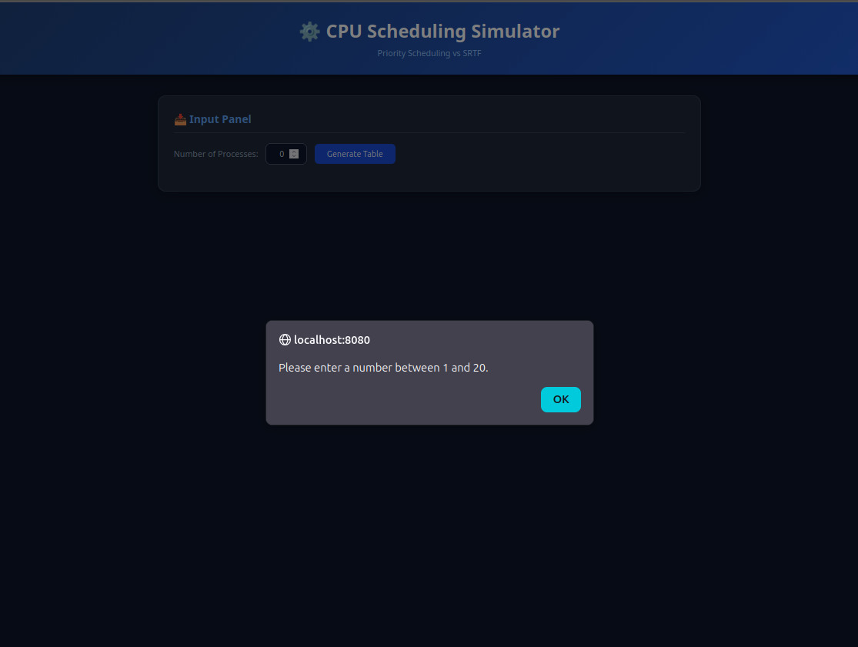
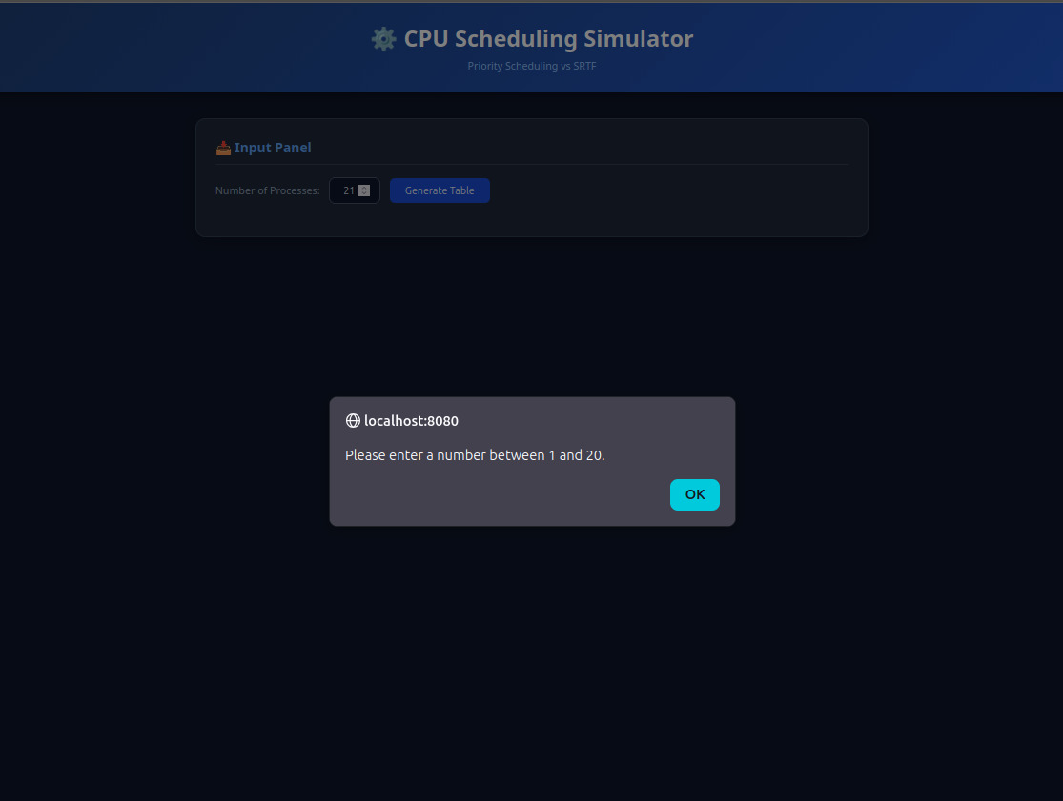

Invalid Input | Detected By | Error Response
Negative AT | Both layers | "Arrival Time must be >= 0"
BT = 0 or negative | Both layers | "Burst Time must be > 0"
Duplicate PIDs | Both layers | "Duplicate PID found: X"
Priority < 1 | app.js | "Priority must be >= 1"
Empty fields (NaN) | app.js | Field-specific error message shown

8. Comparison & Analysis

Analysis Questions

Which algorithm produced the lower average waiting time?
SRTF consistently produces a lower average WT across most workloads, particularly when burst times vary widely (Scenario B: SRTF 2.50 vs Priority 10.50). Priority can match SRTF only when all processes happen to arrive in priority order with similar burst times.

Which algorithm produced the lower average response time?
SRTF consistently produces a lower average RT because it always selects the shortest job, so short processes get CPU access almost immediately. Priority may force a short, low-priority process to wait for all higher-priority processes to complete.

Did priority values improve treatment of urgent processes?
Yes — processes with low priority numbers (high priority) receive CPU preferentially in Priority Scheduling. This is effective when the most urgent process is also short. However, when a high-priority process has a long burst time, it monopolizes the CPU and delays all other processes regardless of their burst length (Scenario B).

Did SRTF favor short jobs more aggressively?
Yes — SRTF is the most aggressive short-job-first scheduler possible, operating at per-tick granularity. Any newly arrived shorter job immediately preempts the current process. This minimizes average WT and RT but can cause long processes to suffer extended waiting, especially if new short jobs keep arriving (convoy effect in reverse).

Side-by-Side Summary (across all scenarios)
Metric / Property | Priority Scheduling | SRTF
Scheduling basis | Priority number (policy-driven) | Remaining burst time (length-driven)
Preemption | Non-preemptive (runs full burst) | Preemptive (per clock tick)
Avg Waiting Time | Higher (especially with long high-pr jobs) | Lower (favors short jobs aggressively)
Avg Response Time | Higher (low-pr short jobs wait longest) | Lower (short jobs respond faster)
Fairness | Unfair to low-priority processes | Unfair to long processes
Starvation risk | High – low-priority may starve forever | Possible for long jobs if short jobs keep arriving
Best use case | Real-time / policy-driven: OS processes, interrupt handling | Batch / throughput: minimize avg WT
Implementation complexity | Simple (scan once per completion) | More complex (tick-by-tick, preemption tracking)

9. Conclusion

Algorithm Performance Summary
Across all tested scenarios, SRTF achieved lower average Waiting Time and lower average Response Time than Priority Scheduling. The improvement is most pronounced when workloads include a mix of short and long burst times regardless of their assigned priorities.

Metrics Comparison
- Average WT: SRTF wins in all non-trivial scenarios (up to 75% lower in Scenario B).
- Average TAT: SRTF wins or ties in all scenarios.
- Average RT: SRTF consistently lower — short processes are never blocked by long high-priority ones.

Trade-Offs Observed
- SRTF offers optimal average WT (provably minimal for preemptive schedulers) but completely ignores process urgency or policy.
- Priority Scheduling respects administrator-assigned urgency, making it indispensable for real-time and OS-level scheduling where policy matters more than raw throughput.
- Both algorithms risk starvation: Priority starves low-priority processes; SRTF can indefinitely defer long processes if short jobs continuously arrive.

Fairness Analysis
Neither algorithm is universally fair. Priority Scheduling is fair within the same priority level (FCFS tie-breaking) but discriminates sharply by level. SRTF is fair to short jobs but systematically disadvantages long ones. A hybrid approach (e.g., aging in Priority, or a weighted fair-queuing variant) would address both concerns.

Recommendation
Use Priority Scheduling when… | Use SRTF when…
Process urgency must be respected (OS, real-time systems) | Minimizing average wait and response time is the primary goal
Different process classes exist (kernel vs user) | Batch processing with highly variable job sizes
Starvation is controlled by aging or bounded priorities | All jobs are equally important regardless of length

For the workloads tested in this project, SRTF performed better on raw efficiency metrics. However, Priority Scheduling remains the more practical choice for general-purpose operating systems where process classes and urgency are fundamental design requirements.

