Design for a Model-Diagram Controller

This is a short note describing the proposed XTools upgrade to allow the event handlers for class-model based diagram editors to be modeled. Currently the event handlers are generated as code with operator assistance via dialogs. The proposal aims to:

- Reduce the amount of material generated.
- Make the event handlers easy to save and load via XML.
- Support the generation of event handlers and associated tool type via a browser.
- Allow arbitrary behaviour via call-outs.

An event handler detects and actions events that occur either as a result of a slot change or as a result of a diagram change. An event handler is therefore an association between instances of classes (on the left) and diagrams (on the right).

The appropriate part of XCore used as the left-part of the association is as follows:

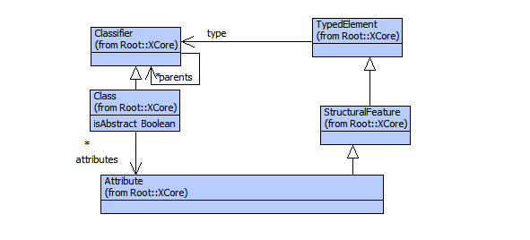
The right-hand side of the association is an XTool for diagrams. We introduce a new type of tool called an MDCTool (for model diagram controller). Otherwise, the rest of XTools is left unchanged: a diagram tool has a tool type consisting of node types and edge types. Note that a diagram tool type is a display type which allows diagrams to be nested by placing diagrams inside nodes.

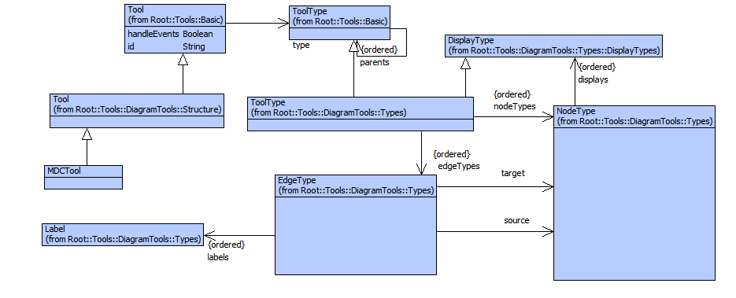

An MDCTool manages an association between the class-model and the diagram type. The element managed by the tool is an instance of a class whose association is represented by Class_x_Tool.

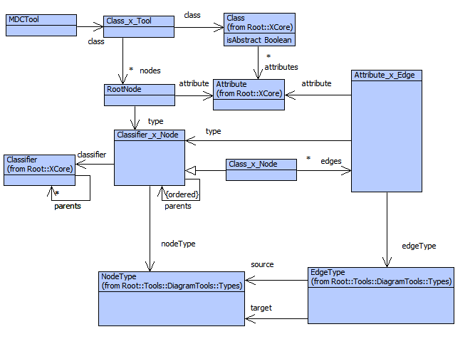
The element managed by the tool is constructed by placing nodes and edges on the diagram, these will modify the slots of the managed element. The corresponding nodes are called RootNodes and are associated with the attributes of the root class.

Each RootNode has a type (corresponding to the type of the associated attribute) which is a Classifier_x_Node associating a classifier with a diagram node. It is more likely that a root node will be a Class_x_Node which is a sub-class associating classes with diagram nodes. Since classes have attributes, each class association has a collection of Attribute_x_Edges associating its attributes with diagram edges.

Classes on diagram may also be represented as edges. The root class association has a number of Class_x_Edge associations between classes and edge types. Each association has a source and target attribute whose types are represented as nodes on the diagram and are associated by Classifier_x_Node via sourceNode and targetNode.

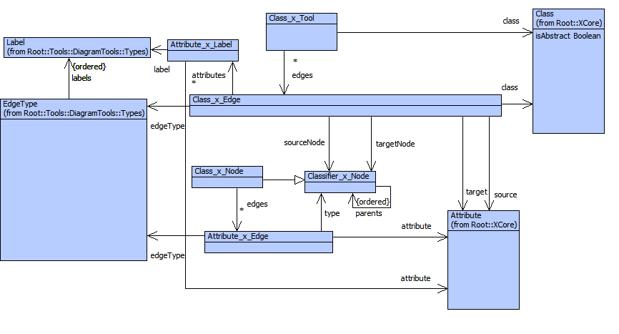
Each class represented as an edge may have attributes represented as labels. These attributes are associated using Attribute_x_Label.
Nodes on diagrams contain display elements. Display elements on a node may be associated with attributes of a class associated with the node. Therefore, Class_x_Node has a collection of Attribute_x_Display associations. Each attribute that is displayed, has a type managed by a Classifier_x_Display. In cases where the multiplicity of the attribute is 1 the displayType of the Attribute_x_Display and is Classifier_x_Display are the same. However, when the multiplicity is * or {ordered} then the display type of the attribute may be the containing box for all the attribute values and the displayType for the classifier will be the display for the individual elements.
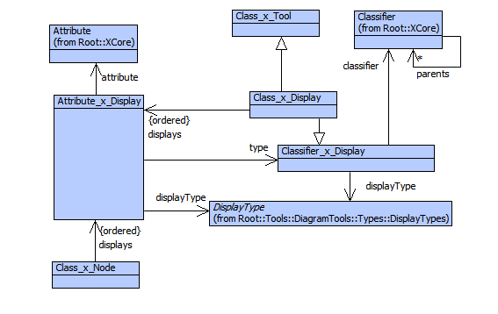

Note that Class_x_Tool is a sub-class of Class_x_Display and therefore we can nest diagrams.

