DUCT SYMBOL CREATION.DOC
CLAMP AND RING CLAMP
Status: None
Revision: 0.1
Revision date: January 22, 2002
Author: CarolineNathan

Table of Contents
1 Revision History 3
2 Introduction 4
3 Support Type 4
4 Symbols 4
4.1 Clamp size for Clamp joint type (I, L, U type) 4
4.1.1 Inputs for Clamp Size 5
4.1.2 Outputs 5
4.1.3 Implementation 6
4.2 Ring Clamp size for Clamp joint type (I type) 7
4.2.1 Inputs for Ring Clamp 7
4.2.2 Outputs 8
4.2.3 Implementation 8
4.3 Flange joint 9
4.3.1 Inputs 10
4.3.2 Outputs 10
4.3.3 Implementation 10
4.4 Stopper Size for Angle Joint Type (I, L, U Type) 11
4.4.1 Inputs 12
4.4.2 Outputs 12
4.4.3 Implementation 12
4.5 Angle Size for Angle Joint Type (II Type) 13
4.5.1 Inputs 14
4.5.2 Outputs 14
4.5.3 Implementation 14
4.6 Plate Size for Rivet Joint Type (II Type) 16
4.6.1 Inputs 17
4.6.2 Outputs 17
4.6.3 Implementation 17
4.7 Band Size for Band Joint Type (U Type) 19
4.7.1 Inputs 20
4.7.2 Outputs 20
4.7.3 Implementation 20

Revision History

Rev | Status | Author | Date | Reason
0.1 | Draft | CarolineNathan | Jan 22, 2002 | Initial draft
0.2 | Draft | Sundar | Dec 10, 2002 | Added documentation for the symbols AngleJoint II, AngleJoint ILU, BandJoint U, FlangeJoint, Rivet Joint II.

The purpose of this section is to provide revision and approval history for this document.
Rev - The initial revision shall be marked 0.1. Subsequent releases before approval shall increment the value to the right of the decimal point. (Ex. 0.1, 0.2, 0.3) Once all members have approved the document the value to the left of the decimal point shall be incremented. Ex. 1.0. Subsequent releases developed and distributed for comments after approval shall increment the value to the right of the decimal point. (Ex. 1.1, 1.2, 1.3)
Status - The status shall be “Draft” or “Appr” (“Appr” stands for “approved”).
Author – Initials of person making the change
Date - The date that the revision was distributed.
Reason - The purpose for the revision.

Introduction
This document describes the process involved in the creation of Gusseted Vertical Pipe Support.

Support Type
There are different types of support for different routing object. The support types listed in this section are related for HVAC Duct. The inputs and outputs for the following symbols will be discussed in the following.
- Clamp Size for ClampJointType (I,L,U type)
- Ring Clamp
- Flange Joint
- Stopper Size for Angle Joint Type (I, L, U Type)
- Angle Size for Angle Joint Type (II Type)
- Plate Size for Rivet Joint Type (II Type)
- Band Size for Band Joint Type (U Type)

Symbols

Clamp size for Clamp joint type (I, L, U type)
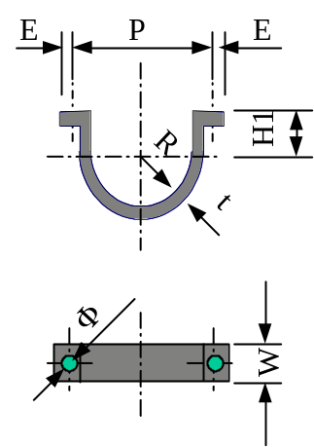
PU-A type clamp (for insulated spiral duct)
Duct Diameter | Clamp | P | E | W | R | t | Φ
80 | PR-80 | 160 | 15 | 25 | 58 | 3.0 | 10
100 | PR-100 | 180 | 15 | 25 | 68 | 3.0 | 10
125 | PR-125 | 205 | 15 | 25 | 81 | 3.0 | 10
160 | PR-160 | 240 | 15 | 25 | 98 | 3.0 | 10
200 | PR-200 | 280 | 15 | 25 | 118 | 3.0 | 10
250 | PR-250 | 330 | 15 | 25 | 143 | 3.0 | 10

U-A type clamp (for un-insulated spiral duct)
Duct Diameter | Clamp | P | E | W | R | t | Φ
80 | R-80 | 128 | 15 | 25 | 42 | 3.0 | 10
100 | R-100 | 148 | 15 | 25 | 52 | 3.0 | 10
125 | R-125 | 172 | 15 | 25 | 64 | 3.0 | 10
160 | R-160 | 208 | 15 | 25 | 82 | 3.0 | 10
200 | R-200 | 248 | 15 | 25 | 102 | 3.0 | 10
250 | R-250 | 298 | 15 | 25 | 127 | 3.0 | 10

Inputs for Clamp Size
- Duct Diameter
- Clamp Length (P)
- Leg Length (E)
- Radius(R)
- Height (H1)
- Thickness (t)
- Width (W)
- Bolt Dia(φ)

Occurrence Attributes
- Duct Diameter.

Outputs
All representations will output a collection of graphics (i.e. G-Types). In additions to graphics, each symbol must output an appropriate set of ports.
Each support will be represented by a collection of symbols. These symbols correspond to the individual components of the support assembly. Each component of the assembly will output ports indicative of its role within the assembly. These ports will expose the location where individual components of the assembly can be connected and aid in placement of the symbol occurrence

- Clamp
- Bolt (left and Right)
- HgrPort_1
- HgrPort_2

Implementation
This Duct Clamp has only Detail Physical Representation.

Construction of the Clamp
Origin located at the Center of the Clamp.
The Clamp is constructed on the X-Y Plane and Projected along the width in the Z-Direction.
The Clamp has been constructed as four elements. The Left Leg, Right Leg, Inner Arc, Outer Arc. They together constitute a complex string.

There are two bolts one on the Left leg and the other on the Right Leg.

Finally the Symbol needs to have Output Ports. This Symbol has 2 output Ports. One Port is located on the Center of the Clamp in the Z-Direction. The Coordinates are (0,0,Width/2)
The Second Port is located on the same X & Z Coordinates as Port1 at a Distance “Height” in the Y-direction. The Coordinates are 0, Height, Width/2).

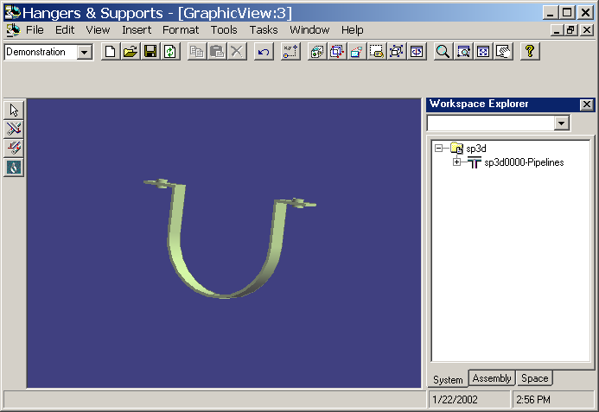

Ring Clamp size for Clamp joint type (I type)
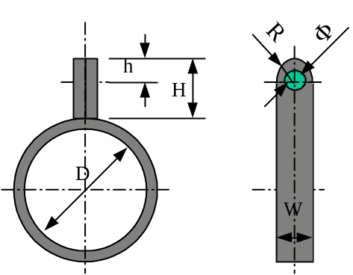
PU-A type clamp (for insulated spiral duct)
Duct Diameter | Clamp | D | W | R | H | h | t | Φ
80 | PR-80 | 160 | 25 | W/2 | 37 | 15 | 2.0 | 10
100 | PR-100 | 180 | 25 | W/2 | 37 | 15 | 2.0 | 10
125 | PR-125 | 205 | 25 | W/2 | 37 | 15 | 2.0 | 10
160 | PR-160 | 240 | 25 | W/2 | 37 | 15 | 2.0 | 10
200 | PR-200 | 280 | 25 | W/2 | 37 | 15 | 2.0 | 10
250 | PR-250 | 330 | 25 | W/2 | 37 | 15 | 2.0 | 10
315 | PR-315 | 357 | 25 | W/2 | 37 | 15 | 2.0 | 10
U-A type clamp (for un-insulated spiral duct)
Duct Diameter | Clamp | D | W | R | H | h | t | Φ
80 | R-80 | 128 | 25 | W/2 | 37 | 15 | 2.0 | 10
100 | R-100 | 148 | 25 | W/2 | 37 | 15 | 2.0 | 10
125 | R-125 | 172 | 25 | W/2 | 37 | 15 | 2.0 | 10
160 | R-160 | 208 | 25 | W/2 | 37 | 15 | 2.0 | 10
200 | R-200 | 248 | 25 | W/2 | 37 | 15 | 2.0 | 10
250 | R-250 | 298 | 25 | W/2 | 37 | 15 | 2.0 | 10
315 | R-315 | 319 | 25 | W/2 | 37 | 15 | 2.0 | 10

Inputs for Ring Clamp
- Duct Diameter
- Duct Diameter
- Ring Diameter (D)
- Width (W)
- Height (H)
- Bolt Height (h)
- Thickness (t)
- Bolt Diameter (φ)

Occurrence Attributes
- Duct Diameter.

Outputs
- Ring
- Rod
- Bolt
- HgrPort_1
- HgrPort_2

Implementation
This Ring Clamp has only Detail Physical Representation.

Construction of the Clamp
Origin located at the Center of the Ring Clamp.
The Ring is constructed on the X-Y Plane and projected along the width in the negative Z-Direction.
The Rod has been constructed as four elements. The Left Line, Right Line, Upper Arc and a Joint Line. They together constitute a complex string.
There is a hole on the top of the Rod, φ as Diameter. Through this hole the Clamp will be bolted to the Support.

Finally the Symbol needs to have Output Ports. This Symbol has 2 output Ports. One Port is located on the Center of the Ring clamp in the Z-Direction. The Coordinates are (0,0, -Width/2)
The Second Port is located on the center of the bolt. The Coordinates are Thickness, Ring Diameter / 2 + Thickness + (Height - Bolt Height), -Width / 2

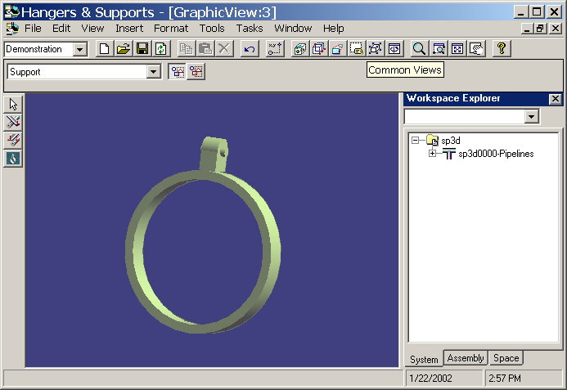

Flange joint
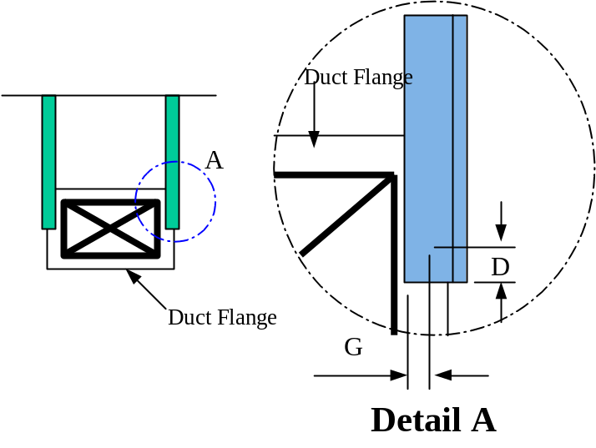
Angle Size | D | G
30x30x3T | 25 | 15
40x40x5T | 25 | 15
50x50x6T | 25 | 15
65x65x6T | 25 | 15
75x75x9T | 25 | 15

Inputs
Part
Width
Depth
HorizontalSpacing
VerticalSpacing
D (D)
G (G)
FlangeThickness
FlangeLength

The DuctWidth and DuctDepth are occurrence attributes for the symbol.

Outputs
FlangeJoint
FlangeCenterPort

Implementation
One complex string has been created between the following five points around the origin and project it along Z-axis for distance FlangeLength.
dblPoints(1) = (dblDuctWidth / 2 + dblHorizontalSpacing)
dblPoints(2) = (dblDuctDepth / 2 + dblVerticalSpacing)
dblPoints(3) = 0#

dblPoints(4) = (dblDuctWidth / 2 + dblHorizontalSpacing)
dblPoints(5) = -(dblDuctDepth / 2 + dblVerticalSpacing)
dblPoints(6) = 0#

dblPoints(7) = -(dblDuctWidth / 2 + dblHorizontalSpacing)
dblPoints(8) = -(dblDuctDepth / 2 + dblVerticalSpacing)
dblPoints(9) = 0#

dblPoints(10) = -(dblDuctWidth / 2 + dblHorizontalSpacing)
dblPoints(11) = (dblDuctDepth / 2 + dblVerticalSpacing)
dblPoints(12) = 0#

dblPoints(13) = (dblDuctWidth / 2 + dblHorizontalSpacing)
dblPoints(14) = (dblDuctDepth / 2 + dblVerticalSpacing)
dblPoints(15) = 0#

Create a Hanger symbol port called ‘FlangeCenter’ in the following way at center of the duct flange.
' create the "FlangeCenter" hanger port
Dim oPortFac As IJHgrPortFactory
Dim oPort1 As IJHgrPort
Set oPortFac = New HgrPortFactory

Set oPort1 = oPortFac.CreateHgrPortEntity(m_outputColl.ResourceManager)
oPort1.Type = SupportedMemberPort
oPort1.Name = "FlangeCenter"
oPort1.PutOrientation 0, 0, 0, _
0, 0, 1, _
0, 1, 0

m_outputColl.AddOutput OUTPUT_2, oPort1
Set oPortFac = Nothing
Set oPort1 = Nothing

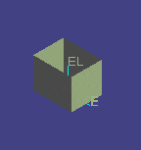

Stopper Size for Angle Joint Type (I, L, U Type)
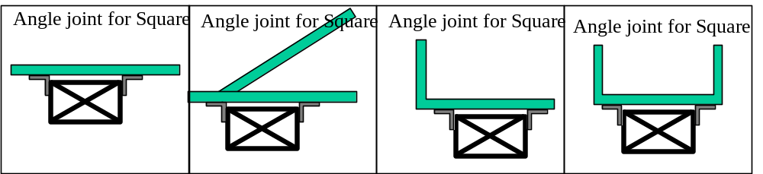
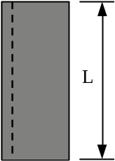
Default stopper angle size is 50x50x6T and length is 150mm.
Angle Size | Length (L)
30x30x3T | 150
40x40x5T | 150
50x50x6T | 150
65x65x6T | 150
75x75x9T | 150

Inputs
Part
Length
The DuctWidth and DuctDepth are occurrence attributes for the symbol.

Outputs
StructuralMember
XsidePort
YsidePort

Implementation
- Get the geometry of the cross section using catalog services in the following way.
CSName = "L5x3x1/2"
CSStandard = "AISC-LRFD-3.0"
SectionType = "L"
Set oCSgeometry = oCatServices.GetCrossSectionGeometry(oResourceManager, CSStandard, SectionType, CSName)

- Project the cross section geometry along Z-axis for a given distance Length and add as output.
' create the projection
Set CreateMember = oGeomFactory.Projections3d.CreateByCurve(oResourceManager, _
oCSgeometry, 0, 0, 1, dblLength, True)
m_outputColl.AddOutput OUTPUT_1, oProjection3d

- Create the hanger port at the X-axis side and add as output.
Set oHgrPort = oHgrPortFactory.CreateHgrPortEntity(m_outputColl.ResourceManager)
oHgrPort.Type = SupportedMemberPort
oHgrPort.Name = OUTPUT_2
oHgrPort.PutOrientation dblX, 0, dblZ + dblLength / 2, _
0, 0, 1, _
0, 1, 0
m_outputColl.AddOutput OUTPUT_2, oHgrPort
Set oHgrPort = Nothing

- Create the hanger port at the Y-axis side and add as output.
Set oHgrPort = oHgrPortFactory.CreateHgrPortEntity(m_outputColl.ResourceManager)
oHgrPort.Type = SupportedMemberPort
oHgrPort.Name = OUTPUT_3
oHgrPort.PutOrientation 0, dblY, dblZ + dblLength / 2, _
0, 0, 1, _
0, 1, 0
m_outputColl.AddOutput OUTPUT_3, oHgrPort

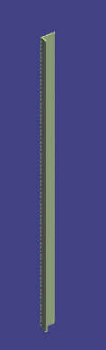

Angle Size for Angle Joint Type (II Type)
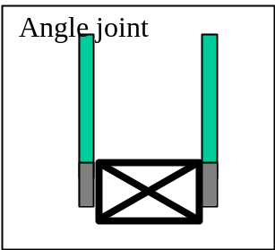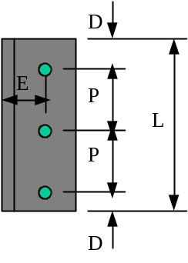

Angle size is same as support angle size.
Angle Size | Pitch (P) | END (E) | Distance(D) | Length (L)
30x30x3T | 70 | 15 | 40 | 220
40x40x5T | 70 | 20 | 40 | 220
50x50x6T | 70 | 30 | 40 | 220
65x65x6T | 70 | 35 | 40 | 220
75x75x9T | 70 | 45 | 40 | 220

Inputs
Part
Pitch
End
Distance
Length
Pie

The DuctWidth and DuctDepth are occurrence attributes for the symbol.

Outputs
StructuralMember
Bolt1
Bolt2
Bolt3
XSidePort
YSidePort
TopPort
BottomPort

Implementation
- Get the geometry of the cross section using catalog services in the following way.
CSName = "L5x3x1/2"
CSStandard = "AISC-LRFD-3.0"
SectionType = "L"
Set oCSgeometry = oCatServices.GetCrossSectionGeometry(oResourceManager, CSStandard, SectionType, CSName)

- Project the cross section geometry along Z-axis for a given distance Length and add as output.
' create the projection
Set CreateMember = oGeomFactory.Projections3d.CreateByCurve(oResourceManager, _
oCSgeometry, 0, 0, 1, dblLength, True)
m_outputColl.AddOutput OUTPUT_1, oProjection3d

- Create the first bolt and add as output.
Dim dblThickness As Double
dblThickness = 0.02
CreateBolt dblX, dblY, dblZ + dblDistance, dblPie / 2, 2 * dblThickness, OUTPUT_2

- Create the second bolt and add as output.
CreateBolt dblX, dblY, dblZ + dblPitch + dblDistance, dblPie / 2, 2 * dblThickness, OUTPUT_3

- Create the third bolt and add as output.
CreateBolt dblX, dblY, dblZ + 2 * dblPitch + dblDistance, dblPie / 2, 2 * dblThickness, OUTPUT_4

- Create the hanger port at the X-axis side and add as output.
Set oHgrPort = oHgrPortFactory.CreateHgrPortEntity(m_outputColl.ResourceManager)
oHgrPort.Type = SupportedMemberPort
oHgrPort.Name = OUTPUT_2
oHgrPort.PutOrientation dblX, 0, dblZ + dblLength / 2, _
0, 0, 1, _
0, 1, 0
m_outputColl.AddOutput OUTPUT_5, oHgrPort
Set oHgrPort = Nothing

- Create the hanger port at the Y-axis side and add as output.
Set oHgrPort = oHgrPortFactory.CreateHgrPortEntity(m_outputColl.ResourceManager)
oHgrPort.Type = SupportedMemberPort
oHgrPort.Name = OUTPUT_3
oHgrPort.PutOrientation 0, dblY, dblZ + dblLength / 2, _
0, 0, 1, _
0, 1, 0
m_outputColl.AddOutput OUTPUT_6, oHgrPort

- Create the hanger port at the bottom and add as output
Set oHgrPort = oHgrPortFactory.CreateHgrPortEntity(m_outputColl.ResourceManager)
oHgrPort.Type = SupportedMemberPort
oHgrPort.Name = OUTPUT_7
oHgrPort.PutOrientation dblX, dblY, dblZ, _
0, 0, 1, _
0, 1, 0
m_outputColl.AddOutput OUTPUT_7, oHgrPort
Set oHgrPort = Nothing

- Create the hanger port at the Top and add as output.
Set oHgrPort = oHgrPortFactory.CreateHgrPortEntity(m_outputColl.ResourceManager)
oHgrPort.Type = SupportedMemberPort
oHgrPort.Name = OUTPUT_8
oHgrPort.PutOrientation dblX, dblY, dblZ + dblLength, _
0, 0, 1, _
0, 1, 0
m_outputColl.AddOutput OUTPUT_8, oHgrPort

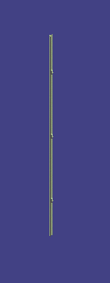

Plate Size for Rivet Joint Type (II Type)
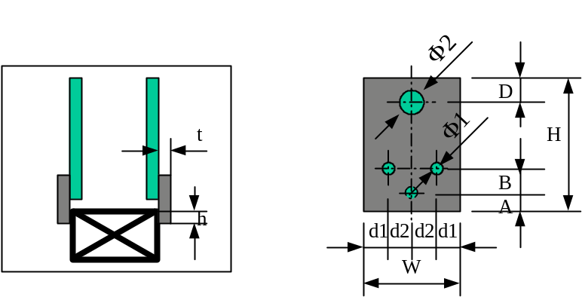
Angle Size | Φ1 | Φ2 | d1 | d2 | W | H | A | B | D | t | h
30x30x3T | 5 | 10 | 10 | 10 | 40 | 70 | 10 | 15 | 10 | 3.2 | 40
40x40x5T | 5 | 10 | 10 | 10 | 40 | 70 | 10 | 15 | 10 | 3.2 | 40
50x50x6T | 5 | 10 | 10 | 10 | 40 | 70 | 10 | 15 | 10 | 3.2 | 40
65x65x6T | 5 | 10 | 10 | 10 | 40 | 70 | 10 | 15 | 10 | 3.2 | 40
75x75x9T | 5 | 10 | 10 | 10 | 40 | 70 | 10 | 15 | 10 | 3.2 | 40

Inputs
Part
Pie01
Pie02
d1
d2
W
H
A
B
D
T
SmallH

The DuctWidth and DuctDepth are occurrence attributes for the symbol.

Outputs
StructuralMember
Bolt1
Bolt2
Bolt3
Bolt4
BottomBoltPort
TopBoltPort

Implementation
- Create the line string in the following way.
Dim dblPoints(1 To 15) As Double
Dim numOfPoints As Double

numOfPoints = 5

dblPoints(1) = 0#
dblPoints(2) = 0#
dblPoints(3) = 0#

dblPoints(4) = dblW
dblPoints(5) = 0#
dblPoints(6) = 0#

dblPoints(7) = dblW
dblPoints(8) = 0#
dblPoints(9) = dblH

dblPoints(10) = 0#
dblPoints(11) = 0#
dblPoints(12) = dblH

dblPoints(13) = dblPoints(1)
dblPoints(14) = dblPoints(2)
dblPoints(15) = dblPoints(3)

Dim oGeomFactory As New GeometryFactory
Dim oLineString3d As LineString3d
Set oLineString3d = oGeomFactory.LineStrings3d.CreateByPoints(Nothing, numOfPoints, dblPoints)

- Project the complex string and add as output.
Dim oProjection3d As Projection3d
Set oProjection3d = oGeomFactory.Projections3d.CreateByCurve(m_outputColl.ResourceManager, _
oLineString3d, 0, 1, 0, dblt, True)
m_outputColl.AddOutput OUTPUT_1, oProjection3d

- Create the bolts
Dim dblX As Double, dblY As Double, dblZ As Double
dblX = 0#
dblY = 0#
dblZ = 0#
- Create the first bolt and add it as output
dblX = dbld1 + dbld2
dblY = -dblt / 2
dblZ = dblA
CreateBolt dblX, dblY, dblZ, dblPie01 / 2, 2 * dblt, OUTPUT_2

- Create the second bolt and add it as output
dblX = dbld1
dblZ = dblB
CreateBolt dblX, dblY, dblZ, dblPie01 / 2, 2 * dblt, OUTPUT_3

- Create the third bolt and add it as output
dblX = dbld1 + 2 * dbld2
dblZ = dblB
CreateBolt dblX, dblY, dblZ, dblPie01 / 2, 2 * dblt, OUTPUT_4

- Create the fourth bolt and add it as output
dblX = dbld1 + dbld2
dblZ = dblH - dblD
CreateBolt dblX, dblY, dblZ, dblPie02 / 2, 2 * dblt, OUTPUT_5

- Create the hanger port at bottom bolt and add as output.
Set oHgrPort = oHgrPortFactory.CreateHgrPortEntity(m_outputColl.ResourceManager)
oHgrPort.Type = SupportedMemberPort
oHgrPort.Name = OUTPUT_6
oHgrPort.PutOrientation dblX, 0, dblZ + dblt / 2, _
1, 0, 0, _
0, 1, 0
m_outputColl.AddOutput OUTPUT_6, oHgrPort
Set oHgrPort = Nothing

- Create the hanger port at the top bolt and add as output.
Set oHgrPort = oHgrPortFactory.CreateHgrPortEntity(m_outputColl.ResourceManager)
oHgrPort.Type = SupportedMemberPort
oHgrPort.Name = OUTPUT_7
oHgrPort.PutOrientation 0, dblY, dblZ + dblt / 2, _
1, 0, 0, _
0, 1, 0
m_outputColl.AddOutput OUTPUT_7, oHgrPort

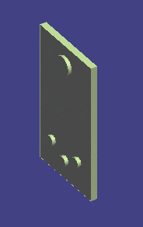

Band Size for Band Joint Type (U Type)

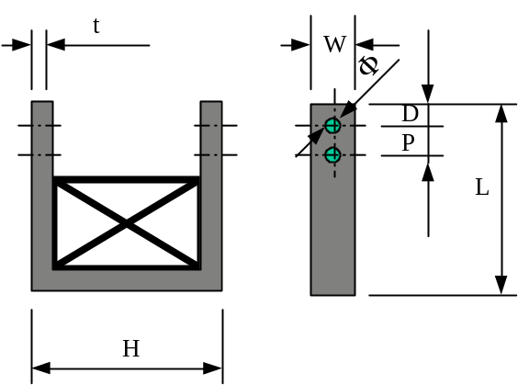
H = Width of duct + 2 + 2*t
L = Depth of duct + 2 + 90 + t

Angle Size | P | D | W | t | Φ
30x30x3T | 40 | 20 | 30 | 3.2 | 12
40x40x5T | 40 | 20 | 40 | 3.2 | 12
50x50x6T | 40 | 20 | 50 | 3.2 | 12
65x65x6T | 40 | 20 | 65 | 3.2 | 12
75x75x9T | 40 | 20 | 75 | 3.2 | 12

Inputs
Part
P
D
W
t
Pie
Width
Depth
AddLength
HorizontalSpacing
VerticalSpacing

The DuctWidth and DuctDepth are occurrence attributes for the symbol.

Outputs
BandJoint
Bolt1
Bolt2
Bolt3
Bolt4
BandTop

Implementation
- Create the complex string in the following way.
Dim dblPoints(1 To 27) As Double
Dim numOfPoints As Double
numOfPoints = 9

' point 1
dblPoints(1) = (dblDuctWidth / 2 + dblHorizontalSpacing)
dblPoints(2) = (dblDuctDepth / 2 + dblAddLength)
dblPoints(3) = 0#

' point 2
dblPoints(4) = (dblDuctWidth / 2 + dblHorizontalSpacing + dblt)
dblPoints(5) = (dblDuctDepth / 2 + dblAddLength)
dblPoints(6) = 0#

' point 3
dblPoints(7) = dblPoints(4)
dblPoints(8) = -(dblDuctDepth / 2 + dblVerticalSpacing + dblt)
dblPoints(9) = 0#

' point 4
dblPoints(10) = -dblPoints(7)
dblPoints(11) = dblPoints(8)
dblPoints(12) = 0#

' point 5
dblPoints(13) = -dblPoints(4)
dblPoints(14) = dblPoints(5)
dblPoints(15) = 0#

' point 6
dblPoints(16) = -dblPoints(1)
dblPoints(17) = dblPoints(2)
dblPoints(18) = 0#

' point 7
dblPoints(19) = -(dblDuctWidth / 2 + dblHorizontalSpacing)
dblPoints(20) = -(dblDuctDepth / 2 + dblVerticalSpacing)
dblPoints(21) = 0#

' point 8
dblPoints(22) = -dblPoints(19)
dblPoints(23) = dblPoints(20)
dblPoints(24) = 0#

' point 9
dblPoints(25) = dblPoints(1)
dblPoints(26) = dblPoints(2)
dblPoints(27) = 0#

Dim oGeomFactory As New GeometryFactory
Dim oProjection As Projection3d
Dim oCSgeometry As Object

' create the cross section
Set oCSgeometry = oGeomFactory.LineStrings3d.CreateByPoints(Nothing, numOfPoints, dblPoints)

- Project the cross section along the Z-axis for the length W and add it as output.
Set oProjection = oGeomFactory.Projections3d.CreateByCurve(m_outputColl.ResourceManager, _
oCSgeometry, 0, 0, 1, dblW, True)
m_outputColl.AddOutput OUTPUT_1, oProjection

- Create the first bolt and add it as output
Dim BoltOrgX As Double, BoltOrgY As Double, BoltOrgZ As Double
BoltOrgX = dblPoints(4) + dblHorizontalSpacing
BoltOrgY = dblPoints(5) - (dblD + dblPie / 2)
BoltOrgZ = dblW / 2
CreateBolt BoltOrgX, BoltOrgY, BoltOrgZ, dblPie / 2, dblt + 2 * dblHorizontalSpacing, OUTPUT_2

- Create the second bolt and add it as output
BoltOrgY = BoltOrgY - dblP
CreateBolt BoltOrgX, BoltOrgY, BoltOrgZ, dblPie / 2, dblt + 2 * dblHorizontalSpacing, OUTPUT_3

- Create the third bolt and add it as output
BoltOrgX = dblPoints(16) + dblHorizontalSpacing
BoltOrgY = dblPoints(17) - (dblD + dblPie / 2)
CreateBolt BoltOrgX, BoltOrgY, BoltOrgZ, dblPie / 2, dblt + 2 * dblHorizontalSpacing, OUTPUT_4

- Create the fourth bolt and add it as output
BoltOrgY = BoltOrgY - dblP
CreateBolt BoltOrgX, BoltOrgY, BoltOrgZ, dblPie / 2, dblt + 2 * dblHorizontalSpacing, OUTPUT_5

- Create the hanger port at the top and add it as output.
Set oHgrPort = oPortFac.CreateHgrPortEntity(m_outputColl.ResourceManager)
oHgrPort.Type = SupportedMemberPort
oHgrPort.Name = "BandTop"
oHgrPort.PutOrientation 0, dblPoints(17), 0, _
0, 0, 1, _
0, 1, 0
m_outputColl.AddOutput OUTPUT_6, oHgrPort

