SYMBOL CREATION.DOC
GUSSETED VERTICAL PIPE SUPPORT
Status: None

Revision: 0.1
Revision date: October 31, 2001
Author: Hanger-Team

Table of Contents
1 Revision History 3
2 Introduction 4
3 Support Type 4
3.1 Support Breakdown 5
3.2 Support Display 5
4 Symbols 6
4.1 Symbol Inputs 6
4.1.1 Inputs for Gusseted Support 7
4.2 Symbol Outputs 9
4.2.1 Outputs 9
4.3 Implementation 9

Revision History

Rev | Status | Author | Date | Reason
0.1 | Draft | CarolineNathan | Oct 31, 2001 | Initial draft

The purpose of this section is to provide revision and approval history for this document.
Rev - The initial revision shall be marked 0.1. Subsequent releases before approval shall increment the value to the right of the decimal point. (Ex. 0.1, 0.2, 0.3) Once all members have approved the document the value to the left of the decimal point shall be incremented. Ex. 1.0. Subsequent releases developed and distributed for comments after approval shall increment the value to the right of the decimal point. (Ex. 1.1, 1.2, 1.3)
Status - The status shall be “Draft” or “Appr” (“Appr” stands for “approved”).
Author – Initials of person making the change
Date - The date that the revision was distributed.
Reason - The purpose for the revision.

Introduction
This document describes the process involved in the creation of Gusseted Vertical Pipe Support.

Support Type
There are different types of support for different routing object. The support types listed in this section are related for piping. Based on the use case documents available, the support types are categorizes as
- Hanger Assembly
- Base Support
- Dummy Leg
- Structural
- Shoes
- Clamps
- Miscellaneous (Bumpers and Guides)

All the support types except “Structural” types are applicable for single pipes. The structural type of support can be applied for one or more pipes.

Support Type | Examples
Hangers | 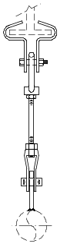 | 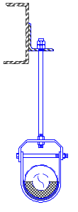
Base Supports | 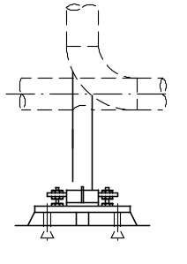 | 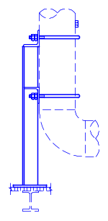
Dummy Legs | 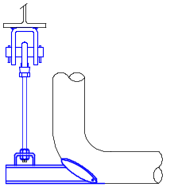 | 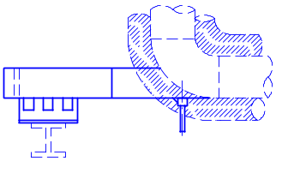
Structural | 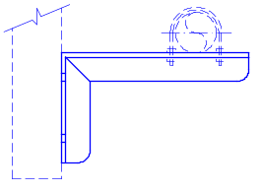 | 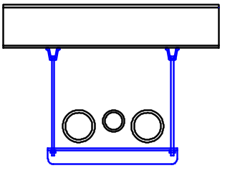
Shoes | 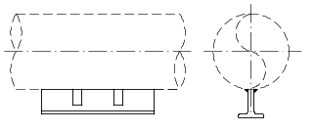 | 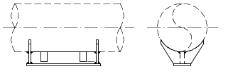
Clamps | 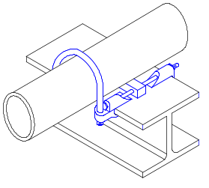 | 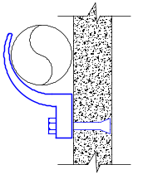
Bumpers | 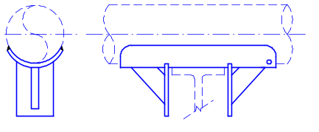 | 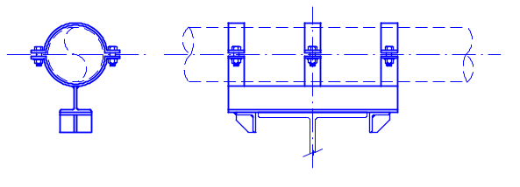

Support Breakdown

Support Display
The support’s geometric configuration is described with symbols. The symbols can be chosen by the designer or by a set of rules.
In order to display the support object in the graphic view the support must first assemble all the symbols that represent the entire support. The end-user has to create the symbols that represent the atomic parts of the support. It is end-users choice to represent the symbol with whatever details that he wants to see.
The logical break down of the part depends on parts that are available in the market. The decision of making the logical breakdown of the parts is left to the user.
There are two approaches that the user can take. It is left to the users decision to select the approach that is suits.
First, the entire support can be treated as one segment having only one part.
Second, the support can be divided as segments, and segments divided as parts.
The user can take either of the approaches depending on how much accurate the symbols should be oriented.
Entire Support as one symbol
Assembly approach
Support Graphics

If the user has to write the code for the symbol, the code for writing a single symbol for entire assembly, will be difficult compared to writing code for symbols that represent the atomic parts. The difficult will be in evaluating the flexible distances, angles etc.
The symbol will have to support different aspects to show different kinds of details for different representations. This is applicable for both the approaches being discussed above.
Though the support is an assembly of symbols, the end user will not be able to locate any of the individual symbols of the support. The entire support assembly is a group and is located as a single object; support object.

Symbols
The graphical representation of each of a support is accomplished through symbols. Primary tasks in the creation of a VB symbol definition involve specification of symbol inputs and outputs. The symbols created for the support application should support the simple physical, and detailed representation of the symbol. The representation are nothing but the aspects of the symbol.
Symbols vary in detail depending upon the aspect that is selected on the view. The simple aspect will have wire frame symbols while symbols in the detail aspect will approach the 3D detail shown in the online Pipe Supports Catalog, www.pipingtech.com, from Piping Technology and Products, Inc. (PT&P). Support types requiring symbols are listed under Catalog Entries in this document.

Symbol Inputs
The fundamental inputs to any support component symbol include:
- The routing object (e.g. pipe, duct, cable tray, etc.)
- The supporting object (e.g. beam, plate, floor, etc.)
- The attributes of the symbol’s related part in the Catalog Data.
Each symbol should incorporate logic to parametrically model the available sizes of a component. Specifications found within the use cases demonstrate the input parameters required to describe the geometry of a given category of components. Examples of such specifications are shown below.

Inputs for Gusseted Support
- Pipe Radius .
- Theta
- PadThickness
- Total Plate length( “A “ obtained from the fig comes from the catalog)
- PlateWidth
- PlateThickness
- Webwidth
- WebThickness
Additional Inputs
- WeepHole in Pad
- 22 dia Hole on Plate Center and at Pad Junction
- One at Plate end
The Additional Inputs are only needed if we need to create a WeepHole in the pad and Holes in the Pad and Plate for bolts.

Description of the Inputs

- PartSelection
“A”( shown in below Fig) value comes from the catalog. From which you will be able to determine the Plate length. Basically PlateLength=A-radius of Pipe – Pad Thickness + Distance from the center of the hole( approx half of Pipe Radius)

- Construction Inputs

Considering the inputs as the ones that are required in general to Create this Symbol.
Pipe Radius
Pad Thickness
Theta to create the Pad
Plate Length
Plate Width
Plate Thickness
Distance from the Top Edge of the pad (Theta-input angle)
Web Thickness
Web width
Distance from the Bottom edge of the pad (Theta-input angle)

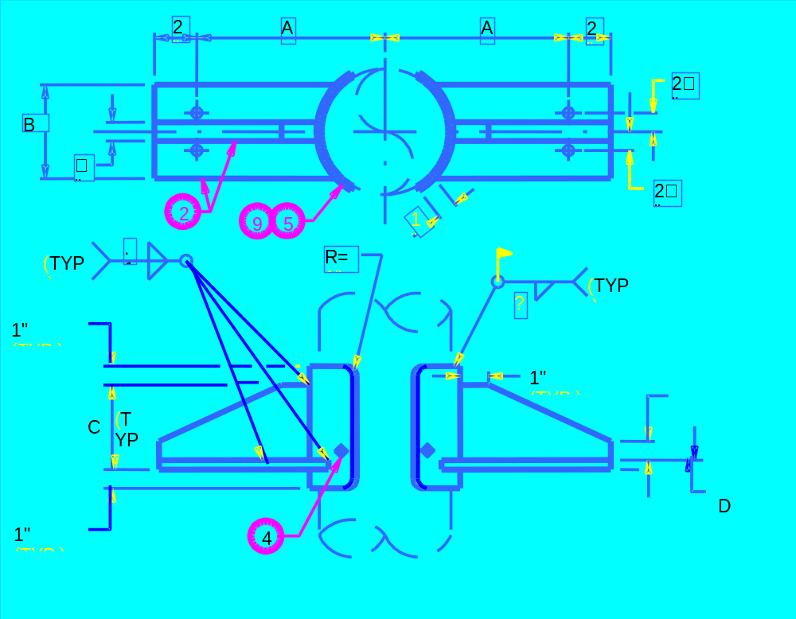

PIPE SIZE | A | B | C | D | MAX ALLOWABLE LOAD
8” | 170 + Insulation Thickness (ie 6 mm) | PlateWidth | WebWidth | PlateThickness | 23.1

Symbol Outputs
SP3D symbol architecture allows the definition of multiple representations (i.e. graphic aspects) for a symbol definition. Each representation is described as a hierarchy of outputs. Support component symbols will have three representations:
- Simple Physical: Provides enough detail to distinguish the support type. The graphics of the support in this representation can be represented by wire frame.
- Detailed Physical: Provides detailed graphics to distinguish the support type and suffice for clash detection.
- Maintenance: Depicts any maintenance aspects related to the part. For example additional space might be indicated to allow access to service panels.
All representations will output a collection of graphics (i.e. G-Types). In additions to graphics, each symbol must output an appropriate set of ports.
- Each support will be represented by a collection of symbols. These symbols corresponding to the individual components of the support assembly. Each component of the assembly will output ports indicative of its role within the assembly. These ports will expose the location where individual components of the assembly can be connected and aid in placement of the symbol occurrence.

Outputs
- Pad
- Plate
- Web
- PipePort
- StructurePort

Implementation
This Gusset Vertical Support has only Detail Physical Representation.
This Support Symbol consists of three parts. The Pad, Plate and Web.

Construction of the Pad:
The Pad surrounds the pipe. They are the same material and thickness as the pipe but with a minimum thickness as 6mm.
The Pad Consists of four Individual Elements ( 2 arcs and 2 lines joining them) and the collection is made as a complexString. This resulting one is projected along the Plate Thickness.
The Theta required to create the Pad has been assumed to be 60°. The Plate Which surrounds the Pad has an input angle (60-θ). The θ is required to produce the distance the Plate away from the Pad.( Refer Fig).
The Plate which lies in the bottom has four individual Elements. It is basically a rectangle and it also made as a complex string and Projected along the PlateThickness.
The Platelength required to construct the plate is calculated from the Value “A” obtained from the catalog.(Refer Diagram).
The Web rests on the Plate is created as a lineString ( which means continuous stream of input points). This is projected along the WebThickness.
Finally the Symbol need to have Output Ports. This Symbol has 2 output Ports.

.
