PAD SYMBOL CREATION.DOC
TRIANGLE, CIRCLE AND RECTANGLE PADS
Status: None
Revision: 0.1
Revision date: January 18, 2002
Author: Caroline Nathan

Table of Contents
1 Revision History 3
2 Symbols For Pads 4
Inputs for Triangular Pad 5
Outputs 5
Inputs for Circular Pad 5
Outputs 5
Inputs for Rectangular Pad 6
Outputs 6
Implementation 6

Revision History

Rev | Status | Author | Date | Reason
0.1 | Draft | Hanger-Team | Jan22, 2002 | Initial draft

The purpose of this section is to provide revision and approval history for this document.
Rev - The initial revision shall be marked 0.1. Subsequent releases before approval shall increment the value to the right of the decimal point. (Ex. 0.1, 0.2, 0.3) Once all members have approved the document the value to the left of the decimal point shall be incremented. Ex. 1.0. Subsequent releases developed and distributed for comments after approval shall increment the value to the right of the decimal point. (Ex. 1.1, 1.2, 1.3)
Status - The status shall be “Draft” or “Appr” (“Appr” stands for “approved”).
Author – Initials of person making the change
Date - The date that the revision was distributed.
Reason - The purpose for the revision.

Symbols For Pads
Method of determining PAD Size for Pipe and HAVC duct
Determination the PAD size by the angle size of the Hanger/support to be attached
- 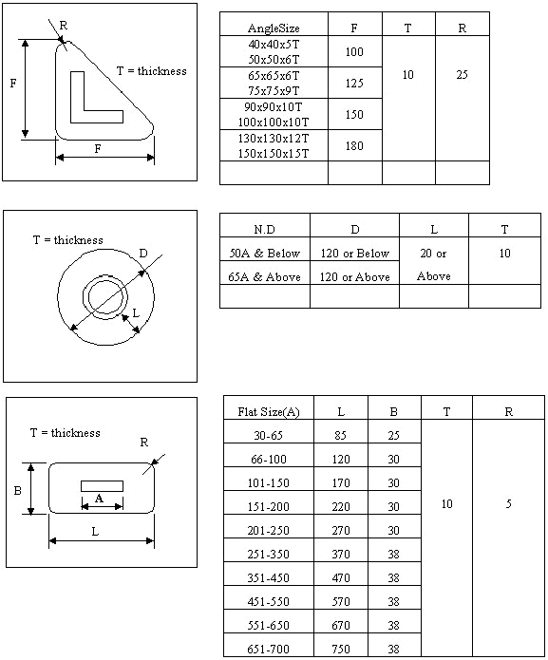
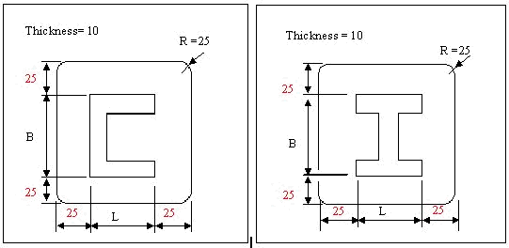

Inputs for Triangular Pad
- Base
- Height
- Radius (R)
- Thickness

Outputs
- Triangle
- HgrPort_1
- HgrPort_2
Note: Inputs Base and Height are required to construct the Triangle.

Inputs for Circular Pad
- Nominal Diameter
- Diameter
- Width (L)
- Thickness

Outputs
- Circle
- HgrPort_1
- HgrPort_2

Note: The Diameter of the Circular Pad depends on the Nominal Diameter of the Pipe and the Width of the Pad.

Inputs for Rectangular Pad
- Length (L)
- Breadth (B)
- Radius (R)
- Thickness (T)

Outputs
- Rectangle
- HgrPort_1
- HgrPort_2

Implementation
All the Pads have only Detail Physical Representation.

Construction of the Pads
Origin located at the Center of the Pads
The Pads constructed on the X-Y Plane and Projected along the Thickness in the Z-Direction.

Ports of Triangular Pad
This Symbol has 2 output Ports. One Port is located on the Center of the Pad, the centroid of the triangle. The Coordinates are (base / 3,height / 3,0)
The Second Port is located on the same X & Y Coordinates as Port1 at a Distance “Thickness” in the Z-direction. The Coordinates are (base / 3,height / 3,Thickness)

Ports of Circular Pad
This Symbol has 2 output Ports. One Port is located on the Center of the Circle. The Coordinates are (0,0,0)
The Second Port is located on the same X & Y Coordinates as Port1 at a Distance “Thickness” in the Z-direction. The Coordinates are (0,0,Thickness)

Ports of Rectangular Pad
This Symbol has 2 output Ports. One Port is located on the Center of the Pad, the centroid of the Rectangle. The Coordinates are (Length / 2,Breadth / 2,0)
The Second Port is located on the same X & Y Coordinates as Port1 at a Distance “Thickness” in the Z-direction. The Coordinates are (Length / 2,Breadth / 2,Thickness)
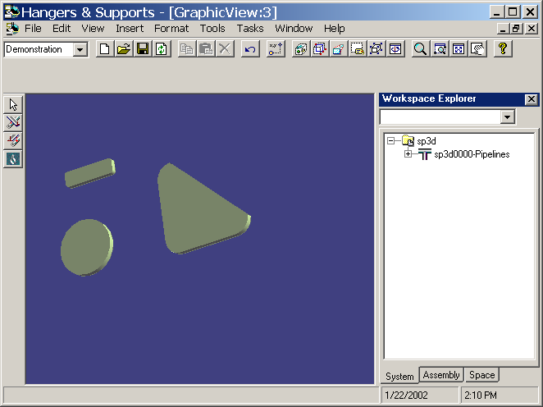

Method of attaching PAD of the Hanger/support
- If the thickness of the Hull Structure (Deck, Wall) or Steel Plate is 16mm and below and Pipe size is 100A and above, the PAD should be attached automatically.
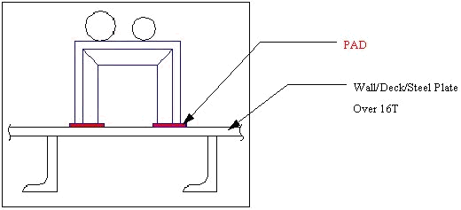
¡¡
But, the PAD does not need to attach in case of following.
There is a profile at the other side of Hull Structure (Deck, Wall) or Steel Plate attaching the support.
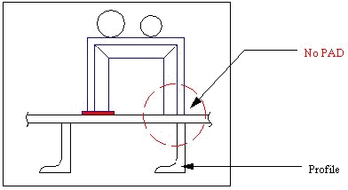
¡¡
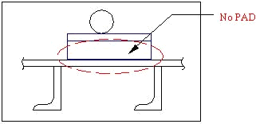
¡¡
All accommodation Area does not need to attach PAD.

