Mfg Service Manager Rules

ServiceManagerRules.doc
Status: Draft
Author: StructMfg-Team


SM3D Concept Design Document.
March 19, 2013
© 2009 Intergraph Corporation. All rights reserved.
The content of this document is proprietary work of Intergraph Corporation, or relevant third parties, and is protected by copyright law and international treaty. Any use, duplication, distriBuilt-Uption or disclosure of such, other than as specified herein, is unauthorized and in violation of applicable copyright law and international treaty. All rights in content or materials bearing copyright notice or other attriBuilt-Uption of third party rights are reserved to the relevant third party. United States Government license rights are limited to those mandatory rights identified in DFARS 252.227-7015(b).
Intergraph may make improvements and/or changes in the products and/or the programs described in this publication at any time without notice.
Any content or materials supplied hereunder are provided "as is," without warranty of any kind, either expressed or implied, including, Built-Upt not limited to, any implied warranties of merchantability, fitness for a particular purpose, or against infringement. In no event shall Intergraph be liable for any damages arising out of, or in connection with the downloading, viewing, use, duplication, distriBuilt-Uption or disclosure of any content or material published by Intergraph, including Built-Upt not limited to any direct, indirect, incidental, special, punitive or consequential damages, or loss or corruption of data.
Some jurisdictions do not allow the exclusions or limitations set forth above, so the above may not apply to you. The exclusions or limitations shall apply in all jurisdictions to the maximum extent allowed by law.

Intergraph Corporation
170 Graphics Drive
Madison, AL 35758
Phone: +1.256.730.2000
Toll Free USA: +1.800.345.4856
Fax: +256.730.2048

Contents
Introduction 2
References 2
Definitions 2
Revisions 2
Release V2013 2
Rules Overview 3
Rule Methods 3
• GetMfgCustomInputSettings 3
• GetMfgCustomDependencyCollection 3
Pre-Defined Enumerators (for Custom Inputs) 5
System Inputs 6
Delivered Rules 7
Rule Implementation 8

Revision # | Date Revised | Revised By | Description
0.1 | 2013-Mar-19 | Nautilus-Team | Initial Version.

Introduction
This document describes the Manufacturing Service Manager rules. It explains the rule API, its working and the presently delivered rules.

References

Definitions
StructMfgSettings.xls | A delivered spreadsheet, which the user can bulk-load to the catalog to set a different service manager rule as the default rule.

Revisions

Release V2013
- Initial version.

Rules Overview
Service Manager Rules provide additional objects that need to be considered as inputs to the MFG Object apart from the standard inputs (also called system inputs).
For example, when a Plate Part that has an opening is manufactured, the Manufacturing Plate object does not consider the opening as an input by default. However, if the user wants the Manufacturing Plate to be reported as out-of-date when Opening is modified, then the user can add the Opening as custom input using these Rules.

Rule Methods
The Rule has to implement the interface IJDMfgServiceMgrCustomInputs which has the following methods

GetMfgCustomInputSettings

GetMfgCustomDependencyCollection

GetMfgCustomInputSettings

Signature
Private Sub IJDMfgServiceMgrCustomInputs_GetMfgCustomInputSettings(lMarkingLine As Long, lMargin As Long, lPartShrinkage As Long, lAssemblyPartShrinkage As Long, lAssemblyShrinkage As Long, lTemplate As Long, lPinJig As Long, lMfgPlate As Long, lMfgProfile As Long)
- This API can be used to set the list of objects to be considered as custom inputs.
- This is done by providing a combination of pre-defined enumerators for each type of manufacturing object.
- The pre- defined enumerators that can be used as inputs are explained below.

Inputs/Outputs
lMarkingLine – To propose the custom inputs for marking lines.
lMargin – To propose the custom inputs for margin objects.
lPartShrinkage – to propose the custom inputs for shrinkages of mode – Part-Private.
lAssemblyPartShrinkage – to propose the custom inputs for shrinkages of mode – Part-Assembly based.
lAssemblyShrinkage – to propose the custom inputs for shrinkages of mode – Assembly.
lTemplate – to propose the custom inputs for templates.
lPinJig – to propose the custom inputs for pinjigs.
lMfgPlate – to propose the custom inputs for manufacturing plates.
lMfgProfile – to propose the custom inputs for manufacturing profiles.

GetMfgCustomDependencyCollection

Signature
Private Function IJDMfgServiceMgrCustomInputs_GetMfgCustomDependencyCollection(ByVal oMfgObject As Object) As IMSCoreCollections.IJElements
- Any additional objects not available with pre-defined enumerators can be provided as custom inputs.

Inputs/Outputs
oMfgObject – The object whose status is being checked
GetMfgCustomDependencyCollection – Collection of additional objects

Pre-Defined Enumerators (for Custom Inputs)
The following table gives a list of pre-defined enumerators and the custom inputs that are used when the enumerator is used.

Enumerator | Custom Inputs | Applicable for
StructMfgServiceMgr_NoCustomInputs | No custom inputs | All
StructMfgServiceMgr_CustomRule | Calls GetMfgCustomDependencyCollection | All
StructMfgServiceMgr_PartProdRouting | Production Routing | Mfg Plate, Mfg Profile
StructMfgServiceMgr_PartParentAssembly | Parent assembly of the parent part | PinJig, Mfg Plate, Mfg Profile
StructMfgServiceMgr_PartCommonPart | Common Part Group | Mfg Plate, Mfg Profile
StructMfgServiceMgr_PartKnuckles | Profile Knuckle lines | Mfg Profile
StructMfgServiceMgr_PartFeatures | Features on the part | Mfg Plate, Mfg Profile
StructMfgServiceMgr_PartOpenings | Openings on the part | Mfg Plate, Mfg Profile
StructMfgServiceMgr_AllAssemblyShrinkages | Assembly shrinkages of all parent assemblies in the assembly hierarchy | Part-Assembly based shrinkages
StructMfgServiceMgr_AssemblyBasePlate | Base plate of the assembly | Assembly shrinkages
StructMfgServiceMgr_BasePlateStiffeners | Stiffeners on the plate or stiffeners on the base plate if assembly is given | Part-Assembly based shrinkages, Assembly shrinkages
StructMfgServiceMgr_BUAssemblyPCs | Physical connections between web and flange plate of Built-Up assemblies | Assembly shrinkages if assembly is of type Built-Up profile or Built-Up member

System Inputs
These are default inputs of the manufacturing object. System inputs are generally those objects that directly modify the selected object.

Manufacturing Object | System Dependencies
Marking Line | Plate Part/Profile Part  Boundaries  Intersecting Frame (If marking by intersection)  Sketching Plane (if marking by projection)
Shrinkage | Plate Part/Profile Part/Assembly  Axes, if shrinkage is of type 'Global Shrinkage'.  Ports, if shrinkage is of type 'Scaling By Edge'
Pin Jig | Supported Plate Parts  Assembly (if Assembly PinJig)  Markings, Margins, Shrinkages  Frame System
Template | Plate Part/Profile Part  Frame System
Manufacturing Plate | Plate Part  Physical Connection collection  Free edge treatments  Marking, Margin, Shrinkage  Frame System
Manufacturing Profile | Profile Part  Physical Connection collection  Free edge treatments  Marking, Margin, Shrinkage  Frame System

Delivered Rules
As part of the delivery of the system, we will be delivering a set of rules, which can reflect different customer expectations. We came with the following list.
Rule | Custom Inputs
No custom | No inputs
CustomInputs | Default + Opening + Features
CustomPlanning | Default + Common Parts + Product Routing are considered
CustomPlnAssembly | Default + Common Parts + Product Routing + Assembly are considered
CustomPlnMfg | Default + Common Parts + Product Routing + Assembly + Assembly Shrinkage are considered

Within an overview between the rule and the manufacturing object, this will have the following impact:
Mfg Object | No Custom | CustomInputs | CustomPlanning | CustomPlnAssembly | CustomPlnAssembly
Marking | System | System | System | System | System
Margin | - | System | System | System | System
Part-Private Shrinkage | System | System | System | System | System
Part-Assembly Based Shrinkage | System | System | System | System | System  Assembly Shrinkages
Assembly Shrinkage | System | System | System | System | System
PinJIg | System | System | System | System  Assembly | System
Template | System | System | System | System | System
Mfg Plate | System | System  Part Opening  Part Features | System  Part Opening  Part Feature  Common Parts  Production Routing | System  Part Opening  Part Feature  Common Parts  Production Routing  Assembly | System  Part Opening  Part Feature  Common Parts  Production Routing  Assembly
Mfg Profile | System | System  Part Opening  Part Features | System  Part Opening  Part Feature  Common Parts  Production Routing | System  Part Opening  Part Feature  Common Parts  Production Routing  Assembly | System  Part Opening  Part Feature  Common Parts  Production Routing  Assembly

The user will have the ability to change the rule that is to be used by the changing the progid in the MfgServiceManager worksheet in the StructMfgSettings excel workbook.
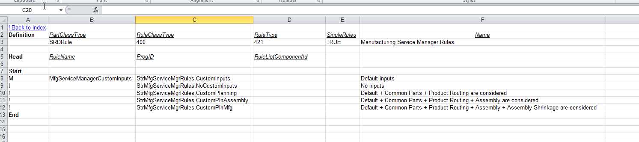
Copy the required progid into the first row (replace StrMfgServiceMgrRules.CustomInputs above) and bulk-load in AMD mode.

Rule Implementation

NoCustomInputs Rule
This Rule proposes no additional custom inputs for any Manufacturing Object. See below for sample code.
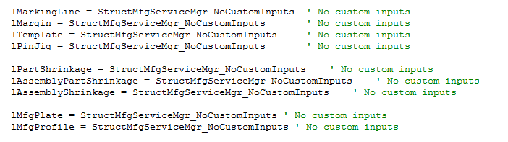

CustomInputs Rule
This Rule provides additional custom inputs for MFG Plate and MFG Profile objects with Opening objects and Feature objects. See below for sample code.
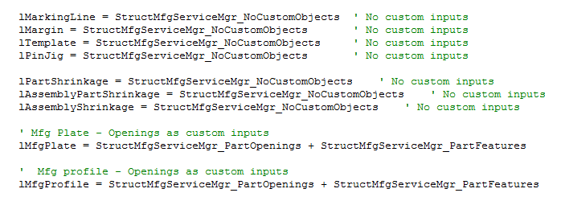

CustomPlanning Rule
This Rule provides additional custom inputs for MFG Plate and MFG Profile objects with Opening, Features, Production Routing and Common Part Group. See below for sample code.
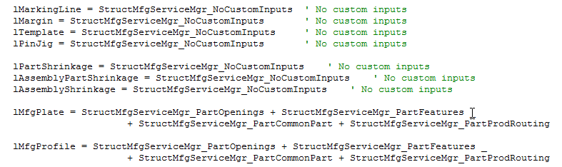

CustomPlnAssembly
This Rule provides additional custom inputs for MFG Plate and MFG Profile objects with Opening, Features, Production Routing, Common Part Group and Parent Assembly. It also proposes Parent Assembly for PinJig. See below for sample code.
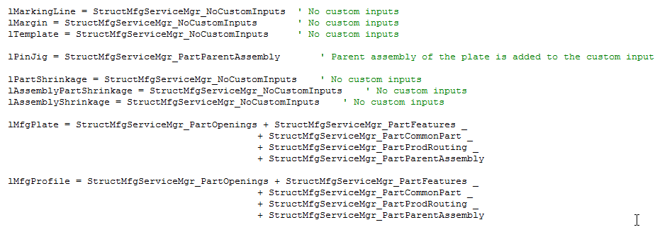

CustomPlnMfg
This Rule provides additional custom inputs for MFG Plate and MFG Profile objects with Opening, Features, Production Routing, Common Part Group and Parent Assembly. It also proposes Parent Assembly Shrinkages for part-assembly based shrinkages. See below for sample code.
