Assembly Shrinkage Rules

AssemblyShrinkageRule.doc
Status: Draft
Author: StructMfg-Team


Sm3D Concept Design Document.
June 12, 2012
© 2009 Intergraph Corporation. All rights reserved.
The content of this document is proprietary work of Intergraph Corporation, or relevant third parties, and is protected by copyright law and international treaty. Any use, duplication, distriBuilt-Uption or disclosure of such, other than as specified herein, is unauthorized and in violation of applicable copyright law and international treaty. All rights in content or materials bearing copyright notice or other attriBuilt-Uption of third party rights are reserved to the relevant third party. United States Government license rights are limited to those mandatory rights identified in DFARS 252.227-7015(b).
Intergraph may make improvements and/or changes in the products and/or the programs described in this publication at any time without notice.
Any content or materials supplied hereunder are provided "as is," without warranty of any kind, either expressed or implied, including, Built-Upt not limited to, any implied warranties of merchantability, fitness for a particular purpose, or against infringement. In no event shall Intergraph be liable for any damages arising out of, or in connection with the downloading, viewing, use, duplication, distriBuilt-Uption or disclosure of any content or material published by Intergraph, including Built-Upt not limited to any direct, indirect, incidental, special, punitive or consequential damages, or loss or corruption of data.
Some jurisdictions do not allow the exclusions or limitations set forth above, so the above may not apply to you. The exclusions or limitations shall apply in all jurisdictions to the maximum extent allowed by law.

Intergraph Corporation
170 Graphics Drive
Madison, AL 35758
Phone: +1.256.730.2000
Toll Free USA: +1.800.345.4856
Fax: +256.730.2048

Contents
Introduction 3
References 3
Definitions 3
Revisions 3
Release V2013 3
Rules Overview 4
Shrinkage Factor Rules 4
MFG Plate/Profile Process Rules 7
Usage 8
Factor Rule Details 9
Factor Rule API 9
Assembly Factor Rules - General 9
Sub Block Factor Rule 12
Pre-Sub Block Rule 14
Panel Assembly Rule 16
Assembly Rule 18
Built Up Profile Assembly Rule 20
Built Up Standard Member Assembly 22
Built Up Custom Member Assembly 24
Part – Assembly Based Shrinkage Rules 26
Part – Assembly Based Rule – By Edge 28
Part – Private Shrinkage Rules 29
MFG Plate Shrinkage Process Rules 29
Overview 29
Example Code 30
Signature 30
Rule Logic 30
UpdateScalingShrinkage API 31
MFG Service Manager – Custom Inputs 31
Old API 31
New API 31
Shrinkage Rules Logging 32
ManufacturingErrorLogEnable 33
Assembly Shrinkage Rule Log 34
Part-Assembly Based Shrinkage Rule Log 35
Helper Methods 37

Revision # | Date Revised | Revised By | Description
0.1 | 2012-Jun-07 | Nautilus-Team | Initial Version.
0.2 | 2013-Feb-08 | Nautilus-Team | Change in shrinkage mode names

Introduction
This document describes several Shrinkage Rules which can be applied to the different modes of the Shrinkage - Assembly, Part-Assembly based and Part-Private.

References

Definitions
MfgShrinkageService.xls | A delivered spreadsheet, which the user can bulk-load in the catalog to set the shrinkage value for the different type of shrinkage.

Revisions

Release V2013
- Initial version.

Rules Overview

Shrinkage Factor Rules

Introduction
There are three sets of Rules for three different modes of Shrinkage. These rules propose Directions and Factors to be applied on Shrinkage

- Assembly Shrinkage Rules
  - These rules propose values for Shrinkages to be applied on Assemblies.
  - They use the Assembly properties like Type and Work Center, Base Plate of the Assembly and Welding Type used in the Assembly as inputs to propose Shrinkage Factors along with Directions.
  - They use Service Tables to propose the outputs based on inputs.
- Part – Assembly Based Shrinkage Rules
  - These rules propose values for Shrinkages to be applied on Parts based on Assembly Shrinkages.
  - They use the Shrinkages from the parent Assemblies to propose values.
- Part – Private Shrinkage Rules
  - These rules used to propose values for Shrinkages to be applied on Parts.
  - Part – Private shrinkage is the existing mode of shrinkage (previously known as part shrinkage) and the rules are the existing rules for simple shrinkage.

Service Table
- Factor Rules use Service Tables to propose the data (Directions and Factors) to be applied on Shrinkage.
- Service Tables are designed based on MfgServiceTableClass part class where some attributes act as inputs and some attributes act as output and Parts act as different possibilities of inputs and outputs.
- A Service Table is designed for each type of Assembly.
- Assembly Factor Rules and Part-Private Factor rules have Service Table for each of them
- The Factor Rule follows the below steps:
  - Gets the inputs based on Assembly/Part (Ex: Assembly Type, Base Plate thickness etc...)
  - Queries the Service Table to see which Part (Row) matches the given inputs
  - Get the outputs of the row and return

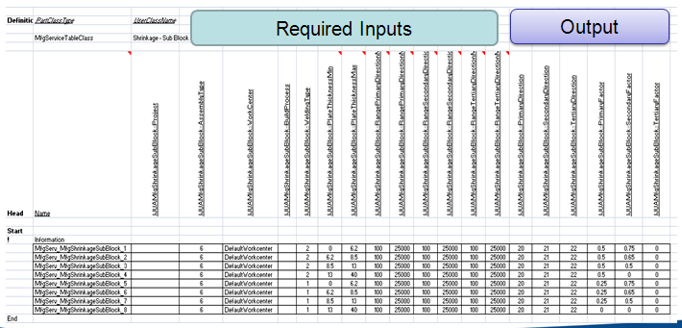

Catalog Changes
- The Factor Rules are listed in Catalog in the sheet "ScalingShrinkage" at below workbook.
\ShipCatalogData\BulkLoad\DataFiles\StructManufacturing\StructMfgSettings.xls
- All those between 1 to 50 will be used by Part-Private mode of Shrinkage
- All those between 51 to 100 will be used by Part-Assembly Based mode of Shrinkage
- All those between 101 to 150 will be used by Assembly mode of Shrinkage
- RuleListComponent ID is unique for each Rule and will be persisted with the Shrinkage.
- User can add more Rules with bulk-load process and use.
- When Rule logic is modified, user will need to recompute the Shrinkages
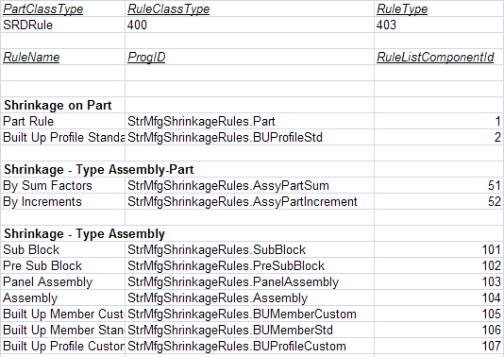
- Service Tables are listed in the following workbook (Added new)
  - \ShipCatalogData\BulkLoad\DataFiles\StructManufacturing\StructMfgServiceTables_Shrinkage.xls
- Associated Codelist are added to the below workbook
  - \ShipCatalogData\BulkLoad\DataFiles\StructManufacturing\AllStructMfgCodeLists.xls
  - The sheets (codelists) are SMShrinkageDirectionType and SMShrinkageWeldingType

Usage
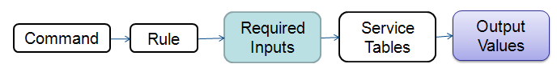
- Shrinkage Commands show these set of Rules under Factor pull-down on the Ribbon Bar as per the Mode
- User will select the desired Factor Rule to be used.
- Upon selection of Object (Plate/Assembly), commands will run these rules. These Rules return the Shrinkage Type, Axes/Ports (as Primary, Secondary Directions) and Shrinkage Factors that will be displayed.
- Upon Finish, Shrinkage Command will create Shrinkage Object on the Assembly/Plate with above values.
- Also, the Rule ID is stored with the Shrinkage object so that it can be recomputed whenever needed.

MFG Plate/Profile Process Rules

Introduction
Existing MFG Plate/Profile Process Attribute for Shrinkage has been extended to allow creating any of the ‘Part-Assembly based’, ‘Part-Private’ or both Shrinkages along with MFG Plate creation.
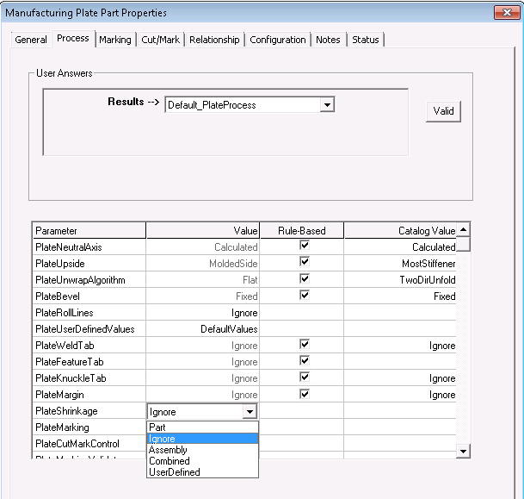
- Plate Shrinkage property – Possible values are explained below
    - Part – Creates new Part-Private Shrinkage if not already exists. Makes this Shrinkage MFG Plate controlled as opposite to user defined Shrinkage.
    - Ignore - Does not create any Shrinkage. If already exists, delete that
    - Assembly – Creates Part-Assembly based Shrinkage if not already present. OOB rule code applies 'By Sum' Factor rule on the created Shrinkage.
    - Combined – Creates both Part-Private & Part-Assembly based Shrinkages if not already present.
    - User Defined – Makes existing MFG Plate controlled Shrinkage user defined.
- Profile Shrinkage properties
  - Similar to Plate.

Catalog Changes
Extended the sheet 'SMPlateProcessShirnkage' sheet at below workbook:
\BulkLoad\DataFiles\StructManufacturing\StrMfgPlateCodeLists.xls
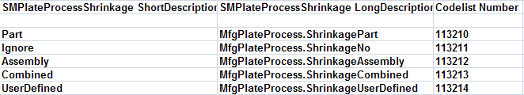
Extended the sheet 'SMProfileProcessShirnkage' sheet at below workbook:
\BulkLoad\DataFiles\StructManufacturing\StrMfgProfileCodeLists.xls
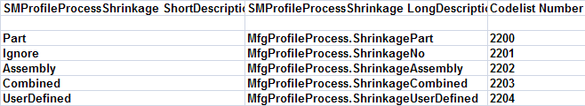

Usage
- When Plate is manufactured, user will review the PlateShrinkage property form Process Tab.
- User will pick the desired option
  - If Part-Assembly Based Shrinkage needs to be created, user can pick 'Assembly' as option.
- The default option for this attribute is 'Ignore'
  - User can customize the Process Parameter Rule so that 'Assembly' option as default, if required so.
- Possible work-flow:
  - Using Standard Shrinkage command, create Shrinkages on Assemblies.
  - With MFG Plate command, pick the 'Assembly' as the Shrinkage process option and apply
  - The Unfolding process triggers the Process Rule associate to Assembly, which is 'MFGPlateProcess.ShrinkageAssembly'
  - This Process Rule will create Shrinkage of mode Part-Assembly Based' and apply 'By Sum' as the Factor rule on it to get the data.
  - Unfolding Process, thus, applies this Shrinkage and adjusts the contour of the Plate accordingly
- Identical process is available for the Member & Profile Part

Factor Rule Details

Factor Rule API

Signature
Each Factor Rule implements below API
Private Sub IJDShrinkageRule_GetShrinkageParameters(ByVal pDispObj As Object, ShrinkageType As String, PrimaryAxis As Object, PrimaryFactor As Double, SecondaryAxis As Object, SecondaryFactor As Double, Optional TertiaryAxis As Object, Optional TertiaryFactor As Double)

Input
- pDispObj - The object on which the shrinkage is to be placed. For assembly shrinkages, the object is either an assembly or a block.

Outputs
- Shrinkage Type: Global Type or Scaling By Edge.
- Primary Axis: The axis or port representing the primary direction. Will be an axis if shrinkage type is Global and a port if the shrinkage type is Scaling By Edge.
- Secondary Axis: The axis or port representing the Secondary direction. Will be an axis if shrinkage type is Global and a port if the shrinkage type is Scaling By Edge.
- Tertiary Axis: The axis or port representing the Tertiary direction. Will be an axis if shrinkage type is Global and a port if the shrinkage type is Scaling By Edge. Optional as the tertiary direction can be calculated implicitly from the primary and secondary directions.
- Primary Factor: The shrinkage factor to be applied in the primary Direction.
- Secondary Factor: The shrinkage factor to be applied in the Secondary Direction.
- Tertiary Factor: The shrinkage factor to be applied in the Tertiary Direction. Optional since it is zero for shrinkages on parts.

Assembly Factor Rules - General

Algorithm
- From input assembly, get the assembly type. Assembly type can be retrieved as shown below.
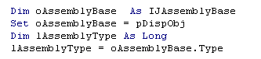

- Get the properties of the assembly and its children which need to be used in calculating the required outputs.
- In this case, Base Plate, its thickness, type are used. Following code can be used to retrieve the base plate of the assembly.
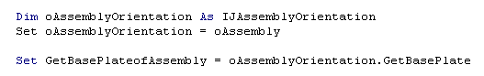

- If the base plate is not present, either the thinnest or the largest plate can be used for the same purpose. Following code can be used for the same.
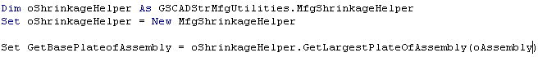

- Next step is to the thickness and type of the plate retrieved above.
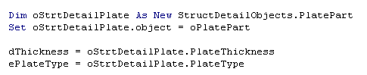

- We will also use the welding type as an input to calculate the outputs. To get the welding type used, we get the physical connections between the plate and one of the profiles.
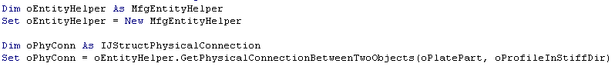

- On the physical connection, there is a property called ‘Single Sided’ which reflects the welding type used (Single or Double Sided).
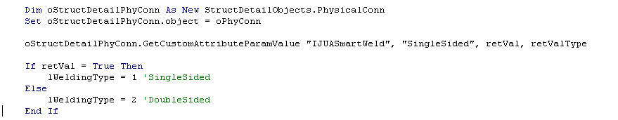
- Next step is to use these values to return the required outputs. For this step, we are using Service Tables. These tables contain a set of outputs for each set of inputs. Inputs can be any properties of the assembly or the base plate. In this simple case, we are using only welding type and base plate thickness as inputs.
- Service table returns all the required outputs – Primary Direction, Secondary Direction and the factors in the three directions.
- Primary (and Secondary) direction returned by the table will be codelist number which will be interpreted by the rule. Explained further below.
- In this case, the directions will be along the welding direction and normal to welding direction. To get the welding direction, we are using the count of stiffeners in each direction; the direction with maximum stiffeners is the welding direction.
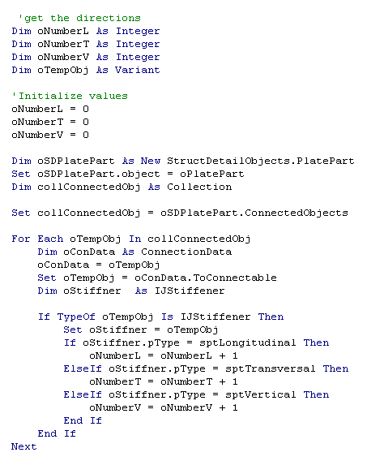

Query
- To retrieve the outputs from the service table, we write simple queries sending the inputs and getting the outputs as a collection. The query used in the case –
strQuery = "SELECT PrimaryDirection, SecondaryDirection, PrimaryFactor, SecondaryFactor, TertiaryFactor FROM JUAMfgShrinkageAssembly WHERE (WeldingType = " + CStr(lWeldingType) + ") AND (PlateThicknessMin <= " + CStr(dThickness) + ") AND (PlateThicknessMax > " + CStr(dThickness) + ")"

- The service table named JUAMfgShrinkageAssembly will be used.
- Let us assume, the welding type we retrieved is 2 (Double Sided) and thickness is 5mm.
- The table contains a column for welding type, minimum plate thickness and maximum plate thickness.
- The row matching the welding type and thickness i.e. welding type = 2 and plate thickness minimum is less than 5mm and plate thickness is more than 5mm is the required row.
- The row values related to Primary Direction, Secondary Direction, Primary Factor, Secondary Factor and Tertiary Factor are returned as a collection.
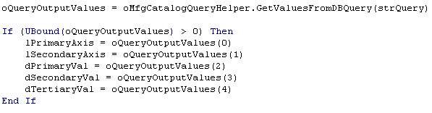
- The values returned by the table will be interpreted by the code and returned to the command.

Sub Block Factor Rule
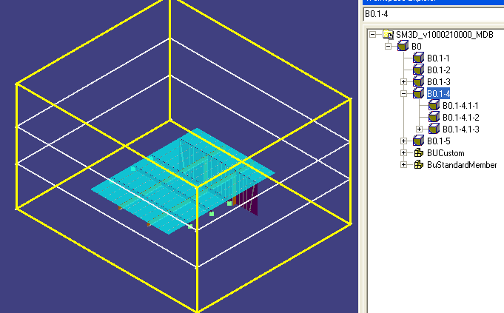

Green - Primary
White -Secondary
Blue - Tertiary
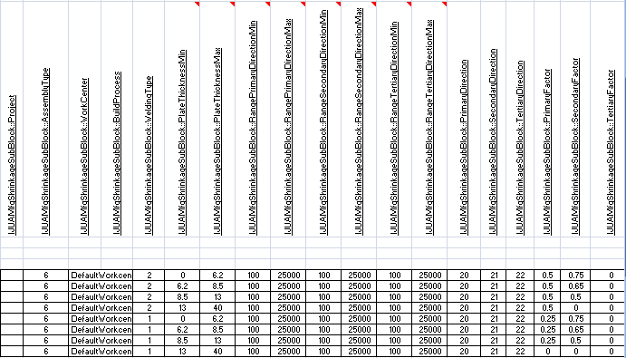

- Target Assembly: Assembly Type – "Sub Block"
- Service Table Inputs:
  - Project
    - For future use
  - Assembly Type
    - Sub Block --> 16
  - Work Center
    - Work Center of the Assembly
  - Build Process
    - For Future use
  - Welding Type
    - Get the Largest Plate in the SubBlock
    - Get the Physical Connection between this Plate and Stiffener
    - Get the Welding Type from the PC
      - If it is Single --> Welding Type is 1
      - If it is Both sides --> Welding Type is 2
      - If it is Alternate --> Welding Type is 3
  - Base Plate Thickness
    - Get the thickness of the largest plate in mm
  - Assembly Range
    - Get the desired Range of the Sub-Block from Planning API IJDPlnIntHelper::GetAssemblyRange()
    - Get the value in each of Direction
      - BlockAxisAlongWelding - Primary Range
      - BlockAxisNormalToWelding - Secondary Range
      - BloackAxisNormalToBasePlate - Tertiary Range
- Service Table Outputs:
  - Directions
    - Based on the CodeList obtained, map as below to get direction
    - 20 --> BlockAxisAlongWelding (Nearest Global direction to welding)
    - 21 --> BlockAxisNormalToWelding
    - 22 --> BloackAxisNormalToBasePlate
  - Factors

Pre-Sub Block Rule
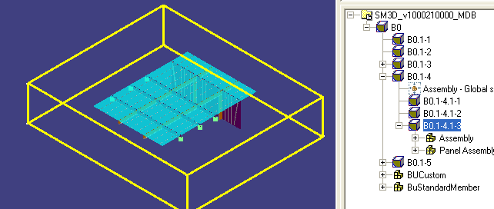

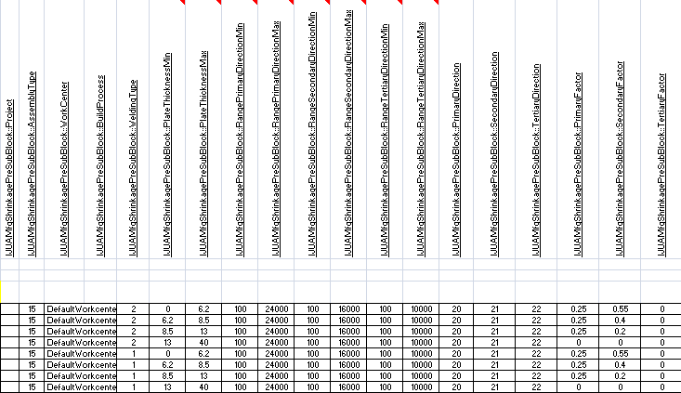

- Target Assembly: Assembly Type – "Pre Sub Block"
- Service Table Inputs: same as sub-block above
  - Project
    - For future use
  - Assembly Type
    - Pre Sub Block --> 15
  - Work Center
    - Work Center of the Assembly
  - Build Process
    - For Future use
  - Welding Type
    - Get the Largest Plate in the PreSubBlock
    - Get the Physical Connection between this Plate and Stiffener
    - Get the Welding Type from the PC
      - If it is Single --> Welding Type is 1
      - If it is Both sides --> Welding Type is 2
      - If it is Alternate --> Welding Type is 3
  - Base Plate Thickness
    - Get the thickness of the largest plate in mm
  - Assembly Range
    - Get the desired Range of the Sub-Block from Planning API IJDPlnIntHelper::GetAssemblyRange()
    - Get the value in each of Direction
      - BlockAxisAlongWelding - Primary Range
      - BlockAxisNormalToWelding - Secondary Range
      - BloackAxisNormalToBasePlate - Tertiary Range

- Service Table Outputs:

  - Directions
    - Based on the CodeList obtained, map as below to get direction
    - 20 --> BlockAxisAlongWelding (Nearest Global direction to welding)
    - 21 --> BlockAxisNormalToWelding
    - 22 --> BloackAxisNormalToBasePlate
  - Factors

Panel Assembly Rule
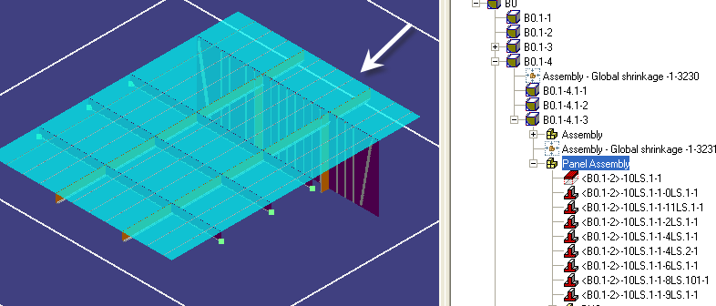
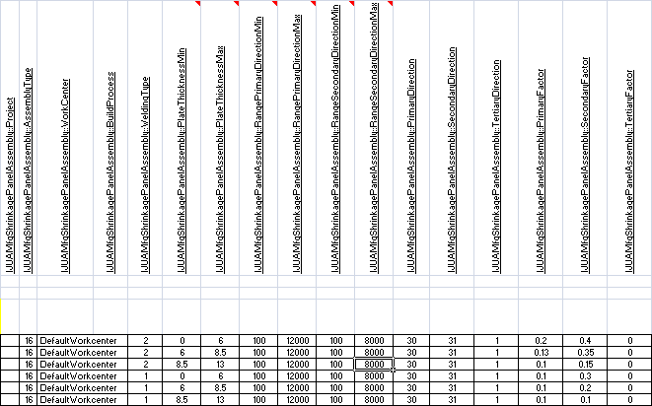

- Target Assembly - Panel Assembly
- Service Table inputs:
  - Project
    - For future use
  - Assembly Type
    - Panel Assembly --> 1
  - Work Center
    - Work Center of the Assembly
  - Build Process
    - For Future use
  - Welding Type
    - Get the Base Plate of the Panel assembly. If not there, get the largest plate.
    - Get the Physical Connection between this Plate and Stiffener
    - Get the Welding Type from the PC
      - If it is Single --> Welding Type is 1
      - If it is Both sides --> Welding Type is 2
      - If it is Alternate --> Welding Type is 3
  - Base Plate Thickness
    - Get the thickness of the largest plate in mm
  - Assembly Range
    - Get the desired Range of the Sub-Block from Planning API IJDPlnIntHelper::GetAssemblyRange()
    - Get the value in each of Direction
      - Assembly Along Welding - Primary Range
      - Assembly Perpendicular Welding - Secondary Range
      - Assembly Normal Welding Plane - Tertiary Range

- Service Table Outputs:
  - Directions
    - Based on the CodeList obtained, map as below to get direction
    - 30 --> Assembly Along Welding
    - 31 --> Assembly Perpendicular Welding
    - 32 --> Assembly Normal Welding Plane
  - Factors

Assembly Rule
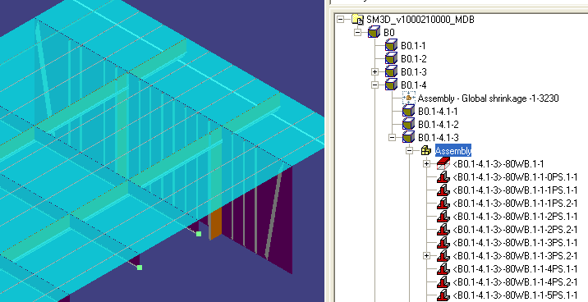
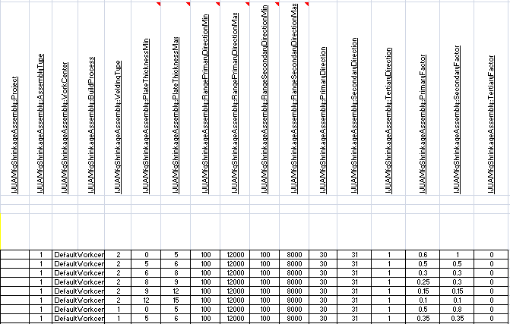

- Target Assembly - Assembly
- Service Table inputs:
  - Project
    - For future use
  - Assembly Type
    - Assembly --> 1
  - Work Center
    - Work Center of the Assembly
  - Build Process
    - For Future use
  - Welding Type
    - Get the Base Plate of the Assembly. If not there, get the largest plate. In this case, the BulkHead.
    - Get the Physical Connection between this Plate and Stiffener
    - Get the Welding Type from the PC
      - If it is Single --> Welding Type is 1
      - If it is Both sides --> Welding Type is 2
      - If it is Alternate --> Welding Type is 3
  - Base Plate Thickness
    - Get the thickness of the plate in mm
  - Assembly Range
    - Get the desired Range of the Sub-Block from Planning API IJDPlnIntHelper::GetAssemblyRange()
    - Get the value in each of Direction
      - Assembly Along Welding - Primary Range
      - Assembly Perpendicular Welding - Secondary Range
      - Assembly Normal Welding Plane - Tertiary Range
- Service Table Outputs:
  - Directions
    - Based on the CodeList obtained, map as below to get direction
    - 30 --> Assembly Along Welding (in this case Z)
    - 31 --> Assembly Perpendicular Welding (in this case Y)
    - 32 --> Assembly Normal Welding Plane (in this case X)
  - Factors

Built Up Profile Assembly Rule
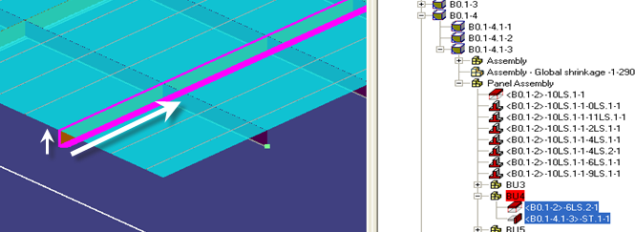
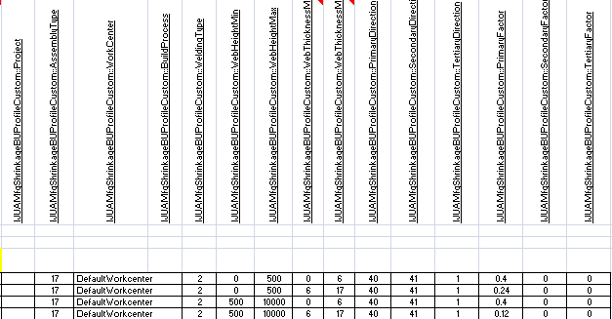

- Target Assembly - Built-up Profile
- Service Table inputs:
  - Project
    - For future use
  - Assembly Type
    - Assembly --> 17
  - Work Center
    - Work Center of the Assembly
  - Build Process
    - For Future use
  - Welding Type
    - Get the Physical Connection between the Plate and the ER (Web and Flange)
    - Get the Welding Type from the PC
      - If it is Single --> Welding Type is 1
      - If it is Both sides --> Welding Type is 2
      - If it is Alternate --> Welding Type is 3
  - Web Height
    - Get the width of the plate acting as Web in mm (Longitudinal BulkHead in this case)
  - Web thickness
    - Get the thickness of the plate acting as Web in mm (Longitudinal BulkHead in this case)

- Service Table Outputs:
  - Directions
    - Based on the CodeList obtained, map as below to get direction
      - 40 --> Built-Up Along Axis (along X axis in this case)
      - 41 --> Built-Up Perpendicular To Axis( along Z axis in this case)
  - Factors

Built Up Standard Member Assembly
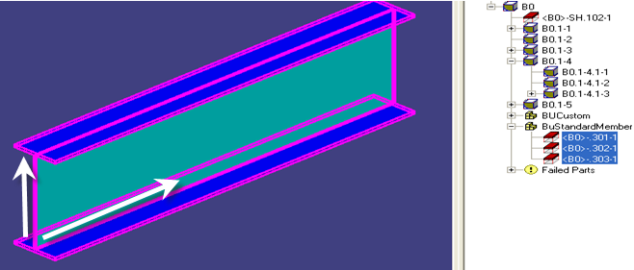

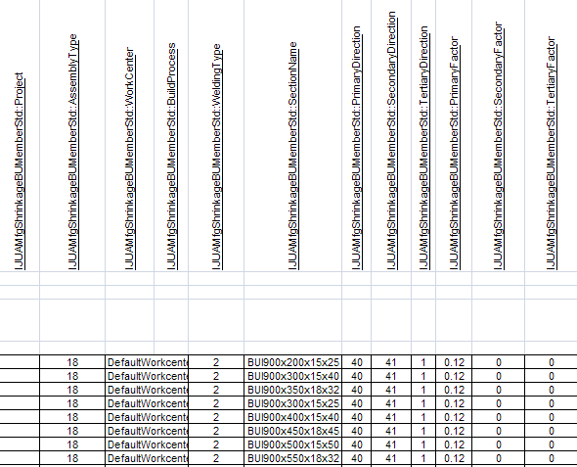

- Target Assembly - Built-up Member
- Service Table inputs:
  - Project
    - For future use
  - Assembly Type
    - Assembly --> 18
  - Work Center
    - Work Center of the Assembly
  - Build Process
    - For Future use
  - Welding Type
    - Get the Physical Connection between the Plates(Web and Flange)
    - Get the Welding Type from the PC
      - If it is Single --> Welding Type is 1
      - If it is Both sides --> Welding Type is 2
      - If it is Alternate --> Welding Type is 3
  - Cross-Section
    - Get the cross-section of the Member Part

- Service Table Outputs:
  - Directions
    - Based on the CodeList obtained, map as below to get direction
      - 40 --> Built-Up Along Axis (along X axis in this case)
      - 41 --> Built-Up Perpendicular To Axis( along Z axis in this case)
  - Factors

Built Up Custom Member Assembly
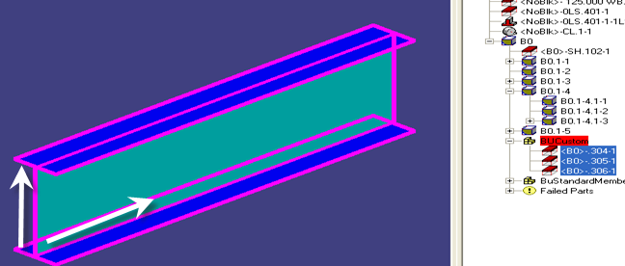

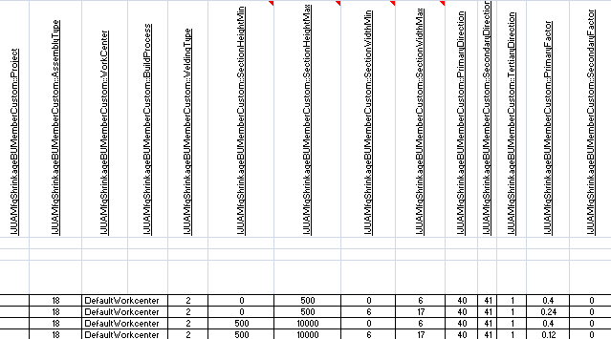

- Target Assembly - Built-up Member
- Service Table inputs:
  - Project
    - For future use
  - Assembly Type
    - Assembly --> 18
  - Work Center
    - Work Center of the Assembly
  - Build Process
    - For Future use
  - Welding Type
    - Get the Physical Connection between the Plates(Web and Flange)
    - Get the Welding Type from the PC
      - If it is Single --> Welding Type is 1
      - If it is Both sides --> Welding Type is 2
      - If it is Alternate --> Welding Type is 3
  - Section Height
    - Web Plate Width (Longitudinal Plate width in the example)
  - Section Thickness
    - Web Plate thickness
- Service Table Outputs:
  - Directions
    - Based on the CodeList obtained, map as below to get direction
      - 40 --> Built-Up Along Axis (along X axis in this case)
      - 41 --> Built-Up Perpendicular To Axis( along Z axis in this case)
  - Factors

Part – Assembly Based Shrinkage Rules

Overview
- Set of rules used to propose values for Part-Assembly based Shrinkages.
- These rules use the Shrinkages on the Parent Assemblies in the hierarchy to propose the values for the parts.
- Two different rules are delivered – one simply cumulates all the factors in a particular direction one by one. The other compounds the factors by adding one factor after another. More explanation below.
- The primary and secondary directions are proposed based on the most stiffening and its perpendicular direction.

By Sum Rule
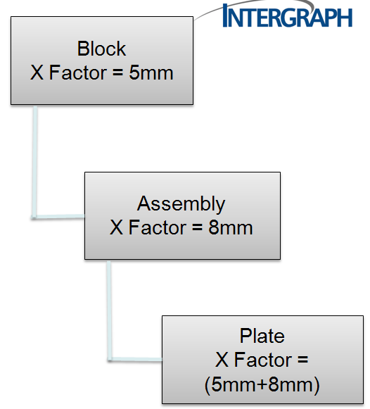

- To calculate value in Primary Direction
  - X- Direction

- This rule CUMULATES all the factors in the X direction of the parent assemblies and applies on the plate.
  - Block has 5 mm/ 1m in X-Dir
  - Assembly has 8 mm/ 1m in X-Dir

- Cumulating both the values:
  - Total factor in X-Dir is (5mm + 8mm) /1mm

- New length after factor is applied:
  - L(1 + 0.013)
  - Where L is the length of the plate.

- Length = 1.013L meters.
- Factor is 13 mm/1m.

By Increment Rule
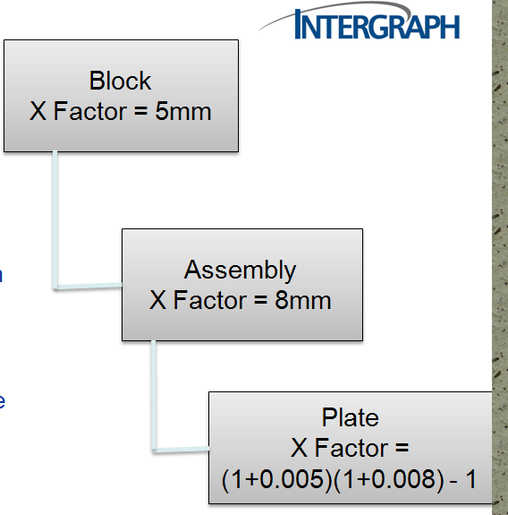

- To calculate value in Primary Direction
  - X-Direction

- This rule calculates the factor by applying the parent assembly shrinkages one by one.
- So first Shrinkage from Assembly is applied on the plate part. Factor on Assembly is 8mm/1m in X-Direction.
  - New length = L(1 + 0.008) m

- After this shrinkage on Block is applied on the effective length of the plate part. Factor on Assembly-I is 5mm.
  - New Length = L (1 + 0.008)(1 + 0.005)

- Total Length = 1.01304 L meters
- Factor = 13.04 mm/ 1 m

Part – Assembly Based Rule – By Edge
If the Part is not in standard orientation, rule will compute the component of each Assembly Shrinkage along the Part Direction and sum them based on the Rule (By Sum or By Increments)
To compute the component a given Assembly Shrinkage below math is used
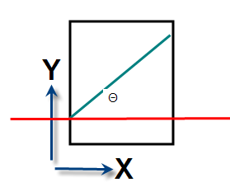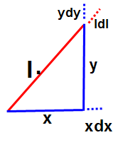
To calculate factor in Third direction based on two components
- Effective Factor (dl)
= (New Length – Old Length) / Old Length
= (New Length / Old Length) - 1
  - x and y: components of l in the X and Y direction.
  - x = l CosΘ
  - y = l SinΘ
  - dx and dy - Factors in X and Y directions
- New length in X-Dir: x + xdx
- New length in Y-Dir: y + ydy
New length: sqrt {(x + xdx)² + (y + ydy)²}
Effective Primary Factor (dl)
= [sqrt {(x + xdx)² + (y + ydy)² } / l ] - 1;
3D Calculation:
- Need to use three factors (x, dx, y, dy, z, dz).
x, y and z: components of l in the X, Y and Z direction respectively.
dx, dy and dz - Factors in X, Y and Z directions
- Calculated from Parent Assembly Shrinkages
New length in X-Dir: x + xdx
New length in Y-Dir: y + ydy
New length in Z-Dir: z + zdz
New length: sqrt { (x + xdx)² + (y + ydy)² + (z + zdz)²}
Effective Primary Factor (dl)
= [ sqrt { (x + xdx)² + (y + ydy)² + (z + zdz)² } / l ] – 1

Part – Private Shrinkage Rules
These are existing Rules.

MFG Plate Shrinkage Process Rules
The Rules are located at \SharedContent\Src\StructManufacturing\Rules\MfgPlate\Process
- ShrinkagePart.cls
- ShrinkageNo.cls
- ShrinkageAssembly.cls
- ShrinkageCombined.cls
- ShrinkageUserDefined.cls

Overview
- Part
  - Will create a new Part-Private Shrinkage object, if not already exists.
  - Applies PartRule as Factor rule on the Shrinkage to get data
- Assembly
  - Will create an Part-Assembly based Shrinkage, if not already exists
  - Applies 'BySumFactors' as the Factor Rule on the Shrinkage to get Data.
- Combined
  - Will create both Part-Private and Part-Assembly based Shrinkage object, if they don’t exist already.
- UserDefined
  - Will create a Part-Assembly based Shrinkage, if not already exists.
  - But the Shrinkage will not be MFG Plate controlled like above.
  - That is, when MFG Plate is deleted, this shrinkage will not be deleted.
- Ignore
  - Will not create any shrinkage.
  - Default option

Example Code
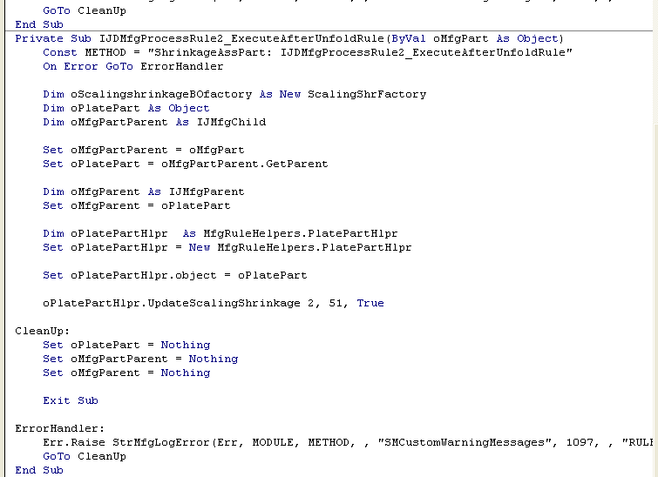

Signature
Private Sub IJDMfgProcessRule2_ExecuteAfterUnfoldRule (ByVal oMfgPart As Object)
- The manufacture plate part (oMfgPlate) is the input.
- Shrinkage object needs to be created on the same plate.

Rule Logic
- From the Mfg Plate, get the detailed part on which the shrinkage has to be placed.
- Call the API ‘UpdateScalingShrinkage‘ on PlatePartHelper class to create the shrinkage object. Mode, Factor Rule and RuleBased option are the inputs to the API.

UpdateScalingShrinkage API

Inputs
- Mode: The mode of the shrinkage to be created. It needs to be either Part-Private Shrinkage (1) or Part-Assembly based Shrinkage (2).
- Factor Rule: The rule using which the shrinkage properties are to be calculated. In this case, we are using BySumFactors (51) rule of Part-Assembly based Shrinkage. The number given will be the number value equal to the rule (explained below).
- Rule Based: Tells whether the new shrinkage created will be of Mfg Plate Rule Based or User Defined. Giving true will create Rule Based object and false will create UserDefined shrinkage.

Algorithm
- Check whether the object already has shrinkage of the same mode.
- If it has, then make it rule based or user defined based on the RuleBased option.
- If it doesn’t, create a shrinkage object.
- Call the rule and retrieve the values proposed by the rule and apply on the Shrinkage object.
- Make the newly created shrinkage rule based or user defined.

MFG Service Manager – Custom Inputs
The custom inputs API has been changed to accommodate the three modes of shrinkage – Part-Private, Part-Assembly Based and Assembly.

Old API
Private Sub IJDMfgServiceMgrCustomInputs_GetMfgCustomInputSettings(lMarkingLine As Long, lMargin As Long, lShrinkage As Long, lTemplate As Long, lPinJig As Long, lMfgPlate As Long, lMfgProfile As Long)

New API
Private Sub IJDMfgServiceMgrCustomInputs_GetMfgCustomInputSettings(lMarkingLine As Long, lMargin As Long, lPartShrinkage As Long, lAssemblyPartShrinkage As Long, lAssemblyShrinkage As Long, lTemplate As Long, lPinJig As Long, lMfgPlate As Long, lMfgProfile As Long)

Inputs:
- lPartShrinkage – Decides the custom inputs for Shrinkage of mode Part-Private.
  - lPartShrinkage = StructMfgServiceMgr_NoCustomObjects (Default)
- lAssemblyPartShrinkage – Decides the custom inputs of mode Part-Assembly Based.
  - lAssemblyPartShrinkage = StructMfgServiceMgr_NoCustomObjects (Default)
  - lAssemblyPartShrinkage = StructMfgServiceMgr_AllAssemblyShrinkages + StructMfgServiceMgr_BasePlateStiffeners (Commented)
- lAssemblyShrinkage – Decide the custom inputs of mode Assembly.
  - lAssemblyShrinkage = StructMfgServiceMgr_NoCustomObjects (Default)
  - lAssemblyShrinkage = StructMfgServiceMgr_AssemblyBasePlate + StructMfgServiceMgr_BasePlateStiffeners + StructMfgServiceMgr_BUAssemblyPCs (Commented)

Logic:
StructMfgServiceMgr_AllAssemblyShrinkages
- Used for Part-Assembly Based shrinkages
- All the parent assembly shrinkage in the hierarchy will be considered for checking if the shrinkage is out of date.
StructMfgServiceMgr_BasePlateStiffeners
- Used for Part-Assembly Based shrinkages
- All the stiffeners on the plate which are used to decide the primary and secondary directions will be considered for checking if the shrinkage is out of date.
StructMfgServiceMgr_AssemblyBasePlate
- Used for Assembly Shrinkages
- The base plate or the largest plate which is considered for proposing the directions and values will be considered for checking if the shrinkage is out of date.
StructMfgServiceMgr_BasePlateStiffeners
- Used for Assembly Shrinkages
- The stiffeners on the base plate or the largest plate which are used for proposing the directions will be considered for checking if the shrinkage is out of date.
StructMfgServiceMgr_BUAssemblyPCs
- Used for Assembly Shrinkages of type Built-Up Members or Built-Up Profiles.
- The physical connections within the built-up assemblies will be considered for checking if the shrinkage is out of date.

Shrinkage Rules Logging
The entire shrinkage rule process for assembly shrinkage and part-assembly based shrinkage can be logged in a log file. This will help the user understand the rule processing and also help him understand when the rule fails or when the rule returns invalid values.
The log file can contain data like:
- Base plate used for calculation
- Number of profiles in each direction
- Direction which is considered along welding and perpendicular to welding
- Inputs sent to the service table and its outputs
- Calculation of final primary and secondary directions

ManufacturingErrorLogEnable
The logging will be done based on the option selected for ‘Enable Shrinkage Rule Logging’ option in the shrinkage tab of ManufacturingErrorLogEnable.exe.
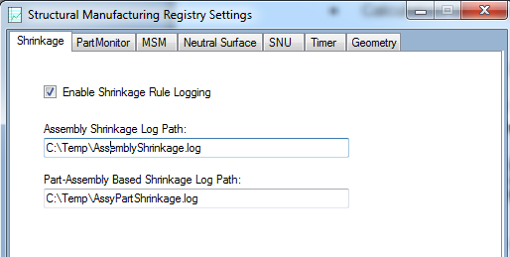

- Checking ON ‘Enable Shrinkage Rule Logging’ option will enable the rule logging.
- The log files for assembly shrinkages will be generated at the path provided under ‘Assembly Shrinkage Log Path’
- The log files for part-assembly based shrinkages will be generated at the path provided under ‘Part-Assembly Based Shrinkage Log Path’
- If NO path is provided then the log files will be generated at the TEMP location with the name ShrinkageRuleProcess.

Assembly Shrinkage Rule Log
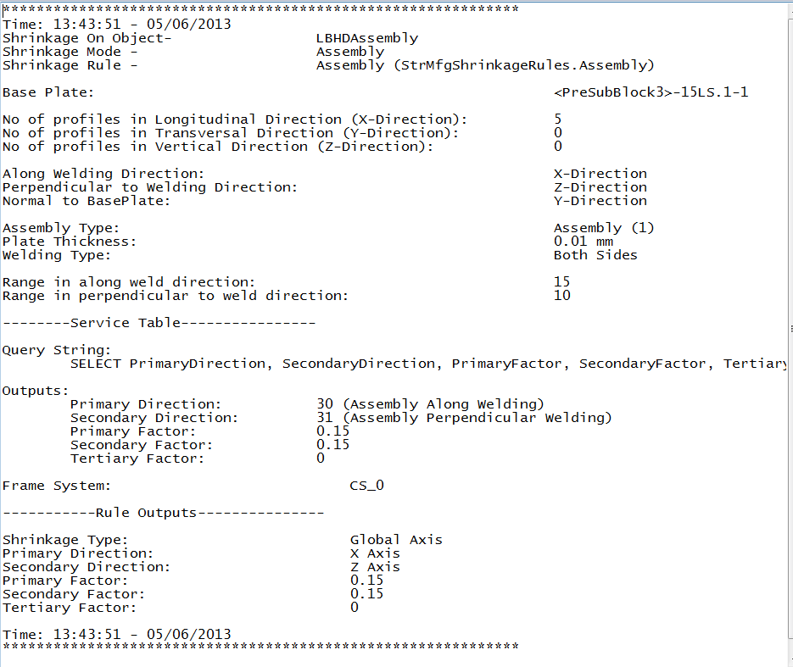
The log file for assembly shrinkage rules contains the following data:
- Rule used and its progid.
- Part/Assembly on which the shrinkage is being applied.
- Shrinkage mode.

Assemblies and Blocks
- Base plate of the assembly.
- Number of profiles in each direction.
- The welding directions inferred based on the profiles.
- Assembly type, welding type and base plate thickness.
- Range in each of the welding directions. (Two directions for assemblies and three directions for blocks).
- Service table query used to retrieve the outputs.
- Service table outputs.
- Frame System (if shrinkage type is global)
- Final rules outputs.

Built Up Member Assemblies and Built Up Profile Assemblies
- Assembly type and welding type.
- Web/Section thickness and web height (Built Up Profile Assemblies)
- Weld directions – along weld and perpendicular to weld direction
- Service table query used to retrieve the outputs.
- Service table outputs.
- Final rules outputs.

Part-Assembly Based Shrinkage Rule Log
The log file for part-assembly based shrinkages contains the following information:
- Rule used and its progid.
- Part/Assembly on which the shrinkage is being applied.
- Shrinkage mode.
- Number of profiles in each direction.
- Directions of the shrinkage calculated based on the number of profiles.
- Data of the parent assembly shrinkages used in the calculation of the factors for the part-assembly based shrinkage. The following data is logged for each parent assembly shrinkage:
  - Assembly Name (full hierarchy string).
  - Shrinkage name.
  - Shrinkage type.
  - Primary direction (Axis if global, vector if scaling by edge).
  - Secondary direction (Axis if global, vector if scaling by edge).
  - Primary factor.
  - Secondary factor.
  - Tertiary factor.
- Final rules outputs.
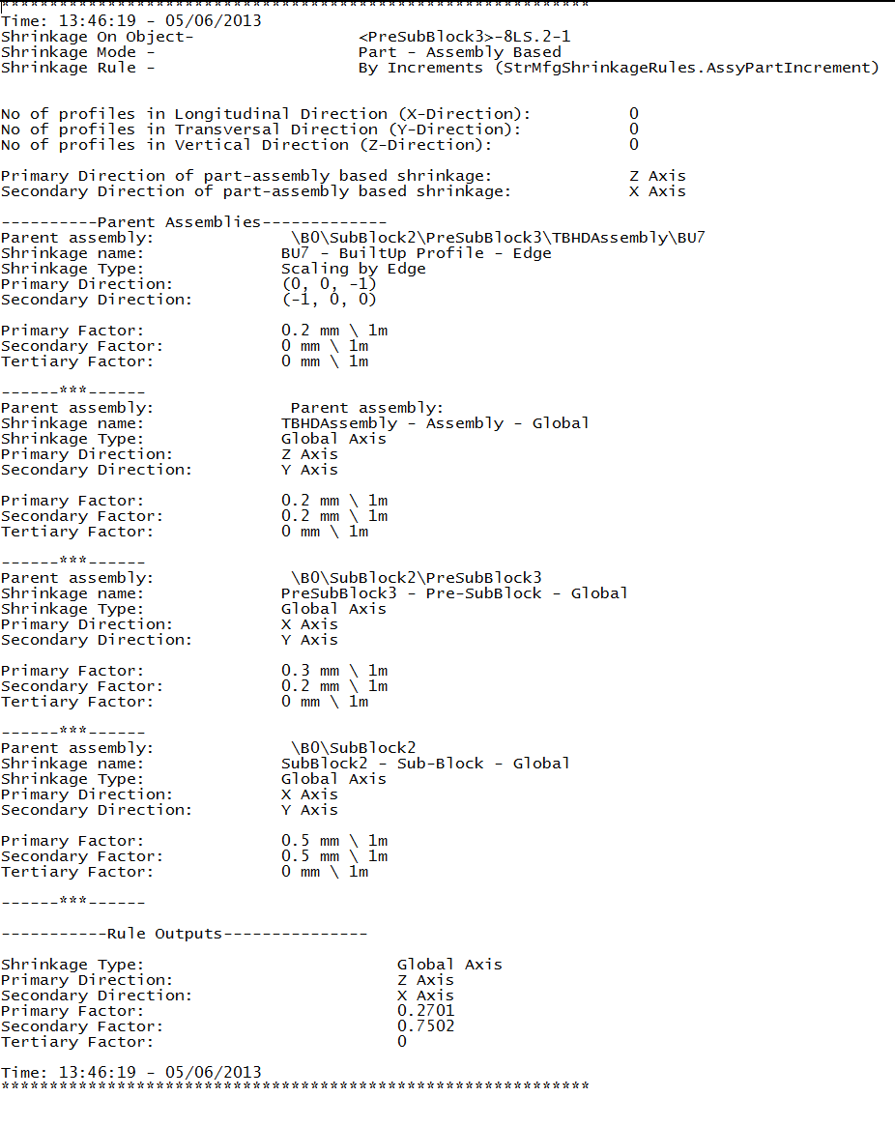

Helper Methods
The following helper methods are provided on the shrinkage helper object which will help in the logging process:
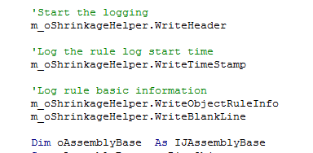
- WriteObjectRuleInfo – writes the rule introduction like the rule name and shrinkage mode.
- WriteStringToLog – writes the input string to the log. This method also checks whether the rule logging option is set to ON.
- ShrinkageRule (Get\Set) – Gets\Sets the shrinkage rule as a long.
- ShrinkageMode (Get\Set) – Gets\Sets the shrinkage mode as a long.
- ShrinkageParent (Get\Set) – Gets\Sets the parent on which the shrinkage is being applied.
- WriteTimeStamp – writes the time to the log file.
- WriteBlankLine – writes a blank line.
- WriteBasePlateName – writes the name of the base plate of the assemblies.
- WriteAssemblyType – writes the type of the assembly.
- WritePlateThickness – writes the thickness of the plate.
- WriteWeldType – wrties the welding type used within the assembly.
- WriteTimeStamp – writes the range in the along weld direction.
- WriteRangeInPerpendicularToWeldingDirection – writes the range in perpendicular to weld direction.
- WriteRangeInNormalToBasePlateDirection – writes the range in normal to base plate/welding plane direction.
- WriteRuleOutputData – writes the final outputs of the rule.
- WriteErrorDescription – writes the description of the error.
- WriteNumberOfProfiles – writes the number of profiles in each direction.
- WriteWeldDirectionsForAssemblies – writes the different weld directions (calculated based on number of profiles) for simple assemblies and blocks.
- WriteWeldDirectionsForBuiltUps – writes the different weld directions (vectors along ports) for built ups.
- WriteServiceTableQuery – writes the query used in the service table.
- WriteServiceTableOutputs – writes the outputs of the service table.
- WriteSectionHeightAndWidth – writes the section height and width of a member.
- WriteMemberSectionName – writes the cross section of the member.
- WriteProfileWebHeightAndThickness – writes the profile web height and thickness.
- WriteFrameSystem – writes the frame system used.
- WritePartAssyBasedShrDirections – writes the directions (axes if global, vectors if scaling by egde) of the part-assembly based shrinkages.
- WriteDataOfParentShrinkages – writes the data of the parent assembly shrinkage used for calculating the factors for part-assembly based shrinkages.

