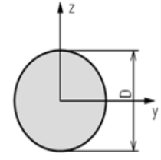 | Circular | D
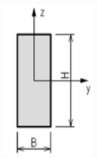 | Rectangular | H; B
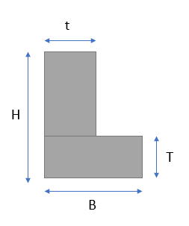 | L Shape | H; B; T; t
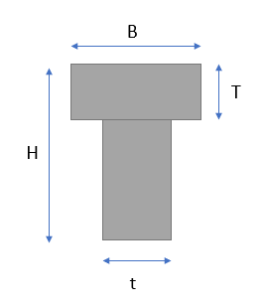 | T Shape | H; B; T; t
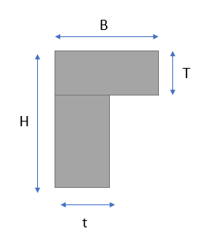 | L Inverted | H; B; T; t
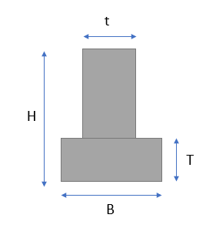 | T Inverted | H; B; T; t
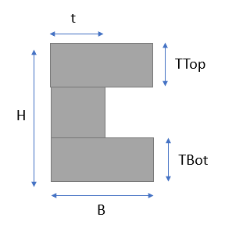 | C Shape | H; B; T1; T2; t
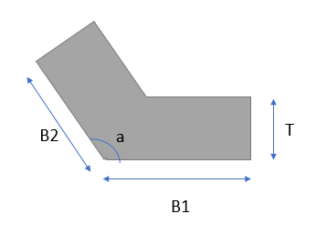 | Elbow | B1; B2; T; a
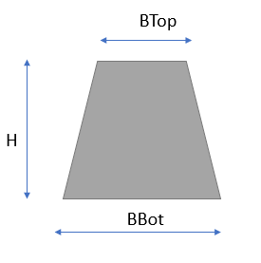 | Trapezium | H; BTop; BBot
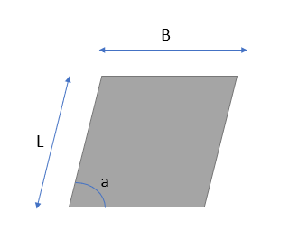 | Parallelogram | B; L; a
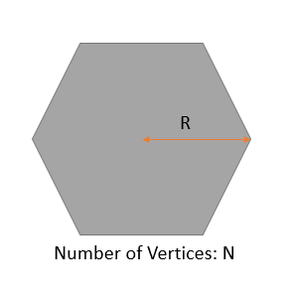 | Polygon | N; R
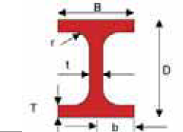 | I Shape | D; B; T; t; r
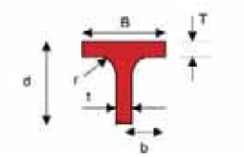 | T Shape | d; B; T; t; r
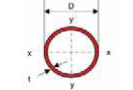 | Circular Hollow | D; t
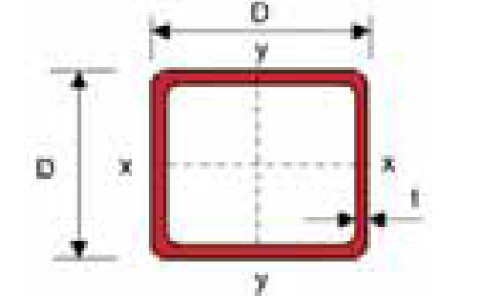 | Square Hollow | D; t
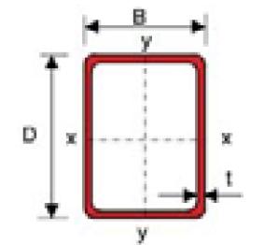 | Rectangular Hollow | D; B; t
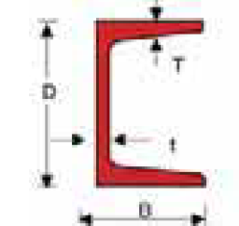 | Tapered Flange Channel | D; B; T; t
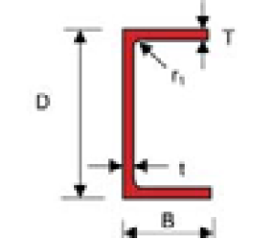 | Parallel Flange Channel | D; B; T; t; r1
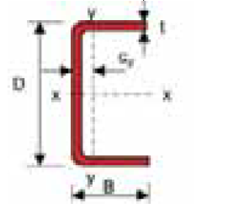 | Plain Channel | D; B; t
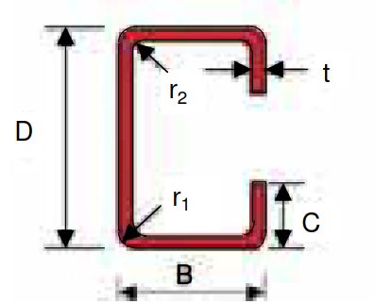 | Lipped Channel | D; B; C; t; r1; r2
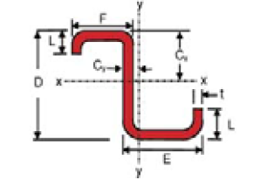 | Z Purlin | D; E; F; L; t  (E>F)
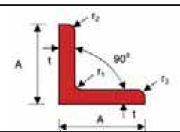 | Equal Angle | A; t; r1; r2  (r1>r2)
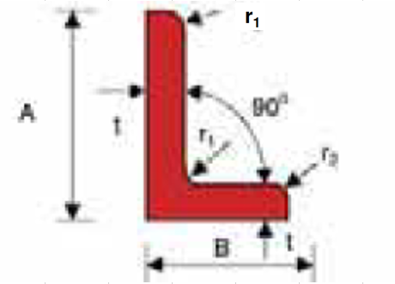 | Unequal Angle | A; B; t; r1; r2
 | Flat Bar | B; t
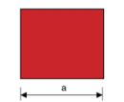 | Square Bar | a
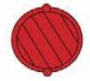 | Deformed Bar | D
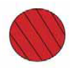 | Round Bar | D

