ABOUT UNIVERSITY

The Area of the state known as North Gujarat is constituted of four districts, Patan, Mehsana, Banaskantha and Sabarkantha. The university was established with a view to catering to the cultural and educational needs of these districts on 17th May, 1986 by the Governors Ordinance No. 5 of 1986. The North Gujarat University Act No. 22 of 1986 was passed on 11th September 1986 by the legislative Assembly of Gujarat and the university was duly established, earlier the districts were covered under the Gujarat University, Ahmedabad. On bifurcation from its parent university, no physical assets were inherited and it started functioning as initial. The university has been functioning since then and growing and expanding steadily.

Patan, a historical town, has been officially designated as the Head-Quarter of the University. For centuries it had been the capital city of a large kingdom extending far beyond the bounds of present day Gujarat under the Solanki rulers and a very important seat of Jain Scholarship. It is the holy land of Hemchandracharya, a great thinker who made valuable contributions to the studies of grammar, literature, religion and philosophy. The Rani-Ki Vav, a great architectural and sculptural monument of yesteryear, the lakes of shahasralings and Khan Sarovar , the Jain temples of Panchasara and a few other remains in and around the place testifying the glory that was Patan, in not so distant past.

The University campus is located on a site of 220 acres. It has established its own 7 Post Graduate Departments of Chemistry, Commerce and Management, English, Library and Information Science, Mathematics, Sanskrit and Bhartiya Vidya. The University also provides Post Graduate instruction in different subjects through its 69 Post Graduate centers run by its affiliated colleges with student’s strength of 55000 in different faculties.

ABOUT INSTITUTE

To fulfill the requirement for technicians of computer application from June-2010 BCA (Bachelor of Computer Application) degree course has been started. The course has an intake capacity of 180 students. The college building which includes laboratories, Classroom, Library area totalling. A built up area of 9419 square meters. The College was started with following main objectives:

* STUDY PROGRAM
* B.C.A

(Bachelor of Computer Application)

* B.B.A

(Bachelor of Business Administration)

* B. Ed.

(Bachelor of Education)

* M.S.W

(Master of Social Worker)

PROJECT PROFILE

| Project Title | My Lab ( Laboratory Management ) |
| --- | --- |
| Project Objective | The purpose of this Website is To provide blood testing facilities to patients at home. |
| Types Of Application | Website |
| Front –End Tools | HTML, CSS, AJAX, JAVASCRIPT And PHP |
| Back –End Tools | MYSql |
| Other Tools | Bootstrap, XAMP, PHPMyAdmin |
| Internal Guide | Prof. Kaveri Panchal |
| External Guide |  |
| Time Duration | 90 Days |
| Submitted To | Grow More Institutions of B.C.A. Himatnagar |
| Developed By | STUDENTS LIST |

TECHNICAL SPECIFICATION

HARDWARE SPECIFICATION (Minimum)

Server side

| Processor | 2.0 GHz |
| --- | --- |
| RAM | 4 GB RAM |
| Hard disk | 500 GB Free space |

Client side

| Processor | 2.0 GHz |  |
| --- | --- | --- |
| RAM | 4 GB RAM |  |
| Hard disk | 500 GB Free space |  |

SOFTWARE SPECIFICATION (Minimum)

**Server side**

| Operating System | Window Server 2003 |
| --- | --- |
| Web Server | Apache V 2.4.9 |
| Database Server | MySQL V 5.6.17 |
| Runtime Environment | Php v 5.5.12 |

**Client side**

| Operating system | Windows 7,Window 8.1 |
| --- | --- |
| Web Browser | Any compatible web browsers. |

INTRODUCTION TO SYSTEM DEVELOPMENT TOOLS

PHP

| Logo |  |
| --- | --- |
| Acronym | Hypertext Preprocessor |
| License | PHP is free software (Open Source) released under the PHP License. |
| Founder | Founder of PHP is Rasmus Lerdorf. PHP was written in the 7 programming language monitoring by Rasmus Lerdorf in 1994 for use in monitoring his online resume and related personal information. The original meaning of PHP is “Personal Home Page”. |
| Operating System | Cross Platform. |
| File Extension | .php |
| What is PHP? | PHP is a powerful tool for making dynamic and interactive Web pages.  PHP is the HTML embedded scripting language.  The goal of this language is to allow web developers to write dynamic generated pages quickly.  PHP offers web applications creations, web site maintenance, website designing, software development, full-featured online shopping stores, web portal developments, Facebook application development etc. |
| What can php do? | Take information from users to store it in the database.  Redirecting pages depending on what the form actions serve different pages to people using different browsers or devices.  Set sessions, cookies for later use. Send email and SMS.  Authenticate and track users. |
| Versions | 1.0 to 5.6 |
| Editor | Notepad, Notepad++, Dreamweaver etc. |

Advantages of PHP

Open Source

PHP is open Source. This means that it is readily available and absolutely free to download for PHP resources: [www.php.net](http://www.php.net/).

Cross Platform

PHP is cross-platform and therefore enables operation across various operating systems (Windows, Linux etc.)

HTML Embedded Easily

PHP can be easily embedded into HTML. This means it take very easy for us to convert an already existing static website into bold and dynamic.

Cheaper Development

PHP applications are much cheaper than other technologies for developing dynamic sites and applications due to license issues.

Other Tools

PHP can easily add any web based tools like Google maps, Facebook plugins etc.

**Bootstrap**

Introduction

Bootstrap is the most popular front end frameworks currently. It is sleek, intuitive, and powerful front-end framework for faster and easier web development. It uses HTML, CSS and JavaScript.

What do you know before using it?

Before working with bootstrap you have known the following basic concepts.

* HTML
* CSS
* JavaScript

History

Bootstrap was developed by *Mark Otto* and *Jacob Thornton* at *Twitter*. It was released as an open source product in August 2011.

Why use Bootstrap ?



Browser Support

It is supported by all popular browsers.

* Easy to get started

With just the knowledge of HTML and CSS anyone can get started with Bootstrap. Also the Bootstrap official site has a good documentation- <http://getbootstrap.com/>.

* Responsive design

Bootstrap's responsive CSS adjusts to Desktops, Tablets and Mobiles. It works by write media-query on the page.

Provides a clean and uniform solution for building an interface for developers.

It contains beautiful and functional built-in components which are easy to customize.

It also provides web based customization.

And best of all it is open source.

What does the Bootstrap Package Include?

* Scaffolding

Bootstrap provides a basic structure with Grid System, link styles, background. This is covered in detail in the section Bootstrap Basic Structure.

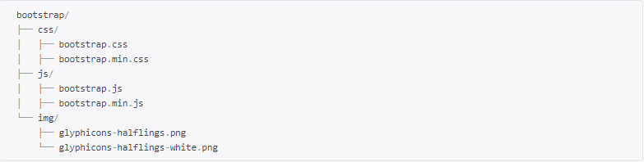

As you can see there are compiled CSS and JS (bootstrap.*), as well as compiled and minified CSS and JS (bootstrap.min.*). Fonts from Glyph icons are included, as is the optional Bootstrap theme.

* CSS

Bootstrap comes with features of global CSS settings, fundamental HTML elements styled and enhanced with extensible classes, and an advanced grid system. This is covered in detail in the section Bootstrap with CSS.

* Components

Bootstrap contains over a dozen reusable components built to provide iconography, dropdowns, navigation, alerts, popovers, and much more.

* JavaScript Plugins

Bootstrap contains over a dozen custom jQuery plugins. You can easily include them all, or one by one. This is covered in details in the section Bootstrap Plugins.

How do you get the Bootstrap Package?

You can download the latest version of Bootstrap from <http://getbootstrap.com/>. When you click on this link, you will get to see a screen as below:

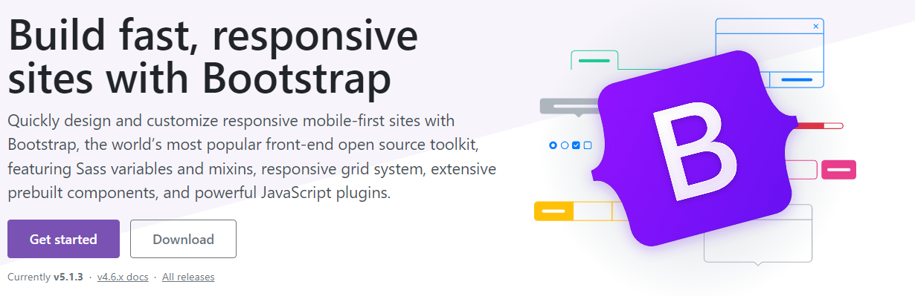

Here you can see two buttons:

Download Bootstrap:

Clicking this, you can download the precompiled and minified versions of Bootstrap CSS, JavaScript, and fonts. No documentation or original source code files are included.

Download Source:

Clicking this, you can get the latest Bootstrap LESS and JavaScript source code directly from GitHub.

INTRODUCTION OF DATABASE TOOLS

Introduction

* MySQL is an open source Relational database management system that relies on SQL for processing the data in the database.
* MySQL falls under the General Public License (GPL).
* MySQL provides APIs for the languages JAVA, .NET, PHP, Python etc.
* MySQL is most commonly widely used for web applications because of its speed and reliability.
* MySQL provides very high performance and it is a multi-threaded and multi-user relational database management system.
* MySQL supports indexing and binary objects.
* MySQL can run on almost all the platforms.

Features of MySQL

Scalability and flexibility

* MySQL can run on almost all the platforms like Windows, Linux and UNIX etc.
* The open source nature of MySQL allows complete customization for those wanting to add unique requirements to the database server.

High Performance

* MySQL can meet all the today’s requirements of the database server. A billion queries, high speed transactions etc.

High Availability

* Rock-solid reliability and constant availability are the main features of MySQL.

Robust Transaction Support

* MySQL supports complete ACID transaction support, unlimited row-level locking, distribution transaction capability, and multi version transaction
* Server-enforced referential integrity, specialized transaction isolation levels, and instant deadlock detection and achieve data integrity.

Backup and Recovery

* MySQL supports complete logical and physical backups as well as full and point-in-time recovery.

Comprehensive Application Development

* MySQL supports stored procedures, triggers, functions, views, cursors, Sub-SELECTs, and more.
* MySQL supports connectors and drivers (ODBC, JDBC, etc.) for database connection.

Introduction



* PhpMyAdmin is a graphical user interface program that allows you to use the functions of a MySQL database.
* With phpMyAdmin we can perform various tasks such as creating, modifying, deleting databases, tables, fields, rows, Import data in SQL format and Export data in SQL format, XML, executing SQL statements, managing user’s permissions, administering multiple servers.
* To open phpMyAdmin just right click, on wampserver and go to phpMyAdmin as below:

Various Parts Of phpMyAdmin

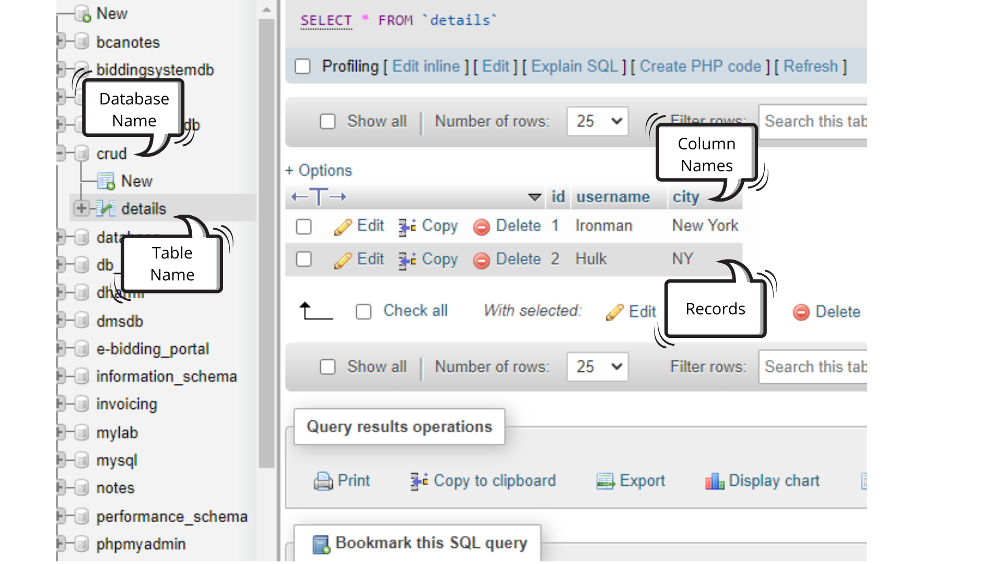



Introduction

* Apache is generally recognized as the world’s most popular web server.
* Apache is free software, distributed by the Apache Software Foundation that promotes various free and open source advanced web technologies.
* Core development of the Apache web server is performed by a group of about 20 volunteer programmers, called the Apache Group. Development of Apache is similar to development of the Linux Operating System.
* The Apache runs under Windows, Linux, OS/2 and other platforms.
* The actual purpose of Apache is to host PHP websites. Apache is the engine which runs the PHP page in the server and displays the output in the client browser.

XAMP

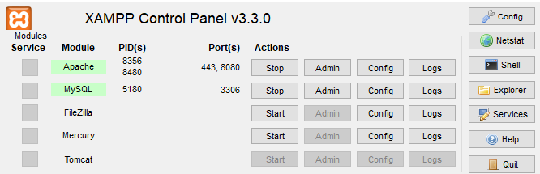

Introduction

* XAMPP is the most popular PHP development environment
* XAMPP is a completely free, easy to install Apache distribution containing MariaDB, PHP, and Perl. The XAMPP open source package has been set up to be incredibly easy to install and to use.

**PROJECT DESCRIPTION**

**MANUAL & EXISTING SYSTEM**

**⦁ The Manual System no one can able to get proper adivasi culture related information (scheme, job, office contact number, news, etc.) and not provide any document, form.**

**⦁ They have to manually visit office to get any sort of adivasi scheme related, jobs related information.**

**⦁ There were much more difficulties in getting any information and not be provided overall information in one place.**

**NEED FOR NEW SYSTEM**

Today we also have to go to the Test Lab center, wait in the queue to get our test done. As Technology is growing rapidly we are also moving to a technical world where everything we want to be online. So with the help of this project we are bringing the use of technology in the field of medical diagnosis where patients can avail all the diagnosis facilities at their door steps. This project makes the diagnosis process easy and reduces the burden of patients. At the same time it helps the diagnostic center to track all their patients' details with their test reports. This access friendly website provides quick and effective services which helps the diagnostic center to increase their sales and profit.

Advantages:

* The system allows an automated diagnosis system.
* Allows for faster service.
* Allows increased sales and profits for diagnostic labs.
* Easy, user friendly GUI.
* Validation of data will ensure only accurate valid and complete data stored in the database.

Disadvantages:

* It reduces employment as human efforts are being automated by this system.

**FUNCTIONAL SPECIFICATION**

**Module : -**

* Login
* Change password
* Forget password
* Manage profile
* Contact
* Contact us
* About us

**Module specification**

Login:-

* In this module Admin can login to the website and manage the whole website.

Change password:-

* In this module Admin can change their password.

Forget password:-

* In this module Admin can forgot password and reset new password.

Manage profile:-

* In this module Admin can manage their profile like update their name, mobile number, e-mail etc.

About us:-

* In this module Admin can manage about us. Like update, view.
* In this module visitor can view about us.

Contacts:-

* In this module admin can manage contacts. Like add, update, delete and view.
* In this module visitor can view contacts.

Feedback:-

* In this module admin can view and delete feedback.
* In this module visitor can send feedback.

Contact us:-

* In this module admin can manage contact us. Edit, view.
* In this module visitors can view contact us.

**USERS OF THE SYSTEM**

In our system there are two users who can work on the system they are

* Admin
* Lab Manager
* Visitor

**User specification**

Admin:-

* Admin can login then after managing the site.
* Admin can change their password.
* Admin can manage their profile.
* Admin can manage Laboratories.
* Admin can Generate Reports Of Laboratories.

Patient / Visitor :

* Visitors can Take appointments for Blood tests.
* Visitor Can Edit His Appointment Details.
* Visitors can Track His Blood Report.
* Visitors can contact.

**FEASIBILITY STUDY**

A feasibility study is a short, focused study, which aims to answer a number of questions:

Does the system contribute to the overall objectives of the Organization?

Can the system be implemented using current technology and within given cost and schedule constraints?

Can the system be integrated with systems which are already in place?

**There are four types of Feasibility Study.**

**Economic Feasibility.**

* Economic Feasibility addresses to the following issues:
* Is the organization having the suitable budget to develop the proposed system?
* How much profit can be earned from the system by an organization?
* Would it be cost-effective to develop the system or it is worthwhile to remain with the current system?
* We would like to answer for the above question, as given below:
* As development tools and software are available, there isn’t any burden of buying them.
* The organization doesn’t have the same system, so it is certainly required for them.
* The profit will be remarkable according to what our team has seen as far as market is concerned.
* So, here we do not need to invest extra funds to develop the system. Thus, it is economically feasible to the Organization.

**Technical Feasibility**

* Technical feasibility tries to answer the following questions to make the software feasible to develop.
* Are the software or tools necessary for building or running the application easily available or not?
* Does software compatibility exist or not?
* Are developers aware of these technologies?
* What about the alternative of these chosen technologies?

**Factors Considered:**

* Here we have to consider those tools that will be required for developing the project.
* The tools that are available and tools that will be required have to take in account./
* We work on Notepad++, Bootstrap. The company's former versions are developed in MySQL. So the company already has the licensed version of Microsoft Product.
* As far as basic knowledge is concerned we had done C, C++, and Visual Basic. We have well experience knowledge of VB.NET and its Technologies. Various technical books, e-books etc. are available.
* Internet facility is always available for technical as well as advanced software help.
* Considering all above points and aspects it is observed that would be incurred in developing this project from a technical perspective would not be too high. Thus it is feasible for the company.

**Operational Feasibility :**

* Operational feasibility measures how well the solution will work in the organization and how the end-user & management feels about the system. Proposed system is helpful for the tourists, citizens and visitors. It will allow them to query them to get the appropriate and adequate information.
* On studying the operational feasibility of the project, the following conclusions could be derived:
* Developed system will provide the adequate throughput and all necessary information to end-users.
* It will provide advantageous and reliable services.
* If it can be within a suitable environment, the system will do operations under an environment of limited resources.

Thus, it is operationally feasible to develop the proposed system.

**Scheduled Feasibility :**

The purpose of accessing schedule feasibility is to gain an understanding of likelihood that all potential time frames and completion date schedules can be met.

With a deadline of 80 days and with PHP, MySQL, AJAX, Dreamweaver, Notepad++ the system seems to be quite feasible in terms of schedule.

**Project Time Scheduling**

| **SR.NO** | **TASK** | **FROM**  **01-12-2021 To 28-04-2022** | **TOTAL DAYS** |
| --- | --- | --- | --- |
| **1** | Requirement Gathering | 01-12-2021 to 07-02-2022 | 07 |
| **2** | System Analysis Designing | 08-12-2021 to 23-02-2022 | 16 |
| **3** | UI Designing | 24-12-2021 to 26-02-2022 | 34 |
| **4** | Coding | 27-01-2021 to 20-04-2022 | 25 |
| **5** | Testing | 21/12/2021 To 25/04/2022 | 5 |
| **6** | Implementation | 26-02-2021 to 28-04-2022 | 3 |

**Timeline Chart**

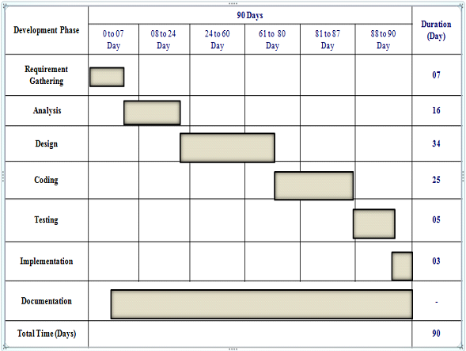

**Flow Chart**

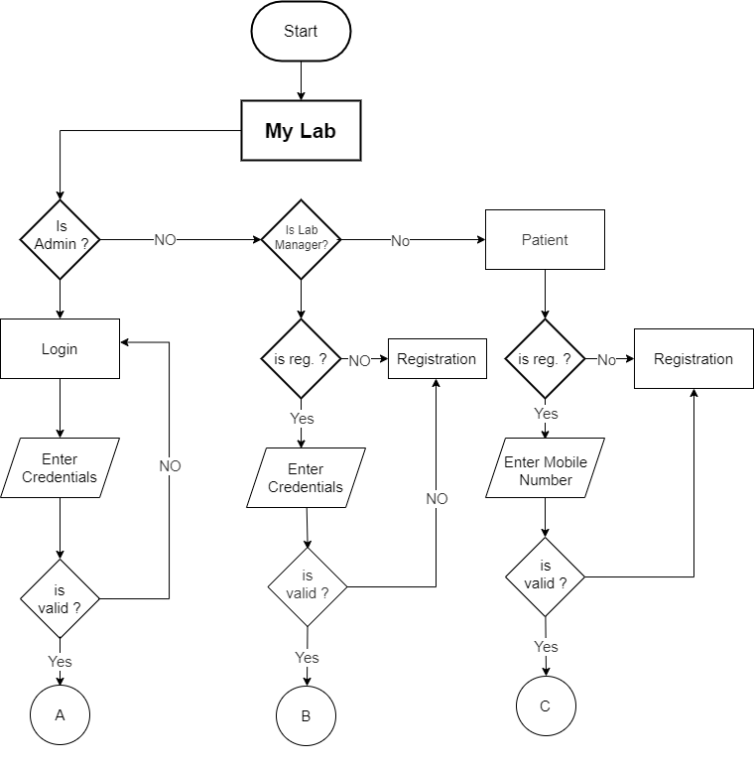

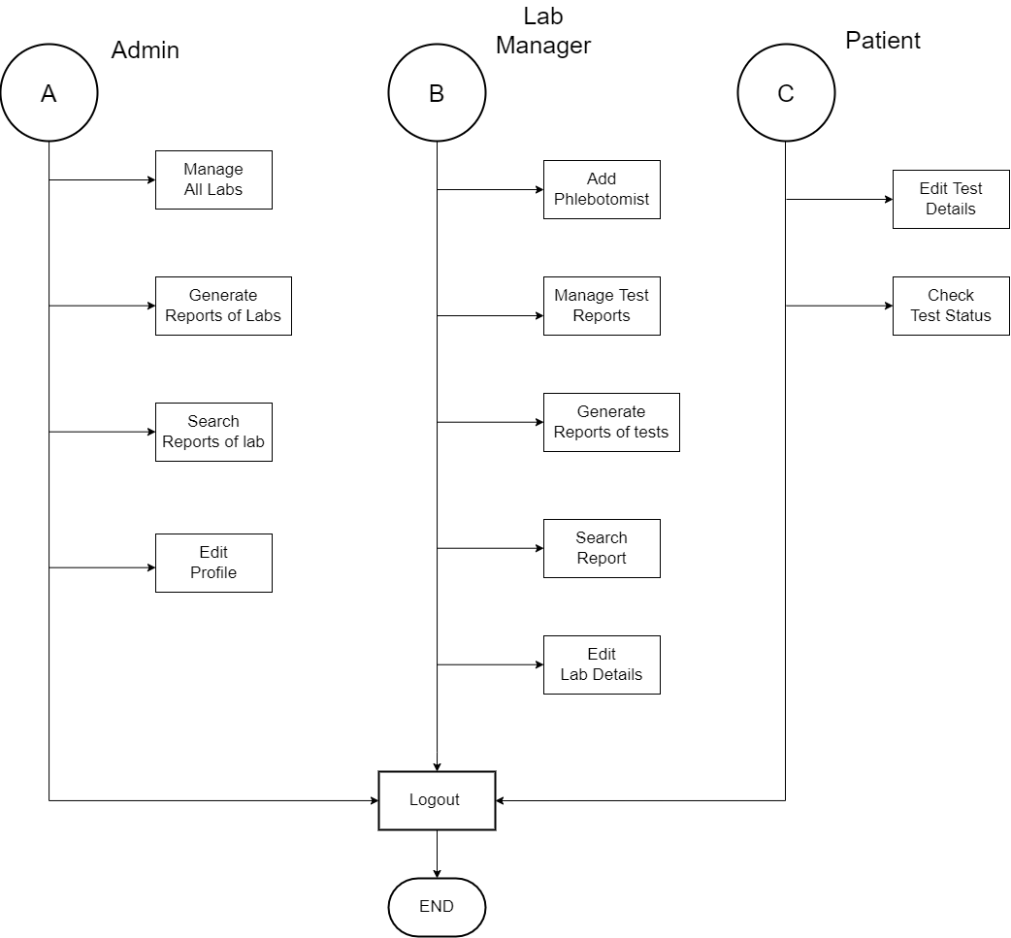

**DFD ( DATA FLOW DIAGRAM )**

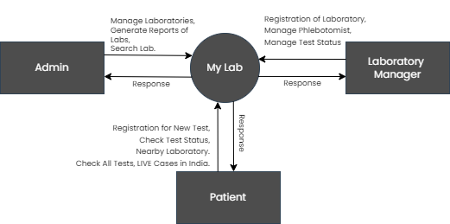

**FIRST LEVEL DFD (ADMIN)**

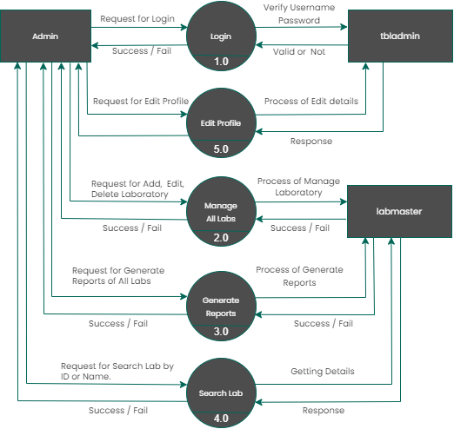

**FIRST LEVEL DFD ( Lab Manager)**

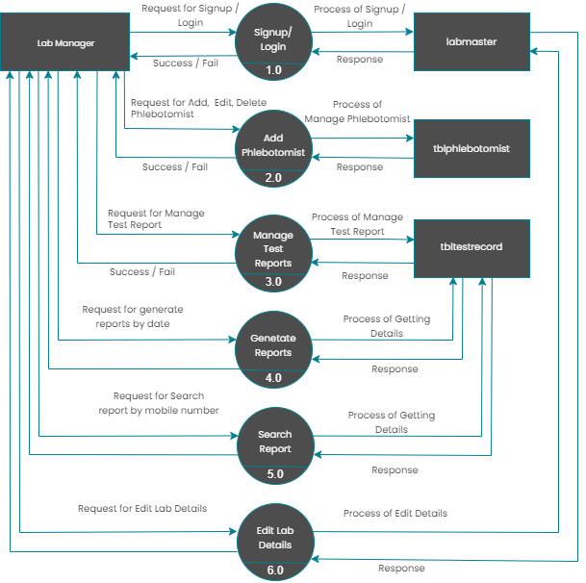

**FIRST LEVEL DFD ( Patient )**

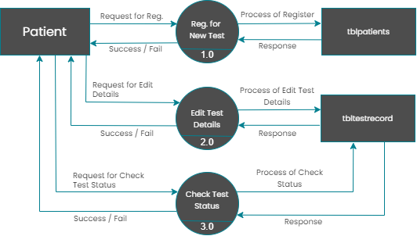

**DATA DICTIONARY**

**Data Tables :**

| **Sr. No** | **Table Name** | **No of Field** | **Description** |
| --- | --- | --- | --- |
| 1 | **tbladmin** | 07 | This store admin personal and login details. |
| 2 | **tblpatients** | 09 | This table stores the patient test record details. |
| 3 | **tblphlebotomist** | 05 | This table stores the phlebotomist information. |
| 4 | **tblreporttracking** | 06 | This table stores the tracking details of tests. |
| 5 | **tbltestrecord** | 12 | This table stores the patient test record details. |
| 6 | **labmaster** | 05 | This table stores all laboratory details. |

**Table Name :- tbladmin**

**Description :- This store admin personal and login details.**

| **Sr.no** | **Field name** | **Data type** | **Size** | **Constraint** | **Description** |
| --- | --- | --- | --- | --- | --- |
| 1 | id | Int | - | PK | Store user id. |
| 2 | AdminName | Varchar | 20 | - | Store Admin Name |
| 3 | AdminuserName | Int | 13 | - | Store Admin Username. |
| 4 | MobileNumber | Varchar | 30 | - | Store Admin Mobile Number. |
| 5 | Email | Varchar | 50 | - | Store Admin Email. |
| 6 | Password | Varchar | 50 | - | Store Admin Password. |
| 7 | AdminRegdate | Int | 2 | - |  |

**Table Name : tblpatients**

**Description : This table store the data of patient personal Information.**

| **Sr.no** | **Field name** | **Data type** | **Size** | **Constraint** | **Description** |
| --- | --- | --- | --- | --- | --- |
| 1 | id | Int | - | PK | Store id. |
| 2 | FullName | Varchar | 30 | - | Store Full Name. |
| 3 | MobileNumber | bigint | 5 | - | Store Mobile Number. |
| 4 | DateOfBirth | date | 20 | - | Store Date Of Birth. |
| 5 | GovtIssuedId | varchar | 150 | - | Store Govt Issued Id. |
| 6 | GovtIssuedIdNo | varchar | 150 | - | Store Govt. Issued Id No. |
| 7 | FullAddress | varchar | 255 |  | Store Full Address. |
| 8 | State | varchar | 255 |  | Store Patient State. |
| 9 | RegistrationDate | timestamp | - |  | Store Registration Date. |

**Table Name : tbltestrecord**

**Description : This table stores the patient test record details.**

| **Sr.no** | **Field name** | **Data type** | **Size** | **Constraint** | **Description** |
| --- | --- | --- | --- | --- | --- |
| 1 | id | Int | - | PK | Store id. |
| 2 | OrderNumber | bigint | 30 | - | Store OrderNumber |
| 3 | PatientMobileNumber | bigint | 5 | - | Store PatientMobileNumber |
| 4 | TestType | varchar | 100 | - | Store TestType. |
| 5 | TestTimeSlot | varchar | 120 | - | Store TestTimeSlot. |
| 6 | ReportStatus | varchar | 150 | - | Store ReportStatus. |
| 7 | FinalReport | varchar | 255 |  | Store FinalReport |
| 8 | ReportUploadTime | varchar | 255 |  | Store Report Upload Time. |
| 9 | RegistrationDate | timestamp | - |  |  |
| 10 | AssignedtoEmpId | varchar | 150 |  | Store Assigned Emp. |
| 11 | AssigntoName | varchar | 180 |  | Store Assign to Name. |
| 12 | AssignedTime | varchar | 100 |  | Store Assigned Time. |

**Table Name : tblreporttracking**

**Description : This table stores the tracking details of tests.**

| **Sr.no** | **Field name** | **Data type** | **Size** | **Constraint** | **Description** |
| --- | --- | --- | --- | --- | --- |
| 1 | id | Int | 11 | PK | Store id. |
| 2 | OrderNumber | bigint | 30 | - | Store OrderNumber |
| 3 | Remark | varchar | 5 | - | Store Remarks. |
| 4 | Status | varchar | 100 | - | Store Status. |
| 5 | PostingTime | timestamp | 120 | - | Store PostingTime. |
| 6 | RemarkBy | int | 5 | - | Store RemarkBy. |

**Table Name : tblphlebotomist**

**Description : This table stores the phlebotomist information.**

| **Sr.no** | **Field name** | **Data type** | **Size** | **Constraint** | **Description** |
| --- | --- | --- | --- | --- | --- |
| 1 | ID | Int | 11 | PK | Store id. |
| 2 | EmpID | bigint | 30 | - | Store EmpID |
| 3 | FullName | varchar | 5 | - | Store Full Name |
| 4 | MobileNumber | varchar | 100 | - | Store Mobile Number |
| 5 | RegDate | timestamp | 120 | - | Store RegDate. |

**Table Name : labmaster**

**Description : This table stores the phlebotomist information.**

| **Sr.no** | **Field name** | **Data type** | **Size** | **Constraint** | **Description** |
| --- | --- | --- | --- | --- | --- |
| 1 | labid | Int | 6 | PK | Store labid |
| 2 | labname | bigint | 30 | - | Store lab name. |
| 3 | labaddress | varchar | 100 | - | Store lab address |
| 4 | labmobile | varchar | 10 | - | Store lab Mobile Number |
| 5 | labpassword | varchar | 25 | - | Store lab man. password |