C# .Net Add-in Examples

References
Each of the example projects requires a reference to “Interop.AlphaCAMMill.dll”. The projects assume that you have installed 64bit Alphacam into the default location (“C:\Program Files\Vero Software\Alphacam 2016 R2”). If you have installed 32bit Alphacam, or you have installed 64bit Alphacam in a different location, you will need to update the reference in order to build the projects.
In Solution Explorer, under the name of the Project in the References section, delete the existing Interop.AlphaCAMMill (it probably has a warning triangle icon next to it indicating that it cannot be found) by right-clicking on it and selecting ‘Remove’.
Next, right-click on “References” and select “Add Reference…” Select either COM or Browse from the left-hand menu and then click on the “Browse…” button in the bottom-right corner.
Navigate to your Alphacam installation folder and select “Interop.AlphaCAMMill.dll”.
In Solution Explorer, right-click on the “Interop.AlphaCAMMill” reference, and select “Properties”. Make sure that “Embed Interop Types” is set to “False”, and then that “Copy Local” is also set to “False”.
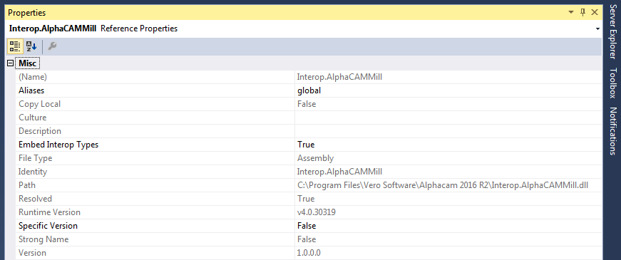

Using your add-in with Alphacam
The example projects include post-build steps to copy the built C# add-in DLL and a file with the same name as the project but with the extension “acamaddin” to c:\Alphacam\LicomDir\DotNetAdd-Ins\<Project Name>. If your LicomDir folder is in a different location you will need to update the post-build steps appropriately.
Alphacam looks in the \LicomDir\DotNetAdd-Ins folder (and its sub-folders) for files with the extension “acamaddin” to determine which C# DLLs to load. These text file contain the name of the C# DLL (with no extension) and various options to indicate how and when it should be loaded. Please look at the example .acamaddin files for more details.
The example .acamaddin files are configured so that the add-in will not be automatically loaded, but will appear in the left-hand side of the “Add-Ins…” dialog box so the user can choose to enable them or not.
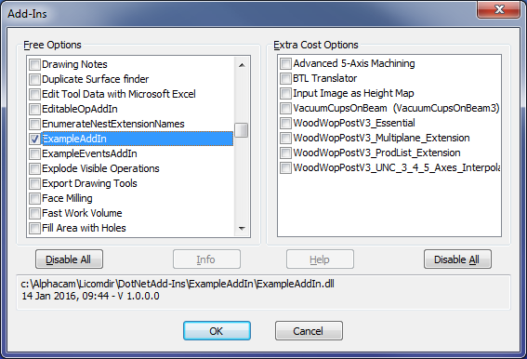

AlphacamEvents class
Each C# add-in must include a public class called “AlphacamEvents” with a constructor defined as taking a single IAlphaCamApp parameter. Alphacam will call this constructor when the add-in is loaded.
From the IAlphaCamApp interface the add-in can retrieve the Frame interface and use the method “CreateAddInInterface” to create an AddInInterfaceClass which can be used to add event handlers such as InitAlphacamAddIn, BeforeInputCad, AfterMachining, etc… (Please refer to the API help for more details about events).
public class AlphacamEvents
{
IAlphaCamApp Acam;
AddInInterfaceClass theAddInInterface;
Fillet CmdFillet;
// This constructor is called when the add-in is loaded by Alphacam
public AlphacamEvents(IAlphaCamApp Acam)
{
this.Acam = Acam;
Frame Frm = Acam.Frame;
theAddInInterface = Frm.CreateAddInInterface() as AddInInterfaceClass;
theAddInInterface.InitAlphacamAddIn += theAddInInterface_InitAlphacamAddIn;
Marshal.ReleaseComObject(Frm); // Free Frame COM variable
}
// Called when the add-in is loaded (Action == acamInitAddInActionInitialise)
// and when it is reloaded after being disabled
// (Action == acamInitAddInActionReload)
private void theAddInInterface_InitAlphacamAddIn(AcamInitAddInAction Action, EventData Data)
{
CmdFillet = new Fillet(Acam);
Data.ReturnCode = 0;
}
}
If the add-in wants to add new commands to the Alphacam interface it must do so in the InitAlphacamAddIn event handler (theAddInInterface_InitAlphacamAddIn method above).
In this example we want to add a new Fillet command immediately after the Alphacam Delete command (which by default appears in the Edit group of the Edit tab in the Ribbon Bar).
public class Fillet : IDisposable
{
IAlphaCamApp Acam;
CommandItemClass Item;
public Fillet(IAlphaCamApp Acam)
{
this.Acam = Acam;
Frame Frm = Acam.Frame;
Item = Frm.CreateCommandItem() as CommandItemClass;

Item.OnCommand += this.OnCommand;
Item.OnUpdate += this.OnUpdate;

// CmdName is just used to generate a unique ID, so use the class name.
bool ok = Frm.AddMenuItem43("Fillet by specified value", GetType().Name, AcamCommand.acamCmdEDIT_DELETE, true, "", 0, Item);

Marshal.ReleaseComObject(Frm); // Free COM variable
}

For each command we create a CommandItemClass instance using the Frame interface and supply the OnCommand and OnUpdate handlers. The OnCommand handler is called when the command is clicked on, and the OnUpdate handler is called when Alphacam needs to know if the command is enabled or not.

In this example, when the user clicks on the command they will be presented with a dialog box requesting a fillet amount. After supplying a value all geometries in the drawing are filleted with this value.

// Called when the menu item is clicked on
void OnCommand()
{
float fillet_amount = 0F;
Frame Frm = Acam.Frame;
if (Frm.InputFloatDialog("Example Add-in", "Fillet amount", AcamFloat.acamFloatNON_NEG, ref fillet_amount))
{
Drawing Drw = Acam.ActiveDrawing;
Paths Geos = Drw.Geometries;

int GeosCount = Geos.Count;
for (int i = 1; i <= GeosCount; ++i)
{
Path Path = Geos.Item(i);

Path.Fillet(fillet_amount);

Marshal.ReleaseComObject(Path);
}
Drw.RedrawShadedViews();

// Free COM variables used
Marshal.ReleaseComObject(Geos);
Marshal.ReleaseComObject(Drw);
}

Marshal.ReleaseComObject(Frm); // Free COM variable

}

The OnUpdate method should only do a minimal amount of work to determine if the command is enabled or not because it may be called many times. In this example the fillet command will be enabled if the active drawing contains at least one geometry.

// Called when the menu item is to be enabled or disabled.
// Return one of the enum AcamOnUpdateReturn values.
AcamOnUpdateReturn OnUpdate()
{
AcamOnUpdateReturn ret = AcamOnUpdateReturn.acamOnUpdate_UncheckedDisabled;

Drawing Drw = Acam.ActiveDrawing;
if (Drw.GetGeoCount() > 0)
ret = AcamOnUpdateReturn.acamOnUpdate_UncheckedEnabled;

Marshal.ReleaseComObject(Drw);

return ret;
}

The add-in in action: -
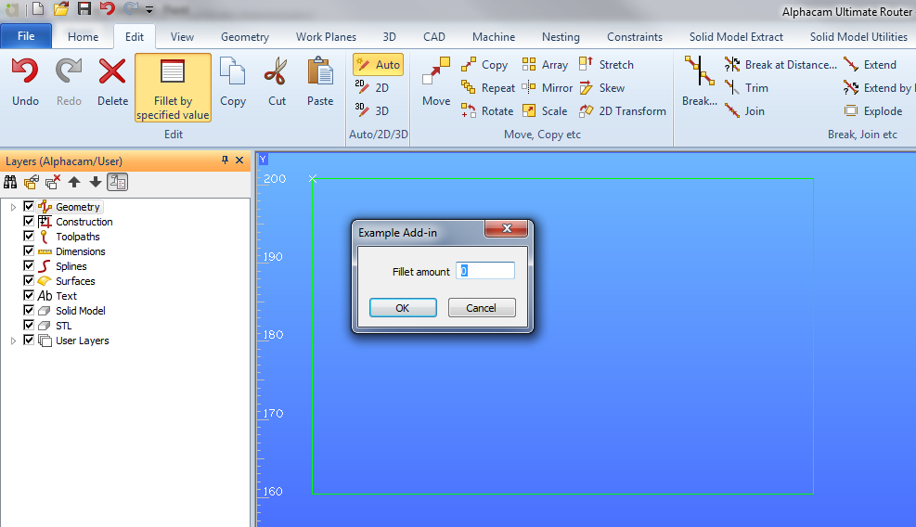
In addition to responding to events, an add-in can respond to various notifications such as when different kinds of entities (geometries, splines, surfaces, etc…) are added or modified.
In the AlphacamEvents constructor, call the CreateAddInNotifications method on the Frame object to create an AddInNotificationsClass, and then add the handlers you wish to support.
theAddInNotifications = Frm.CreateAddInNotifications() as AddInNotificationsClass;
theAddInNotifications.GeometriesUpdated += theAddInNotifications_GeometriesUpdated;
You can then implement the handlers you need: -
// Called when geometries are changed eg move, copy, delete etc
void theAddInNotifications_GeometriesUpdated()
{

}
For more information please refer to the example source code and the Alphacam API Help.

Releasing COM objects in .NET
When developing add-ins for an application that has a COM interface (like Alphacam), all COM objects must be released. The most common problems caused by COM objects not being released are: application slows down, application cannot quit and application hangs (deadlocks).
There are different ways to release COM variables, however we recommend the use of Marshal.ReleaseComObject(). ReleaseComObject gives you control over when and how your COM object is released.
For samples showing how to use it, check the DVD samples ExampleAddIn and EditableOpAddIn.
Some general rules:
Don’t use double dots: Avoid code like “Drawing.Geometries.count”. In this code Drawing.Geometries will create a Paths COM object which will not be released by .NET and you will not be able to release it because it is not stored in a variable. The solution would be to create a local variable to hold on to the Paths collection so you can release it when you have finished with it.
Don’t use foreach on COM collections: Avoid code like “foreach (Path p in Paths) {…}”. When using foreach in a COM collection such as Paths, foreach automatically generates an internal enumerator which is a COM object that will not be released. In this case there is no way to get the enumerator COM object and therefore you cannot release it. The solution is to use a normal for loop and release each COM object in the collection that you use (as well as the collection itself).
For more information read the web sites below:
https://www.add-in-express.com/creating-addins-blog/2013/11/05/release-excel-com-objects/
https://www.add-in-express.com/creating-addins-blog/2011/11/04/why-doesnt-excel-quit/ https://www.add-in-express.com/creating-addins-blog/2008/10/30/releasing-office-objects-net/ http://dotnetdebug.net/2005/09/10/runtime-callable-wrapper-internals-and-common-pitfalls/

