Object Oriented Programming

**Semestral project – EspaTrip desktop application**

Petra Miková

**Contents**

Project objective 1

Project requirements 1

UML diagram and classes relationship 2

UML diagram 2

Classes relationship 2

Criteria fullfilment 2

Main criteria 2

1. Inheritance 2

2. Polymorphism 3

3. Aggregation 3

4. Encapsulation 4

5. Code organization (packages) 4

Secondary criteria 5

6. Design patterns 5

7. Own exceptions 5

8. Graphical user interface separated from application logic 6

9. Using generics in own classes 7

10. Explicit use of RTTI 7

11. Using nested classes and interfaces 8

12. Using lambda expressions or method references 9

13. Using serialization 9

Functionality of the app 10

Main GitHub versions 11

Commits on Mar 20, 2023 11

Commits on Mar 23, 2023 11

Commits on Apr 3, 2023 11

Commits on Apr 11, 2023 11

Commits on Apr 27, 2023 11

Commits on May 2, 2023 11

Commits on May 8, 2023 11

Conclusion 12

Project objective

The desktop app EspaTrip allows a user to register as a customer who wants to go on a trip to Spain, or a Spanish local who offers a stay for people from all around the world. For now, there are three favorite Spanish destinations available - Madrid, Barcelona and Valencia.

**As a customer** - you decide on a city and your preferences on a local, and after that you will be offered to choose from multiple restaurants and sights, depending on what you want to see and what food you want to try. After all this, you get a price offer and a summary of your trip , which you can reject or accept and send in the order. Then your order is pending and if a sufficient local accepts it, you are good to go!

**As a local** - within your initial sign up, you fill in the registration form created for locals and your information will be stored, and then in your profile you will see all the created trips from customer whose criteria you meet. You can either reject or accept the trip, and if you accept it it will move into your accepted trips part of the profile and you can start preparing for the adventure!

Project requirements

The project runs on Gradle. The Java source compatibility for this project is 18, so it is important that in your IDE you are able to run SDK either Java 18.0.2 or Java Amazon Corretto 18.0.2. Gradle should show you the option to download this SDK if your IDE is not recognizing it or you do not have it set up in the IDE.

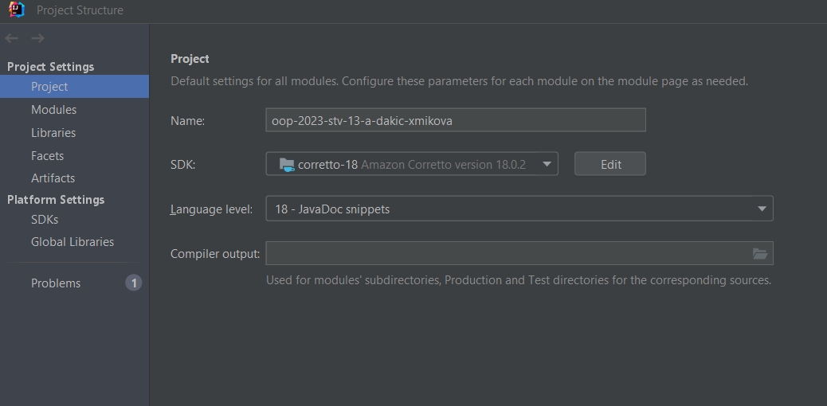

When the Gradle build is all set up, you can either run it with gradle run configuration or directly by running the Boot class which is located in the org.example.app package. To run the JAR file, please build it with fatJar configuration and then it is possible to run it even outside the IDE.

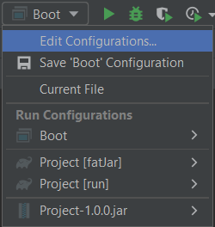

UML diagram and classes relationship

UML diagram

Obrázok, na ktorom je text, snímka obrazovky, diagram

Automaticky generovaný popis

Classes relationship

1. The Customer and Local classes inherit from User class
2. The BarcelonaPlacesController, MadridPlacesController, and ValenciaPlacesController inherit from PlacesController
3. The UserManager class uses generic type of subclasses of User class
4. Both the RegistrationAndLoginExceptions and OrderExceptions classes have multiple nested classes that inherit from these super classes and handle specific exceptions. The super classes themselves inherit from Java builtin class Exception.
5. The OrderController and LocalOrderController classes implement the AfterLoginScreen interface.

Criteria fullfilment

Main criteria

1. Inheritance

First case of inheritance is by classes Customer and Local from super class User, as they use the same functionalities, but have some additional attributes each.

Obrázok, na ktorom je text, snímka obrazovky, písmo

Automaticky generovaný popis

Second case of inheritance is by classes BarcelonaPlacesController, MadridPlacesController, and ValenciaPlacesController, which inherit from PlacesController. They all use the same methods, but have different attributes which represent places in each location.

Obrázok, na ktorom je text, snímka obrazovky, písmo

Automaticky generovaný popis

1. Polymorphism

Polymorphism is used in both exceptions classes – RegistrationAndLoginExceptions and OrderExceptions. The default message is „Error“ and then every nested class of those which represents a specific excpetion overrides it and displays its own message based on the specific error.

1. Aggregation

Aggregation is used in the Customer class, where we have an attribute preferences, whose type is CustomerPreferences (another class).

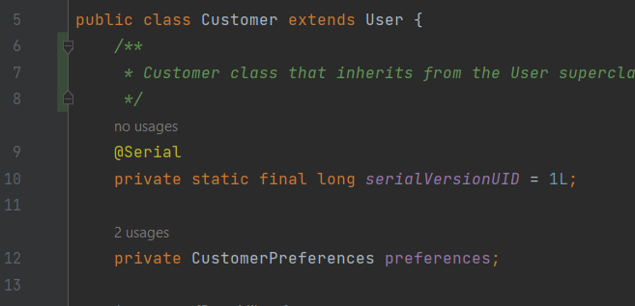

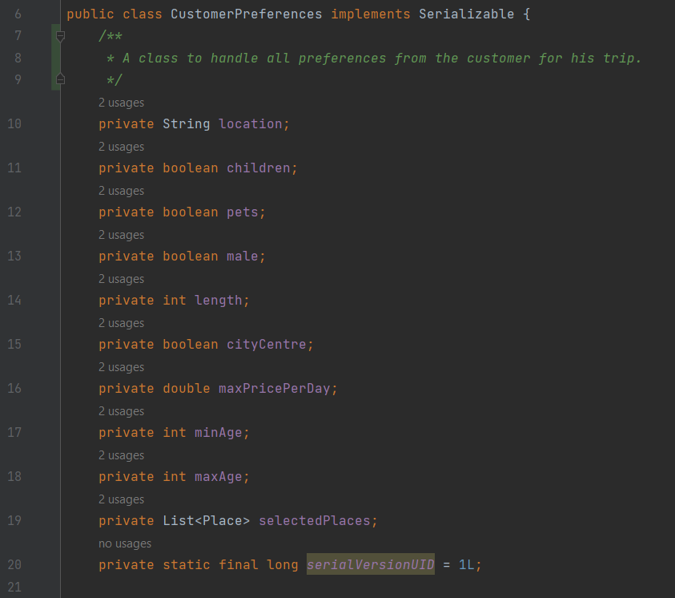

1. Encapsulation

All classes in the org.example.objectclasses use encapsulation – so have private attributes wrapped into public getters and setters. Besides these, the classes UserManager and OrderManager (Singleton classes) use encapsulation as well (org.example.tools).

1. Code organization (packages)

The main package (also a main module) is the org.example. This package is then efficiently organized into 5 packages. The GUI is in resources directory in FXML folder. The app package includes the booting classes. The controllers package includes all the controllers that handle user interaction with GUI. The exceptions package includes all the custom exceptions classes. The package objectclasses includes all the objects used in app – User, Order, Place. Lastly, the tools include other essential miscellaneous classes for handling the functionality like managers using Singleton or class for deserializing JSON database. The FXML in resources includes all the .fxml files for functional GUI of the app.

Obrázok, na ktorom je text, snímka obrazovky, softvér, dizajn

Automaticky generovaný popis

Obrázok, na ktorom je text, snímka obrazovky, softvér

Automaticky generovaný popis

Secondary criteria

1. Design patterns

In my implementation, I use the **Singleton design pattern** in classes UserManager - uses the Singleton design pattern to ensure that only one instance of the class can exist at any given time, and provides access to a single instance of the currentUser object of type T which extends the User class, and OrderManager - uses the Singleton design pattern to ensure that there is only one instance of the class at any given time, which provides the ability to work with one order object throughout the whole order creation even in different controllers.

Besides this design pattern, my implementation also uses the **MVC (Model-View-Controller) design pattern:**

Model: The objectclasses, tools, exceptions and app packages that contain the application logic and represent the data and logic of my application.

View: The FXML directory in resources folder with user interface (UI) files. These files describe the structure and appearance of the UI and how the UI interacts with the user.

Controller: The classes in the controllers package handle user input, manage the state of the UI, and communicate with the model to update the data and logic.

1. Own exceptions

My implementation also includes handling exceptional states using own exceptions. For this, I have implemented two classes for handling exceptions during registration and login, and during the order creation – RegistrationAndLoginExceptions and OrderExceptions. These inherit from the builtin Java Exception class and have several subclasses for specific exceptions which are then thrown in the application process.

An example of my own exception:

Obrázok, na ktorom je text, snímka obrazovky, softvér, multimediálny softvér

Automaticky generovaný popis

The message is then overriden like this:

Obrázok, na ktorom je text, snímka obrazovky, písmo, multimediálny softvér

Automaticky generovaný popis

1. Graphical user interface separated from application logic

My GUI is fully separated from the logic as I already mentioned. All the GUI .fxml files are in the resources directory and the interaction from user is handled via controllers using the FXML functions with parameter ActionEvent. The controllers are in the controllers package of my app.

Some of the examples:

1. goBackToAfterLogin in OrderController class

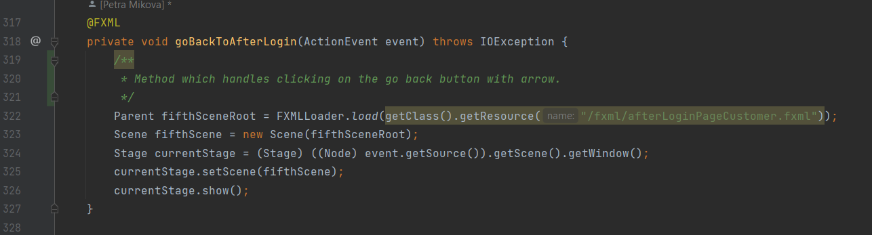

1. hyperLinkHandlerTripSummary in TripSummaryController

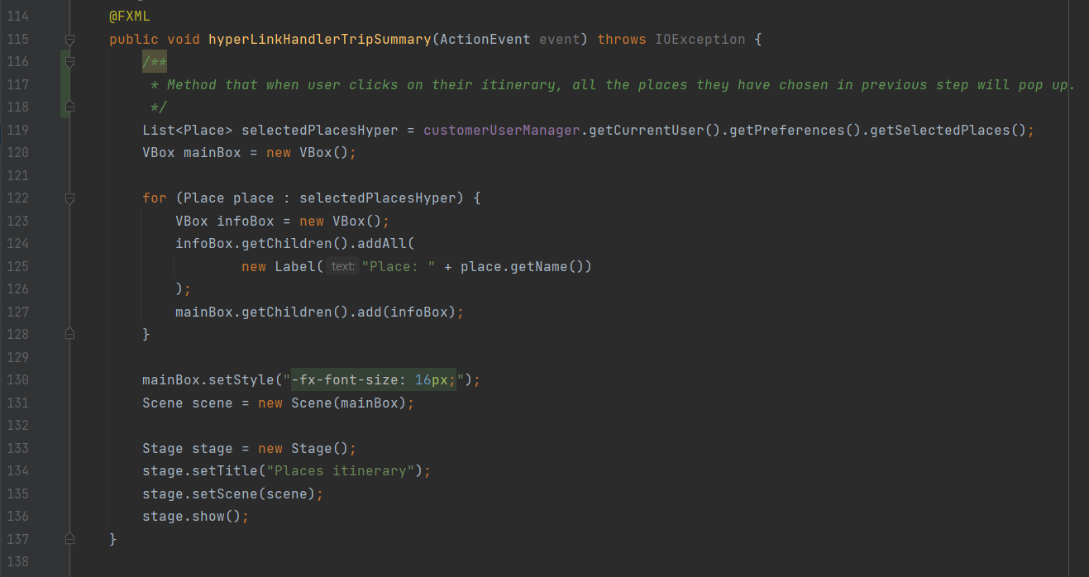

1. Using generics in own classes

The generic type parameter T is declared in the class signature as UserManager<T extends User>, and it is used as the type of the currentUser field, which is declared as private T currentUser = null. The generic type T must extend the User class, which means that any object of the UserManager class can work with a specific subtype of User.

Obrázok, na ktorom je text, snímka obrazovky, softvér, multimediálny softvér

Automaticky generovaný popis

1. Explicit use of RTTI

In the PlacesController class in method checkBoxesSetSelectedPlaces I use RTTI (instanceof) to determine the type of an object and retrieve chosen places by user in the GUI.

Obrázok, na ktorom je text, snímka obrazovky, displej, softvér

Automaticky generovaný popis

1. Using nested classes and interfaces

In my implementation, I use nested classes in both the exceptions classes – RegistrationAndLoginExceptions and Order exceptions. Both of these have several nested static classes which extend the main one and override displaying the message.

Example from my code:

Obrázok, na ktorom je text, snímka obrazovky, softvér

Automaticky generovaný popis

Obrázok, na ktorom je text, snímka obrazovky, softvér

Automaticky generovaný popis

I also use one interface in my implementation, called AfterLoginScreen, which declares basic methods that apply to both customer and local after they login into account. The classes OrderController and LocalOrderController implement this interface.

Obrázok, na ktorom je text, snímka obrazovky, písmo

Automaticky generovaný popis

1. Using lambda expressions or method references

I use lambda expressions in method ordersForReview in LocalOrderController class.

Obrázok, na ktorom je text, písmo, snímka obrazovky

Automaticky generovaný popis

1. Using serialization

In the User class, I use serialization to read and write user data to a binary file called "users.dat". In the getUsers() method, I create an ObjectInputStream that reads the data from the "users.dat" file and deserializes it into an ArrayList of User objects. Then I return this list of users. In the setUsers() method, I take an ArrayList of User objects as an argument and create an ObjectOutputStream. Finally, I serialize the users ArrayList and write it to the "users.dat" file.

Obrázok, na ktorom je text, snímka obrazovky, softvér

Automaticky generovaný popis

Functionality of the app

A gif visually representing the functionality is in ReadMe file documentation on GitHub.

* 1. You can sign in – either as a local or customer. If you register as a local, you fill out further registration form. The users are serialized into users.dat file.
  2. Then you log in – if you are customer, you have two buttons to create a new order or view your current trips and their status. If you are a local, you have two buttons to review orders and other to see accepted trips. In both cases you can log out there.
  3. When creating new order as a customer, you are led through multiple scenes to choose your preferences for local and the trip itself. The places are stored in a JSON database which is deserialized into Places array list. In each step you have the option to go back. Eventually, you get to trip summary scene, where you can either reject or accept the offer. If you accept it, it is stored in a SQLite database and available for locals to review from now on.
  4. Then you can simply see your current trips by clicking on the button in after login page.
  5. As a local, if there are any trips for you to review, they will appear after clicking on the button made for reviewing offers. For every trip, you have accept and reject button so you can decide on each trip. If you accept any, they will pop up after clicking on a button made for it.

Main GitHub versions

## Commits on Mar 20, 2023

* included gradle into project
* javafx plugin working

## Commits on Mar 23, 2023

* essential classes added
* simple GUI

## Commits on Apr 3, 2023

* working login and registration with functional GUI
* exceptions for login and registration

## Commits on Apr 11, 2023

* Working Program Version
* order creation process, setting the preferences on Local
* redirection to page with places in chosen city, and provided description of every place
* redirection to trip summary page (was a WIP)

## Commits on Apr 27, 2023

* SQLite for orders added
* modified build.gradle to be fully functional
* module info added

## Commits on May 2, 2023

* functional SQLite communication and customer being able to accept or reject the order and thus change the status in the database

## Commits on May 8, 2023

* interaction with order from local’s side functional
* log out and go back to previous page buttons
* GUI finalised
* division of code into packages

## Commits on May 13, 2023

* final commit
* fully completed application
* documentation + JavaDoc added into Documentation repo
* ReadMe finalised

Conclusion

A travel app, as it was stated in the general topic, covers the connection between people who want to travel to three locations in Spain and people from Spain who offer stay at their home.

It is provided with authentification of the user (login) and offers possibility for customer to create a trip exactly how they want, so that their preferences are fullfiled. Then it is up to review for local and if they accept it as well, the adventure can begin!

For storing the information, I used serialization into .dat file for login information, JSON database for beforehand stored places for each location, and SQLite database for storing orders and updating their status.

My assignment fulfilled the main criteria of OOP which were inheritance, aggregation, polymorphism, encapsulation, and division into packages. Besides that, it fullfiled many of the secondary criteria, which have been described earlier in this documentation. Thus, I would state that the app fulfills the assignment and subject requirements.